**BINDURA UNIVERSITY OF SCIENCE EDUCATION**

**FACULTY OF COMMERCE**

**DEPARTMENT OF ECONOMICS**



**TOPIC: THE ROLE OF SMALL AND MEDIUM ENTERPRISE (SMEs) ON ECONOMIC DEVELOPMENT IN ZIMBABWE.**

**NAME: KELLY ROPAFADZO TAMWA**

**REG NUMBER: B202271B**

**SUPERVISOR: MR S BINDU**

**A DISSERTATION SUBMITTED IN PARTIAL FULFILMENT OF THE REQUIREMENTS FOR THE BACHELOR OF SCIENCE HONORS DEGREE IN ECONOMICS OF BINDURA UNIVERSITY OF SCINCE EDUCATION, FACULTY OF COMMERCE**

**JUNE 2024**

# RELEASE FORM

**NAME OF STUDENT:** KELLY ROPAFADZO TAMWA

**DISSERTATION TITLE:** THE ROLE OF SMALL AND MEDIUM ENTERPRISE (SMEs) ON ECONOMIC DEVELOPMENT IN ZIMBABWE

**DEGREE TITLE:** BACHELOR OF SCIENCE HONOR’S DEGREE IN ECONOMICS

**YEAR OF COMPLETION:** 2024

Permission is here by granted to BINDURA UNIVERSITY OF SCIENCE EDUCATION to produce single copies of this dissertation and lend or sell such copies for private, scholarly or scientific purpose only. The author does not reserve other publication rights for the dissertation.

**AUTHOR’S ADDRESS: 9550 BUDIRIRO 5B, HARARE**

# APPROVAL FORM

The undersigned certifies that they have supervised the student, TAMWA ROPAFADZO KELLY’s dissertation entitled**: THE ROLE OF SMALL AND MEDIUM ENTERPRISE (SME’s) ON ECONOMIC DEVELOPMENT IN ZIMBABWE**, submitted in partial fulfillment of the requirements of **Bachelor of Science Honor’s Degree in Economics at the Bindura University of Science Education.**

**(Signature of Student) and Date**

**………………………… 23…/…09…/24….**

**Signature of Supervisor** **Date 23/09/2024**

**(Signature of the Chairperson) and Date**

**………………………****……………………… ……23/…09…/…24….**

# DEDICATION

This study is dedicated to my mother, Senzenia Chakauya who has been my constant source of love, support and inspiration throughout my academic journey. Your unwavering encouragement and belief in my abilities have been invaluable and l am grateful for the sacrifices you have made to help me pursue my dreams, I love you Amai.

**ABSTRACT**

*The**main objective of this study was to investigate on the role of SMEs on economic development in Zimbabwe, hence to achieve that the model used time series data obtained from the World Bank World Development Indicators from 1990-2022. Even if some adjustment where made on the model employed for this study, the model was adapted from a research by . Real Gross Domestic Product (RGDP) was used as the dependent variable in this model and the main independent variable used was Credit to SME (CSME) wich was used as the proxy to measure capital per SME worker. CSME was used to study the role of SMEs on economic development and the Domestic Credit To Privater sector (% GDP) was the measure of Credit to SME. Gross Capital Formation (GCF), Capacity utilization (CPU), Electricity Distribution (ED) and unemployment (UNER) were the other explanatory variables employed on this study. The findings after using an Auto-regressive distributed lag (ARDL) model for estimating the regression, suggested that a 1% increase on credit to SME is associated with 0.047853 increase in economic development in the long run and 0.040209 increase crease in economic development in the long run. More so Gross Capital Formation has an insignificant negative relationship with economic development in Zimbabwe both in the Short run and in the long run, Capacity utilization has a positive significant impact on economic development of Zimbabwe in the long and in the short run. Electricity distribution has negative relationship with economic development both on the short run and in the long run in the economic development of Zimbabwe mainly due to poor quality and reliability of electricity in the country. Unemployment portrays a positive relationship to economic growth both on the short run and in the long run*

**ACKNOWLEDGEMENT**

First and foremost, l would like to thank the Lord Almighty for enabling me to have made it this far. As it states in Romans 8 vs 37 “No, in all these things we are more than conquerors through him who loved us.” Additionally, l would like to thank Bindura University of Science Education and the Economics Department for granting me the opportunity to purse my studies. A special thanks to my supervisor Mr S Bindu for his guidance and extensive knowledge which played a crucial role in bringing this project to fruition. Truly he is a great mentor. My sincere thanks go to my family and friends. Their unwavering support has been valuable in achieving this ultimate goal. Your presence surely strengthened me in this academic journey. Last but not least l am indebted to my classmates for all the discussions and contributions. Special mention to Bertha Mutamiswa, l recall all the sleepless nights and everything we have had over the past four years

**Table Of Contents**

RELEASE FORM I

APPROVAL FORM II

DEDICATION III

**LIST OF TABLES** IX

LIST OF FIGURES X

LIST OF ACROYNIMS XI

CHAPTER ONE: INTRODUCTION 1

**1.0 Introduction to the Study** 1

**1.1 Background of the Study** 1

**1.2 Statement of the Problem** 4

**1.3 Objectives of the Study** 4

**1.4 Research Question** 5

**1.6 Significance of the Study** 5

**1.7 Assumptions** 6

**1.8 Limitations of the Study** 7

**1.9 Delimitations of the Study** 7

**1.10 Definition of Terms** 7

**1.11 Summary of the Study** 8

CHAPTER TWO: LITERATURE REVIEW 9

**2.0 Introduction** 9

**2.1 Theoretical literature review** 9

**2.1.1 Finance Led Growth Hypothesis** 9

**2.1.2 Neoclassical Growth Theory** 10

**2.1.3 The Endogenous Growth** 11

**2.2 Empirical Literature Review** 11

**2.2.1 Impact of finance on Economic Development** 11

**2.2.2 Impact of SMEs on Employment** 13

**2.2.3 Bank Lending on SME and Economic growth** 14

**2.3 Research Gap** 15

**2.4 Conclusion** 15

CHAPTER 3: RESEARCH METHODOLOGY 17

**3.0 Introduction** 17

**3.1 Research Design** 17

**3.2 Sampling Design** 17

**3.3 Theoretical Model** 18

**3.4 Model Specification** 19

**3.5 Justification and Measurement of Variables** 20

**3.5.1 Real Gross Domestic Product (lnRGDP)** 20

**3.5.2 Gross Capital Formation (lnGCF)** 20

**3.5.3 Credit to SMEs (CSME)** 21

**3.5.4 Capacity Utilization (CAPU)** 21

**3.5.5 Electricity Distribution (ED)** 22

**3.5.6 Unemployment (UNER)** 22

**3.6 Types of data and sources** 23

**3.7 Estimation Method** 23

**3.8.1 Unit root test** 23

**3.8.2 Optimal Lag Length Selection** 24

**3.8.3 Cointegration test** 24

**3.9 Diagnostic test** 25

**3.9.1 Multicollinearity Test** 25

**3.9.2 Normality test** 26

**3.9.3 Heteroscedasticity test** 26

**3.9.4 Autocorrelation** 26

**3.9.5 Model Stability test** 27

**3.9.6 Model Specification** 28

**3.10 Conclusion** 28

CHAPTER 4 29

DATA PRESENTATION AND INTERPRETATION 29

**4.0 Introduction** 29

**4.1 Descriptive Statistics** 29

**4.2 Unit root test** 30

**4.3 Optimal Lag Selection** 32

**4.4 Cointegration test** 32

**4.5 Diagnostic test** 33

**4.5.1 Multicollinearity test** 33

**4.5 Post diagnostic test** 35

**4.5.1 Heteroscedasticity test** 35

**4.5.2 Autocorrelation test** 35

**4.5.3 Normality Test** 36

**4.6 Model Specification** 36

**4.7 Parameter stability test** 37

**4.8 Regression results** 37

**4.5.1 Gross Capital Formation (GCF)** 38

**4.5.2 Credit To SMEs (CSME)** 39

**4.5.3 Capacity Utilization (CAPU)** 40

**4.5.4 Electricity Distribution (ED)** 40

**4.5.5 Unemployment (UNER)** 41

**4.6 Short Run Results Interpretation** 43

**4.7 Conclusion** 43

CHAPTER 5 44

SUMMARY, CONCLUSIONS & POLICY RECOMMENDATIONS 44

**5.0 Introduction** 44

**5.1 Summary of the research** 44

**5.2 Conclusions** 46

**5.3 Policy Recommendations** 47

**5.4 Suggestions for future study** 49

APPENDICES INDEX 53

Appendix 1.1 : Original Data set 53

**Appendix 1.2: Transformed Data set** 54

**Appendix 2 Descriptive statistics** 55

**Appendix 3 ADF Unit root test** 56

**Appendix 4 Optimal Lag Selection** 62

**Appendix 5 Cointergration test** 63

**Appendix 6.1 Variance Inflation Factor** 63

**Appendix 6.2 Correlation Matrix** 64

**Appendix 6.3 Hetroscedacitsity test** 64

**Appendix 6.4 Autocorrelation test** 65

**Appendix 6.6 Ramsey reset results** 67

**Appendix 8 Turn It In report** 70

**LIST OF TABLES**

**Table 1 Descriptive Statistics results 31**

**Table 2 ADF results 32**

**Table 3 VAR Lag Order Selection Criterion results 33**

**Table 4 F-Bound test results 34**

**Table 5 VIF results 35**

**Table 6 Correlation Matrix results 36**

**Table 7 heteroscedasticity results 36**

**Table 8 Autocorrelation results 37**

**Table 9 Normality results 37**

**Table 10 Ramsey reset results 38**

**Table 11 ARDL Long run regression summary table 39**

**Table 12 ARDL Short run regression summary table 43**

# LIST OF FIGURES

**Figure 1 .1 Trend for Real GDP & Credit to SME 3**

**Figure 2 Cusum test 39**

# LIST OF ACROYNIMS

ADF Augmented Dickey-Fuller

ARDL Auto-regressive Distributed Lag

BLUE Best Linear Unbiased Estimators

CAPU Capacity Utilization

CSME Credit to SME

DW Durbin Watson

ECM Error Correlation Model

ED Electricity Distribution

FIN Financial Development

GCF Gross Capital Formation

GDP Gross Domestic Product

IMF International Monetary Fund

INF Inflation

IOM International Organization for Migration

Ln Logarithm of

OLS Ordinary Least Square

RGDP Real GDP per capita

SME Small to Medium Enterprise

VAR Vector Autoregressive

UNER Unemployment Rate

# CHAPTER ONE: INTRODUCTION

## **1.0 Introduction to the Study**

The economic development of a country is influenced by various factors, and Small and Medium Enterprises (SMEs) have been recognized as significant contributors to economic growth and development, Akingunola, (2011). This is mainly because of their capacity to enhance economy productivity and living standards, according to Sunusi (2003) SMEs can contribute to about 50% of the GDP for many developing economies. There is no a complete definition of what really SMEs are, according to Madanchian *et al* (2015) they are defined from country to country basing on the number of full-time employees or annual sales turn over. For instance, according to the World bank SMEs are defined as enterprises of 300 employees, UNDP says it employees 200 people, whereas the African bank defines using a threshold of SMEs consisting of 50 employees. According to Dabengwa, (2023) in Zimbabwe the Zimbabwe Revenue Authority (ZIMRA) classifies SMEs as business that employ 5-40 people with annual turnover and assets from as low as $50,000 to $2 million. SMEs operate in diverse sectors, such as textiles, agribusiness, information and communications technology (ICT), and construction. In Zimbabwe, SMEs have played a crucial role in driving economic activities, creating employment opportunities, and fostering innovation. Therefore, this study aims to investigate the role of SMEs in the economic development of Zimbabwe from 1991 to 2022.

## **1.1 Background of the Study**

Over the past few decades, Zimbabwe has experienced significant economic challenges, including hyperinflation, political instability, and limited foreign investment. In such a context, SMEs have emerged as a vital sector, contributing to job creation, poverty alleviation, and the overall economic well-being of the country. All over the world globally there has been debates over the impact of Small and Medium Enterprises to economic growth, hence as a result the in 2015 the Group of Twenty which is a group the world’s major economies held a G20 Summit in Belek, Antalya Province in Turkey. According to Alibhai, Bell, & Conner (2017) during the summit the President of Turkey spoke equivocally on the importance of SMEs to the global economy. There has been an increase in the focus of financing SMEs worldwide so that they contribute more towards global economic growth due to the G20 summits, Watambwa & Shingolo (2021). For instance, in Zimbabwe there is the Vision 2030 by E.D Munangagwa new Dispensation in 2018 is focused on promoting innovation, entrepreneurship, equitable development and prosperity for all, under a market economy that leverages on and also involves generation of jobs hence to achieve this goal SMEs can play a vital role.

More over the Ministry of Small and Medium Enterprises and Cooperative Development is a clear gesture that the government of Zimbabwe is committed towards the success of SMEs. According to Zindiye (2018) they are also several institutions that are working hand in glove to promote SMEs for example among others SEDCO. According to a research study conducted by Finmark Trust (2013), it was found that Zimbabwe had approximately 3.5 million micro, small, and medium-sized enterprises (MSMEs) in 2012 collectively generating a turnover of USD 7.4 billion. The study also revealed that around 2.8 million Zimbabweans were involved as owners of these enterprises at that time and the MSME sector employed approximately 2.9 million individuals. The research findings align with the data from Zimstat in 2016, which indicated that 94.5% of the 6.3 million individuals classified as employed were engaged in the informal economy. Understanding the historical background and trends in the variables related to SMEs is essential to comprehend their impact on economic development. Figure 1.1 below shows a trend of Real GDP and the Credit to SME (CSME) (Domestic Credit To Private sector (% GDP)) being the proxy for government expenditure to SMEs, using the data obtained from the world bank, both data being in their natural log form, from (1991-2022).

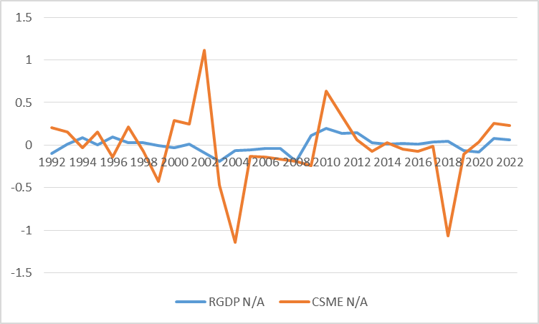

Figure 1.1 Trend for Real GDP & Credit to SME

**Figure 1.1 Trend for Real GDP & Credit to SME**

*Source Microsoft excel authors own computation Data from World Bank*

From fig 1.1 above a period from 1991 to 2000 a period just after independence, both RGDP and CSME experienced fluctuations Real GDP showed both positive and negative growth rates, indicating periods of economic expansion and contraction, Credit to SME which is SME financing or SME funding also had mixed results with both positive and negative values. This suggests that the role of SMEs in economic development during this period may have been influenced by various factors, including economic conditions and government policies since after independence several economic and political changes where being implemented. In 2002, there was a significant decline in RGDP, accompanied by a sharp increase in CSME, indicating that SMEs played a crucial role in supporting the economy during a period of overall economic decline which was mainly due to a drought over that period. Over a period from 2003 to 2008, both RGDP and CSME experienced mostly negative growth rates a period experienced challenging economic environment for SMEs and limited credit availability Masuko & Marufu (2003) as during this period Zimbabwe was experiencing an inflationary environment which continued to 2009, where by RGDP showed positive growth, while CSME experienced a negative growth rate. This indicated that SMEs did not fully benefit from the economic recovery. The reason behind this discrepancy was that they lacked formal management training. From 2010 to 2022, both RGDP and CSME generally displayed positive growth rates, albeit with some fluctuations hence portrays a positive relationship between SMEs and economic development during this period. In order to attract foreign investors, the government according to Gono (2006) introduced investment promotion strategies to stimulate growth and development of SMEs in Zimbabwe. Tax relief was introduced as the SMEs are under a lower cooperate and capital gains tax threshold, they were also given a 5-year grace period on taxation during their startup phase hence allowed them to graduate from informal sector to formal sector therefore widen the tax base which increased the real GDP.

## **1.2 Statement of the Problem**

Despite the significant presence of Small and Medium Enterprises (SMEs) in Zimbabwe and their potential to contribute to economic development, there is a need to understand the extent of their impact and the factors that have influenced their performance over the period from 1991 to 2022. While some studies have examined the relationship between SMEs and economic development in Zimbabwe, there remains a gap in comprehensive analysis that incorporates key variables such as Real GDP and Credit to SMEs. This thesis tries to examine on how the capital per worker from SMEs through SME financing by the financial institutions, i.e. credit given to SMEs impact economic development. Additionally, there is a lack of research that explores the influence of factors such as inflation, and unemployment rates on the role of SMEs in the country's economic development. Therefore, this dissertation aims to address these gaps by investigating the trends, fluctuations, and relationships between SMEs and economic development in Zimbabwe over the specified period, in order to provide a deeper understanding of the challenges and opportunities faced by SMEs and their overall contribution to the country's economic growth.

## **1.3 Objectives of the Study**

**Main objective**

The primary objective of this study is to examine the role of SMEs on the economic development of Zimbabwe from 1991 to 2022. To achieve this, the following specific objectives will be pursued:

1. To assess the short run and long run contribution of SME (Credit to SMEs) to GDP growth in Zimbabwe.
2. To assess the short run and long run impact of gross capital formation, capacity utilization, electricity distribution and unemployment rates on economic development in Zimbabwe.
3. To determine the short run speed of adjustment which contribute to long run equilibrium.

## **1.4 Research Question**

To achieve the previously described research objectives, the following research questions must be answered, which are:

1. How do the Small and Medium Enterprises (SMEs) and Real GDP to each other?
2. What is the impact of SMEs on GDP?
3. What policy suggestions can we obtain from the study?

**1.5 Research Hypothesis**

H0: There is no significant relationship between SMEs and economic development in Zimbabwe.

H1: There is a significant relationship between SMEs and economic development in Zimbabwe.

## **1.6 Significance of the Study**

Understanding the extent to which SMEs contribute to the country's GDP growth is essential for policymakers and economists. This study aims to assess the contribution of SMEs to GDP growth in Zimbabwe hence by analyzing the data and trends over the period from 1991 to 2022, the study will provide insights into the role of SMEs in driving economic growth and development. The study also seeks to assess the impact of key macroeconomic factors such as interest rates, inflation, and unemployment rates on economic development in Zimbabwe. Policymakers can gain a better understanding of how changes in these variables influence the performance and growth of SMEs, and subsequently, their impact on the overall economy.

The findings of this study will provide policymakers with valuable insights and recommendations for formulating effective policies to support SMEs and promote economic development. By understanding the challenges and opportunities faced by SMEs in Zimbabwe, policymakers can design targeted interventions and initiatives to create an enabling environment for SME growth, such as providing access to finance, improving business regulations, and fostering innovation and entrepreneurs. The study aims to provide a nuanced understanding of the roles of SMEs in economic development. By analyzing the historical background, trends, and fluctuations in SMEs' contribution to the economy, the study will shed light on the challenges and opportunities faced by SMEs over the years. This comprehensive analysis will contribute to a deeper understanding of the factors that have influenced the performance of SMEs in Zimbabwe and their overall contribution to the country's economic growth.

## **1.7 Assumptions**

1. The thesis makes an assumption that SMEs have the potential to significantly contribute to economic development in Zimbabwe.
2. Government policies and support programs are adequately designed and implemented to foster the growth and development of SMEs.
3. SMEs in Zimbabwe have access to sufficient financial resources, including loans and capital, to support their growth and expansion.
4. There is a conducive business environment in Zimbabwe that promotes entrepreneurship and supports the establishment and growth of SMEs.

## **1.8 Limitations of the Study**

This study acknowledges certain limitations, such as the availability and reliability of data, time constraints, and potential biases in data collection the availability and reliability of the data pose limitations as there may be gaps or inconsistencies in the data, which could affect the accuracy of the analysis and findings. For instance, there were gaps in the data on interest rate and credit to SME, hence the data required interpolation. Also, the study looked on macroeconomic factors only but didn’t look on some political factors that may influence economic development. Efforts will be made to mitigate these limitations through rigorous research design, data validation techniques, and comprehensive analysis.

## **1.9 Delimitations of the Study**

This study will focus on SMEs in Zimbabwe, specifically examining their role in economic development from 1991 to 2022. The geographical scope will be limited to Zimbabwe, and the study will primarily utilize secondary data sources.

## **1.10 Definition of Terms**

**Small and Medium Enterprises (SMEs):** According to Dabengwa, (2023) in Zimbabwe the Zimbabwe Revenue Authority (ZIMRA) classifies SMEs as business that employ 5-40 people with annual turnover and assets from as low as $50,000 to $2 million. Whilst the World bank SMEs are defined as enterprises of 300 employees, UNDP says it employees 200 people, whereas the African bank defines using a threshold of SMEs consisting of 50 employees.

**Economic Development:** According to Piketty (2014), economic growth is typically understood as changes in a country's Gross Domestic Product (GDP), which is examined in terms of the different contributions made by the population in relation to national income or capital.

## **1.11 Summary of the Study**

This dissertation is structured into five sections, starting with the Introduction as the first section. In this section, the background, objectives, research questions, significance, and limitations and delimitations of the study have all been addressed and discussed. The remaining sections of this dissertation are structured as follows. In Chapter 2, an extensive literature review is presented to establish the theoretical framework and contextual background for the study. Chapter 3 outlines the research methodology, encompassing details on data collection and analysis methods. The empirical findings and analysis of the correlation between SMEs and economic development are presented in Chapter 4. Lastly, Chapter 5 delves into the implications of the findings, offers policy recommendations, and identifies potential avenues for future research.

# CHAPTER TWO: LITERATURE REVIEW

## **2.0 Introduction**

Over the years different economies have been on debates on analysis the role of SME in economic development this chapter hence provide a review on the existing theoretical and empirical studies on this study.

## **2.1 Theoretical literature review**

Several theories have been put forward on literature for a better understanding of the role of SME in economic development, and these theories provides the deep knowledge of how SME impact to economic growth. Some of the theories include among others the agency theory, pecking order theory, finance led growth hypothesis, neoclassical theory as well as the endogenous growth just to mention a few.

### **2.1.1 Finance Led Growth Hypothesis**

The Finance-Led Growth Hypothesis is an economic theory that posits a positive relationship between financial development and economic growth. Schumpter, (1912) who is the profounder of the theory stated that activities by financial institutions serve as some useful tool to productivity capacity of the economy. The Finance-Led Growth Hypothesis has been supported by various scholars and economists. Notably, King and Levine (1993). The theory therefore, suggest that financial development, characterized by a well-functioning financial system and efficient allocation of resources, plays a pivotal role in fostering economic growth. According to this theory, an adequately developed financial sector facilitates savings mobilization, capital allocation, technological innovation, and entrepreneurial activities, ultimately driving economic expansion. The most important thing to note on the theory is that a well-developed financial sector provides SMEs with improved access to financing, allowing them to invest in productive assets, expand operations, and innovate trough research and development. Accessible financial services, such as loans, credit facilities, and venture capital, can empower SMEs in Zimbabwe to drive economic development (Beck et al., 2000).

### **2.1.2 Neoclassical Growth Theory**

This theory is an influential economic theory that focuses on the determinants of long-term economic growth and was pioneered by economists such as Robert Solow and Trevor Swan, in 1956. Solow and Swan (1956) posit that the long-term economic growth of a country is primarily driven by technological progress and capital accumulation. According to this theory, factors such as labor, capital, and technology interact to determine the rate of economic growth, therefore emphasizes the importance of productivity improvements and efficient resource allocation for sustained economic development. SMEs, through their investment in physical capital, contribute to the accumulation of productive assets in the economy. Increased capital investment by SMEs leads to higher output levels and enhanced productivity, thereby promoting economic growth (Solow, 1956).

Meanwhile on the other hand SMEs in Zimbabwe can foster technological progress by adopting and adapting new technologies, improving production methods, and promoting innovation. Technological progress, driven by SMEs, can positively impact productivity and facilitate long-term economic growth (Romer, 1990). More so according (Lucas, 1988) SMEs, through their entrepreneurial activities, they contribute to resource allocation by identifying and exploiting market opportunities in the economy. Efficient resource allocation enhances overall productivity and promotes sustainable economic development.

### **2.1.3 The Endogenous Growth**

Endogenous Growth Theory is a prominent economic theory that focuses on the factors driving long-term economic growth, particularly emphasizing the role of innovation, knowledge, and human capital. Udo and Mohammed, (2022) suggested that was developed by Romer, Lucas Rebelo in 1980 as a response to the criticism on the traditional neoclassical growth, model. According to this theory, economic growth is endogenously determined by factors such as innovation, human capital accumulation, and knowledge creation. It suggests that investment in research and development (R&D), education, and technology can lead to sustained economic growth. SMEs play a crucial role in fostering innovation and knowledge creation within an economy. Through their entrepreneurial activities and R&D investments, SMEs can develop new products, processes, and technologies, leading to productivity gains and thus will lead to economic development (Romer, 1990). They also often provide opportunities for skill development, training, and entrepreneurship, contributing to the accumulation of human capital in Zimbabwe hence increased human capital levels enhance productivity and promote economic growth (Lucas, 1988).

## **2.2 Empirical Literature Review**

So many studies have been available on the assessment of SME financing on economic development both from developing and developed countries. Therefore, this section highlights an over view of some of the existing literature on the role of SME on economic growth.

### **2.2.1 Impact of finance on Economic Development**

Mazikana, (2019) conducted research on the impact of small to medium enterprise to the Zimbabwe economy and the challenges they face. It also aimed to critically assess the roles of Small and Medium Enterprises (SMEs) in the Zimbabwean economy. It sought to establish the major challenges or constraints faced by SMEs and how these affect the Zimbabwean economy, suggest ways to address the challenges faced by SMEs, and assess how managers of manufacturing SMEs apply principled management. The study involved a comprehensive international literature review and data collection from 300 owners/managers and employees of SMEs using a five-point Like-rt scale survey of 30 small and medium-sized units. The data were analyzed using descriptive statistics. The results of the study revealed that SMEs play a positive and significant role in the economic progress of Zimbabwe, including a fundamental role in foreign exchange earnings and GDP. The study further suggested that SMEs provide job opportunities in the country and have a major contribution to the export sub-sector of Zimbabwe.

Another study conducted by Glonti et al, (2021) obtained that small and medium entrepreneurship (SME) is a crucial sector for the national economy as it determines the economic growth rate of a country or region and the structure of the gross national product. The aim of their study was to evaluate the contribution of SME to the regional economic development, using the example of Adjara A.R. (Republic of Georgia). In the research section, the article presents an econometric analysis of SME key indicators using a linear log-regression model based on statistical data from 2006-2019. The Ordinary Least Squares (OLS) results of the research study show positive impacts of the number of employees and their productivity on gross value added. The study emphasizes the importance of government policies that support a favorable SME environment and conditions, as this is a prerequisite for regional economic development.

Onyeiwu, *et al* (2020) carried out an investigation from 1999 - 2018 in Nigeria on what extent does SMEs financing influence the economic development of the country. Using the Ordinary Least Squares estimation with the EViews 10.0 software the findings suggest that using aggregate of SME contribution to Gross Domestic Product (ASGDP) as the dependent variable Lending rate and Gross capital formation has a negative impact on (ASGDP). Surprisingly, credit to SMEs did not have the expected massive effect on growth, as seen in previous studies. This can be attributed to the choice of using SME contribution to GDP as the target variable. Electricity distribution increased ASGDP by 4.6% which means it has a positive impact on economic development.

### **2.2.2 Impact of SMEs on Employment**

Abdul-kemi and Zubair (2014) on the study of entrepreneurship and economic development in Nigeria evidence of SMEs financing found that entrepreneurs contribute to employment and wealth generation, stimulate indigenous entrepreneurship, and promote an entrepreneurial culture. Small and medium-scale enterprise (SME) operators or entrepreneurs are considered the main drivers of the economy due to their capacity to enhance productivity and improve the standard of living of the common people, as they account for over 50% of the GDP in developing economies. However, the lack of access to affordable and effective sources of finance has been identified as a major factor hindering the contribution of SMEs to economic growth in developing countries. This paper assessed the impact of SME financing on the economic growth and development of Nigeria using a correlational research design and secondary data for a period of 22 years (1992-2013). Applying the Autoregressive Integrated Moving Average (ARIMA) model, the study found that aggregate commercial banks' financing of SMEs has a significant positive impact on the economic growth and development of Nigeria. Additionally, the study found that microfinance banks' financing in the areas of transportation, commerce, manufacturing, and food processing has significantly impacted the economic growth and development of Nigeria during the period.

Ajuwon et al. (2017) evaluated the relationship between micro, small, and medium enterprises (MSMEs) and employment generation in Nigeria, with the objective of ascertaining if MSMEs are fulfilling their purported significant role in terms of employment generation. The study employed a dataset of 473 enterprises across all sectors of the Nigerian economy, comprising 110 micro enterprises, 218 small-scale enterprises, 116 medium-scale enterprises, and 29 large-scale enterprises. The data was sourced from the 2014 World Bank Enterprise Survey on Nigeria. The variables used as indicators of employment generation included gross job creation, net job destruction, and net job creation for the sampled firms. The study employed a non-parametric variance analysis using the locally-weighted scatterplot smoothing (LOWESS) method. The key findings of the study are that MSMEs, particularly small and medium-sized enterprises, are more effective in generating employment compared to large firms in Nigeria. The policy implication of this study is that any targeted intervention to reduce unemployment should focus on MSMEs, as the study has confirmed that small businesses are indeed net creators of jobs. Furthermore, the study recommends the encouragement of MSME development centers to stimulate MSME growth in Nigeria.

### **2.2.3 Bank Lending on SME and Economic growth**

Benson (2017) investigated the relationship between bank lending and economic growth in Nigeria from 1992 to 2015. Using the ordinary least squares (OLS) method, the study measured GDP as the dependent variable and bank lending to small businesses, money supply, lending to the private sector, and interest rate as the explanatory variables. The findings showed an insignificant relationship between the dependent and independent variables. In contrast, Onyeiwu (2014) examined the impact of SME financing on Nigeria's economic growth and found that SMEs had a significantly higher impact on growth compared to variables such as loans to the private sector, capital formation, and money supply. Muganda et al. (2016) assessed the effect of business financing on the performance of SMEs in Kenya. The descriptive statistics results clearly showed that business financing, deposit money bank loan financing, retained earnings financing, and trade credit financing significantly influenced the financial performance of SMEs.

In an attempt to study the micro, small and medium enterprise financing and its impact on economic growth using an Ordinary Least Squares (OLS) and the Error Correction Mechanism in Nigeria Udo and Mohammed, (2022) used time series data from 1992 to 2020 using data from the central bank of Nigeria. The study's empirical findings from the short-run error correction model indicate that credit to SMEs by deposit money banks (DMBs), total savings with DMBs, and the total output of SMEs in Nigeria (SMEQ) had a direct and significant positive impact on real gross domestic product in Nigeria. However, the prime lending interest rate, inflation rate, and unemployment had an inverse relationship with real gross domestic product in Nigeria. Based on these findings, the study recommends that the Central Bank of Nigeria should strengthen its policy on deposit money banks' credit to MSMEs in Nigeria to sustain funding and thereby enhance growth and development. Additionally, the government at all levels should establish government-owned MSMEs, as this would lead to a reduction in inflation, an increase in employment generation, and a boost in economic growth and development in Nigeria.

## **2.3 Research Gap**

Several studies have been given that have examined the relationship between SME financing, performance, and their overall contribution to the economy. Mazikana (2019) found that SMEs in Zimbabwe make a positive and significant contribution to economic progress, including generating foreign exchange earnings and GDP. Similarly, Abdul-kemi and Zubair (2014) demonstrated that SME financing has a significant positive impact on economic growth and development in Nigeria. Glonti et al. (2021) emphasized the importance of government policies in creating a favorable environment for SMEs to drive regional economic development. However, the studies where mainly giving focus on the SMEs financing (Credit to SME) thus basically focusing on capital per worker but this research included SMEQ which measures the total output of SME and a component of GDP to assess exactly how SME results in economic development. More there is need to conduct this research as more of the existing literature used the Ordinary Least Squares model and mainly in Nigeria. However, the validity of the further investigation of this study lies on the fact that on this study the researcher conducted an Auto-Regressive Distributed Lagged Model (ARDL) and specifically in the country of Zimbabwe.

## **2.4 Conclusion**

The chapter outlined the fundamental theoretical underpinnings of the study which are the agency theory, pecking order theory, finance led growth hypothesis, neoclassical theory as well as the endogenous growth theory. The chapter then proceeded to evaluate the empirical literature on the relationship between small and medium enterprise (SME) and economic development. Finally, it analyzed the research gap to identify differences across the various studies on this topic. The next Chapter provides the research methodology.

# CHAPTER 3: RESEARCH METHODOLOGY

## **3.0 Introduction**

For analysis and achieving the objectives of this study, this chapter provides an over view of the research technique as well as the methodology used to carry out the study of the role of SMEs in the economic development of Zimbabwe. The chapter consist of the model specification as well as the justification of the variables used in the study. This chapter helps to ascertain the parameter and test executed on the research.

## **3.1 Research Design**

The study provides an empirical review of the role of SMEs in the economic development of Zimbabwe. A quantitative data approach was used to collect the data from the World Bank and the data used in this research is a time series secondary data collected from year 1991 to 2022. To analyze the outcome results of this study the researcher made use of the E-Views 10 software to do the regression analysis on the data following the Classical Linear Regression Model assumptions by Gujarati, (2004).

## **3.2 Sampling Design**

The study chose to study the SME sector because of its greater importance as a pillar strength to the achieving of the Vision 2030 in Zimbabwe. Also, the is sufficient evidence that the output brought by SMESs in Zimbabwe has significantly contributed to economic development. As a result, the study used the credit to SMEs as the proxy for capital per worker and the Gross Capital Formation, Capacity utilization, electricity distribution and unemployment among other variables to analyze the SME role to economic development.

## **3.3 Theoretical Model**

The model was built from the theoretical framework after the neoclassical theory (Solow and Swan, 1956). Which suggests that SMEs through their investment in physical capital, contribute to the accumulation of productive assets in the economy hence that is uplifting economic development. The Solow-Swan growth model is expressed as:

**Y = F(K, L)**

**(1)**

Where:

- Y is the output or real GDP

- K is the capital stock

- L is the labor force

Now to have a deterministic econometric model we make the following assumptions and transformations:

1. Assume a Cobb-Douglas production function:

**Y = AKαL(1-α)**

**(2)**

Where:

- A is the total factor productivity

- α is the capital share of output

Following the equation 2 above the previous studies for instance Udo and Mohammed, (2022) and Onyeiwu, *et al* (2020) they suggest that SMEs plays a very important role in economic development hence the general model to explain the role of SMEs to economic development can be linearized as;

**lnY = lnA +lnK + lnL**

Where: RGDPt = f (GCF, CSME, UNER)

**lnRGDP = 𝛽0 + 𝛽1lntGCF+ 𝛽2InCSMEt + 𝛽3lnUNER𝑡 + U𝑡**

**(3)**

Where: RGDP = Real gross domestic product; CSME = Credit to SME (K/L a proxy for capital per worker); GCF = Gross Capital Formation (proxy for capital formation, capital input); UNER = Unemployment rate (proxy for labor market conditions); Ut = Disturbance term or error term, β0 = Intercept, β1 – β3 = Coefficient of the independent variables and t is the time trend.

## **3.4 Model Specification**

For the case of this study the researcher adapted a model from Onyeiwu, *et al* (2020) for analyzing the regression, hence econometric model used for is now expressed as equation 4 below, note that the **(L)** on variables RGDP, GCF, CSME and CAPU represent logarithm of the respective variable and it was done to reduce variability and smooth the data set (Gujarati, 2009). From the econometric model used by Onyeiwu, *et al* (2020) the researcher doped the lending rate due to unavailability of the data on the indicator and in addition it included capacity utilization (CAPU) and Unemployment rate (UNER). Hence the ARDL model that was used on this study following the leads by Pesaran & Shin, (1998) by applying the auto-regressive models (VAR) of order *p* in *Gt* will be as follows;

*Gt = α0* ***+*** *iGt-1* ***+*** *t*

**(4)**

Where *α0* is the vector of intercepts, and *Gt* is the vector of y and x respectively where y is the dependent variable and x represents the dependent variables. The unrestricted error correction (UECM) ARDL model used for this research is there for as follows;

**DlnRGDP t = *α0* + DlnRGDP t + t + InCSMEt + lnCAPUt  + lnED𝑡 + lnUNER𝑡 + 𝛽1lnGCFt + 𝛽2InCSMEt + 𝛽3lnCAPUt + 𝛽4lnED𝑡 + 𝛽5lnUNER𝑡 + U𝑡**

**(5)**

Where: RGDP = Real gross domestic product; CSME = Credit to SME (K/L a proxy for capital per worker); GCF = Gross Capital Formation (proxy for capital formation, capital input); ED= Electricity Distribution; CAPU = Capacity Utilization (proxy for new investment required to expand output); UNER = Unemployment rate (proxy for labor market conditions); D = is the first difference operator; P = it is the optimal lag length for each variable which probably differs with variables; Ut = Disturbance term or error term, ***α0*** = Intercept, β1 – β5 = Coefficient of the independent variables and t is the time trend. The first part of equation 5 with $∆$ represents the short run dynamics of the model whilst the second part with β1 – β5 represents the long run relationship.

## **3.5 Justification and Measurement of Variables**

### **3.5.1 Real Gross Domestic Product (lnRGDP)**

The presented variables on equation 4 was used to estimate the role of SMEs in economic development in Zimbabwe, using GDP (constant 2015 US$) as a proxy to measure Real gross domestic product (RGDP). According to World Bank (2022) this measure of RGDP shows the Gross Domestic Product (GDP) measured in constant 2010 US dollars. It provides a measure of economic output adjusted for inflation, allowing for a comparison of GDP over time and is a perfect indicator for economic development. The variables like RGDP, SMEQ and CSME were presented in log format as denoted by the (**L**) to make the model a linear equation and to compresses the scale and reduces the influence of large values of the variables which are in millions.

### **3.5.2 Gross Capital Formation (lnGCF)**

Gross capital formation, also known as gross domestic investment, refers to the total value of additions to the fixed assets of an economy, plus net changes in the level of inventories (OECD, 2020). It is a measure of the investment activity within an economy, capturing both private and public investments in physical capital. The researcher used the Gross capital formation (% of GDP) as the proxy to measure this variable using data from the World Bank. This indicator measures the total investment in fixed capital as a percentage of GDP and it can be used as a proxy for the capital input in the Cobb-Douglas production function. According to the Solow Swan growth model this variable is expected to have a positive to economic development as investment results in accumulation of both physical and human capital which increase productivity. Onyeiwu, *et al* (2020) however surprisingly found a negative relationship between GCF economic growth in their study.

### **3.5.3 Credit to SMEs (CSME)**

It refers to the total amount of financial loans and credit facilities extended by banks, microfinance institutions, and other lending organizations specifically to small and medium-sized enterprises (SMEs) in a given country or region. The researcher employed this variable as the measure of capital per worker due to unavailability of direct measures of capital stock at firm level. SMEs often rely on external financing such as credit to fund investments therefore the amount of credit available to SMEs serve as a proxy for the level of capital per worker for this firms. Mazikana, (2019), Glonti et al, (2021) and Onyeiwu, *et al* (2020) in their research on SMEs financing economic development find out that credit to SMEs has a positive relationship with economic development. This align with the existing theory of finance led growth model which says there is a positive relationship between financial development and economic growth. For this case the researcher employed Domestic credit to private sector (% of GDP) from the World Bank as the proxy to measure credit to SMEs because it is one of the more commonly used indicators to assess financial sector development and private sector credit availability.

### **3.5.4 Capacity Utilization (CAPU)**

CAPU measures the extent to which a firm or industry is using its production capacity and it is calculated by dividing the actual output by the maximum potential output, and is usually expressed as a percentage (CZI, 2022). For this particular research, the Gross Value Added at Basic Prices (current US$) (GVA) was used as a proxy to measure CAPU. GVA reflects the contribution of different economic sectors, including agriculture, industry, and services, to the overall economy at basic prices. According to the theory of neoclassical theory some total factor productivity results in economic growth as this variable is some sought of total factor productivity the anticipated sign is positive effect to economic development. Sola, *et al* (2013) and Idoko and Taiga, (2018) found a positive effect on CAPU to economic development.

### **3.5.5 Electricity Distribution (ED)**

Electricity distribution is an important factor that can influence the operations and growth of SMEs, and consequently, their contribution to economic development. Reliable and accessible electricity supply is crucial for SMEs to power their machinery, equipment, and day-to-day business activities (Adom & Amankwaa, 2022). Inadequate or unreliable electricity distribution can lead to disruptions in production, increased costs, and reduced productivity, which can hinder the ability of SMEs to thrive and contribute to economic growth (Okoye et al., 2016). From the World Bank the most direct and relevant proxy for ED is Electric power transmission and distribution losses, as it measures the efficiency and performance of the electricity distribution infrastructure and it was the one used on this particular study. Onyeiwu, *et al* (2020) employed the variable and found positive relationship or effect as electricity distribution increased aggregate distribution of SMEs to economic development.

### **3.5.6 Unemployment (UNER)**

Oppong et al, (2021) says that unemployment rate (UNER) refers to the percentage of the labor force that is actively seeking employment but is unable to find work. It is a measure of the unutilized labor supply within an economy. Examining the relationship between UNER and the economic outcomes for SMEs can provide insights into the challenges and opportunities faced by the sector in the context of prevailing labor market conditions. Typically, unemployment reacts negatively with economic growth as rates are generally associated with adverse economic conditions and lower levels of economic development thus according to the Solow Swan theory hence UNER is exacted to have a negative impact on economic development. Udo and Mohammed, (2022) as well as Makaringe and Khobai, (2018) found a negative effect on unemployment and economic development.

## **3.6 Types of data and sources**

Quantitative secondary data collected from the World Bank and from the International Monetary Fund (IMF) from period of 1991-2022. This are trusted data source with World Development Indicators used in this research, the series from the world development indicators was used as the proxy to measure the specified variables. Some interpolation of data was done on the Credit to SME variable due to a gap from 2008-2011.

## **3.7 Estimation Method**

The regression estimation method which was employed in this study is the Auto-Regressive Distributed Lagged Model (ARDL). The ARDL method is a popular approach for cointegration analysis, particularly when dealing with variables that exhibit different orders of integration (Pesaran & Shin, 1998). Unlike traditional cointegration techniques, such as the Engle-Granger or Johansen methods, the ARDL approach is more flexible and can be applied regardless of whether the underlying variables are I(0), I(1), or a mix of both (Pesaran et al., 2001). This makes the ARDL method particularly useful when the order of integration of the variables is uncertain, as it avoids the pre-testing issues associated with other cointegration techniques (Bahmani-Oskooee & Ng, 2002). Furthermore, the ARDL method is capable of providing reliable results even in small samples, making it a preferred choice for studies with limited data availability (Narayan, 2005).

### **3.8.1 Unit root test**

Mostly to avoid spurious regression results the variables mean and covariance should be constant over time. Therefore, according to Gujarati (2004) unit root test is conducted to check for stationarity of variables, thus checking if variables mean and covariance doesn’t change over time. Prior to this study Augmented Dickey-Fuller (ADF) test was conducted at 1%, 5%, and 10% level of significance under the hypothesis that;

H0: There is no stationary (presence of the unit root problem).

H1: There is stationary (absence of unit root problem)

If the p-value under this test is less than 5% significance level we reject the null hypothesis and conclude that there is no unit root problem.

### **3.8.2 Optimal Lag Length Selection**

The selection of the appropriate lag length is critical in autoregressive modeling because we want the error terms to be Gaussian (i.e., have a standard normal distribution without issues like non-normality, autocorrelation, or heteroscedasticity) (Nkoro and Uko 2016). The optimal number of lags can be determined using appropriate model order selection criteria, such as the Akaike Information Criterion (AIC), Schwartz Bayesian Criterion (SBC), or Hannan-Quinn Criterion (HQC). In this study the Schwartz Bayesian Criterion (SBC) was used for lag length selection and the decision rule is to choose the model with lowest SBC as it is the one that balances goodness of fit.

### **3.8.3 Cointegration test**

Engle and Granger (1987) postlude that cointegration exist when there is a long run relationship among variables. Since the variables of this case some are stationary at level and the others at first difference therefore the ARDL Long Run Form and Bounds Test supported with the Error Correction Regression were used to test for the long run relationship.

H0: Co-integration is absent

H1: Co-integration is present

In this case on the bound test if the computed F-statistic is greater than the lower bound I (0) and the upper bound I (1) we reject the null hypothesis and conclude that there is presence of cointegration. On the other hand, on the ECR if the error correction term has a negative coefficient and p-value less than 0.05 we reject the null hypothesis and suggest existence of a long run relationship.

## **3.9 Diagnostic test**

The Classical Linear regression model (CLRM) assumptions according to, Gujjarti (2004) suggest that all econometric model must have variables which a stationary, free from multicollinearity, auto-correlation as well as heteroscedasticity and also, they should follow a normal distribution and there must be existence of a long run relationship within the variables. As a result, the research conducted the diagnostic test to check for non-violation of those assumption and as the steps to follow the ARDL model.

### **3.9.1 Multicollinearity Test**

Watambwa and Shilongo, (2021) in their research suggested that this problem occurs when predictor variables are highly correlated, in simple way it means there is linear relationship among explanatory variables. This study conducted 2 test to check for multicollinearity which are the correlation matrix and the Variance Inflation Factor (VIF) this is because the correlation matrix only can capture a linear relationship between two variables only on the other hand the VIF captures on more than three variables. The test was conducted under the hypothesis that:

H0; Presence of Multicollinearity

H1; Absence of Multicollinearity

Under the correlation matrix the decision rule is to reject the null hypothesis only if the correlation coefficient is less than 0.8 and also, we reject the null hypothesis on VIF when the centered VIF are less than 5 and we conclude that there is no multicollinearity.

### **3.9.2 Normality test**

According to Hair *et al.* (2006) it is very crucial to check if the generated series follows a normal distribution, the Jarque-Bera test was conducted to check for normality under the hypothesis bellow;

HO: Data is normally distributed.

H1: Data does not follow a normal distribution

If the Jarque-Bera probability value is greater than 0.05 level of significance we fail to reject the null hypothesis and conclude that the data follows a normal distribution.

### **3.9.3 Heteroscedasticity test**

It is a violation of the assumption of homoscedasticity which suggest that the variance of the error term should remain constant over time. Among the several methods of detecting heteroscedasticity the research conducted the Breusch Pagan-Godfrey test under the following;

Ho: Heteroscedasticity is absent

H1: Heteroscedasticity present

We fail to reject the null hypothesis and conclude that there is homoscedasticity when the p-value is more than 0.05 significance level.

### **3.9.4 Autocorrelation**

It occurs when there is correlation between the residuals in the model, and if it happens it implies that the model is not a perfect fit or correctly specified for policy making, (Gujariti, 2004). The Durbin-Watson (DW) test and Serial Correlation LM test are used to detect auto correlation in the model.

H0: no autocorrelation

H1: autocorrelation present

If the p-value on the Serial Correlation LM is greater than 5% significance level we fail to reject the null hypothesis and conclude that there is no autocorrelation. Similarly, on the DW, if its value is close to 2 (1,5-2,4) it indicates absence of autocorrelation.

### **3.9.5 Model Stability test**

The researcher plans to assess the stability of the model, as model stability is essential and useful for policy analysis and forecasting. If a model is unstable, its predictions may be unreliable, and its practical usefulness may be limited. To test the stability of the model, the researcher will employ the CUSUM of Squares test. The CUSUM of Squares test is a statistical method used to detect changes in the variance of a time series or process. It works by calculating the cumulative sum of the squared deviations from the mean of the process over time. This cumulative sum is then compared against a threshold value to determine if a change in the variance of the process has occurred. Under the following hypothesis:

H0: Model is stable

H1: Model is not stable

If the Cusum line lies between the significance level we fail to reject the null hypothesis and conclude that there is stability in the model.

### **3.9.6 Model Specification**

The Ramsey RESET test is a statistical test used to detect model misspecification in regression analysis. Its purpose is to detect whether a linear regression model has omitted variables or is otherwise incorrectly specified. So the test goes under the hypothesis below;

H0: The model is correctly specified.

H1: The model is mis specified

If the p-value associated with the test statistic is less than the 5% significance level, the null hypothesis is rejected, indicating model misspecification vice versa is true if its greater than 5%.

### **3.10 Conclusion**

This chapter provides a highlight of the research methodology that was used to study the role of SMEs in economic development in Zimbabwe. It provides information on the research design used, data sources, estimation method used as well as justification of the variables used in the model. The presentation and interpretation of all the conducted test are on the following chapter.

# CHAPTER 4

# DATA PRESENTATION AND INTERPRETATION

## **4.0 Introduction**

An e-views 10 software was used to estimate the regression as well as conducting all the necessary diagnostics test for time series data on the role of SMEs in economic development in Zimbabwe. Hence the thrust of this chapter is to show the presentation and interpretation of the obtained results.

## **4.1 Descriptive Statistics**

This helps to understand the characteristics of each of the variables in the model by giving information on the measures of central tendency, distribution of outliers and variability.

**Table 4.1** **Descriptive Statistics results**

|  |  |  |  |  |  |  |
| --- | --- | --- | --- | --- | --- | --- |
|  | LRGDP | LGCF | LCSME | LCAPU | ED | UNER |
| Mean | 23.58164 | 2.338139 | 2.778406 | 22.9687 | 16.0265 | 50.42491 |
| Median | 23.65955 | 2.414732 | 2.873376 | 22.74614 | 17.02649 | 49.981 |
| Maximum | 23.815 | 3.201822 | 4.440437 | 24.19596 | 24.42064 | 55.514 |
| Minimum | 23.06039 | 0.693368 | 1.655884 | 22.18876 | 6.349857 | 48.455 |
| Std. Dev. | 0.197958 | 0.67327 | 0.609586 | 0.606573 | 4.250321 | 1.862812 |
| Skewness | -1.005593 | -1.057188 | 0.207695 | 0.521475 | -0.730678 | 1.272034 |
| Kurtosis | 3.04707 | 3.46428 | 3.672611 | 1.770059 | 2.93837 | 3.92379 |
| Jarque-Bera | 5.396108 | 6.2482 | 0.833273 | 3.467334 | 2.852481 | 9.767555 |
| Observations | 32 | 32 | 32 | 32 | 32 | 32 |

Table 1 Descriptive Statistics results

*Authors own computation (E-Views 10) appendix 2*

Fromtable 4.1 above shows the descriptive results which shows the measures of dispersion which include the mean, maximum, median, minimum and the standard deviation. Whereby maximum and minimum are used to check presence of outliers in the variables, they are 32 observations of each variable. On the real GDP variable has a mean of 23.58, indicating the average level of real GDP. The standard deviation of 0.198 suggests relatively low dispersion in the LRGDP values, meaning they are clustered close to the mean. The negative skewness of -1.01 shows the distribution has a longer left tail, implying more observations below the mean, on Jarque-Bera test statistic of 5.40 is above the p-value of 0.1, suggesting the LRGDP variable is normally distributed. The mean gross capital formation is 2.338, with a standard deviation of 0.673, indicating moderate variation in the data. The negative skewness of -1.06 implies more observations below the mean and the Jarque-Bera test statistic of 6.25 is above 0.1, so the LGCF variable is not normally distributed.

Credit to SME has mean of 2.778 and a standard deviation of 0.610, suggesting the data points are fairly clustered around the mean. The positive skewness of 0.208 indicates a longer right tail. The Jarque-Bera test statistic of 0.833 is below 0.1, so LCSME is normally distributed. Capacity utilization has a mean of 22.97, with a standard deviation of 0.607, indicating low dispersion. The positive skewness of 0.521 suggests more observations above the mean with a Jarque-Bera test statistic of 3.47 is above 0.1, so LCAPU is normally distributed. The mean electricity distribution is 16.03, with a standard deviation of 4.25, showing moderate variation in the data. The negative skewness of -0.731 implies a longer left tail. The Jarque-Bera test statistic of 2.85 is above 0.1, hence ED is normally distributed. The mean on unemployment rate is 50.42, with a standard deviation of 1.863, showing relatively low variation. The positive skewness of 1.27 implies a longer right tail. The Jarque-Bera test statistic of 9.77 is above 0.1, so UNER is not normally distributed.

## **4.2 Unit root test**

The table below shows the stationary results of all variables which was conducted using the ADF test.

**Table 4.2 ADF results**

|  |  |  |  |  |
| --- | --- | --- | --- | --- |
| Variable | ADF test | Critical Value | P-value | Oder of integration |
| DLRGDP | -3.45204 | 1% -3.67017  5% -2.96397  10% -2.62101 | 0.0168 | I(1) |
| DLGCF | -7.07918 | 1% -3.67017  5% -2.96397  10% -2.621007 | 0.0000 | I(1) |
| DLCMES | -4.527306 | 1% -3.67017  5% -2.96397  10% -2.621007 | 0.0012 | I(1) |
| DLCAPU | -6.873718 | 1% -3.67017  5% -2.96397  10% -2.621007 | 0.0000 | I(1) |
| ED | -3.490746 | 1% -3.699871  5% -2.976263  10% -2.62742 | 0.0162 | I(0) |
| UNER | -3.19711 | 1% -3.67017  5% -2.96397  10% -2.62101 | 0.0301 | I(0) |

Table 2 ADF results

*Authors own computation (E-Views 10) appendix 3*

The ADF results obtained shows that the lnCSME, lnRGDP, lnCAPU and lnGCF are integrated of order 1 they are stationary after first difference whilst on the other hand ED and UNER are stationary at level that is integrated of order zero which means the mean and variance of the variables does not change over time. Therefore the **(D)** on the variables meant that the variable was stationary after first deference.

## **4.3 Optimal Lag Selection**

**Table 4.3 VAR Lag Order Selection Criterion results**

|  |  |  |  |  |  |  |
| --- | --- | --- | --- | --- | --- | --- |
| Lag | LogL | LR | FPE | AIC | SIC | HQ |
| 0 | -119.3656 | NA | 0.000229 | 8.645901 | 8.92879 | 8.734498 |
| 1 | -45.71453 | 111.7464 | 1.81E-05 | 6.049278 | 8.029499* | 6.669459 |
| 2 | 2.939139 | 53.68681* | 1.08e-05* | 5.176611* | 8.854165 | 6.328375* |

Table 3 VAR Lag Order Selection Criterion results

*Authors own computation (E-Views 10) appendix 4*

When conducting a Vector Autoregression (VAR) analysis, the rule of thumb is to select the criteria that has the lowest/smallest value. In this case, the Schwarz Criterion (SIC) has the minimum figure among the selection criteria presented. The table shows the results of the lag selection criteria. Based on the SIC, the optimal lag length to choose is lag 1, as it has the lowest/least SIC value compared to the other lag lengths considered. The lower the SC value, the better the model fit. So, the evidence indicates that a 1-lag VAR model is the optimal choice, as it has the smallest/best SIC value among the alternatives shown.

## **4.4 Cointegration test**

An ARDL Long run form and bound test was used to check for the long run relationship in this model supported by the Error correction regression because the obtained unit root results indicate some variables being integrated of order 1 and some of order zero.

**Table 4.4 F-Bound test results**

|  |  |  |  |  |
| --- | --- | --- | --- | --- |
| Test Statistic | Value | Significant level | I(0) Bound | I(1) Bound |
| F-statistic | 4.795351 | 10% | 2.08 | 3 |
| k | 5 | 5% | 2.39 | 3.38 |
|  |  | 2.50% | 2.7 | 3.73 |
|  |  | 1% | 3.06 | 4.15 |

Table 4 F-Bound test results

*Authors own computation (E-Views 10) appendix 5.1*

Table 4.5 shows that we have to reject the null hypothesis and conclude that there is a long run relationship within variables because the computed F-Statistic from the test has a value of 4.795351 which is greater than the lower bound I (0) and the upper bound I (1).

## **4.5 Diagnostic test**

All econometrics model should not violet the CLRM assumptions therefore the following will be the diagnostic test for time series data which was conducted in this reach.

### **4.5.1 Multicollinearity test**

The correlation matrix and the variance inflation factor tests were conducted to check if there is existence of a linear relationship in the variables and the results on table 4.5.1 and 4.5.2 were obtained.

**Table 4.5.1 VIF results**

|  |  |
| --- | --- |
| Variable | Centered VIF |
| DLRGDP (-1) | 1.987592 |
| DLGCF | 1.376227 |
| DLCSME | 1.465804 |
| DLCAPU | 1.305408 |
| DLCAPU (-1) | 2.010747 |
| ED | 1.276052 |
| UNER | 1.481359 |
| C | NA |

Table 5 VIF results

*Authors own computation (E-Views 10) appendix 6.1*

**Table 4.5.2 Correlation Matrix results**

|  |  |  |  |  |  |  |
| --- | --- | --- | --- | --- | --- | --- |
|  | DLRGDP | DLGCF | DLCSME | DLCAPU | ED | UNER |
| DLRGDP | 1.0000 | 0.155244802 | 0.199753003 | 0.549208666 | -0.225447807 | 0.090023876 |
| DLGCF | 0.155244802 | 1.0000 | 0.289643046 | 0.221487436 | 0.002464177 | -0.038071356 |
| DLCSME | 0.199753003 | 0.289643046 | 1.0000 | -0.219590687 | 0.022806733 | 0.098781675 |
| DLCAPU | 0.549208666 | 0.221487436 | -0.219590687 | 1.0000 | -0.007855165 | -0.17440248 |
| ED | -0.225447807 | 0.002464177 | 0.022806733 | -0.007855165 | 1.0000 | -0.488615708 |
| UNER | 0.090023876 | -0.038071356 | 0.098781675 | -0.17440248 | -0.488615708 | 1.0000 |

Table 6 Correlation Matrix results

*Authors own computation (E-Views 10) appendix 6.2*

The above results on table 4.3 and 4.4 indicate that there is no multicollinearity in the model, the correlation coefficient on the correlation matrix is less than 0.8 hence we reject the null hypothesis and conclude the absence of multicollinearity. Similarly, the on the VIF the centered VIF are less than 10 hence we also reject the null hypothesis and conclude that there is no linear relationship among the variables to.

## **4.5 Post diagnostic test**

The model should also be normally distributed, free from heteroscedasticity and autocorrelation and correctly specified hence the following are the post diagnostic test conducted to check for that.

### **4.5.1 Heteroscedasticity test**

**Table 4.6 heteroscedasticity results**

|  |  |  |  |
| --- | --- | --- | --- |
| F-statistic | 0.571962 | Prob. F(7,22) | 0.7708 |
| Obs*R-squared | 4.619029 | Prob. Chi-Square(7) | 0.7063 |
| Scaled explained SS | 1.925324 | Prob. Chi-Square(7) | 0.9639 |

Table 7 heteroscedasticity results

*Authors own computation (E-Views 10) appendix 6.3*

From the Breush-Pagan test the F-statistic Probability value is greater than the 0.05 significance level and it is also supported by the Obs*R-squared p-value which is also more than the 5% level significance of hence we fail to reject the null hypothesis and conclude that there is no heteroscedasticity in the model.

### **4.5.2 Autocorrelation test**

The Breush-Godfrey Serial Correlation LM test was conducted to check for this econometric problem and results on table 4.7 were obtained.

**Table 4.7 Autocorrelation results**

|  |  |  |  |
| --- | --- | --- | --- |
| F-statistic | 0.35554 | Prob. F(2,20) | 0.7051 |
| Obs*R-squared | 1.03 | Prob. Chi-Square(2) | 0.5975 |

Table 8 Autocorrelation results

*Authors own computation (E-Views 10) appendix 6.4*

As supported by the DW test value which was close to 2 the p-value of the F-statistic (0.4789) is greater than 5% same as that of which is the significance level therefore, we do not rule out the null hypothesis and the conclusion is that there is no autocorrelation in the model.

### **4.5.3 Normality Test**

**Table 4.8 Normality results**

|  |  |  |  |  |  |
| --- | --- | --- | --- | --- | --- |
| Mean | Skewness | Kurtosis | Jarque-Bera | probability | Standard Dev |
| -1.17E-16 | -0.4727 | 2.550174 | 1.370172 | 0.504047 | 0.050832 |

Table 9 Normality results

*Authors own computation (E-Views 10) appendix 6.5*

From the observation we can conclude that the model follows a normal distribution because the p-value on the Jarque-Bera is greater than the significance level that is 0.05.

## **4.6 Model Specification**

**Table 4.9 Ramsey reset results**

|  |  |  |  |
| --- | --- | --- | --- |
| 1. Statistic | 0.660479 | Probability | 0.5161 |
| F-Statistic | 0.436232 | Probability | 0.5161 |

Table 10 Ramsey reset results

*Authors own computation (E-Views 10) appendix 6.6*

From the above Ramsey reset results the probability values are greater than the level of significant 0.05 implying that the model is correctly specified and is stable and good for policy making.

## **4.7 Parameter stability test**

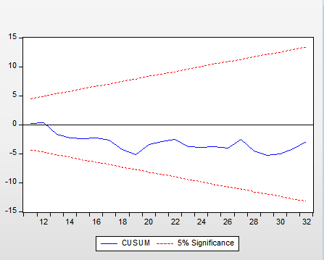

Figure 2 Cusum test

**Figure 4.1 Cusum test**

The Cusum results above indicate that the model is stable as the Cusum line is lying between the lines of significance therefore the model is said to be structurally stable at 5% significant level.

## **4.8 Regression results**

The estimated regression results on table 4.10 and 4.11 shows the magnitude of the coefficient as well as its direction for the study on the role of SMEs in economic development in Zimbabwe.

**Table 4.10 ARDL Long run regression summary table**

|  |  |  |  |  |
| --- | --- | --- | --- | --- |
| Variable | Coefficient | Std.Error | T-statistic | P-value |
| DLGCF | -0.012492 | 0.023384 | -0.534224 | 0.5985 |
| DLCSME | 0.047853 | 0.035455 | 1.349694 | 0.0108 |
| DLCAPU | 0.47284 | 0.104382 | 4.529883 | 0.0002 |
| ED | -0.003706 | 0.003691 | -1.004133 | 0.3262 |
| UNER | 0.017162 | 0.01041 | 1.648633 | 0.1134 |
| C | -0.807553 | 0.552302 | -1.46216 | 0.1578 |
| R-squared | 0.715454 |  |  |  |
| Adjusted R-squared | 0.705292 |  |  |  |

Table 11ARDL Long run regression summary table

*Authors own computation (E-Views 10) appendix 6.1*

### **4.5.1 Gross Capital Formation (GCF)**

From the findings above GCF is associated with a negative impact to economic development, the coefficient suggests that “ceteris paribus” a 1% increase in gross capital formation can result in a 0.012492 decrease in economic development. The p-value of 0.5985 shows that the relationship is not statistically significant as it is greater than the 5% level of significance. The obtained results conflict with the theory as Solow Swan growth model suggest a positive effect, however it aligns with the findings by Onyeiwu, *et al* (2020) who also surprisingly obtained the negative impact suggesting that an increase in GCF will result in a reduction in the overall contribution of SMEs contribution to economic development. The main reasons for these results include the following;

* **Crowding out effect:**

The increase in GCF, which represents the overall investment activity in the economy, has been causing a crowding out effect, where larger firms or public investments have taken precedence over investments in SMEs. This could have reduced the relative contribution of SMEs to economic development.

* **Capital-intensive investments:**

An increase in Gross Capital Formation may have been driven by capital-intensive investments, such as in large infrastructure projects or heavy industries, which tend to benefit larger firms more than SMEs. This shift in the investment focus away from SMEs could have diminished their overall contribution to economic development.

* **Inefficient allocation of capital:**

In Zimbabwe mostly the increased GCF face a challenge on being channeled effectively towards productive and efficient investments, and this could or eventually is leading to a misallocation of capital, reducing the productivity gains that SMEs could have otherwise generated.

* **Access to finance challenges for SMEs:**

The increase in overall investment activity is making it more difficult for SMEs to access financing, as financial institutions are probably now have been prioritized larger, more established firms. This have constrained the growth and development of SMEs and hence reducing the impact of GCF to contribute on the aggregate contribution for SMEs to influence development.

**4.5.2 Credit To SMEs (CSME)**

The table 4.12 above shows that holding other variables constant a 1% increase on credit to SME is associated with a 0.047853 increase in economic development. The coefficient on this variable is small but statistically significant (0.047853, p-value= 0.0108) the p-value is less than 0.05 level of significance. The results suggests that changes in credit to SMEs do have a meaningful impact on economic development in the model and it confirms with the expected sign. Onyeiwu, *et al* (2020) in the study on Nigeria also found the same results as surprisingly, credit to SMEs have the expected effect on growth and also the small coefficient, also research by Udo and Mahommed obtained the same results as obtained on this research. This also align with the existing theory of finance led growth model which says there is a positive relationship between financial development and economic growth as the credit being given to the SMEs is stimulating economic growth.

**4.5.3 Capacity Utilization (CAPU)**

Capacity utilization has a positive effect to economic growth as indicated by the findings that a 1% increase in CAPU will increase economic development by 0.47284 and the p-value is less than 0.05 meaning that the relationship is statistically significant. A higher capacity utilization rate indicates that the SME sector is operating closer to its full potential, suggesting positive economic conditions and potential growth hence a positive relationship that was anticipated (Solow Swan) is obtained. The results also confirm with the one obtained by Sola, *et al* (2013) and Idoko and Taiga, (2018)

**4.5.4 Electricity Distribution (ED)**

From the results ED does not result in increase in economic development the negative coefficient (-0.003706) suggests that holding other things constant an increase in electricity distribution will result in a decrease in economic growth in the long run. Also, the relationship is not statistically significant. This contradicts with the expected sign and to the results obtained by Onyeiwu, *et al* (2020) employed the variable and found positive relationship or effect as electricity distribution increased aggregate distribution of SMEs to economic development. The reasons behind the negative effect between electricity distribution and economic development in Zimbabwe include;

* **Infrastructure quality and reliability issues:**

The electricity distribution infrastructure in the country is of poor quality, with frequent outages, voltage fluctuations, or other reliability problems. This means that the increased electricity distribution is not translating into reliable and productive power supply, undermining its potential positive impact on economic development.

* **Misalignment between electricity distribution and SME needs:**

The increased electricity distribution is particularly being not be tailored to the specific requirements and usage patterns of the SMEs. Hence if the electricity supply is not matched with the actual demand from SMEs, it may not effectively support their productivity and growth, leading to the observed negative relationship.

**4.5.5 Unemployment (UNER)**

From the table the coefficient on the unemployment rate is positive but somehow small and statistically insignificant as shown by a p-value which is more than 0.05 (0.017162, p-value=0.1134), suggesting that the unemployment rate does not have a strong impact on economic development in Zimbabwe based on this analysis. Also, Udo and Mohammed, (2022) found that unemployment had an insignificant impact on economic growth on Nigeria even though the coefficient was negative. It is also important to note that also researches by Ajuwon et al. (2017) and Abdul-kemi and Zubair (2014) suggest that SMEs are fulfilling their purported significant role in terms of employment generation.

**Table 4.11 ARDL Short run regression summary table**

|  |  |  |  |  |
| --- | --- | --- | --- | --- |
| Variable | Coefficient | Std.Error | T-statistic | P-value |
| DLRGDP(-1)* | -0.84025 | 0.170402 | -4.931 | 0.0001 |
| DLGCF** | -0.0105 | 0.020247 | -0.51843 | 0.6093 |
| DLCSME** | 0.040209 | 0.031168 | 1.290077 | 0.2104 |
| DLCAPU(-1) | 0.397305 | 0.097977 | 4.055099 | 0.0005 |
| ED** | -0.00311 | 0.002993 | -1.04046 | 0.3094 |
| UNER** | 0.01442 | 0.009276 | 1.554503 | 0.1343 |
| CointEq(-1)* | -0.84025 | 0.128553 | -6.53622 | 0.0000 |

Table 12 ARDL Short run regression summary table

*Authors own computation (E-Views 10) appendix 6.2*

R-Squared = 0.668022

Adjusted R-Squared = 0.562393

Durban-Watson stat = 2.103768

F-Statistic = 6.32421

Prob(F-Statisti**c) =** 0.00038

From the results the R-squared indicates that 67% of the variation in economic development is explained by the specified independent variables, whilst the other 33% is explained in the disturbance error term. Meanwhile after adjusting for the degrees of freedom the adjusted R-squared shows that 56% of the variation on economic development is reflected in the model whilst 34 % is reflected by the error term. This therefore imply that the model is a better fit to explain the role of SMEs in economic development in Zimbabwe and can be used for policy making. This is also supported by the Prob(F-Statisti**c)** which is 0.00038 a value less than the 5% level of significance hence the whole model is correctly specified. The coefficient of the error correction model (ECM) term is -0.84025, which indicates a rapid adjustment process. This suggests that more than 84% of the prior period's disequilibrium or imbalance adjusts back towards the long-run equilibrium in the current period. The negative sign of the error correction term is as expected hence confirms that the adjustment will occur in the opposite direction of the disequilibrium. This means that there is convergence back towards the long-run equilibrium relationship, rather than divergence away from it. If the adjustment was in the same direction as the disequilibrium, it would lead to the series moving further away from their long-run equilibrium.

## **4.6 Short Run Results Interpretation**

From the short run analysis the lagged variable of real GDP which is DLRGDP(-1) has a statistically significant relationship with the dependent variable as indicated by the coefficient of -0.84025 and a p-value of which is less than 5% level of significance. More so based on the short-run regression results above a 1% increase in credit to SMEs is associated with a small (0.040209) increase in economic development and the p-value of 0.0104 is less than the 5% significance level, indicating that this relationship is statistically significant in the short run as it is also in the long run. Also, in Gross Capital Formation has a negative insignificant relationship to economic development in the short run as well. The findings suggest that a 1% increase in GCF will result in a decline in economic growth by 0.010497.

Capacity utilization also have a positive relationship with economic development the findings indicate that 1% increase in CAPU results in a 0.397305 increase in economic development and the p-value is less than 0.05 meaning the relationship is statistically significant. According to the coefficient on the electricity distribution variable an increase in ED will lead to a fall in economic growth by 0.003114 and it is important to note that the relationship is also statistically insignificant as indicated by a p-value more than 0.05. Unemployment though portraying a positive coefficient the results by the p-value suggests that it has an insignificant impact on economic development.

## 

## **4.7 Conclusion**

According to the research objective the summary provides the detailed results and interpretation on the research findings on the data and note that full results on E-Views can be seen on the list of appendices. The next chapter gives the summary, conclusions and policy implications from the study.

# CHAPTER 5

# SUMMARY, CONCLUSIONS & POLICY RECOMMENDATIONS

**5.0 Introduction**

For the past decades economic world have existed debates on the role of small to medium enterprise (SMEs) on economic development and several findings have been obtained from different empirical researches. This chapter provides the brief summary of this study findings outlining conclusions and policy recommendations to be made out of this study. Furthermore, the study lastly provides suggestions for future study for this particular research.

**5.1 Summary of the research**

Themain objective of this study was to investigate on the role of SMEs on economic development in Zimbabwe, hence to achieve that the model used time series data obtained from the World Bank World Development Indicators from 1990-2022. Even if some adjustments were made on the model employed for this study, the model was adapted from research by Onyeiwu, et al (2020). Real Gross Domestic Product (RGDP) was used as the dependent variable in this model and the main independent variable used was Credit to SME (CSME) which was used as the proxy to measure capital per SME worker. CSME was used to study the role of SMEs on economic development and the Domestic Credit To Private sector (% GDP) was the measure of Credit to SME. Gross Capital Formation (GCF), Capacity utilization (CPU), Electricity Distribution (ED) and unemployment (UNER) were the other explanatory variables employed on this study.

To check if the classical linear regression assumptions were meet the study conducted the necessary diagnostic tests and from the findings the model was free from multicollinearity, heteroscedasticity and autocorrelation. After conducting the bound test and error correction regression to check for cointegration the conclusion was that the model variables have a long run relationship. In addition, the normality test implied that the residuals in the model followed a normal distribution also the Cusum test and Ramsey reset test confirmed the model stability for forecasting.

To answer the research hypothesis the study conducted an auto-regressive lagged distribution (ARDL) model for estimating the regression and found out that Credit to SME has a positive impact on economic development in Zimbabwe, i.e. assuming ceteris paribus the findings suggested that a 1% increase on credit to SME is associated with 0.047853 increase in economic development in the long run and 0.040209 increase crease in economic development in the long run. The coefficients p-values implied that the relationship was statistically significant both on the short run and in the long run as they were all less than 0.05 level of significance. Therefore, we reject the null hypothesis of the study and conclude that there is significant relationship between SMEs and economic development as the financing of SME is resulting in economic development.

**5.2 Conclusions**

From the observation and findings on this research the conclusions which we made include, firstly basing on the research question “How do the Small and Medium Enterprises (SMEs) and Real GDP respond to each other?” the following conclusions were made.

* The Small and Medium Enterprises (SMEs) from the Credit to SMEs has a positive and statistically significant impact on the economic development of Zimbabwe both from the short run and the long run analysis.
* Credit to SME however has a positive impact to economic development as more finance to SMEs help them through investment and capital accumulation which results in increased productivity hence this improving

economic development.

* Gross Capital Formation has an insignificant negative relationship with economic development in Zimbabwe both in the short run and in the long run.
* The negative relationship on GCF and real GDP is because in the Zimbabwean country increase in GCF is causing a crowding effect and also there is an ineffective allocation of capital in Zimbabwe therefore this reduces the impact of GCF to allow SMEs to increase economic Development.

From the obtained results on the model, it can also be concluded that,

* The obtained r-squared and probability F-Statistic shows that the model is a good fit and correctly specified for policy making. The performed diagnostic test suggest that the model was free from all econometric problems.
* The past values of real GDP portrays a negative relationship to the current GDP in the short run.
* Capacity utilization has a positive significant impact on economic development of Zimbabwe in the short run and long run.
* Electricity distribution has negative relationship with economic development both on the short run and in the long run in the economic development of Zimbabwe mainly due to poor quality and reliability of electricity in the country.
* Unemployment portrays a positive relationship to economic growth both on the short run and in the long run thus contradictory with the neoclassical theory which says that if a number of people are employed it will result in economic development.

**5.3 Policy Recommendations**

Based on the conclusions drawn from the research on the relationship between SMEs and real GDP in Zimbabwe, here the main policy recommendations that can be implemented:

1. **Improve Access to Finance for SMEs**

The study found that credit to SMEs has a positive impact on economic development, likely due to the lack of access to finance for SMEs in Zimbabwe therefore policy recommendations should focus on improving access to credit and other financial services for SMEs. This can include, promoting microfinance institutions and development banks to cater to the financing needs of SMEs and also providing tax incentives or subsidies to encourage commercial banks to lend more to the SME sector.

1. **Address Corruption and Inefficient Allocation of Capital**

Policies should aim to improve transparency and accountability in the allocation of capital and other business support services to SMEs as inefficient allocation of credit and high levels of corruption in Zimbabwe may be hampering the positive impact of SMEs on economic development. So, to avoid this, authorities can strengthen anti-corruption measures and enhancing the rule of law as well as enhancing monitoring and evaluation mechanisms to ensure equitable and efficient distribution of resources to SMEs. Strengthen the institutional and governance frameworks to promote the efficient allocation of capital, ensuring that investments are directed towards productive and high-impact projects that can maximize the contribution of SMEs to economic development. Government should also encourage the development of capital markets and alternative financing mechanisms, such as venture capital, angel investing, and crowd-funding, to diversify the sources of financing available to SMEs.

1. **Provide Targeted Support for SME Development**

Policies should focus on providing targeted support and interventions to help SMEs improve their productivity, competitiveness, and integration into the broader economy. This could include, investing in infrastructure for instance on the electricity distribution, technology, and skills development programs tailored to the needs of SMEs. Invest in upgrading and maintaining the electricity distribution infrastructure to improve the quality and reliability of power supply. This could involve upgrading transmission and distribution networks, implementing smart grid technologies, and improving maintenance and repair processes. In addition, implementation of procurement policies that prioritize the participation of SMEs in government and large-scale private sector contracts for instance making emphasis on the **“Nyika inovakwa nevana vayo”** policy the President this can increase the growth of SMEs and result in economic development.

**4. Enhance the Policy and Regulatory Environment for SMEs**

Reviewing and simplifying business registration and licensing procedures for SMEs by addressing regulatory barriers and bureaucratic hurdles that impede the growth and operations of SMEs. Also Developing tailored policies and incentives to encourage the formalization of informal SMEs and promote their integration into the formal economy. By fostering policy dialogue and collaboration between the government, private sector, and SME representatives it ensures responsive and inclusive policy making. By implementing these policy recommendations, Zimbabwe can better harness the potential of SMEs to contribute to economic development and inclusive growth.

**5.4 Suggestions for future study**

This study has limitations in its scope, as it focused solely on the role of Small and Medium Enterprises (SMEs) in driving economic development in Zimbabwe. To gain a more comprehensive understanding of the critical factors influencing economic growth in the country, future research should expand its analysis to include the impact of both private equity and public sector investment. While SMEs are an important component of the economic landscape, they are not the only drivers of economic development in Zimbabwe. To get a more holistic picture, future studies should investigate the influence of additional factors, such as private equity and public sector investment, on the country's economic growth.

By incorporating the assessment of these additional variables alongside the examination of SMEs, future research can provide a more well-rounded and representative understanding of the critical factors that shape and influence the economic development of Zimbabwe. This expanded approach can offer policymakers and stakeholders a more comprehensive set of insights to guide their decisions and interventions aimed at fostering sustainable economic growth in the country.

**References:**

Abdul-kemi, I.Z., 2014. Entrepreneurship and economic development in Nigeria: Evidence from small and medium scale enterprises (SMEs) financing. International Journal of Business and Social Science, 5(11), pp.215-230.

Akingunola, R.O. (2011). Small and medium scale enterprises and economic growth in Nigeria: An assessment of financing options. Pakistan journal of business and economic review, 2(1).

Alibhai, S., Bell, S., & Conner, G. (2017). Lessons From Financing Smes. Washington: World Bank Group.

Eisenhardt, K.M., 1989. Agency theory: An assessment and review. Academy of management review, 14(1), pp.57-74.

Gono, G. (2006). Unlocking SMEs' Potential for sustainable development. [Online]. Available: <http://www.herald.co.zw/inside.aspx?sectid=29835&cat=8>.

Glonti, V., Manvelidze, R. and Surmanidze, I., 2021. The contribution of SME to regional economic development: On example of adjara autonomous republic. European Journal of Sustainable Development, 10(1), pp.513-513.

Jensen, M.C. and Meckling, W.H., 2019. Theory of the firm: Managerial behavior, agency costs and ownership structure. In Corporate governance (pp. 77-132). Gower.

King, R.G. and Levine, R., 1993. Finance and growth: Schumpeter might be right. The quarterly journal of economics, 108(3), pp.717-737.

Levine, R., Loayza, N. and Beck, T., 2000. Financial intermediation and growth: Causality and causes. Journal of monetary Economics, 46(1), pp.31-77.

Lucas Jr, R.E., 1988. On the mechanics of economic development. Journal of monetary economics, 22(1), pp.3-42.

Mamudu, Z.U. and aliu, M.M., 2022. Micro, Small and Medium-Scale Enterprises (MSMES) Financing and Economic Growth in Nigeria: Evidence from Error Correction Model. Journal of Economics, 3(2), p.13.

Madanchian, M., Hussein, N., Noordin, F. and Taherdoost, H. (2015). The role of SMEs in economic developqament; case study of Malaysia. International Journal of Academic Research in Management, 4(3), pp.77-84.

Mazikana, A.T., 2019. The Impact of Small to Medium Enterprises to the Zimbabwean Economy and the Challenges They Face. A Case Study on Small and Medium Enterprises Association of Zimbabwe. A Case Study on Small and Medium Enterprises Association of Zimbabwe (October 28, 2019).

Myers, S.C. and Majluf, N.S., 1984. Corporate financing and investment decisions when firms have information that investors do not have. Journal of financial economics, 13(2), pp.187-221.

Onyeiwu, C., Muoneke, O.B. and Nkoyo, U., 2020. Financing of small and medium scale enterprises and its growth impact in Nigeria. The Journal of Entrepreneurial Finance (JEF), 22(2), pp.1-19.

Romer, P.M., 1990. Endogenous technological change. Journal of political Economy, 98(5, Part 2), pp.S71-S102.

Sibanda, K., Hove-Sibanda, P. and Shava, H. (2018). The impact of SME access to finance and performance on exporting behaviour at firm level: A case of furniture manufacturing SMEs in Zimbabwe. Acta Commercii, 18(1), pp.1-13.

Solow, R.M., 1956. A contribution to the theory of economic growth. The quarterly journal of economics, 70(1), pp.65-94.

Watambwa, L. and Shilongo, D. (2021). Analysisian analysis of the impact of SME financing on economic growth in Zimbabwe (2015-2019). Available at SSRN 3779488.

World Bank. (2014). Global Financial Development Report 2014: Financial Inclusion. World Bank.

World Bank. (2016). Doing Business 2016: Measuring Regulatory Quality and Efficiency. World Bank.

World Bank. (2020). Global Economic Prospects Slow Growth, Policy Challenges. Washington D.C.: The World Bank Group.

World Bank. (2020b). Improving SMEs' access to finance and finding innovative solutions to unlock sources of capital. Washington, DC 20433 USA: World Bank Group.

# APPENDICES INDEX

# Appendix 1.1 : Original Data set

|  |  |  |  |  |  |  |
| --- | --- | --- | --- | --- | --- | --- |
| **YEAR** | **RGDP** | **GCF** | **CSMES** | **UNER** | **ED** | **CAPU** |
| 1991 | 17595834085 | 20.58535633 | 15.28035698 | 55.514 | 9.866220736 | 7667736600 |
| 1992 | 16009469333 | 22.36275964 | 18.70318763 | 54.896 | 10.3541013 | 6148410200 |
| 1993 | 16177802283 | 23.59172221 | 21.80480661 | 54.083 | 20.43219619 | 5995982500 |
| 1994 | 17671854489 | 21.37146361 | 21.22171031 | 53.22 | 6.748794858 | 6203067600 |
| 1995 | 17699780559 | 24.57726015 | 24.79000928 | 52.383 | 10.4445919 | 6285457300 |
| 1996 | 19533601151 | 18.0404905 | 21.54409091 | 51.842 | 9.448214057 | 7599075600 |
| 1997 | 20057217726 | 18.04965093 | 26.58099655 | 51.409 | 6.349856616 | 7521221700 |
| 1998 | 20635910938 | 20.60148315 | 24.81541915 | 51.003 | 11.05782406 | 5550407800 |
| 1999 | 20467146118 | 2.553698826 | 16.16158328 | 50.511 | 18.41105879 | 5536450700 |
| 2000 | 19841017282 | 11.79797761 | 21.56249904 | 49.898 | 19.85615569 | 5739475500 |
| 2001 | 20126651621 | 12.11780113 | 27.72415723 | 49.614 | 20.32880629 | 6119517000 |
| 2002 | 18336582470 | 10.17249068 | 84.81197208 | 49.291 | 19.90892993 | 5681802900 |
| 2003 | 15220266577 | 13.81376201 | 53.16815667 | 48.974 | 24.42063584 | 5106264700 |
| 2004 | 14336343808 | 5.107807664 | 17.04778478 | 48.765 | 16.41095579 | 5357389200 |
| 2005 | 13517583213 | 2.000441269 | 14.94879881 | 48.712 | 15.15588023 | 5312500900 |
| 2006 | 13049672720 | 2.224682266 | .. | 48.492 | 16.85513121 | 5161605900 |
| 2007 | 12572925525 | 5.078394447 | .. | 48.455 | 15.97692501 | 5193887900 |
| 2008 | 10351422062 | 3.28590955 | .. | 48.565 | 16.02050204 | 4329702800 |
| 2009 | 11595617445 | 9.929205707 | 7.159107402 | 48.802 | 12.68196721 | 8510874400 |
| 2010 | 14083116363 | 17.01173025 | 13.54362895 | 49.142 | 16.924976 | 10707619500 |
| 2011 | 16142097163 | 14.63470971 | 18.98323589 | 49.431 | 19.53837276 | 12550668700 |
| 2012 | 18683650519 | 12.14834026 | 20.14062022 | 49.798 | 17.50217014 | 15243858400 |
| 2013 | 19280916546 | 9.181371137 | 18.7319126 | 50.18 | 19.20026078 | 17151180600 |
| 2014 | 19567149970 | 9.609292486 | 19.21037138 | 50.506 | 17.78474399 | 17654780900 |
| 2015 | 19963120600 | 9.995566525 | 18.31568566 | 50.712 | 16.43726312 | 17918808800 |
| 2016 | 20142979412 | 9.807839172 | 17.09856236 | 50.896 | .. | 18670635500 |
| 2017 | 20964866130 | 9.663851194 | 16.8751082 | 50.791 | .. | 15967459311 |
| 2018 | 22015177995 | 11.04830634 | 5.830264969 | 50.473 | .. | 32223533291 |
| 2019 | 20621078643 | 10.69935177 | 5.237706364 | 50.064 | .. | 20636375851 |
| 2020 | 19009139108 | 10.04608116 | 5.415074173 | 49.529 | .. | 20312242538 |
| 2021 | 20618836222 | 12.40705787 | 6.988542902 | 48.9 | .. | 26752760388 |
| 2022 | 21963674100 | 11.32697566 | 8.78568463 | 48.746 | .. | 24185194426 |
|  |  |  |  |  | .. |  |

## **Appendix 1.2: Transformed Data set**

|  |  |  |  |  |  |  |
| --- | --- | --- | --- | --- | --- | --- |
| **YEAR** | DLRGDP | DLGCF | DLCSME | DLCAPU | ED | UNER |
| 1991 | N/A | N/A | N/A | N/A | 9.866220736 | 55.514 |
| 1992 | -0.094481794 | 0.082817094 | 0.202125825 | -0.22082793 | 10.3541013 | 54.896 |
| 1993 | 0.010459693 | 0.053498837 | 0.153436462 | -0.025103883 | 20.43219619 | 54.083 |
| 1994 | 0.088333159 | -0.098839341 | -0.027105703 | 0.033954282 | 6.748794858 | 53.22 |
| 1995 | 0.00157901 | 0.139765075 | 0.155415992 | 0.013194656 | 10.4445919 | 52.383 |
| 1996 | 0.098583877 | -0.309202927 | -0.140339145 | 0.189788008 | 9.448214057 | 51.842 |
| 1997 | 0.026452957 | 0.000507642 | 0.21009497 | -0.010298023 | 6.349856616 | 51.409 |
| 1998 | 0.028443732 | 0.132236725 | -0.068731345 | -0.303857182 | 11.05782406 | 51.003 |
| 1999 | -0.008211835 | -2.087820243 | -0.428828176 | -0.002517775 | 18.41105879 | 50.511 |
| 2000 | -0.031069597 | 1.5303853 | 0.288318626 | 0.036014202 | 19.85615569 | 49.898 |
| 2001 | 0.014293513 | 0.026747411 | 0.251348485 | 0.064115342 | 20.32880629 | 49.614 |
| 2002 | -0.093146782 | -0.174988455 | 1.118132578 | -0.074214578 | 19.90892993 | 49.291 |
| 2003 | -0.186270239 | 0.305978258 | -0.466977055 | -0.106800436 | 24.42063584 | 48.974 |
| 2004 | -0.059830029 | -0.994895059 | -1.137439388 | 0.048008608 | 16.41095579 | 48.765 |
| 2005 | -0.05880654 | -0.937402493 | -0.131389321 | -0.008414063 | 15.15588023 | 48.712 |
| 2006 | -0.035228244 | 0.106246313 | -0.18406141 | -0.028814952 | 16.85513121 | 48.492 |
| 2007 | -0.03721732 | 0.825381054 | -0.18406141 | 0.006234778 | 15.97692501 | 48.455 |
| 2008 | -0.194421827 | -0.435351665 | -0.18406141 | -0.181983628 | 16.02050204 | 48.565 |
| 2009 | 0.113503313 | 1.105836992 | -0.18406141 | 0.675845785 | 12.68196721 | 48.802 |
| 2010 | 0.194349439 | 0.538422635 | 0.63753094 | 0.229610904 | 16.924976 | 49.142 |
| 2011 | 0.136453931 | -0.150507036 | 0.337640019 | 0.158818356 | 19.53837276 | 49.431 |
| 2012 | 0.146218248 | -0.186203528 | 0.059182414 | 0.194402747 | 17.50217014 | 49.798 |
| 2013 | 0.031466989 | -0.280016002 | -0.072510057 | 0.117890317 | 19.20026078 | 50.18 |
| 2014 | 0.014736311 | 0.045554043 | 0.025221684 | 0.028939608 | 17.78474399 | 50.506 |
| 2015 | 0.020034463 | 0.03941105 | -0.047692477 | 0.014844313 | 16.43726312 | 50.712 |
| 2016 | 0.00896921 | -0.018959666 | -0.068763445 | 0.041101063 | 16.78263782 | 50.896 |
| 2017 | 0.039992184 | -0.014789738 | -0.013154739 | -0.156399137 | 17.12801253 | 50.791 |
| 2018 | 0.048884129 | 0.133884901 | -1.0627772 | 0.702144175 | 17.47338724 | 50.473 |
| 2019 | -0.065418337 | -0.032093986 | -0.107178763 | -0.445641697 | 17.81876195 | 50.064 |
| 2020 | -0.081393919 | -0.063000533 | 0.033302892 | -0.015831552 | 18.16413666 | 49.529 |
| 2021 | 0.081285169 | 0.21108287 | 0.255085502 | 0.275413875 | 18.50951137 | 48.9 |
| 2022 | 0.063184874 | -0.091078386 | 0.22885157 | -0.100897015 | 18.85488608 | 48.746 |
|  |  |  |  |  | 19.20026078 |  |

## **Appendix 2 Descriptive statistics**

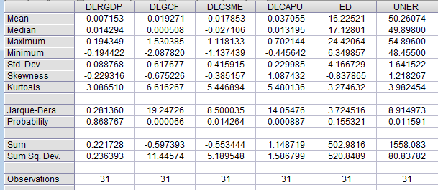

### **Appendix 3 ADF Unit root test**

**LRGDP Unit root result**

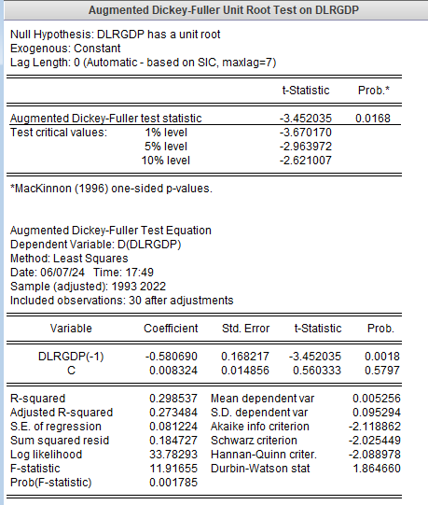

**LGCF Unit root result**

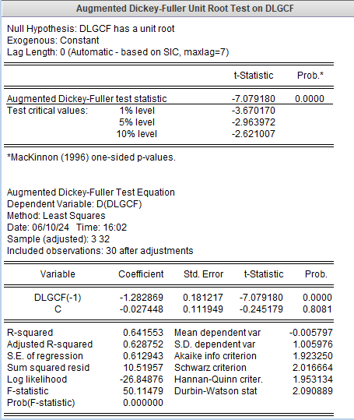

**LCSME Unit root result**

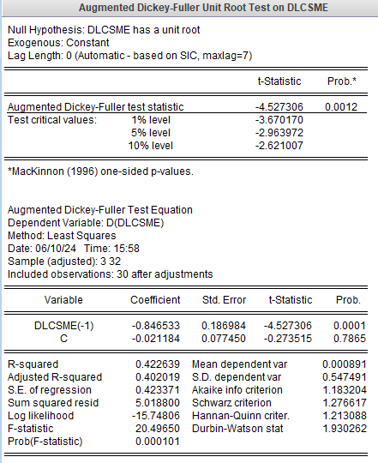

**LCAPU Unit root result**

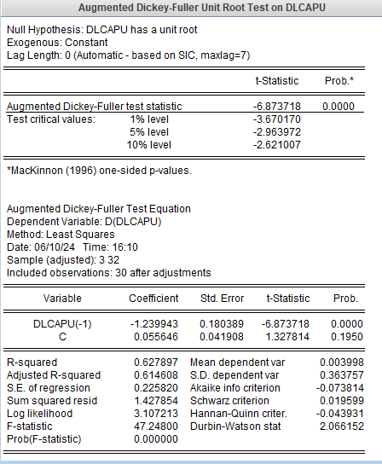

**ED Unit root result**

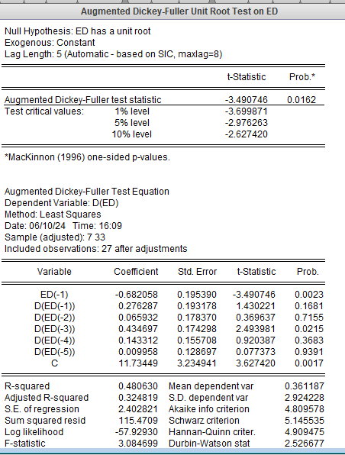

**UNER Unit root result**

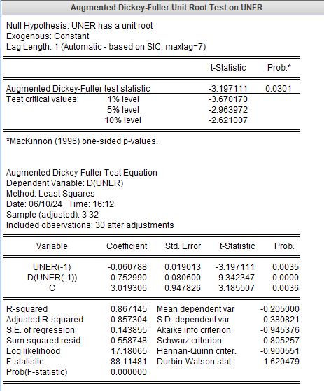

### **Appendix 4 Optimal Lag Selection**

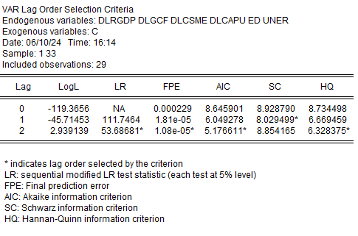

**Appendix Diagnostic tests**

### **Appendix 5 Cointergration test**

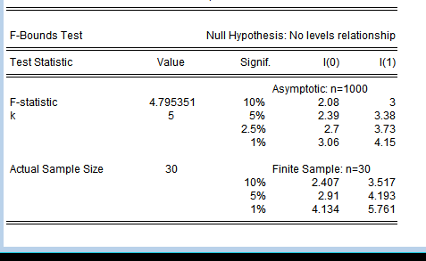

## **Appendix 6.1 Variance Inflation Factor**

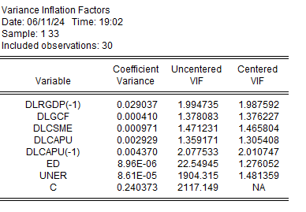

### **Appendix 6.2 Correlation Matrix**

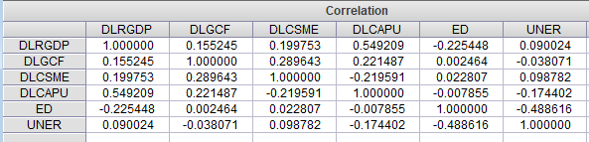

### **Appendix 6.3 Hetroscedacitsity test**

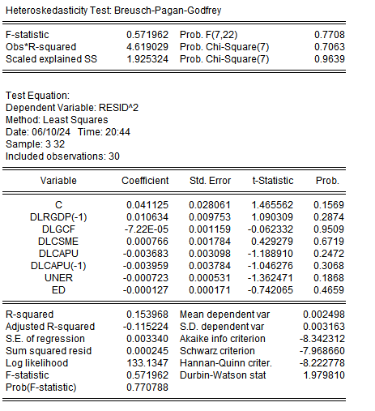

### **Appendix 6.4 Autocorrelation test**

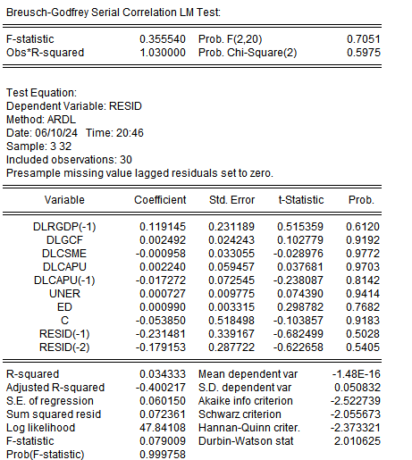

**Appendix 6.5 Normality Test**

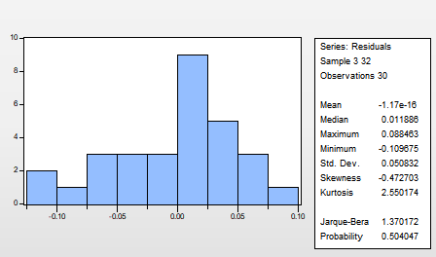

### **Appendix 6.6 Ramsey reset results**

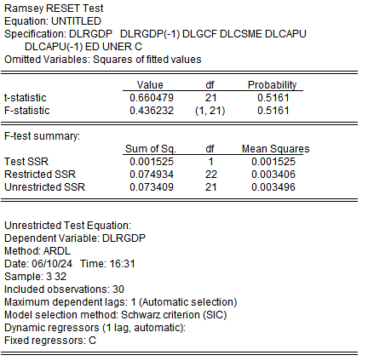

**Appendix 7 Regression results**

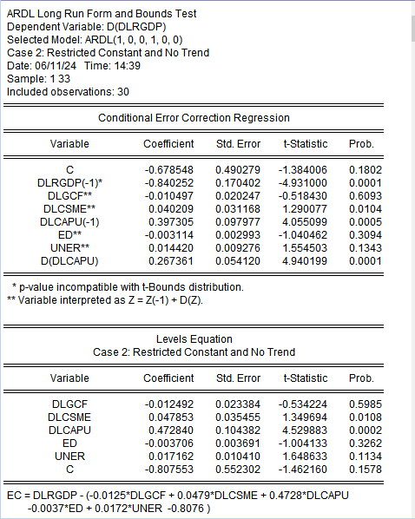

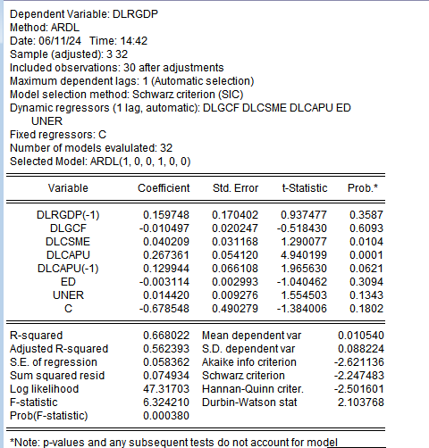

### **Appendix 8 Turn It In report**

