**BINDURA UNIVERSITY OF SCIENCE EDUCATION**

**. FACULTY OF COMMERCE**

**DEPARTMENT OF HUMAN CAPITAL MANAGEMENT**

**THE RELATIONSHIP BETWEEN WORKPLACE FLEXIBILITY AND EMPLOYEE PERFORMANCE IN CONTEXT OF COVID-19: A CASE OF HOWARD MISSION HOSPITAL**

B1850081

**HAZEL M MICKSON**

**A DISSERTATION SUBMITTED IN PARTIAL FULFILMENT OF THE REQUIREMENTS FOR THE BACHELOR OF COMMERCE (HONOURS) DEGREE AT THE BINDURA UNIVERSITY OF SCIENCE EDUCATION**

**DECEMBER 2023**

# APPROVAL FORM

I certify that the dissertation meets the preparation guidelines as presented in the faculty guide and instruction for preparing dissertations.

Submitted by **Hazel** **Minora** **Mickson**, **Registration** **number** **B1850081** in partial fulfilment of the requirements of the Bachelor of Commerce (Honours) Degree in Human Capital Management.

Hazel M. Mickson  30 / 09 /2024

Name of student Signature Date

Doc. T. Tichagwa 30 / 09 /2024

Name of Supervisor Signature Date

Doc. S. Chisango  30 / 09 /2024

Name of Chairperson Signature Date

# RELEASE FORM

Name of student : Hazel Minora Mickson

Registration number: B1850081

Dissertation Title : The relationship between workplace flexibility and employee performance in context of Covid-19. A case of Howard Mission Hospital

Year granted : 2024

Permission is grated to Bindura University of Science Education Library and the department of Human Capital Management to produce copies of this dissertation for academic use only.

Hazel M. Mickson  30 / 09 /2024

Name of student Signature Date

# DEDICATION FORM

I would like to begin this dedication by expressing my deepest gratitude to the Almighty for guiding and blessing me throughout this journey. To my dearest mother (Agnes Mawonera), words cannot adequately express the depth of my appreciation for your unwavering support, your love, sacrifice and constant encouragement. Without your belief in me, l would not have had the courage to pursue my dreams, thank you for always being my rock and for being there through every challenge and triumph. I also like to remember and honour my late dad (Peter Mickson), who may not be physically present, but his spirit continues to guide and inspire me, your wisdom and teachings will forever be embedded in my heart, your memory serves as a constant reminder to persevere and succeed, no matter the obstacles that come my way. To my sister Catherine, l cannot put into words how grateful l am for your generosity, you are truly a gift from God, and l am blessed to have you by my side.

# ABSTRACT

The purpose of the study was to investigate the relationship between workplace flexibility and employee performance in context of Covid-19 using Howard Mission Hospital as a case study. The primary objectives of this research were to identify the characteristics of workplace flexibility at Howard Mission Hospital, to identify the benefits of using workplace flexibility at Howard Mission Hospital, to identify the challenges associated with workplace flexibility at Howard Mission Hospital, and to assess the extent of correlation between workplace flexibility and employee performance at Howard Mission Hospital. The study used a descriptive survey methodology. The study used a mixed research approach. A sample of 92 participants, 23 from management and 69 from non-management staff members. Data was gathered through the use of questionnaires and interviews and was then analysed using Statistical Package for Social Sciences (SPSS). Data was presented using tables, pie charts, and bar graphs. The main findings of the investigation are flexible working arrangements results in improved employee performance, as well as benefiting organisational outcomes. The study also highlighted the preferences and expectations of workers from various age groups and sex regarding adaptable working conditions, providing valuable insights together with recommendations for organisations. The main conclusion or contribution of the study is that implementing flexible working practices is a beneficial strategy for organisations to increase worker performance, this then result in positive organisational outcome.

# 

# 

# ACKNOWLEDGEMENTS

I am deeply grateful to my supervisor, DR Tichagwa, who provided consistent and clear academic support throughout this research. His input on the structure and topic of my research paper was incredibly helpful. I would like to give a special thanks to my mentor, Mr Gumbo, from my industrial attachment at Howard Mission Hospital, who went out of his way to teach me about the Hospital’s operations. The knowledge and skills I acquired will be invaluable to my future endeavour. To Primrose Mudawariwo, your unwavering friendship and constant motivation have been paramount in my academic journey, having you as a friend has made this experience more worthwhile.

**Table of Contents**

Table of Contents

APPROVAL FORM ii

RELEASE FORM iii

DEDICATION FORM iv

ABSTRACT v

ACKNOWLEDGEMENTS vi

LIST OF ABBREVIATIONS xi

LIST OF TABLES xii

LIST OF FIGURES xiii

CHAPTER 1 1

1.1Introduction 1

1.2 Background of the study 1

1.3 Statement of the problem 4

1.4 Purpose of the study 4

1.5 Research Objectives 5

1.6 Research Questions 5

1.7 Significance of the study 5

1.7.1 Significance of the study to future Human Resource Practitioners 5

1.7.2 Significance of the study to Howard Mission Hospital 6

1.7.3 Significance of the study to the researcher 6

1.7.4 Significance of the study to Bindura University of Science Education 6

1.8 Delimitations of the study 6

1.8.1 Conceptual Delimitation 6

1.8.2 Population Delimitation 7

1.8.3 Geographical Delimitation 7

1.8.4 Temporal Delimitation 7

1.9 Limitations of the study 7

1.10 Assumptions of the study 8

1.11 Definition of terms 8

1.12 Chapter Summary 9

CHAPTER 2 10

2.1 Introduction 10

2.2 Conceptual Framework 10

2.2.1 Flexible Working Arrangements 12

2.2.2 Employee Performance 13

2.2.3 Employee Engagement 13

2.2.4 Job satisfaction 14

2.3 Theoretical Framework 15

2.3.1 Expectancy Theory 15

2.3.2 Goal-setting Theory 16

2.3.3 Control Theory 18

2.4 Empirical Research 19

2.5 Research Gap 21

2.6 Chapter Summary 22

CHAPTER 3 23

3.1 Introduction 23

3.1 Research Design 23

3.1.1 Case Study 23

3.2 Research Method 24

3.3 Study Subject 25

3.3.1 Target Population 25

3.3.2 Sample 25

3.3.4 Sampling Techniques 26

3.4 Data Collection Instruments 27

3.4.1 Interview Guide 28

3.4.2 Questionnaires 28

3.4.3 Secondary Data 29

3.4.4 Reliability and validity of research instruments 29

3.5 Data Collection Procedures 31

3.6 Ethical Considerations 31

3.7 Data Presentation and Analysis 32

3.8 Chapter Summary 33

CHAPTER 4 34

4.1 Introduction 34

4.2 Response Rate 34

4.3 Instrument Reliability and Validity 34

4.4 Demographic Characteristics 35

4.5 Workplace Flexibility 42

4.5.1 Howard Hospital is doing enough by offering flexible working arrangements like compressed work week, part-time schedule, shift work and annul hours. What is your comment on this statement? 42

4.5.2 What is your view on flexible working arrangements schedules, are they beneficial? 44

4.5.3 Employees’ are facing many challenges associated with flexible working arrangements. Do you agree with this statement? 46

4.5.4 How is your current work output? 48

4.5.5 What is your comment on individual workload? 49

4.5.6 If the company decides to implement flexible hours, how much would this change contribute to your performance? 50

4.5.7 If you could choose which of those working options do you think would increase your productivity? 52

4.5.8 Do you think HR is doing enough in addressing flexible working arrangements or condition? 53

4.8 Discussion of Results 55

4.9 Chapter Summary 56

CHAPTER 5 57

5.1 INTRODUCTION 57

5.2 Summary of Results 57

5.2.1 Objective 1 57

5.2.2 Objective 2 58

5.2.3 Objective 3 59

5.2.4 Objective 4 60

5.3 Conclusions 61

5.4 Recommendations 62

5.4.3 Areas for further research 63

5.5 Chapter Summary 63

REFERENCES 64

APPENDIX 1: A QUESTIONNAIRE FOR RESPONDENTS 73

APPENDIX 2: INTERVIEW GUIDE FOR MANAGEMENT 78

# 

# LIST OF ABBREVIATIONS

**MHCC-** Ministry of Health and Child Care

**RBF-** ResultsBasedFinance

**WHO-** World Health Organization

**SPSS-** Statistical Package for Social Sciences

# LIST OF TABLES

**Table 4.3.2 Sex 1** 36

**Table 4.1 Response for questionnaires 1** 34

**Table 4.2 Reliability Statistics 1** 34

**Table 4.3.1 Age range of responses 1** 35

**Table 4.3.10 Current work output 1** 49

**Table 4.3.11 Individual workload 1** 50

**Table 4.3.12 Implementation 1** 52

**Table 4.3.13 Working Options 1** 53

**Table 4.3.13 Working Options 1** 53

**Table 4.3.14 Flexible working Conditions 1** 54

# LIST OF FIGURES

**Figure 2.1 1 Conceptual Framework** 10

**Figure 3.1 Yamane Sample Size formula 1** 26

**Figure 4.1 Age 1** 36

**Figure 4.10 Current work output 1** 49

**Figure 4.11 Individual Workload 1** 51

**Figure 4.12 Implementation 1** 52

**Figure 4.13 Working Options 1** 54

**Figure 4.14 Flexible working conditions 1** 55

**Figure 4.14 Flexible working conditions 1** 55

# CHAPTER 1

## 1.1Introduction

The first chapter of the research paper acts as an introductory section that presents the research background, research objectives, establishes the study’s scope and limitations, and definitions of key terms.

## 1.2 Background of the study

In light of COVID-19, the study investigates the connection between workplace flexibility and worker performance. The topic of flexible work arrangements has always been fascinating, especially in light of the 2020 global Covid-19 pandemic. This issue is more crucial than ever because the pandemic is still active in some countries and could eventually make its way back to Zimbabwe. The global public and private sector's ability to operate is now threatened by the pandemic. Howard Mission Hospital was among the many organizations whose operations were significantly impacted by its threats. This led to the creation of new work arrangements that fit the current setting. Flexible work schedules were implemented by Howard Hospital with assistance from the Ministry of Health and Child Care (MHCC) as a new working strategy to lessen the effects of the Covid-19 pandemic and to satisfy organizational goals, staff needs, and Covid-19 regulations. Flexible work arrangements are scheduling plans that give full-time employees the freedom to select their daily start and end times, as long as they complete their assigned tasks within those allotted hours (Nabe-Nielsen, Garde, Austb, & Diderichsen, 2012).

As the world undergoes dramatic change, today’s organizations must address environmental, social and demographic aspects. Given the degree to which society’s requirements are changing, most governments and commercial companies throughout the world have recognized the value of workplace flexibility and the influence it may have on employee performance (Golden, 2008). The influencing social and demographic changes are increasing in numbers of women in the economy and working environment, increasing numbers of working mothers, especially those with young children (Halpern, 2005), UK also provides policies which encourage the employment of mothers (Lewis & Campbell, 2008). According to a number of sources, including Zeijen et al. (2018), Bal and De Lange (2014), and Wheatley (2017), introducing flexible work arrangements can raise employee satisfaction and engagement. The World at Work Report (2015) states that there has been an increase in flexible work arrangements, with roughly 80% of organizations globally now providing some kind of work flexibility. Additionally, the expansion of workplace flexibility has been impacted by the growing trend of work-life balance (Bailyn, 2001).

Many countries have experienced rapid changes in their populations due to factors like the aging of their workforce and the entry of a new generation of workers (Twenge et al., 2010; United Nations, 2009). As a result, regular, rigid work schedules have proven to be insufficient, and one way to address these changes has been to change the nature of employment to one that is more flexible (Twiname et al., 2006). Flexible work schedules have been shown to positively impact emotional engagement in earlier studies. In a study on flexible work arrangements, the British Panel Survey and Understanding Society found that, in the UK's post-industrial economies, the number of flexible work arrangements has significantly increased over the previous 20 years. This demonstrates that organizational emotional engagement was positively impacted by flexible working (Herrbach et al., 2009).

Targeting work-related outcomes like productivity, satisfaction, and absenteeism, Baltes et al. (1999) carried out a meta-analysis of 31 studies on flexitime and shortened workweeks in the United States. According to the study, flexitime significantly improves worker productivity, job satisfaction, and absenteeism. Additionally, compared to work schedules with shorter core times, researchers discovered that less flexible work schedules were linked to better performance outcomes. Additionally, they discovered that the implementation's efficacy gradually decreased, suggesting that staff members had grown accustomed to the new rules and believed them to be standard. Increasing work autonomy or enabling employees to modify their working hours to suit their daily schedules are two ways to improve workplace personalization and boost productivity. According to general theory (Twenge et al., 2010, 2012), younger workers value flexibility at work more and are therefore more emotionally affected by it; as a result, these arrangements may enhance worker job satisfaction. According to the study's findings, fewer work-life conflicts, higher job satisfaction, and employee loyalty to the organization are to blame for the drop in absenteeism.

Mwebi and Kadaga (2015), researchers at Jomo Kenyatta University of Agriculture and Technology, examined the effects of flexible work schedules on worker productivity at Nairobi CBD Commercial Bank in Nairobi. The survey was carried out in response to a variety of issues that demanding banking sector workers encountered, such as role conflicts between work and home, weariness, and work pressure. With 76% of bank employees agreeing with the statement used to measure employee performance, the researchers discovered that the use of flex-time programs had a significant impact on employee performance. This result is in line with Brummerlhuis, Haarb, and Lippe's (2010) observations. They discovered that flexible work schedules allow for more effective customer service. As a result, more customers are served by staff members who are more youthful, astute, and compassionate. Employers use adaptable HRM to keep workers motivated and performing well (Herrbach et al., 2009). Non-banking institutions were not taken into account by Mwebi and Kadaga. Thus, the purpose of this research is to ascertain how flexible scheduling affects hospital staff performance.

Furthermore, a study on flexible work schedules and employee performance in a manufacturing company in Anambra State, Nigeria, was carried out by Uzochukwu, Ogechukwu, and Olohi (2019). This study's main goal was to look into the relationship between employees' performance and variable work hours in a manufacturing company in the Nigerian state of Anambra. The study monitors a number of factors, from production scheduling concerns to high-quality product development that contribute to subpar workplace engagement and poor organizational performance. Since the study revealed a favourable correlation between flexible scheduling and worker performance, Omotayo (2012) hypothesizes that flexible work schedules play a significant role in worker satisfaction.

According to a study on flexible work schedules conducted in Zimbabwe by Muchowe, Mawonde, and Pande (2021), compressed work weeks, teleworking, and flexible time all significantly improve organizational performance in the country during pandemics. According to Jones (2020), the global Covid-19 pandemic compelled governments to enact policies aimed at slowing the virus's spread. Governments from all around the world enacted policies including social distancing and national lockdowns, and they also pushed for workplace decluttering among private and public sector enterprises. Employing flexible work arrangements was one of the tactics that organizations adopted to get through the challenging circumstances (Paaulson & Hyden, 2020). The current trend in human capital management is flexible work arrangements, which has been sparked by the Covid-19 pandemic. Still, this research concentrated on how flexitime affected staff performance at Howard Hospital rather than the higher education institutions in Mashonaland Central Province.

## 1.3 Statement of the problem

The Covid-19 pandemic has caused a sharp rise in staff turnover at Howard Mission Hospital, along with poor employee performance. These issues have led to high absenteeism rates, a lack of cooperation and communication among co-workers, conflicts between employees' personal and professional lives, and stress for staff members as a result of rigid work schedules (Gajendran & Harrison, 2007). Howard Mission Hospital had a labour turnover of 21% as of September 2021, when 50 employees left the company, bringing its total workforce down to 180. According to the Howard Mission Hospital Annual Report (2022), there was a 33% increase in labour turnover from January to November 2022, which resulted in 60 employees leaving the organization. Numerous tactics, including incentives, professional development, and outsourcing, have been implemented in an attempt to address the issue, but with no success. The principal aim of the study is to ascertain the elements that led to the effective implementation of flexible work arrangements in the Covid-19 pandemic, along with the possible advantages for individuals and institutions. According to research by Ciarniene and Vienazindiene (2018), flexible work schedules can help with poor performance. Labour turnover will continue to rise if Howard Mission Hospital does not take appropriate action to prevent it from becoming uncompetitive and demotivating its staff.

## 1.4 Purpose of the study

This study evaluates the connection between Howard Mission Hospital employees' performance levels and flexible work schedules. This investigation will examine whether changing an employee's work schedule will improve their output. Examining the relationship between flexible work arrangements and employee well-being as well as productivity may yield insightful findings that will inform organizational policies and practices regarding the benefits of implementing flexible work arrangements. In light of the aforementioned data, researchers made the decision to investigate the effects of flexible scheduling on staff performance at Howard Mission Hospital.

## 1.5 Research Objectives

i) To identify the characteristics of workplace flexibility at Howard Mission Hospital.

ii) To identify the benefits of using workplace flexibility at Howard Mission Hospital.

iii) To identify the challenges associated with workplace flexibility at Howard Mission Hospital.

iv) To assess the extent of correlation between workplace flexibility and employee performance at Howard Mission Hospital.

## 1.6 Research Questions

i) What the characteristics of workplace flexibility at Howard Mission Hospital?

ii) What are the benefits of using workplace flexibility at Howard Mission Hospital?

iii) What are the challenges associated with workplace flexibility at Howard Mission Hospital?

iv) What is the relationship between workplace flexibility and employee performance at Howard Mission Hospital?

## 1.7 Significance of the study

The investigation is expected to benefit future Human Resource practitioners, Howard Mission Hospital, Bindura University of Science Education and to the researcher.

## 1.7.1 Significance of the study to future Human Resource Practitioners

The research findings will be used as supporting documentation by other researchers studying the relationship between employee performance and flexibility. Human resource practitioners will benefit from the project's assistance in building a knowledge base. Other researchers can use this research as a foundation to generate topics based on the study's limitations.

## 1.7.2 Significance of the study to Howard Mission Hospital

Hospitals will benefit from the research by developing strategies for flexible working hours and improving their policies. Based on research findings, this study will guarantee that flexible time schemes are applied equitably to boost employee motivation, which will assist hospitals in improving staff performance.

## 1.7.3 Significance of the study to the researcher

The significance of this study lies in its ability to provide researchers with pertinent skills, knowledge, and competencies concerning the effects of flexible work schedules on employees' performance. This study assists researchers in fulfilling the prerequisites for a Bachelor of Commerce (Honours) in Human Capital Management. Additionally, students will gain from this research as it serves as a foundation for future related studies.

## 1.7.4 Significance of the study to Bindura University of Science Education

The study will be used by other students at Bindura University of Science Education as a reference. The findings of this study will help the university become more widely known and respected as a reliable information source, which will enhance the university's reputation.

## 1.8 Delimitations of the study

## 1.8.1 Conceptual Delimitation

The study focused on examining how well employees performed when given flexible work schedules. The investigator additionally discovered data regarding the enhancement of worker productivity and motivation via the implementation of flexible work schedules. This leads to a rise in organizational results and a decrease in staff attrition, a problem that Howard Mission Hospital was experiencing.

## 1.8.2 Population Delimitation

Employees at Howard Mission Hospital were the target group since they had access to flexible work schedules. This include employees that are able to work from home, have flexible working arrangements and those employed in sectors that don’t generally provide these configurations were studied.

## 1.8.3 Geographical Delimitation

The study was carried out at a non-profit organization in Mashonaland Central. The researcher selected Howard Mission Hospital as a case study because it was the institution to which the student was attached, making it much easier to gather information because the researcher was already acquainted with the establishment. Howard Mission Hospital was selected as the study site by the researcher because it was experiencing a sharp rise in employee turnover and poor performance as a result of rigid work schedules.

## 1.8.4 Temporal Delimitation

The study was conducted from September 2022 to November 2023 The study covered two years whilst focusing on the flexible work practices put forward to promote employee’s performance at the workplace.

## 1.9 Limitations of the study

The emphasis of this investigation was entirely on Howard Mission Hospital and their implementation of adaptable work arrangements in relation to employee performance. Time was a scarce resource and limited the ability to gather as much data as possible. To curb the time problem, the researcher worked on overtime and weekends, prioritizing tasks according to their urgency and importance, avoiding distractions, setting realistic deadlines, delegating tasks, streamlining processes and use of time management techniques. The researcher encountered the problem of resistance and ignorance by the participants, participates were unwilling to provide the information fearing that the information will be advanced to their supervisors. To curb this problem, the researcher explained to participates that the responses will be used for academic purposes only. Therefore, to involve and increase interest of potential respondents to enhance cooperation regarding the research, the researcher clearly stated the primary aim of the research, use social media platforms to reach potential respondents thus it promote the research. Therefore, researchers used quantitative data.

## 1.10 Assumptions of the study

The respondents may not be truthful in their responses to researcher’s questions. To overcome this problem, the researcher explained to the participants that no personal data will be captured and information collected is purely for academic purposes.

## 1.11 Definition of terms

**a) Flexible working Arrangement**

Flexible working arrangements are those that allow for changes to the work that benefit several employees. This gives workers the freedom to change their regular work schedules, which includes meeting times and locations. According to Hidayah, Singh, and Hussain (2021), it can also be defined as an option whereby workers decide with their employers when, where, and for how long to work during specific times.

**b) Employee Performance**

According to Motowidlo (2003), an organization's expectations for an employee's behaviour while they perform their job are what constitutes employee performance. According to Williams and Anderson (1991), an employee's performance is determined by their understanding of their work, their capacity for performing it, and their level of enthusiasm for doing so.

**c) Covid-19**

The illness caused by the severe acute respiratory syndrome coronavirus 2 (SARS-CoV, also known as 2019-nCoV), a novel coronavirus that was purportedly first discovered in the Chinese city of Wuhan, is referred to as "novel coronavirus disease" (Covid-19) (CDC, 2020b). It was identified in 2019 and first appeared as a respiratory disease epidemic. WHO was informed of this in December 2019, and in January 2020, the organization declared the COVID-19 pandemic a global public health emergency (World Health Organization, 2022).

## 1.12 Chapter Summary

The key components of the chapter include the introduction, research background, the purpose of the research, and the goals that researchers want to achieve. The chapter also discussed the assumptions inherent in the study, limitations and delimitations of the study, definitions of terms, explanations of acronyms, and the structure of the study. The next chapter presents a theoretical and conceptual framework for earnings training and essential aspects of the relevant literature.

# CHAPTER 2

**LITERATURE REVIEW**

## 2.1 Introduction

This chapter aims to define and clarify the purpose of a literature review, as well as provide a theoretical and empirical analysis of the study's objectives. It focuses on the review of literature and exploration of empirical evidence on flexible time management, it also explains how a theoretical literature study can be used to determine the existence of current studies and the extent of research conducted on them, and the emergence of new concepts. It also includes a variety of scholarly perspectives on the impact of flexible working arrangements on employee performance. Finally, it will highlight on the gap that informs the research field of this research study and findings adequately address the issue.

## 2.2 Conceptual Framework

Conceptual framework seeks to draw the relationship that exist between flexible work arrangements (independent variable) and employee performance (dependent variable). This can be seen in Figure 2.1 below.

**Figure 2.1 1 Conceptual Framework**

**INDEPENDENT VARIABLE**

**(FLEXIBLE WORK ARRANGEMENT)**

**DIMENTIONS OF FLEXTIME**

1. **Compressed work week**
2. **Part time schedule**
3. **Flexible work schedule**
4. **Shift work**
5. **Annualized hours**

**DEPENDENT VARIABLE**

(EMPLOYEE PERFORMANCE)

INDICATORS OF EMPLOYEE PERFORMANCE

1. **Job Satisfaction**
2. **Quality service delivery**
3. **Learning and growth**
4. **Health and safety**
5. **Employee engagement**
6. **Employee contentment**

*Figure 2.1 Conceptual Framework*

*Source: Researcher (2023)*

The study topic, examines the connection between flexible working schedules and employee performance. This conceptual framework seeks to draw the relationship that exits between flexible work arrangements (independent variable) and employee performance (dependent variable). This can be seen in Figure 2.1 above.

Telecommuting, flexible scheduling, and job sharing are examples of flexible work arrangements that provide employees’ greater freedom over when and how they work as well as where they are employed (Weideman & Hofmeyr, 2020). Various factors influence the concept of different working conditions, including changes in worker demographics, technological advancements, and the maintenance of a healthy work-life balance.

Employee engagement is the measure of how dedicated, inspired, and motivated workers are by their jobs. Employees that are engaged are more dedicated to assisting the organization in achieving its goals and are also more creative and productive, according to SHRM (2012) and Shmailan (2016). Engagement among employees is influenced by a variety of factors, such as corporate culture, leadership, job design, and communication.

Employee happiness is a measure of how content workers are with their positions and workplace settings. Workers who are happy with their jobs are more likely to be devoted, faithful, and productive. Armstrong et al. (2014) state that a variety of factors, including job autonomy, work-life balance, job security, and income, have an impact on employee happiness.

According to the conceptual framework, raising employee autonomy can have a noticeable effect on engagement and job satisfaction right away. However, there is a complicated relationship between flexible scheduling, employee performance, and engagement that is influenced by a number of factors, such as communication styles, job design, leadership philosophies, organizational norms, and values.

The conceptual framework, taken as a whole, offers a helpful framework for comprehending the part that flexible work schedules play in worker happiness and engagement. It highlights the significance of fostering an environment at work that gives employees greater control over their responsibilities while also going over other elements that affect employee happiness and engagement.

## 2.2.1 Flexible Working Arrangements

Flexibility is the ability an organization gives its workers to select the days and times of their work, according to Allen et al. (2013). The literature has identified irregular flexibility and daily flexibility as the two types of organizational flexibility. An approach called irregular flexibility helps workers deal with varying workloads at different times (Casper & Harris, 2008). Regular flexibility, as defined by Bal & De Lange (2014), is related to a worker's capacity to make decisions regarding their daily work schedule, such as choosing their start and stop times and job-sharing arrangements.

For the purposes of this study, flexible work arrangements will be referred to as having regular flexibility. Telecommuting, shortened workweeks, and other flexible work arrangements Flexible scheduling (Michel et al. 2011). Organizations all across the world show a strong interest in flexible work schedules. According to the 2015 World at Work Report, eighty percent of businesses globally provide flexible work schedules to their staff. According to the 2017 IOL Business Report, South African businesses and the HR specialists who work for them were deemed competitive because they offered FWA to their staff members.

One popular reason for organizations to create flexible work arrangements is to help employees to balance their time since travelling consume a significant portion. Using alternative work schedule procedures is crucial for preserving employees’ time (Chen & Fulmer, 2017). According to a global traffic assessment carried out by TomTom in 2016, peak travel time congestion has a significant impact on travel time in South Africa. During peak traffic, a total of 37 minutes of travel time was added to the journey (TomTom Traffic Index, 2016). Van Ommeren and Gutierrezi Puigarnau (2011) discovered a direct relationship between commuting times and absenteeism in their investigation. A further study discovered a link between mobility and stress (Zhou et al., 2017). Employee engagement is measured using categories such as absenteeism and stress related to work-life conflict (Kurtessis et al., 2017).

According to Thompson, Payne and Taylor (2015), younger people entering the workplace prefer to have more control over their job and leisure activities, preferring to blend the two at their discretion, whereas generations prior to them prefer defined boundaries between work and leisure. Flexible work arrangements have become a workplace expectation for younger generations (Lynons & Kuron, 2014). Sweet, Pitt-Catsouphes and Boone James (2016), found that older managers were less likely to put in place FWAs, whereas women were more likely to make use and enforce such arrangements.

## 2.2.2 Employee Performance

Performance is the art of completing a task within the set parameters. Employee performance is influenced by a variety of circumstances at work, and it is described as the manner in which a job assignment is carried out in accordance with the job description (Saeed et al 2013). Employee performance is the behaviour that the organization expects of its employees while on the job (Motowidlo, 2003). Dessler (2008) defines Employee performance as the completion of a work-related job that is required of employees and the quality with which the task was completed. Performance can be monitored on a monthly, quarterly, semi-annual, or yearly basis in order to enhance a certain company sector. Employee performance, according to Inuwa (2016), is critical to organizational development and profitability, and management's capacity to understand employee happiness and its relationship to schedules and daily responsibilities will have a significant influence on responsibilities will have a significant influence on employee performance.

In this case, the employer has established standards from which an employee is expected to achieve the required results for a specific job if adequate resources are provided. Employee behaviour toward their work is measured using a variety of techniques that vary depending on the task. Employees are generally evaluated based on how well they perform these tasks in comparison to the employer-determined standards.

## 2.2.3 Employee Engagement

As stated by Kahn (1990) as well as Weideman & Hofmeyr (2020), employee engagement entails employees’ cognitive, physical, and emotional commitment to their professional responsibilities. Workers' commitment can be strengthened when they believe their work is valuable and invest in their careers. Furthermore, CIPD (2021a) emphasized the link between employee engagement and work schedules, which is defined as a person's drive, dedication, and enthusiasm for their work. According to Kruse (2012), worker involvement is also associated with superior resolution, outstanding dedication, and a sense of attachment to the organization's successes, resulting in employees' love of their tasks as well as the business for which they work. Weideman & Hofmeyr (2020) define worker engagement as which involves mental, emotional, and behavioural engagement.

Employee participation has become an essential aspect of Human Capital Management (HCM) in order to improve employee performance, keep highly skilled workers, and reduce turnover as well as absenteeism (Anderson & Kelliher, 2009). According to Bloomfield and Proffitt (2017), worker engagement is critical for companies that employ a large percentage of young adults because these workers look for meaningful work, higher job satisfaction, and opportunities for growth. According to Kilber et al., (2014) and Maxwell et al., (2010), organizations have to offer motivation and attraction in order to engage and retain employees.

Employee performance and engagement might be influenced by a variety of factors, including workers' intrinsic interest in their roles, opportunities provided by the organization, and rewards and benefits (Zafari et al., 2019). Furthermore, flexible work arrangements are a significant variable that can positively impact employee engagement, leading to increased levels of productivity and job satisfaction (Anderson & Kelliher, 2009; Weideman & Hofmeyr, 2020). Businesses that implement alternative work practices gain a significant competitive advantage by attracting and retaining top talent. Furthermore, this strategy may increase employee commitment and satisfaction, which may increase drive and job satisfaction. Despite these benefits, it's important to remember that flexible working hours can lead to increased workload and employee instability, as Zafari et al. (2019) discovered.

## 2.2.4 Job satisfaction

Job satisfaction is defined by Saeed et al., (2014) as a pleasurable emotional state resulting from the appraisal of one's job as achieving or facilitating one's job values. Employees can be satisfied with their jobs thanks to flexitime work arrangements. Employee satisfaction stems from their autonomy to work under limited supervision, which results in the achievement of organizational goals as well as their personal needs. In a meta-analysis of 31 studies, including two different flexible work time schedules (flex-time and compressed work week), Baltes et al., (1999) discovered that flex-time positively affected job satisfaction and satisfaction with the work schedule. According to Caillier (2013), employees who are allowed to choose their own working hours are more satisfied with their jobs than employees who must work under fixed work hours. Gathungu and Wachira (2013) emphasized that increased freedom of action and decision making, as well as trust placed in employees, correlate positively with job satisfaction.

## 2.3 Theoretical Framework

## 2.3.1 Expectancy Theory

Expectation theory of motivation, developed by Yale School of Management professor Victor Vroom, explains the relationship between performance, outcomes, and efforts (Vroom, 1964). According to expectation theory, individuals within an organization will be more motivated if they think that exerting more effort will result in better job performance. An increase in pay or other incentives will be given by the organization for better job performance. This motivational theory states that three factors influence an employee's motivation: the possibility that their efforts will produce the desired performance, the belief that their performance will result in a reward, and the possibility that the reward will be something they value or desire (Kaur & Singh, 2020).

According to expectation theory, workers can be motivated to achieve any goal, even if it is not their own, as long as they believe that their hard work will lead to the outcome they hope for (Performance → Output).There is a positive correlation between their efforts and performance (Effort → Performance). It is expected that they will place value on the outcome per se or the subsequent reward (Value (Reward)). An individual's Motivational Force is comprised of the three elements of expectation theory (Kim & Lee, 2019). Values, or what matters to us, are the foundation of valence, whereas expectations and instrumentality are attitudes, or the ways we think. Expectation (Work → Outcome): Expectation is the belief that "I can do this" or that your efforts will lead to better performance (Kramar & Syed, 2019). Competency is one of the driving forces behind this, such as having the skills and knowledge necessary for the job.

Expectations are high when you know you have everything you need to achieve your goal. The notion of instrumentality (Result → Performance) refers to the belief that your efforts will produce a desired outcome (Filipova, 2018). Instrumentality is high when the outcomes are precise, individualized, and well-defined. Valence is the unique value you give the outcome you expect. Preference for the kind of reward that best satisfies an employee's internal motivators has an impact on valuation. Value is the expected value one places on the outcomes, not the real satisfaction one feels when achieving a goal. When an employee would prefer to accomplish the goal than not, they are exhibiting positive valence.

Proficient leaders understand that there isn't a single, all-encompassing approach to employee motivation. Even though they carry out the same tasks, the same employees will differ in their approach to their work, have different backgrounds and worldviews, and place different values on meaningful incentives. They will also have different levels of strength. Understanding expectation theory can help create more effective and beneficial individual motivation programs and create a positive relationship between work, results, and rewards for all employees (Wigfield & Eccles, 2000). Rewards at work could be in the form of longer vacation time, bonuses, or pay increases. It's equally important to acknowledge, though, that different people may value accomplishment, advancement, and more flexible work schedules equally. Managers need to find out what motivates their team members and adjust rewards appropriately. Remember that incentives work best when people perceive the prize as having greater value than the cash associated with it. Additionally, talent and HR should be aware of the points in an employee's career when these values and motivators may change, and they should mentor HR directors in recognizing the distinctive motivators and character attributes of their teams. Giving workers greater autonomy in the workplace can help address certain issues that contribute to subpar performance, such as a lack of autonomy or a poor work-life balance. Furthermore, flexible work schedules can offer chances for professional advancement by fostering the acquisition of new abilities. Expectancy theory can therefore help create more effective and beneficial individual motivational programs as well as create a favourable link between work, results, and rewards for all employees.

## 2.3.2 Goal-setting Theory

Edwin Locke established the goal-setting theory of motivation in the 1960s (Locke & Latham, 2006). According to the theory, task performance and goal setting are directly correlated. This theory holds that an employee's personal goals play a significant role in motivating him to give it his all. Clear, challenging objectives and relevant feedback promote higher and better task performance. At work, the main source of motivation is the willingness to put in the effort required to accomplish the goal. Clear, specific, and challenging goals are more motivating than easy, general, and ambiguous ones. Clearly defined goals lead to improved performance and increased output. Having specific, measurable goals with a deadline for completion helps to avoid misunderstandings. Goals should be both realistic and difficult (Lunenburg, 2011). This makes an employee feel triumphant and proud. This gives the employee even more motivation to accomplish the next goal.

Appropriate performance feedback also affects employee behaviour and elevates performance levels in comparison to situations in which it is not given. Feedback is useful for managing goal difficulties, clarifying things, and building reputation. It boosts job satisfaction and motivates employees to participate more. It also implies that in order to motivate the workforce to reach peak performance, managers and supervisors should show the human side of their business. Providing each employee with individualized support and encouragement is the foundation of this human-to-human interaction (Salaman et al., 2005). Employee performance is a significant multidimensional construct that is meant to yield results and has a close relationship with the planned goals of an organization, according to Abbas and Yaqoob (2009). Performance is the main multi-character factor intended to achieve outcomes closely related to the organization's planned objectives, according to Sabir et al., (2012). Employee well-being is influenced by the design and people in a work environment, which also affects productivity, employee loyalty, and the company's capacity for innovation (Taiwo, 2009).

A study by Locke, Latham, and Edwin (2002) found that if people are given direction and a standard to gauge their progress against, they can achieve even the most difficult goals. Latham and Locke's (2006) scholarly work offers copious evidence that, by focusing employees' attention on specific objectives, clearly defined goals can boost motivation and performance. Systems for performance management keep an eye on the monitoring procedure. These kinds of systems give employees the power to manage and enhance their work. Employees are motivated to work even harder to achieve these goals. Employees then went above and beyond to devise novel strategies for overcoming difficult roadblocks in the way of accomplishing their objectives. Leaders can boost goal commitment by effectively communicating and offering a compelling vision or superior goal for followers to rally around.

A clearly defined goal gives employees energy and zeal. It is in line with the objectives, core values, and competitive advantages of the company. Effective goal-setting promotes coordinated action in accordance with the organization's mission (Lunenburg, 2011). Rather than just planning tactics for a specific challenging performance target, it encourages employees to give their all when faced with a difficult task. This change in viewpoint leads to an improvement in performance. This is a result of employees racing to come up with new ideas in order to meet a performance goal because they want to perform to the best of their abilities. This could lead to performance anxiety and evaluative pressure. Thus, goal-setting theory and performance management systems have an effect on employee performance. The outcomes form the foundation for choosing the following set of goals. This process can be repeated in a cycle to improve the performance of the employees.

The goal-setting theory is largely applicable in both small and large organizations. The difference is that participation in goal-setting by employees is not always desirable in larger organizations. This is because there's a chance that this kind of involvement could go against management goals. In small businesses, goal acceptance is higher when employee participation is involved in the goal-setting process. This strengthens the employee's dedication to reaching the goal. In larger organizations, it is impractical for employees to participate in goal-setting. Larger organizations have more complex long-term goals due to their larger resource base.

## 2.3.3 Control Theory

The theory goes that the more control a person has over their work-related obligations, the more content they will be. Employees can influence the creation of their own jobs if their workplace offers flexibility (with regard to location, volume, and work schedule) (Fonner & Roloff, 2010; Gajendran & Harrison, 2007). It is widely acknowledged that a person's degree of happiness is largely determined by their capacity to influence their surroundings (Ganster & Rosen, 2013). Employees will experience stress if they have demanding jobs over which they have little to no control. Control-oriented employees in high-demand jobs report feeling less stressed, according to studies (Gronlund, 2007). On the other hand, the flexibility to balance work and personal obligations is advantageous for job sharers and remote workers. The employee's control over their work necessitates this. Employees who have flexible work schedules may have more time for extracurricular pursuits like caring for their families or attending evening or part-time classes.

## 2.4 Empirical Research

Several scholars have investigated how different work schedules affect employee engagement and worker performance. Studies show that these arrangements are advantageous to both sides. For instance, Kiran and Khumran (2018) investigated the relationship between flexible scheduling and job satisfaction. The study's objective was to determine the connection between employee satisfaction and internal workplace flexibility. Using self-administered questionnaires, the study gathered data from ten (10) registered software houses in Lahore, Pakistan. With a total of 358 participants, the study indicates that flexitime is positively correlated with affective organizational commitment, employee engagement, job satisfaction, and ultimately employee happiness based on non-parametric data analysis.

Additionally, Mwebi and Kadaga (2015) examined the effects of flexible work schedules on workers' productivity in commercial banks situated in the central business district of Nairobi. In response to the numerous difficulties that workers in the extremely demanding banking industry encounter, including fatigue, work-related stress, and conflicts between work and family obligations, a study was carried out. According to the study, 76% of the workers agreed with the statements used to assess their performance, indicating that flexible work schedules significantly increased the productivity of bank workers. Results corroborate Brummelhuis, Haarb, and Lippe's (2010) theory that flexible scheduling fosters more efficient customer service. As a result, by day's end, more customers are served because staff members are more focused, collected, and driven. HRM flexibility is used by organizations to sustain worker performance and motivation (Herrbach, Mignonac, Vandenberghe, & Negrini, 2009).

Furthermore, Uzochukwu (2019) investigated flexible work schedules and worker productivity in manufacturing firms in the Nigerian state of Anambra. The study was carried out in response to a number of issues, including incompatibilities in production schedules and subpar output, which result in subpar organizational and employee performance and low commitment at work. The results of the study indicate that flexible scheduling and employee performance are positively correlated. According to Omotayo et al. (2012), employee satisfaction is significantly influenced by flexible work schedules.

Moreover, Mupani (2015) studied the use of flexible resourcing in state universities in Zimbabwe. The aim of the research was to determine if flexible resourcing strategies can enhance state universities' reputation as premier employers as a sufficient branding tool. The study was carried out in reaction to several factors, such as the changing nature of the economy, increased competition, and new technological developments, which have compelled many organizations to actively look for more effective and efficient ways to use their resources (Mupani, 2015). The research results show that in order to maintain employer of choice status in state universities, temporal, functional, and financial flexibility are essential.

Elke and Beblo (2004) conducted a study on flexible work schedules in Germany. The main objective of the study was to assess how flexible work schedules affect firm efficiency using representative establishment data from Germany. They also found that work schedules with some flexibility were positively correlated with technical efficiency. They also find a negative correlation between the organizational efficiency of the work flow and highly flexible work schedules.

Erkut Altindag and Funda Siller (2014) conducted an empirical study in Turkey to examine the effects of flexible working methods on employee performance. They found that improving and sustaining employee performance depends on flexible work arrangements. Employee performance has been demonstrated to be directly impacted by a number of flexible methods variables, including a job's suitability for flexibility, job loyalty, and attitude toward flexible working hours. Work-life balance is now more important to employees than it was in the past. This suggests that there would be greater employee loyalty in organizations offering flexible work schedules. Masuda, Nicklin (2010), and Stavrou and McNall (2005) all claim that flexible work schedules reduce employee attrition. Financial metrics for organizational productivity, such as profitability, productivity, profit, return on equity, return on assets, and return on investment, are analysed in relation to flexible work arrangements (Baltes et al. 1999; Stavrou, 2005; de Menezes & Kelliher, 2011). Human resource management could boost output and profitability by implementing flexible work arrangements that foster employees' creativity and productivity.

Employer-driven agreements need to boost organizational productivity in order to be justified. Previous research indicates that they negatively impact organizational productivity. While weekends, overtime, and shift work increase employee turnover, they have no impact on the productivity of the organization (Stavrou, 2005: Stavrou & Kilarsiotis, 2010). Additionally, shift work increases absenteeism and long-term employee turnover (Shers & Dicker, SMffi). Previous findings suggest that more investigation is needed to ascertain whether arrangements that are driven by employers or by employees have different effects on organizational productivity and whether these effects change depending on who is the arrangement's primary beneficiary.

Flexible work schedules have been found by Kossek and Thompson (2016) to enhance both employee well-being and workplace performance. Vander Elst, Verhoogen, and De Witte's 2017 study revealed similar results, demonstrating that flexible work schedules also increase employee engagement.

Organizations use HRM flexibility to maintain employee motivation and performance (Herrbach, Mignonac, Vandenberghe, & Negrini, 2009). Frequent implementation of flexible work schedules positively impacts employees' engagement and well-being. Telecommuting, flexible work schedules, and the capacity to manage work and personal commitments have all been associated with higher levels of worker satisfaction, engagement, and output.

## 2.5 Research Gap

The purpose of this study is to investigate how employee performance is affected by flexible work arrangements at Howard Mission Hospital. Drawing from prior research, the study will focus on job sharing, remote work, and flexible work schedules. The study's goal is to evaluate how these factors affect worker performance while taking into consideration a variety of factors that might differ between countries, such as sex, age, and cultural norms (Ciarniene & Vienazindiene, 2018; Neto, 2020).

The current study was conducted at a hospital, whereas Muchowe, Mawonde, and Pande (2021) conducted a study on flexible work arrangements and organizational performance in higher and tertiary education institutions in Mashonaland Central province during the Covid-19 period in Zimbabwe. Their study was conducted in a university setup. Furthermore, a study on flexible work schedules and employee performance in a manufacturing company in Anambra State, Nigeria, was carried out by Uzochukwu, Ogechukwu, and Olohi (2019). While the current study is focused on the effects of workplace flexibility on employee performance at Howard Hospital, a non-profit organization unlike Anambra, and they have different socioeconomic setups, their study was primarily focused on flexible time and employee performance in manufacturing firms.

In 2023, Alolayyan and Sharif carried out research on the relationship between hospital performance and operational flexibility by examining the functions of management capability and employee engagement. These studies were conducted in various economic sectors and outside the nation. Regarding the study objectives—namely, the impact of organizational climate, flexible work schedules, growth and development opportunities, and management style on employee performance—no recent research has been conducted in Zimbabwe. Therefore, the goal of the current study was to determine how workplace flexibility affected Howard Mission Hospital employees' performance in light of COVID-19. There aren't many local studies on the factors influencing workplace flexibility and employee performance in organizations because the majority of studies on the subject were conducted abroad. The current study focused on Howard Mission Hospital and thoroughly examined these factors.

## 2.6 Chapter Summary

This chapter covered the theoretical and conceptual frameworks, as well as an overview of relevant literature on the research topic and research gap. The implementation of flexibility and its impact on worker performance were also covered. The following chapter will go into further detail regarding the research methodology.

# CHAPTER 3

## 3.1 Introduction

This chapter focuses on the study methods that will be used. Numerous aspects of research methodology are covered, including study design, research subjects, and research instruments, as well as their benefits and drawbacks, validity and reliability, data collection techniques, ethical issues, and presentation and analysis.

## 3.1 Research Design

According to Cresswell (2014), a research design is a collection of techniques and protocols used to gather and examine data on the variables listed in the research problem. According to Sekaran and Bougie (2013), a research design is similar to a blueprint that can be used to collect data, measure the data, assess the data, and analyse the data to define a research question. A study's research design outlines its independent and dependent variables, hypotheses, research problem, data collection strategies, and statistical analysis plan. A research design is, to put it simply, a framework created to address research questions. A case study design was chosen by the researcher.

## 3.1.1 Case Study

The case study that provided this paper's foundation describes Howard Mission Hospital. Hopkins (2018) adduces that analysing a sequence of interpersonal events that transpire after a predetermined period of time is the aim of descriptive case studies. Case studies employ both qualitative and quantitative methodology. Weakley (2019) further affirms that a case study enables the researcher to switch from general factors to specific factors that impact the application of flexible practices. It provides an opportunity for the researcher to examine the data from the context, or the study's actual setting in this case, Howard Mission Hospital. Most importantly, an analysis that helps explain the current problem is made using past experience. To illustrate why flexitime was introduced to enhance employee performance, consider Howard Hospital's historical performance. A case study research design can also be useful in figuring out whether a specific theory or model actually explains phenomena that occur in the real world, according to Thomas (2011). The researcher selected the case study approach in order to obtain dependable data regarding the impact of flexitime on employee performance and to enable broader generalization of the results.

## 3.2 Research Method

A mixed-methods research design was employed in this study. A research approach, according to Chetty (2016), is a plan and procedure that moves from broad theories to a particular technique for obtaining, processing, and interpreting data. In order to understand a research problem, Cresswell (2012) defines a mixed approach as a way to collect, analyse, and integrate quantitative and qualitative research methods in a single study. Through comparisons between various data sets or methodologies, the researcher employed triangulation to improve the validity and reliability of findings. Marcee (2012) states that the goal of qualitative research is to collect detailed descriptive information about a particular phenomenon or context in order to obtain understanding of the topic under observation and investigation. It focuses on how individuals and groups perceive the world, interpret it, and derive meaning from their experiences. Neuman (2011) states that the qualitative approach to research entails producing narrative, descriptive accounts of real-world settings through the use of techniques like case studies and participant observation. Using a qualitative research approach, the researcher saw the subjects' consistent behaviour in fulfilling their duties and made a connection between that behaviour and the effect that flexible work schedules had on employee performance.

Khan (2011) states that a quantitative research approach is a planned, systematic procedure with the goal of defining, testing, and examining relationships between variations by examining their causes and effects. The researcher employed a quantitative research approach, providing participants with questionnaires, in order to gather precise, bias-free data. Muhammad (2013) claims that secondary data analysis is a well-liked quantitative method in which a researcher looks at data that was originally acquired by another research team. The quantitative approach lowers the possibility of receiving biased information because it uses mathematical calculations to determine flex-time work arrangements and employee performance. As a result, it is regarded as a scientific method.

Therefore, the mixed researcher approach was used to compare qualitative and quantitative data. A mixed methods approach offers more robust and persuasive evidence to support an assessment or set of guidelines (Henderson et al. 1999).

## 3.3 Study Subject

The target population, study sample, and sampling technique are all described in this study.

## 3.3.1 Target Population

The investigator employed 120 workers from Howard Mission Hospital in total for the study. This group includes office workers, medical professionals, nurses, paramedics, nurse assistants, and general hands. In total, 92 study participants were surveyed, comprising 69 non-managerial staff members from Howard Mission Hospital who completed a questionnaire and 23 management personnel who responded to interview questions. As per Cooper and Schindler (2014), a population is the complete collection of elements that we wish to make inferences from.

## 3.3.2 Sample

The researcher used a sample size of 92 employees, which is equivalent to 120 people in the population as a whole. The managerial and non-managerial staff of the organization are the main subject of the study. Ninety-nine staff members, comprising 23 members from management and 69 from non-management, participated in the study. Given that the researcher obtained information from both sources, the two were helpful in the data collection process. Human Resources, medical professionals, nurses, financial professionals, paramedics, nurse assistants, and general hands were among the departments from which respondents were selected. Ott and Longnecker (2015) emphasized that selecting a suitable sample size is crucial to guaranteeing that inferences made from scholarly research are based on factual information. The researcher uses Yamane's formula to calculate the sample size in order to provide an adequate sample size for quantitative data.

**YAMANE’S FORMULA: n = N/1+N (e) 2**

**The variables in this formula are:**

**n= the sample size**

**N= the population of the study**

**e= the margin error in the calculation**

**Therefore: 120/1+120(0, 05)2**

**Sample= 92**

**Figure 3.1 Yamane Sample Size formula 1**

***Source: Researcher (2023)***

## 3.3.4 Sampling Techniques

Obtaining a sample is crucial for gathering data and producing research findings since it has the data required for the investigation. The researcher employed two sampling techniques: purposive sampling (non-probability) and stratified random sampling (probability). It is crucial to understand the difference between a non-probability sample, which allows participants to choose their participation voluntarily and may not be as objective, and a probability sample, in which participants are chosen at random from the population (Blumberg et al., 2014 & Saunders et al., 2019).

Samples are used in research to create a manageable, representative subset of data from a large population (O'Reilley & Parker, 2013). These two sampling techniques are justified in their use because they complement each other on the research paradigm, making it possible to draw precise conclusions about the study population after a representative sample is examined (Creswell & Creswell, 2018).While non-probability sampling employs random sampling and does not enable you to ascertain the odds of any member being selected for a sample, probability sampling enables the researcher to compute the odds of selecting a sample (Robson, 2017).

Saunders et al. (2015) define stratified random sampling as a sampling technique that partitions the population into several relevant strata. This study employed a sample population of 100 employees, which was split into 5 uniform strata, each with 5 employees. The researcher then selects participants at random from each stratum. This meant that every unit had an equal chance of being represented. Random sampling aims to ensure that each unit in the population has an equal chance of being included in the sample (Chikoko, 2016). Stratified random sampling was used because it enabled the researcher to collect information from a wider sample about how flex-time affects employee performance.

Purposive sampling, as defined by Patton (2017), is a non-probability sampling technique in which the researcher selects study participants at random from the population. The researcher employed purposive sampling to select participants who could provide relevant data towards the study's objectives. The researcher selects two participants from top management and three participants from middle management. Consequently, the researcher chooses a sample based on their comprehension of the population and methodology of the study (Creswell and Creswell, 2018). Given his limited time to collect data from the entire population, the researcher thought that this sampling strategy was appropriate. A purposive sample, according to Neumann (2000), can be used to select people from a population that is difficult to reach or to select exceptional cases that are especially illuminating. Stratified random sampling is a more difficult sampling technique to use, but with a small sample size, purposeful sampling allows for the generalization of the entire population. For these reasons, it was used.

## 3.4 Data Collection Instruments

The researcher collected the information from both primary and secondary sources. Khan (2011) defines secondary data as information that has been collected and analysed by others for purposes other than the current issue, like annual reports that are released on a monthly and quarterly basis. On the other hand, questionnaires and interviews will be used to collect primary data. For this study, the researcher employed interviews and questionnaires to collect primary data. The HR manual, performance assessment forms from 2020 to 2021, HR acquittal reports from 2020 to 2021, HR performance reports, and management meeting minutes from 2020 to 2021 were used to collect secondary data. The investigator used both primary and secondary sources to obtain data because they complement one another in providing relevant information about how flexitime affects employee performance.

## 3.4.1 **Interview Guide**

Interviews, as defined by Annum (2015), are an oral exchange in which the interviewer asks the interviewee questions in order to elicit the necessary information. Interviews are considered the primary data collection approach in qualitative techniques. Cohen (2006) defines interviews as ones in which the researcher can ask follow-up questions and the participants can express themselves. The researcher used interviews because they allow for greater flexibility in the questioning process, which lowers the possibility of biased information being obtained. Annum (2015) contends that interviews could be useful as a follow-up to specific question responses, offering an opportunity to delve deeper into the employees' responses. Interviews allow the researcher to observe participant reactions as they answer questions. Even though the interviews aren't as long, the researcher still needs to schedule a time to conduct them so as not to disturb the staff or management. The researcher used semi-structured interview questions as they consist of a combination of unstructured and structured questions. Semi-structured interviews are frequently open-ended to allow flexibility. This is why the researcher went with a semi-structured approach, interviewers can prepare questions in advance to help steer the discussion and keep participants on topic, and participants can provide open-ended answers to provide more detailed information. Furthermore, it facilitates bidirectional communication, giving participants time to talk freely about delicate topics, and yields qualitative data that can be compared to previous and future data.

## 3.4.2 Questionnaires

A questionnaire is described by Weakley (2019) as a research instrument made up of a set of inquiries intended to elicit information from participants. Hopkins (2018) argues that questionnaires are a useful tool for gathering data because the respondent who provides the information is a part of the receiving context. According to Armstrong (2009), a questionnaire is a methodical approach to gathering data that entails soliciting responses from participants concerning the principal concerns and viewpoints pertinent to a study. All that a questionnaire is a "tool" for gathering and documenting data regarding a specific topic of interest. The researcher used the questionnaire method to collect data because it gives respondents more time to provide relevant information. It also allows the researcher to quickly gather a significant amount of data. The questionnaire method consists primarily of a list of questions and statements, questionnaire questions will include open-ended answers, it should also include clear instructions and space for answers or administrative details. A rating scale known as a Likert scale is employed to gauge beliefs, dispositions, or actions. It starts with a statement or question and ends with five or seven answer statements (Delport & Roestenburg, 2011). Respondents are given a choice of options, Likert scales are excellent for more nuancedly capturing respondents' feelings or level of agreement with the statement or question. It is important to note that the purpose of the questionnaires should always be linked to the objectives of the research, and the researcher took precautions to protect the participants' privacy and confidentiality. The survey questions were direct, concise, and easy to understand. The researcher took precautions to protect the participants' privacy and confidentiality. Sixty-nine (69) non-managerial staff members will receive the questionnaires from the researcher in order to gather comprehensive data from a variety of perspectives.

## 3.4.3 Secondary Data

Secondary data was used in order to increase the investigation's dependability and credibility. The researcher also examined information from company newsletters and strategy plans in order to fully understand the specific research question. By using secondary data sources, particularly the documents mentioned in this section, the researcher was able to extract material in its original form (Armstrong, 2009). Data collection is also rapid and effective. Nevertheless, data might not encompass the targeted field of investigation; thus, the investigator chose to utilize alternative methods, such as questionnaires, to adopt a multidisciplinary approach.

## 3.4.4 Reliability and validity of research instruments

Validity and data reliability are essential components of a study that assures the relevance and accuracy of the data collected, thereby assessing the study's credibility and trustworthiness. According to Saunders and Lewis (2011), reliability is the degree to which a test or procedure yields results that are consistent under all circumstances. Validity was defined by Saunders and Lewis (2011) as the degree to which a method or methods of collecting data accurately measure the thing that they are supposed to measure.

The researcher carried out a pilot study to address major issues and improve the validity and honesty of the questionnaires before beginning the larger investigation. As per Saunders et al. (2016), a pilot test is a procedure that involves testing a questionnaire on a limited scale to minimize the possibility of respondents encountering difficulties with answering the questions and documenting data. Using the pilot study, the researcher evaluated the following techniques' instrument validity and reliability: Content validity: The pilot study can support content validity by confirming that the instrument measures all relevant aspects of the construct under investigation. Changes can be made based on feedback from pilot project participants regarding the instrument questions' clarity and relevance.

By using a mixed research design and a variety of data collection tools, the researcher employed data triangulation to make sure the information was accurate and dependable. Senior executives were interviewed as part of this strategy in order to validate the results. Triangulation preserves the data's interpretative validity and demonstrates the data's reliability. Cronbach's alpha is used in the Statistical Package for Social Sciences (SPSS) version 20 to assess data dependability. A reliable Cronbach's alpha value is 0.70 or above. (2013, Gray).

Most significantly, prior to the actual study, the researcher carried out a pilot study as a control mechanism to address key difficulties and enhance the reliability and truthfulness of the questionnaires. According to Saunders et al. (2016), a questionnaire is tested on a limited scale using a procedure known as a pilot test in order to reduce the likelihood that respondents may experience problems answering the questions and recording data. The researcher used the pilot study to assess the instrument validity and reliability of the following techniques, content validity by ensuring that the instrument measures all pertinent facets of the construct being examined, the pilot study can contribute to content validity. Participants in the pilot project can offer input on the instrument questions' relevance and clarity, and changes can be made.

Another method the researcher used the pilot study to test for instrument accuracy and reliability was construct validity. By analysing the correlation between the instrument scores and other measures that are conceptually connected to the construct and test-retest reliability, content validity assesses whether the instrument is assessing the intended construct. A test-retest reliability pilot study can assess the stability scores of the instrument over time by administering the test to the same volunteers twice and comparing the results.

## 3.5 Data Collection Procedures

The researcher asked the hospital's administrator for permission to conduct the research in compliance with study conduct guidelines. The researcher gave questionnaires to the selected respondents after obtaining their consent. Research participants had the chance to learn about the project, voice concerns, and ask questions. The participants were told by the researcher that no personal information would be retained and that all data collected would only be utilized for academic purposes. It's also essential to remind respondents of the submission deadline and to mandate that they complete the questionnaire collection within five days. To ensure a high response rate, follow-up calls were placed to the sampled respondents.

## 3.6 Ethical Considerations

The investigation was conducted in accordance with the Social Sciences and Humanities Researcher's Code of Ethics. This code of ethics outlines the concepts of informed consent, voluntary participation, and protection of vulnerable populations in addition to highlighting the significance of respecting human dignity, privacy, and confidentiality. Since they guarantee the protection of research participants' rights and welfare throughout the study, these principles are especially pertinent to a study on the impact of flexible scheduling on employee performance.

Respect for human dignity is the principle that calls for researchers to treat human subjects with dignity and respect, recognizing their inherent worth and value as human beings. Privacy is the entity that allows individuals to control permission to their personal data. Confidentiality is the responsibility of researchers to maintain the privacy of individual subjects by keeping individual subjects' personal information confidential. Obtaining participants' explicit consent after providing them with all relevant information about the research study is the process of obtaining informed consent. Voluntary participation refers to the right of individuals to participate in research without coercion or pressure. Lastly, protection of vulnerable populations, describes the duty placed on researchers to go above and beyond in order to safeguard the welfare and rights of vulnerable groups, including children, the elderly, and people with impaired mental capacity. According to Saunders (2016), these moral considerations are essential for guaranteeing that research is carried out in a way that respects the rights and welfare of all parties involved.

The researcher requested permission in writing to conduct the study in order to guarantee voluntary participation. The goals and purpose of the study were sincerely explained to each and every participant. Furthermore, the investigator disclosed to the participants that the study was carried out with utmost confidentiality regarding the findings. Furthermore, the employer approved the research. Because no experiment or demonstration was taken into consideration, the subjects' rights to be free from physical harm and to serve were not agreed upon at the time of the study (Gray, 2013).

## 3.7 Data Presentation and Analysis

The findings were presented by the researchers using descriptive analysis, tables, pie charts, and graphs. This manuscript aims to support the investigator in drawing conclusions from the data via statistical analysis, utilizing the SPSS (Statistical Package for the Social Sciences). Furthermore, pie charts, bar graphs, and percentages of real numbers were among the various presentation techniques used to produce conclusions. For his study on descriptive statistics, the researcher employed frequency distributions, measures of central tendency (mean, median, and mode), and indicators of variability (standard deviation, range).

Additionally, the researcher employed inferential statistical methods like regression analysis to find out how much flexible work schedules predict employee performance, correlational research to look at the connection between alternative work schedules and performance, and statistical significance testing to find out if there is a relationship between employee performance and flexible work schedules.

In order to fully understand the data and draw important conclusions, the researchers chose to combine inferential and descriptive statistical techniques in their investigation. Using a sample, inferential statistics were chosen to make generalizations about the population. Researchers who want to draw conclusions about a larger group from a smaller survey use this approach. Additionally, the researcher summarized and explained the features of an information set using in-depth statistics. For example, measurements of variability (interval, standard deviation), measures of central tendency (mean, median, and mode), and form (skewness, kurtosis) are examples of fundamental characteristics of the data that researchers seek to understand, they use this technique. Descriptive statistics are also used by researchers to look for connections and patterns in the data, Illustrative quotes are used to present qualitative data.

## 3.8 Chapter Summary

The research methodology section of this chapter covered the following topics: gap analyses, study designs, research questions, and data collection tools, data gathering instruments, and information presentation and evaluation. The next chapter discusses data display, interpretation, and decision-making.

# CHAPTER 4

**DATA PRESENTATION, ANALYSIS AND DISCUSSION**

## 4.1 Introduction

The previous chapter covered study validity and reliability, research ethics, population and sample, sampling technique, data collection tools, and methods for presenting and analysing data. This chapter will cover the presentation, analysis, and discussion of the study's findings.

## 4.2 Response Rate

The total number of respondents, expressed as a percentage of all eligible responses in a sample, is referred to as the response rate. The following is the response from questionnaires:

|  |  |  |  |
| --- | --- | --- | --- |
| Category | Questionnaires distributed | Questionnaires  returned | % Response |
| Non-managerial staff | 92 | 69 | 75 |

**Table 4.1 Response for questionnaires 1**

Out of 92 questionnaires issued, 69 were returned and considered for analysis, 75% of questionnaires returned out of 100% that was distributed.

## 4.3 Instrument Reliability and Validity

|  |  |
| --- | --- |
| Cronbach’s Alpha | Number of items |
| **.**950 | 12 |

**Table 4.2 Reliability Statistics 1**

***Source: Primary statistics***

The researcher used the statistical package for social science (SPSS) to analyse the data's reliability using Cronbach’s alpha, which indicates a threshold of 0.70 and anything above it (Gray, 2013). This increased the researcher's confidence in the data's reliability.

## 4.4 Demographic Characteristics

To understand the composition of the sample, an analysis is conducted on the respondents' demographic characteristics. A single tabular form containing the statistics obtained from the questionnaire will be provided, accompanied by descriptive remarks. The responses came from Howard Mission Hospital staff members.

**Table 4.3.1 Age range of responses 1**

|  |  |  |  |  |  |
| --- | --- | --- | --- | --- | --- |
| **Age** | | | | | |
|  | | | | | |
|  | | Frequency | Percent | Valid Percent | Cumulative Percent |
| Valid | Below 30 years | 25 | 36.2 | 36.2 | 36.2 |
| 30-40 years | 15 | 21.7 | 21.7 | 58.0 |
| 41-50 years | 19 | 27.5 | 27.5 | 85.5 |
| Above 50 years | 10 | 14.5 | 14.5 | 100.0 |
| Total | 69 | 100.0 | 100.0 |  |

***Source: The researcher (2023)***

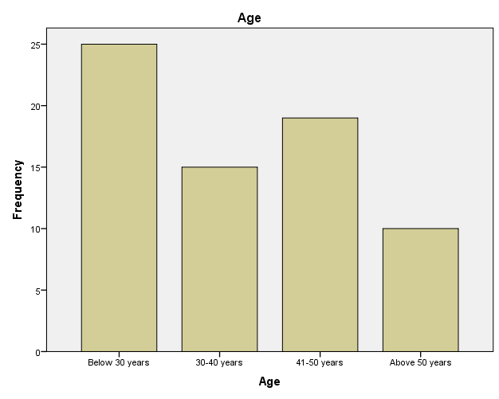

**Figure 4.1 Age 1**

***Source: The researcher (2023)***

According to the above bar graph, 25 (or 36.2%) of the respondents were below the age of 30, 15 (21.7%) were between the ages 30 and 40, 19 (or 27.5%) were between the ages of 41 and 50, 10 (14.5%) were over 50. According to recent studies (Truxillo & Fraccaroli, 2013; Zaniboni et al., 2013), employees behave differently based on their age in the workplace, the researcher used age diversity. The investigator noted that a fair representation of all age groups was found.

**Table 4.3.2 Sex 1**

|  |  |  |  |  |  |
| --- | --- | --- | --- | --- | --- |
| **Sex** | | | | | |
|  | | Frequency | Percent | Valid Percent | Cumulative Percent |
| Valid | Female | 39 | 56.5 | 56.5 | 56.5 |
| Male | 30 | 43.5 | 43.5 | 100.0 |
| Total | 69 | 100.0 | 100.0 |  |

***Source: The researcher (2023)***

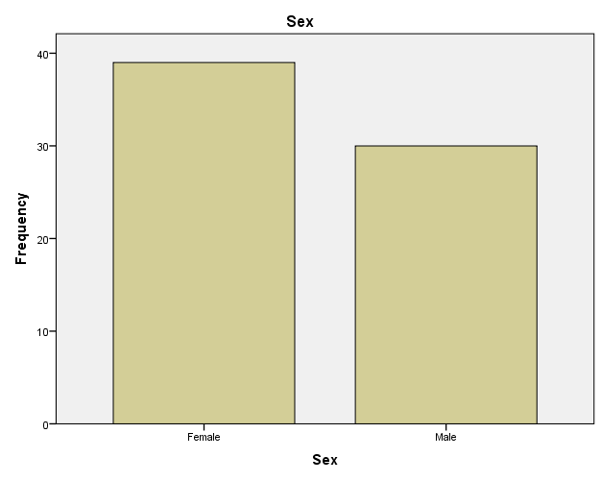

**Figure 4.2 Sex 1**

***Source: The Researcher (2023)***

The above bar graphs demonstrate that 39 (56.5%) were women and 30 (43.5%) of the respondents were men. In order to determine whether flexible work arrangements and employee performance are related, the researcher considers the gender of the respondents.

**Table 4.3.3 Marital Status 1**

|  |  |  |  |  |  |
| --- | --- | --- | --- | --- | --- |
| **Marital status** | | | | | |
|  | | Frequency | Percent | Valid Percent | Cumulative Percent |
| Valid | Married | 27 | 39.1 | 39.1 | 39.1 |
| Single | 32 | 46.4 | 46.4 | 85.5 |
| widow | 10 | 14.5 | 14.5 | 100.0 |
| Total | 69 | 100.0 | 100.0 |  |

***Source: The Researcher (2023)***

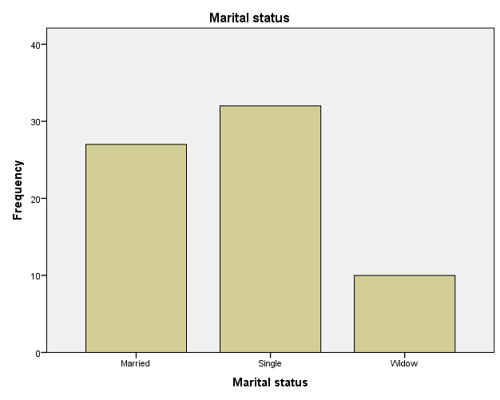

**Figure 4.3 Marital Status 1**

***Source: The researcher (2023)***

According to the above bar graphs, 27 (39.1%) were married and 32 (46.4%) of the respondents were single and 10 (14.5) were widows. In order to establish a relationship between employee performance and flex-time work arrangements, the researcher takes into account the respondents' marital status.

# 

**Table 4.3.4 Position or Work level 1**

|  |  |  |  |  |  |
| --- | --- | --- | --- | --- | --- |
| **Position or work level** | | | | | |
|  | | Frequency | Percent | Valid Percent | Cumulative Percent |
| Valid | General hands | 15 | 21.7 | 21.7 | 21.7 |
| Pharmacist | 5 | 7.2 | 7.2 | 29.0 |
| Physicians | 3 | 4.3 | 4.3 | 33.3 |
| Nurses | 25 | 36.2 | 36.2 | 69.6 |
| Paramedics | 6 | 8.7 | 8.7 | 78.3 |
| Nurse aids | 15 | 21.7 | 21.7 | 100.0 |
| Total | 69 | 100.0 | 100.0 |  |

***Source: The researcher (2023)***

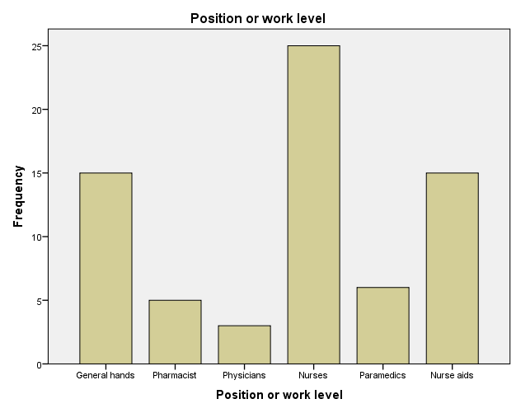

**Figure 4.4 Position or Work level 1**

**Source: The Researcher (2023)**

With respect to position at the hospital, the respondents were divided according to their professions, 21.7% were general hands, 7.2% pharmacist, 4.3% physicians, 36.2% nurses, 8.7% paramedics, 21.7 nurse aids respectively.

**Table 4.3.5 Years of Service 1**

|  |  |  |  |  |  |
| --- | --- | --- | --- | --- | --- |
| **Years of Service** | | | | | |
|  | | Frequency | Percent | Valid Percent | Cumulative Percent |
| Valid | Below 5 years | 39 | 56.5 | 56.5 | 56.5 |
| 5-9 years | 20 | 29.0 | 29.0 | 85.5 |
| 10+ years | 10 | 14.5 | 14.5 | 100.0 |
| Total | 69 | 100.0 | 100.0 |  |

***Source: The Researcher (2023)***

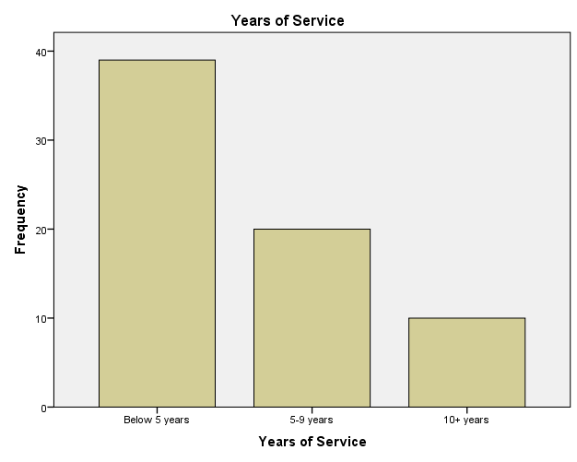

**Figure 4.5 Years of Service 1**

***Source: The Researcher (2023)***

According to the above bar graph, 29% of respondents had worked at Howard Hospital for more than five years but less than ten, 14.5% had worked there for more than ten years, and 56.5% of respondents had worked there for less than five years. This illustrates the range of employment backgrounds that Howard Mission Hospital staff members possess. This aligns with the requirements of the health sector's workforce, which necessitates experience. This study is similar to that of Ahluwalia and Preet (2018), who discovered that, based on a range of work experiences, employees with more work experience are more committed to their positions.

**Table 4.3.6 Level of Education 1**

|  |  |  |  |  |  |
| --- | --- | --- | --- | --- | --- |
| **Level of education** | | | | | |
|  | | Frequency | Percent | Valid Percent | Cumulative Percent |
| Valid | O Level | 15 | 21.7 | 21.7 | 21.7 |
| A Level | 16 | 23.2 | 23.2 | 44.9 |
| Diploma | 30 | 43.5 | 43.5 | 88.4 |
| Degree | 5 | 7.2 | 7.2 | 95.7 |
| Masters | 3 | 4.3 | 4.3 | 100.0 |
| Total | 69 | 100.0 | 100.0 |  |

***Source: The Researcher (2023)***

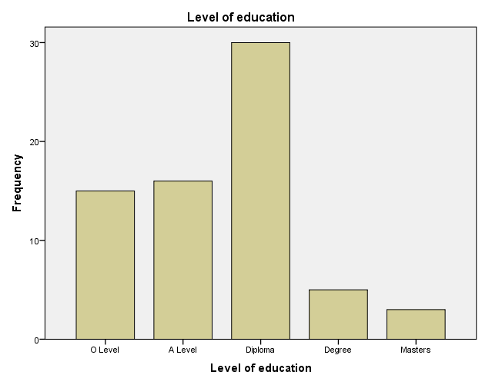

**Figure 4.6 Level of Education 1**

***Source: The researcher (2023)***

Based on the aforementioned bar graph, 21.7% of the respondents held an O level, 23.2% A level, 43.5% Diploma, 7.2% held a degree certificate and 4.3% Maters, because education levels can be used to explain a variety of responses to flexible work schedules, the researcher took this into account.

## 4.5 Workplace Flexibility

This section's main goal is to evaluate how employees view workplace flexibility and how it affects their productivity. Furthermore, an analysis will be conducted on their schedule preferences and level of agreement with the fit between their workload and working hours.

## 4.5.1 Howard Hospital is doing enough by offering flexible working arrangements like compressed work week, part-time schedule, shift work and annul hours. What is your comment on this statement?

**Table 4.3.7 Flexible Working Arrangement 1**

|  |  |  |  |  |  |
| --- | --- | --- | --- | --- | --- |
| **Flexible working arrangements offered** | | | | | |
|  | | Frequency | Percent | Valid Percent | Cumulative Percent |
| Valid | Strongly Disagree | 10 | 14.5 | 14.5 | 14.5 |
| Disagree | 5 | 7.2 | 7.2 | 21.7 |
| Neutral | 15 | 21.7 | 21.7 | 43.5 |
| Strongly Agree | 25 | 36.2 | 36.2 | 79.7 |
| Agree | 14 | 20.3 | 20.3 | 100.0 |
| Total | 69 | 100.0 | 100.0 |  |

***Source: Researcher (2023)***

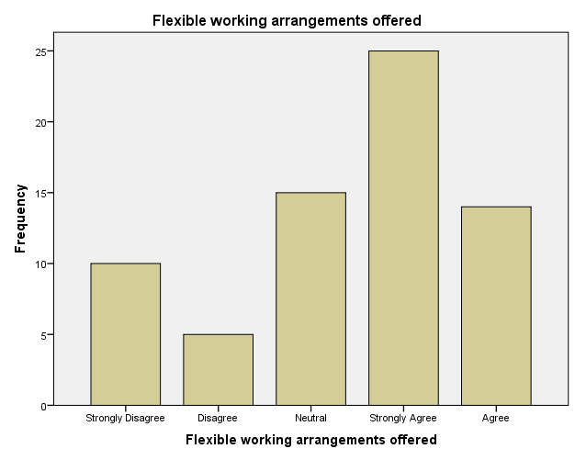

**Figure 4.7 Flexible Working arrangement 1**

***Source: The Researcher (2023)***

In relation to flexible working arrangements, respondents had different views. Meanwhile, 10 (14.5%) respondents strongly disagreed, 5 (7.2%) disagreed, 15 (21.7%) were neutral, 25 (36.2%) strongly agreed and 14 (20.3%) agreed that flexible working arrangements are being offered at Howard Mission Hospital. Finally, 36.2% plus 20.3% totally agreed which is 56.5%, this indicate a strong perception of flexible working hours being offered. A total of 21.7% including those who strongly disagreed and disagree indicates potential dissatisfaction hence it hinders there performance or stain in managing their responsibilities within the given timeframe. The researcher concluded from these data that although shift work and annual hours are common, Howard Mission Hospital offers flexible working arrangements. Flexible work arrangements are now widespread in companies and are frequently employed as a human resources tactic to draw in, develop, and keep top talent (Hill et al., 2008). As a result, companies have begun to provide their employees with flexible work arrangements (Hogarth et al., 2000). The results of the interviews, that consisted of quotes from two participants who stated that:

R1: "Shift working complemented by annualized hours is the common flexible working arrangement at this Hospital," provide support to the statistics.

R2: "The hospital uses shift labour for its staff."

## 4.5.2 What is your view on flexible working arrangements schedules, are they beneficial?

**Table 4.3.8 Benefits of flexibility 1**

|  |  |  |  |  |  |
| --- | --- | --- | --- | --- | --- |
| **Benefits of flexible working arrangements schedule** | | | | | |
|  | | | | | |
|  | | Frequency | Percent | Valid Percent | Cumulative Percent |
| Valid | Strongly disagree | 10 | 14.5 | 14.5 | 14.5 |
| Disagree | 10 | 14.5 | 14.5 | 29.0 |
| Neutral | 12 | 17.4 | 17.4 | 46.4 |
| Strongly Agree | 20 | 29.0 | 29.0 | 75.4 |
| Agree | 17 | 24.6 | 24.6 | 100.0 |
| Total | 69 | 100.0 | 100.0 |  |

***Source: The researcher 2023***

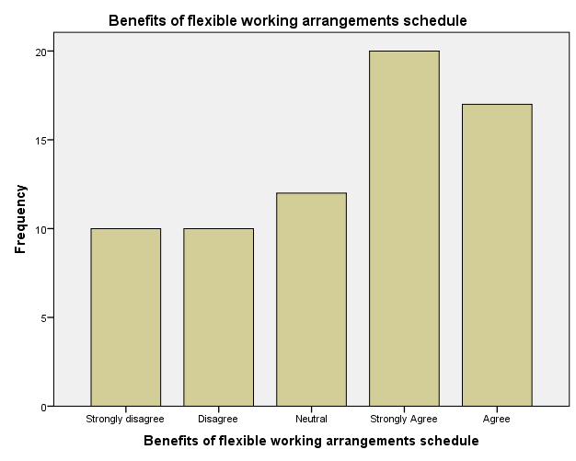

**Figure 4.8 Benefits of Flexibility 1**

***Source: Researcher 2023***

Twenty respondents (29%) strongly agreed that flexible work arrangements are beneficial and they have improved employee performance at Howard Mission Hospital, 24.6% of respondents agreed, 17.4% were neutral, 14.5% of respondents disagreed; and 14.5 % of respondents strongly disagree about the statement. This suggests that increased employee performance at Howard Hospital was greatly influenced by flexible working. In one survey, 16000 employees from 88 countries were found to have benefited from flexible work schedules in 81% of the cases (Regus.com, 2012). The interview results support this, with respondents B and D stating, respectively, that:

B: “When flexible working arrangements are implemented in support of employee needs, such as work-life balance and autonomy, they promote employee performance. Employees feel valued and important for the organization's survival as a result, and they give their all in the workplace.”

D: “We are able to achieve our goals thanks to our flexible work schedule. Our three-shift work schedule means that worn-out workers will be replaced by new workers who take over and hand over after completing their core hours. We are able to provide patients with services around-the-clock thanks to the three-shift work schedule, which helps the organization meet its goals.”

## 4.5.3 Employees’ are facing many challenges associated with flexible working arrangements. Do you agree with this statement?

**Table 4.3.9 Challenges 1**

|  |  |  |  |  |  |
| --- | --- | --- | --- | --- | --- |
| **Challenges associated with flexible working arrangements** | | | | | |
|  | | Frequency | Percent | Valid Percent | Cumulative Percent |
| Valid | Strongly Disagree | 24 | 34.8 | 34.8 | 34.8 |
| Disagree | 17 | 24.6 | 24.6 | 59.4 |
| Neutral | 13 | 18.8 | 18.8 | 78.3 |
| Strongly Agree | 6 | 8.7 | 8.7 | 87.0 |
| Agree | 9 | 13.0 | 13.0 | 100.0 |
| Total | 69 | 100.0 | 100.0 |  |

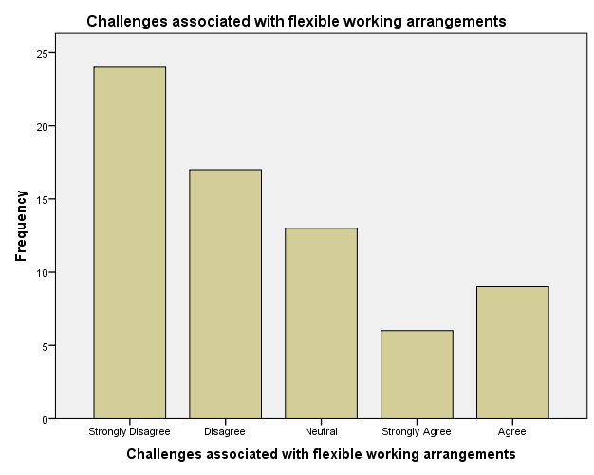

**Figure 4.9 Challenges 1**

***Source: The researcher (2023)***

Challenges being faced by employees while applying flexible working arrangements varied among respondents. A significant number of respondents, 34.8% strongly disagree and 24.6% disagreed that they are challenges associated with flexible working arrangements, stated that there were able to deliver their results effectively while applying flexibility. Additionally, a considerate portion of respondents reported difficulties in maintaining a routine of work (8.7% strongly agree and 13% agreed) whilst 18, 8% were neutral. This indicates that a portion of employees adapted well to flexible arrangements and did not encounter significant hindrances. According to the number of respondents who strongly disagreed and disagreed on facing challenges, flex-time work arrangements increased employee commitment at Howard Mission Hospital. Respondent D stated:

D: “I'm committed to exert by effort in my area of operation since flex-time provide us the room to have control over our work, which suggests that some employees adapted well to flexible arrangements and did not encounter significant obstacles.”

## 4.5.4 How is your current work output?

**Table 4.3.10 Current work output 1**

|  |  |  |  |  |  |
| --- | --- | --- | --- | --- | --- |
| **Current work output** | | | | | |
|  | | Frequency | Percent | Valid Percent | Cumulative Percent |
| Valid | Poor | 19 | 27.5 | 27.5 | 27.5 |
| Good | 40 | 58.0 | 58.0 | 85.5 |
| Excellent | 10 | 14.5 | 14.5 | 100.0 |
| Total | 69 | 100.0 | 100.0 |  |

*Source: The Researcher (2023)*

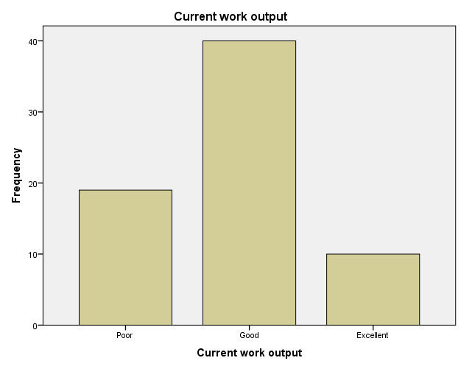

**Figure 4.10 Current work output 1**

***Source: The Researcher (2023)***

It is evident from the results that most respondents 58% of them were content with the productivity they were able to attain while utilising flexible work schedules. In relation to their productivity under a flexible work arrangement, about 14.5% said they were extremely pleased, while 27.5% said they were not. Regarding this, two interviewees, {A} and {E}, stated that:

“Work arrangements that allow for flexibility in scheduling lead to higher job satisfaction because they allow us to balance work and personal obligations. We can serve more patients when we are happy with our work.”

"Having control over our work feels good, and it inspires us to do our jobs fairly."

## 4.5.5 What is your comment on individual workload?

**Table 4.3.11 Individual workload 1**

|  |  |  |  |  |  |
| --- | --- | --- | --- | --- | --- |
|  | | | | | |
| **individual workload** | | | | | |
|  | | Frequency | Percent | Valid Percent | Cumulative Percent |
| Valid | Poor | 10 | 14.5 | 14.5 | 14.5 |
| Good | 16 | 23.2 | 23.2 | 37.7 |
| Excellent | 43 | 62.3 | 62.3 | 100.0 |
| Total | 69 | 100.0 | 100.0 |  |

*Source: The Researcher (2023)*

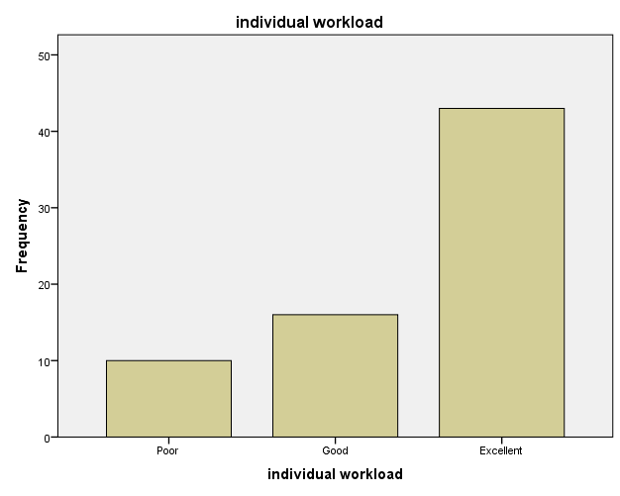

**Figure 4.11 Individual Workload 1**

*Source: The Researcher (2023)*

Respondents' opinions on the compatibility of workload and working hours varied. In the meantime, 23.2% of respondents are happy with the current workload, 14.5% are not, and 62.3% agree that it is excellent.

## 4.5.6 If the company decides to implement flexible hours, how much would this change contribute to your performance?

**Table 4.3.12 Implementation 1**

|  |  |  |  |  |  |
| --- | --- | --- | --- | --- | --- |
| **Implementation of flexible working hours contribute to employee performance** | | | | | |
|  | | Frequency | Percent | Valid Percent | Cumulative Percent |
| Valid | A lot | 33 | 47.8 | 47.8 | 47.8 |
| More or less | 20 | 29.0 | 29.0 | 76.8 |
| It would not change | 16 | 23.2 | 23.2 | 100.0 |
| Total | 69 | 100.0 | 100.0 |  |

*Source: The Researcher (2023)*

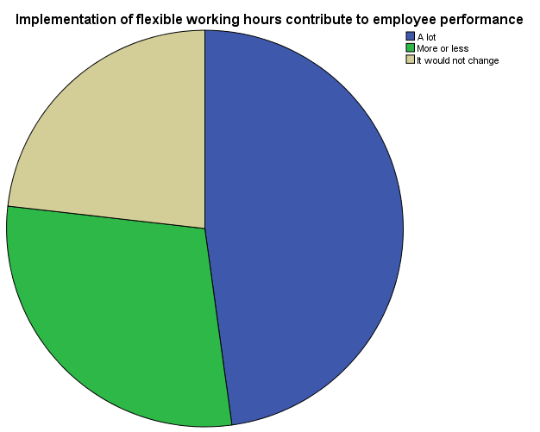

**Figure 4.12 Implementation 1**

*Source: The Researcher (2023)*

The results shows that 47.8% of the respondents agreed that the implementation of flexible working hours would contribute to performance, 33 (47.8%) respondents agreed that the implementation causes a lot of change to their performance, 23.2% of the respondents agreed that the implementation of flexible working hours would not change their performance whilst 29% agreed that implementation of flexible working hours would contribute more or less to their performance. This indicates that increased employee performance at Howard Hospital was greatly influenced by flexible working. According to Kossek and Thompson (2016), flexible work schedules improve workplace performance and employee well-being. Vander Elst, Verhoogen, and De Witte (2017) found that flexible work schedules also boost employee engagement. This researcher concurs that implementing flexible hours would improve performance.

## 4.5.7 If you could choose which of those working options do you think would increase your productivity?

**Table 4.3.13 Working Options 1**

|  |  |  |  |  |  |
| --- | --- | --- | --- | --- | --- |
| **Working options to increase productivity** | | | | | |
|  | | Frequency | Percent | Valid Percent | Cumulative Percent |
| Valid | 100% working from home | 20 | 29.0 | 29.0 | 29.0 |
| Hybrid | 39 | 56.5 | 56.5 | 85.5 |
| 100% working at the office | 10 | 14.5 | 14.5 | 100.0 |
| Total | 69 | 100.0 | 100.0 |  |

*Source: The Researcher (2023)*

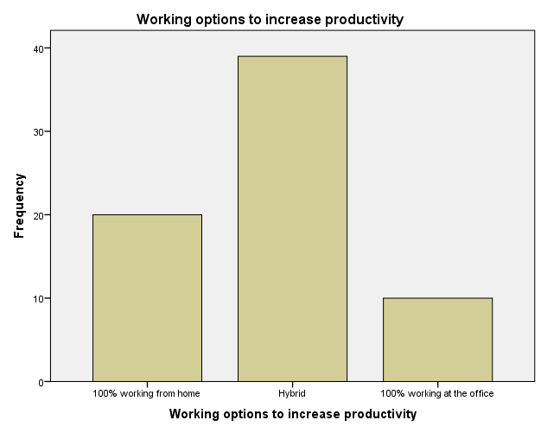

**Figure 4.13 Working Options 1**

*Source: The Researcher (2023)*

When asked about their preferred working options for increased productivity, respondents expressed varied preferences. Approximately 29% favoured working from home, while 56.5% preferred a hybrid model that combines working from home and at the office. A smaller percentage (14.5%) indicated a preference for 100% working at the office.

## 4.5.8 Do you think HR is doing enough in addressing flexible working arrangements or condition?

**Table 4.3.14 Flexible working Conditions 1**

|  |  |  |  |  |  |
| --- | --- | --- | --- | --- | --- |
| **Addressing flexible working condition** | | | | | |
|  | | Frequency | Percent | Valid Percent | Cumulative Percent |
| Valid | Strongly Disagree | 7 | 10.1 | 10.1 | 10.1 |
| Disagree | 4 | 5.8 | 5.8 | 15.9 |
| Neutral | 10 | 14.5 | 14.5 | 30.4 |
| Strongly Agree | 20 | 29.0 | 29.0 | 59.4 |
| Agree | 28 | 40.6 | 40.6 | 100.0 |
| Total | 69 | 100.0 | 100.0 |  |

*Source: The Researcher (2023)*

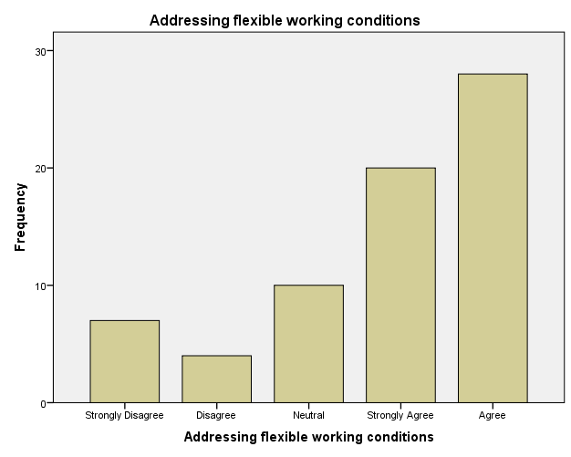

**Figure 4.14 Flexible working conditions 1**

*Source: The Researcher (2023)*

Respondents view on HR in addressing flexible working arrangements or condition differ, 29% of respondents strongly agreed that HR is doing enough when it comes to addressing flexible working arrangements, 28% of respondents agreed, 14.5% were neutral, 5.8% of respondents disagreed; and 10.1 % of respondents strongly disagree about the statement.

## 4.8 Discussion of Results

These findings demonstrate how crucial it is to take into account individual preferences and variations when putting flexible work arrangements into place. Howard Mission Hospital conducted research, concentrating on the effects of age and sex, on the performance of employees when varying work schedules were implemented. The study's conclusions shed light on the connection between employees' performance and variable work schedules. By examining the employees' age, sex, and job roles, among other demographic details, the study's sample composition was determined. This information helps to contextualize the following findings and their importance to the organization. According to the analysis of work flexibility, the majority of employees think that having flexible hours boosts productivity. This demonstrates how crucial it is to consider flexible work schedules in order to raise employee satisfaction and well-being.

The introduction of flexible working hours yielded results that demonstrated a lack of consistency in employees' perceptions of the change and its potential to enhance performance. They did, however, say that it helps to improve worker performance. Furthermore, a sizable majority of workers selected a working arrangement that boosts productivity, they favoured a hybrid model that combines working at the office and from home. The aforementioned results highlight the need for flexible working options policies that also acknowledge the benefits of flexible work schedules, shift work, compressed work weeks, part-time work, and annul hours. Even with obstacles like stress from a heavier workload and interruptions, many workers reported improvements in job satisfaction, task ease, and productivity. These results imply that, depending on the situation, shift work may be a flexible way to increase productivity.

All things considered, the research indicates that flexible work arrangements, such as shift work and annual hours, can have a significant impact on worker satisfaction, productivity, and engagement. Organizations can maximize the advantages these arrangements offer to workers by comprehending and resolving the issues they raise. The practical implications of these findings extend to Howard Mission Hospital and related establishments. They emphasize how crucial it is to implement flexible work schedules in order to improve employees' productivity, well-being, and job satisfaction. Offering employees the flexibility to work from home and modifying policies to suit their needs are two ways that organizations can foster a positive work environment that meets the diverse needs of their workforce. It is important to keep in mind that the research's findings only pertain to Howard Mission Hospital and might not be entirely applicable to other companies. They do, however, provide useful information and set the stage for further research in this area.

## 4.9 Chapter Summary

The knowledge of how flexible work schedules affect employee performance, satisfaction, and engagement has been greatly advanced by this chapter. The research findings indicate that flexible scheduling has a favourable impact on worker satisfaction, productivity, and engagement. The following chapter offers a conclusion and recommendations

# CHAPTER 5

## 5.1 INTRODUCTION

In the chapter before, we discussed data presentation, interpretation, and analysis. The suggestions, conclusions, and summary of findings from the study are examined in this chapter.

## 5.2 Summary of Results

This study's main goal was to investigate how different work schedules affected workers' performance as well as their satisfaction and engagement, all of which had a significant impact on the results. Through a case study that focused on employee performance, engagement, and satisfaction, the study examined the effects of Howard Mission Hospitals' alternative work schedules on worker performance and satisfaction. Additionally, the study looked at how flexible policies affected workers' productivity while taking into account employees of various ages and genders.

Overall, the study found that participants enjoyed having flexible work schedules and were happy with their level of involvement. An extensive review of prior research made clear how important organizational agility is to both employers and employees. The study looked into the benefits and drawbacks of workplace flexibility as well as how it impacts worker engagement and productivity. While the company's cooperation and involvement in the research is acknowledged by the author, it would be beneficial for future studies to look at organizations that are not.

## 5.2.1 Objective 1

**To identify the characteristics of workplace flexibility at Howard Mission Hospital.**

The study discovered that Howard Hospital offers four different flexible work schedules that is annualized hours, shift work, compressed work weeks, and part-time. The researcher discovered that shift work and annualized hours are typical flexible work arrangements meant for full-time Howard Hospital staff members. Employees who choose these flexible work schedules are given a start and end time. As long as they completed the required number of hours of work, employees are free to depart the hospital. Additionally, workers must be present during the designated core hours. This is consistent with the definition provided by Nabe-Nielsen et al. (2012), which states that flexible is a scheduling program for full-time employees that gives them the freedom to select their daily start and end times, as long as the assignments are finished within the allotted number of hours.

## 5.2.2 Objective 2

**To identify the benefits of using workplace flexibility at Howard Mission Hospital.**

At Howard Hospital, the researcher discovered that flexible work schedules enhance staff members' health and happiness. The researcher discovered that flexibility gives workers more time to decompress, enabling them to perform better when they return to work in less stressful environments. These results are consistent with the conclusion drawn by Sparks et al. (2001) regarding flexibility that employee health matters to businesses because, in addition to the financial toll that illness-related absences take, well-being improves productivity.

The researcher discovered that employees at Howard Hospital are able to reconcile work and personal life thanks to flexible work arrangements. The researcher discovered that workers make an effort to balance their obligations in life and at work so as not to jeopardize either. The researcher comes to the conclusion that when work and home life are in balance, workers are more likely to give their all at work in order to meet demands at home. These results are consistent with research by Almer, Cohen, and Single (2003), which found that when people consider adopting flexible working arrangements, the primary consideration is reducing work-family conflicts and enabling individuals to spend more time with their families and be involved in their children's everyday lives.

The study discovered that flexible work schedules at Howard Hospital improved worker productivity. The researcher discovered that having more freedom and flexibility with flexibility encourages workers to give their best work. The researcher discovered that the employees were able to reach their goals thanks to flexibility. This is corroborated by Brummelhuis, Haarb, and Lippe (2010), who point out that flexible scheduling facilitates methods of providing effective customer service, thereby increasing the quantity of people served by the end of the day because more employees are more alert, focused, relaxed, and driven.

The study discovered that flexible work schedules increase Howard Hospital employees' job satisfaction. The researcher discovered that when flexible work arrangements are created to meet the needs of workers, such as work-life balance and job autonomy, they are positively received by the workforce. The claim made by Wingen et al. (2004) that employees' job satisfaction is positively correlated with their level of autonomy and decision-making authority as well as their level of trust is in support of this.

At Howard Hospital, the researcher discovered that flexible work schedules improved organizational commitment, which in turn affects worker performance. Berkery et al. (2017) corroborated these findings, concluding that packages of flexible work arrangements, such as flexible, when employee-oriented, were perceived as a sign of concern for the well-being of the employees, resulting in higher psychological commitment and motivation.

At Howard Hospital, the researcher discovered that flexible work schedules lower absenteeism. He discovered that employees who have flexible work arrangements typically feel more satisfied with their workplace because they are linked to a higher degree of freedom. This is consistent with the results of Baltes et al. (1999), who found that flexibility positively impacted absenteeism and positively impacted productivity, job satisfaction, and schedule satisfaction but not self-rated performance. These other positive effects were somewhat weaker.

The study comes to the conclusion that Howard Hospital's expenses are decreased by flexible work arrangements. He discovered that Howard Hospital staff members put in less than 8 hours of work each day, which reduces the likelihood of workplace mishaps brought on by extended workdays. He discovered that flexible work schedules lessen workplace disturbances brought on by employees concentrating in large groups. These results are consistent with those of Duncan and Pettigrew (2012), who note that flexible work arrangements allow organizations to increase operating hours at the workplace without incurring additional costs associated with salary.

## 5.2.3 Objective 3

**To identify the challenges associated with workplace flexibility at Howard Mission Hospital.**

The study discovered that managers at Howard Hospital were under more stress due to flexible work schedules. He discovered that managers have an excessive amount of responsibilities, which could cause them stress. These observations are consistent with the research conducted by Towers-Perrin (2001), which concludes that managers will probably be more burdened with flexible work arrangements, particularly when it comes to managing employee scheduling, communication, and supervision.

This study also discovered that Howard Hospital staff members are more resistant to flexible work schedules. The researcher discovered that when adopting flexible work arrangements for the first time, there may be resistance. This is consistent with Podnar and Golob's (2010) conclusion that workers may oppose flexible on their own, particularly if the current system comes with a certain amount of freedom and tolerance.

The researcher discovered that employees at Howard Hospital were resentful of flexible work arrangements. The researcher discovered that when they are denied the same privileges as other employees, they become irritated. This relates to AlRajudi's (2012) conclusion that, while flexible has been shown to lower the frequency of conflicts at work, resentment may develop if the nature of one's job prevents other employees from using this arrangement for the sake of business continuity, particularly with regard to customer service staff.

The study discovered that Howard Hospital's flexible working policies restrict employee benefits like overtime and sick pay. The researcher discovered that if flexibility is implemented for the organization's rather than the employees' benefit, it reduces employee benefits. Regarding this, Kalleberg (2000) contends that it is preferable for businesses to use part-time workers to cover every shift because of this (Kalleberg, 2000).

## 5.2.4 Objective 4

**To assess the extent of correlation between workplace flexibility and employee performance at Howard Mission Hospital.**

The study discovered that employees are more likely to be satisfied with their jobs when they have the flexibility to work remotely or with flexible hours. The researcher discovered that performance is positively impacted by the increased satisfaction of employees’ when there are more driven and invested in their work. This related to the finding of Allen et al. (2013) that there is a positive correlation between workplace flexibility and outcomes like organizational commitment and job satisfaction, which may subsequently result in enhanced employee performance.

According to the study, workplace flexibility helps workers better balance their personal and professional obligations, which lowers stress and burnout. Additionally, the researcher found that employees are more likely to be focused, productive, and give their best work when they have a healthier work-life balance. Employees with flexibility can work in settings that best meet their needs or during their most productive hours. Employees can better optimize their workflow, which improves performance, which raises productivity and efficiency. This relates to the findings of Gajendran and Harrison (2007), who found a positive correlation between flexible work arrangements like telecommuting and flexibility and performance outcomes like task performance and creativity.

The study's findings show that flexibility boosts retention and lowers absenteeism. According to studies, companies that offer flexibility see lower absenteeism and turnover rates. The study found that employees are more likely to remain at Howard Mission Hospital and lower absenteeism and turnover costs when they are given the freedom to manage unforeseen circumstances or personal needs. This is comparable to the findings of Kossek, Lautsch, and Eaton (2006), who discovered that workers with high schedule control levels had better job satisfaction and fewer intentions to leave, all of which were positively correlated with worker performance.

## 5.3 Conclusions

This chapter investigate how worker's performance is affected by flexibility, with an emphasis on the company that is being studied. Previous research has demonstrated that employee engagement is a critical factor in determining the performance of an organization, and employers ought to give top priority to their workers' drive and dedication. Flexible work schedules can boost worker engagement and output, but the effects may differ depending on the age and gender of the worker, according to DelCampo et al. (2011) and Anderson and Kelliher (2009).

Through the use of a mixed approach technique, this investigation seeks to investigate the relationship between worker performance and alternative working options. It also analyses and evaluates prior theories and literature. The COVID-19 pandemic has brought to light the significance of flexible work arrangements in improving the performance of organizations. Therefore, it is necessary to investigate employees' viewpoints regarding the benefits and drawbacks of sudden changes, as well as their assessment of the productivity and engagement levels associated with flexible work arrangements.

The study, whose data is restricted to a specific industry and organization, provides insightful information about how different work schedules affect employees' performance. It emphasizes how important it is for employers to take into account what their workers need and to create a productive workplace. As a result, this study adds to the body of knowledge on flexible working arrangements by offering suggestions to human capital managers and organizations.

## 5.4 Recommendations

After this study's findings were obtained, the researcher made recommendations to Howard Mission Hospital. It may be possible to prevent employee performance at Howard Hospital from being jeopardized by implementing the following advice:

It has become clear that the most important tactic for raising performance is training and development. It guarantees that staff members possess the necessary competencies, expertise, and knowledge that are essential to the hospital's survival. It gives staff members the chance to advance at this hospital and maintain relevance in their line of work. Thus, the researcher proposed that that investing in employees is an effective way to improve their performance. .

It appeared that the best way to guarantee employee performance was through performance feedback. To reduce under performance, management should give staff feedback on their performance. In order to close the performance gap, the researcher advises the management team of Howard Mission Hospital to provide performance feedback to staff members.

Offering incentives to staff members is another tactic to raise productivity. Employee morale is raised by incentives, which motivates them to work harder to meet the hospital's overall objectives. Therefore, it is advised that the hospital offer incentives to its staff in order to improve performance.

Improved communication between management and staff has become a key tactic in raising employee performance. Workers must be made aware of the expectations placed on them. Employee performance improves when they are aware of what is expected of them. In order to enhance employee performance, the researcher advises Howard Hospital to implement two-way communication.

It has become clear that one key tactic for raising employee performance is performance appraisal. By evaluating employees' work, the hospital can develop initiatives to enhance productivity and reduce employee vulnerability. Thus, the researcher suggests that Howard Mission Hospital evaluate staff performance on a regular basis.

## 5.4.3 Areas for further research

The study's goal was to investigate how flexible work schedules affect Howard Mission Hospital employees' performance. Therefore, I advise that a comparable study be carried out on a much larger institution using a quantitative technique and at an expanded scope to stop the outcomes from being generalized. In addition to determining the elements such as retention strategies and health-related quality of life that impact health professionals' motivation, it's critical to assess the degree of dissatisfaction with each migration push and component.

## 5.5 Chapter Summary

The previous section's main topics were the study's conclusions, recommendations, and summary of results.

# REFERENCES

Abbas, Q., & Yaqoob, S., 2009. ‘Effect of leadership development on employee performance in Pakistan’: Pakistan Economic and Social Review, Vol. 47, pp.269-292.

Altindag, E., & Siller, F., 2014. ‘Effects of Flexible Working Method on Employee Performance’: An Empirical Study in Turkey. Bus Eco J 5:104. doi:10.4172/2151-6219.1000104

Allen, T., Johnson, R., Kiburz, K., & Shockley, K., 2013. ‘Work-family conflict and flexible work arrangements’: Deconstructing flexibility, Personnel Psychology, vol. 66, no.2, pp. 345-376. <https://doi.org/10.1111/peps.12012>.

Anderson, D., & Kelliher, C., 2009. ‘Flexible working and engagement: the importance of choice’, Strategic HR Revie, vol.8, no.2, pp. 13-18.doi:10.1108/14754390910937530.

Armstrong, M., & Taylor, S., 2014. *Armstrong’s handbook of human resource management practice 13th ed.* Pearson: London.

Bailyn, L., Rayman, P., Bengsten, D., Carre, F., & Tierney, M., 2001. ‘Fleet financial and Radcliffe explore paths of work/life integration’. Journal of Organizational Excellence, vol.20, 49-64.

Bal P., & De Lange, A., (2014). ‘From flexibility human resource management to employee engagement and perceived job performance across the lifespan’: A multi sample study, Journal of Occupational and Organizational Psychology, vol.88, no. 1, pp.126–15.

Baltes, B. B., Briggs, T. E., Huff, J. W., Wright, J. A., & Neuman, G. A. (1999). ‘Flexible and compressed workweek schedules: A meta-analysis of their effects of work –related criteria’. Journal of Applied Psychology, vol.84, no. 4, pp.496-513. doi:10.1037/00219010.84 .4.496

Bloomfield, L., & Proffit, S., 2017. Flexible working: an employer’s perspective. People Management. [Online]Available at: <https://www.peoplemagement.co.uk/voices/comment/flexible-working-employers-perspective> [Accessed on May 2023]

Brummelhuis, L. L0. Haarb, J. M., & Lippe, T. v. (2010). ‘Collegiality under pressure: the effects of family demands and flexible work arrangements in the Netherlands’. The International Journal of Human Resource Management, 2831-2847.

Carlier, S. I., LIorente, C. L., & Grau, M. G., 2012. 'Comparing Work-life Balance in Spanish and Latin- American Countries', European Journal of Training and Development, vol. 36,no. 2-3, pp. 286-307.

Casper, W., & Harris, C., 2008. ‘Work-life benefits and organizational attachment: Self-interest utility and signalling theory models’. Journal of Vocational Behaviour, vol. 72, no.1, pp 95–109. https://doi.org/10.101wo

CDC, 2020b. Corona Virus. https://www.cdc.gov/coronavirus/2019-ncov/index.html

Chen, Y., & Fulmer, I.S., 2017. ‘Fine-tuning what we know about employees’ experience with flexible work arrangements and their job attitudes’. Human Resource Management, vol.57, no.1, pp.381-395.doi: 10.1002/hrm.21849.

Ciarniene, R. & Vienazindiene, M., 2018. Flexible Work Arrangements from Generation and Gender Perspectives: Evidence from Lothuania Engineering Economics, vol. 29, no 1, pp. 84-92.

CIPD (2021a) Employee engagement and motivation. Available at: <https://www.cipd.co.uk/knowledge/fundamentals/relations/engagement/factsheet> (Accessed: 25 May 2023).

Dessler, G., 2008. Human Resource Management. New Jersey: Pearson Education Limited.

Filipova, A. A., 2018. Expectancy theory in organisations. In Global Encyclopedia of Public Administration, Public Policy, and Governance. Springer Link.

Fonner, K. L., & Roloff, M. E., 2010. ‘Why teleworkers are more satisfied with their jobs than are office-based workers: When less contact is beneficial’. Journal of Applied Communication Research, vol.38, pp.336-361. Doi: 10.1080/00909882.2010.513998

Gajendran, R. S., & Harrison, D. A., 2007. ‘The good, the bad, and the unknown about telecommuting: Meta -analysis of psychological mediators and individual consequences’. Journal of Applied Psychology, vol.92, pp.1524-1541. Doi: 10.1037/0021-9010.92.6.1524

Ganster, D. C., & Rosen, C. C., 2013. Work stress and employee health: A multidisciplinary review. Journal of Management, vol.39, pp.1085-1122. DOI: 10.1177/0149206313475815

Gathungu, J., & Wachira H. W., 2013. 'Job Satisfaction Factors that Influence the Performance of Secondary School Principals in their Administrative Functions in Mombasa District, Kenya'. International Journal of Education and Research, vol. 1, no. 2, pp. 1-15. [Online]. Available: <http://www.ijern.com/images/February-2013/08.pdf> (Accessed 11 January 2017).

Golden, L., 2008. ‘Disparities in flexible work schedules and work- at-home’. Journal of Family and Economic Issues, vol.29, pp. 86-109, http://link.springer.com/journal/10834

Gronlund, A., 2007. ‘More control, less conflict? Job demand-control, gender and work-family conflict’. Gender, Work and Organization, 14(5), 476–497. https://doi.org/10.1111/j.1468-0432.2007.00361.x

Halpern, D. F., 2005. ‘How time-flexible work policies can reduce stress, improve health, and save money’. Stress and Health Journal, vol.21, pp.157-168.

Herrbach, O., Mignonac, K., & Vandenberghe, C., 2009. A multilevel model of transformational leadership and adaptive performance and the moderating role of climate for innovation. Group & Organisation Management, vol.34, no.6, pp. 699-726

Hidayah, N. A., Singh, J.K., & Hussain, I.A., 2021. ‘Impact of flexible working arrangements in the public sector in Indonesian’. International Journal of Human Resource Studies, vol.11, no.2, pp.2162-3058.

Inuwa, M., 2016. ‘Job satisfaction and employee performance: An empirical approach’. The Millennium University, vol.11, no.2, pp.1-9.

IOL Business Report. 2017. Consequences of flexible working hours. Retrieved from <https://www.iol.co.za/business-report/careers/consequences-of-flexible-working-hours-9411450>

Jones, P., 2020. Human Resource Management. New Jersey: Pearson

Kahn, W. A. 1990. 'Psychological Conditions of Personal Engagement and Disengagement at Work'. Academy of Management Journal, vol. 33, no. 4, pp. 692- 724.

Kaur, S., & Singh, S., 2020. ‘Expectancy theory and its implications for employee motivation’. Academy of Leadership Journal, vol.6, no.3, pp.97-105.

Kilber, J., Barclay, A., & Ohmer, D., 2014. ‘Seven Tips for Managing Generation Y’. Journal of Management policy and Practice, vol.15, pp.80-91

Kiran, M., & Khurram, S., 2018. ‘Flexitime and employee happiness at workplace: A quantitative study of software houses’. Pakistan Journal of Commerce and Social Sciences, vol.12, no.3, pp. 1008-1024

Kim, J. Y., & Lee, S. H., 2019. *Roles of expectancy on employee engagement and job performance.* SSRN.

Kossek .E.E., & Ozeki, C., 2016. ‘Bridging the work –family policy & productivity gap. A literature review community’. Work & Family, vol.2, no.1, pp.7-32.

Kramar, R., & Syed, J., 2019. ‘HRM practices and innovation: an empirical systematic review’. International Journal of Innovation and Digitalisation in Governance, vol.1, no.1, pp.1-22.

Kruse, K., 2012. 'What is Employee Engagement?' Forbes. Available at: [https://www.forbes.com/sites/kevinkruse/2012/06/22/employee-engagement-what-and why/](https://www.forbes.com/sites/kevinkruse/2012/06/22/employee-engagement-what-and%20why/)? Sh=6c87d3d47b0a (Accessed 25 May 2023)

Kurtessis, J., Eisenberger, R., Ford, M., Buffardi, L., Stewart, K., & Adis, C., 2017. ‘Perceived organizational support: A meta-analytic evaluation of organizational support theory’. Journal of Management, vol. 43, no. 6, pp. 1854–1884.https://doi.org/10.1177/0149206315575554

Lewis, S. E., & Campbell, M. A., 2008. ‘Introducing flexible time management as an employee and organizational resource’. Asia Pacific Journal of Human Resource, vol.46, no.3, pp. 389-403.

Locke, E. A., & Latham, G. P., 2006. ‘New Directions in Goal-setting theory’. Current Directions in Psychological Science, vol.15, pp.265-268

Locke, E. A., & Latham, G. P., 2002. Building a practically useful theory of goal setting and task theory of goal setting and task motivation: A 35-year odyssey. American Psychologist, 15, 705-717

Loretto, W., & Vickerstaff, S., 2015. Gender, age and flexible working in later life, *Work Employment and safety, vol.29, no 2, pp. 233-249.*

Lunenburg, F. C., 2011. Goal-setting theory of motivation. International Journal of Management, Business, and Administration, 15, 1-6

Lyons*,* S*.,* &Kuron*,* L*.,* 2014. *Generational differences in the workplace: A review of the evidence and directions for future research.* JournalofOrganizationalBehaviour*,* vol*.* 35*,* no*.* 1*,* pp*.* 139*–*157. <https://doi.org/10.1002/job.1913>

Maxwell, J. A., 2010. Using Numbers in Qualitative Research. Qualitative inquiry, 16, 475-482

Michel*,* J*.,* Kotrba*,* L*.,* Mitchelson*,* J*.,* Clark*,* M*.,* &Baltes*,* B*.,* 2011. *'*Antecedents of work-family conflict: A meta-analytic review'*.* JournalofOrganizationalBehaviour*,* vol*.* 32*,* no*.* 5*,* pp*.* 689*–*725*.* <https://doi.org/10.1002/job.695>

Motowidlo, S. J., 2003. Job performance. Handbook of psychology: Industrial and organizational psychology, vol.12, pp. 39-53. John Wiley & Sons, Inc.

Mupani, H., 2015. Journal of Business and Management(IOSR-JBM) e-ISSN: 2278487X, p-ISSN: 2319-7668. Volume 17, Issue 2.Ver. I

Mwebi, M.B., & Kadaga M.N., 2015.‘Effects of Flexitime Work Arrangement on Employee Performance in Nairobi CBD Commercial Banks International Journal of Novel’, Research in Marketing Management and Economics Vol. 2,

Muchowe, R., Mawonde, D., and Pande, C., 2021. ‘The relationship between flexible work arrangements and organizational performance in higher and tertiary education Institutions in Mashonaland Central Province during the Covid-19 period in Zimbabwe’: International Journal of Research and Innovation in Social Science, Volume V: 2454-6186.

Nabe-Nielsen, K., Garde, A. H., Austb, B., & Diderichsen, F., 2012. ‘Increasing work-time influence: consequences for flexibility, variability, regularity and predictability’*.* JournalofErgonomics*,* 440*-*499*.*

Neto, A. C., 2020, ‘Arranjos Flexivels da jounada de trabalho no Brazil’, Revista Pensamento Contemporaneov em Administracao, vol. 14, no. 2, pp. 1-17

Omotayo, O.A., Abiodun A. J., & Fadugba A. O., 2012. ‘Executives. *‘*Perception of the Impact of Flexi time On Organizational Performance: Evidence from the Nigerian Private Sector’. International Journal of Applied Behavioural Economics, Vol 1.

Ozochukwu, C., 2019. Workplace flexibility and employee performance in selected commercial banks in Anambra state, Nigeria. International Journal of Research in Business studies and Management, vol.6, no.5, pp.1-14

Paaulson, J., & Hyden, M. C., 2020. Trends in Human Resource Management in Eastern Europe. 3rd ed. London: Cengage.

Sabir, M. S., Iqbal, J. J., Rehman, K., Shah, K. A. and Yameen, M., 2012.’Impact of corporate ethical values on ethical leadership and employee performance’. International Journal of Business and Social Science, Vol. 3, pp. 163-171

Saeed L. M. (2013) Factors Affecting the Performance of Employees at Work Place in the Banking Sector of Pakistan. Middle-East Journal of Scientific Research, 17

Saeed, I., Waseem, M., Sikander, S., Rizwan, M., 2014. 'The relationship of turnover intention with job satisfaction, job performance, leader member exchange, emotional intelligence and organizational commitment'. International journal of learning and development, vol. 4, no. 2.

Salaman, Graeme, Storey, John; Billsberry. 2005. Strategic Human Resource Management: Theory and Practice.2nd Edition. Sage Publications Ltd.

Shmailan, A., 2016. The relationship between job, job performance and employee engagement: An explorative study. Issues in Business Management and Economics Original Research Article, vol. 4, no. 1, pp. 1-8.

SHRM, 2012. Employee job satisfaction and engagement: How employees are dealing with uncertainty.Alexandria, VA: Society for Human Resource Management (SHRM). [Online]. Available: <http://www.shrm.org/Legallssues/StateandLocalResources/StateandLocalStatuessandRegulations/Documents/12-0537%202012> Job Satisfaction FNLonline.pdf (Accessed20February2017).

Sweet, S., Pitt-Catsouphes, M., & Boone James, J., 2016. Successes in changing flexible work arrangement use. Work and Occupations, vol. 43, no. 1, pp. 75–109. <https://doi.org/10.1177/0730888415595094>

Taiwo, A. S., 2009. The influence of work environment on workers’ productivity: a case of selected oil and gas industry in Lagos, Nigeria. African Journal of Business Management, Vol. 4, pp. 299-307.

Taylor, S., 2019. Resourcing and Talent Management 7th Edition. CIPD, Kogan Page, London.

Thompson, R. J, Payne, S & Taylor, A. B., 2015. Applicant attraction to flexible work arrangements: Separating the influence of flexitime and flexplace, Journal of Occupational and Organizational Psychology, vol. 88, no. 4, pp. 726- 749.

TomTom Traffic Index, 2016. Retrieved (n.d.) from https://corporate.tomtom.com/static-files/5289c5aa-310c-4965-a4c0-516760a8a6fdUduji, J. I. 2013. Hygiene factors: 'The foundations for heightening the marketing executives’ motivation in the banking industry in Nigeria'. European Journal of Business and Management, vol. 5, no. 15, pp. 68-75.

Twenge, J. M., Campbell, S.M., Hoffman, B.J., & Lance, C. E., 2010. Generational differences in work values: Leisure and extrinsic values increasing, social and intrinsic values decreasing. Journal of Management, 36(5), 1117-1142.

Twenge, J. M., Campbell, S.M., Hoffman, B.J., & Lance, C. E., 2012. Generational differences in work-related attitudes: A meta-analysis. Journal of Business and Psychology, 27(4), 375-394.

Twiname, L. J., Humphries, M., & Kearins, K., 2006. ‘Flexibility on whose terms?’.Journal of Organizational Change Management, vol.19, pp.335-355.

United Nations. 2009. World population ageing. New York

Vroom, V. H., 1964. Work and motivation*.* John Wiley & Sons.

Van Ommeren, J., & Gutierrez Puigarnau, E., 2011. The flexible working arrangements are not yet flexible enough: The effect on votes of leaving type of work in the Netherlands. The Geneva Papers on Risk and Insurance- Issues and Practice, 495-505.

Vander Elst, T., Verhoogen, R., & De Witte, H., 2017. The role of workplace flexibility and autonomy in explaining turnover intention in the public sector. Review of pubic Personnel Administration, vol.37, no.4, pp.409-432

Weideman, M., & Hofmeyr, K. B., 2020. The influence of flexible work arrangements on employee engagement: An explanatory study*.* South African Journal of Human Resource Management, vol.18, no. 1, pp. 1-18.

Wheatley, D., 2017. Employee satisfaction and use of flexible working arrangements; Work, Employment and Society, vol. 31, no.4, pp. 567-585*.*

Wigfield, A., & Eccles, J. S., 2000. Expectancy-value theory of achievement motivation.Contemporary educational psychology, 25(1), 68-81.

Williams, S., & Anderson, S. E., 1991. Job satisfaction and organizational commitment as predictors of organizational citizenship and in-role behaviours. Journal of Management, 17(3), 601-617.

World Health Organisation. WHO responds to the Lancet Covid-19 commission [press release], Geneva: WHO; 2022? Available from: https://www.who.int/es/news/item/15-09-2022-who-responds-to-the-lancet-covid-19-commission

World at Work. 2015. Trends in workplace flexibility. Scottsdale, AZ. Retrieved from <https://www.worldatwork.org/dA/10dc98de55/Trends%20in%20Workplace%20Flexibility%20-%202015.pdf>

Zafari, F., Gkelias, A., & Leung, K. K., 2019. A survey of Indoor Localization Systems and Technologies. IEEE Communications surveys and tutorials, 1-1

Zeijen, M. E. L., Peeters, M. C. W., Van Den Heuvel, M., & Jansen, P.G. W., 2018. Age differences in the relation between need for recovery, work demands and work ability. Aging & Mental Health, 22(1), 70-77.

Zhou, L., Wang, M., Chang, C., Liu, S., Zhan, Y., & Shi, J., 2017. Commuting stress process and self-regulation at work: Moderating roles of daily task significance, family interference with work, and commuting means efficacy. Personnel Psychology, vol. 70, no. 4, pp. 891–922. https://doi. org/10.1111/peps.12219

# APPENDIX 1: A QUESTIONNAIRE FOR RESPONDENTS

**A QUESTIONNAIRE SURVEY ON THE MODERATE ROLE OF FLEXIBLE WORKING ARRANGEMENTS ON EMPLOYEE PERFORMANCE. A CASE STUDY OF HOWARD MISSION HOSPITAL.**

The following questions relate to your organisation, and you are required to respond to them. The information you will provide will be held confidentiality, specifically be used for academic purposes and will not be disclosed to another part without your prior permission.

INSTRUCTION:

Please do not write your name on the questionnaire.

Put a tick to your selected response

Fill in the blank space provided with your response where applicable.

1.

|  |  |  |  |  |
| --- | --- | --- | --- | --- |
| **What is your age range?** | **Below 30** | **30-40** | **41-50** | **Above 50** |
| **Response** |  |  |  |  |

2.

|  |  |  |
| --- | --- | --- |
| **What is your sex?** | **Female** | **Male** |
| **Response** |  |  |

3.

|  |  |  |  |
| --- | --- | --- | --- |
| **What is your Marital Status** | **Married** | **Single** | **Widow** |
| **Response** |  |  |  |

4.

|  |  |  |  |  |  |  |
| --- | --- | --- | --- | --- | --- | --- |
| **What is your position or work level at the company?** | **General hands** | **Pharmacist** | **Physicians** | **Nurses** | **Paramedics** | **Nurse Aids** |
| **Response** |  |  |  |  |  |  |

5.

|  |  |  |  |
| --- | --- | --- | --- |
| **For how long have you been working for your organisation** | **Below 5** | **5-9** | **10+** |
| **Response** |  |  |  |

6.

|  |  |  |  |  |  |
| --- | --- | --- | --- | --- | --- |
| **What is your level of Education** | **O Level** | **A Level** | **Diploma** | **Degree** | **Masters** |
| **Response** |  |  |  |  |  |

7.

|  |  |  |  |  |  |
| --- | --- | --- | --- | --- | --- |
| **Flexible working arrangements are being offered at your organisation. What is your comment on this statement** | **Strongly Disagree** | **Disagree** | **Neutral** | **Strongly Agree** | **Agree** |
| **Response** |  |  |  |  |  |

8.

|  |  |  |  |  |  |
| --- | --- | --- | --- | --- | --- |
| **What is your view on flexible working arrangements schedules, are they beneficial?** | **Strongly disagree** | **Disagree** | **Neutral** | **Strongly Agree** | **Agree** |
| **Response** |  |  |  |  |  |

9.

|  |  |  |  |  |  |
| --- | --- | --- | --- | --- | --- |
| **Employees’ are facing many challenges associated with flexible working arrangements** | **Strongly disagree** | **Disagree** | **Neutral** | **Strongly Agree** | **Agree** |
| **Response** |  |  |  |  |  |

10.

|  |  |  |  |
| --- | --- | --- | --- |
| **How is your current work output?** | **Poor** | **Good** | **Excellent** |
| **Response** |  |  |  |

11.

|  |  |  |  |
| --- | --- | --- | --- |
| **What is your comment on individual workload?** | **Poor** | **Good** | **Excellent** |
| **Response** |  |  |  |

12.

|  |  |  |  |
| --- | --- | --- | --- |
| **If the company decides to implement flexible hours, how much would this change contribute to your performance?** | **A lot** | **More or Less** | **It would not Change** |
| **Response** |  |  |  |

13.

|  |  |  |  |
| --- | --- | --- | --- |
| **If you could choose which of those working options do you think would increase your productivity?** | **100% working from home** | **Hybrid (working from home and at the office)** | **100% work at the office** |
| **Response** |  |  |  |

14.

|  |  |  |  |  |  |
| --- | --- | --- | --- | --- | --- |
| **Do you think HR is doing enough in addressing flexible working arrangements or condition?** | **Strongly Disagree** | **Disagree** | **Neutral** | **Strongly Agree** | **Agree** |
|  |  |  |  |  |  |

**15. What recommendations do you propose?**

**Answer……………………………………………………………………………………………………………………………………………………………………………………………………………………………………………………………………………………………………………**

**THE END**

**THANK YOU FOR YOUR COOPERATION KINDLY ASSIST BY RETURNING THE QUESTIONNAIRE TO THE STUDENT RESEARCHER.**

# APPENDIX 2: INTERVIEW GUIDE FOR MANAGEMENT

1. What are flexitime working arrangements at Howard Mission Hospital?
2. What made your organization to engage in flexible working arrangement?
3. What are the characteristic of flex-time at Howard Mission Hospital?
4. What are the benefits of flex-time in relation to employee performance?
5. What are the challenges associated with flex-time in relation to employee performance?
6. What are the strategies implemented by this hospital to minimize the challenges associated with flexitime?
7. What are the measures of employee performance at your organization?
8. To what extent did flexitime contribute to employee performance?
9. How can flex-time be implemented is such a way that employee performance could not compromised?