**BINDURA UNIVERSITY OF SCIENCE EDUCATION**

**FACULTY OF COMMERCE**

**DEPARTMENT OF ACCOUNTANCY**



THE IMPACT OF IPSAS ON ACCOUNTABILITY IN PUBLIC SECTOR ACCOUNTING. A CASE STUDY OF BINDURA PROVINCIAL HOSPITAL

BY

B192428B

A dissertation submitted in partial fulfillment of the requirements for the Bachelor of Accountancy (Honours) Degree of Bindura University of Science Education.

2023

# APPROVAL FORM

The undersigned certify that they have read and recommend to Bindura University of Science Education for acceptance, a research project entitled, **The impact of IPSAS on accountability in public sectors accounting**.

Submitted by…………………………………………………………………

Date ……………………………………………..

Supervisor……………………………… Signature………………………….

Chairperson………………………………Signature…………………………

Date ……………………………………..

External ………………………………… Signature…………………………

Date …………………………………..

# RELEASE FORM

Student Reg Number : B192428B

Dissertation title : The impact of IPSAS on accountability in public sector

Accounting : A Case study of Bindura Provincial

Hospital

Degree Title : Bachelor of Accountancy (Honours)

Year this Degree Granted : 2023

Permission is hereby granted to Bindura University of Science Education Library to produce single copies for private, scholarly or scientific research purpose only. The author reserves other publication rights and no extensive extracts from it may be printed or reproduced without the author’s written permission

Signed……………………………………………………………………………….

Permanent Address Mutumba Primary School Private Bag 1026

Madziwa

Contact Number 0774266953

Email Address [julianchinyani@gmail.com](mailto:julianchinyani@gmail.com)

Date……………………………………………………………………………

# DEDICATION

I dedicate this research project to my parents, friends and family members who supported me during this research project. I am sincerely grateful for your assistance without you all, this project could have not been possible.

# ACKNOWLEDGEMENTS

I would like to give my gratitude to my supervisor Mr. Manyani for assisting and directing me to achieve a well-established research project, through his professionalism, dedication, patience and support during the research process. I also want to acknowledge all those who took their time to fill in the questionnaires and provide a more practical approach to the study which in itself facilitated completion of this research. Sincere appreciation goes to the heads of departments who spared their time from their busy schedule to attend my interviews. I would also pass my gratitude to fellow Accountants who were able to assist me in different ways by giving me ideas in different ways up to the last day. Above all l would give thanks and praise to the almighty God for giving me strength, motivation and hope.

# ABSTRACT

One of the often used instruments used by governments to create better accountability worldwide is International Public Sector Accounting Standards (IPSAS). The adoption of IPSAS was a significant component of public sector reforms and followed a global trend toward financial responsibility and openness in government, both of which are essential elements of a democratic society. This study used the instance of Bindura Provincial Hospital to analyze how the implementation of IPSAS affected accountability in Zimbabwe's public sector accounting. For the purpose of gathering data, a survey with a five-point Likert scale was used. Accountants, auditors, and senior management of Bindura Provincial Hospital received the questionnaire. Both primary and secondary sources were used to acquire the data. 33 respondents made up the target population, of which a sample of 28 was used. Both surveys and interviews were used to collect the data. The data was then displayed in tables, graphs, and pie charts after the valid surveys had been evaluated with descriptive statistics and SPSS 20. The study concludes that the use of IPSAS raises the degree of accountability and openness in the utilization of public expenditures. Although the implementation of IPSAS would not completely eradicate corruption, it does improve governance quality, which improves accountability and financial reporting quality. The results also indicated that IPSAS implementation is hampered by a lack of management support, a lack of necessary knowledge and skills, a lack of requested resources, reluctance to change, a lack of available technology, and a lack of requested resources. The study recommended that organizations receive financial help from the government. Educational institutions have to offer program courses that consider IPSAS. Government agencies should recruit IT professionals and offer appropriate training programs.

**Table of Contents**

APPROVAL FORM i

RELEASE FORM ii

DEDICATION iii

ACKNOWLEDGEMENTS iv

ABSTRACT v

CHAPTER I 1

INTRODUCTION 1

1.0 Introduction 1

1.1 Background of the study 1

1.2 Statement of the problem. 3

1.3 Objectives 3

1.4 Research Questions 4

1.5 Assumptions 4

1.6 Significant of the study 4

1.6.1 To the researcher 4

1.6.2 To the University 5

1.6.3 To the organization 5

1.7 Delimitations 5

1.8 Limitations 5

1.8.1 Financial Resources 5

1.8.2 Time Constraints 5

1.8.3 Obtaining Information 5

1.9 Definition of terms and Abbreviations 5

1.9.1 Definition of terms 6

Summary 6

CHAPTER II 7

2.1 Introduction 7

2.2 Conceptual Framework 7

2.2.1 International Public Sector Accounting Standards 7

2.2.2 Benefits of IPSAS 7

2.2.3 What is Accountability? 8

2.2.4 Effects of IPSAS on corruption 8

2.2.5 Public sector accounting 8

2.2.6 Public Sector 9

2.2.7Accrual and cash basis of accounting 9

2 .2.8 IPSAS accounting base transition from cash to accrual. 10

Quality of Financial Reporting 10

2.3 Challenges of Accrual based IPSAS implementation. 10

Basic prerequisites for the installation of Accrual Based IPSAS 11

2.4 New Public Sector Management 11

2.5 Theoretical Review 12

2.5.1 Agency Theory 12

2.5.2 Commander Theory 12

2.5.3 Accounting Theory 13

2.5.4 Governance Theory 13

2.6 Emperical Review 14

2.7 Justification of the study 17

2.8 Summary 17

CHAPTER III 18

RESEARCH METHODOLOGY 18

3.0 Introduction 18

3.1 Research Design 18

3.1.1 Descriptive Design 18

3.2 Target Population 19

3.3 Sampling Method 19

3.4 Data Types 19

3.4.1 Primary data 19

Advantages of primary data 20

Disadvantages of primary data 20

3.4.2 Secondary data 20

Merits of secondary data 20

Demerits 20

3.5 Research Instruments 20

3.5.1 Questionnaire 20

Advantages of Questionnaires 21

Disadvantages of Questionnaires 21

3.5.2 Likert Scale 21

3.5 .3 Interviews 21

3.6 Data presentation and analysis 22

3.8 Summary 23

CHAPTER IV 24

DATA PRESENTATION AND ANALYSIS 24

4.1 Response Rate for the Questionnaires 24

4.2 Demographic details 24

4.2.1 Gender 24

4.2.2 Age of the respondents 26

4.2.3 Highest Academic Qualifications 27

4.2.4 Working experience in public sector. 28

4.3The IPSAS will improve accountability in public sector accounting. 29

4.4 The IPSAS will improve accountability in public sector accounting through governance quality. 30

4.5 The public sector’s accountability for financial reporting will increase with the introduction of IPSAS. 31

4.6 Factors affecting IPSAS implementation 32

4.7 An analysis on the interview response rate from BPH. 38

4.8 Summary 40

CHAPTER V 41

5.0 Introduction 41

5.1 Summary of Chapters 41

5.2 Research Findings 42

5.3 Conclusion 43

5.4 Recommendations 43

5.5 Suggestions 44

5.6 Summary 44

References 45

# List of Tables

Table 3.1: Target Population 19

Table 4.1: Shows the response rate to questionnaires 24

# List of Figures

Figure 4.1: Gender of respondents 25

Figure 4.2: Shows the age of respondents 26

Figure 4.3 Illustrates highest academic qualification 27

Figure 4.4: Presents respondents working experience in public sector 28

Figure 4.5: IPSASs will improve accountability in public sector accounting 29

Figure 4.6: IPSAS improve accountability through governance quality 30

Figure 4. 7: IPSAS will improve financial reporting accountability in public sector 31

Figure 4.8: Shows the respondents response on how resistance to change affect IPSAS implementation 32

Figure 4.9: Shows how lack of requested resources affect the implementation of IPSAS 33

Figure 4.10: Shows how lack of Management support affect the implementation of IPSAS 34

Figure 4.11: Shows how lack of knowledge and skills affect IPSAS implementation 35

Figure 4.12: Shows how the level of available technology affect IPSAS implementation 36

Figure 13: Illustrate how the introduction of IPSAS will aid in the eradication and control of corruption 37

# CHAPTER I

# INTRODUCTION

# 1.0 Introduction

At the core of democratic government is accountability. The adoption of IPSAS by the government of Zimbabwe has intensified the attention on the need for responsible governance by addressing public debates on accountability and financial viability in government and government-related organizations. In response to the need for increased financial responsibility and transparency from the government, the implementation of IPSAS was a significant component of reforms to the public sector (Chan, 2008; Carlin, 2005). The Ministry of Health and Child Care will be the specific public sector accounting entity where this study will be focused on the effect of IPSAS on accountability. A case study of Bindura Provincial Hospital.

# 1.1 Background of the study

There is an urgent need for greater uniformity in the standards' guiding statements to ensure that they remain understandable and give users everywhere the same information because globalization has led to an increase in international trade, financial commerce, and cooperation among nations. IPSAS was approved by the Zimbabwean government as a means of advancing international efforts toward uniform financial statements. IPSAS are standards that control how transactions and events are recognized, measured, presented, and disclosed in general purpose financial statements. Accrual and cash bases for reporting accounting information are also included in IPSAS. Bindura hospital is a Provincial Hospital located in Mashonaland Central. It started its operation in 1939 and its situated 87km from capital city Harare. Its mission is to provide affordable safe high quality health care services with maximum utilization of available resources. Bindura hospital had established its Bindura school of Nursery and Midwifery in 1986 as a multidisciplinary school training state certified Nurses, state certified Maternity Nurses and Environmental Health Technicians. Despite knowledge of the importance of the principle of a sound corporate governance which is accountability, there was an increase in allegations in the organization. The management also failed to value the importance of budgeting and budgetary control as evidenced by budget deficit, decline in surpluses and increase in external debts. With reference to Easter (2006), budgets aim to help management by providing accurate and timely critical financial and statistical information used by management to plan, assess, and control inside the institution to ensure appropriate use of and accountability for its resources. In order to overcome the above mentioned problems the management of Bindura Provincial Hospital decided to adopt IPSAS as a better tool to facilitate responsibilities in public accounting. The purpose of IPSAS is to improve the preparation, presentation, and comparability of official financial accounts in order to advance the public interest, according to IFAC (2008) (Oulasvirta, 2014). If IPSAS encourage responsibility, openness, and decision-making, it is believed that their adoption will improve governance quality. The focus of earlier research on this subject was on how IPSAS affect accountability in general. (Oyeshola et al., 2022) looked into how IPSAS affected the calibre of financial reporting at a particular Federal Health Institution in Nigeria. The results imply that IPSAS has a considerable impact on the calibre of financial reporting.

Mhaka (2014) conducted research on IPSAS as a guaranteed method of high-quality government financial reporting using a comparative approach and discovered that, among other things, adopting IPSAS raises the standard of accountability and improves the quality of financial information for the public sector. Ball and Plugrath (2012) assert that implementing IPSAS standards correctly and consistently ensures high-quality data for better comparison and analysis. Ijeoma (2014) contends that the use of IPSAS improves the reliability, credibility, and integrity of financial reporting and prepares the way for reporting standardization.

Another study on the effect of IPSAS implementation on transparency in public sector financial reporting was conducted in Nigeria (Deunya, 2017). The results of the study indicate that the adoption of IPSAS in Nigeria will greatly improve financial reporting in the country's public sector. The application of IPSAS ensures greater openness and responsibility in the use of public finances in Liberia, according to (Atuilik and Salia, 2019).

Tawiah (2023) investigated how IPSAS adoption affected both emerging and developed countries' levels of governance quality. The outcome indicates that there was a significant and beneficial impact on administration quality, indicating that IPSAS help guarantee responsibilities and openness among the administration and constituents. Nevertheless, as part of accountability in public sector accounting, this research is taking into account governance, financial reporting, and corruption. Transparency will also be considered in this investigation. This research demonstrates how IPSAS enhanced financial reporting quality, accountability, and openness in the public sector at Bindura Provincial Hospital. This study lays the groundwork for future researchers who are keen to look more into how IPSAS affects accountability in local health institutions' public sector accounting. This study will aid in bridging the gap between earlier studies and more recent ones.

# 1.2 Statement of the problem.

Some years ago public hospitals in Zimbabwe were producing accounting information which were not prepared in accordance to IPSAS. There was no room for comparison of financial statements. Due to the lack of adherence to IPSAS the financial reporting in the public health institutions in Zimbabwe made financial statement more vulnerable for manipulation. The financial statement of BPH shows a surplus when in actual fact there were no excess cash in hand. Lack of IPSAS in the preparation of financial statements caused deterioration in governance and it was worsened by the management failure to see the connection between downfall of the record system and the huge miscarriage of financial management. There was non-existence of documented proof to support financial events and this resulted in poor accounting as financial statements were materially misstated.

The Bindura Provincial Hospital has recently struggled with issues such widespread corruption, poor financial statement quality and non-comparability, a lack of accountability and transparency, credible governance, and harmonization of accounting standards. Therefore, the goal of this study is to comprehend how IPSAS affects accountability in public sector accounting. This study must also consider the impact that the adoption of IPSAS has had on Bindura Provincial Hospital's financial reporting in order to enhance the organization's openness and caliber.

# 1.3 Objectives

To access whether the adoption of IPSAS improves accountability in public sector accounting.

To examine the effects of IPSAS on transparency

To find out whether IPSAS improves accountability through governance quality in public sector accounting.

To what extent does IPSAS adoption improves of accountability of financial reporting in public sector accounting

To examine challenges faced on the implementation of IPSAS

# 1.4 Research Questions

Does IPSAS play a significant role on improving accountability in public sector accounting?

What are the effects of IPSAS on transparency?

Does IPSAS improves accountability through governance quality in public sector accounting?

Does IPSAS improves the level of accountability on financial reporting in public sector accounting?

What are the challenges faced by BPH on implementation of IPSAS?

# 1.5 Assumptions

-There was enough cooperation and participation from respondents

- Information collected was accurate, relevant and reliable

-Unrestricted access to the organization books

-All respondents have a reasonable comprehension of IPSAS and information relating to public sector

-Full collaboration from management in supplying information to the researcher

-Findings of the research are true representation of the whole population

# 1.6 Significant of the study

# 1.6.1 To the researcher

The researcher's prerequisites for the Bachelor of Commerce with Honours in Accounting are partially satisfied by this research report.

# 1.6.2 To the University

The study will add pertinent writing on similar research areas which other authors and academics may use to aid in further study. The report will also be used in the future by academics as a reference.

# 1.6.3 To the organization

The study aims to offer an invaluable foundation for present and future management thinking on deployment of IPSASs. It will assist management in creating plans to guarantee sure implementation of IPSAS result in responsibility.

# 1.7 Delimitations

The research was conducted at the Bindura Provincial Hospital in the town of Bindura. The research was only limited to IPSAS-related publications. Top management, Accountants and auditors were the target audience of the study.

# 1.8 Limitations

# 1.8.1 Financial Resources

The researcher did not have enough money to cover all the expenses associated with the research.

# 1.8.2 Time Constraints

Due to the investigation runs concurrently with the last semester, there was little time to complete it. Weekend were used for research.

# 1.8.3 Obtaining Information

Certain officers considered other material to be private and confidential.

# 1.9 Definition of terms and Abbreviations

IPSAS- International Public Sector Accounting Standards

IPSASB- International Public Sector Accounting Standard Board

IFAC-International Federation of Accountants

BPH- Bindura Provincial Hospital

# 1.9.1 Definition of terms

Cash basis – is a type of accounting system where income earned and outlay made are recorded during the reporting period in which the cash was received.

Accruals – is a type of accounting system where revenue earned and outlay made are recognized in the period in which they belong regardless to whether the cash has been received or not.

# Summary

The introduction and background information for the research were presented at the beginning of the chapter. The chapter also discussed the statement of the problem, research objectives and research questions. Significant of the research as well as the limitations, acronyms and word definitions where also discussed in this chapter. A review of academic literature is presented in the next chapter.

# CHAPTER II

**LITERATURE REVIEW**

# 2.1 Introduction

This chapter will provide a thorough overview of the arguments made in the literature by other authors in favor of the implementation of IPSAS and accountability in public accounting. The literature will be used by other authors to derive the research deficit, which is the basis for the study. This chapter includes a conceptual framework, theoretical and empirical support, as well as a synopsis and the research reason. Studies from all over the world will be examined.

# 2.2 Conceptual Framework

# 2.2.1 International Public Sector Accounting Standards

IPSAS, as defined by Deloitte & Touche (2013) and the IPSASB (2008), refers to suggestions provided by the IPSASB at the request of the IFAC. IFAC (2018) described IPSAS as a set of top-notch standards that enhance governance quality by increasing openness and accountability in managing public resources (Baker et al., 2017). According to Kanellos et al. (2013), the IPSASB publishes IPSASs addressing financial reporting under both cash and accrual bases of accounting. The major duty of IPSASB is to ensure that published financial statements are uniform in content and structure and convey the precise information that is intended to be conveyed. This promotes greater transparency and accountability by helping decision-makers assess resource allocation decisions made by governments in a more informed manner.

# 2.2.2 Benefits of IPSAS

The integrity of the accounting records reported by public bodies must be raised as a result of IPSAS's widespread implementation in order for financiers, those who pay taxes, and members of the public to fully comprehend the consequences of decisions made by the government in relation to finances effectiveness, financial standing, and cash flow. The widespread adoption of IPSAS will make it easier for data to be standard and comparable on a worldwide scale and will support internal management decisions about the distribution of resources (planning and budgeting), monitoring, and accountability.

# 2.2.3 What is Accountability?

Accountability is the duty to respond to questions about one's behaviour and provide explanations to those who have the legal right to ask and a legitimate expectation of obtaining such responses. Accountability, in the words of Adegite (2010), refers to the entrusted officer's obligation to prove that the particular duty has been carried out in accordance with established standards and rules and that the reports submitted accurately and fairly reflect actual performance in relation to mandated roles and plans. In accordance with Rodnelli (2007), accountability takes place when the general public demands accountability from elected officials, members of civil society organizations, company owners, and institutional stakeholders.

# 2.2.4 Effects of IPSAS on corruption

The main goal of IPSAS is to increase responsibilities and openness in how public entities operate. According to Agu (2016), IPSAS can only significantly reduce corruption and increase openness and responsibility if the application of the mechanism is more strictly followed According to Nweze (2013), the correct application of IPSAS will open up a door for a reduction in the incidence of financial resource manipulation inside the government bodies. The acceptance and as well as the deployment of IPSAS by the accounting profession are key advancements in the global fight against corruption, given that corrupt officials undermine government legitimacy and authority while limiting the amount of public monies available to fund public services (Chan 2006). The degree to which IPSAS succeed in reducing corruption will depend on how strictly adopters and implementers of IPSAS adhere to them.

# 2.2.5 Public sector accounting

Municipalities and other governmental bodies utilize public sector accounting as a method to record money transactions. Accounting for the public sector is more specifically defined as a system or process that collects, documents, classifies, and outlines financial events that take place in the public or government sector as accounting records and comprehends them in accordance with the needs of responsibilities and financial openness in order to provide information to users connected to public institutions. It establishes a moral and accountable norm for the nation's financial information. An audit will be simpler to pass if a country follows commonly accepted public accounting principles.

# 2.2.6 Public Sector

Public sector is the most essential part of the economy. The public sector, which consists of the government, state agencies, and all entities receiving funding from the state, is in charge of providing public goods, programs, and services (IIA Global, 2012). In 2011, IFAC identified the following features as being crucial to the general public sector: the significant number and monetary worth of non-exchange transactions broken down into taxes and other non-exchange transfers and the supply of non-market-oriented goods and services; importance of the allocated funds as a mandatory paper work; the type of property, plant, and equipment; and ownership or management of Governments, all publicly controlled, managed, and/or subsidized.

# 2.2.7Accrual and cash basis of accounting

According to IPSAS, there are two types of accounting systems that can be utilized to create governmental accounts: cash-based and accrual-based (Lau & Mahat, 2019). Two key fundamental rules of financial accounting reporting must be followed in order to determine when, how, and when not to disclose transactions (Tudor and Mutiu 2006). Accrual accounting records costs and revenues as they are incurred, regardless of whether money is paid out or not. It offers a clear picture of the cost and financial performance of government activities, according to Flynn et al. (2016). In addition to its collection of accrual-based IPSAS, the IPSASB has published a standard for financial reporting utilizing the cash basis of accounting. According to Bunea-Bontas and Petre (2009), the cash basis, as opposed to the accrual basis, acknowledges and records transactions as soon as cash is received. The accrual basis preserves the accounting matching concept and requires that transactions be recorded in the period in which the specified events take place, regardless of when the money is received. No liabilities, assets, or equity are included on a cash basis. According to Flynn et al. (2016), Abeysinghe & Samanthi (2016), Stefanescu & Turlea (2011), the usage of IPSAS (accrual basis) is suggested as it can give data that results in more fiscal openness and accountability.

# 2 .2.8 IPSAS accounting base transition from cash to accrual.

The hospital in Bindura opted to switch from cash basis to accrual basis due to the drawbacks of cash basis. A technique known as cash basis accounting offers no data on liabilities, assets, or equity. Nevertheless, the use of the accrual basis is advocated because it can deliver data for more fiscal openness and responsibility (Flynn et al., 2016; Abeysinghe & Samanthi, 2016; Stefanencu & Turlea 2011, among others). Accrual-based IPSAS are used by public sector companies, according a variety of studies (Flynn et al., 2016; Stefanescu & Turlea, 2011; Affandi et al., 2020; Tawiah,2021). In turn, this leads to exceptional financial reporting that meets the requirements of the stakeholders (Suharsono et al., 2020). Accountability and openness are two of these advantages. Additionally, accrual accounting lessens the likelihood of corruption by accurately recording and monitoring assets and commitments. It also reduces resource and money theft. The internal controls are strengthened by this strategy's encouragement of accountability. The reporting company must also submit disclosure of comments regarding the data in the financial statements as part of accrual accounting, which produces better financial information (Painter, 2006).

# Quality of Financial Reporting

Financial reporting is the dissemination to outside parties of a business enterprise's financial statements and related information. The basic objective of financial reporting, according to the IASB (2010), is to provide accurate data on reporting firms so that choices about the economy can be made with confidence. When making economic decisions, such as judgments about investments, loans, and resource allocation, this may have a favourable impact on current and potential capital providers as well as other stakeholders (IASB, 2008; 2010). Accountability extends beyond the limited parameters of a company's legal obligation to stakeholders. Strong financial reporting has the potential to enhance public sector decision-making and increase political accountability (Izedomni, 2013).

# 2.3 Challenges of Accrual based IPSAS implementation.

According to Mulyani et al. (2018), in order to fully benefit from an accrual-based accounting system, a corporation must determine every potential implementation impediment. Despite a number of benefits, adopting accrual accounting by public organizations is sometimes accompanied by a number of challenges that could restrict the realization of the anticipated benefits (Christiaens & Rommel 2008). The implementation of accrual accounting is also hampered by a number of factors, including individual resistance to change, a lack of requested resources, a lack of management support, absence of knowledge as well as skills needed about how to implement the accrual-based system, and the absence of an appropriate system for accounting, according to Stamatiadis (2009). Creating accounting policies, identifying assets, setting up accounting systems, purchasing computers, testing the system, and developing skills and training for financial preparers and users are all included in the price of establishing such a system, according to IFAC (2000).

# Basic prerequisites for the installation of Accrual Based IPSAS

A defined plan of development must be formed from the beginning in order to implement the transition to accrual bases, which is a significant cultural, transformations in administration and technology. Without appropriate and affordable standard software, the adoption of accrual accounting is unthinkable (Hepworth, 2003). Additionally, accrual accounting should be correctly implemented in the public sector to reap the desired benefits, a company needs qualified accounting staff who are competent and well-educated, as well as motivated employees who are provided with a suitable incentive structure (IFAC, 2003). Adopting accrual accounting has problems that can be managed through a project strategy that ensures top management support, the creation and management of communication and training strategies, and the timely writing of new accounting regulations (Aggestam, 2010).

# 2.4 New Public Sector Management

Both subnational and national government entities and agencies use it as a management method for public service organizations. The NPM outlines a management method that strongly emphasizes the importance of citizen-centered activities in addition to promoting accountability for outcomes (UNECA, 2003). It involves implementing different management strategies and procedures, many of which are lifted from the private sector, into the public sector. This has been fuelled by the perceived success of these techniques and is quickly becoming a global phenomenon, according to OIufemi and David (2010). It is backed by the IPSASB's release of IPSAS accrual accounting rules, which have the dual objectives of measuring efficiency and facilitating competitiveness with the private sector. According to UNECA (2003), the primary goal of NPM is to encourage organizations within the government sector to become less expensive to run and more responsible for performance to the public they serve and who provide operational funds.

The NPM techniques call for improved decision-making, strengthened accountability for the government, and enhanced openness in government operations. Through implementing the core ideas of current social, economic, and public sector reforms, IPSAS can be utilized to enhance openness, responsibility, and supervision in the public sector. The NPM was a financial reform driven by a desire to reduce waste, inefficiency, insufficient service delivery, overspending, a lack of responsibility, openness, and substandard service delivery in public services (Pollitt et al., 2007).

# 2.5 Theoretical Review

IPSAS are often explained using several theories and these theories include the agency theory, commander, and accounting and governance.

# 2.5.1 Agency Theory

In 1976, Jensen and Meckling created the agency theory. According to them, an agency relationship is "an agreement under which one or more individuals (the principal(s) or entity owner(s) / shareholder(s) engage another person (the agent or manager) to perform some service on those they represent and involves delegating some decision-making authority to the agent" (cited in Mitzkus, 2013). Due to the division of ownership and control, a connection between agent and principle is developed. The agency theory was discussed from the perspective of the public sector by Biaman (1982), who was cited by Deunya, Upaa, and Tsgba (2017). According to Biaman, a government official is chosen or appointed to represent the public as an agent, managing resources on their behalf (as the principal). IPSAS help to manage the pooled resources of all citizens that are entrusted to government administration on their behalf. The agency theory consequently demands for increased openness and accountability between the agent and principal, which can be accomplished by using detailed financial statements that adhere to IPSAS.

# 2.5.2 Commander Theory

There is divorce of ownership from control. In the opinion of Goldberg (1965), the commandeer hypothesis presupposes that owners of resources may also act as their controllers, and that in some circumstances, a clear boundary between ownership and control is required. This theory may also result in the formation of a principal-agent relationship, but the controller will continue to have overall control over the institution despite the fact that the owner will expect the controller to provide reports and to be held accountable. This approach allows for work to be delegated by departmental directors, who then carry out their responsibilities with their aid and are also held accountable to relevant authorities for the job carried out on their behalf. Given that IPSASs support complete disclosure of all pertinent financial information so that stakeholders can make informed decisions; the commander idea is no longer really out of date. The strict commitment to this principle necessitates the complete disclosure of all financial transactions involving the public sector, allowing for the creation of reliable and comparable government financial reports that will encourage openness and responsibility in governance.

# 2.5.3 Accounting Theory

This theory revolves around improved and fair collection, organising, classification, summarising, interpretation and reporting financial affairs f an entity. Accounting should conform to review guidelines in manner to give a fair picture of financial reports within the demise of the judicial and institutional system. It is important to maintain uniformity when encoding and reporting financial statements.

# 2.5.4 Governance Theory

A method of managing an entity's operations and affairs is known as governance. According to Stoker (1998), governance is the independent self-government of a network of actors that must be able to distinguish between the responsibilities and boundaries that are constantly morphing in order to address economic and social challenges. According to Ruggie (2014), governance is a system of norms, institutions, and practices that are authoritative and used by countries to conduct their affairs, whether locally or internationally. The multi-dimensional construct of governance is addressed in this theory, which refers to group decision-making procedures. It argues that good governance fosters development by making it easier to delegate state authority to chosen individuals so they can act in the interests of those whom they represent, responsibly use the state's collective wealth for the benefit of its citizens in a transparent manner, and account to the people by outlining how those resources were obtained and used.

# 2.6 Emperical Review

In 2019, Obuagu conducted research on the benefits of IPSAS adoption on transparency and accountability in Nigerian public sector organizations, using the Anambra state ministry of finance as a point of comparison. The study's data were evaluated using the Wilcoxon statistical approach and were obtained from primary data sources. The study's conclusions showed that the endorsement of IPSAS had a significant impact on accountability and transparency in Nigerian public sector enterprises.

In his study of IPSAS, A Guaranteed Way of Quality Government Financial Reporting, Mhaka (2014) contrasted it with the existing cash accounting system. The study's approach involved looking over and analysing relevant interviews, books, and other materials from a range of professional organizations, well-known authors, non-governmental organizations, as well as success stories of IPSAS adoption. According to the findings, IPSAS implementation strengthens and increases the governmental financial statements quality, asset management, and accountability levels, which increases donor organizations' trust in giving the public sector financial support. The report advised Zimbabwe's government to allocate the required financial resources for the hiring, education, and acquisition of accounting personnel.

In order to ascertain how the adoption of IPSAS influenced Accountability in Public Sector Financial Reporting in Nigeria, Deunya et al. conducted a study in 2017.The population included Accountants, auditors, and accountants. The sample, which consisted of 130 respondents, was drawn from 193 individuals in the state of Benue. Within the data analysis techniques employed were the chi-square goodness of fit, Kruskal Wallis H, Mann Whitney U, and Cohen effect size tests. According to the study's outcomes, adopting IPSAS will improve government decision-making and accountability in Nigeria. The research recommended that the Federal Government move forward with implementing IPSAS in Nigeria since they would enhance responsibility and decision-making.

The effects of foreign public sector accounting standards in Nigerian government have been studied by Balogun (2016) using the Office of The Accountant General of Ekiti as a case study. 45 employees' answers to a questionnaire were utilized to gather data. The study's hypothesis was examined using the chi-square test. According to studies, the acceptance of IPSAS is expected to increase the Nigerian administration transparency and accountability.

How IPSAS impacted government reporting in Nigeria was examined by Obara and Nangih (2017). The accountants of government agencies, ministries, and departments within the River State Civil Service were contacted for primary data. The information was displayed in tables and graphs before being further evaluated with a simple percentage. Implementing IPSAS will increase financial accountability and transparency, which will strengthen internal controls, enhance resource stewardship, and enhance the efficiency of governance and decision-making, claims the paper.

Matsvai (2015) looked into the subject of whether the Zimbabwean central government should use accrual accounting or cash accounting for financial reports. The study sought to give the same literature in this field while improving public sector accounting reports. Because it may be used to elicit opinions from respondents, the qualitative research design was used for this study. Trainers, Accountants, Auditors, and Economists made up the population. To balance the issue of time-cost savings and representation, a sample of 40 public finance management employees was chosen. The sample was stratified, and convenient sampling techniques were used. Together with a review of the yearly financial reports for developing nations in Africa, a self-administered questionnaire was employed to gather data. The findings demonstrated that both the cash and accrual bases of accounting have advantages, and that IPSAS actual and modified are preferable because of their comprehensiveness for the earlier and later to enable some degree of comprehensiveness. All financial statements of receipts and payments, considerations for adopting IPSAS, and additional research on the factors and difficulties associated with IPSAS implementation in various nations were recommended.

Opanyi (2016) conducted research on the impact of IPSAS on Kenya's financial reporting standards.19 Ministries of the Kenya national government were the focus of a descriptive survey with a specific target audience. Descriptive statistics and a t-test for differences were used to collect and analyze secondary data. According to the study, the implementation of IPSAS increased the calibre of comparability, relevance, timelessness, and faithful presentation while degrading the characteristics of understandability. Findings indicate that improvements aimed at enhancing accountability and openness may not have been totally successful. However, there is no discernible difference. The government of Kenya was advised to progressively transition away from the currently used cash basis and toward using accrual based IPSAS standards.

Ofoegbu (2014) investigated whether adopting and implementing IPSAS will increase accountability in the Nigerian public sector from the viewpoints of employees and legislators. the use of a five-point Likert scale questionnaire for the study. A total of 146 academics from Enugu State, Nigeria, who have sufficient knowledge of IPSAS made up the study's population, which also included auditors and public sector accountants. 107 people made up the study's sample. Data analysis employed the descriptive and inferential statistics Friedman's test and Chi-square. The study's conclusions showed that adopting and implementing IPSAS in Nigeria will considerably increase transparency and accountability in the public sector.

Tawiah (2023) investigated how IPSAS adoption affected both emerging and developed countries' levels of governance quality. A sample of 107 of both emerging and developed countries was used. The outcome indicates that there was a significant and beneficial impact on administration quality, indicating that IPSAS help guarantee responsibilities and openness among the administration and constituents.

The Rushinga Rural District Council in Zimbabwe served as the case study for Scholastica's (2018) analysis of how IPSAS affect the calibre of financial reporting in the public sector. A qualitative research methodology was employed in the study to answer the research questions. A sample of 28 respondents was chosen from the 33 respondents that made up the targeted audience, which also included management, internal auditors, and the necessary accounting personnel. Data from both primary and secondary sources were used. According to the study, implementation costs, the amount of technology available, and the training skills needed to adopt IPSAS all have an impact on how widely used IPSAS are in public sector reporting. The research also demonstrates that IPSAS implementation will increase financial reporting quality, increasing transparency and accountability. The advice was for IPSAS to continue providing financial support to public sectors in order to reduce difficulties, enhance communication, and expand public sector training programs.

# 2.7 Justification of the study

After recognizing the gap that earlier researchers had left, the researcher decided to fill it. The majority of the work was completed in Nigeria. Although Mhaka (2014) and a select few other academics conducted their studies on the influence of IPSAS on state owned entities in Zimbabwe, this research is distinct since it focuses on the public sector but uses the Ministry of Health and Child Care in Bindura and the Bindura Provincial Hospital as a case study. Studies conducted in the past on this subject have mostly focused on accountability in general. Nevertheless, as part of accountability in public sector accounting, this study also considers governance, financial reporting, transparency, and corruption.

# 2.8 Summary

Reviewing the research on how IPSAS have affected public sector accounting accountability was the chapter's main goal.

# CHAPTER III

# RESEARCH METHODOLOGY

# 3.0 Introduction

The demographic and sample techniques used in the study, along with the researcher's methodology and research tools, are all discussed in this chapter. More specifically, this chapter went on to discuss the data collection methods and research strategy utilized to conduct this study, with an emphasis on how the implementation of IPSAS might affect accountability and public sector accounting.

# 3.1 Research Design

The study design is the overarching strategy for gathering, analysing, and measuring data. In order to successfully handle the research problem, the researcher must combine the numerous study components in an orderly and cohesive way. According to Luke (2012), a study design is a strategy that includes the procedure and the data collection method. According to Cooper and Schinder (2011), the study design entails creating a framework for data collecting and analysis that is methodically structured. The research design establishes a structure for the data collecting, measurement, and analysis. The researcher utilized a descriptive study design to collect data; it included observation, surveys with questionnaires, and interviews that the researcher self-administered and performed.

# 3.1.1 Descriptive Design

According to Miles and Huberman (1994), a descriptive design is one in which data is gathered without modifying the environment and is a helpful approach of gathering information used to show relationships and describe elements as they are. According to Leedy and Ormrod (2005), descriptive research designs combine qualitative and quantitative components to allow for the collecting of data and the description of that data with regard to the phenomenon being studied. In order to collect statistical information and facts on the perceptions and attitudes of the targeted population toward potential benefits of IPSAS adoption to the public sector, the researcher used a descriptive design. Concerns include the suitability of IPSAS implementation in the public sector and its potential to result in enhanced accountability and transparency, which would improve the calibre of financial reporting.

# 3.2 Target Population

Population in research refers to the entire congregation or the case study's constituent parts. The target population is an in-depth breakdown comprising the variables being examined or on which a study is planned and which have a number of shared features (Kolter 2003). This study focused on three groups in particular: top management, accountants, and auditors.

**Table 3.1: Target Population**

|  |  |
| --- | --- |
| Target population | Sample size |
| Top management | 8 |
| Accountants | 19 |
| Auditors | 6 |
| Total | 33 |

# 3.3 Sampling Method

The approach we use to select participants from the population for the study is known as the "sampling method." Sampling, according toVan de Velde et al. (2004), is the process of looking at observations that are representative of the entire group and then drawing more observations that are also representative of the population at large. The researcher chose a simple random sampling technique for the sample selection. The main goal of this sampling strategy is to draw attention to particular demographic features that are intriguing and will be most useful to the researcher in determining solutions regarding their research questions.

# 3.4 Data Types

In this study, data from primary and secondary sources were both utilised.

# 3.4.1 Primary data

The term "primary data" describes information that is obtained for the first time, such as through questionnaires and interviews.

# Advantages of primary data

* Provide realistic information
* Provide accurate facts due to its first-hand knowledge.

# Disadvantages of primary data

* If you need to travel to the data source, it is costly.
* It requires a lot of time

# 3.4.2 Secondary data

Is the data that is gathered from past events for example taking information from text books and Journals.

# Merits of secondary data

* Compared to original research, secondary research is simpler and less expensive.
* It might offer an answer to the question being investigated.
* It might give the problem the appropriate context and literature evaluation, which would foster innovation in the study report.

# Demerits

* Information may be expressed in measures that are not usable by researcher
* It is challenging to judge the accuracy of secondary data.

# 3.5 Research Instruments

Self-administered questionnaires and interviews were utilized in conjunction with study tools to gather and record information on the research topic.

# 3.5.1 Questionnaire

Is a tool for gathering and storing data about a specific topic of interest. It enables the researcher to present respondents with a set of questions, clear instructions, and room for responses, as well as to consistently gather the respondents' opinions.

# Advantages of Questionnaires

* information collected is simple to analyse
* It maintains confidentiality since respondent’s details remain anonymous
* It also saves time
* Through the use of questionnaires, this study is able to obtain information without the prejudice that results from in-person interactions.

# Disadvantages of Questionnaires

* Can only be used to educated respondents
* Some inquiries might not receive a response.
* Technique prevents deeper exploration and monitoring of nonverbal communication.

**Solutions**

* When the surveys are collected, remind everyone to answer all the questions.
* This study provides guidance on how to complete the surveys.

# 3.5.2 Likert Scale

The researcher gathers data from the respondents using a Likert scale, which allows for ranking the outcomes. The unidimensional scale is therefore used by academics to gather respondents' views and opinions by scoring ranging from strongly agree (SA), agree (A), uncertain (U), disagree (D), and severely disagree (SD).

# 3.5 .3 Interviews

Is a conversation between two or more persons that can take place over the phone or in person. Better communication skills are required for both the interviewer and the interviewee with this technique.

**Merits of interviews**

* Personal interaction
* Justification of subjective aspects
* Improved communication since gestures and facial expressions facilitate better conversation.
* Each respondent will have a space to separately respond to each question.
* The interview offers fresh perspectives.

**Demerits of interviews**

* It is time consuming
* Ineffective if the audience is not paying attention
* Respondents occasionally lied while providing facts

# 3.6 Data presentation and analysis

All of the information derived from respondents and obtained by the researcher through questionnaires and interviews will be given in the next chapter. Pie charts, graphs, and tables were used to portray the data in a way that clearly analysed the study's conclusions.

**3.7 Validity and reliability**

Research tools were delivered to the respondents after the accuracy and dependability of the findings were assessed. This was carried out to ensure that the analysis was well-organized and that the data will be used to draw all appropriate conclusions about the research topics. When verifying validity and reliability, emphasis was placed on the study's goal. To guarantee the respondents could grasp the words, which helped ensure the research's data were accurate, clear and less technical language was employed.

# 3.8 Summary

The research approach was the primary subject of the chapter. It looked at the research's target audience, sample methods, data sources, and tools the researcher utilized, as well as how the data were presented and analysed. The gathered information will be examined, processed, and presented in the subsequent chapter.

# CHAPTER IV

# DATA PRESENTATION AND ANALYSIS

**4.0 Introduction**

The presentation and evaluation of data from secondary and primary sources in light of the study's goals was the main focus of this part. Using SPSS 20 for statistical analysis, the data collected at the Bindura Provincial Hospital through questionnaires and interviews was displayed using tables, graphs, and pie charts.

# 4.1 Response Rate for the Questionnaires

**Table 4.1: Shows the response rate to questionnaires**

|  |  |
| --- | --- |
| Administered Questionnaires | 28 |
| Completed and Returned Questionnaires | 23 |
| Response Rate | 82.14% |

**Source raw data 2023**

The response rate to questionnaires distributed to various groups of persons at Bindura Provincial Hospital is displayed in the aforementioned table 4.1. 28 questionnaires in total were distributed to the targeted population and 23 were successfully completed and returned giving a response rate of 82.14%. It gives the researcher that the results will be valid since response rate is above 50%.

# 4.2 Demographic details

The study was sought to determine demographic profile of the respondents by establishing the gender, age of respondents, highest academic qualifications and how long they have saved in public sector. The outcomes were presented and analysed below:

# 4.2.1 Gender

The researcher classified the respondents according to their gender and the findings were presented using a pie chart in fig 4.1 below

**Gender of respondents**

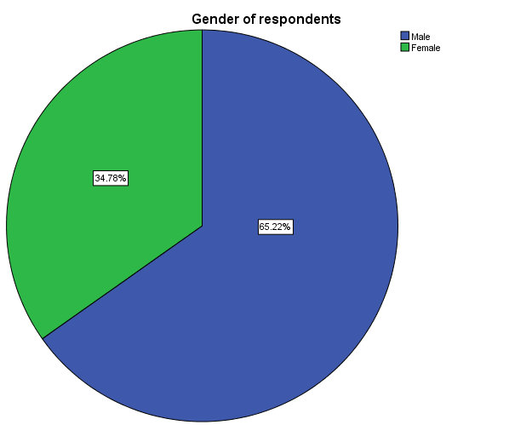

**Figure 4.1: Gender of respondents**

The demographic and personal data of the respondents are shown in the pie chart above, broken down by gender. Eight (34.78%) were women and fifteen (65.22%) men out of the twenty-three respondents. This shows that male respondents participated in the survey more frequently than female respondents.

# 4.2.2 Age of the respondents

**Age of respondents**

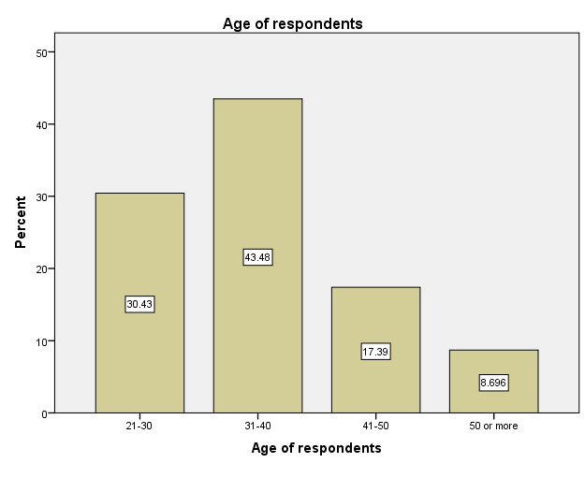

**Figure 4.2: Shows the age of respondents**

Figure 4.2 shows demographic data on the respondents' ages. It shows that none of the respondents were younger than 20 years old, and that 30.43% (7) were between the ages of 21 and 30, 47.83%(10), between the ages of 31 and 40, 13.04%(4), between the ages of 41 and 50, and 8.696%(2) were older. Therefore, based on this result, the majority of respondents fell into the modal age range, which is between 31 and 40 years old. This age group can participate more actively in IPSAS since they are still seen as being more economically active than older people who are about to enjoy work advantages as they approach retirement.

# 4.2.3 Highest Academic Qualifications

**Highest academic qualification**

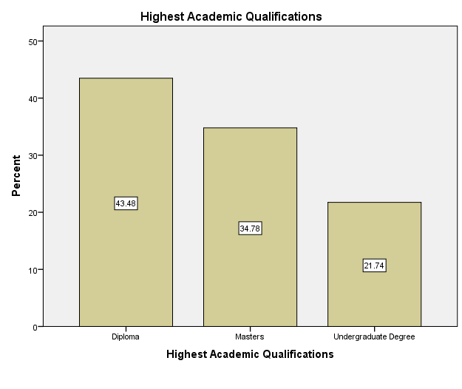

**Figure 4.3 Illustrates highest academic qualification**

A' level certificate are not held by any respondents, as seen in the fig. 4.3 above, which shows the respondents' highest degrees. Out of the total population of 23, only 10(43.48%) respondents have diplomas, 5(21.74%) have undergrad degrees, and 8 (34.78%)have master's degrees as their highest degrees. The population who has accounting degrees predominately demonstrates that they are aware of how IPSAS affects the reliability of public sector financial reporting.

# 4.2.4 Working experience in public sector.

**Respondents’ working experience in public sector**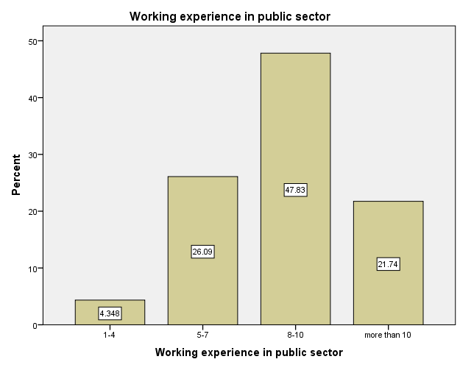

**Figure 4.4: Presents respondents working experience in public sector**

The Fig 4.4 above illustrate that none of the respondents worked for less than 1year in public sector,one(4.348%) of the respondents worked between 1-4years,6(26.09%) repondents worked for 5-7years in public sector,11 (47.83%)respondents worked for 8-10years and only 5 (21.74%,)respondents out of a population of 23 worked for more than 10years. The result present that the dominating group of respondents worked between 8-10years and possess greater professional experience in accounting for the public sector. As a result, the collected data is more reliable because employees with more expertise in public sector accounting have a better understanding of it than those who don't.

# 4.3The IPSAS will improve accountability in public sector accounting.

**IPSASs will improve accountability in public sector accounting**

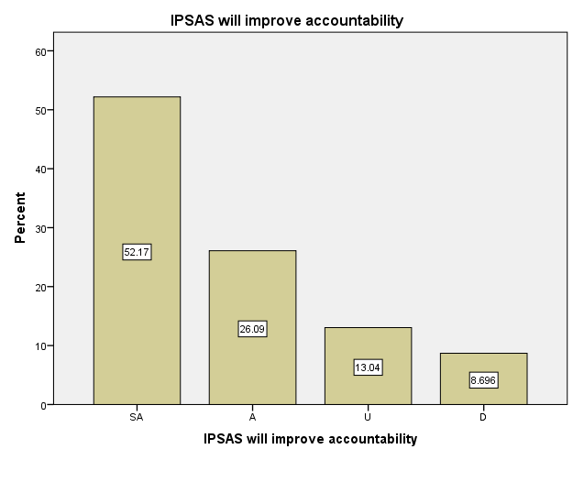

**Figure 4.5: IPSASs will improve accountability in public sector accounting**

Assessing whether the adoption of IPSAS will lead to greater accountability was the goal of the questionnaire. As shown in fig 4.5 above, 52.17% of respondents strongly agreed that IPSAS adoption would increase accountability in public sector accounting, followed by 26.09% in agreement, 13.04% in uncertainty, 8.696% disagreeing, and none strongly disagreeing. 78.26% of respondents agree that IPSASs will increase accountability in public sector accounting. Ofoegbu (2014), who claims that IPSAS acceptance and implementation will increase accountability in the public sector, backed up this claim.

# 4.4 The IPSAS will improve accountability in public sector accounting through governance quality.

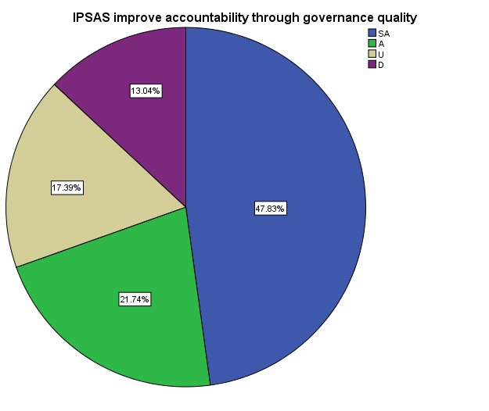

**Figure 4.6: IPSAS improve accountability through governance quality**

The questionniare was sought to establish if IPSAS will improve accountability through governance quality in public sector. 47.83% of respondents strongly believed that IPSAS will increase accountability through improved governance in public sector accounting, as shown by the fig4.6 above, which summarizes the responses.21.74%were in agreement and 17.39% were uncertian. None of the respondents severely disagreed and 13.04% disagreed. Therefor 69.57% of the population approve that IPSAS will improve accountability through governance quality. This was supported by Tawiah (2023), who asserts that the adoption of IPSAS will raise accountability by raising the bar for governance in the public domain.

# 4.5 The public sector’s accountability for financial reporting will increase with the introduction of IPSAS.

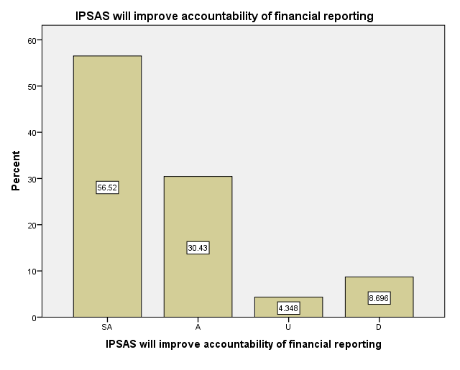

**Figure 4. 7: IPSAS will improve financial reporting accountability in public sector**

The purpose of the question was to establish whether IPSAS will enhance the public sector's financial reporting accountability. In accordance with the summary above, 56.52% strongly agreed, 30.43% agreed, and 4.35% of the respondents were unsure. 8.7% of respondents disagreed, although none strongly. The adoption of IPSAS enhances the quality of financial reporting and administration of government money, according to Atuilik et al. (2019), who also supports the majority's 86.95% vote for acceptance.

# 4.6 Factors affecting IPSAS implementation

The aim was to identify the elements influencing the use and the adoption of IPSAS in the government sector.The outcomes of the study was conducted at BPH utilizing questionnaires and interviews are reported in the subsections that follows.

**4.6.1Resistance to change**

**Respondents’ response on how resistance to change affect IPSAS implementation**

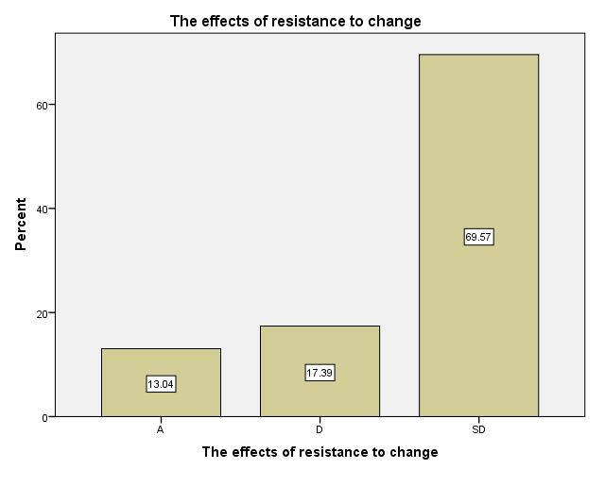

**Figure 4.8: Shows the respondents response on how resistance to change affect IPSAS implementation**

Fig 4.8 above reveals that out of 23 responses 16(69.57%) respondents severely disagreed that resistance to change affected IPSAS adoption,4(17.39%) disagreed and 3(13.04%)agreed. None of them strongly agreed nor being uncertain. The majority of the respondents were in disagreement as they say the institution is flexible enough to follow the changes. This was supported by Ahmad et al.,(2019) who stated that more than half of the respondents disagreed saying that instituatoins are flexible enough to changes that are required by IPSAS adoption.

**4.6.2 Lack of requested resources**

**How lack of requested resources affect the implementation of IPSAS**

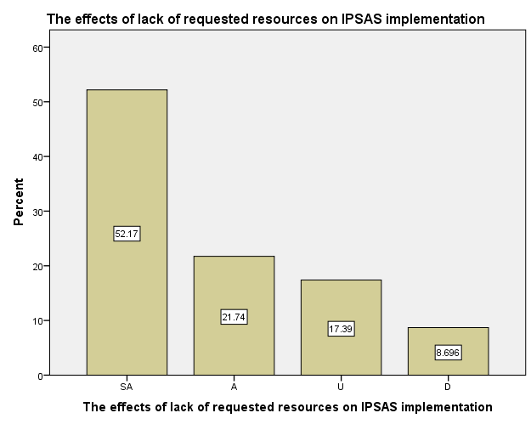

**Figure 4.9: Shows how lack of requested resources affect the implementation of IPSAS**

The fig 4.9above shows the effects of lack of requested resources on IPSAS implementation.Out of 23 respondents 12 (52.17%)were strongly in agreement that it affects IPSAS implementation,5 (21.74%) were in agreement, 4 (17.39%)were uncertain and none of the respondents severely disagreed. Only two(8.696%) respondents were in disagreement. Therefore the majority of the respondents were in agreement that lack of resources affect implementation of IPSAS as supported by Adamu,& Ahemend(2014) and Ofoegbu (2014) who reported that resources required to roll out IPSAS fully are expensive.

**4.6.3 Lack of management support**

**Shows how lack of Management support affect the implementation of IPSAS**

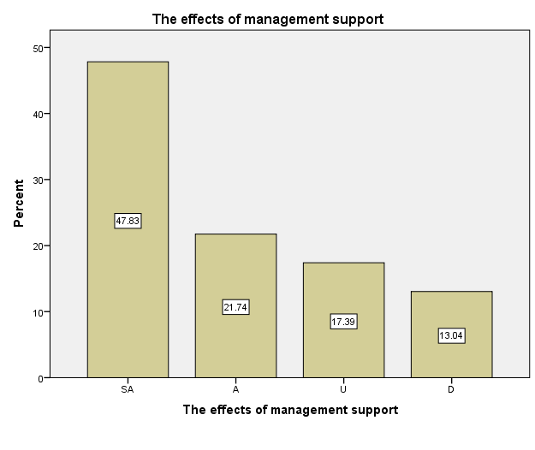

**Figure 4.10: Shows how lack of Management support affect the implementation of IPSAS**

Fig 4.10 above demonstrates that the respondents were in strongly view that lack of Management support affect will affect the implementation of IPSAS they contributed to a total of47.83%, 21.74% agreed,17.39%were uncertain and 13.04%of the respondents were in disagreement. None of the respondents were severely in disagreement. The total of 69.57%were in agreement and they dominated the whole population and this was supported by Shehadeh (2022), who claimed that IPSAS adoption in the public sector can be hampered by a lack of management support.

**4.6.4 Absence of required skills and knowledge need to implement IPSAS**

**Shows how lack of knowledge and skills affect IPSAS implementation**

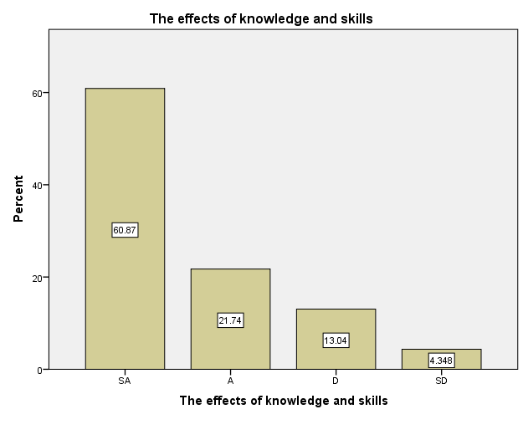

**Figure 4.11: Shows how lack of knowledge and skills affect IPSAS implementation**

Data from fig 4.11 above show that 21.74% of respondents agreed with this statement, and 60.87% strongly agreed, that knowledge and skill gaps make it difficult to adopt IPSAS. No respondents expressed uncertainty, 13.04% of respondents disagreed, and 4.348% of respondents strongly disagreed with the notion that a knowledge and skill gap prevents the public sector from using IPSAS. This was corroborated by Alshujaira (2014), who discovered that the largest obstacle to the adoption of IPSAS in Iraq is the shortage of competent laborers and qualified accountants.

**4.6.5 Level of available technology**

**Shows how the level of available technology affect IPSAS implementation**

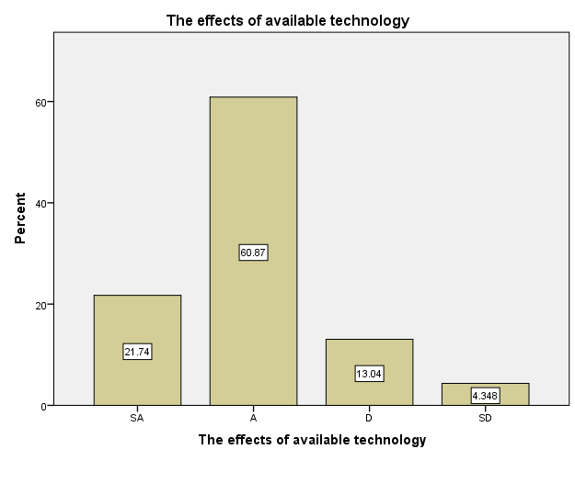

**Figure 4.12: Shows how the level of available technology affect IPSAS implementation**

The respondents’ responses to how the state of available technology affects IPSAS adoption are displayed in the fig 4.12 above. The outcomes are shown in the following graph above: 60.87% of respondents agreed, 21.74% strongly agreed, none were uncertain, and 13.04% disagreed that the quantity of technology available has an impact on how well IPSAS are implemented. The opinion that technology level affects IPSAS implementation in public sector accounting was strongly disagreed with by just 4.348% of respondents. The majority of respondents, who made up 82.61% of the total, agreed, and Alshujairi (2014) found that the public sector's IT infrastructure is not up to par sufficient for the introduction of IPSAS in Iraq.

**4.6.6 Will IPSAS implementation aid in reducing and containing financial reporting corruption in the public sector.**

**Illustrating how the introduction of IPSAS will aid in the eradication and control of corruption.**

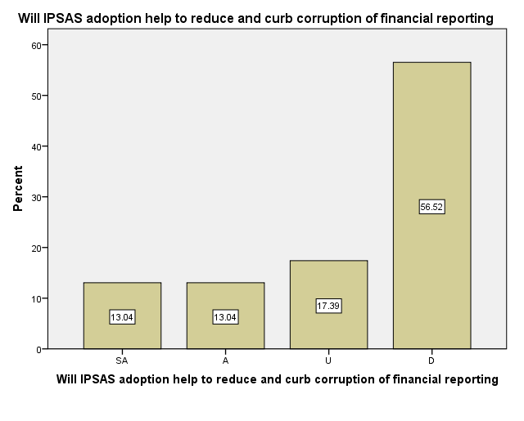

**Figure 13: Illustrate how the introduction of IPSAS will aid in the eradication and control of corruption**

In Figure 4.13 above, the answers to the question of how IPSAS adoption will lessen and finally eradicate financial reporting fraud in the public sector are presented.3(13.04%)respondents strongly agreed, 3(13.04%) were in agreement,4(17.39,%) were uncertain and 13(56.52%) respondents were in disagreement. None of respondents were severely in disagreement. The total of 6/23 were in agreement making up a 26.08% .According to Aug (2016), IPSAS can only significantly reduce corruption, increase accountability, and enhance transparency if there is strict adherence to IPSAS implementation.

# 4.7 An analysis on the interview response rate from BPH.

The interviews were scheduled and conducted. Only six interviews were scheduled and 4were conducted giving a response rate of 66.67%.

**4.7.1 How long have you been employed in the public sector?**

The average working experience of 4 respondents is 7years and 3of these respondents have more than 5years work experience. This show that they have more working experience in the public sector.

**4.7.2 In order to enhance public sector accountability, is the government willing to embrace IPSAS?what extent if yes**

The respondents replied that to a greater extent the government is willing to adopt and IPSAS implementation because IPSAS enhance quality financial reporting which prevents manipulation of financial statements due to better accountability of government funds and also give rise to good corporate governance due to transparency and accountability of financial and non financial resources.

**4.7.3 What problems exist with IPSAS deployment in the public sector?**

Resistance to change as employees doesn't have enough prior experience with IPSASs.Lack of required skills can be a barrier for workers to accept the changes since they will be afraid of losing their jobs due to incompetents. The adoption of IPSAS in to the organization will be viewed as a threat by employees not as an opportunity in the organization.

Lake of both financial and human resources as it requires huge amount of money to provide resources needed for proper implementation of IPSAS. It is very expensive for a company to have all the required resources that will be needed to make sure that full emplemation of IPSAS is met.

Lack of Management support, since managers are the ones that controls day to day running of the business and if the organization lack management oversight it became a challenge to implement IPSASs. Management must put their insight on the whole process of IPSAS implementation so that the process will be done effectively.

Lack of required knowledge and skills due to lack of IPSAS -related training has a potential of reducing confidence of proffessional accountants to use the IPSAS guidelines.Lake of knowledge and skills on how to use the IPSASs in preparation of financial statements can make life of the workers more complicated since they will be making a lot of mistakes in the presentation of financial reports. This will demotivate the workers since they will be incompetent to adjust quickly to changes that will be required by IPSASs.

Respondents agreed that the organization they work doesn't have enough technical resources to adopt IPSAS guidelines. Lack of IT system in the organization can make it difficult to adopt IPSAS since it make use of the IT system and other technical resources.

**4.7.4 Do you believe that greater transparency will result from the compilation of financial statements in line with IPSAS?**

Through the compilation of financial statements in compliance with IPSAS, the integrity of financial information that promotes accountability and openness would be improved.This is because IPSAS will provide a framework for the presentation of financial information and this will lead to standardized financial statements that will be easily understood by the users of financial statements. A company can also compare it's financial statements to those that are in the same industry. IPSAS adoption reduce the room for manipulation of financial statements.

**4.7.5 Do you think IPSAS will improve governance quality in public sector**

It enhance governance quality as it takes into consideration pillars of good corporate governance that is accountability and transparency. Due to good corporate governance it will be easy to assign work to workers since there will be clear chain of command. This increases the level of transparency and accountability within the organisation.All the delegated work will be done with due care.

**4.7.6** **Do you believe the use of IPSAS will successfully lessen and stifle corruption in public sector financial reporting?**

We anticipate IPSAS will lessen corruption because improved accountability and transparency will make it easier to prevent the misappropriation of funds.Others who responded said that because of coordination in business practices and through observation, it is still difficult to regulate corruption in the public sector.

# 4.8 Summary

This portion focused on the analysis, interpretation, and presentation of the information acquired through the distribution of questionnaires and the conducting of interviews. Pie charts, tables, and graphs were used to present the data. The study's conclusions and recommendations are covered in the next chapter.

# 

# CHAPTER V

**SUMMARY, CONCLUSION AND RECOMMENDATIONS**

# 5.0 Introduction

This section acts as the research paper’s conclusion, passing comments on the topic under investigation and making proposals for additional research based on research findings from chapter 4.

# 5.1 Summary of Chapters

The study's main objective was to investigate the link between IPSAS implementation and accountability. One of the other goals was to determine whether or not greater accountability at Bindura Provincial Hospital would arise from the adoption of IPSAS.

**Chapter one**

At the beginning of the chapter, background information and an introduction were provided. In the chapter, the problem statement, study goals, and research questions were also covered. Additionally, covered in this chapter were the importance of the research, its constraints, acronyms, and word definitions.

**Chapter two**

The second chapter of the research study included related material, primarily from journals, as part of answering the research objectives. This chapter reviewed related literature on the application of IPSAS and accountability in public sector accounting.

**Chapter three**

The study methods constituted the most of the chapter. It looked at the study approach, the intended audience, the sampling methods, the data sources, the research tools, and the data presentation and analysis methodologies the researcher utilized.

**Chapter four**

The chapter concentrated on the analysis, presentation, and interpretation of data acquired through interviews that were performed, questionnaires that were circulated, fully answered, and returned, as well as their analysis, presentation, and interpretation. With the use of tables, graphs, and pie charts, research findings were presented and analysed.

# 5.2 Research Findings

**To assess whether IPSAS adoption will improve accountability in public sector accounting**

The results show that the public sector will become more transparent and accountable after adopting IPSAS. According to the poll's results, 78.26% of participants thought the adoption of lPSAS will improve the accountability of public sector accounting.

**To find out whether IPSAS adoption will improve accountability through governance quality in public sector.**

The findings showed that the public sector will benefit from high-quality governance after adopting IPSAS. Positive accountability in the public sector will result from good governance. This is consistent with the findings of the survey, which revealed that 69.57% of respondents agreed that adopting IPSAS will boost accountability through better governance.

**To what extent does IPSAS adoption improves the level of accountability on financial reporting**

According to the study, implementing IPSAS will improve the standard of financial reporting in the public sector. The majority of respondents felt that the adoption of IPSAS would result in excellent financial documentation that made it simpler to hold government accountable for how the funds they contributed were spent.

**To assess whether IPSAS adoption will lead to transparency**

According to the findings, the public sector will have more transparent financial reporting as a result of IPSAS adoption. Corruption cannot be decreased by applying IPSAS, though. Despite the fact that most respondents disagreed with this assertion, IPSAS adoption will reduce corruption and financial statement manipulation.

**Challenges affecting the adoption of IPSAS**

The results of the study show that, the major obstacles to IPSAS implementation include the high cost of acquiring the requested resources, a lack of management support, resistance to change, a lack of the necessary skills and knowledge, and the level of technological resources available in the public sector. The majority of respondents agreed that these criteria have an impact on whether IPSAS are adopted.

# 5.3 Conclusion

The study investigated how the deployment of IPSAS affected accounting for the public sector. *According to the study, the use of IPSAS will improve the public sector's openness, governance* quality, and accountability. The IPSAS adoption will not in any way curb corruption in public sector financial reporting. However, the researcher also concluded that there are factors that affect IPSAS adoption which includes lake of knowledge and skills required, lack of management support, level of available technology as well as lack of requested resources.

# 5.4 Recommendations

The researcher recommend that the government of Zimbabwe should commit to adoption of IPSASs in public sector. The public entities should adopt IPSAS since it leads to greater accountability, transparency and improved management of public funds.

Education institution like tertiary and collages should involve the study of IPSAS in public sector in their training course programs. This will enable the students to have better understanding of IPSAS adoption and how the financial statements will be prepared.

The government should embark in more training programs for all stakeholders in order to improve their knowledge and for them to be competent enough to carry out the IPSASs implementation. The government should also finance the public sector so that the organization will be improve its human capital development which help to restore confidence in employee since this will improve competent of staff.

Public sector should practice the hiring of technological experts and purchase of IT equipment’s that suits the implementation of IPSAS.IT experts will then help to make IPSAS implementation successful as they have enough knowledge on how to update and upgrade the IT system to suit for the IPSASs requirements.

**Government ownership and management support for the implementation initiative**

# 5.5 Suggestions

Recommendations to further research are to look at other areas that need to be undertaken on the impact of IPSAS on accountability in public sector accounting.

# 5.6 Summary

The chapter examined the research synopsis, research results, conclusion, and recommendations. The study space was likewise outfitted by it.

# References

|  |  |  |  |  |
| --- | --- | --- | --- | --- |
| |  | | --- | |  | | Oyeshola, B.A., Olaniyi, I.J. and Olayiwola, R.L., The Influence of International Public Sector Accounting Standards (IPSAS) on Financial Reporting Quality of Public Health Institutions in Nigeria. | | Mhaka, C., 2014. IPSAS, a guaranteed way of quality government financial reporting? A comparative analysis of the existing cash accounting and IPSAS based accounting reporting. International Journal of Financial Economics, 3(3), pp.134-141.  Kinne, S., Schulz, M., Textor, C., Guibert, S., Balkanski, Y., Bauer, S.E., Berntsen, T., Berglen, T.F., Boucher, O., Chin, M. and Collins, W., 2006. An AeroCom initial assessment–optical properties in aerosol component modules of global models. *Atmospheric Chemistry and Physics*, *6*(7), pp.1815-1834.  Ijeoma, N.B., 2014. The impact of international public sector accounting standard (IPSAS) on reliability, credibility and integrity of financial reporting in state government administration in Nigeria. International Journal of Technology Enhancements and Emerging Engineering Research, 2(3), pp.2347-4289. |  | |
| Ball, I. and Pflugrath, G., 2012. Government accounting. *World Economics*, *1*, pp.1-18. |
| Atuilik, W.A. and Salia, H., 2019. Impact of IPSAS adoption on transparency and accountability in managing public funds in developing countries: Evidence from Liberia. |
| Carlin, T.M., 2005. Debating the impact of accrual accounting and reporting in the public sector. *Financial Accountability & Management*, *21*(3), pp.309-336.  Oulasvirta, L., 2014. The reluctance of a developed country to choose International Public Sector Accounting Standards of the IFAC. A critical case study. *Critical Perspectives on Accounting*, *25*(3), pp.272-285.  Tawiah, V., 2023. The effect of IPSAS adoption on governance quality: evidence from developing and developed countries. *Public Organization Review*, *23*(1), pp.305-324.  Toudas, K., Poutos, E. and Balios, D., 2013. Concept, Regulations and Institutional Issues of IPSAS: a critical review. European Journal of Business and Social Sciences, 2(1), pp.43-54.  Duenya, M.I., Upaa, J.U. and Tsegba, I.N., 2017. Impact of international public sector accounting standards adoption on accountability in public sector financial reporting in Nigeria. *Archives of Business Research*, *5*(10).  Obara, L.C. and Nangih, E., 2017. International Public Sector Accounting Standards (IPSAS) Adoption and Governmental Financial Reporting in Nigeria-An Empirical Investigation. *Journal of Advance in Social Science and Humanities ISSN*, *2395*, p.6542.  Opanyi, R.O., 2016. The effect of adoption of international public sector accounting standards on quality of financial reports in public sector in Kenya. European Scientific Journal, 12(28), pp.161-187.  Nweze, A.U., 2013. *Using IPSAS to drive public sector accounting*. ICAN Journal.  Duenya, M.I., Upaa, J.U. and Tsegba, I.N., 2017. Impact of international public sector accounting standards adoption on accountability in public sector financial reporting in Nigeria. *Archives of Business Research*, *5*(10).  Alshujairi, M.H.A., 2014. Government accounting system reform and the adoption of IPSAS in Iraq. *Research Journal of Finance and Accounting*, *5*(24), pp.1-20.  Luke, S.R. 2012. Management Accounting and focus on decision making, Harcoun College, US of America.  Matsvai, C. 2015. Impact of IPSAS on reforming government financial information system : a comparative study. International Review of Administrative.  Bolugan. I.J. 2015. International Public Sector Accounting Standards: Conceptual and Institutional Issues.  Aggestam.C. 2010. A project management perspective on the adoption of accrual-based IPSAS. International Journal of Government Financial Management, 10(2), 49. <http://doi.org/10.1111/faam.12265>  SHEHADEH, E., 2022. A Movement Towards the Accrual Based IPSAS Implementation in Developing Countries: Evidence from Jordan. The Journal of Asian Finance, Economics and Business, 9(3), pp.389-397.  IFAC. 2011. IFAC handbook of international public sector accounting pronouncement. New York:IFAC.  LAU, W.T. and MAHAT, F.B., 2019. Robustness of cash flow value: Investment in ASEAN. The Journal of Asian Finance, Economics and Business, 6(2), pp.247-255.  Mulyani, S., Puspitasari, E. and Yunita, D.H., 2018. Analysis of the Critical Factors in Supporting the Implementation of the Accrual-based Accounting in the Local Government. *Review of Integrative Business and Economics Research*, *7*, pp.183-199.  Painter, M., 2006. Thaksinisation or managerialism? Reforming the Thai bureaucracy. *Journal of Contemporary Asia*, *36*(1), pp.26-47.  Bunea-Bontas, C.A. and Petre, M.C., 2009. Arguments for introducing accrual based accounting in the public sector. *Available at SSRN 1491663*.  Oladipupo, A.O. and Izedomi, F., 2013. Global demand for timely financial reporting: how prepared are Nigerian companies. *Research Journal of Finance and Accounting*, *4*(8), pp.63-75.  Pollitt, C., 2007. The new public management: An overview of its current status. Administratie Si Management Public, (8), p.110.  Stamatiadis, F., 2009. Investigating the governmental accounting reform of Greek national health system (ESY): Some preliminary evidence. *International Journal on Governmental Financial Management*, *9*(2), pp.73-97.  Chan, J.L., 2006. IPSAS and government accounting reform in developing countries. *Accounting reform in the public sector: mimicry, fad or necessity*, pp.31-42.  Ruggie J.G. Global governance and new governance theory : Lessons from business and human rights. Global Governance 20:5-17.  Cheema, G.S. and Rondinelli, D.A. eds., 2007. Decentralizing governance: emerging concepts and practices.  Ogbuagu, N.M. and Onuora, J.K.J., 2019. Effect of IPSAS adoption on accountability and transparency in the Nigerian public sector organizations. *Journal of Accounting and Financial Management*, *5*(3), pp.65-80.  Jensen, M.C. and Mecklin, W.H., 1976. Theory of the Firm: Managerial Behaviour, Agency Costs and Ownership Structure. Organisational Economics. JB Barney and WG Ouchi.  Stoker, G., 1998. Governance as theory: five propositions. *International social science journal*, *50*(155), pp.17-28.  Adamu, S.A. and Ahmed, A.D., 2014. IPSAS and Nigerian Public Sector: The challenges of first-time adopters. International Journal of Social Sciences and Humanities Innovations, 2(1), pp.151-160.  BLAIR, J., GOLDBERG, H. and ROTH, S., 1965. The command system(Ground commands and internal logic functions for Relay I satellite command system). *1965.*, pp.153-169.  Christiaens, J.et al. 2015 .The effects of IPSAS on reforming government reporting : An internal comparison. International review of administrative sciences.[online] volume 81(1) page 158-177  Tawaih,V. 2021. The impact of IPSAS adoption on corruption in developing countries .Financial Accountability & Management, 21,33-47.https://doi.org/10.1111/faam.12288  Stefanescu, A. and Turlea, E., 2011. Accrual Accounting, Foundation For The Financial Reporting Into The Public Sector Entities. *Annales Universitatis Apulensis: Series Oeconomica*, *13*(2), p.309.  IFAC 2003. Transition to the accrual basis of accounting : Guidance for governments and government entities.New York :International Federation of Accountants.  IFAC. 2000. Study 11- Government Financial Reporting: Accounting Issues and Practices. New York: IFAC  AFFANDI, M.A., MURWANINGSARI, E., MAYANGSARI, S. and DWIMULYANI, S., 2020. Role of ABAS and bureaucratic reformation in improving governmental financial performance through financial decision making. *The Journal of Asian Finance, Economics and Business (JAFEB)*, *7*(11), pp.1069-1075.  Flynn, M.S., Moretti, D. and Cavanagh, J., 2016. *Implementing accrual accounting in the public sector*. International Monetary Fund. |
| Augusto, S., 2018. The impact of International Public Sector Accounting Standards (IPSAS) on financial reporting quality in public sector: case study Rushinga Rural District Council.  Leedy, P.D. and Ormrod, J.E., 2005. Practical research (Vol. 108). Saddle River, NJ, USA: Pearson Custom. |  |

Abeysinghe, C. and Samanthi, D., 2016. Accrual basis and political interest in public sector accounting: The case of a Municipal Council in Sri Lanka. *International Journal of Academic Research in Accounting, Finance and Management Sciences*, *6*(3), pp.58-68.

Chan, J.L., 2008. International public sector accounting standards: conceptual and institutional issues. *The Harmonization of Government*, *21*, pp.1-15.

Christiaens, J. and Rommel, J., 2008. Accrual accounting reforms: only for businesslike (parts of) governments. *Financial Accountability & Management*, *24*(1), pp.59-75.

Hepworth, N., 2003. Preconditions for successful implementation of accrual accounting in central government. *Public Money & Management*, *23*(1), pp.37-44.

Suharsono, R.S., Nirwanto, N. and Zuhroh, D., 2020. Voluntary disclosure, financial reporting quality and asymmetry information. *Journal of Asian Finance, Economics and Business*, *7*(12), pp.1185-1194.

**Appendix I**

QUESTIONAIRRES FOR BPH STAFF (HIGHLY CONFIDENTIAL)

Instructions

1. Do not indicate your identity
2. Tick in relevant box for your response
3. Express your responses and opinion in the space provided

Demographic data

1. Gender: Male( ) Female ( )

Age groups

|  |  |
| --- | --- |
| Less than 20 years |  |
| 21-30 years |  |
| 31- 40 years |  |
| 41-50 years |  |
| 50 years or more |  |

1. Highest Academic Qualificactions

|  |  |
| --- | --- |
| A level certificates |  |
| Diploma |  |
| Undergraduate degree |  |
| Masters |  |
| Other (please indicate) |  |

1. How long have you been worked in public sector

|  |  |
| --- | --- |
| Less than 1 year |  |
| 1-4 years |  |
| 5-7 years |  |
| 8-10 years |  |
| More than 10years |  |

Please respond to the following statements by indicating the extent to which you agree or disagree with them. Using the following scale in answering SD for severely disagree, D for disagree, U for uncertain, A for agree and SA for strongly agree

1. The IPSAS will accountability in public sector accounting

|  |  |  |  |  |
| --- | --- | --- | --- | --- |
| SA | A | U | D | SD |
|  |  |  |  |  |

1. The IPSAS will improve accountability through governance quality

|  |  |  |  |  |
| --- | --- | --- | --- | --- |
| SA | A | U | D | SD |
|  |  |  |  |  |

1. The public sector accountability will improve for financial reporting will increase with the introduction of IPSAS

|  |  |  |  |  |
| --- | --- | --- | --- | --- |
| SA | A | U | D | SD |
|  |  |  |  |  |

1. Factors affecting IPSAS implementation at BPH

|  |  |  |  |  |  |
| --- | --- | --- | --- | --- | --- |
| FACTORS | SA | A | U | D | SD |
| Resistance to change |  |  |  |  |  |
| Lack of requested resources |  |  |  |  |  |
| The absence of required knowledge and skills needed on how to implement IPSAS |  |  |  |  |  |
| Lack of management support |  |  |  |  |  |
| Level of technology available doesn’t implementation of IPSAS |  |  |  |  |  |

1. Will IPSAS implementation aid in reducing and containing corruption in the public sector

|  |  |  |  |  |
| --- | --- | --- | --- | --- |
| SA | A | U | D | SD |
|  |  |  |  |  |

**Appendix II**

INTERVIEW QUESTION GUIDE TO BPH STAFF

1. How long have you been employed in public sector
2. In order to enhance accountability, is the government willing to embrace IPSAS? What extent if its yes
3. What problems exist with IPSAS deployment in public sector
4. Do you believe that greater transparency will result from compilation of financial statements in line with IPSAS
5. Do think IPSAS will improve governance quality in public sector
6. Do you believe that use of IPSAS will successfully lessen and stifle corruption in public sector financial reporting