**BINDURA UNIVERSITY OF SCIENCE EDUCATION**

FACULTY OF SCIENCE EDUCATION

DEPARTMENT OF SCIENCE AND MATHEMATICS EDUCATION



**ANTI-MICROBIAL EFFECTS OF CASTOR BEAN PLANT (*RICINUS COMMUNIS*) ROOT EXTRACTS AGAINST THE *STAPHYLOCOCCUS AUREUS,* AND *ESCHERICHIA COLI*.**

**BY**

**WEST MUZA**

**[B1130630]**

**SUPERVISOR: DR N. MGOCHEKI**

**DISSERTATION SUBMITTED IN PARTIAL FULFILMENT OF THE REQUIREMENTS OF THE BACHELOR OF SCIENCE HONOURS DEGREE IN BIOLOGICAL SCIENCES EDUCATION**

APPROVAL FORM

TITLE OF THE DISSERTATION: ANTI-MICROBIAL EFFECTS OF CASTOR BEAN PLANT (*RICINUS COMMUNIS*) ROOT EXTRACTS AGAINST THE *STAPHYLOCOCCUS AUREUS,* AND *ESCHERICHIA COLI*.

**S**ubmitted by West Muza

In partial fulfilment of the requirements for the *BACHELOR OF SCIENCE HONOURS DEGREE OF SCIENCE EDUCATION* IN BIOLOGY

W.MUZA………… ……29…/……06……/……23…../

*(Signature of Student) Date*

*……………………………………… ………/…………/…………/*

*(Signature of Supervisor) Date*

*…………………………………………………… ………/…………/…………./*

*(Signature of the Chairperson) Date*

**DEDICATION**

I dedicate this work to the Lord Almighty and my lovely children, spouse and the members of the Muza family for unwavering emotional support.

**ACKNOWLEDGEMENT**

The combined efforts of a number of persons who collaborated with me throughout the process led to the completion of this study. I want to express my gratitude to my Supervisor, Doctor Mgocheki, who restlessly supported, encourage and guided me. I also want to thank the Bindura University of Science Education lab assistants from the biology department, who worked incredibly hard with me in the biology lab to make my research a success. Additionally, I would like to thank the lab technicians for the chemistry department, for helping me with the technical aspects of the lab. I would also like to appreciate the support and contribution from my colleagues Katsiru Tichaona, Charumba Garikai and Bhaiseni Remeredzai, for enlightening me on the value of various herbs as folk medicine. I want to thank my family for always being there.

DECLARATION

By signing this document, I Muza West B1130630 certify that the study is an accurate reflection of my own research and that neither it nor any of its components have ever been submitted for credit at another university. Without the author's permission, or that of the Bindura University of Science Education acting on their behalf, no portion of this research may be duplicated, stored in any information retrieval system, or transmitted in any format or by any method (including electronic, mechanical, photocopying, recording, or other) without that permission.

Muza West Date: 29/07/23

ABSTRACT

Due to the lack of medicine in clinics and the expensive cost of medications in pharmacies, many rural residents of Zimbabwe have started adopting natural herbal items for healthcare. The scant information on the safety and effectiveness of these products in the literature demonstrates how few of them have undergone thorough testing. This study examined the phytochemical content and anti-microbial properties of castor bean plant (*Ricinus communis*) root extracts against *Staphylococcus aureus*, and *Escherichia coli*. *Ricinus communis* is a herb that rural Zimbabweans frequently utilize for a variety of uses. *Escherichia coli* and *Staphylococcus aureas* bacteria were utilized to assess the herb's antibacterial properties using agar paper disc diffusion. According to antimicrobial activity test results, the ethyl acetate extract was successful in preventing *Escherichia coli* from growing (diameter of inhibition zone 17mm). *Staphylococcus aureas* exhibited resistance to the extracts' antibacterial activity (width of the inhibition zone: 9 mm), which is equivalent to ethanol, the extracts' negative control. Analytical procedures were used to determine the phytochemical makeup. The testing revealed that alkaloids and flavonoids are present in *Ricinus communis.*

TABLE OF CONTENTS

Contents …………………………………………………………………………………… Page

Approval form …………………………………………………… ………………….…. i

Dedication ……………………………………………….………………………………. ii

Acknowledgement ………………………………………………………………………… iii

Declaration ……………………………………………………………………………… iv

Abstract ………………………………………………………………………………… v

Table of contents …………………………….…………………………………………….. vi

List of figures …………………………………………………………………………..… ix

List of tables ………………………………………………………………………………. ix

CHAPTER 1: … ……………………………………………………………………….…… 1

* 1. Topic …………………………………………………………………………………… 1
  2. Background ……….…………………………………………………………………… 1
  3. Statement of the problem ……………………………………………………………… 2
  4. Significance of the study ……………………………………………………………… 3
  5. Aim of the research ……………………………………………………………….......... 3
  6. Specific objectives ……………………………………………………………………… 3
  7. Research questions ……………………………………………………………………… 3
  8. Hypothesis ……………………………………………………………………………… 4

1.9.0 Delimitations ...……………………………………………………………………… 4

* 1. .1 Limitations …………………………………………………………………………… 4

1.9.2 Definition of terms …………………………………………………………………… 4

CHAPTER 2: ……………………………………………………………………………… 5

2.0 Literature review ……………………………………………………………………… 5

2.1 Castor bean plant …………………………………………………………………….. 5

2.2 Antimicrobial ………………………………………………………………………… 6

2.3.0 Test microbes ……………………………………………………………………… 6

2.3.1 Escherichia coli …………………………………………………………………… 6

2.3.2 Staphylococcus aureus ………………………………………………………….… 7

2.4.0 Phytochemicals …………………………………………………………………… 7

2.4.1 Flavonoids ……………………………………………………………………….. 7

2.4.2 Alkaloids ………………………………………………………………………… 8

2.4.3 Terpenes ………………………………………………………………………… 9

2.4.4 Steroids ………………………………………………………………………… 9

2.5 Antimicrobial and anti-inflammatory properties …………………………………. 10

CHAPTER 3…………………………………………………………………………… 11

3.0 Methodology ………………………………………………………………………. 11

3.1 Collection of plant material …………………………………………………........... 11

3.2 Preparation of plant extracts ……………………………………………………….. 11

3.3 Screening for phytochemicals ……………………………………………………… 11

3.3.1 Alkaloid determination …………………………………………………………... 11

3.3.2 Flavonoid determination …………………………………………………………. 12

3.3.3 Steroids determination …………………………………………………………… 12

3.3.4 Terpenes determination …………………………………………………………... 12

3.4.0 Antibacterial activities determination ……………………………………………. 12

3.4.1 Disc diffusion method with agar paper …………………………………………... 12

3.5 Data analysis ……………………………………………………………………… 13

CHAPTER 4 ………………………………………………………………………….. 14

4.0 Results …………………………………………………………………………….. 14

CHAPTER 5 …………………………………………………………………………. 18

5.1 Discussion ………………………………………………………………………... 18

Chapter 6 …………………………………………………………………………….. 20

6.1 Recommendations ……………………………………………………………….. 20

6.2 Conclusion ……………………………………………………………………….. 20

References …………………………………………………………………………….. 21

Appendix ………………………………………………………………………………. 23

LIST OF FIGURES

Figure 2.1 picture of *Ricinus communis*…………………………………………………..… 5

Figure 4.1chart of extraction yield …………………………………………………….…… 15

Figure 4.2chart of flavonoids concentration ………………………………………………. 17

LIST OF TABLES

Table 4.1 Antimicrobial activities of ethanol extract..…………………………………….. 14

Table 4.2 Quantitative analysis of phytochemicals ………………………………….….... 16

Table 4.3 Qualitative analysis of flavonoids …………………………………………….. 16

**CHAPTER ONE**

**1.1 TOPIC**

**Anti-microbial effects of Castor bean plant (*Ricinus communis*) root extracts against *Staphylococcus aureus* and *Escherichia coli*.**

**1.2 Background of the study**

There is an increasing demand of plant-based medicines, health products, food supplements and pharmaceutical products. The Plant Kingdom contains unlimited sources of potent principles which are essential in management of human health disorders. The active principle of herbals has benefit of being used together with many other substances that seem to be inactive. Boaudu and Asase (2017), state that the additional components make the entire plant to be safe and powerfully strong and better to the individuals’ healthy system.

The castor bean plant contains essential phytochemicals that are exploited for therapeutic purposes such that might be used as precursors in chemo-pharmaceutical synthesis. The presence of the phytochemicals is found to be very beneficial to humans system and their consumption results in far less side effects (Bhakta and Das, 2015). More so, research reviews that the castor bean plant is believed to contain the phytochemicals (secondary metabolites) such as alkaloids, flavonoids, polyketides and lactants ẞ Cephalosporin and which make root extracts more vital in human health.

The utilization of medicinal plants like castor bean plants has played a positive role in human health. Medicinal plants assist in prevention of diseases that are transmittable and non- transmittable. The castor bean plant is a medicinal plant whose extracts or tissues are utilized in the production of synthetic drugs. Ada et al. (2014), asserts that the extracts or tissues are principal raw materials in the production of other conventional medicines.

It has been discovered that the castor bean plant tissues or organs (leaves, roots, stem tissues and seeds) have high medicinal value. In few years ago the bacteria have depicted resistance against antimicrobial agents. The herbals that are purely natural from the castor bean plant and herbal plant species have been used to treat various infections or diseases and the plants antimicrobial properties make it rich source of many potent drugs, Jena and Gupta (2012).

With reference to castor bean plant, Jena and Gupta (2012), state that the medicinal significance of castor bean plant made it turned into commercialized crop in medicine. It is now grown for the purpose of increasing the yields in order to meet its medicinal demand for the benefit of people (Mahmood and Muhammad, 2013).

The parts of the plant used for medicinal purposes are leaves, root, stem, fruits, the complete aerial parts, the whole plant, barks (root and stem) and flowers. The emmenagogue effect of ricinoleic acid detected in the castor seed oil frees the flow of menstruation and eases the pain as well as cramps. It is effective in relieving extreme pain during menstruation (Erecevit and Kirbag, 2017). However, leaves were found most frequently used part. Castor leaves are used externally by nursing mothers to increase the flow of milk. It is a natural emollient and can be applied to the skin and hair as a softener. In manufacturing, castor seeds are used to make paints, varnishes, and lubricating oils (Erecevit and Kirbag, 2017). Juice from the leaves of the castor plant is used against rheumatism, headache, dropsy, abscesses, ringworms, and warts. Castor oil is used for temporary constipation, but is not effective for chronic constipation. It has also been used for colic and acute diarrhea due to slow digestion. Roots are used to treat toothaches. Externally castor oil is used to treat ringworm and itch.

**1.3 Statement of the problem**

There is a surge in resistance of bacteria to antibiotics and the increasing consumer concerns on negative health impact of synthetic preservatives hence there has been an elevation in the application of natural antimicrobials of plant extracts. Many plant extracts have shown to possess antioxidant, anticancer, anticonceptive and antibacterial properties. The launch of the practical research is to establish how castor bean plant root extracts are effective in fighting, inhibiting and resisting antigens, toxins and impact of *Escherichia coli* and *Staphylococcus aureus* as anti-microbes medicines. There is need to make conclusion on how and what extent the root extracts of castor bean plant be helpful in human health against these bacterial microbes.

**1.4 Significance of the study**

The research will provide the basis of the findings on significance of castor bean plant roots extracts in combating the *E. coli* and *S. aureus*. The research could be used in recommendations on utilization of plant root extracts and how the extracts could be made is a rich information learners or readers could get when they used this research. The literature and the gap covered could also assist the readers and other people with interest in importance of castor bean plant to conduct further researches related to this species of medicinal plant.

**1.5 Aim of the research**

The aim of the research is to determine the antimicrobial effects of *R. communis* root extracts against *E. coli* and *S. aureus*.

**1.6 Specific objectives**

1. Identify the medicinal phytochemical compounds from castor bean root that work against bacterial organisms E*. coli and S. aureus*
2. Investigate the antimicrobial activity of the castor bean plant root extracts against E. *coli and S. aureus*.
3. Establish how the root extracts are processed to produce medicines against bacterial organism (preparation).

**1.7 Research questions**

The research questions to be answered are:

1. What are the medicinal phytochemical compounds found from castor bean root that work against bacterial organisms E. *coli and S. aureus*?
2. What are the differences in antimicrobial activity of castor bean root extracts against E*. coli and S. aureus*?
3. How are medicines produced from root extracts?

**1.8 Assumption**

It is assumed that the extracts of castor bean plant roots have a positive bearing fighting against bacterial infection.

**1.9 Hypothesis**

The research would be conducted by considering the null and test hypothesis that:

H0: Extracts from *R. communis* roots do not have antibacterial effects on pathogenic bacteria.

H1: Extracts from *R. communis* roots have antimicrobial effects against *E. coli* and *S. aureus*.

**1.9.0 Delimitation**

The study is confined to antimicrobial effects of castor bean plant root extracts against impact of E*. coli* and *S. aureus*. The research is strictly laboratory practical, the results are subjected to practical test and analysis using chemicals.

**1.9.1 Limitations**

The study could be affected by unavailability of solvents in time. The materials for making solvents and processing bacterial cultures would be in short supply. This could affect smooth flow of the research work. Industrial action by laboratory technician due to economic challenges may lead to ineffective assistance during conduction of the practical.

**1.9.2Definition of terms**

Antimicrobial are substance called the secondary metabolites produced by plants and other organisms such as fungi (Rashmi, Pathak and Kumar, 2019).

Castor bean plant is a plant species *Ricinus communis* used in production of castor oil and poison ricin (Naz and Bano, 2012)

**Chapter 2**

**2.0 Literature review**

**2.1 Castor bean plant**

Castor bean plant is a plant species *R. communis* used in production of castor oil and poison ricin. Health care in ancient period considered the use of leaves, seed, stem and roots of the castor bean plant for their therapeutic value. According to Kennedy and Wightman, (2013), the medicines extracted from the castor bean plant initially took the form of crude drugs such as powders and other herbal formations, knowledge of the specific plants like the castor bean plant to be used and methods of application for particular ailment or health disorder were passed through oral history and information regarding the castor bean plant and other medicinal plants was eventually recorded in herbals. The whole plant and its organs have medicinal significant. The use of the castor bean plant is a form inheritance in herbalism which has been used since the ancient time to date. Researches revealed that the leaves, stem barks and tissues, seed oil and root tissues have the bioactive or phytochemical compounds that are of medicinal importance. It is these compounds that resist or fight bacterial growth, replication and destroy bacteria (Oliniyan. 2010).

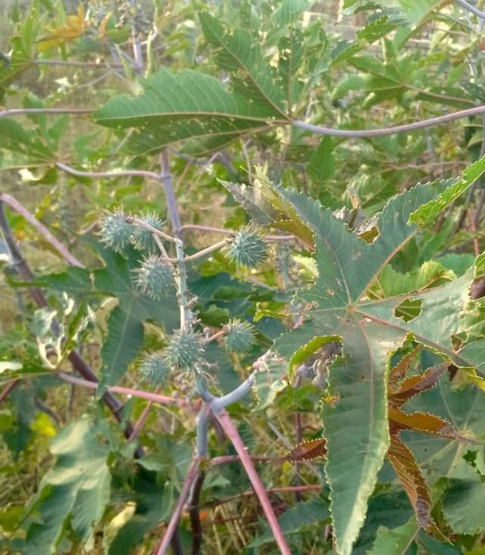

Figure 2.1: Picture of *Ricinus communis*: Adapted from (Kennedy and Wightman, 2013)

**2.2 Antimicrobial**

The castor bean plant and other plant species have different types of antimicrobials that are extracted and modified to fight the pathogens responsible for causing diseases. Antimicrobials are substance called the secondary metabolites produced by plants and other organisms such as fungi. The antimicrobials appear to be of medicinal significant (Momoh, Oladunmoye and Adebolu, 2012). They are found to be different types categorised as antibiotics, antifungal and antiprotozoal. Antibiotics are used to treat bacterial infections caused by *B. subtilis, S. aureus* and *E.coli*. Examples of antimicrobials that negatively affect the bacteria include polyketides (tetracycline), aminoglycosides (vancomycin), alkaloids, tannin and second-generation ẞ lactants (Cephalosporin). Most antibiotic antimicrobials exert their action by either inhibition of bacterial cell wall or protein synthesis. Plants according to Iqbal *et al.* (2012) produce these antimicrobials (phytochemicals) which demonstrated their potential as antibacterial when used alone and as synergists of other antimicrobials agents. Phytochemicals frequently respond through different mechanisms than conventional antibiotics and they are of great use in the treatment of resistant bacteria (Mahavidyalaya and Osmanabad, 2014).

**2.3.0 Test microbes**

**2.3.1 *Escherichia coli***

*Escherichia coli* are normal flora in the body of human beings and they can be non-pathogenic commensals or pathogenic (Ulanova and Kravchenko, 2013). When pathogenic, they cause urinary tract infection and enteric infections. Resistance of *E. coli* is due to increasing in use of antimicrobial agents that are artificial based. Medicinal plant extracts for example the castor bean plant extracts of different organs have an effective results and remedy in fighting, resisting and destroying *E. coli*. The phytochemicals in the plant tissues successfully resist or make the root extracts beneficial in human health against *E. coli*. (Momoh *et al*., 2012).

**2.3.2 *Staphylococcus aureus***

*Staphylococcus aureus i*s a gram-positive bacterium that causes disease such as skin and soft tissue infections as well as food poisoning and toxic shocks (Tong *et al*., 2019). The rate of mortality due to *S. aureus* in developing countries has rapidly increasing. The use of synthetic antibiotic against Staphylococcus aureus has led to the development of resistance hence there is need to develop new anti *S. aureus* antimicrobial agents (Aruna, Bhadraiah, and Pindi, 2015.). Studies have revealed that some edible plant extracts have antimicrobial effects against *S. aureus* bacteria (Rashmi, Pathak and Kumar, 2019).

**2.4.0 Phytochemicals**

Non-nutritive plant compounds known as phytochemicals have anti-inflammatory or disease-preventive effects (Ashly *et al*., 2016). They are non-essential nutrients, which means that the human body does not need them to maintain life. Typically, plants create them to support their growth or to fend off competitors, predators, or pathogens. Different phytochemicals have been employed as drugs and as poisons. Phytochemists investigate phytochemicals by first isolating and extracting components from the source plant, then evaluating them in vitro tests on lab animals utilizing model systems like cell structures. The area has difficulties in isolating certain compounds, figuring out their very complex structures, and defining which individual phytochemical is principally in charge of any given biological action. Numerous phytochemicals exist, and they all function differently. Flavonoids, alkaloids, steroids, and terpenes are a few of them (Omari *et al.*, 2015).

**2.4.1 Flavonoids**

In photosynthesizing cells, flavonoids, which are phenolic substances, are widely distributed. They are typically present in a variety of widely consumed plant parts, including fruits, vegetables, nuts, and oil seeds. Two benzene rings connected by a heterocyclic pyrene ring make up the 2-phenyl-benzopyrene, or flavine nucleus, of flavonoid compounds. There have been 14 different classes of flavonoids identified so far. They differ in terms of their chemical makeup and where the substituents are located on the various rings (Ejikeme *et al*., 2014). Numerous flavonoids are known to have anti-inflammatory and antioxidant properties. These secondary metabolic products were also believed to contribute to antibacterial action in one experimental research. The health benefits of these natural compounds are well known, and efforts are being made to separate the so-called flavonoids from the other constituents (Ejikeme *et al*., 2014).

Dzomba and Muchanyerei (2012) stated that, a wide range of nutraceutical, pharmacological, therapeutic, and cosmetic uses depend on flavonoids as a key ingredient. This is explained by their ability to influence the activity of essential cellular enzymes as well as their anti-oxidative, anti-inflammatory, anti-mutagenic, and anti-carcinogenic capabilities. With the revelation of the low cardiovascular death rate and also chronic heart diseases prevention, research on flavonoids received an additional boost. Uncertainty still exists regarding the flavonoids' functioning processes (Omari, 2015). However, it has long been understood that products with a plant origin have a wide range of biological activities. The isolation, identification, characterisation, and uses of flavonoids for health benefits are the current developments in flavonoid research and development. Molecular docking and bioinformatics expertise are increasingly being utilized to forecast potential industrial uses and production. In this study, efforts have been made to explore flavonoid research and development trends, flavonoid modes of action, flavonoid functions, and flavonoid applications. Javaid, Rana, and Javed (2015), has also been predicted that flavonoids may one day be used as medications to prevent chronic diseases.

**2.4.2 Alkaloids**

A group of naturally occurring organic nitrogen-containing substances known as alkaloids are regularly observed in the plant kingdom Javaid *et al.* (2015). Numerous alkaloids are effective drugs that can be used to treat a wide range of illnesses, including malaria, diabetes, cancer, cardiac dysfunction, etc. Similar to this, the root cause of diseases related to blood clotting is platelet aggregation that occurs for reasons other than homeostasis. Based on the research from the past ten years, this review provides a full grasp of alkaloids as antiplatelet agents with a potential mode of action. The antiplatelet activity of alkaloids and their therapeutic use as effective antiplatelet medicines will also be covered in this review, along with a description of structural relationship activity and potential lead compounds for further drug discovery. Alkaloids are found in natural medicinal plants in large quantities and at high concentrations, and several of them have antiplatelet action, according to the aforementioned literature review (Gana, Amosun and Alhaji, 2014).

Curcumin, reticulin, piperlongumine, and melicarpinone have been discovered to be the most significant and effective alkaloids that can be employed as antiplatelet drugs. Gana *et al.* (2014) explained that from a molecular perspective, they are extremely adaptable and, unlike aspirin, which is a cyclooxygenase inhibitor, interfere with a variety of clot-forming mediators. In this regard, these drugs are unique prospects for additional in-depth research to determine their therapeutic value and may serve as the basis for compounds with improved antiplatelet activity.

**2.4.3 Terpenes**

Major components of biosynthetic synthesis are terpenes. For instance triterpene squalene is a source of derivatives such as steroids. Terpenes and terpenoids are also the main components of many different kinds of plants and flowers' essential oils. Terpenes and terpenoids play a key role as ecological interaction mediators in plants Javaid *et al*. (2015). They aid in the recruitment of mutualists like pollinators, disease resistance, and plant defense against herbivory, and perhaps even plant-to-plant communication. They appear to serve as feed inhibitors. Terpenoids also aid in plant elongation, light absorption, photo protection, and the regulation of fluidity and permeability in membranes. When the weather gets warmer, trees emit more terpenes, which may act as a natural cloud-seeding process. The clouds' reflection of sunlight helps the forest maintain its desired temperature. Some insects use terpenes as a kind of defense. For instance, Nasutitermitinae termites use a specific device known as Fontanel gun, which fires a resinous combination of terpenes, to fend off predatory insects. (Boadu and Asase, 2017).

**2.4.4 Steroids**

A steroid is an organic molecule having four rings organized in a certain chemical configuration that is physiologically active. The two main biological roles of steroids are as signaling molecules and as critical elements of cell membranes that affect membrane fluidity. Numerous steroid species can be found in fungi, animals, and plants. Lanosterol (opisthokonts) or cycloartenol are the two sterols used to make all steroid compounds in cells (plants). Squalene, a triterpene, is cyclized to produce lanosterol and cycloartenol (Gana *et al.,* (2014). The most known examples of steroids acting as signaling molecules are steroid hormones. Steroids and phospholipids are also parts of cell membranes. Cholesterol and other steroids make membranes less fluid. Steroids are extremely concentrated energy reserves, just like lipids. They are typically digested and eliminated by mammals, not used as sources of energy. In many diseases, including cancers like prostate cancer, where steroid synthesis both inside and outside the tumor enhances cancer cell aggressiveness, steroids play important roles. (Boadu and Asase, 2017).

**2.4.5 Antimicrobial and anti-inflammatory Properties**

To stop the spread of bacterial infections, the inflammatory action brought on by any drug reaction or injury needs to be treated. Gangrene can develop in the affected area as a result of increased bacterial infection brought on by inflammation. *R. communis* root extract showed anti-inflammatory and free radical scavenging activities (Naz and Bano, 2012). The anti-inflammatory potential of *R. communis* has been evaluated using several divisions, such as ethanolic, ethanolic, or hexane. Nevertheless, they are not the anti-inflammatory potential of *Ricinus communis* has been evaluated using several divisions, such as ethanolic, or hexane. In one study, the anti-inflammatory effects of *R. communis* extract were investigated using fractions of hexane acetone and methanol (Naz and Bano, 2012). The ethanolic extract demonstrated notable anti-inflammatory effect, which may be due to the presence of flavonoids. In a different investigation, it was discovered that ricinolein interfered with both pro- and anti-inflammatory activities following reapplication. It is more frequently used to reduce inflammation than any other anti-inflammatory treatment since it is a cost-effective medication. *R. communis* is said to have a quicker anti-inflammatory therapeutic effect than any other drug. It also lessens inflammation-related burning, rashes, itching, and swelling (Erecevit and Kirbag, 2017).

**CHAPTER 3**

**3.0 METHODOLOGY**

**3.1 Collection of plant material**

*Ricinus communis* roots were harvested from Kutama community 17°48'24"S 30°23'10"E in Zvimba district of Zimbabwe's Mashonaland West Province. The roots were divided into little pieces and allowed to dry for two weeks in the shade. For analysis, they were brought to Bindura University of Science Education, 17°32'08"S 31°33'94"E.

**3.2 Preparation of plant root extracts**

Using a mortar and pestle, the dried roots were crushed into a powder, which was then sieved through a 0.75-mm laboratory king test sieve. Ethyl acetate and ethanol were the extraction solvents used. 10g of the powdered substance were combined with 50ml of each solvent in triplicates, and the mixture was shaken for 5 hours on an orbital shaker. The mixture was then put through a Whatman No. 1 filter. To guarantee that there was adequate extract produced, exhaustive extraction was used. The filtrate was then evaporated in a rotary evaporator to concentrate it to around a tenth of its initial volume. In weighted petri plates, the concentrated extracts were let to stand until they dried. The dried extracts' weight was estimated, and the extracts were then dissolved in the appropriate solvents, sealed in clean bottles, and kept in a refrigerator.

**3.3 Screening for phytochemicals**

**3.3.1 Alkaloid determination**

With a few minor adjustments, the alkaline precipitation gravimetric method outlined by Javaid et al. (2015), was used to determine the presence of alkaloids in the sample. 5g of the sample were mixed in a 1:10 (10%) ratio with 10% acetic acid solution in ethanol. At 28°C, the mixture was let to stand for 4 hours. Whatman No. 1 filter paper was used to filter it. The filtrate was reduced to a quarter of its initial volume by rotational evaporation, and then it was treated by adding concentrated ammonium hydroxide drop by drop until the alkaloid precipitated. A weighted filter paper was used to collect the alkaloid precipitate, which was then cleaned in a 1% ammonia solution and dried at 80°C. The amount of alkaloid in the sample was calculated and expressed as a percentage of the sample weight.

**3.3.2 Flavonoid determination**

Using the Ejikeme et al. (2014), approach, total flavonoids were estimated 0.5ml of the 2% AICl ethanol solution was added to 0.5ml of the crude extract. Using a spectrophotometer, the mixture's absorbance at 362 nm was measured after it had been let to stand for an hour. Flavonoids were detected by their yellow color. The final concentration of the extract sample was 0.1 mg/L.

**3.3.3 Determination of Steroids**

Salkowski test was used to qualitatively detect the presence of steroids in *R. communis* root extracts (Gana *et al.*, 2014). To 1cm³ of extract, 1cm³ of concentrated sulfuric acid was added. The presence of a steroid ring is indicated by the color red.

**3.3.4 Determination of terpenoids**

The technique outlined by Javaidet al. *(*2015), was used to determine the presence of terpenoids. 2ml of chloroform, followed by 3ml of strong sulphuric acid, were added to 5ml of the extract. Terpenoids are present because a reddish brown precipitate coloring developed at the contact.

**3.4.0 Antibacterial activities determination**

The bacteria employed for screening were *Escherichia coli* and *Staphylococcus aureus*. These were acquired from the biology department's standard stock cultures at Bindura University. Agar paper disc diffusion was the technique used to assess antibacterial activity.

**3.4.1 Disc diffusion method with agar paper**

With a few minor modifications, the agar disc diffusion method was used to assess the antibacterial activity of *R. communis* roots extract in Dzomba and Muchanyereyi's (2012) study, 500ml of distilled water and 14g of nutritional agar were combined to make the medium for culture bacteria. To completely dissolve the medium, the flask was heated. After that, it was autoclaved for 1 hour at 121°C. After the flask had cooled, the medium was poured into clean Petri dishes while periodically employing a burner flame to sanitize the flask's opening. 24 hours were given for the medium to set. One millilitre of each bacterium's suspension was carefully combined with 20 millilitres of molten agar in a test tube, and cotton swabs were used to distribute the mixture onto the nutrient agar in petri dishes with the proper labels. The extract and some solvent were impregnated on sterile Whatman no.1 filter paper discs, some of which were then placed on the designated spots on the petri dishes. For 24 hours, the petri dishes were incubated at 37 °C. The inhibition zones' diameters were measured in millimetres. The sizes of the inhibition zones (inhibition zone plus disc diameter) surrounding each disc were measured. For three replicates, the average zone of inhibition was computed. Kanamycin was used as a positive control in the experiment. Both ethanol and ethyl acetate were employed as negative controls.

**3.5 Data analysis.**

An extremely small diameter of the inhibitory zone was created by ethanol extract. Results were shown as mean values with standard deviations based on three replicates. The ethyl acetate negative control showed no activity, demonstrating that it has no antibacterial properties. The diameter of the inhibition zone due to ethyl acetate was zero. Due to the low activity, *S. aureus* displayed resistance to the extracts. The gathered data was analysed using SPSS ANOVA package.

**CHAPTER 4**

**4.0 RESULTS**

**Table 4.1: Antimicrobial activities of ethanol extract, positive control kanamycin and negative control and ethyl acetate**.

|  |  |  |  |  |  |
| --- | --- | --- | --- | --- | --- |
| Test Organism |  | Zone of inhibition (mm) | | | |
|  | Negative control (ethyl acetate) | Negative control (ethanol) | Positive Control  (Kanamycin) | Ethanolic extracts | Ethyl acetate extracts |
| *Escherichia coli* | 8.0 | 7.0 ± 0.0 | 18.7 ± 2.2sd | 10.0 ± 2.4sd | 17.0 ± 1.4 |
| *Staphylococcus aureus* | 8.0 | 10.0 ± 0.0 | 17.7 ± 2.2sd | 8.0 ± 1.4sd | 9.0 ± 2.5 |

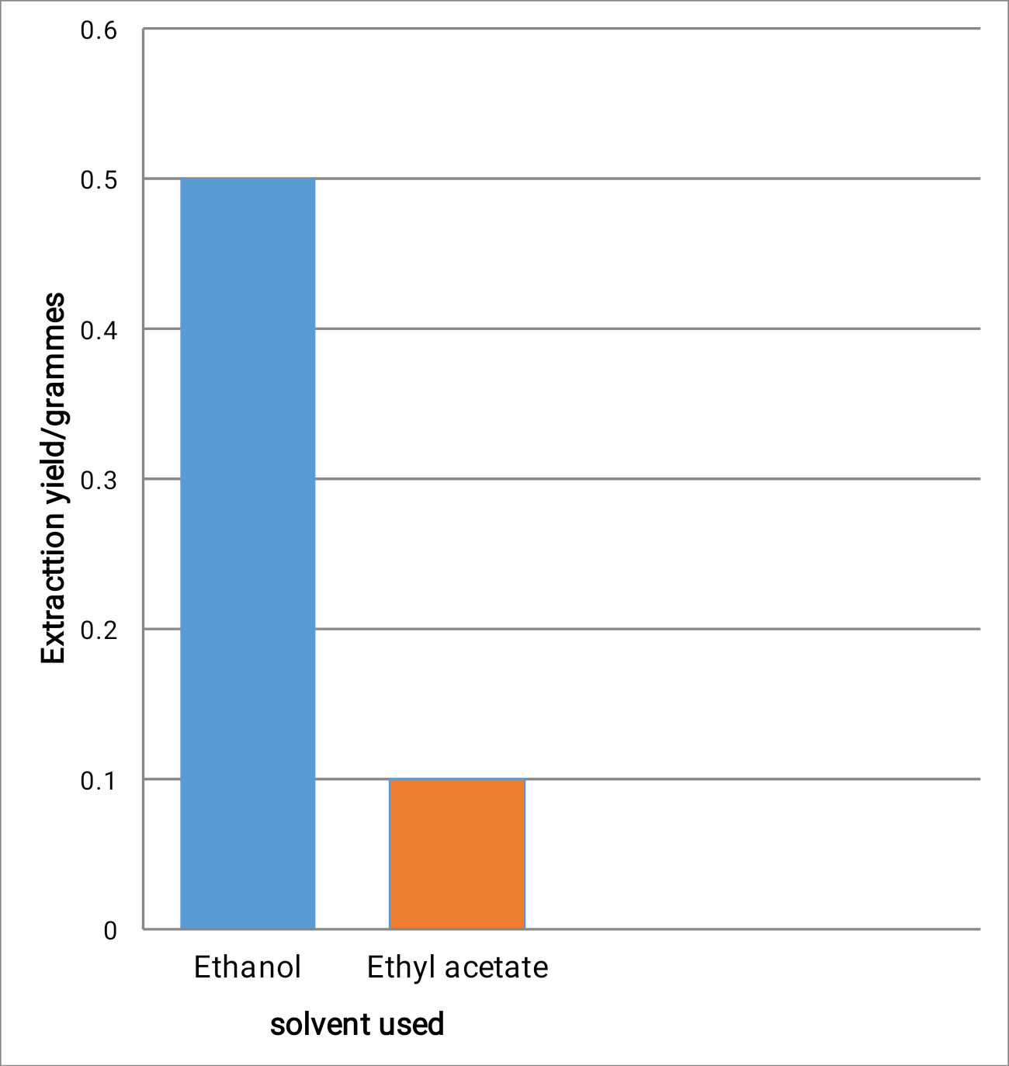

Figure 4.1: A bar chart showing extraction yield in grams of *Ricinus communis*

**4.2 PHYTOCHEMICAL SCREENING**

**Table 4.2 Qualitative analysis of phytochemicals**

|  |  |  |  |
| --- | --- | --- | --- |
| Phytochemical | Tests | Observation | Conclusion |
| Flavonoids | Sodium hydroxide | Yellow color | + |
| Alkaloids | Dragendorf’s test and Wagner’s reagent | Precipitate formed | + |
| Terpenoids | Liberman-Burchard’s test | Reddish brown precipitate | + |
| Steroids | Salkowski’s test | Reddish color | + |

**Table 4.3 Qualitative analysis of flavonoids**

|  |  |  |  |  |  |  |
| --- | --- | --- | --- | --- | --- | --- |
| Sample | | Solvent | Concentration mg/L | | | |
| Crude extract | |  | 1 | 2 | 3 | Mean ± SD |
| Ethanol | 0.306 | 0.307 | 0.298 | 0.304 ± SD |
| Ethyl acetate | 0.324 | 0.322 | 0.323 | 0.323 ± SD |
|  |

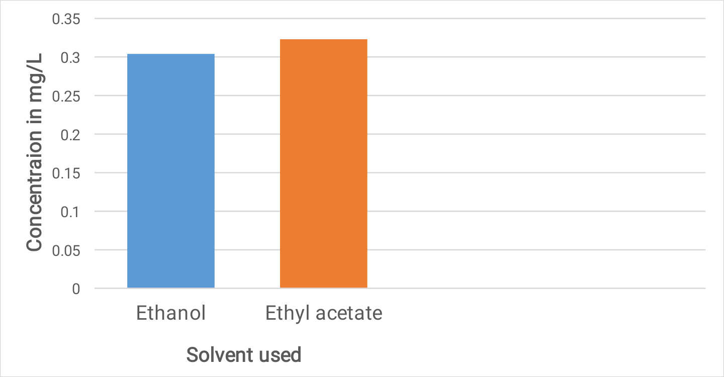

Figure 4.2: Flavonoid concentration in mg/L of *R. communis* roots extract.

**CHAPTER 5**

**DISCUSSION**

*Ricinus communis* is used in traditional medicine to treat a number of ailments, such as abscesses, ringworm, stomachaches, dropsy, rheumatism, headaches, and warts. The biological activity of plants is assumed to be mediated by a variety of secondary metabolites (Kennedy and Wightman, 2013). According to the results of the current study, *R. communis* includes a number of phytochemicals with antioxidant, anti-inflammatory, and antibacterial activity, making it appropriate for use in conventional medicine (Ashly *et al.,* 2016). Since alkaloids and flavonoids are the primary antibacterial compounds, they were measured. The extract was found to contain flavonoids at a concentration of 0.323 mg/L. Alkaloids were discovered in 0.783g of the 10g specimen powder. *R. communis* has been found to have antimicrobial characteristics. The presence of biologically active compounds, such as the pharmacologically active alkaloids, may be the root of the antibacterial activity (Ada *et al*., 2014).

To increase the yield of crude extract, ethanol was utilized as a solvent. However, it turned out that the ethanol extract had just a small amount of antibacterial activity (10 mm in diameter). The antibacterial activity of *R. communis* roots extract was more pronounced in the latter as compared to ethanol extract using the solvent ethyl acetate (diameter of inhibition zone, 17mm). Ethyl acetate can extract some polar secondary metabolites as well as some non-polar secondary metabolites since it is semi-polar. The results of the present investigation indicate that the large width of zone inhibition demonstrated by ethyl acetate extract can only be attributable to the extract of *R. communis* roots because ethyl acetate solvent lacks anti-bacterial properties. The effectiveness of the ethyl acetate extract was very close to that of the positive control. The inhibitory zone of the antibiotic kanamycin has a diameter of 91.7 mm and is readily available. Ethyl acetate from *R. communis* root can be used to make antibiotics. The problem of antibiotic resistance has made it imperative to find new antibacterial compounds, and plants can serve as a suitable replacement (Bhakta and Das (2015). A root extract from *R. communis* may include new antibiotics that are required to halt the spread of antibiotic resistance.

The results of the present investigation indicate that the large width of zone inhibition demonstrated by ethyl acetate extract can only be attributable to the extract of *R. communis* roots because ethyl acetate solvent lacks anti-bacterial properties. The effectiveness of the ethyl acetate extract was very close to that of the positive control. The inhibitory zone of the antibiotic kanamycin has a diameter of 91.7 mm and is readily available. Ethyl acetate from *R. communis* root can be used to make antibiotics. The problem of antibiotic resistance has made it imperative to find new antibacterial compounds, and plants can serve as a suitable replacement (Bhakta and Das, 2015).

According to the results of this study, gram-negative bacteria like *E. coli* are more effectively inhibited by the *R. communis* roots extract than gram-positive bacteria like *S. aureus* are. *R. communis* root extracts' antibacterial properties weren't efficient against *S. aureus*. These findings are comparable to those of Ejikemeet al*. (*2014), who found that gram-positive bacteria known as *S. mutants* were resistant to *R. communis* extracts. Because they quickly alter their appearance to develop resistance, gram-negative bacteria pose the greatest threat (Javaid *et al*., 2015). The discovery of new antibiotics may help to lessen the problem of antibiotic resistance, which is more prevalent in gram-negative bacteria, since *E. coli* is a gram-negative bacterium.

**Chapter 6**

**6. 1 RECOMMENDATIONS**

Future researchers should carry out structure exposition on *Ricinus communis* extracts. In addition, various solvents should be employed in preparation of the crude extract. Based on the results of the present study, *Ricinus communis* should continue to be used in the treatment of bacterial diseases provided the bacteria causing the disease are proven to be gram negative.

**6.2 CONCLUSION**

It has been demonstrated that *Ricinus communis* contains a variety of beneficial phytochemicals, including terpenoids, flavonoids, alkaloids, and steroids. It was discovered that *Ricinus communis* had antimicrobial qualities. Alkaloids and terpenoids have a partial antibacterial activity. The findings of the current investigation demonstrated that the solvent ethyl acetate may be successfully used to extract the active antibacterial component from *R. communis*. The current study also showed that while *E. coli,* which is a member of the gram-negative group of bacteria, was successfully stopped from growing, *S. aureus*, which is a member of the gram-positive group of bacteria, demonstrated resistance to the antibacterial activity of *R. communis* root extracts. Therefore, it can be said that *R. communis* extract works well to manage gram-negative bacteria like *E. coli*. Results of its antibacterial activity support the use of this substance in conventional medicine.

**References:**

Ada, Z., Nandini, M. and Kusuma, D. (2014). *Antimicrobial activity of medicinal plant extracts.* Journal of Medicinal Plant Studies 2(5), 51-54.

Aruna, B., Bhadraiah, B. and Pindi, P.K. (2015*). Effect of different AM fungi on biomass productivity of castor (Ricinus communis)*. Bioinfolet 12, 176-179.

Ashley, A. Thiede, B. S. and, Zidenberg-cherr, S. (2016). *Nutrition and Health information sheet: Phytochemicals. Centre for nutrition in schools*. Department of nutrition. University of California. Davis.

Bhakta, S. and Das, S.K. (2015) *In Praise of the Medicinal Plant Ricinus communis:* A Review. Global Journal. Resources. Medicinal. Plants & Indigenous. Medicines.4 (5), 9-105.

Bhaumik, A., Swapna, M., Sucharitha, M., Sravya, S., Lavanya, M. and Ahmed, S.M. (2014). *Phytochemical and antimicrobial screening of various extracts of castor fruit-seeds (Ricinus communis L*). International Journal of Information Research and Review 1, 124-127.

Boadu, A.A. and Asase, A. (2017). *Documentation of Herbal medicines used for the treatment and Management of human diseases by some communities in Southern Ghana*. Evidence-Based Complementary and Alternative Medicine; 1-12. DOI: 10.1155/2017/3043061

Dzomba, P. and Muchanyerei, N. (2012). *Potential Antimicrobial Plant Extract Based Therapeutics from Temnocalyx Obovatus Roots*. European Journal of Medicinal Plants 2(3), 209-215.

Ejikeme, C. M, Ezeonu, C. S. and Eboatu, A. N. (2014). *Determination of physical and phytochemical constituents of some tropical timbers indigenous to Niger Delta Area of Nigeria,* European Scientific Journal 10(18), 247-270.

Erecevit, P. and Kirbag, S. (2017). *Antimicrobial activity of some plant species used for the medical purpose in Turkey*. The Journal of Phytopharmacology 6 (2), 93-97.

Iqbal, J., Zaib, S., Farooq, U., Khan, A., Bibi, I. and Suleman, S. (2012). *Antioxidant, antimicrobial, and free radical scavenging potential of aerial parts of periplocaaphylla and Ricinus communis.* International Scholarly Research Network. 2012, 1-6.

Javaid, B., Rana, N. and Javed, K. (2015). *Antimicrobial studies of Ricinus communis seeds extracts.* International Journal of Scientific Research and Management 3, 2752-2759.

Kennedy, D O. and Wightman, E.L. (2013). *Herbal extracts and phytochemicals: Plant secondary metabolites and the Enhancement of human brain function*. Advances in Nutrition 2, 32-50.

Mahavidyalaya, S. and Osmanabad, G. (2014). *Phytochemical analysis and Antibacterial activity in Ricinus Communis* Periodic Research 1(1), 49-51.

Mahmood, A. and Muhammad, W. (2013). *Plants as potential source of antimicrobial agents.* Journal of Pharmacy and Alternative Medicine 2(3), 2222-2268.

Momoh, A.O., Oladunmoye, M.K. and Adebolu, T.T. (2012). *Evaluation of the antimicrobial and phytochemical properties of oil from castor seeds (Ricinus communis Linn*). Bulletin of Environment, Pharmacology and Life Sciences 1, 21-27.

Naz, R. and Bano, A. (2012). *Antimicrobial potential of Ricinus communis leaf extracts in different solvents against pathogenic bacterial and fungal strains*. Asian Pacific Journal of Tropical Biomedicine 2, 944-947.

Oliniyan, A.M. (2010). *Effect of Extraction Conditions on the Yield and Quality of Oil from Castor Bean.* Journal of Cereals and Oilseeds 1, 24-33.

Omari, A., Mgani, Q.A. and Mubofu, E.B. (2015). *Fatty acid profile and physio-chemical parameters of castor oils in Tanzania.* Green and Sustainable Chemistry 5(04), 154

Tong, S.Y.C, Davis, J.S, Eichenberger, Holland T.L and Fowler, V.G. (2015). *Staphylococcus aureus infections: epidermiology, pathosphysiology, clinical manifestations, and management*. Clinical Microbiology Reviews 3(28), 603-661.

Ulanova, R. and Kravchenko, I. (2013). *Lactic acid bacteria fermentation for detoxification of castor bean meal and processing of novel protein feeds supplement*. International Journal of Engineering Science and Innovative Technology 2, 618-624.

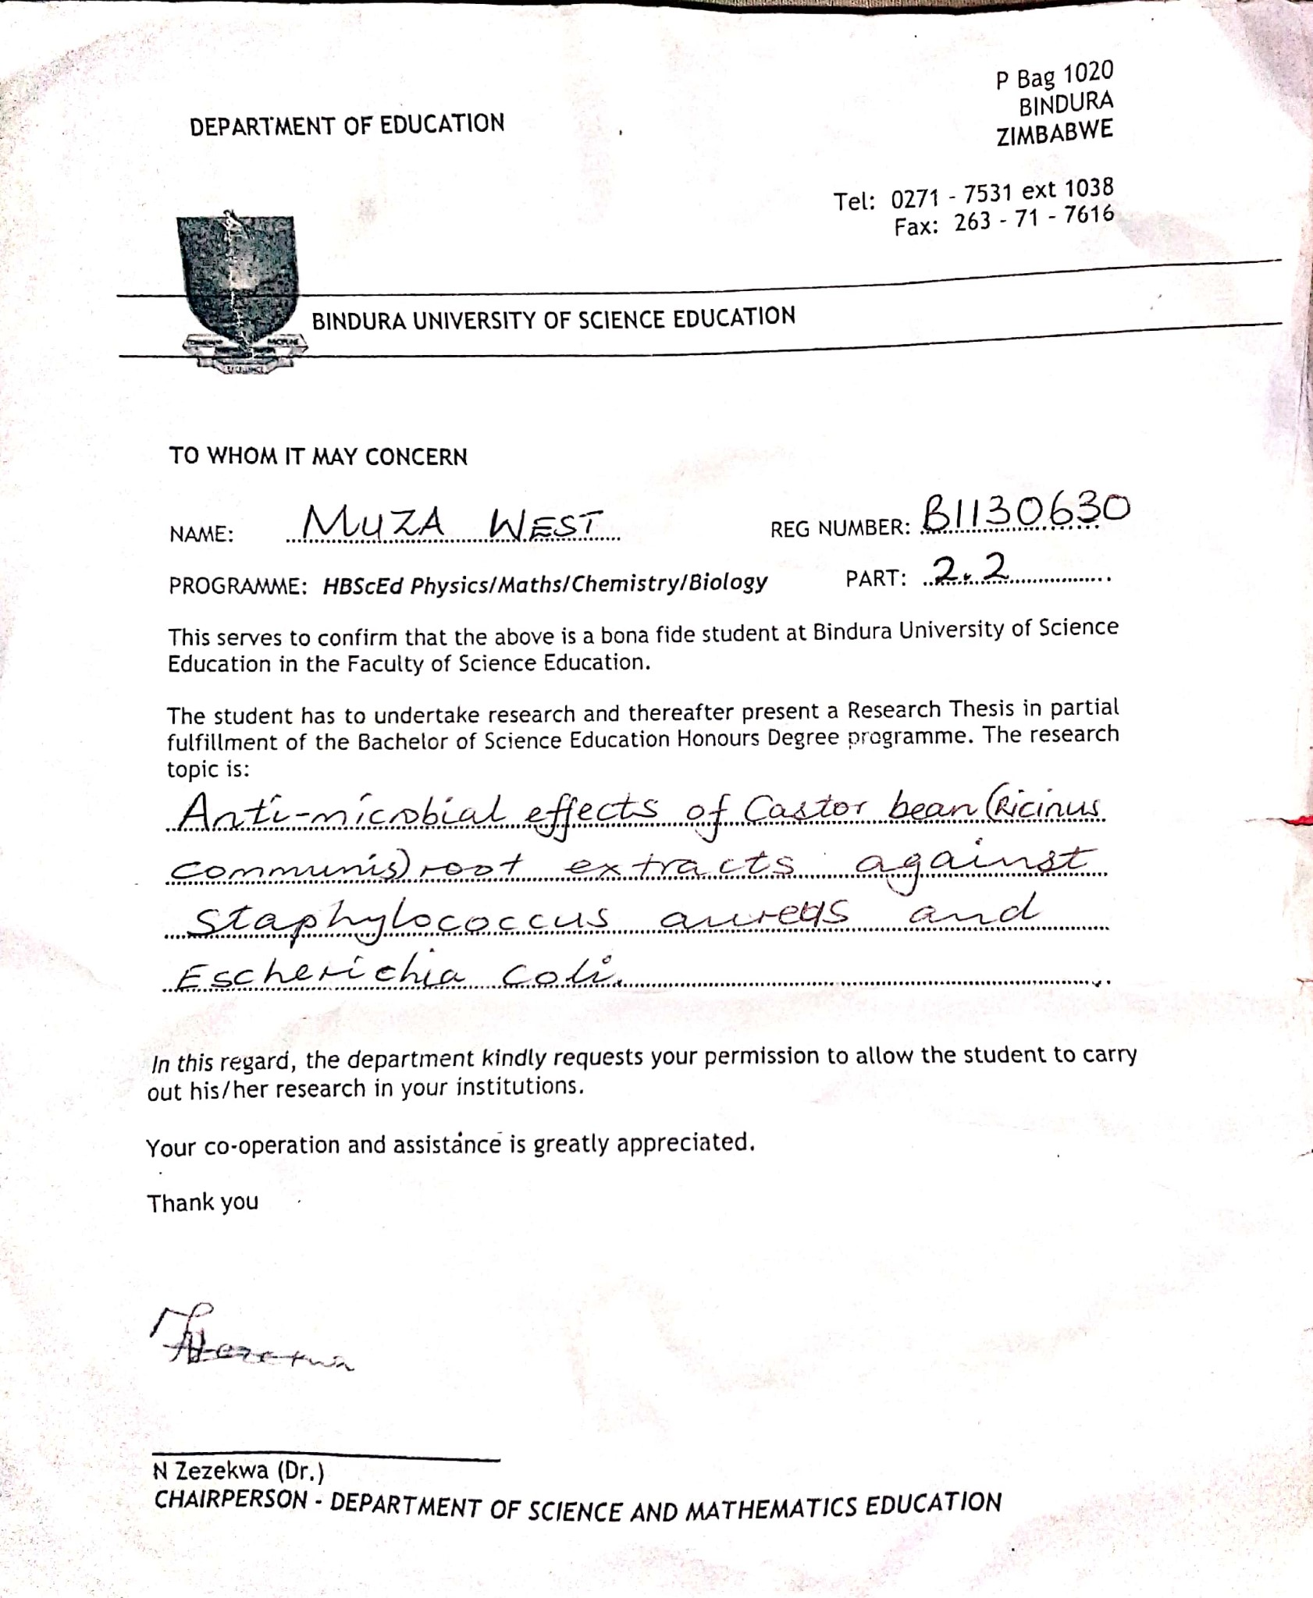**Appendix: University letter**