**BINDURA UNIVERSITY OF SCIENCE EDUCATION**

**FACULTY OF COMMERCE**



**DEPARTMENT OF ECONOMICS**

**BACHELORS HONOURS DEGREE IN PURCHASING AND SUPPLY**

**TITLE: COVID-19, SUPPLY DISRUPTIONS AND ORGANISATIONAL PERFORMANCE. THE CASE STUDY OF OK ZIMBABWE.**

**DONE BY:**

**MBIRIRI SIKHULULIWE**

**REGISTRATION NUMBER: B193335B**

**SUPERVISOR: MR CHIKABWI**

**A DISSERTATION SUBMITTED TO BINDURA UNIVERSITY OF SCIENCE EDUCATION IN PARTIAL FULFILMENT OF THE REQUIREMENTS FOR THE BACHELOR OF COMMERCE HONOURS DEGREE IN PURCHASING AND SUPPLY.**

APPROVAL FORM

The undersigned certify that they have supervised, read and recommend to the Bindura University of Science Education for acceptance of a research project entitled: “COVID-19 SUPPLY CHAIN DISRUPTION AND ORGANISATIONAL PERFORMANCE: A CASE STUDY OF OK ZIMBABWE HARARE (March 2020-JANUARY 2023)” submitted by Mbiriri Sikhululiwe in partial fulfillment of the requirements for the award of Bachelor of Commerce Honours Degree in Purchasing and Supply.

**………………………………….**  **…………………………..**

**Supervisor Date**

**…………………………………. ……………………………**

**Chairperson Date**

# Release Form

Registration Number: B193335B

Dissertation Title: COVID-19 supply chain disruption and organizational performance. A case study

of OK Zimbabwe Harare (March 2020-Jan 2023)

Degree Title: Bachelor of Commerce Honours Degree in Purchasing and Supply

Year Granted: 2019

Permission is here by granted to Bindura University Library to single copies of this dissertation, to lend or to sell such copies for private, academic or scientific research purpose. The researcher holds other publication rights. The dissertation may be printed or otherwise reproduced without the author’s written permission.

**Signed: ………………………….**

**Date: …………………………..**

**Permanent address: 3rd street Harare Zimbabwe**

# DEDICATION

I dedicate the project to Almighty God, family that is my father, mother, my brothers and my sisters for their continued support. I also dedicate this project to my friends that are Herbert, Constance and Rachel for their hand towards my project. To my supervisor Mr Chikabwi for their dedication and guidance, to my Chairperson Dr Mutsvangwa and to the entire Bindura University of Science Education for giving me this opportunity and made my environment conducive during my research project.

# DECLARATION

I, Sikhululiwe Mbiriri (B193335B) declare that my dissertation has never been submitted to any University or other institutions with a related topic and program.

Student Name: Sikhululiwe Mbiriri Signature………….. Date…………….

Supervisor: Mr Chikabwi Signature………….. Date…………….

# ACKNOWLEDGEMENTS

I thank God for giving me this opportunity, grace and compassion in fulfilling this work. I am grateful to fulfill my project and of this great institution by their commitment becoming the best they could be, have inspired me to do the same.

# ABSRACT

This study examined the effects of COVID-19 supply chain disruption and organizational performance on OK Zimbabwe. The study used the questionnaires and interviews to gather the first hand source data and also it helps in testing the reliability and viability. Out of 110 questionnaires distributed, 100 were successfully filled which gives an excellent percentage of 91. The government imposed the COVID-19 national lockdown have the negative impact on the profit of OK Zimbabwe. The closing of boarders, curfews, retrenchment of workers causes some losses to OK Zimbabwe. On the other hand, COVID-19 came to worsen the situation but as mentioned earlier in the study, the cash flows and profitability were falling drastically due to fluctuations of exchange rate. The supply chainecosystem was heavily disrupted due to COVID-19. The suppliers were not be able to produce and the buyers were not be able to place their requisitions. The closing of boarders disrupt the supply chain, also it stops the international logistics. I recommend the Zimbabwean government to loosen up the lockdown restrictions because it causes the closing of organizations.

**KEY WORDS:** COVID-19, supply chain disruption, organizational performance, OK Zimbabwe.

# LIST OF ABBREVIATIONS

COVID-19…………………..Corona Virus Disease for 2019

SARS-COV-2……………Severe Acute Respiratory Syndrome CoronaVirus 2

WHO………………………..World Health Organization

CDC………………………… Centers for Disease Control and Prevention

VUCA……………………… Volatility, Uncertainty, Complexity, and Ambiguity

Contents

APPROVAL FORM 2

Release Form 3

DEDICATION 4

DECLARATION 4

ACKNOWLEDGEMENTS 4

ABSRACT 4

LIST OF ABBREVIATIONS 5

CHAPTER I 8

1.0 INTRODUCTION 8

1.1 BACKGROUND OF THE STUDY 9

1.2 STATEMENT OF PROBLEM 13

1.3 OBJECTIVES OF THE STUDY 14

1.4 RESEARCH QUESTIONS 14

1.5 ASSUMPTIONS 14

1.6SIGNIFICANCE OF THE STUDY 14

1.6.1 To the institution (BUSE) 14

1.6.2 To the student 15

1.6.3 To the organization to be studied (OK Zimbabwe) 15

1.7 LIMITATIONS 15

1.8 DELIMITATIONS 15

1.9.1 DEFINITION OF TERMS 16

1.10 CONCLUSION 16

**CHAPTER II** 16

2.0 INTRODUCTION 16

2.1 THEORETICAL LITERATURE REVIEW 17

2.2.1 Resource based theory 17

2.2.2 Resources and Capabilities as the Foundation for Strategy 18

***2.2.3 Resources and Capabilities as a Source of Direction*** 18

2.2.4 Resources as the Basis for Corporate Profitability 19

2.2.5 Taking Stock of the Firm's Resources 19

2.2.6 Conceptual Framework 20

2.3 EMPIRICAL LITERATURE REVIEW 22

2.3.1 Studies from developed countries: Europe 22

2.3.2 Studies from developing countries: Africa 23

2.3.3 Studies from Zimbabwe 23

2.5 CHAPTER SUMMARY 24

CHAPTER III 25

3.0 INTRODUCTION 25

3.1 RESEARCH DESIGN 25

3.2 TARGET POPULATION 25

3.3 SAMPLE SIZE AND TECHNIQUE 25

3.3.1 Simple Random Sampling 26

3.3.2 Stratified Random Sampling 26

3.3.3 Convenience Sampling 27

3.3.4 Quota Sampling 27

3.4 POPULATION DISTRIBUTION 28

3.5 SAMPLE SIZE 28

3.6 SAMPLING TECHNIQUE. 29

3.7 DATA SOURCES 29

3.7.1 Primary Data 29

3.7.2 Secondary Data 29

3.8 RESEARCH INSTRUMENTS 29

3.8.1 Questionnaires 30

3.8.2 Interviews 30

3.9 DATA COLLECTION PROCEDURE 30

3.9.1 Validity 31

3.9.2 Reliability 31

3.9.3 Ethical Consideration 32

3.10 DATA PRESENTATION AND ANALYSIS TECHNIQUES 32

3.11 CHAPTER SUMMARY 32

CHAPTER IV: 33

4.0 DATA PRESENTATION & DISCUSSION 33

4.1 INTRODUCTION 33

4.2 DATA PRESENTATION AND ANALYSIS 33

4.3 RESPONSE RATE 35

4.4 PRESENTATION ANALYSIS 37

4.4.1 Objective 1: To analyze ways in which COVID-19 disrupts supply chain ecosystems of OK Zimbabwe operations. 37

4.4.2 Objective 1: To establish the effects of Government imposed national wide lockdown measures on profitability of OK Zimbabwe. 40

4.5 CONCLUSION 40

CHAPTER V: 41

5.0 SUMMARY, CONCLUSIONS AND RECOMMENDATIONS 41

5.1 INTRODUCTION 41

5.2 SUMMARIES 41

5.2.1 SUMMARY ON OBJECTIVE1 41

5.2.2 SUMMARY ON OBJECTIVE 2 41

5.3 CONCLUSIONS 41

5.3.1 CONCLUSIONS ON OBJECTIVE 1 41

5.3.2 CONCLUSIONS ON OBJECTIVE 42

5.4 RECOMMENDATIONS 42

5.5 SUGGESTIONS FOR FURTHER STUDIES 42

REFERENCES 44

APPENDIX 46

**SECTION A: DEMOGRAPHIC** 47

Instructions 47

1. Gender 47

2. Which age are you ranging? 47

3. Academic qualifications 47

4. Department 48

5. Position/Post 48

**SECTION B** 49

**SECTION C** 50

# 

# CHAPTER I

## 1.0 INTRODUCTION

This study investigates the effects of COVID-19 on OK Zimbabwe supply chain disruptions and performance. A disruption occurs when there exists an unprepared stop to goods movement that looks at both finished products and work-in-progress within a supply chain (Revilla and Saenz, 2017). Supply disruption poses a great negative impact on the productivity of the organization and its performance at large (Marley at el, 2014). The study is of great importance taking into regard the disruption magnitude experienced in recent years globally as a result of the COVID-19 virus and it has become a question of organizations managers on possible ways to mitigate the production schedules damage in the disruptions (Kumar et al, 2020), the emerging of COVID-19 pandemic furthered this need. Chapter one focuses on the background of the study, statement of problem, objectives of the study, research questions, and significance of the study, study assumptions, limitations, delimitations and conclusion. The background of the study analyses the evolution of COVID-19, how it affects the global supply chain and the operations of OK Zimbabwe. The statement of the problem will articulate the major concern of this study which warrantee to be researched whereas the objectives of the study would explain main purpose for carrying out this study.

## 1.1 BACKGROUND OF THE STUDY

It is necessary to explain the causal effect that has changed the daily life of the world's population in recent months and challenged the entirety of corporate strategies adopted so far. The supply chain management personnel had to take quick decisions and solutions, with trade relations and supply sources faced with danger which disturbed the operations of logistics and caused the meltdown of organizations. On the 31st of December 2019 the People's Republic of China authorities informed the World Health Organization about dozens of mysterious pneumonia cases in Wuhan city. Many cases were of workers at the 'Huanan Seafood Wholesale Market', a fish and animal wholesale market. On 7 January 2020, Chinese scientists performed clinical tests and discovered a virus which they named 2019-nCoV, as it was a Corona-virus family, like SARS. On the 20th of January 2020 it was ascertained that the virus transmission was human to human, and annulling the previously thought theory that it was an animal to human case. This development led to the hypothesis that infected Wuhan market residents who travelled and the high rates of migration people for the Chinese New Year is what created a conducive environment for the rapid spread of the virus to the rest of the world. The rate of infections began extended to neighboring countries such as Thailand, South Korea, and Japan. Three days after the discovery of the outbreak of the virus, Wuhan went into total lockdown, and by the end of January, Sweden also announced its first case of COVID-19. WHO announced on 11 February 2020 that the respiratory disease caused by the new corona-virus as COVID-19. The spread of COVID-19 was declared on 12 March 2020 a global pandemic (Devignes, 2020). By May 2022, reported COVID-19 cases totaled 517 worldwide, with confirmed deaths at 6.25 million (Abdelnour, 2020). In most cases natural disasters strike quickly at local level and bear an immediate visible impact whereas in contrast, pandemics growth is persistent with reappearance over periods of months and years at various places. Moreover, the most obvious difference between other disasters and pandemics is the economic damage and effect on manufacturing and production world results from the response to the pandemic. Common symptoms of COVID-19 patients include high fever, dry coughs, feeling of fatigue, and shortness of breath. However, some patients experienced sore throat, headache, runny nose, and body ache. The World Health Organization (WHO) recommendation and of Centers for Disease Control and Prevention (CDC) was the running of diagnostic tests for COVID-19 to monitor its epidemiology and deduce ways to suppress the virus transmission.

Scientists tasked themselves to the formulation of a sensitive test that would detect the virus’s genetic material in samples, in particular the SARS-COV-2, 4-pharyngeal swab-based tests. However, the insidious aspect that was shown by COVID-19 made it more complicated compared to any of the previous pandemics as many of infected people often showed no symptoms of the infection. The main emblematic aspect was the fact that some the infected people never revealed any of the first labeled symptoms but still did spread the disease, the asymptomatic positives. Asymptomatic transmissions made the combating of this virus complicated because simple, fast and affordable tests such as checking body temperature could not ascertain the infection. Other several factor contributed to the international and exponential spread of COVID-19: the prevalence of air travel, asymptomatic transmission, and super-spreading events. In a bid to compact the spread of the virus, the policymakers and public health practitioners, and experts sat and developed measures that were to be followed and observed in most countries around the global, that were interpersonal contact restrictions in the face of assembling and travelling, high level of hygiene, the wearing protective face masks in public places (Randery, 2020), the infected patients were to be isolated at COVID-19 quarantine camps and the wearing of personal protective clothing by health practitioners when treating affected patients. The clinical spectrum of COVID-19 was broad as infected people, some showed only mild and subclinical symptoms at the early phase of the disease. Number of COVID-19 patient’s experienced severe acute respiratory complication with these infected people being subjected to intensive care in hospitals and being put on oxygen supplementation. Elderly people and those that had chronic disease history in their genes had a higher risk of infection and mortality.

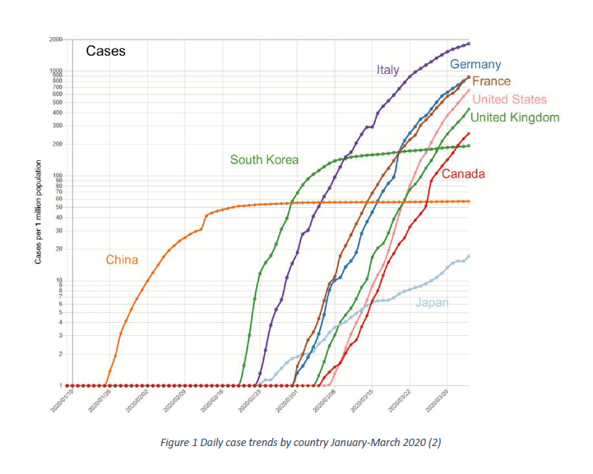

The trends on the virus spread shown in the graph above shows how the curve of infections in China flattened towards the middle of February and with the first few days of March Italy overtook China in terms of the number of infected in the country.

In China, given the flat curve, the situation returned to normal as the weeks go by, while in the other European and American countries it was getting worse and worse. (Christopher, 2004). In March 2020, the situation started to worsen, with both the number of people who are positive and those who have died from the virus increasing. Most of the world's governments launch various restrictive measures aimed at decreasing the rapidity of the virus' spread, first by closing schools, then businesses, and declaring a country-wide lockdown. On 9 March, Italy was the first to take such drastic measures on the European

Continent. 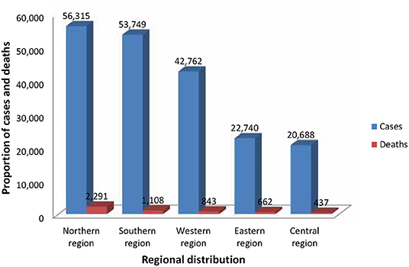

Figure 2 COVID-19 trend in AFRICA by region

From Figure 2 looking at the trend of the spread of COVID-19 in Africa by region we can see that the northern region was the highest in recording new cases so as the number of deaths followed by the Southern region which Zimbabwe is encompassed in resulting in a surge COVID-19 cases and by so doing there was significant mortality rate by 20 June 2020.

In November 2022, almost three years after the start of the pandemic, the spread of the virus followed typical seasonal flu trends:

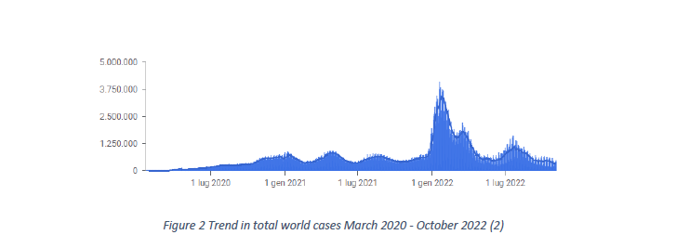

Figure 3 trend in total world cases March 2020 to October 2022

Due to COVID-19 outbreak nation-wide, there were lockdowns, airspace and borders were closed, witnessing an uncommon disturbance to the global economy, irrespective of size and level of supply chain operations globally (Araz et al, 2020). COVID-19 continued to spread across the globe, causing disruption and uncertainty to business operations. According to Ivanov and Dolgui (2020), 75% of companies have experienced supply chain disruptions because of COVID-19 limiting the logistics activities significantly. Moreover, the volatility in the supply chain practices; uncertainty in the decision making; complexity in co-ordination; and ambiguity in information sharing makes global supply chain a perfect candidate for VUCA model (Bennett and Lemoine, 2014).

The supply chain disruption from COVID-19 caused several social-economic challenges in many countries across the globe. The eruptions of pandemic or any other outbreak diseases cause many challenges on human lives and economy at large. The outbreak of influenza in some past decades in the United States of America (USA) which killed many people and had caused some shortages in all sectors of organization. It also causes the shortage of human labor because many people died during Influenza pandemic, and it leads to losses in production hence it was a serious supply chain disruption.

However, no one anticipated the severity of COVID-19 outbreak would lead to high disruption and uncertainty in the global supply chain practices and organizational profitability a case study OK Zimbabwe profit and loss and cash flow trends as shown below:

Figure 4: OK Zimbabwe Cashflow, and profit and loss for the period April 1 2014 to march 31 2022

The graph above shows the profits and cash flow of the company before COVID-19 and during the pandemic. From the trend, of profit and cash flow has faced a constant decline and in the financial year 2020 to 2021 when the government lifted the COVID-19 restrictions there was a significant increase of cash flow and profits but after the emergence of new COVID-19 variant the restrictions were imposed again seeing a major decline in the profitability and cash flow trends explain the decrease of both profits and cash flows as an event of the COVID-19 pandemic.

## 1.2 STATEMENT OF PROBLEM

COVID-19 affected the global supply chain in various ways. The supply chain was disrupted in the field of market, logistics, and supply. Since many countries rely on raw materials and finished goods from China, the effects of COVID-19 were immediate than expected (Rodgers, 2020). China’s responses to compact further spreading of COVID-19 disrupted the global supply chain. This worsened as the pandemic spread across the globe to Africa and Zimbabwe at large. Almost all countries-imposed control measures to suppress the further spreading of the virus (Autry, 2021). These measures including border closures reduced working hours, closure of non-essential sectors and curfews among others are believed to have disrupted global supply chain and affect operations of many organizations including OK Zimbabwe. The extent to which the retail sector has been affected is less known since it was affected in various ways. This study therefore examines the effects of COVID-19 on OK Zimbabwe performance.

## 1.3 OBJECTIVES OF THE STUDY

The general objective of this study is to investigate the effects of COVID-19 supply chain disruptions on OK Zimbabwe performance. Specifically, the study seeks to:

1. To analyze ways in which COVID-19 disrupts supply chain ecosystems of OK Zimbabwe operations.
2. To establish the effects of Government imposed national wide lockdown measures on profitability of OK Zimbabwe.

## 1.4 RESEARCH QUESTIONS

1. In what ways does COVID-19 disrupts supply chain ecosystems and OK Zimbabwe operations?
2. What are the effects of Government imposed national lockdown measures on profitability of OK Zimbabwe?

## 1.5 ASSUMPTIONS

1. No further COVID-19 infections would warrantee lockdowns which would disrupt data collection by the researcher.
2. The researcher will be able to balance the taught courses and dissertation requirements during the dissertation writing period.
3. The findings of the study will be useful solutions to the OK Zimbabwe and the Zimbabwean government.

## 1.6 SIGNIFICANCE OF THE STUDY

### 1.6.1 To the institution (BUSE)

This study aims to test the impact of the corona virus(COVID-19) on OK Zimbabwe, with regard to supply disruption and its performance which is going to help other students to do their research that takes into consideration unplanned disruptions to any organization.

### 1.6.2 To the student

It provides the student with enough knowledge and enables critical thinking after you have come up with better solutions or accurate judgment which can help the economy at large. It is also a university requirement for me to do my project to graduate.

### 1.6.3 To the organization to be studied (OK Zimbabwe)

This research provides a basis for avoiding and eliminating the negative impact of unplanned for pandemic disruptions like COVID-19 on OK Zimbabwe and to reduce the severity of the disruptions on the organization’s profitability which is the whole agenda of the existence of large firms like OK Zimbabwe. This study will assist all the other OK Zimbabwe supermarkets in the economy of Zimbabwe and at large on how to tackle supply chain disruption after the occurrence of unplanned events like COVID-19 as I focused my study on OK Zimbabwe, Harare.

## 1.7 LIMITATIONS

The researcher faced the following challenges which are; some workers in the organization were not willing to give their time to be interviewed. Because of the introduction of government restrictions to lower the number of workers at the working place at a given time it reduced the data field which when big can help after inference in providing correct information. Inadequate finances to go in the field to carry out my research, travel restrictions were imposed by the government in order to reduce the spreading of the pandemic on the transport providers making the small left commuter buses to charge hefty price, so it limited the researcher to get enough and relevant data. Social distancing policies were an obstacle where people were to stand a meter apart so I ended up missing some important information during my recordings which lead to loss of information. The organization was not allowing its employees to be interviewed since they were operating few hours so they were avoiding me to concentrate on their work.

## 1.8 DELIMITATIONS

The study specifically focused on COVID-19, supply chain disruption and organizational performance which was carried out in Harare, Zimbabwe. The researcher gathered data specifically on the effects of COVID-19 supply chain disruptions on OK Zimbabwe performance for the period March 2020 to January 2023.

## 1.9.1 DEFINITION OF TERMS

- Supply chain: It is the network of organizations that are involved, through upstream and downstream linkages, in the different processes and activities that produce value in the form of products and services delivered to the ultimate consumer (Christopher, 1992).

- Supply chain disruption: is an unexpected event that stops or slows the normal flow of material with potentially negative consequences to supply chain members (Chopra and Sodhi, 2004).

## 1.10 CONCLUSION

This chapter focused on introduction of the study which gives the guide, background of the study, statement of the problem, objectives of the study, research questions, the assumptions and the conclusion of the study. The background of the study analyzed the evolution of COVID-19, how it affects the global supply chain and the operations of OK Zimbabwe. The statement of the problem also articulated the major concern of this study which warrantee to be researched whereas the objectives of the study explained main purpose for carrying out this study. The following chapter is going to focus on literature review. Both theoretical and empirical literature would be reviewed in this chapter.

# **CHAPTER II**

## 2.0 INTRODUCTION

The previous chapter introduced the study, background of the study, statement of the problem, objectives of the study, research questions, the assumptions, definition of key terms, limitations, delimitations, and the conclusion of the study. The background of the study analyzed the evolution of COVID-19, how it affects the global supply chain and the operations of OK Zimbabwe. The statement of the problem also articulated the major concern of this study which warrantee to be researched whereas the objectives of the study explained main purpose for carrying out this study. This chapter is going to focus on literature review which consist of theoretical literature review and empirical literature review. The theoretical literature review will look at the relevant theories that link COVID-19 to organizational performance. Empirical literature review on the other hand would analyze previous studies related to this topic.

## 2.1 THEORETICAL LITERATURE REVIEW

According to Mele et al. (2010), systems theory is a theory that may be used to explain a variety of business disciplines by using a holistic perspective. Despite the fact that OK Zimbabwe may appear exclusive and independent, it is a part of a broader whole society, and if this relationship is not acknowledged, the organization may fall apart. Systems theory in management was made popular by Kenneth Boulding's investigation into how the systems thinking would apply to management and benefit industry practitioners (Boulding, 1956). According to Aristotle, the study of parts will not yield the same results as the study of the whole sum (Bertalanffy, 1972). Deming's philosophy of quality management, which he developed in the 1960s, encouraged quality practitioners to see the pursuit of quality as an organizational responsibility and that all departments are connected in the quest for superior performance in an effort to increase market share (Devor et al., 1992). Systems theory is quite broad in its application and has gaps for management's implementation research (Teece, 2018), but it is still valued as a tool for explaining how an organization's relationships are complex when taking into account how it interacts with the outside world (Bertalanffy, 1972; Cordon; Mele, 2013; 2010). The systems theory is crucial to this study because, as an interaction-focused theory (Mêlée et al., 2010), it gives meaning to the interdependent relationship between an event outside of managerial control in the external environment and an organization, looking at how they affect suppliers/customers and cause firm productivity and customer disruptions. It also helps prepare for an event by assisting in identifying its potential impact and managing the subsequent ripple effect.

### 2.2.1 Resource based theory

The resource based theory states that an organization can achieve good returns if they have superior resources that set them apart from other businesses (Charles, 2014). The theory examines unique capabilities that a firm can put into practice to gain a competitive advantage in the midst of constraints within the business environment. As a result, the firm should use its resource to keep up with the pace and be current. However, this was no longer working during COVID-19 era because even if the companies have all the resources, the employees were not going to work to avoid the spread of the disease. There were tight lockdowns, no one was going to work and all businesses were closed, borders were closed and not only in OK Zimbabwe or in Zimbabwe but globally (Buzell, 2022). Yes, superior resources can be available but if we lack manpower, the thing called supply disruption can hit an organization. Other big companies in Europe and Asia in China closed in 2019 when COVID-19 started up until the cases of death were decreasing. There is also a point where World Health Organization (WHO) was helping countries with food because of hunger and supply chains were cut.

Figure1. A Resource-Based Approach to Strategy Analysis:

A Practical Framework

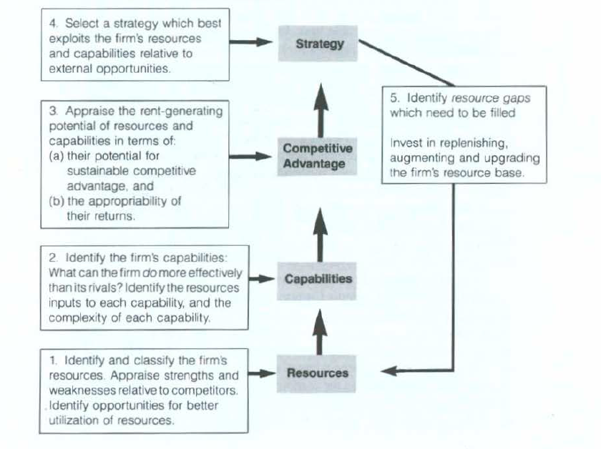

Figure 5: Resource-Based Approach to Strategy Analysis

### 2.2.2 Resources and Capabilities as the Foundation for Strategy

The case for making the resources and capabilities of the firm the foundation for its long-Term strategy rests upon two premises: first, internal resources and capabilities provide the basic direction for a firm's strategy, second, resources and capabilities are the primary source of profit for the firm (Ricardo, 2020).

### 

### ***2.2.3 Resources and Capabilities as a Source of Direction***

As a Source of Direction, Resources and Capabilities

A statement of the company's identity and purpose, typically in the form of a mission statement that provides an answer to the question "What is our business?" must serve as the foundation for the design of any strategy. For example, "Who are our customers?" and "Which of their needs are we seeking to serve?" are typical questions used to define a business in terms of the market that the company serves. However, an externally centered perspective does not offer a strong platform for developing long-term strategy in a world where consumer preferences are changeable, the identity of customers is changing, and the technologies for meeting customer requirements are always expanding (Gavery, 2016). When the outside world is changing, the firm's own resources and capabilities may be a much more stable base on which to define its identity while the external environment is in change. Therefore, defining a firm in terms of what it is capable of achieving rather than in terms of the demands that it attempts to serve may provide a more reliable foundation for strategy.

### 2.2.4 Resources as the Basis for Corporate Profitability

The attractiveness of the industry in which a firm is based and the establishment of a competitive edge over competitors are two elements that determine a firm's ability to generate a rate of profit beyond its cost of capital. Industrial organization economics places a strong emphasis on industry attractiveness as the fundamental driver of superior profitability, with the implication that strategic management should focus on finding favorable industry environments, identifying strategic groups and attractive segments within industries, and reducing competitive pressures by executing considerable influence on the industry’s structure and its rivals behavior (Ponomarov, 2014). However, empirical research has been unable to prove a connection between industry structure and profitability. The majority of studies indicate that variations in profitability between industries is significantly more valuable than the structural difference between industries. The causes of the variations are easy to identify that is increased global rivalry, technical advancements, and corporate diversification across industry borders have made industries that were previously comfortable havens for producing simple profits exposed to fierce competition.

### 2.2.5 Taking Stock of the Firm's Resources

There is a crucial and noticeable dividing line of distinction between resources and capabilities: resources are the fundamental units of analysis since they are inputs into the manufacturing process (Guan, 2017). The firm's individual resources include factors like capital equipment, expertise of specific personnel, patents, brands, financing, and other influencing factors.

As the Foundation for Profitability, Resources

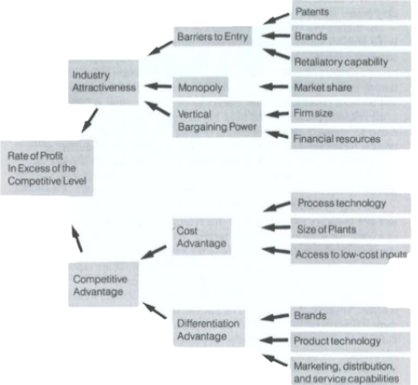

Figure 6: Resources as the Basis for Profitability

But few resources are productive on their own. The collaboration and coordination of a number of resources is necessary for productivity action to happen. The ability of a group of resources to complete a task or activity is known as a capability. While a firm's capabilities are largely derived from its resources, this is not the case for its competitive edge.

### 2.2.6 Conceptual Framework

Outbreak of COVID-19

Government Response

Strictest Lockdowns due to COVID-19 Measures

Reduced working hours

Banning of Transport

Closing of Boarders

Reduction in Supply Chain in retail shops

Supply Chain Disruption Strategies

* Multiple sourcing
* Local sourcing
* Electronic procurement

**Source:** Author (202

## 2.3 EMPIRICAL LITERATURE REVIEW

### 2.3.1 Studies from developed countries: Europe

Fuzzy VIKOR Sort in 2022 did a study on Pakistan assessing the organizational resilience to supply chain disruption as a result of the COVID-19 pandemic by sending questionnaires as Google forms to the unit of study that was workers using the quantitative approach focusing on a vast of diverse sectors of the economy. The results reveal that the lead time with the highest weight value was the major cause of supply chain disruptions in supply chain seconded by manpower shortage due to unconducive working environment and poor infrastructure being the lest contributing factor to supply chain disruption which all points to the COVID-19 pandemic as the prime cause.

Findings of Fuzzy VIKORSort 2022,will differ from mine because my study focuses on one sector of the economy that is the retail sector, a sector in which OK Zimbabwe is in . Also, I used qualitative methodology while the former used quantitative methodology. My data gathering technique also had to do with physical visits to OK Zimbabwe outlets which motivates participation in the survey subjects and for this cause our results are likely to be different.

Supply chain disruption during the COVID-19 pandemic: Recognizing potential disruption management strategies is a study under Elsevier Journal since January 2020. It was done by Javid Moosavi, Amir M. Fathollahi-Fard and Maxim A. Dulebenets under School of the Built Environment, University of Technology Sydney, Australia.

(Ajmal, Khan, Shad, Alkatheeri, & Jabeen, 2021) used a quantitative approach for data collection and structural equation modeling to analyze the findings of a study on the empirical examination of societal, financial, and technological challenges in the context of the ongoing COVID-19 pandemic in the service supply chain network. The findings offered concrete proof that physical and social isolation, rules, and lockdown procedures have reduced economic activity, which in turn has led to an increase in societal and financial problems. The findings of Ajmal et al are likely to differ from my findings as they focused on the COVID-19 effects on creating technology related challenges in the service sector while my research is focusing on the effects of COVID-19 on the supply chain and organizational performance disruptions on the retail sector of Zimbabwe a developing country with less engagement on online trade as a result of less technological advancement.

### 2.3.2 Studies from developing countries: Africa

Alicia N Weber in 2021 conducted a study on responding to supply chain disruptions caused by the COVID-19 pandemic. An exploratory qualitative research design was used in the study. Virtual data collection took place through 17 semi-structured interviews with nine distinct prominent South African Omni channel retailers. According to the survey, during the pandemic, Omni Channel retailers encountered both internal and external supply chain disruptions. The most obvious external disruption was the abrupt shift in consumer behavior toward online channels and the shops' failure to keep up with demand hikes. Internally, front- and back-end operations' system limitations were regarded as the most significant disruptions.

However, this research was conducted with a goal on how to respond to supply chain disruptions caused by COVID-19 pandemic during the pandemic, so the results will be definitely different because mine is being conducted now in 2023 were COVID-19 is no longer wreak havoc the country and at globe, and I will be capable to get data not only from the managers or the superiors but from the pupils because everyone was affected by the pandemic.

In a study on supply chain resilience in developing nations to COVID-19, Sadaf and Stephan (2021) first constructed an open-ended structured questionnaire and then collected information from nearby rising economies, including Pakistan, India, and Iran. Building on the results of the previous technique, data was collected in a structured manner using a quantitative structured questionnaire and was then further examined through frequency and contingency analysis.

The results of (Aman & Seuring, 2021) will differ from my results because the contingency findings demonstrated that supply chain disruption is a significant threat for emerging markets, that supply chain structure and social capital play a pivotal role in making supply chains resilient against disruption, whereas my study will concentrate on one sector of the economy, the retail sector, and I will use the qualitative approach as the first-hand source of information.

### 2.3.3 Studies from Zimbabwe

Numerous research on the COVID-19 disruption on supply chains and performance of organisations that have been conducted in Europe, Asia, Africa, and even in Zimbabwe. A case of COVID-19 in Zimbabwe was the subject of a study on pandemic outbreaks and food supply chains in underdeveloped countries by (Chari F et al, 2022). 32 participants from the food supply chain networks participated in a descriptive survey using a qualitative methodology for the study. The findings show that COVID-19 restrictions caused food supply chains to be interrupted at every stage, from production to transit to market access. Particularly, COVID-19 rules and regulations had a severe impact on food production and supply.

Findings from Chari, Muzinda, Novukela and Ngcamu (2022) are likely to be different from findings of this study. Whereas both studies have been conducted in Zimbabwe using similar methodologies, this study is sector specific while the former is an industry study. Again Chari, Muzinda, Novukela and Ngcamu’s study looked at how COVID-19 affected supply chain disruptions, whereas this study expanded the investigation to include how COVID-19 affected organizational performance

According to a research by (Rukasha, T; Nyagadza, B; Pashapa, R; Muposhi, A, 2021) on COVID-19 impact on Zimbabwean agricultural supply chains and markets: A sustainable livelihoods perspective at Marondera University of Agricultural Sciences and Technology in 2021. The research methodology that was applied is a systematic literature survey anchored on inductive research approach. This article is based on the systematic review of secondary data sources, such as journals, policy reports, as well as reports from national and international organizations. Their results were, COVID-19 pandemic poses a severe threat to an already critical food security situation arising mainly from the prevailing poor macroeconomic conditions and consecutive years of drought in Zimbabwe.

They continued by pointing out that the COVID-19 pandemic added to the nation's problems, which already included hyperinflation, a faulty healthcare system, stagnant productivity, crop failure, widespread unemployment, and poor basic service delivery. However, the results of this study is likely to be different because of the methodology used, the study was mainly focused on the secondary data due to strictly COVID-19 lockdown restrictions and indeed the area of study is different. The researcher is studying on effects of the pandemic on OK Zimbabwe as the study is mainly focusing on retail sector.

## 2.5 CHAPTER SUMMARY

This chapter focused on literature review which consist of theoretical literature review and empirical literature review. The theoretical literature review looked at the relevant theories that link COVID-19 to organizational performance. Empirical literature review on the other hand analyzed previous studies related to this topic. The following chapter is going to focus on the methodology used in this study. The chapter therefore would focus on the research design.

# CHAPTER III

## 3.0 INTRODUCTION

The previous chapter focused on literature review which consist of theoretical literature review and empirical literature review. The theoretical literature review looked at the relevant theories that link COVID-19 to organizational performance. Empirical literature review on the other hand analyzed previous studies related to this topic. This chapter is going to focus on methodology of the study. It consists the methods used by the researcher to gather data and it comprises of the research design, research instruments, data collection procedure, data analysis methods, validity and reliability.

## 3.1 RESEARCH DESIGN

The research design is an application of various methods and techniques in order to create scientifically obtained knowledge using objectives, methods and procedures (Sanders, 1997). This study used descriptive research design. It gives the researcher the chances to solicit more information on how COVID-19 has disrupted supply chain at OK Zimbabwe. Descriptive design was used since the researcher gathered quantitative and qualitative data that described the nature and characteristics of the effects of COVID-19, supply chain disruption and organizational performance in OK Zimbabwe. To add on, questionnaires, interviews and observations were used to confirm facts pertaining the study area and figures gathered from field survey.

## 3.2 TARGET POPULATION

Target population involves employees under the study. The following is the target population used, which comprises of all OK Harare, Zimbabwe employees who were directly involved in daily operations of the business during COVID-19. Therefore, the target population of this research was including 15 procurements officers and those who were working under procurement department, 10 administration officers, 10 finance team, 10 directors and their assistances, 15 records and warehouse or stores officers and 10 from approved suppliers who supplied goods and services to Ok Zimbabwe during the pandemic. The study target population was drawn from the total population of 60 members including other stakeholders of an organization.

## 3.3 SAMPLE SIZE AND TECHNIQUE

On this study, the sample size used considering the cost and time to be taken by the researcher to gather, collect and analyze the whole population. 45 is the sample size decision made by the researcher with people who can be able to give us accuracy data which will make my study to be relevant. The population includes the employees of an organization who are under procurement department and others who work hand in hand with it, and also the selected suppliers who supplied an organization for several years and during the pandemic.

### 3.3.1 Simple Random Sampling

Researchers use two major sampling techniques: probability sampling and non-probability sampling. With probability sampling, a researcher can specify the probability of an element’s (participant’s) being included in the sample (Teece, 2015). With non-probability sampling, there is no way of estimating the probability of an element’s being included in a sample. If the researcher’s interest is in generalizing the findings derived from the sample to the general population, then probability sampling is far more useful and precise. Unfortunately, it is also much more difficult and expensive than non-probability sampling. Probability sampling is also referred to as random sampling or representative sampling. The word random describes the procedure used to select elements (participants, cars, test items) from a population. When random sampling is used, each element in the population has an equal chance of being selected (simple random sampling) or a known probability of being selected (stratified random sampling). The sample is referred to as representative because the characteristics of a properly drawn sample represent the parent population in all ways. One caution before we begin our description of simple random sampling: Random sampling is different from random assignment. Random assignment describes the process of placing participants into different experimental groups. We will discuss random assignment later in the book.

### 3.3.2 Stratified Random Sampling

This procedure known as stratified random sampling is also a form of probability sampling. To stratify means to classify or to separate people into groups according to some characteristics, such as position, rank, income, education, sex, or ethnic background (Brandon-Jones, 2016). These separate groupings are referred to as subsets or subgroups. For a stratified random sample, the population is divided into groups or strata. A random sample is selected from each stratum based upon the percentage that each subgroup represents in the population. Stratified random samples are generally more accurate in representing the population than are simple random samples. They also require more effort, and there is a practical limit to the number of strata used. Because participants are to be chosen randomly from each stratum, a complete list of the population within each stratum must be constructed.

### 3.3.3 Convenience Sampling

Convenience sampling is used because it is quick, inexpensive, and convenient. Convenience samples are useful for certain purposes, and they require very little planning. Researchers simply use participants who are available at the moment. The procedure is casual and easy, relative to random sampling. Contrast using any available participants with random sampling, where you must (1) have a well-defined population, (2) construct a list of members of the population if one is not available, (3) sample randomly from the list, and (4) contact and use as many individuals from the list as possible. Convenience sampling requires far less effort (Ivanov, 2016). However, such convenience comes with potential problems, which we will describe. Convenience samples are non-probability samples. Therefore, it is not possible to specify the probability of any population element’s being selected for the sample. Indeed, it is not possible to specify the population from which the sample was drawn.

### 3.3.4 Quota Sampling

In many large-scale applications of sampling procedures, it is not always possible or desirable to list all members of the population and randomly select elements from that list. The reasons for using any alternative procedures include cost, timeliness, and convenience (Elliot, 2020). One alternative procedure is quota sampling. This technique is often used by market researchers and those taking political polls. Usually, when this technique is used, the population of interest is large and there are no ready-made lists of names available from which to sample randomly. The Gallup Poll is one of the best known and well conducted polls to use quota sampling. This poll frequently reports on major public issues and on presidential elections. The results of the poll are syndicated for a fee that supports it. In this quota sampling procedure, localities are selected and interviewers are assigned a starting point, a specified direction, and a goal of trying to meet quotas for subsets (ethnic origins, political affiliations, and so on) selected from the population. Although some notable exceptions have occurred, predictions of national elections over the past few years have been relatively accurate—certainly, much more so than guesswork.

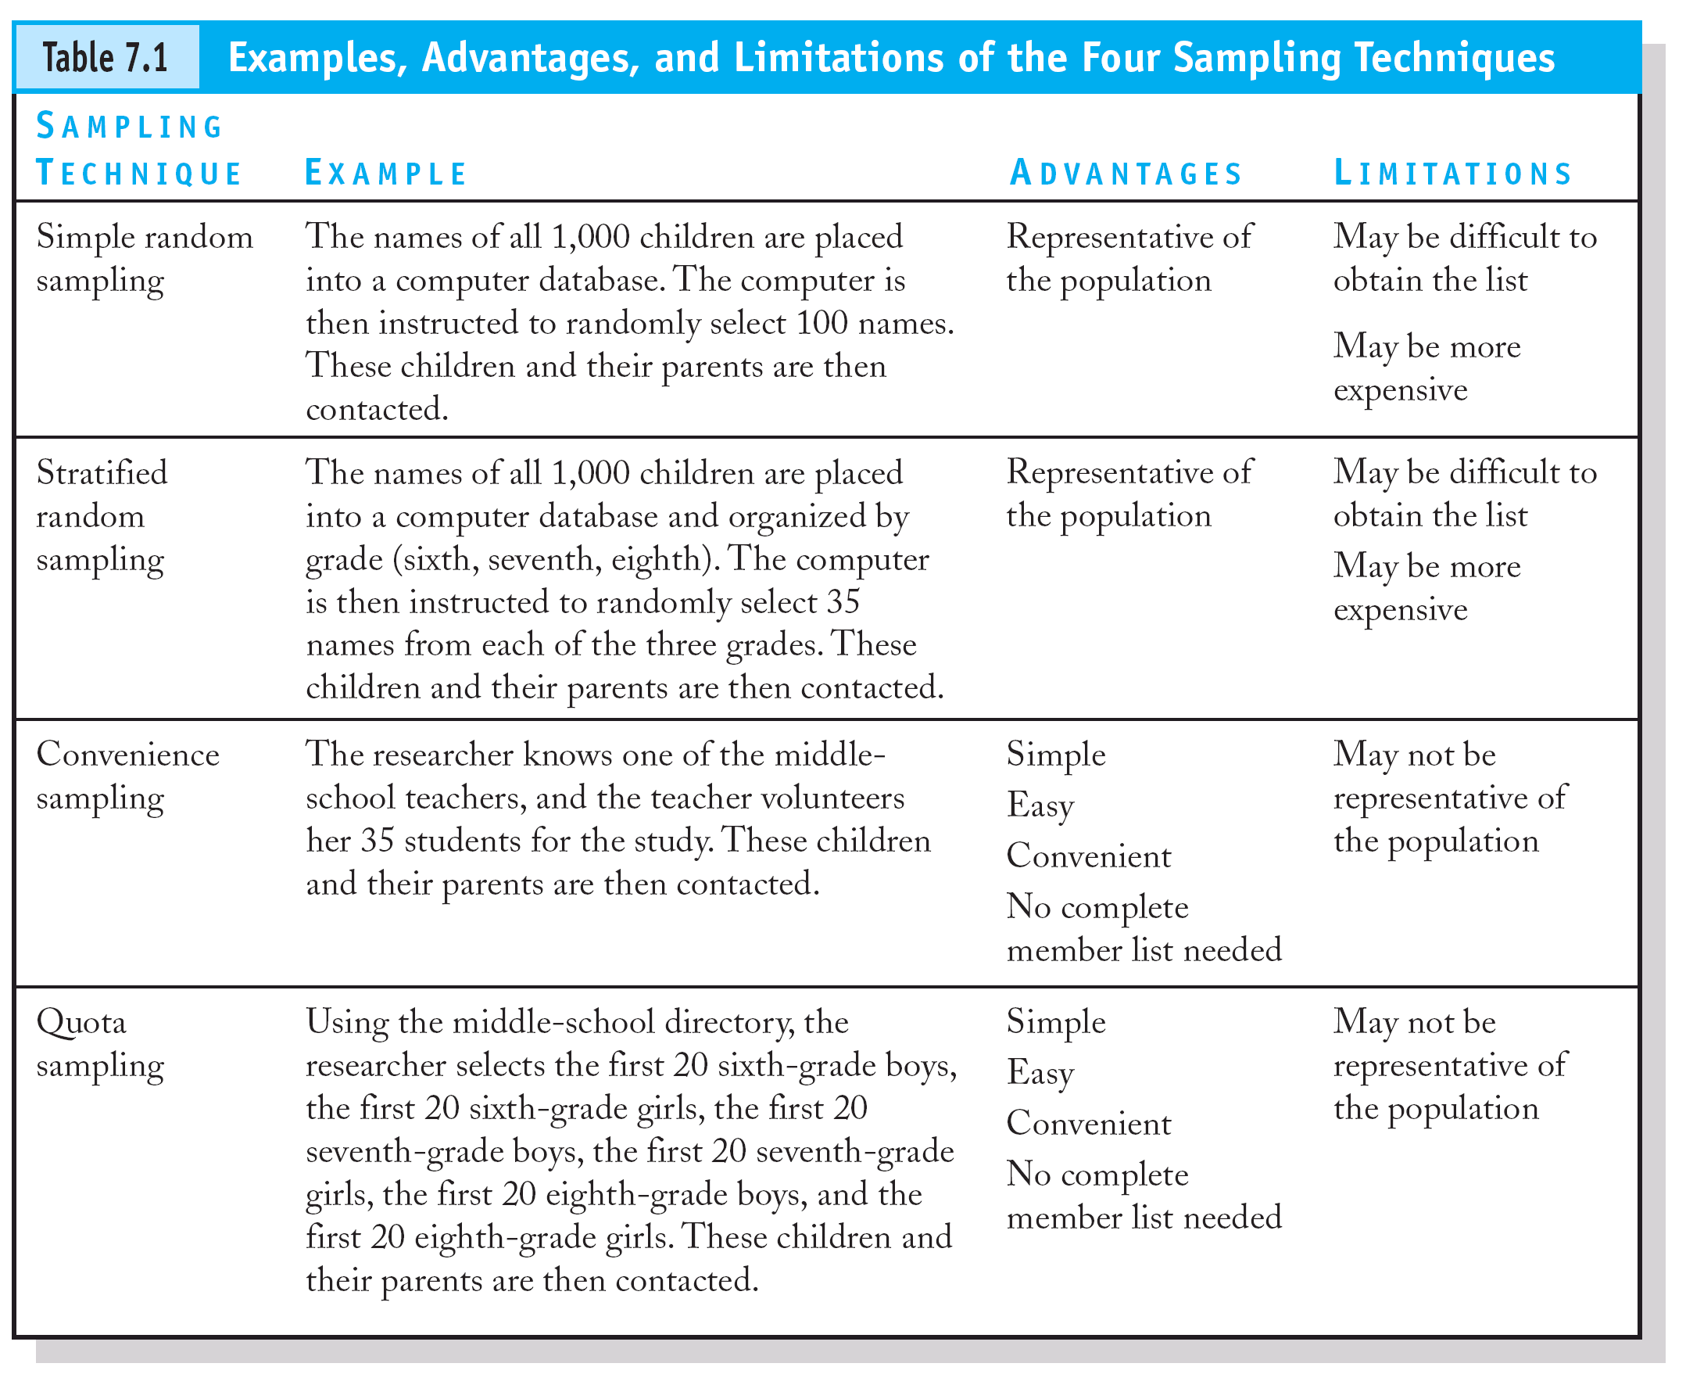

## 3.4 POPULATION DISTRIBUTION

The study target population was ten OK stores as making a total population of 10.

## 3.5 SAMPLE SIZE

A sample is portion or part of the population of interest. For purpose of manageability, the study used a selected representative sample of 10% of the target population as recommended by Mugenda and Mugenda (2003). The study used Yamane's formulae, n= N/ (1 + Ne2), to determine the sample size (Yamane, 1967).

Where;

**n** was the sample size for the study.

**N** was that sample study.

**e** was the level of precision.

## 3.6 SAMPLING TECHNIQUE.

This study used random sampling technique. The purpose of sampling is to gain an understanding about some features or attributes of the whole population based on the characteristics of the sample. Huber, (2018) reports that a sample constitutes a percentage of the research population carefully selected to participate in a study as a population representative.

## 3.7 DATA SOURCES

The study used both primary data and secondary to gather information of the study. These sources gave the researcher access to more information so as to improve the reliability and validity of the sources.

### 3.7.1 Primary Data

Refers to first hand source of information (Gill, 2019). It comprises of questionnaires, interviews, focus groups, surveys and observations. The use of primary data when conducting a study is very useful in that the researcher will get data which will be first applied to carry out a study. The use of primary data has couple of advantages where it directly solves a problem at hand.

### 3.7.2 Secondary Data

Secondary data refers to second hand information gathered from the third parties (Fowler, 2015). Usually, the information had been successfully used to solve a certain problem aroused. The data is readily available and the researcher can get this information from published journals, text books and internet. In the 20th Centuries and going back, there was no COVID-19 which means there were several problems causing supply chain disruptions and organizational performance other than COVID-19 which are poor logistics, lack of inventory, lack of technology and inefficiency and they are written in journals and text books. The secondary data helped the researcher to get more information and also to be in line with empirical literature review, hence it allows the researcher to get enough data on the research topic. The secondary data has a disadvantage that the data might not be relevant to the research project hence inaccuracy findings can be produced which might lead to invisibility and unreliable.

## 3.8 RESEARCH INSTRUMENTS

These are tools used to collect data which are questionnaires and interviews. It enables the researcher to get variety of information relevant to the study.

### 3.8.1 Questionnaires

It is very useful to the researcher to use questionnaires as an instrument because questionnaires contain all the detailed information, covering many subjects or issues; they can also be very simple and focus on one important area. The respondents are freely to give their opinions and suggestions without use of violence (John, 2014).

The researcher prepared a questionnaire specifically to the employees of an organization who are under procurement department and others who works hand in hand with it, and also the selected suppliers who supplied OK Zimbabwe. Different information gathered because each and every respondent were to respond at their level of understanding hence couple of answers were to be gathered. However, this had increased the amount of time spent in completing the questionnaires and this may provide irrelevant responses that seem disjointed.

### 3.8.2 Interviews

Interviews ‘involve a set of assumptions and understandings about the situation which are not normally associated with a casual conversation’ (Denscombe 1998: 109). Interviews have long been used in research as a way of obtaining detailed information about a topic or subject. It can be virtual or face-face conversation. Especially duringCOVID-19, interviews were conducted online thus reducing the spreading of the pandemic. The researcher used virtual interviews because COVID-19 cases were still rising. The researcher also did face-face interviews if she gets enough time to balance the courses and time to go in field.

Interviews were done in a short period of time because the respondents were giving their opinions during and after the discussion. Also, the researcher was able to pick suspicious information made by an interviewee, thus is by gestures or communication so accurate data was collected.

However, Johnson and Turner (2003, p. 308) list the strengths of the interview encounter as follows; good for measuring attitudes and most other content of interest, allow probing by the interview, can provide in-depth information, allow good interpretative validity, very quick turnaround for telephone interviews, moderately high measurement validity for well-constructed and well-tested interview protocols. To improve validity and reliability of the gathered information, the researcher booked for an appointment with the respondents.

## 3.9 DATA COLLECTION PROCEDURE

Firstly, the data was collected by the use of the questionnaire. The questionnaire had few questions to answer so as to encourage all respondents to answer. If the questionnaires contain many questions, it may turn up some respondents hence the opinions of the respondents will be few so the researcher made use of very few questions so as to come up with judgment. The researcher distributed them through emails because COVID-19 is still there. Also, the questionnaires distributed carried all the instructions on how they were to be answered.

Interviews were conducted so as to gather crucial information about the research problem. The researcher drafted interview questions which were clear and understandable. The researcher made sure that the interview questions were the same so as to gather consistent data of the research problem.

The researcher used published journals, text books from Bindura University Library and organizational documents to collect relevant data. The use of second-hand information helped the researcher to get more information which made it easier to get more important source from other past researchers.

### 3.9.1 Validity

Validity is concerned with whether our research is believable and true and whether it is evaluating what it is supposed or purports to evaluate (Garvey, 1999). The researcher used questionnaires, interviews and observation to collect relevant data which improves the degree of validity and reliability. In order to strengthen the validity of evaluation data and findings, the investigator should try to collect data through several sources, questionnaires, interviews and classroom observations. Gathering data through one technique can be questionable, biased and weak. However, collecting information from a variety of sources and with a variety of techniques can confirm findings.

### 3.9.2 Reliability

Reliability deals with the consistency, dependability and reliability of “the results obtained from a piece of research” (Nunan, 1999, p. 14).The use of multiple researchers or participant researchers as Nunan (1999, p. 60) acknowledges “In much research this is not feasible, because a research team consisting of several members can be extremely expensive.” However, he suggests that the researcher can ask the experienced participants to help him/her verify and confirm in the data collection, analysis and interpretations. Therefore, the researcher used expert sampling in the analysis, interpretation and validating conclusions. The researcher used expert sampling in providing confirmation of validity to another approach of a selection of sampling.

### 3.9.3 Ethical Consideration

It is very important to ethical research and study in order to get relevant results. The informed participants should not be forced to give full information the researcher requested. The participants should be free during interviews and when responding to the questionnaires. The respondents can be allowed to leave the process at any time with or without giving the information, also without notice. The researcher should be open when collecting data from the respondents that is by starting introducing herself and let them know that you are doing a research so that you get relevant and accuracy data.

## 3.10 DATA PRESENTATION AND ANALYSIS TECHNIQUES

The researcher presented and analyzed data by use of bar graphs, line graph, tables and pie charts posed in the next chapter. The use of descriptive clears all the confusion to the reader, also, it is short and precise and easy to understand.

## 3.11 CHAPTER SUMMARY

This chapter focused on the research methodology. The chapter focused on the research design, target population, sample size and technique, data sources both primary and secondary, research instruments, data collection procedure, validity and reliability, ethical consideration ending with data presentation and analysis techniques. The following chapter is going to focus on data presentation, analysis, discussion and interpretation of findings. Data would be presented using bar graphs, line graph, tables and pie charts.

# CHAPTER IV:

## 4.0 DATA PRESENTATION & DISCUSSION

### 4.1 INTRODUCTION

The previous chapter broadly looked at methodology and then focused on what constitute the methodology. This chapter presents the research findings, data analysis, presentation and interpretation of the findings. The data presented includes response rate, background information of the respondents and a presentation of findings against each individual objectives of the study. The data analyzed and presentation was based on the responses to the items in the questionnaires and interviews done. Descriptive statistics are also used in analyzing the findings of this research project.

## 4.2 DATA PRESENTATION AND ANALYSIS

The data collected was coded, analyzed, classified, and tabulated into pie charts and bar charts to all the sections enhancing uniformity, understanding and easy interpretation of the data. The questionnaire was coded into different sections to minimize the margin of error and highest accuracy during analysis. The data was processed by use of Excel to analyze variables that included age of the respondents, educational qualifications, the critical success factors and the challenges. It was interpreted using tables and pie charts to articulate research findings.

Figure 7: Gender respondents

**Source**: Primary Data (2023)

Figure 8: Age Respondents

**Source**: Primary Data (2023)

Figure 9: Educational Qualifications

**Source**: Primary Data (2023)

Figure 10: Department Respondents

**Source**: Primary Data (2023)

Figure 11: Position Respondents

**Source**: Primary Data (2023)

## 4.3 RESPONSE RATE

For the purpose of this study, 110 questionnaires were evenly administered to the organization departments. Out of the 110, 100 (one hundred) were successfully filled and returned and as such, they were considered as the sample with a response rate of 91% and 10 were unsuccessfully responded to because of illiteracy having a 9% as presented in table 4.3

Figure 4.3 below shows the results on questionnaire respondents

Figure 11: Questionnaire Percentage Respondents

**Source**: Primary Data (2023)

Table 4.1 Response rate per OK Zimbabwe branch.

|  |  |  |  |
| --- | --- | --- | --- |
| Branch | Actual response | Expected | Percentage |
|  | 10 | 10 | 100% |
|  | 10 | 10 | 100% |
|  | 8 | 9 | 88% |
|  | 9 | 9 | 100% |
|  | 8 | 8 | 100% |
|  | 7 | 7 | 100% |
|  | 6 | 7 | 85% |
|  | 9 | 9 | 100% |
|  | 10 | 10 | 100% |
|  | 10 | 10 | 100% |
| Total | 87 | 89 | 97% |

Figure 12: Response Rate per Branch OK Zimbabwe Harare

**Source**; Field data, 2023

## 4.4 PRESENTATION ANALYSIS

### 4.4.1 Objective 1: To analyze ways in which COVID-19 disrupts supply chain ecosystems of OK Zimbabwe operations.

The first objective of this study was aimed to analyze ways in which COVID-19 disrupts supply chain ecosystems of OK Zimbabwe. With the help of primary and secondary data, the common COVID-19 impacts in supply chain management were identified. Here, a data triangulation approach was used to identify the impacts from three sources:

First, a literature review was carried out to collect research articles for this study. Articles were identified in scientific databases such as SCOPUS, Web of Science, Google Scholar, EBSCO, and Science Direct. Several keywords such as ‘COVID-19 AND developing countries’, ‘Impact of COVID-19 in supply chains’, ‘COVID-19 AND sustainability’, ‘COVID-19 AND SDGs’, and ‘COVID-19 AND global trade’ were used for the collection of the articles. In the initial stage, 100+ articles were taken from a variety of journals. Next, a screening process was introduced to find the most relevant papers. The articles included in the literature review were selected based on the following inclusion criteria: (i) articles published in English only considered, (ii) must be peer-reviewed, and (iii) articles focusing on the COVID-19 impacts on supply chains were considered. The exclusion criteria included conference proceedings, short communications, and duplicative works. After the final screening, only 33 articles were found to match the criteria to conceptualize this study’s supply chain disruption risk constructs and variables. Therefore, these articles were acknowledged in this study.

However, to identify the impacts in a real-life scenario, in-depth interviews with Ok Zimbabwe managers were conducted from January 2023 to May 2023. 20 supply chain managers working at any branch were approached for the interviews via email and, out of 20, only 18 were interviewed. The interview started with a basic introduction of COVID-19 and how it has affected industrial activities. Finally, the interview focused on identifying the COVID-19 impacts on supply chain activities. From these interviews, few impacts were identified.

Finally, here a list of 25 COVID-19 impacts on the supply chain was identified from the literature review and interviews were carried out with the managers. They were asked to mark the impacts that appeared to be significant from their view and the neglect impacts that they felt were insignificant. By consolidating the responses of the managers, 20 common impacts were selected. The finalized COVID-19 impacts considered for this study are given in Table 4.2

Table 4.2 COVID-19 impacts on supply chain activities.

|  |  |
| --- | --- |
| COVID-19 Impacts | Definition |
| Technical workforce shortage | Restricted movement of labor results in  technical workforce shortages |
| Stalled industrial activity | Lack of workforce and demand halted  industrial activity |
| Difficulty in demand forecasting | Being unsure about the buying capacity of  people, it is difficult to predict the demands |
| Reduced production capacity | Insufficient demand in the market results  in a reduction of production capacity |
| Disproportionateness between supply and demand | Supply and demand equation has been  collapsed due to panic buying |
| Obsolescence of machines | Prolonged suspension of production made  the machine obsolete |
| Production disruption and backlog | Industries were unable to complete the  earlier committed assignments |
| Disruption in supply | Lockdown restriction prohibited the  movement of supply |
| Pilling up of inventory | Absence of market demand increased the  inventory |
| Increased transportation cost | Limited transportation option is directly  proportional to increased  transportation cost |
| Lack of supplier engagement | Citing uncertainty in the global market,  most of the suppliers disengage from the  supply chain network |
| Increased lead time to delivery | Collapsed supply chain network increase  the delivery time |
| Lack of international trade | Segmented lockdown restricted  global trade |
| Supply chain collapse | Individual lockdown by different countries  collapsed the supply chain network |
| Lack of physical distribution channel | Disengagement of suppliers creates a void  in the supply chain network |
| Ripple effect on supply chain operations | Suspension of supply chain activity in one  end creates catastrophe at the other end |
| Mass layoffs | Absence of industrial activity leads to  mass layoffs |
| Lockdown restriction | Imposed to control COVID-19 outbreak |
| Distress on Return of investment | Stalled industrial activity raised a question  on the return of investment |
| Reduced cash inflow | Absence of supply and demand activity  reduced cash inflow |

### 4.4.2 Objective 1: To establish the effects of Government imposed national wide lockdown measures on profitability of OK Zimbabwe.

The second objective was to establish the effects of government imposed national lockdown on profitability of OK Zimbabwe. They was reduction in business hours which came to effect on March 30 2020, when President Mnangagwa put Zimbabwe on national lockdown as part of measures to curb the spread of COVID-19, which chewed the retail giant, OK Zimbabwe’s revenue. Under the lockdown measures businesses were allowed to operate between 08:00hrs and 15:00 hours. For about three months into the lockdown Ok-Zimbabwe revenue for the quarter dropped compared to the same period from previous years (Munyuru, 2020). Revenue for the quarter was below prior year by 13% (inflation adjusted) and grew by 661% (historical) over the same period. Also same volumes for the quarter were 32.7% below the same period in the prior year. Profit margins are within expectations. So concluding the researcher established that the effects of government on national lockdown made the revenue of OK-Zimbabwe to drop and take a loss.

## 4.5 CONCLUSION

The study was undertaken to understand the supply disruptions and organizational performance due the COVID-19. Results also showed the level of preparedness of supply chain organizations before and after COVID-19. Organization and supply chain planning, and distribution, were the top two areas cited as being affected. The escalating severity of the COVID-19 outbreak among countries has intensified supply chain disruption and uncertainty. The survey showed varying levels of readiness prior to the outbreak of the pandemic. However, respondents seemed to think that their present preparedness is better than it was before. The study supports the need for improved forecasting tools and an integrated approach to respond to supply chain disruptions. The pandemic has reiterated that only organizations with concrete comprehensive readiness plans can assert with certainty that they are ready for major supply chain disruptions. The integration of technology to simulate similar supply chain disruptions and being cognizant of supply chain partners' level of preparedness will also be helpful.

# CHAPTER V:

## 5.0 SUMMARY, CONCLUSIONS AND RECOMMENDATIONS

### 5.1 INTRODUCTION

The findings are compiled in this chapter, and conclusions are made in light of them. The previous chapter focused on the research results, data analysis, data presentation, interpretation of the results and conclusions. This chapter presents a summary of the study findings and recommendations based on the major findings.

## 5.2 SUMMARIES

### 5.2.1 SUMMARY ON OBJECTIVE1

This study's objective was to analyze ways in which COVID-19 disrupts supply chain ecosystems of OK-Zimbabwe operations. The common COVID-19 effects on supply chain disruption were found using primary and secondary data. To determine the impacts in this situation, a data triangulation strategy was applied. To illustrate the impacts of COVID-19 the researcher constructed a table with the definitions explaining the impacts in detail.

### 5.2.2 SUMMARY ON OBJECTIVE 2

To establish the effects of Government imposed national wide lockdown measures on profitability of OK-Zimbabwe was the second objective of the study. By looking into OK-Zimbabwe Revenues the researcher highlighted enough information that shows that OK-Zimbabwe had disruptions and business went down to a certain percentage. Also data shows that before or prior previous years the revenue was at its most high and during COVID restrictions they was a decrease in the revenue. The results show that the lockdown affected the supply chain.

## 5.3 CONCLUSIONS

### 5.3.1 CONCLUSIONS ON OBJECTIVE 1

The study examined COVID-19 disruptions on supply chain at OK-Zimbabwe. The study was planned to include 110 respondents but the response of 100 was received. It was revealed that COVID-19 disrupts supply chains and poses a threat to organizations.

5.3.2 CONCLUSIONS ON OBJECTIVE2

The study established the effects of government imposed national lockdown measures on profitability of OK-Zimbabwe. It was revealed that due to those restrictions this organization had to do lay-offs so that they can manage their revenues and make as little profits they can make. Also it is revealed some measures had to be put in place since businesses were closing earlier than usual.

## 5.4 RECOMMENDATIONS

COVID-19 created the various supply chain dimensions suggested that the pandemic caused fluctuations and shifts in demand (both reduction and an exponential increase). Although this might appear to be an isolated event, the survey highlights the need for improved forecasting tools across the supply chains. It might also be argued that demand planning alone may not be enough. Integrating supply and demand planning through an integrated approach will help to respond more quickly to rapid disruptions (Ivanov, 2020b). Organizations should create continuity plans defining a variety of crisis scenarios to build policies to limit the harm, much like banks conduct stress tests.

The difference between being somewhat prepared and fully prepared can significantly determine supply chain partners response, recovery, and future actions. Including amongst survey respondents, there may be a risk of organizations overestimating their ability to face disruptions; it needs to be reiterated that only organizations with concrete comprehensive readiness plans can assert with certainty that they are ready for major supply chain disruptions.

Advanced planning tools and simulator software can help supply chain managers develop readiness plans to support organizations through major disruptions. The pandemic has also highlighted the need to know and access the readiness plans of supply chain partners as significant impact can also be felt from the unpreparedness of other supply chain stakeholders. This necessitates the need to continually evaluate supplier performance and create contingency plans involving partners.

The road to recovery presents several challenges. Although most of the survey respondents were optimistic regarding a speedy recovery, reestablishing links with suppliers that have been affected by the pandemic can be an organizational challenge. Transparent communication, collaboration, and information exchange among key supply chain partners will be critical to recovery. The survey insights and recommendations can help supply chain leaders, executives, business partners, customers for better understand the industry and how COVID-19 has impacted supply chains in the global economy.

## 5.5 SUGGESTIONS FOR FURTHER STUDIES

This study focused on the supply chain disruptions and organizational performance, it therefore recommends that further studies should be conducted to focus on other retail stores and the industry at large and how they were affected by the pandemic and how they survived through the pandemic. Finally, lessons from COVID-19 pandemic suggest bottlenecks in supply chains for essential equipment and services that must be addressed to improve resilience against future crisis.

# REFERENCES

1. Abdelnour, A., Devignes, J., Randery, T., and Rogers, J. (2020). COVID-19 crisis: How distributors can emerge stronger than before. McKinsey & Company Article, October 2020.

2. Brandon-Jones, E., Squire, B., Autry, C.W. and Petersen, K.J. (2014). A contingent resource-based perspective of supply chain resilience and robustness. Journal of Supply Chain Management, Vol. 50 No. 3, pp. 55-73.

3. Christopher, M. and Peck, H. (2004). Building the Resilient Supply Chain. The International Journal of Logistics Management, Vol. 15 No. 2, pp. 1-14. https://doi.org/10.1108/09574090410700275

4. de Vos, J. (2020). The effect of COVID-19 and subsequent social distancing on travel behavior Transp. Res. Interdiscip. Perspect., 5 (2020), p. 100121, 10.1016/j.trip.2020.100121

5. Garvey M.D., and Carnovale S. (2020). The rippled newsvendor: A new inventory framework for modelling supply chain risk severity in the presence of risk propagation. International Journal of Production Economics. 2020; 228:107752

6. Gölgeci, I. and Ponomarov, S.Y. (2015). How does firm innovativeness enable supply chain resilience? The moderating role of supply uncertainty and interdependence. Technology Analysis

7. Guan, D., Wang, D., Hallegatte, S. et al., (2020). Global supply-chain effects of COVID-19 control measures. Nat Hum Behav 4, 577–587 (2020). https://doi.org/10.1038/s41562-020-0896-8

8. Ivanov, D. (2020a). Predicting the impacts of epidemic outbreaks on global supply chains: a simulation-based analysis on the coronavirus outbreak (COVID-19/SARS-CoV-2) case Transp. Res. E Logist. Transp. Rev., 136 (2020), p. 101922.

9. Ivanov, D. (2020b) Viable supply chain model: integrating agility, resilience and sustainability perspectives—lessons from and thinking beyond the COVID-19 pandemic. Annals of Operation Research (2020). https://doi.org/10.1007/s10479-020-03640-6

10. Johnson, N., Elliott, D. and Drake, P. (2013). Exploring the role of social capital in facilitating supply chain resilience. Supply Chain Management: An International Journal, Vol. 18 No. 3, pp. 324-336.

11. Banik, A.; Nag, T.; Chowdhury, S.R.; Chatterjee, R. Why Do COVID-19 Fatality Rates Differ Across Countries? An Explorative Cross-country Study Based on Select Indicators. Glob. Bus. Rev. **2020**, 21, 607–625. [CrossRef]

12. Kandel, N.; Chungong, S.; Omaar, A.; Xing, J. Health security capacities in the context of COVID-19 outbreak: An analysis of International Health Regulations annual report data from 182 countries. Lancet **2020**, 395, 1047–1053. [CrossRef]

13. Chowdhury, P.; Paul, S.K.; Kaisar, S.; Moktadir, M.A. COVID-19 pandemic related supply chain studies: A systematic review. Transp. Res. Part E Logist. Transp. Rev. **2021**, 148, 102271. [CrossRef] [PubMed]

14. Koshta, N.; Devi, Y.; Patra, S. Aerial Bots in the Supply Chain: A New Ally to Combat COVID-19. Technol. Soc. **2021**, 66, 101646. [CrossRef] [PubMed]

15. Rizou, M.; Galanakis, I.M.; Aldawoud, T.M.S.; Galanakis, C.M. Safety of foods, food supply chain and environment within the COVID-19 pandemic. Trends Food Sci. Technol. **2020**, 102, 293–299. [CrossRef]

16. Chen, J.; Wang, H.; Zhong, R.Y. A supply chain disruption recovery strategy considering product change under COVID-19. J. Manuf. Syst. **2021**, 60, 920–927. [CrossRef]

17. Belhadi, A.; Kamble, S.; Jabbour, C.J.C.; Gunasekaran, A.; Ndubisi, N.O.; Venkatesh, M. Manufacturing and service supply chain resilience to the COVID-19 outbreak: Lessons learned from the automobile and airline industries. Technol. Forecast. Soc. Chang. **2021**, 163, 120447. [CrossRef]

18. Anser, M.K.; Khan, M.A.; Nassani, A.A.; Abro, M.M.Q.; Zaman, K.; Kabbani, A. Does COVID-19 pandemic disrupt sustainable supply chain process? Covering some new global facts. Environ. Sci. Pollut. Res. **2021**, 28, 59792–59804. [CrossRef]

19. Hoekman, B.; Mavroidis, P.C. WTO Reform: Back to the Past to Build for the Future. Glob. Policy **2021**, 12, 5–12. [CrossRef]

20. Remko, V.H. Research opportunities for a more resilient post-COVID-19 supply chain—closing the gap between research findings and industry practice. Int. J. Oper. Prod. Manag. **2020**, 40, 341–355. [CrossRef]

21. Tanyaradzwa Rukasha, Brighton Nyagadza, Rumbidzai Pashapa & Asphat Muposhi | (2021) Covid-19 impact on Zimbabwean agricultural supply chains and markets: A sustainable livelihoods perspective, Cogent Social Sciences, 7:1, 1928980, DOI: 10.1080/23311886.2021.1928980

22. Weber, A.N., 2021, ‘Responding to supply chain disruptions caused by the COVID-19 pandemic: A Black Swan event for omnichannel retailers’, *Journal of Transport and Supply Chain Management* 15(0), a628. https://doi.org/10.4102/ jtscm.v15i0.628

23. Felix Chari, Ozwell Muzinda, Cawe Novukela & Bethuel Sibongiseni Ngcamu (2022) Pandemic outbreaks and food supply chains in developing countries: A case of COVID-19 in Zimbabwe, Cogent Business & Management, 9:1, 2026188, DOI: 10.1080/23311975.2022.2026188 url: https://doi.org/10.1080/23311975.2022.2026188

# APPENDIX

**Research Application letter to OK Zimbabwe Harare**

# **SECTION A: DEMOGRAPHIC**

### Instructions

* Fill in the boxes or gaps of each question with an answer of your choice, provide with yes/no and or a tick.
* Do not fill all the boxes as one question requires the best answer of your choice.
* Cancel once the wrong answer and write the correct one on top of the box.

1. Gender Male Female

### Which age are you ranging?

16-24

25-40

Above 40

### Academic qualifications

Certificate

Diploma

Undergraduate degree

Postgraduate degree

### Department

Procurement 

Sales and Marketing 

Production 

Finance and Administration 

### Position/Post

Top Directors 

Management 

Low level staff 

Others, specify

…………………………………………………………………………………………………………………………………………………………………………………………………………………………………………………………………………………………………………………………………………………………………………………………………………………………………………………………………………………………………………………………

1. What are your years of work experience at OK Zimbabwe?

……………………………………………………………………………………………………..

# **SECTION B**

Instructions: Kindly provide the best answer.

1. In which ways does COVID-19 disrupts supply chain ecosystems and the operations of OK Zimbabwe?

………………………………………………………………………………………………………………………………………………………………………………………………………………………………………………………………………………………………………………………………………………………………………………………………………………………………………………………………………………………………………………………………………………………………………………………………

1. What effects were incurred by OK Zimbabwe Harare after the government imposed national lockdown during the COVID-19 pandemic era?
2. Positive effects……………………………………………………………………………... ................................................................................................................................................................................................................................................................................................
3. Negative effects……………………………………………………………………………………………………………………………………………………………………………………………………………………………………………………………………………………………………………………………………………………………………………

# **SECTION C**

1. a) The following are the strategies used to mitigate supply chain disruptions, which positively contribute to organizational performance during COVID-19.

Of the strategies mentioned below if it had a positive effect on OK Zimbabwe’s organizational profitability and sales, tick on either strongly agree or agree selection box, and if it had a negative effect tick on either strongly disagree or disagree selection box otherwise tick on the uncertain selection box if you are not sure.

1. Local sourcing.
2. Strongly disagree b) Disagree c) Strongly agree

d) Agree e) Uncertain

ii. Multiple Sourcing.

1. Strongly disagree b) Disagree c) Strongly agree

d) Agree e) Uncertain

iii) Electronic Procurement

1. Strongly disagree b) Disagree c) Strongly agree

d) Agree e) Uncertain

1. If there are any other not mentioned above strategies that were used to mitigate supply chain disruptions in OK Zimbabwe which positively contribute to the organizational profitability and sales, specify.

…………………………………………………………………………………………………………………………………………………………………………………………………………………………………………………………………………………………………………………………………………..............................................................................................................................................................................................................................................................