**BINDURA UNIVERSITY OF SCIENCE EDUCATION**

**FACULTY OF COMMERCE**

**DEPARTMENT OF ACCOUNTANCY**



**TOPIC: AN ASSESSMENT OF THE EFFECTS OF DIGITALIZATION ON THE ACCOUNTING PROFESSION**

**BY**

**MASHOKO CHARLENE SHAMISO**

**(B1953682)**

# APPROVAL FORM

The undersigned certify that they have read and recommended to the Bindura University of Science Education for acceptance of the dissertation entitled **AN ASSESSMENT OF THE EFFECTS OF DIGITALIZATION ON THE ACCOUNTING PROFESSION**

Submitted by **B1953682** in partial fulfilment of the requirements of the Bachelor of Accountancy (Honours) Degree

………………………………… ……………………… ………/…………/……………

Name of Student Signature Date

………………………………. ……………………… ………/………./……………

Name of Supervisor Signature Date

……………………………. ……………………….. ………/………/……………..

Name of Chairman Signature Date

# RELEASE FORM

**AUTHOR: B1953682**

**TITLE: An assessment of the effects of digitalization on the Accounting Profession**

**PROGRAM:** Bachelor of Accountancy (Honors)

Permission is do hereby given to Bindura University of Science Education library to produce copies of this dissertation or lend such copies for private, scholarly or scientific research only. The author does not reserve other publication rights on the dissertation and extensive extracts from it be printed or otherwise produced without the author’s written permission.

**SIGNED :…………………………………………………..**

**DATE :……………………………………………………**

**PERMANENT ADDRESS :**

# 

# Dedication

This research is dedicated to all the people in accounting sector and also to my lecturers, fellow students and true friends for their social and academic backing.

To my mother and my guardian.

# Acknowledgements

First of all I am grateful to the almighty God who made it all possible through his sufficient grace. I am also grateful to all those who assisted me through their support and their relentless efforts. I thank my supervisor Mr Masinire for his time and dedication in the research for he showed me how to do it. I am also grateful to all those who participated in answering the questionnaires I am really grateful for their help towards my research. Special thanks goes deepest and profound love to my family especially my parents for the support they gave me during the time of research in form of words of encouragement. Last but not least I thank my friends and colleagues who were with me all the way in carrying out the necessary researches.

# Abstract

Digitalization and digital technologies is the currently discussed among various profession as some professions are at the verge of losing their relevance as some of the tasks that are used to be carried out by humans are now being carried out by machines and computer programs. The aim of this study was to assess the effects of digitalization on the accounting profession. The research was carried out as an exploratory research as the researcher tried to explore the future effects to be experienced that are not part of the current effects being encountered. The researcher used questionnaires as research instruments for data collection and the data collected was analyzed and presented. In the study it was found that there is a high chance that some of accounting tasks are going to be automated and carried out by machines and computer programs. However, despite the fact of automation of some of accounting tasks, the profession still will remain relevant because some of the tasks in accounting requires human input especially in the decision making process. It was also concluded that the education system for accounting professionals needs to be reformed in order for the accounting professionals to be able to embrace the demands of the new digital solutions and remain relevant as a profession.

Contents

Declaration 2

Dedication 3

Acknowledgements 4

Abstract 5

**CHAPTER ONE: INTRODUCTION** 10

**1.0** **Introduction** 10

**1.1** **Problem Statement** 11

**1.2** **Purpose of the study** 11

**1.3** **Objectives** 12

**1.4** **Significance of the Study** 12

**1.5** **Assumptions of the study** 12

**1.6** **Research Questions** 12

**1.7** **Scope of the study** 13

**1.8** **Limitations of the study** 13

**1.9** **Organization of the study** 13

**CHAPTER TWO: LITERATURE REVIEW** 14

**2.0 Introduction** 14

**2.1. Accounting** 14

**2.3 DIGITALISATION AND TECHNOLOGIES** 15

**2.4 Digitalization as an innovation** 16

**2.5 Digital technologies affecting Accounting** 17

**2.6 Automation and Robotics Process Automation** 17

**Use Cases of RPA in Finance** 18

**Use cases of RPA in Auditing** 18

**Human Driven (Manual) vs RPA Process** 19

**Requirements of Effective RPA process in Accounting** 20

**2.7 Artificial intelligence** 21

**2.8 Big Data** 22

**2.9. Blockchain** 23

**2.10 EMPIRICAL REVIEW** 23

**CHAPTER THREE: RESEARCH METHODOLOGY** 25

**3.0 INTRODUCTION** 25

**3.1 Research Design** 25

**3.2 Target population and Sampling Techniques** 26

**Arguments for Quota Sampling Technique** 26

**3.3 Research Instruments** 27

**Advantages of using questionnaires in this research** 27

**3.4 Data Collection** 28

**3.4.1 Primary Sources of Data** 28

**3.4.2 Secondary Sources of Data** 29

**3.5 Data Presentation** 29

**3.6 Data Validity and Reliability Analysis** 29

**3.6 Chapter Summary** 30

**CHAPTER FOUR DATA PRESENTATION AND ANALYSIS OF RESULTS** 30

**4.0 Introduction** 30

**4.1 Response Rate** 30

**4.2 Objective 1: Effects of Digitalization on the accounting profession** 31

**4.3 objective 2: Digital technologies being used in Accounting** 37

**4.4 Objective 3: New accounting dimensions possible** 40

**4.6 Summary** 42

**CHAPTER FIVE:** 43

**CONCLUSIONS AND RECCOMENDATIONS** 43

**5.0 Introduction** 43

**5.1 Summary of Findings** 43

**5.1.1 Key effects of digitalization on the accounting profession** 43

**5.1.2 Digital technologies in use today in Zimbabwe.** 43

**5.1.3 New Dimensions for the Accounting Profession** 44

**5.2 Conclusion** 44

**5.3 Recommendations** 44

**5.4 Areas of Further research** 45

References 45

Appendix A 47

**Table of figures and tables**

**Table 1: Reliability Statistics** 28

**Table 2: Response rate** 29

**Table 3 Extent of use of [Big data] Technology** 37

[**Table 4 Extent of use of Automation and robotics process automation** 37

**Figure 1: Human driven vs. RPA process** 19

**Figure 2: Skillset requirements for a robot** 19

**Figure 3: Major effects of digitalization on the accounting profession** 30

**Figure 4: Automation and work efficiency** 31

**Figure 5: Automation and accuracy by accounting professionals** 32

**Figure 6: Big data and Cost to accounting** 33

**Figure 7: Artificial intelligence and strategic decision making** 34

**Figure 8: Digitalization and loss of relevance of some of accountants ‘roles** 35

**Figure 9: Digital technologies currently in use in Zimbabwe** 36

**Figure 10: Digital technologies and new skill requirements for accountants** 39

**Figure 11: Skill requirements for accountants to cope with digitalization** 40

**Figure 12: Strategies to ensure accountants have necessary skills required in digital world** 41

# **CHAPTER ONE: INTRODUCTION**

## **Introduction**

This chapter outlines the background to the study, the statement of the problem. It is this that the purpose and objectives of the study were outlined. The chapter also contains the research questions, the assumptions that were used in the study, the limitations that the researcher was exposed to as well as the scope of the study.

1. **Background to the Study**

Accounting is an old profession that stretches back to over a thousand years ago and it has developed and new set of rules have been developed overtime however the set of principles that are used in accounting have not changed. The double entry system which is the basis of accounting was developed by Luca Pacioli in 1494 is still used in modern accounting. Digitalization has effects on the strategic and competitive objectives of a business. It does not only influence the strategic and competitive objectives but, it also affects how the company practice its marketing strategies, develop its business models and create competitive advantage over other companies. In addition digitalization also influence the management, processing and storing of accounting information within the organization (Mancini, 2017). Digitalization and the ever evolving technology comes with updates and changes in the accounting profession. Due to technological developments accounting is now practiced through the use of digital platforms which has replaced physical books of prime entry and journals. In modern accounting accountants are no longer carrying out a lot of physical accounting and balancing off of books as these processes can be automated and carried out by computer programs. This has led to reduced workloads on accountants. In modern accounting companies are now using computer systems to track and record financial transactions this implies that the role traditional accountants used to play in now done faster and easy through the use of computer programs. These developments brought by digitalization and modern technology are forcing various professions to change constantly with new technologies being adopted. The accounting profession is at the top of the list of the professions that is mostly affected by this rapid development in technology. There were many technological systems that were not used in the accounting profession over a decade ago but due to development in technology these systems are now used in accounting profession (Tekbas, 2018). In a research carried out by (Frey, 2017) on the jobs that are at risk of extinction due to automation of processes, accounting was at the top of the list of the jobs with highest probability of being replaced by artificial intelligence and automation of processes.

## **Problem Statement**

The rapid development and adoption of digital technologies entails that the accounting profession might lose its relevance in the business world as firms move to employ digital solutions such as artificial intelligence and robotics process automation in place of traditional human accountants. This study aims to solve the problem of accounting profession losing its relevance by investigating the effects of digitalization on the accounting profession as well as determining the dimensions that the profession should venture into in order to maintain its relevance.

## **Purpose of the study**

The purpose of this study is to establish and analyze the key challenges that digitalization brings to the accounting profession in Zimbabwe. It is also the purpose of this research to establish the next steps that need to be taken by accountants to ensure that the profession still preserve its value in this rapid developing digital world. It is also the purpose of this study to determine the new dimensions that can be established in the accounting profession in order for the profession to stay afloat not to sink down due to the developments in the digital world.

## **Objectives**

1. To establish the key effects of digitalization on the accounting profession
2. To establish new dimensions that the accounting profession can expand into in the digital world
3. To establish the digital technologies that are used by accounting firms today

## **Research Questions**

1. What are the key challenges of digitalization to the accounting profession?
2. What are the new dimensions that the accounting profession can venture into in the digital world?
3. What are the digital technologies that are used by accounting firms in Zimbabwe?

## **Significance of the Study**

The study is important as it highlighted to the accountants and accounting students the potential threats that the profession face in the rapid developing digital world. The study is also important as it helped to undermine the new skillset the digital accountant needs to have in the emerging world of big data, cloud computing, blockchain and artificial intelligence. The study is also significant as it helped in establishing the new dimensions that the accounting profession needs to venture and expand into in order for the profession to remain relevant in the new digitalized world.

## **Assumptions of the study**

In carrying the study it was assumed that the researcher has no access to information about company specific processes to do with digitalization and automation of accounting processes that are being implemented by companies except those in the public domain.

It was also assumed that the accountants and the accounting students have knowledge of digitalization but are not fully aware of its effects to the profession.

.

## **Scope of the study**

The study was carried out in Zimbabwe and the information in this research was obtained from existing accountants who works for accounting firms in Zimbabwe that specializes in proving accounting, auditing and tax consulting services in Harare as well as students that are majoring in accounting at the Bindura University of Science Education. **Limitations of the study**

The study was carried out over short space of time given the importance of the study and what it meant to the fate of accounting profession more time is needed to establish the dimensions that the profession needs to venture into. However, to deal with this problem, the researcher resorted to gather expert knowledge from other accountants and accounting students that has vast knowledge to do with both the effects of digitalization and accounting profession. The researcher also gathered expert knowledge from external professionals outside accounting profession with critical analytical skills which were actuaries and data scientist.

In addition, since the researcher required expert skills of other external professionals given the budgetary constraints due to the fact that the researcher was a university student she was not able to raise consulting fees. In order to deal with this the researcher reached out to these experts for their opinions through the questionnaire that the researcher used for carrying out data collection.

## **Organization of the study**

The study consist of five chapter with the first chapter being the introductory chapter that introduces the subject of the study. The first chapter outlines the background to the study, the stamen of the problem. It is in the chapter one that the purpose and objectives of the study were outlined. The first chapter also contains the research questions, the assumptions that were used in the study, the limitations that the researcher was exposed to as well as the scope of the study.

The second chapter which is literature review consist of theoretical literature about digitalization and its possible effects of the accounting profession. It also consist of the empirical literature on the findings of other researchers in relation to effects of digitalization on the accounting profession. It is also in this chapter that the hypothesis was developed.

Chapter three outlines a detailed methodology that the researcher employed in carrying out the study. This chapter highlights the research design that was used as well as the research instruments that researcher employed. A detailed analysis on the arguments for the suitability of the research design and instruments were highlighted in this chapter. The chapter further outlined the target population and sampling techniques that were used as well as the sources of data the researcher used in conducting the research.

Chapter four consist of data analysis and presentation of results of the data that was obtained by the methodology outlined in chapter. The results and analysis of results in this chapter formed the basis of the recommendations and conclusion in the final chapter.

The final chapter which is chapter five comprise of the recommendation and conclusion the researcher reached after carrying out data analysis and presentation of results in chapter four.

**CHAPTER TWO: LITERATURE REVIEW**

Literature review is an academic writing that comprise of background body reviewing and discussion of sources and conclusion whose main purpose is to demonstrate knowledge and understanding of the academic writing (literature) on the specific topic being discussed.

**2.0 Introduction**

In this chapter we focus on defining the key concept of the research which is the effect of digitalization on the accounting profession. The key concept defined in this chapter are words that are commonly used on day to day basis in the accounting profession but some of them are misinterpreted the terms include accounting itself and digitalization. In the chapter the research went further to give a brief history of the accounting profession. It is also in this chapter that the researcher give a detailed explanation of digitalization and its main concept. Finally the empirical studies on the research topic by other scholars were given in this chapter and their findings outlined.

**2.1. Accounting**

Many scholars defines accounting in different ways some of them defines accounting as a social science and some of them defines accounting as statistical science. Therefore in this section we will look at the various definitions of accounting by different scholars so that the reader of this research will have a high level understanding about the profession.

(Laughlin, 1987)Defines accounting as a method and logical process that is used and followed by accountants to record process and analyze data. In this case accounting is viewed as a statistical science. This definition only gives the quantitative side of accounting, however, accounting has also its qualitative side which involves critical thinking in decision making. Accounting is the recording of transactions, data analysis, and prediction of results in order to make informed investment decisions (Duncan, (1909)). Accounting was defined as a statistical science which accountants use in making investment decisions.

The American Accounting Association defines accounting “as a process of identifying, measuring and communicating economic information to permit informed judgements and decisions by users of the information”. From this definition it was outlined that there are various users of accounting information and it can also be deduced that the users of accounting information have different requirements.

From the definitions above it can be noted that accounting can be subdivided into three different categories which are the technical operations, interpretations and social operations. The technical operations involves the recording of transactions and classification of data. Interpretations involves analysis and interpretations of events to predict the future. Social operations involves the interaction with customers and other users of accounting information. This research therefore seeks to analyze the effects of digitalization on these three categories of accounting it seeks to address how will the technical operations of the accounting profession can be influenced by digitalization as well as how the interpretations and the social operations are going to be influenced by the rapid development in technology.

**2.3 DIGITALISATION AND TECHNOLOGIES**

Digitalization is defined as a technical process of encoding and converting physical information into a digital format through the use of a computer (Maltaverne, 2017). This implies that there is no longer use of physical files but the use of files in computer program and software. Many people actually view digitalization and digital transformation as same terms but actually are different terms which are used similarly but on the actual fact they have different meanings. Digital transformation involves changes in strategies, business conduct and competencies into more advanced systems (Bharadwaj, 2013). Digital transformation involves the business going advancing its strategies by going digital or using digital technologies. The diagram below shows how Unruh and Kiron defines digitization, digitalization and digital transformation.



Definition of Digitization, Digitalization and Digital Transformation.

Source: Digital Transformation on Purpose by Unruh and Kiron, 2017.

The diagram above shows the distinction between the concept of digitization, digitalization and digital transformation so as to outline the differences between the concepts. Digitalization has been crucial for the work of accountants over the past decades while digital transformation was not of significant use.

**2.4 Digitalization as an innovation**

As outlined earlier during the definition of digitalization it is important to note that digitalization involves transforming analogue knowledge and information to become a stored digital form of knowledge and information. This allows easy access of information by accountants in real time via any electronic devices that are compatible with the information that has been stored on the various digital platforms. Therefore it is important to understand that digitalization is an innovation that is bringing a critical transformation in the accounting industry as a whole and other industries as well.

Innovation is defined as a process of changing an idea into a useful product or service that can be used to add value to users of the created product or services. An innovative product adds value to customers or consumers of the product. This implies that digitalization is an innovation in the accounting industry. (SouthernCrossUniversity, 2016) On their blog outlined that digital accounting will help the accounting industry in value creation through the use of its technological services, techniques to satisfy consumers and bring new consumer segments.

**2.5 Digital technologies affecting Accounting**

There are several digital are affecting accounting and among the technologies are automation (Belkadi, 2015), artificial intelligence, cloud computing and blockchain technology. These technologies are impacting accounting in both good and bad ways. Some of them are making the accounting profession a better profession and some are a threat to the role of accountants in the digital world. In this section we are going to take a look at each of the technologies and try to outline how it influences the accounting profession. Despite the fact that these technologies are not in much use in the accounting industry of Zimbabwe their impact on the industry should not be left unrevealed.

**2.6 Automation and Robotics Process Automation**

Software developers and programmers have developed software’s and applications that allows accountants to automate some accounting processes so that the most usual and repetitive tasks can be done and completed immediately with efficiency. Automation has been used for decades in manufacturing industries where robots were programmed to carry over repetitive tasks perfectly over and over again. The use of Robotics Process Automation (RPA) has a brought a massive transformation in various industries. RPA does not just involve perfect execution of repetitive tasks by robots but involves a process where a robotic software would carry out as a human would, in essence it is an alternative to traditional automation (Willcocks, 2015).

The RPA has the advantage that it can interact with other applications and software helping fast and easy execution of tasks. Over the recent years RPA for accounting and finance has gained so much traction from accounting firms, audit firms and other companies due to its cost saving, increase employee morale and better productivity (Omid, 2020). RPA has been used in accounting and finance in Purchase Order Processing, due to the fact that the staff can spend large amounts of time in processing orders. In those cases programmers can configure intelligent software through RPA that can carry out the task effectively and efficiently. Robotics Process Automation is also now being used by firms in invoice processing as this kind of work is repetitive and give a lot of challenge to back office staff therefore the use of RPA software will help in such kind of circumstances.

**Use Cases of RPA in Finance**

As outlined earlier RPA can be used in Purchase order processing and invoice processing in finance however the use of RPA is not only limited to the outlined. RPA can also be useful in basic accounts reconciliations and improved financial reporting.

It can take a considerable amount of time for a clerk to compare balances on important business accounts as it may require the clerk to log back and forth to compare the balances. However,

RPA robots can carry out the task of reconciling balances easily and only requiring human effort and input when the data does not align expected.

Accurate information is essential to decision makers when making decisions from accounting information. The information to be accurate for decision making it requires good, accurate and detailed reporting. The data that is used in financial reporting come from different sources and different formats and human effort might result in errors which will affect the quality of financial reports. When an organization use RPA robotics to handle data processing and other finance tasks that can be automated employees will devote their time in improving the quality and accuracy of financial reports. Due to the fact that machines make fewer mistakes than humans (Jędrzejka, 2019), the quality of financial reports will generally be improved.

**Use cases of RPA in Auditing**

There is now increased relevance of internal audits and external audits due to increase in fraud by employees in companies. RPA play an important role in internal and external audits. In this section we focus on the use of RPA in auditing.

The process of auditing is time consuming especially when dealing with big organizations with large amounts of data and they will improve data visibility as well as saving time. RPA can be used when carrying out revenue audits. The purpose of carrying out revenue audits is to ensure that an organization is keeping track of its cash flows from sales and there is clear as well as accurate bookkeeping. In organization where there are large sales volumes the process can be time consuming if carried out by humans. Robots can carry out and handle such audits in a more continuous, more accurate way while the accountant’s role is to take responsibility of the reports and ensure that books are aligned.

There circumstances when the staff or the auditors will take time to notice red flags in a business which might undermine the operations of the company. In such cases robots can be used for exception flagging, which is exposing those problems that humans cannot timely notice. This is due to the fact that RPA are rule and principled based programs therefore they can easily detect violations of rules and principles due to their programmed memories.

The RPA robots can also assist with risk assessment and monitoring. The ongoing risk assessment rules and principles can be fed into a robot program by an accountant or an audit professional. The robots will detect potential violations of the risk assessment rules and send alerts before or sooner than when doing manual assessments.

**Human Driven (Manual) vs RPA Process**

In this section we look at the differences between the human driven process or the manual process and the RPA process. The differences will help in determining the effects of digitalization on the accounting profession. The figure below illustrates the difference and similarities between Manual vs RPA process.

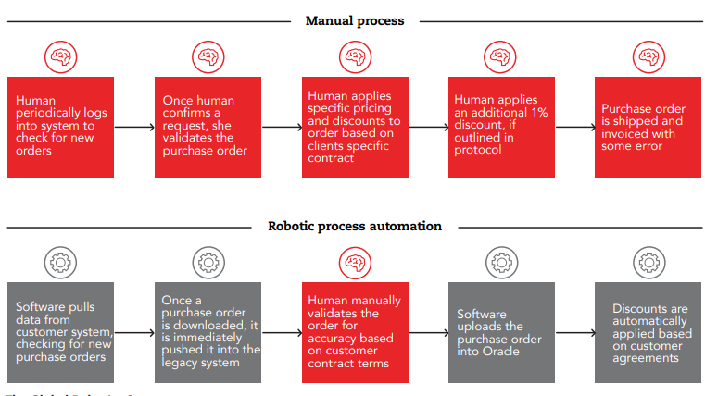

**Figure 1: Human driven vs. RPA process**

Source: ACCA, The rise of Automation in Accounting

From the figure above it can be note that an RPA process is more effective than a manual process because it can carry out processes continuously whereas humans periodically logs into system to check for orders. However human effort is needed to validate orders. From the diagram above it with an RPA system human less human input is required this implies that the work of accountants is at risk and new skills are required in order to survive in such a world.

**Requirements of Effective RPA process in Accounting**

An effective RPA system requires specific skills. The robot will be carrying out tasks that were previously carried out by humans therefore like a human it requires a certain skillset in order to perfectly and effectively carry out the work or tasks programmed. RPA software, more commonly known as a robot, is used to capture and interpret existing digital data from applications to enable transaction processing, data manipulation and communication across systems (ACCA, 2018). For a robot to carry out the tasks it requires seven skills which are shown in the figure below.

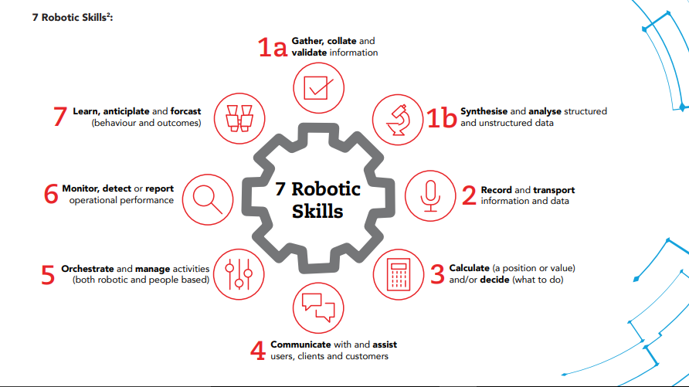

**Figure 2: Skillset requirements for a robot**

Source: ACCA 2018, the rise of automation in Accounting.

The above figure shows the skill requirements RPA robot. The robot must be programmed in such a way that it can be able gather, collate and validate information that is presented to it in a digital format. The information might be structured or unstructured, this implies that the robot must have a skill to synthesize and analyze structured and unstructured data. The robots must also be able to record and transport the information and data to other servers or applications linking the data through a process of successful data integration across the institution. The RPA must also be able to calculate values from the data presented to it and decide or interpret the results of the calculations. It must also be able orchestrate and manage activities both robot and some of people based activities. The robot must also have the skill to monitor, detect or report operational performance and asses the risk in the organization. Now robots are required to have a skill to learn, participate and forecast outcomes through the study of data patterns which is a skill that was previously done through human effort. If a robot or an RPA have such process such kind of skillsets, what it means for a professional accountant or the accounting profession will it cease to exist or it will move into another dimension. It is the purpose of this study to assess the impact of digitalization on the accounting profession.

**2.7 Artificial intelligence**

Automation is widely associated with artificial intelligence (EY, 2018) meaning one cannot talk of artificial intelligence without mentioning automation. In other words artificial intelligence is the next level of automation. Artificial intelligence is a field of research that seeks to equip machines with the cognitive performances of a human being which are reasoning, language, memory, learning, …) (Sharif, 2018). Artificial intelligence can be segmented into two parts which are “strong” and “weak” artificial intelligence. Strong artificial intelligence involves machines that would be able to reproduce 100% of the functioning of the human brain and would therefore be capable of reasoning, adapting and even having feelings. However, such a technology does not exist today but tech wizards are in the process of developing such robotic programs. The artificial intelligence currently available can be described as “weak” the one in which machines only perform tasks humans have programmed them to accomplish, and are neither evolutionary, independent nor conscious. In a word, they just imitate programmed human behavior (Sharif, 2018).

Artificial intelligence and automation can significantly reduce the need for human labor, and it can be integrated into accounting and auditing processes (Gulin, Hladika, & Valenta, 2019) . The neural network and fuzzy logic of artificial intelligence enables the programming of robots to function more like a human brain. The neural network systems installs the ability of a robot or a computer program to learn, imitate human brain through structural simulations of computer programs (Shukla, 2013). Neural networks is one of the most important aspect of artificial intelligence. The fuzzy logic is a concept of artificial intelligence that deals with the process of reasoning that resembles the reasoning of humans. (Kovalenko, 2020) , views artificial intelligence as a revolutionary development that could put forward the accounting profession to execute and make strategic decisions more effectively than it has in the past.

**2.8 Big Data**

As the name suggest big data involves very large amount of data which is too voluminous and complex to be analyzed by traditional accounting tools (Törnqvist, 2018) . Traditional accounting tools will not be able to process and analyze such quantities of data therefore digital accounting tools and more developed RPA systems will be used to process and deal with such kind of data. The accounting profession now uses large volumes of data due to an increase in the cliental base of firms which has been fueled by a rapid increase in population and globalization. Big data comprise of large volumes of data which (ACCA, 2013) approximately estimate to be 2.5 quintillion each day. The data consist high velocity these very fast creation which come as structured and unstructured data. The data will be in different formats and sources, the data can be images, telephone signals, barcodes, personal searches, digital images etc. (Moll, 2019) ; (Törnqvist, 2018). Due to the quantities and the speed at which the data is received, dealing with big data is a very tricky and complex situation therefore RPA and artificial intelligence are required when dealing with such kind of data. Therefore it very important to effectively analyze such data as the data’s good analytics will help the business to create high value (profit) from the analysis of the data. New patterns can be identified, new markets and products can be developed through analysis of big data and it will help accountants in making well informed decisions. Big data implementation is very costly as it requires very large servers and skillset that smaller companies will not afford therefore it is currently being implemented by large companies.

**2.9. Blockchain**

Blockchain refers to a database that contains a history of transactions (Rückeshäuser, 2017). Blockchain technology is usually associated with crypto currencies such as Bitcoin (Sarmah, 2018). Most of companies in the world are now involved in crypto currency investments which uses blockchain technology. Crypto currency use blockchain technology for managing and recording transactions, wherein multiple entities maintain identical records of transactions, making it an extremely secure technology for investments by companies. There are two types of blockchain technology which are public blockchain technology (the one which is accessible to every member of the public for instance bitcoin) and private blockchain technology (only accessible to certain private individuals and it has got restricted access) (Blockchain France, 2016). Blockchain consist of three main principles which are high transparency (information accessible to all users), decentralization (there is no central control and governance authority, the blockchain is based on peer-to-peer relations and information is saved on all participants’ servers) in addition, there is high security and data protection

Blockchain technology is very important in the accounting profession because it is very secure than the traditional databases and is less risk to fraud and server attacks from hackers (Moll, 2019). One of the main effects of Blockchain on the accounting profession is that if blockchain replaces the traditional databases, accountants will have to learn the computer languages specific to blockchain and develop the necessary skills to manage this complex system (Desplebin, 2019).

**2.10 EMPIRICAL REVIEW**

(Kovalenko, 2020), carried out a research to ascertain the impact of artificial intelligence in accounting. The research was based on the fundamental applied developments by scientists and practitioners on the topic of artificial intelligence. In their research they put forward the argument that artificial intelligence is revolutionary development that could enhance the accounting profession to execute and make much more strategic decisions more effectively than it has previously been done. The researchers also argued that the introduction of artificial intelligence in the accounting profession results in efficiency, convenience and with adequate performance of accounting activities as the human labor is aided by computers through programmed robots which carry out some administrative activities. They also further explained that enhancements in artificial intelligence will help to or be used to mitigate fraud, deal with human errors and this will in turn improve the accuracy of the accounting functions as IA thinking complements human thinking.

A research carried out by (Gulin, Hladika, & Valenta, 2019) on the challenges of digitalization on accounting gave a detailed analysis of the effects of digitalization on the accounting profession. The unveiling of the challenges of digitalization provided a step towards the solution of what accountants should do to overcome the problems of digitalization. The research was carried out as literature based research where the researchers reviewed available academic literature as other relevant professional literature. The researchers outlined in their research that the key problems to accounting will stem from the following digital tools which are artificial intelligence, the use of big data in accounting and reporting, cloud computing and blockchain technology. They argued that reporting periods will change from year to year to daily reporting due to these advancements that are being brought up by digitalization. They went further to outline that the rapid developments of digitalization will cause education systems to change as new skills will be required from the accountants to cope up with the technological developments. In their research they also outlined that users of accounting information needs information to be provided straight away not with a time lag, this implies that continuous accounting is the norm in a digital world.

A multiple case study based research carried out by (Kathrine, 2016) on the impact of digitalization on accountings firms business models. The research was carried out through multiple interviews with accounting organizations. The main aim of the research was to investigate how digital accounting businesses could set up a general business model, in order to be a successfully digitalized business. The major finding of the research was that digitalization has a direct impact on how an accounting firm should structure and strategize its business operating model. The researcher went further to explain that digitalization requires accounting firms to adopt a more friendly business culture. A shift from a supplier based market to a demand based market is likely to happen under the digital world as the customers of accounting firms will have more bargaining power than the service providers.

**CHAPTER THREE: RESEARCH METHODOLOGY**

**3.0 INTRODUCTION**

This chapter looks at the methods used to carry out the study and several research elements. The techniques that were used by the researcher to carry out data analysis were also outlined in this section of the document. A detailed analysis into the research design and the research instruments used by the researcher is explained in this section of the document.

* 1. **Research Design**

Research design refers to the strategy employed by the researcher to answer the research questions using empirical data collected.Therefore this research was carried out using an exploratory research. An exploratory research is a research that is carried out to investigate a phenomenon which is not clearly defined. The research is carried out in order to have a better understanding of existing problem or possible problems or benefits of the changes to accounting profession as a result of digitalization. In this study the researcher was trying to figure out the possible impacts of a changes which are yet to come to the Zimbabwean accounting profession. The research method was appropriate as the aim of the study was to try to explain and outline the possible effects of digitalization on the accounting profession. The approach to the study helped in how to deal with it, especially in case of uncertainty (an expected effect of digital accounting tools that have not yet been applied). The steps that the researcher used in the design of this research process were problem identification, creation of hypotheses and the carrying out of further research once the data was obtained through the use of descriptive investigation. The research design was justifiable as it gave the researcher a lot of flexibility and was able to adapt to changes throughout the research process. In addition the research design proved to be low cost method. The research design is also justifiable in that it has a few theories and past studies which were there to support the findings of the researcher which make it easier for the researcher to assess it and move ahead in her study. More so, the research design was also appropriate in the study in that through the use of questionnaires, quantitative data was gathered and it was generalized to test the hypotheses developed.

**3.2 Target population and Sampling Techniques**

The study population is the Zimbabwe’s accounting profession industry with the already qualified accountants and accounting students being the target population for the research. In carrying out the research, the researcher used Quota Sampling technique to gather data from the target population. Quota Sampling is a sampling technique of selecting members of a study population basing on a pre-set standard as the selection criteria. Quota sampling is a non-probability method of sampling. Since the sample is created based on specific attributes or qualities then, the formed sample will have the same qualities as the study population. In creating the sample the researcher used the following criteria that is the respondent have to be a fully qualified accounting professional (these auditors, chartered accountant, etc, or an accounting student. The selection criterion was put in place to eliminate bias emanating from lack of knowledge about the accounting profession.

**Arguments for Quota Sampling Technique**

The sampling technique employed by the researcher in this study was appropriate due to the research design the researcher used. The researcher was carrying out an exploratory research so all other types of probability sampling were not appropriate to the study therefore this non-probability sampling technique was the most appropriate of all the sampling techniques.

In order to eliminate bias from respondents the researcher had to set selection criterion in determining the respondents from the target population. The creation of a selection criterion made the quota sampling technique more appropriate as it is the only sampling technique that has such requirements. More so, the sampling technique enables the author to gather data and opinions from expert in the industry, which was very relevant to the study.

In addition the sampling technique was more appropriate as the researcher did not have access to the entire audience that is all insurance experts in the industry. The respondents were more spread out and the emails that the researcher sent and some of the social media platforms, did not access the entire population. Therefore, the use of quotas to represent the target population was appropriate in this study.

Furthermore, Quota sampling saved the researcher’s time and money. Since it is a non-probability sampling techniques, quota sampling does not require sampling frame or strict random sampling technique therefore it is much faster. It was also very cheap as the researcher used it at a very low budgetary cost.

**3.3 Research Instruments**

The researcher used questionnaires as the sole research instrument.

**Advantages of using questionnaires in this research**

Questionnaires were less expensive, given that the research was an undergraduate student so other methods of collecting data for this research were beyond the budget of the researcher. The questionnaires were self -administered so there was no need to hire surveyors to carry out the data collection. In addition, the questionnaires were distributed and responses were gathered online, which made them less costly.

The other advantage that the researcher gained from using questionnaires in this research is that they were more practicable. They were practical in that the researcher was able to choose the target population, questions answered in the question that is whether open ended or multiple choice questions and the questions were derived from the hypotheses that were being tested which made analysis much easier for the researcher.

Results were obtained quickly with questionnaires. Taking the advantage of vast internet access amongst the targeted population and availability of mobile tools this made result collection quick due to the use of online platforms to distribute questionnaires and some responses were even obtained within 24 hours of distribution. This made questionnaires more useful in carrying out this research as the researcher had limited time to carry out the research, so questionnaires speeded up the research process.

Unlike interviews, questionnaires quantified data that was gathered in the research. The data was used in making comparisons on the findings of the researcher and other researcher in the same subject with evidence rather than arguing using data from interviews unless the researcher had a recording of the interview.

Data obtained using questionnaires was analyzed and visualized easily. Questionnaire results were quantitative in their nature due to the fact that the questions were close ended. The researcher has a good statistical background and was able to use built in tools such as excel to analyze and visualize data to make reasonable conclusions.

The use of questionnaires allowed respondents to remain anonymous. Digital questionnaires give the best sense of anonymity and privacy. The questionnaires were responded online and allowed complete invisibility, which gave respondents comfort in their responses. This anonymity puts respondents at ease and gave them the courage to answer questions honestly without duress.

Questionnaires do not have any time limitations. In this study, the questionnaires were distributed online, using emails and other social media platforms such as WhatsApp and LinkedIn. These distribution methods gave no time limit to the respondent and there was no one at the other end waiting for a response like in the case of face-to-face interviews of phone interviews. This implies that respondents were able to take their time to respond to the questions and we assumed they were able to answer truthfully and bias was eliminated in the responses.

Furthermore, questionnaires distributed covered every aspect of the research topic as the researcher was able to ask as many questions as he like given that there was no time constraints to the respondent.

**3.4 Data Collection**

In carrying out the research the researcher used both primary and secondary sources of data in the collection of data.

**3.4.1 Primary Sources of Data**

The primary source of data that the researcher utilized was the data the researcher collected from directly from the target population through the use of questionnaires as outlined earlier in this chapter. The researcher created and sent questionnaires to the target population through the use of emails, WhatsApp and LinkedIn to collect primary data and information from the target population.

**3.4.2 Secondary Sources of Data**

In carrying out the research, the researcher also used some secondary sources of data. The researcher utilized articles by companies and other experts to gather data about the subject of the research area. The researcher used online sources in carrying out this research as well as literature on other studies carried out by other researchers in the study area. Some of the secondary sources utilized by the researcher were cited within this paper and references are at the end of the paper.

**3.5 Data Presentation**

In carrying out the study descriptive analysis and inferential analysis were used to summarize the characteristics of data set and to assess whether the data is generalizable to the broader population (that is hypothesis testing). The results of the analysis were used to arrive at conclusions and in making recommendations about the possible impact of digitalization on the accounting profession.

**3.6 Data Validity and Reliability Analysis**

The questionnaire was sent and presented, to accounting students and other accounting related professionals in Zimbabwe, to ensure the appropriateness and validity of the questionnaire’s contents and paragraphs data validity was carried out. In order to measure the stability of the internal consistency of questions within the questionnaire of the study the researcher used Cronbach's Alpha. The results of the test are shown in the table below

**Table 1: Reliability Statistics**

|  |  |
| --- | --- |
|  | |
| Cronbach's Alpha | N of Items |
| .768 | 12 |

*Source: SPSS Data analysis*

The reliability analysis showed a value of alpha which was equal to 0.768, this value was good and acceptable as it was above 0.5. (Sekaran & Bougie, 2016: 325) outlined that an alpha value of 0.7 is a good indication of the reliability in statistical analysis and internal consistency. In a research an alpha value of between 0.8 and 0.9 is considered good and is highly recommended however the researcher considered the value observed an excellent value as there were many questions in the questionnaire and many of the respondents were giving varied responses so the alpha value was considered good and reliable by the researcher despite it being less than 0.8.

**3.6 Chapter Summary**

This chapter contains the research methodology that the researcher used in carrying out this research. In this chapter the researcher outlined the research design that he used in the study. Furthermore, the arguments for the research design the research instrument that was used as well as the sampling techniques that the researcher employed in carrying out this research were also explained. It is in this chapter also that the researcher outlined the data collection and sources used in carrying the research. This chapter concluded by outlining the data presentation that the researcher used in the research

**CHAPTER FOUR DATA PRESENTATION AND ANALYSIS OF RESULTS**

**4.0 Introduction**

In this chapter, the researcher reports and discusses the findings of the quantitative and qualitative investigations of the data that have been collected using the questionnaires as outlined in chapter 3. Analysis is based on information that was obtained from the questionnaires that were distributed to several participants in the Zimbabwe’s accounting industry**.**

**4.1 Response Rate**

**Table 2: Response rate**

|  |  |  |
| --- | --- | --- |
| Sample size | Respondents | Percentage |
| 90 | 73 | 81% |

An excellent response rate was obtained from the sample that the researcher has sent his questionnaires to, the response rate stood at 81%. This was a higher response rate than expected as the researcher expected a response rate of around 60% given the short time frame of the research. A total of 90 questionnaires were dispatched to accounting professionals and students in Zimbabwe of which a total of 73 were responded to and the total number of responses were not enough to reach the required sample population as calculated in chapter three which was a total of 90 responses. However, the researcher continued to carry out the data analysis with responses which were available because of time constraints.

**4.2 Objective 1: Effects of Digitalization on the accounting profession**

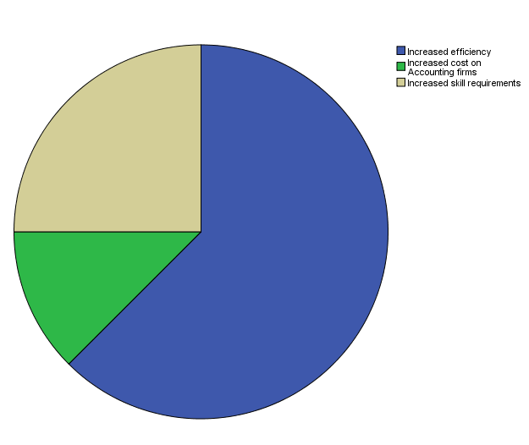

**Figure 3: Major effects of digitalization on the accounting profession**

The pie chart above shows the responses of the respondents on their views about the major effects of digitalization on the accounting profession. The pie chart shows that digitalization has resulted in major increase in efficiency as highlighted by the large blue slice of the pie, many of the respondents has responded that digitalization has a large positive impact on the level of efficiency in the accounting profession. Some of the respondents have expressed their view outlining that digitalization also come with increased cost to accounting firms as implementation of some of the digital technologies such as big data and artificial intelligence requires large amounts of investments. Increased skill requirement among the accountants was another major effect outlined by the respondents in their responses as they expressed their views that the use and adoption of these digital technologies requires accountants to earn extra skills on top of their already existing skills this is shown by the grey area of the pie chart slice.

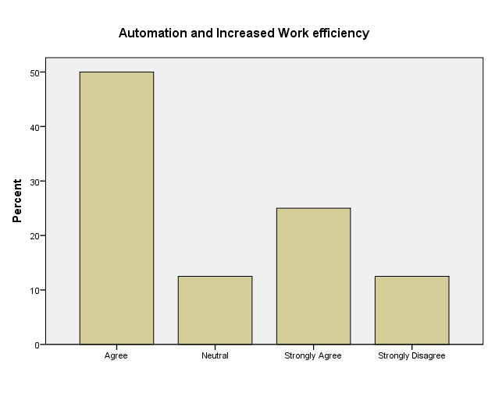

**Figure 4: Automation and work efficiency**

The graph above shows the views of the respondents on the effect of automation and robotics automation process and work efficiency in the accounting profession. The respondents agreed with the view that automation and robotics process automation results in increased work efficiency in the accounting profession, this is shown in the graph above as the bars of agree and strongly agree have larger percentages than others with the bars shown that nearly 50% of the respondents agreed and more than 20% strongly agreed with the fact that automation result in increased efficiency. However a few individuals from the sample disagreed with this fact but they were few than those who agreed this is shown by the strongly disagree bar which was less 15% as shown in the bar graph above. The results as presented in the bar graph above led the research to conclude that automation and robotics process automation results in increased efficiency in the accounting work. The findings of the survey on automation and robotics process is in line with the findings of (Omid, 2020) who outlined that automation and robotics process will result in improved productivity and improved employee morale. Increased productivity as outlined by (Omid, 2020) only come due to increased work efficiency by existing accounting professionals in the organization.

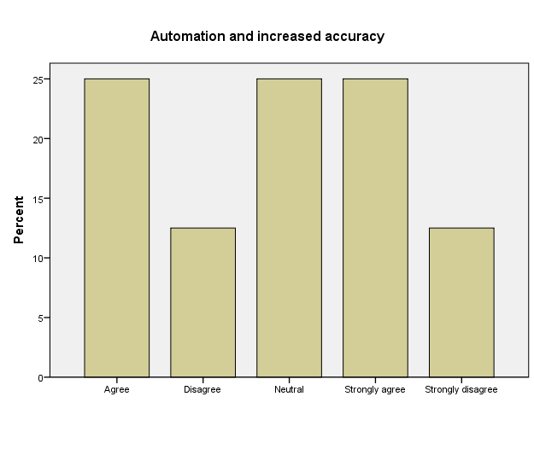

**Figure 5: Automation and accuracy by accounting professionals**

In the graph above the researcher present the findings of the effects of automation and robotics process automation on the accuracy of financial statements and other work that is carried out by accountants in an organization. The results of the research as presented by the graph above, the respondents were of the view that automation and robotics process automation results in improved accuracy by accountants and accounting professional in the industry. This fact is supported by the bars of strongly agree and agree which were both above 25%. However. A few individuals disagreed with the fact that automation and robotics process results in increased accuracy as shown by the cars of disagree and strongly disagree which were both less than 15%. Almost 25% of the respondents opted to remain neutral to the fact that they will be a positive. Accuracy change due automation and robotics process automation in accounting work. (Jędrzejka, 2019) In their research outlined that automation will results in a few errors being made as machines makes fewer mistakes than humans in carrying out work. The findings of the research as shown by the graph above are almost the same as the findings of (Jędrzejka, 2019) as improved accuracy stem from fewer errors and mistakes being made. However, we must not ignore that the inputs and the codes in the automation and robotics process automation are written by humans, this implies that an error by an accountant will result in the RPA work being full of errors and compromised.

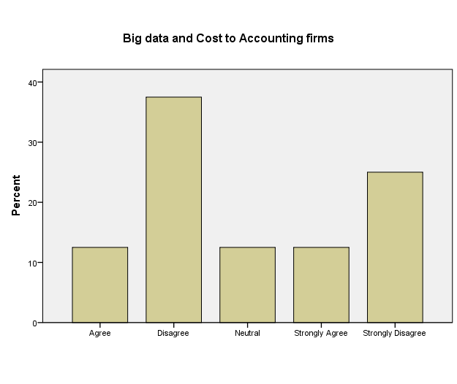

**Figure 6: Big data and Cost to accounting**

Big data is fast growing and becoming common in various sectors of accounting and other professions. The graph above shows the respondents’ views on the cost and benefits of big data to accounting profession. The respondents were of the view that benefits of big data outweighs the cost of using big data technology in an accounting set up. This is shown in the graph above as most of the respondents disagreed with the fact that the cost of big data technology outweighs the benefits, as shown by the disagree bar and strongly disagree bar which stood at more than 30% and 20% in the graph above. However, some of the respondents agreed with the fact that big data technology has more cost to accounting profession than the benefits as it requires high processing server to deal with the large volumes of data which come from different sources and different formats. Their view on the cost of big data being extremely high are in line with the views of (Moll, 2019) and (Törnqvist, 2018) who outlined that dealing with big data technology is very complex and tricky due to the fact that big data technology deals with data from different sources and different formats. However, most of the respondents’ view were in line with the findings of (Belkadi, 2015) who outlined that big data unveils hidden patterns in the market which can be more beneficial to accountants in their work.

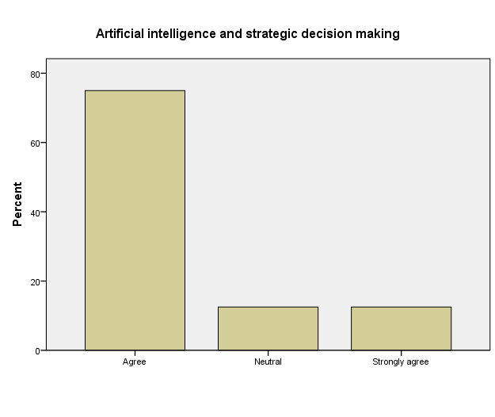

**Figure 7: Artificial intelligence and strategic decision making**

The graph above shows the respondents’ view on the effects of artificial intelligence on strategic decision making by accounting professionals. Most of the respondents agreed to the fact that artificial intelligence is a revolutionary development that can be used by accountants to perfectly execute task and better their decision making process, this is shown from the graph as presented by the agree bar which stood at above 70% of the respondents. However a smaller potion less than 10% disagreed with the fact that artificial intelligence results in better strategic decision making in the accounting profession while a few individuals just remained neutral to the fact. (Kovalenko, 2020) In their research outlined that artificial intelligence is a revolutionary development that could help accountants in better strategic making. They further explained that enhancements in artificial intelligence will help to or be used to mitigate fraud, deal with human errors and this will in turn improve the accuracy of the accounting functions as IA thinking complements human thinking. Their findings are in line with the results of this research as presented in the above graph.

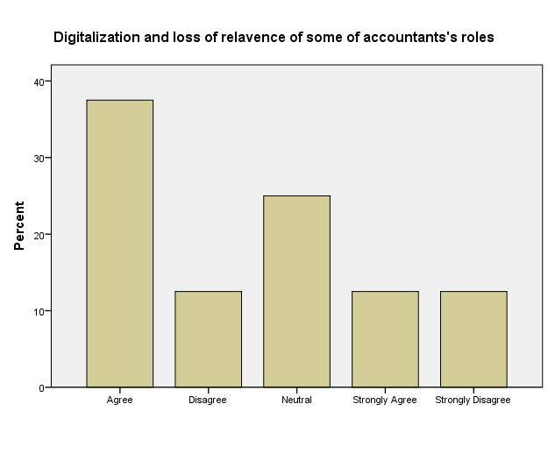

**Figure 8: Digitalization and loss of relevance of some of accountants ‘roles**

The graph above shows their views of the respondents on the loss of relevance to some of the accounting roles due to digitalization. The respondents were of the view that accountants will lose their relevance in the industry as professionals as some of their work will be carried out by machines and robots, this is shown in the graph as most of the respondents agreed that digitalization will result in loss of relevance of some of accountants’ roles. However a few individuals opted to remain neutral whilst another few individuals disagreed with the fact that digitalization will result in loss of relevance of accountants. The findings of the research are significantly the same as those of (ACCA, The rise of Automation in Accounting, 2018) & (EY, 2018) who wrote in their research that automation, robotic process automation and artificial intelligence involves the assumption of some tasks that were previously carried out by a human program being carried out by a computer program. This means some of the task that were physically done by accountants will be carried out by computer programs.

**4.3 objective 2: Digital technologies being used in Accounting**

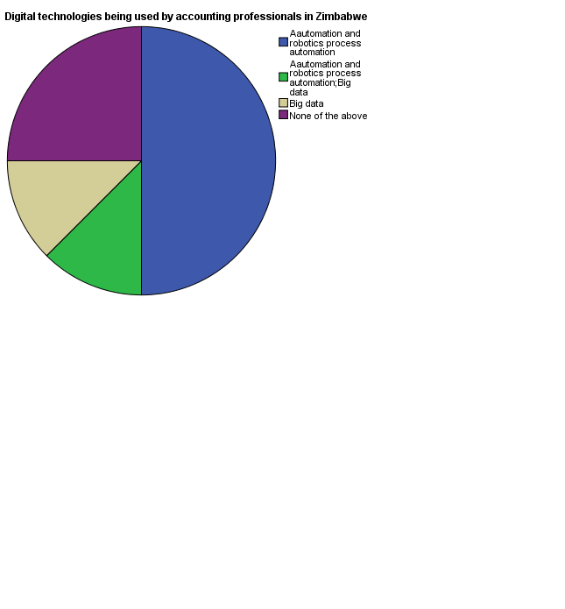

**Figure 9: Digital technologies currently in use in Zimbabwe**

The pie chart above shows the digital technologies that are currently being used by accounting firms and other organization that employee accounting professionals in Zimbabwe. From the pie chart above it is shown that most of the organization and accounting firms in Zimbabwe use automation and robotics process automation and others use big data technology but they are fewer less than 20%. For those who use automation and robotics process automation also use big data technology. 25% of the respondents outlined that they have never been exposed to any digital technology they still carry out their tasks traditionally, in addition the respondents also outlined that they are yet to implement real artificial intelligence meaning it’s not yet in use in the accounting industry of Zimbabwe.

**Table 3 Extent of use of [Big data] Technology**

|  |  |  |  |  |  |
| --- | --- | --- | --- | --- | --- |
|  | | | | | |
|  | | | | | |
|  | | Frequency | Percent | Valid Percent | Cumulative Percent |
| Valid | 0 | 27 | 37.5 | 37.5 | 37.5 |
| 20 to 30% | 0 | 0 | 0 | 12.5 |
| 5 to 10% | 9 | 12.5 | 12.5 | 50.0 |
| Above 60% | 0 | 0 | 0 | 50.0 |
| Less than 5% | 36 | 50.0 | 50.0 | 100.0 |
| Total | 72 | 100.0 | 100.0 |  |

Source: SPSS Data Analysis

The table above indicate the extent to which big data technology has been implemented in Zimbabwe by the firms that are currently using big data technology. The table above shows that big data technology is not widely used by the firms that have implemented the technology. Most of the firms and organizations that have implemented bug data technology only utilize less than 5% in accounting decisions and analysis most of the firms have implemented big data technology but do not use big data technology in accounting but in other professions whilst above 12.5% use big data 5 to 10% times in making accounting decisions. The findings shows that big data technology is not widely used in Zimbabwe’s accounting industry.

**Table 4 Extent of use of [Automation and robotics process automation**

|  |  |  |  |  |  |
| --- | --- | --- | --- | --- | --- |
|  | | | | | |
|  | | Frequency | Percent | Valid Percent | Cumulative Percent |
| Valid | 0 | 18 | 25.0 | 25.0 | 25.0 |
| 30 to 40% | 7 | 9.72 | 9.72 | 34.72 |
| 5 to 10% | 12 | 16.6 | 16.6 | 51.32 |
| 50 to 60% | 0 | 0 | 0 | 51.32 |
| Above 60% | 0 | 0 | 0 | 51.32 |
| Less than 5% | 35 | 48.68 | 48.68 | 100.0 |
| Total | 72 | 100.0 | 100.0 |  |

Source: SPSS Data analysis

The frequency table above shows the extent of use of automation and robotics process automation by accounting professionals in Zimbabwe. From the table above, accounting professionals who use automation in carrying accounting jobs use it mostly less than 5% of their time they carry out work. Those who use automation on a large extent of their work use it between 30 to 40% and they represent 9.72% of the respondents meaning they are fewer. The results in the table shows that despite automation and robotics automation being well known and in use its relevance in the accounting profession in Zimbabwe is not yet well established as some of the tasks that can be automated are still being carried out manually.

**4.4 Objective 3: New accounting dimensions possible**

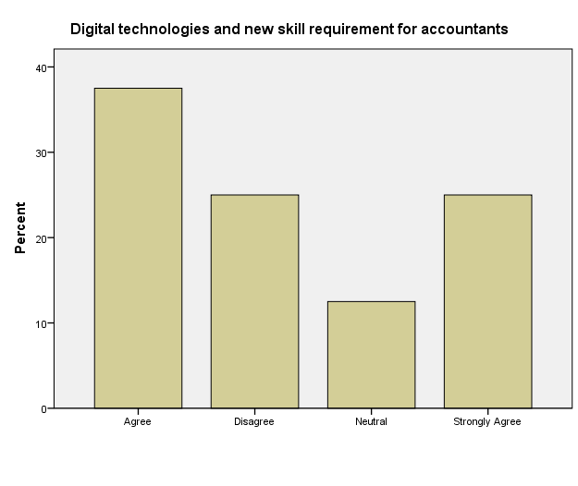

**Figure 10: Digital technologies and new skill requirements for accountants**

The graph above shows the responses of the respondents on whether accountants requires new skills in order to cope up with the requirements of digital technologies. Most of the respondents were in agreement that accountants’ needs to earn new skills that are beyond the traditional accounting rules and principles they need to possess some of soft skills in order to ensure their survival in the digital world. This is shown from the graph above as more than 35% and 20% of the respondents agreed and strongly agreed respectively to the fact that accountants need to earn new skills to cope up with the developments brought about by digitalization.

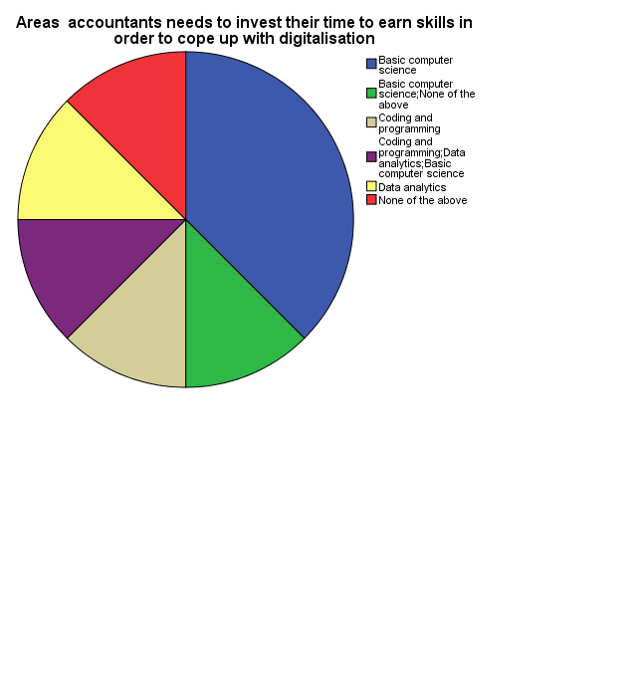

**Figure 11: Skill requirements for accountants to cope with digitalization**

The pie chart above shows the results of the investigation on the actual skills that accountants in the new digital world of artificial intelligence, automation, big data, cloud computing and reporting need to possess in order to cope up with digitalization. The respondents were of the view that basic computer science skills are essential for the accountants in this digital world this is shown by the blue slice of the pie chart which takes more than 30% of the pie. Others were of the view that accountants need to be trained in order to have coding and programming skills in order to be able to perfectly execute some of the tasks. Others were of the view that they also need to have data analytics skills to be able to use big data technology. From the results above it can be concluded that all the skills in the pie chart are essential for accounting professionals in the industry.

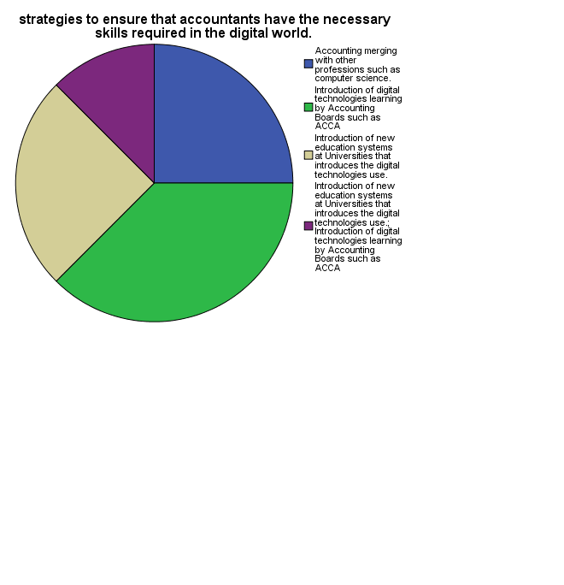

**Figure 12: Strategies to ensure accountants have necessary skills required in digital world**

The pie chart above outlines the strategies that can be used to ensure that accounting professional have the necessary to ensure that they have the necessary skills in the digital world. The most effective strategies that have been seen by the respondents as the one that could be essential is the introduction of digital technologies in learning and syllabuses of Accounting Boards such as ACCA and CIMA, This is shown by the green slice of the pie in the pie chart above. Some of the respondents were suggesting that accounting need to merge with other professions such as computer science to come up with programs such as computer science for accounting that will be part of education and learning in accounting. Others were suggesting that universities need to update and upgrade their learning accounting programs through the introduction of digital technologies at University. The suggestions are in line with the findings of (Gulin, Hladika, & Valenta, 2019) who suggested that education system for accounting needs to change in order to cope up with digitalization.

**4.6 Summary**

This chapter outlines the results and presented the views of the respondents who have responded to the questionnaire that was used for data collection, an analysis of findings and linking the findings of the research as shown by various data presentation method to the existing findings of other scholars was carried out in this chapter. This chapter formed the basis of recommendation and conclusion in the next chapter.

**CHAPTER FIVE:**

**CONCLUSIONS AND RECCOMENDATIONS**

**5.0 Introduction**

This chapter outlines the summary of findings of the research and the conclusions that were drawn by the researcher based on the results of the analysis of the findings in the previous chapter. The previous chapters laid out the basis upon which the conclusions and recommendation and conclusions were drawn. As highlighted in chapter 1, the objectives of this study were:

1. To establish the key effects of digitalization brings on the accounting profession
2. To establish the digital technologies that are used by accounting firms today
3. To establish new dimensions that the accounting profession can expand into in the digital world

**5.1 Summary of Findings**

After carrying out the data presentation and analysis in chapter four the following findings were noted about the research objectives.

**5.1.1 Key effects of digitalization on the accounting profession**

From the results in chapter four it was noted that automation and robotics process automation will result in increased work efficiency by accountants. It was also noted that they will be improved accuracy as machines makes few errors than humans therefore the quality of financial statements and other reports will be relatively improved. It was also noted that digital technologies such as big data and artificial intelligent are of high importance in strategic decision making by accounting professionals. However, it was also noted that these technologies pose a high threat to the relevance of accounting professionals, automation of some of the accounting tasks that were traditionally carried out manually results in some accountants losing their jobs and relevance in an organization.

**5.1.2 Digital technologies in use today in Zimbabwe.**

It was noted that despite the advancements in the use of digital technologies in other countries especially the developed European and western counties digital technologies are not widely used in Zimbabwe. From the findings of the research it was noted that only automation and big data technology are the ones being used by accounting professionals in Zimbabwe. The technologies are used but not very often with the two combined being used at most 10% in accounting work. Technologies such as artificial intelligence and blockchain are yet to be used for accounting work in Zimbabwe.

**5.1.3 New Dimensions for the Accounting Profession**

Digitalization implied that accounting professionals have to earn new skills and enter new dimensions in order to cope up with the requirements of work in the digital world. The findings as outlined in chapter four showed that accountants have to earn new skills in areas of data analytics, basic computer science, coding and programming. This has been apprehended so that the accountants will remain relevant in the digital world and to be able to perfectly execute tasks using these highly advanced digital technologies. It was also found that in order to earn the skills accounting professionals need to have exposure to learning to other professions such as computer science and data analytics. In order for that to be done accounting professional boards such as ACCA needs to introduce these digital technologies in their syllabuses. In addition it was found that the education system needs to change as accounting needs to merge with other professions such as computer science and data analytics as well as information systems.

**5.2 Conclusion**

The results of the study showed that digitalization has a lot of positive effects on the accounting profession as the digital technologies results in efficiency, improved accuracy, less fraud , better decision making etc. However the adoption of these technologies comes at high cost to accounting professionals as some of the accounting professionals will lose their relevance due to automation of some tasks and artificial intelligence. In addition accounting professionals are also required to have a new set of skills in addition to the traditional accounting hard skills in order to remain relevant in the profession

**5.3 Recommendations**

After the investigation the research recommend that accounting firms and other organizations needs to implement use the new digital technologies in order to reap high benefits from their use and reduce cost of hiring too much labor as some tasks can be carried out by robots

In addition the research recommend that accounting professionals needs to invest their time to learn new skills over and above the accounting principles in order to remain relevant in the digital world.

**5.4 Areas of Further research**

The area of digitalization is not yet fully exploited and the effects on the accounting profession are not yet clear therefore the researcher recommend a further study be carried in this area of research in Zimbabwe.

The researcher also recommend that further studies be carried out to determine the most suitable dimensions the accounting profession should venture into in order to remain relevant as a profession.

# References

ACCA. (2013). Technology trends: their impact on the global accountancy profession. Retrieved from https://www.accaglobal.com/uk/en/technical-activities/technical-resources-search/2013/may/technology-trends.html

ACCA. (2018). *The rise of Automation in Accounting.* Middle East: ACCA.

Belkadi, N. (2015). Digitalisation de l’expertise-comptable : Chance ou malchance ? pp. 32-33.

Bharadwaj, A. E. (2013). Digital business strategy: toward a next generation of insights. *Management Information Systems Quarterly*, 37 (2), 471–482.

Desplebin, O. L. (2019). Comprendre la blockchain : quels impacts pour la. Retrieved from https://www.cairn.info/revue-accra-2019-2-page-5.htm

Duncan, J. ( (1909)). A Definition of Accounting.

EY. (2018). *Robotics and intelligent automation : Combining the power of human and machine*. Retrieved from https://assets.ey.com/content/dam/ey-sites/ey-com/en_gl/topics/emeia-financial-services/ey-human-and-machine-power-robotics-ai.pdf

Frey, C. B. (2017). The future of employment: How susceptible are jobs to computerisation. *Technological Forecasting and Social Change Vol 114*, 254-280.

Gulin, D., Hladika, M., & Valenta, I. (2019). *Digitalization and the Challenges for the Accounting Profession.* Zagreb.

Jędrzejka, D. (2019). Robotic Process Automation and Its Impact on Accounting. *Zeszyty Teoretyczne Rachunkowości*, 105 (161), 137-166.

Kathrine, B. (2016). The digitalization impact on accounting firms models.

Kovalenko, K. P. (2020). Artificial intelligence in the Accounting Profession.

Laughlin, R. (1987). Accounting Systems in Organisational Contexts:A Case for Critical Theory. *Accounting, Organizations and Society*, 479 – 502.

Maltaverne, B. (2017). *Digital transformation of Procurement: a good abuse of language?* Retrieved from Medium. https://medium.com/procurement-tidbits/digital-transformation-of ofprocurement-

Mancini, D. L. (2017). Trends of Digital Innovation Applied to Accounting Information and Management Control Systems”,. 1-19.

Moll, J. Y. (2019). The role of internet-related technologies in shaping the work of accountants: New directions for accounting research. *The British Accounting Review*, 1-20. Retrieved from https://doi.org/10.1016/j.bar.2019.04.002

Omid, A. (2020). *KOFAX*. Retrieved from kofax.com: https://www.kofax.com/learn/blog/12-innovative-use-cases-rpa-finance-accounting

Rückeshäuser, N. (2017). Do We Really Want Blockchain-Based Accounting? Decentralized Consensus as Enabler of Management Override of Internal Controls.

Sarmah, S. (2018). Understanding Blockchain Technology. Computer Science and Engineering. 23-29. Retrieved from https://www.researchgate.net/publication/336130918_Understanding_Blockchain_Technology

Sharif, W. (2018). Quelle sera l’évolution du métier de comptable face à l’accroissement des technologies? Retrieved from http://doc.rero.ch/record/323775/files/TDEE_364_Travail_de_Bachelor_2018_de_Wida d_SHARIF.pdf?version=1

Shukla, S. a. (2013). *Applicability of artificial intelligence in different fields of life.* International Journal of Scientifc Engineering and Research (IJSER).

SouthernCrossUniversity. (2016, September 16). *Accounting in a digital world*. Retrieved from https://online.scu.edu.au/accounting-digital-world/

Tekbas, I. (2018, April 19). *The Profession of the digital age: Accounting Engineering*. Retrieved from https://www.ifac.org/global-knowledge-gateway/technology/discussion/profession-digital-age-accounting-engineering

Törnqvist, E. &. (2018). Automated accounting in accounting firms - A qualitative study on impacts and attitudes. Retrieved from https://pdfs.semanticscholar.org/9c26/dfea081fd035a6070e382f1b5f0727faa37a.pdf

Willcocks, L. L. (2015). The IT Function and Robotic Process Automation. *London School of Economics and Political Science*. Retrieved from http://eprints.lse.ac.uk/64519/1/OUWRPS_15_05_published.pdf

1. Frey, C. B., Osborne, M. A. (2017), “The future of employment: How susceptible are jobs to computerization?” Technological Forecasting and Social Change, Vol. 114, pp. 254-280

2. Mancini, D., Lamboglia, R., Castellano, N. G., Corsi, K. (2017), “Trends of Digital Innovation Applied to Accounting Information and Management Control Systems”, in Corsi, K., Castellano, N. G., Lamboglia, R., Mancini, D. (Eds.), Reshaping Accounting and Management Control Systems – New Opportunities from Business Information Systems, Springer, Cham, Switzerland, , pp. 1-19

3. Tekbas, I. (2018),”The Profession of the digital age: Accounting Engineering“, available at: https://www.ifac.org/global-knowledge-gateway/technology/discussion/profession-digital-age-accounting-engineering (19 April 2019).

# Appendix A

**QUESTIONNAIRE**

**SECTION 1: EFFECTS OF DIGITALIZATION ON ACCOUNTING PROFESSION**

In this section the aim is to establish the positive and negative effects that digitalization has brought to the accounting profession.

QN: Which of one of the following is one of the major effects of digitalization on the accounting profession?

* Increased efficiency
* Increased skill requirements
* Increased cost on accounting firms
* Extension of the profession in the years to come

QN: Automation and Robotics Process Automation allows accountants to automate some accounting processes so that the most usual and repetitive tasks can be done and completed immediately with efficiency.

* Strongly disagree
* Disagree
* Neutral
* Agree
* Strongly agree

QN: Automation of some of the accounting process such as back office reconciliation will result in improved accuracy and better decision making as robots makes fewer mistakes than humans.

* Strongly disagree
* Disagree
* Neutral
* Agree
* Strongly agree

QN: Big data involves the use large volumes of data from different sources and in different formats and this requires higher processing servers and data managements systems this makes big data more costly than the benefits that can be obtained from its use.

* Strongly disagree
* Disagree
* Neutral
* Agree
* Disagree

QN: Artificial intelligence is revolutionary development that could enhance the accounting profession to execute and make much more strategic decisions more effectively than it has previously been done.

* Strongly disagree
* Disagree
* Neutral
* Agree
* Strongly disagree

QN: Digital technologies such as automation and artificial intelligence will assume some of the roles that were previously done by accountants and this will result in accountants losing their relevance in an organization.

* Strongly Disagree
* Disagree
* Neutral
* agree
* strongly agree

**SECTION 2: DIGITAL TECHNOLOGIES USED IN ACCOUMTING**

The aim of this section is to establish the digital technologies that are being by accounting firms that are in Zimbabwe. The main aim is to establish the level of digitalization by accounting firms.

QN: which of the following digital technologies is being used at your firm?

* Blockchain technology
* Artificial intelligence
* Cloud computing and reporting
* Automation and Robotics Process Automation
* Big data
* None of the above

QN: Kindly indicate the extent to which the above digital technologies are being used at your organization

* Automation and Robotics process automation
* Artificial intelligence
* Cloud computing and reporting
* Blockchain technology
* Big data

**SECTION 3: DIMESIONS THAT ACCOUNTING NEEDS TO EXPAND TO IN THE DIGITAL ERA**

Digitalization comes with great skill requirements as well as high cost, therefore this section aims to review the dimensions that the traditional accounting can expand to in order to ensure survival of the profession in the digital era.

QN: The digital technologies will require accountants to possess new skills such as programming skills in order to perfectly execute tasks using these technologies.

* Strongly disagree
* Disagree
* Neutral
* Agree
* Strongly agree

QN: Which of the following areas do accountants need to invest their time to earn skills in order to cope up with digitalization?

* Coding and programming
* Data analytics skills
* Basic computer science
* Basic data science and engineering

QN: Which of the following strategies is the most effective to ensure that accountants have the necessary skills required in the digital world.

* Introduction of new education systems at Universities that introduces the digital technologies use.
* Accounting merging with other professions such as computer science.
* Introduction of digital technologies learning by Accounting Boards such as ACCA