BINDURA UNIVERSITY OF SCIENCE EDUCATION

FACULTY OF COMMERCE

##### DEPARTMENT OF ECONOMICS



THE ROLE OF EDUCATION ON THE INDUSTRIAL SECTOR IN ZIMBABWE (1990 –

2022)

SUBMITTED BY

MUNYARADZ SARAI

B202090B

##### THIS DISSERTATION IS SUBMITTED IN PARTIAL FULFILMENT OF THE

REQUIREMENTS FOR THE BACHELOR OF SCIENCE HONOURS DEGREE IN ECONOMICS OF BINDURA UNIVERSITY OF SCIENCE EDUCATION, FACULTY OF COMMERCE.

##### JUNE 2024

# RELEASE FORM

NAME OF AUTHOR: MUNYARADZI SARAI

STUDENT NUMBER: B202090B

PROJECT TITLE: The role of education on the industrial sector in Zimbabwe

Zimbabwe (1990-2022)

DEGREE TITLE: BACHELOR OF SCIENCE HONOURS DEGREE IN

ECONOMICS

YEAR GRANTED: 2024

Permission is hereby granted to the Bindura University Library to produce single copies for private, scholarly or scientific research purpose only. The author reserves other publication rights and neither the project nor extensive extracts from it may be printed, or otherwise reproduced without the author has written permission.

SIGNED………………………………… DATE:……………………………….

PERMANENT ADDRESS : Kuwadzana Extension Harare

# APPROVAL FORM

The undersigned certify that they have supervised, read and recommend to the Bindura University of Science Education for acceptance of the research project entitled: THE ROLE OF EDUCATION ON THE INDUSTRIAL SECTOR IN ZIMBABWE (1990-2022), submitted MUNYARADZI SARAI, in partial fulfilment of the requirements for the BACHELOR OF SCIENCE (HONORS) DEGREE IN ECONOMICS.

Signature: ............................................ Date: ..........02/10/24.....................................................

Supervisor

Signature: .....  Date: .........03/10/2024..................................................

Chairperson



Signature: ... Date: ........02/10/2024.......................................................

Student

# DEDICATION

This study is dedicated to my mother and the entire family for the confidence they showed in me and supporting me throughout the duration of the course (2020-2024). Moreover, I dedicate this work to my friends whose unwavering support played an instrumental role in my academic journey.

# ABSTRACT

The research sought to analyze the relationship between the roles of education on the industrial sector in Zimbabwe. The research problem is to determine if education actually enhance industrial sector, given the limited empirical evidence on the subject. The OLS econometric model was used as the main model of analysis estimated using E-views 10 software, and a series of diagnostic and stability tastes were conducted to ensure model robustness. The sample consists of time series data from the World Data Bank from 1990-2022. The study findings show that investment negatively affects the industrial sector in Zimbabwe at a 1% level possibly due to lack of infrastructure and political instability in Zimbabwe. Furthermore education, government size and capacity utilization positively affect industrial sector and are significant at 5% significant level. The CUSUM test confirms 95% confidence in the model’s stability for forecasting. The study recommends that policy makers should implement policies aimed to improve education in Zimbabwe such as aligning education curriculum with the industrial needs. Additionally, policy makers should consider promote innovation, and technological advancement to drive industrial growth, and establish a mechanism to improve access to finance for industrial enterprises, especially small and medium enterprises. This can include setting up dedicated industrial funds, providing loan guarantees, and promoting innovative financing options tailored to the needs of the industrial business.

Key words: Economic growth, inflation, education

# ACKNOWLEDGEMENT

Firstly, I would like to thank the Almighty God for guiding me through the entire duration of the program and for making me accomplish my dream of being an Economist. My sincere gratitude is expressed to my family for their precious support through the course of academic research. Furthermore, I would like to show my appreciation to my supervisor for his steadfast, resilient command and guidance throughout the study. Equal thanks go to the BUSE Economics Department who natured my chosen profession. Appreciation is to my friend’s classmates, your support is appreciated, and you will be remembered endlessly.

# Table of Contents

RELEASE FORM i

APPROVAL FORM ii

DEDICATION iii

ABSTRACT iv

ACKNOWLEDGEMENT v

Table of Contents vi

LIST OF TABLES ix

LIST OF FIGURES x

LIST OF APPENDICES xi

LIST OF ACROYNIMS xii

CHAPTER 1 1

INTRODUCTION 1

1.0 Introduction 1

1.1 Background of the Study 1

1.2 Statement of the Problem 6

1.3 Objective of the Study 7

1.4 Research Question 8

1.5 Study Hypothesis 8

1.6 Significant of the Study 8

1.7 Delimitations of the study 8

1.8 Limitations of the Study 9

1.9 Definition of terms 9

1.9.1 Economic Growth 9

1.9.2 Inflation 9

1.9.3 Education 9

1.10 Chapter Summary 10

CHAPTER II 11

LITERATURE REVIEW 11

2.0 Introduction 11

2.1 Theoretical Literature 11

2.1.1 Exogenous growth mode: Solow model 11

2.1.2 Endogenous growth models 12

2.2 Empirical Evidence 14

2.2.1 To assess the relationship between education indicators (e.g., enrollment rates, educational attainment) and industrial development 14

2.2.2 To identify ways in which education influences the industrial sector 15

2.3 Literature Gap Analysis 16

2.4 Chapter Summary 16

CHAPTER III 17

RESEARCH METHODOLOGY 17

3.0 Introduction 17

3.1 Research design 18

3.2 Population and Sample 18

3.3 Data sources 18

3.4 Data Collection Instruments 19

3.5 Model Specification 19

3.5.1 Theoretical Specification 19

3.5.2 Empirical specifications 20

3.6 Measurement of variables and expectations 21

3.7 Justification of Variables 23

3.8 Estimation Method 23

3.9 Econometric Model Diagnostics Testing 23

3.9.1 Stationarity Test 24

3.9.2 Multicollinearity Test 24

3.9.3 Heteroskedasticity Test 25

3.9.4 Autocorrelation Test 25

3.9.5 Normality Test 26

3.10 Econometric Model Stability Testing 26

3.11 Chapter Summary 27

CHAPTER IV 27

DATA PRESENTATION, ANALYSIS AND DISCUSSION 27

4.0 INTRODUCTION 27

4.1 Descriptive Statistics 28

4.2 Econometric Model Diagnostic Test 29

4.2.1 Stationery Test 29

4.2.2 Multicollinearity Test 30

4.2.3 Heteroscedasticity 31

4.2.4 Autocorrelation 32

4.2.5 Normality Test 32

4.3 Econometric Model Results 33

4.3.2 Model Stability 34

4.3.3 Ramsey reset test 35

4.4 Model Results Interpretations and Discussion 36

4.4.1 EDUCATION 36

4.4.2 GOVERNMENT SIZE 36

4.4.3 INVESTMENT 37

4.4.4 CAPACITY UTILIZATION 38

4.5 Chapter Summary 38

CHAPTER V 39

SUMMARY, CONCLUSION AND POLICY RECOMMENDATIONS 39

5.0 Introduction 39

5.1 Summary 39

5.2 Conclusion 40

5.3 Policy Recommendations 40

5.4 Suggestion of Areas for Future Study 42

REFERENCES 43

APPENDICES 48

APPENDICES INDEX 48

Appendix 2.2: Diagnostic test 51

# LIST OF TABLES

Table 1: Summary of Variables and Expected Signs

Table 2: Descriptive Summary

Table 3: ADF Test Results

Table 4: Variance Inflation Factor

Table 5: Heteroskedasticity Test: Breusch-Pegan-Godfrey

Table 6: Durbin Watson Statistic

Table 7: Jarque-Bera Normality Test

Table 8: OLS Model Results

# LIST OF FIGURES

Fig 4: CUSUM of Square Test

# LIST OF APPENDICES

Appendix 1.1: Original Data Set

Appendix 1.2: Transformed data set

Appendix 2.1: Descriptive Statistics

Appendix 2.2: Multicollinearity

Appendix 3.1: Unit Root Test

Appendix 4.1: Auto-correlation Results

Appendix 4.2: Heteroscedasticity Test Results

Appendix 4.3: Normality Test Results

Appendix 4.4: Ramsey Reset Test

Appendix 5: Regression Results

# LIST OF ACROYNIMS

ADF Augmented Dickey-Fuller

BLUE Best Linear Unbiased Estimators

DW Durbin Watson

ESAP Economic Structural Adjustment Program

FD1 Foreign Direct Investment

GDP Gross Domestic Product

OLS Ordinary List Squares

VAR Vector Auto Regressive

STEM Science Technology Engineering and Mathematics

xi

# CHAPTER 1

# INTRODUCTION

# 1.0 Introduction

Around the world, economies are developing and growing because of education. The industrial sector cannot advance without a highly educated workforce, as is well understood. The provision of the skills, knowledge, and expertise required for a healthy industrial sector is largely dependent on education. It boosts productivity and competitiveness in the industrial sector, encourages innovation and technological improvements, and helps to create a trained labor force. In addition, by raising labor quality and efficiency, it raises workforce productivity and competitiveness. People with higher levels of education are more likely to be effective, flexible, and able to handle the shifting needs of the industrial sector. To close the gap between theoretical knowledge and practical abilities, companies and educational institutions must work together. By facilitating information transfer, research partnerships, and the creation of industry-relevant curricula, these collaborations guarantee that graduates are adequately equipped for the industrial sector. Lastly, Education fosters innovation and technological advancements by promoting research and development activities. It encourages the adoption and application of new technologies in the industrial sector, leading to increased productivity and efficiency. This chapter aims to provide a concise and persuasive introduction to the study, highlighting the value and importance of investigating the role of education in the industrial sector. Furthermore, it will outline the objectives, research hypothesis, significance, limitations, delimitations, and the organization of the rest of the dissertation.

# 1.1 Background of the Study

There has been a lot of economics study done on the connection between economic progress and education. Education is a key determinant of economic growth and productivity. Countries that invest in quality education systems tend to experience higher levels of industrialization and economic prosperity. The manufacturing, mining, construction, and other associated industries that make up the industrial sector are important contributors to employment and economic growth. This study's historical context will be used to examine trends in the industrial sector and education utilizing time series data spanning from 1990 to 2022. We will investigate the relationship between education and industrial development by looking at the data and looking for any potential correlations or patterns. This analysis will help to identify potential research gaps and provide a foundation for the study problem.

Let us take a background view of what happened in education and the industrial sector since independence. The government introduced Economic structural adjustments, which negatively affected Zimbabwe's educational sectors. Equally troubling was the picture of schooling that surfaced during ESAP. The impoverished were negatively impacted by the reduction in educational spending, the removal of government education subsidies, and the implementation of school fees, which led to a drop in educational standards and made it impossible for low-income parents to send their children to school. Leon (2002) argued that ESAP was undermining the country's educational system, which would raise dropout rates and lower the quality of the nation's future labor force.

Zimbabwe's industrial sector saw both growth and decrease following its independence, as well as several obstacles. Following its independence in 1980, Zimbabwe's manufacturing sector grew significantly in the early years. To spur industrialization and draw in foreign investment, the government established policies that resulted in the growth of manufacturing sectors in industries including food processing, textiles, engineering, and chemicals. However, Zimbabwe's economy started to deteriorate in the 1990s, which had a bad effect on the manufacturing sector. Several factors, including political unpredictability, widespread inflation, poor economic management, and land reform initiatives, caused the collapse.

The manufacturing industry, which previously made up a sizable portion of the GDP of the nation, encountered several difficulties. Antiquated infrastructure, insufficient foreign exchange availability, power problems, and loan availability issues hindered manufacturing industry expansion. The mining industry that of gold and platinum, continued to play a significant role in Zimbabwe's industrial sector. Nonetheless, the industry had to deal with issues like deteriorating ore grades, a lack of funding for innovative technology, and unclear legislation. The agricultural sector's performance and the industrial sector's performance are strongly related. Agro-processing businesses and the industrial sector suffered from the downturn in agriculture, especially in the early 2000s because of land reform initiatives.

According to the World Bank school, enrolment tertiary (percentage gross) was used a unit of measurement for tertiary education between 1990-2022. There was an increase in tertiary education enrollment between 1990 and 2022; this indicates a rise in gross enrolment. The government in the early years following independence built more post-secondary educational establishments, like universities, teacher-training programs, technical colleges, and agricultural colleges. Following this, enrollment remained stable between 1990 to 1993 and dropped in 1994 because of draught, which heats the nation in 1992. Enrollment in tertiary education began to rise again in 1996 up to 2001. In 2002, there was a massive drop in education enrolment; Zimbabwe was going through a period of political and economic turmoil, which hurt total tertiary enrolment.

After that, enrollment rose dramatically between 2004 and 2022. This was due to increased funding and scholarships from the government and international organizations to support students in pursuing higher education. There was also a growing demand for skilled workforce in various sectors of the economy including healthcare, engineering, and technology. This demand has motivated more students to enroll in tertiary education. In 2017, there was the introduction of a new curriculum in Zimbabwe, which also contributed to the rise of tertiary education up to date.

Enrollment pattern in tertiary education from 1990 to 2022. See Figure 1 below.

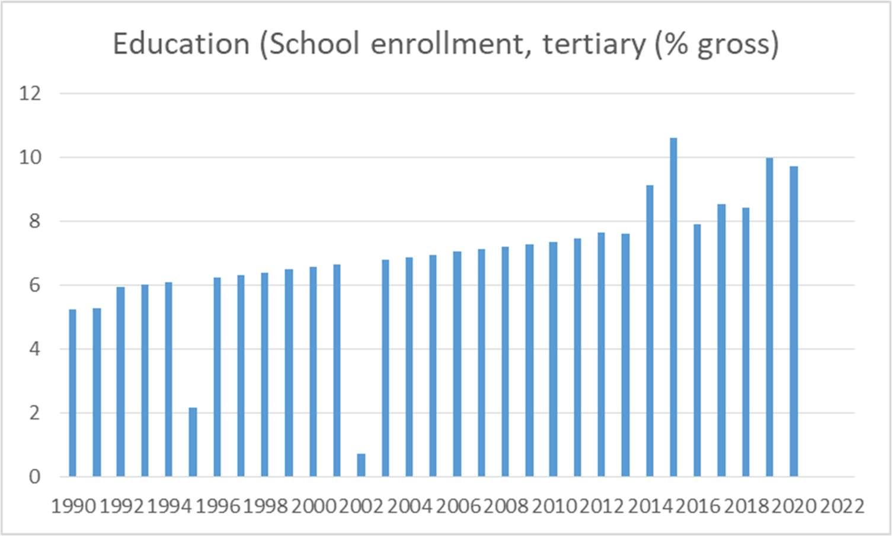

Fig 1: Tertiary Education Enrollments

Source: World Bank (200)

INDUSTRIAL SECTOR PERFORMANCE

The GDP is the market worth of all completed goods and services produced annually inside a nation's borders. It includes the revenue of foreign workers in an economy but excludes the money derived from resources in other nations. Economic growth and education are positively and strongly correlated. Nations with high rates of school enrollment have seen faster increases in per capita income (PCI) since these rates are associated with significant productivity improvements.

According to the World Bank manufacturing value added (% of GDP) was used a unit of measurement for industrial sector performance. There was an increase in industrial sector performance between 1990 and 1992. Following this, the main cause of the industrial sector's decline from 1992 to 2002 there was a severe downturn partly brought on by the 1992 drought that affected the economy. From 2004 to 2007, it increased to a peak.

The economy contracted between 2008 and 2010. This could be explained by the divisive land reform that started in 2000, the hyperinflation that occurred during that time, the economic depression caused by the drought in 2002, and the political and economic changes that took place.

The industrial sector performance increased again from 2011 to 2012 after the introduction of multi-currency, which saw many firms resurrecting. There was a massive drop in industrial sector performance from 2014 to 2017 this was caused by shortages of foreign currency in the country and economic instability. In 2018 industrial performance rose after the introduction of the RTGS currency, which saw firms, resuming their production up to date. Industrial sector in Zimbabwe from 1990 to 2022. See Figure 2

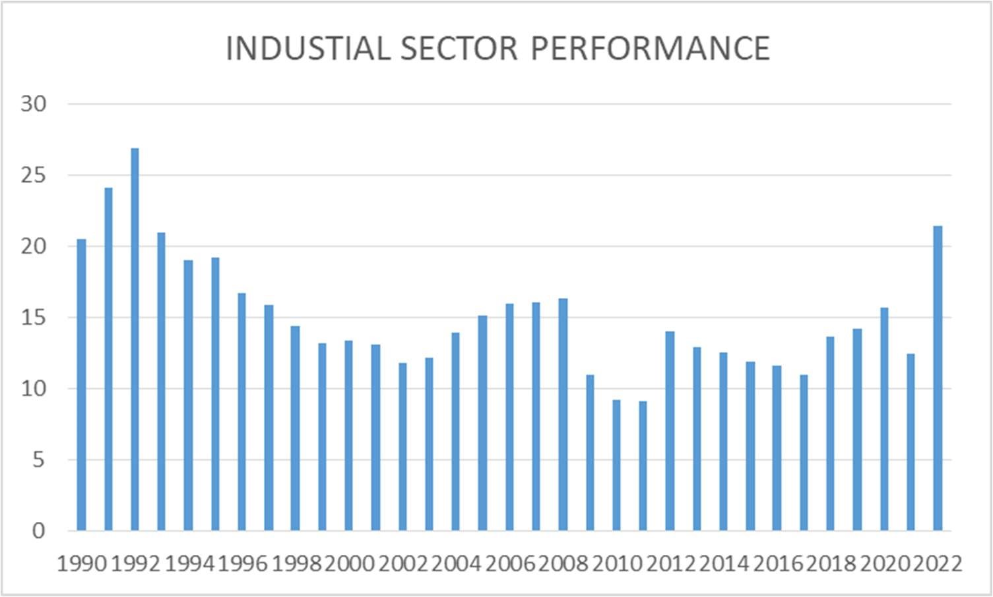

Fig 2: Industrial Sector Performance Source: World Bank (2022)

Trend of Education and Industrial Sector Performance for the Study Period

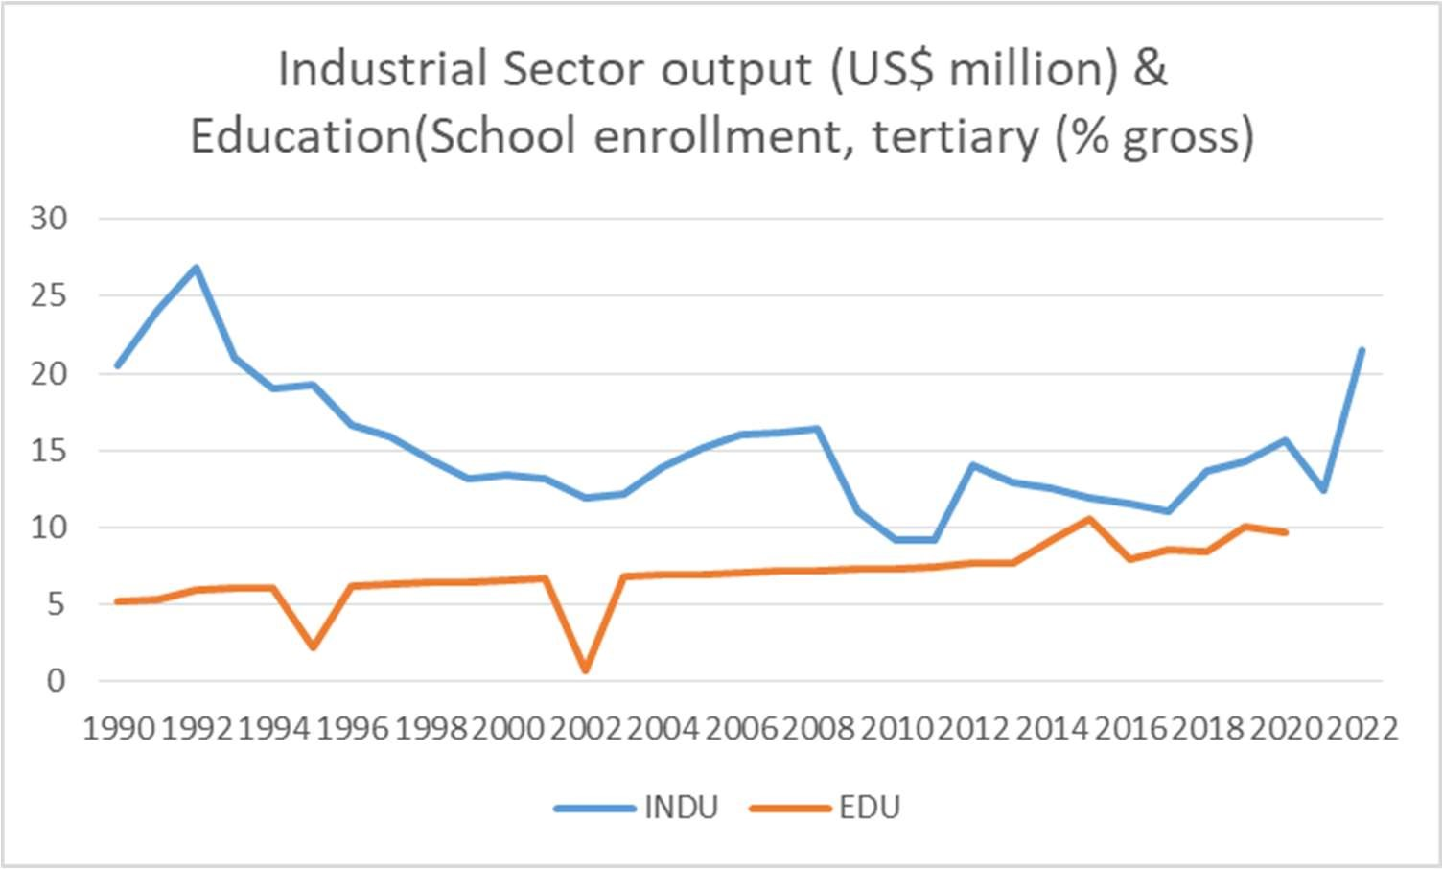

Fig 3: Industrial Sector Performance and Education

Source: World Bank (2022)

Industrial sector performance increased from 1990 to 1992 while education enrolment steadily increased from 1990 to 1994. During the global economic recession of 2008, higher education enrolment increased while industrial sector performance dropped. However, with the increase in the rate of education enrolment, the industrial sector performance does not correspond to the same since at some point education enrolment increases while industrial sector performance is declining.

# 1.2 Statement of the Problem

This study's problem statement centers on comprehending the unique function of education in the industrial sector. Despite the high literacy rate in Zimbabwe, industrial sector performance is lower than the increase in educational enrollment. There is a need for a deeper investigation into the impact of education on the industrial sector, because we can clearly see from previous trends that as education enrollment increase industrial output also increase and sometimes when education enrollment increases industrial sector output decreases. By addressing this problem, we aim to contribute to the body of knowledge in economics and provide insights into the policies and strategies that can enhance the role of education in fostering industrial growth. The impact of education on the industrial sector has been the subject of countless empirical research. Adam Smith proposed the theory of labor productivity in 1776, which states that increased production levels can be attainable without a matching rise in labor inputs. Workforce education, training, and skill levels are major factors in labor productivity. A workforce with higher levels of education and training is probably going to be more productive than one with lower levels.

The Solow growth model examines the roles played by capital accumulation, labor force expansion, and technical advancement in explaining long-term economic growth. The assumptions of the model are there is a production function that explains how labor (L) and capital (K) inputs and inputs converted into output (Y). As to the Solow model, education is a critical factor in driving technical advancement, which in turn drives long-term growth. Research, development, and invention are frequently the catalysts for technological improvement and the need for a workforce that is educated and skilled. A person with a higher level of education is more likely to create and accept new technologies that boost economic growth and productivity. The empirical evidence is insufficient to establish the impact of education on Zimbabwe's industrial sector. Therefore, it is uncertain if education has a beneficial or detrimental impact on the industrial sector. This has thus prompted the researcher to investigate the nature of education's role in the sector using time series data from 1990 to 2022.

# 1.3 Objective of the Study

This study's main goal is to investigate the function of education in the industrial sector. To achieve this, the following specific objectives will be pursued:

1. To analyze the trends in education and the industrial sector from 1990 to 2022.
2. To assess the relationship between education indicators (e.g., enrollment rates, educational attainment) and industrial development.
3. To identify ways in which education influences the industrial sector.
4. To recommend policy implications and strategies for leveraging education to promote industrial growth.

# 1.4 Research Question

To achieve the previously described research aims, the following research questions, which are:

1. How do the industrial sector and education relate to each other?
2. How does education affect the industrial sector? iii. What policy suggestions can we get from the study?

# 1.5 Study Hypothesis

H0: There is a positive relationship between education and the industrial sector.

H1: There is a negative relationship between education and the industrial sector.

# 1.6 Significant of the Study

This research is very important for academics and policymakers. By providing empirical evidence on the role of education in the industrial sector, it will contribute to the existing literature on the topic. The findings will help policymakers and government authorities in formulating effective strategies to enhance educational systems and promote industrial development. Furthermore, students and researchers in the field of economics will benefit from the insights gained from this study, which will stimulate further research and exploration in this area.

# 1.7 Delimitations of the study

The study will focus on a developing country like Zimbabwe from a specified period, which is from 1990 to 2022. By delimiting the study in this manner, education is going to measure by school enrolment tertiary (% gross) and the industrial sector performance is going to be measured by the manufacturing value added (% of GDP).

# 1.8 Limitations of the Study

Every study has its limitations, and this research is no exception. The data's accessibility and dependability, the analysis's restricted scope to time series data from 1990 to 2022, and the findings' applicability in other situations are a few possible limitations of this study. However, will make efforts to mitigate these limitations through data sharing and collaboration with other institutions that have already collected the data before, through independent verification of data involving external experts and through comparative analysis from similar context.

# 1.9 Definition of terms

## 1.9.1 Economic Growth

According to Mankiw (2017), a rise in an economy's output of goods and services over time is known as economic growth, and it is primarily gauged by variations in real GDP per capita.

## 1.9.2 Inflation

McConnell & Brue (2023) defines inflation as the gradual rise in the average price of goods and services throughout an economy.

## 1.9.3 Education

OECD (2021) defines education, as multifaceted process of facilitating learning, knowledge acquisition, skill development, and personal growth. It encompasses a broad range of activities, formal and informal, that aim to enhance individuals' intellectual, social, emotional, and physical capacities. Education involves the transmission of knowledge, values, beliefs, and cultural practices from one generation to another, fostering personal development and societal progress.

# 1.10 Chapter Summary

The problem statement, study background, significance of the research, and research aims were the main topics of this chapter. The review of theoretical and empirical literature will be the main topic of the following chapter. The organization is as follows: the literature review is covered in chapter 2, the research technique and econometric procedures are covered in chapter 3, the results are presented in chapter 4, and the conclusion includes policy recommendations and a summary in chapter 5.

# 

# CHAPTER II

# LITERATURE REVIEW

# 2.0 Introduction

The literature on the relationship between the role of education in the industrial sector is extensive, with both theoretical and empirical studies examining from various perspectives. This chapter reviews the existing literature, focusing on key theoretical frameworks using different economics schools of thought and empirical findings.

# 2.1 Theoretical Literature

The relationship between education and the industrial sector in Zimbabwe is examined from a theoretical perspective using different schools of thought, including endogenous and exogenous growth models. The literature also covers theories that promote education.

## 2.1.1 Exogenous growth mode: Solow model

The Solow was established in 1956 and is a theoretical framework that aims to explain output growth in terms of economic saving rate, technological progress, and population growth. The analysis by the model shows how the output is dependent not only on labor and capital but also on technological progress. Technology only establishes the maximum output that can be produced with a given amount of labor and capital and improves labor efficiency. As technology advances, fewer workers are needed to generate a given amount of production, and many workers can produce a greater quantity of output. We refer to this as labor-augmenting technology.

Mankiw et al. (1992) added human capital to the Solow model by utilizing cross-national data. Mankiw et al. (1992) claim that education can improve the human capital characteristics of the labor force by raising labor productivity, which in turn promotes transitional growth toward a higher equilibrium level of output. Neoclassical theories contend that education can promote economic advancement by enabling people to gain the skills required to assimilate and process new information as well as adapt to new technology developed by others Benhabib and Spiegel (1994). The Solow growth model relates to the study because Education affects the industrial sector through its impact on labor productivity, which is one of the key drivers of economic growth. Higher levels of education and human capital lead to increased labor productivity, as educated workers tend to be more skilled, innovative, and adaptable. This, in turn, enhances the efficiency and effectiveness of the industrial sector. Higher levels of education can affect both the rate of convergence to the steady state and the steady-state level of production per capita in the Solow model. When the level of education rises, it leads to higher labor productivity, which increases the output per worker. This, in turn, raises the steady-state level of output per capita. Furthermore, increased innovation and technical advancement can result from greater education, which can speed up production development.

The Solow model emphasizes technological progress as a key driver for economic growth; this has some important implications for the role of education in the industrial sector of Zimbabwe. Education, especially in STEM subjects (science, technology, engineering, and mathematics), may have a major role in improving the technological prowess of a nation's industrial sectors. Investing in education, particularly (STEM) subjects, in Zimbabwe could potentially enhance the technological capabilities of its industrial sector, leading to increased productivity and economic growth in line with the predictions of the Solow model. This would involve not only improving access to education but also aligning educational curricula and programs with the specific needs of the industrial sector Chikasha (2020).

## 2.1.2 Endogenous growth models

Lucas (1998) created the endogenous growth model, which views education as a means of accumulating human capital and views human capital as a factor of production. In addition to labor and physical capital, education was considered a factor of production and served as a means of accumulating human capital. This indicates that improvements in the labor force participation rates and education attainment benefit productivity, improving overall economic performance. This is in line with the research understudy because Education equips individuals with industry-relevant skills and knowledge, enhancing workforce capabilities within the industrial sector. By improving the quality and level of education, workers are better prepared to perform their tasks efficiently, adopt new technologies, and contribute to productivity growth. Through education, people can develop specific talents, critical thinking abilities, problem-solving strategies, and other qualities that have a direct impact on how well they function in the industrial sector.

Alharbi (2023), education facilitates the adoption and implementation of continuously invented new technologies. Human capital with education is aware of and supportive of technology utilization. However, educated individuals implement or use technology in organizations. One fundamental and significant factor in determining growth can be education. This is also in line with research because education enhances the productivity of the industrial sector by equipping workers with the necessary skills, knowledge, and abilities. Educated individuals are more capable of performing complex tasks, adapting to changing technologies, and implementing best practices. Higher levels of education among the workforce contribute to higher productivity levels, which directly benefit the industrial sector.

Greater growth rates, however, may not be associated with education, as workers with higher levels of education may be more inclined to engage in socially harmful behaviors like stealing or exploiting other people's work without permission. Lackluster education has not produced any encouraging outcomes that point to an expansion in human capital, and a large pool of highly qualified workers has stifled growth and earnings. The human capital Theory takes into consideration including education, work experience, and skill development. Hoeffler, (2022). This is in line with topic understudy because while education is a component of human capital and is generally believed to contribute positively to industrial sector performance, the quality and relevance of education become crucial factors. If the education system fails to provide practical skills, critical thinking abilities, or ethical values, educated individuals may not effectively contribute to the industrial sector

Additionally, Glewwe et al. (2012) assert that less developed nations may see a negligible correlation between education attainment and economic growth because their primary focus is on the quality of education rather than the sheer number of educated individuals. Higher education can influence economic growth in three ways. the neoclassical growth theory, which focuses on the development of productive skills and abilities; the endogenous growth theory, which focuses on the creation of new knowledge through innovation; and the innovation and adoption of technologies, which speeds up the adoption of current cutting-edge technologies. The economy's capacity for innovation and its awareness of cutting-edge goods, services, and technology can both be enhanced by education.

Romer’s (1936) model of endogenous growth emphasized the importance of knowledge and nonrival human capital, much as it does in the innovation and adoption of technology. New information produced by investing in new machinery can be shared by businesses that have not made the same tangible capital investment. For example, if a firm installs new machinery in a factory, for instance, it creates new skills as people learn how to use the equipment and increase the efficiency with which a given commodity may be produced. Higher economic growth rates result from businesses ensuring people, are appropriately trained and equipped to operate equipment and apply this knowledge in the workplace. This is in line with the study as a result; several writers have emphasized the importance of scientific and mathematical abilities in connecting education with long-term economic growth Hanushek (2021). Even though there are many ways to improve these skills, obtaining a higher education would, all else being equal, result in greater progress.

# 2.2 Empirical Evidence

Numerous researches have explored the direct effects of the research understudy, and their findings have indicated positive, negative, and mixed results.

## 2.2.1 To assess the relationship between education indicators (e.g., enrollment rates, educational attainment) and industrial development.

Ahmadizad et al. (2016) examine the relationship between education and industrial development in Iran. The researcher used autoregressive distributed lag estimator. Education was broken down into primary, secondary, and tertiary to provide a clear image. Their research, which took place between 1980 and 2015, showed that secondary education had a positive impact on industrial development and that tertiary education had a negative impact on industrial development.

Bawakyillenuo et al (2013) also conducted a study to investigate the l relationship between tertiary education and industrial development in Ghana from 1990-2010. They utilized the Johansen Cointegration technique and the results showed tertiary education negatively affects industrial development

Effiong et al (2020) examine the between relationship education and industrial development in Nigeria during the period 1980 to 2018. The study utilized ordinary least squares. The findings demonstrated that education negatively affects industrial development in Nigeria.

## 2.2.2 To identify ways in which education influences the industrial sector.

Nowak and Dahal (2016) used OLS and the Johansen Cointegration approach to examine the longterm link between education and economic growth in Nepal. The 1995–2013 analysis demonstrates that secondary and higher education have a beneficial impact on Nepal's real GDP per capita.

Nadia and Arshed (2016) analyzed panel data for the SAARC countries (Pakistan, India, Bangladesh, Bhutan, Nepal, Sri Lanka, Maldives, and Afghanistan) from 1960 to 2013 using a linear Cobb-Douglas production function. They looked into the connection between economic expansion and education in schools. The findings demonstrated that, in comparison to enrollment in primary and secondary school, tertiary education enrollment has the greatest influence on growth.

Owusu-Nantwi (2015) also used vector error correlation and cointegration analysis to examine the relationship between economic growth and education spending in Ghana. The research, which took place between 1970 and 2012, showed a strong and favorable long-term correlation between education spending and real GDP, gross capital formation, and labor force participation. Granger causality, however, operates in both ways in the short term between economic growth and education.

Furthermore, from 1970 to 2005, Habibullah et al. (2014) carefully examined the relationship between education and economic development in China and India. They examined the dynamic relationship between education and economic growth using dynamic ordinary least squares, or DOLS. Their research showed that education and economic growth in China and India have a longstanding tendency. In the long-run, a unidirectional causality link was shown for both nations, with income levels in China correlated with education expenditures and income levels in India correlated with education expenditures.

In order to examine the impact of the long-term cointegration relationships between education and economic growth in South Africa, Malangeni and Phiri (2018) undertook a study. The autoregressive distributive model's boundaries approach was employed in the study to estimate the connection for the years 1980–1994–2014. The study's findings demonstrated that there is little correlation between South Africa's economic growth and education. This suggests that the importance of education lay in its quality rather than its quantity.

# 2.3 Literature Gap Analysis

The research aims to explore the relationship between the role of education in the industrial sector in Zimbabwe from 1990 to 2022, and it differs from other studies in various ways. The effects of education on economic growth and industrial development were the primary subjects of the earlier research. In contrast, this study looks particularly at the industrial sector itself and the study covers a more recent and relevant period from 1990 to 2022, which encompasses significant changes in Zimbabwe such as the introduction of the new curriculum.

# 2.4 Chapter Summary

The material written by other researchers was reviewed in this chapter. It examined the gaps in the study and provided evidence for the need to statistically investigate this link in Zimbabwe. The chapter also examined other viewpoints and ideas on this relationship from diverse authors.

# CHAPTER III

# RESEARCH METHODOLOGY

# 3.0 Introduction

This chapter will provide a detailed methodology and the method employed to explore the role of education in the industrial sector in Zimbabwe from 1990-2022. The chapter will cover the research design, data sources, and collection instruments. However, this chapter will contain the model specification, justification of variables, the estimation procedures, and the econometric test used in the analysis.

# 3.1 Research design

The quantitative research methods used in this study are recognized in the fields of statistics and economics. Secondary data are used in the study. Information that has already been acquired, examined, and processed for a particular purpose by other researchers or organizations is referred to as secondary data. Anderson et al (2014). The use of secondary data has its benefits which include cost-effectiveness, availability of large sample sizes, and the ability to conduct historical analysis.

# 3.2 Population and Sample

The study extracted relevant data from the World Bank database to obtain findings. The research used non-probability sampling, as it is more appropriate for explanatory research. According to Babbie (2016), nonprobability sampling is used in explanatory research to explore identified patterns or trends further. Time series data from 1990 to 2022 were used in the analysis since this period takes into account economic shifts as the introduction of the multi-currency system in 2009 and the adoption of the slogan "Zimbabwe is open for business" in 2017. The COVID-19 epidemic in 2019 and the implementation of a new curriculum in the educational system are also included in this period.

# 3.3 Data sources

The information was taken from reliable sources, including the World Bank database. The use of secondary data from trusted sources has its advantages such as reliability, wide coverage, and easy access, Papaioannou et al (2016).

# 3.4 Data Collection Instruments

A structured data extraction was used to identify the necessary variables and data points. Microsoft Excel was used to collect data by scraping it from the database, which reduced errors and minimized the need for manual data entry.

# 3.5 Model Specification

To investigate the role of education in the industrial sector in Zimbabwe, the study will follow the specification used by Malangeni and Phiri (2018).

## 3.5.1 Theoretical Specification

In order to determine the macroeconomic input-output relationship in an economy, the study uses the Cobb-Douglas production function, which offered a mathematical expression of production function. By calculating the total quantity of labor and capital invested, it calculates the amount of output created. The expression in mathematics is

P (L, K) = bLα Kβ

The Cobb-Douglass production model is a useful tool when combined with other crucial elements like the importance of human capital. It is now possible to quantify the estimates of education's contribution to economic growth by linking output (Y), labor (L), capital (K), and human capital

(H)

Y= f (K, L, H)

In order to examine the connection between education and economic growth, Malangeni and Phiri (2018) included control variables such as terms of trade, government size, investment, and inflation in the aforementioned equation.

## 3.5.2 Empirical specifications

Estimating a bi-variate empirical regression between the time series is the simplest regression method identified in the literature for examining the debt-growth relationship. The function form that follows is assumed in such a regression

GDPt = α + β1EDUt + et …………………………………………1

EDU is a normally distributed disturbance term that measures education, whereas GDP is a measure of economic growth. Based on the bias caused by omitted variables, the bi-variate equation above is susceptible to criticism. Nonetheless, when modeling the relationship between education and growth, multivariate regression parameters offered a more secure option. This is how the multivariate regression will be:

GDPt = α +β1EDUt + et + β2Xt + et …………………………………………2

In this case, X stands for a matrix of growth elements that the model incorporates to guarantee robustness. The study found that the control variables of terms of trade, government size, investment, and inflation were pertinent. An important metric for monetary policy, inflation is a measure of how well a program targeting inflation is being implemented to maintain price stability and foster economic expansion. Since the new development plan and the new growth path both represent larger-scale spending initiatives meant to enhance long-term economic growth, government size is another crucial factor. Since investment is viewed as a growth engine, it is represented in the empirical literature as a standardized growth determinant. Finally, it is believed that terms of trade, a gauge of openness, contribute positively to economic expansion. The final multivariate regression model, which includes growth determinant factors, will look like this:

GDPt = α + β1EDUt + β2GOVt + β3INVt + β4INFt + β5TOTt + et ………………………….3

Where GOV is government size, INV is investment, INF is inflation and TOT is terms of trade.

However, the researcher is going to use the industrial output as a dependent variable from Equation 3 instead of GDPt. This is because industrial output focuses on the production and output of goods within the industrial sector. By using industrial output as a dependent it, help to focus on analyzing the performance and trends within the industrial sector specifically, rather than considering the broader economy as whole. The researcher also dropped inflation as independent variables because the variables was not making the model a good fit in explaining the model. Terms of trade was also dropped to the unavailability of data from reliable sources for the selected country and time period under study.

However, after dropping the two variables the researcher included capacity utilization as independent variable because by including capacity utilization as independent variable, the model can capture the impact of production efficiency on industrial output. This will help to assess how effectively resources are being employed and how changes in capacity utilization influence output levels. The final equation will be as follows:

INDUt = α + β1EDUt + β2GOVt + β3INVt + β4CAPUt + et……………………………4

Where INDUt is industrial out, EDU is education, GOV is government size, INV is investment, and CAPU is capacity utilization

# 3.6 Measurement of variables and expectations

Education, Government size, Investment, and Capacity utilization are supposed to have a positive sign since they influence on the industrial sector.

The aggregate production output of the economy's industries, which mostly include manufacturing, mining, utilities, and occasionally construction, is referred to as industrial output (OECD, 2020). The industrial sector is the primary indicator of GDP even though it only makes up a small fraction of the economy. However, the researcher in this study as a stand-in for industrial sector production will use the manufacturing value added (as a percentage of GDP) as a proxy for industrial sector output.

OECD (2021) defines education, as multifaceted process of facilitating learning, knowledge acquisition, skill development, and personal growth. It encompasses a broad range of activities, formal and informal, that aim to enhance individuals' intellectual, social, emotional, and physical capacities. Education involves the transmission of knowledge, values, beliefs, and cultural practices from one generation to another, fostering personal development and societal progress.

One indicator of education level is the tertiary school enrollment percentage (%) gross. Education and the dependent variable have a positive association, indicating that education is an important primary input factor for an industry's growth. Rapid increases in productivity are a direct result of high enrollment rates, which is why the education coefficient should be positive. Using education, Nowak & Dahal (2016) discover a positive correlation between real GDP per capita and education.

Carbaugh (2019) FDI is a long-term investment that signifies a persistent interest in and control over an organization by foreign investors that is based in an economy that is located in a different nation. FDI- Foreign investment is a net inflow (% of GDP) made by a firm or individual in one country into business interest located in another country. It creates employment in the recipient country, which leads to higher output and contributes to economic growth. The FDI coefficient is supposed to have a positive sign. Idoko and Taiga (2018) found that FDI has a positive effect on manufacturing output

Government size, according to the OECD (2019), is the extent and magnitude of government activity inside an economy. It is commonly expressed as the amount of public expenditure or government spending as a proportion of GDP (gross domestic product). It gives a sense of how the government functions and is involved in the economy. One often-used proxy is the final consumer expenditure (% OF GDP) metric. The overall amount spent by the government indicates its magnitude. The government grows in size proportion to its expenditures; conversely, it shrinks in proportion to its expenditures. Since more government spending is linked to higher output and employment, the researcher will focus more on the size of the government. According to studies by Odhiambo (2015) and Phiri (2017), which indicate that there is a positive association between government size and output, the coefficient of government size should have a positive sign.

Capacity utilization in simple terms is a measure of whether existing assets are sweating, (CZI, 2022) that is to measure of whether new investment is required to expand output or if already existing assets are still capable producing additional output. It measures the extent to which a firm or an industry utilizes its production capacity. Gross Value Added at Basic Prices (current US$) (GVA) is used as a proxy to measure CAPU. Sola et al (2013) makes use of CAPU and find a positive relationship with industrial output

Table 1: Summary of Variables and Expected Signs

|  |  |  |
| --- | --- | --- |
| Independent variables | Expected signs | Scholars |
| Education | Positive (+) | Nowak & Dahal (2016) |
| Investment | Positive (+) | Idoko and Taiga (2018 |
| Capacity Utilization | Positive (+) | Sola et al (2013) |
| Government size | Positive (+) | Odhiambo (2015) &  Phiri (2017) |

# 3.7 Justification of Variables

The variables in the model based on theoretical relevance and empirical evidence of their relationship with economic growth.

# 3.8 Estimation Method

The investigator will examine the causal association between education and the industrial sector in Zimbabwe using the Ordinary List Square (OLS) technique. The OLS model is a highly dependable approach for evaluating the correlation between economic variables since it provides the most accurate linear unbiased estimates (BLUE). The diagnosis tests must carry to make sure that estimates are BLUE.

# 3.9 Econometric Model Diagnostics Testing

The researcher will employ some diagnostic tests to check the assumption of OLS and make sure that they are BLUE.

## 3.9.1 Stationarity Test

The consistency of a time series data's mean, variance, and auto-covariance over a range of lags is what determines whether or not the data passes the stationarity test (Gujarati 2004). Unlimited shocks can also affect the behavior and characteristics of non-stationarity tests. To check for stationarity, one might utilize the Augmented Dickey-Fuller (ADF) test. The following hypothesis is examined by the ADF to determine if a series has a unit route or not:

H0: The series has no unit root.

H1: The series has a unit root.

The decision rule under this taste is that if the p-value>0.05 we reject the null hypothesis, but if the p-value is less than 0.05 significance level we fail to reject the null hypothesis and conclude that the variables are stationary.

## 3.9.2 Multicollinearity Test

Multicollinearity is defined as a condition in which certain explanatory variables in a model have a perfect linear relationship or when they are significantly inter-correlated, according to Cook and Weisberg (1992). Because of this, it will be challenging to distinguish between how each explanatory variable affects the dependent variable. A correlation coefficient above 0.8 indicates a strong correlation between the explanatory variables, which will result in low ratios and high pvalues. The correlation matrix will be utilized to test for multicollinearity, and the following procedures will be performed to test the hypothesis:

H0: There is no multicollinearity among explanatory variables.

H1: There is multicollinearity among explanatory variables.

The decision rule will be, that if the correlation matrix is greater than 0.8, we do not rule out the null hypothesis therefore we conclude the existence of multicollinearity.

## 3.9.3 Heteroskedasticity Test

Heteroskedasticity occurs when the errors in a model do not have a constant variance across observations (Gujarati 2004). This may be the result of the model lacking some crucial variables or outliers. Ignoring heteroskedasticity will result in biased and inefficient estimates. The researcher will employ the Breusch- Pegan-Godfrey test to test for heteroskedasticity. The hypothesis will be as follows:

H0: There is homoskedasticity.

H1: There is heteroskedasticity.

The decision will be if the p-value is greater than a 5% significance level we fail to reject the null hypothesis and conclude that there is no heteroskedasticity.

## 3.9.4 Autocorrelation Test

According to Gujarati (2004), Autocorrelation is when there is non-zero covariance among different error terms, indicating a relationship between two or more successive error terms. Autocorrelation might occur when the assumption of independence between consecutive values of the error term is violated. This can happen when influential variables are excluded from the model. The researcher will use Durbin Watson the Serial Correlation to test for autocorrelation. The hypothesis is stated as follows:

H0: There is no autocorrelation.

H1: There is autocorrelation.

The decision rule will be, on the Durbin-Watson test if its value is close to 2, i.e. (between 1.5 and 2.5) it suggests that there is no autocorrelation. On the Serial Correlation LM test, we reject the null hypothesis if the value is less than 0.05 and conclude that there is no autocorrelation in the model.

## 3.9.5 Normality Test

When using OLS, it is assumed that the model has a normal distribution; if this is not the case, biased and ineffective parameter estimations will result. In essence, it is crucial to check if the error term is normal. By doing this, you may assist guarantee that the OLS model is dependable and valid for producing precise statistical inferences and predictions. The Jarque-Berra test will be used in this investigation to verify that the data are normal. The following will be the hypothesis's statement:

H0: The error term is normally distributed.

H1: The error term is not normally distributed.

The decision rule is based on, when the p-value is greater than 0.05 we conclude that the data is normally distributed that is we fail to reject the null hypothesis.

# 3.10 Econometric Model Stability Testing

The researcher will test for the stability of the model because it is essential for policy analysis and forecasting. If the mode is unstable the predictions may be unreliable, and its usefulness may be limited. The researcher will employ the CUSUM of squares test to the stability of the model. The CUSUM test is used to test the changes in variance of a time series or process. The method involves calculating the cumulative sum of squared deviations from the mean of the process over time and comparing this cumulative sum against a threshold value to determine if a change in variance occurred. The hypothesis is tested as follows:

H0: The model is stable for forecasting.

H1: The model is not stable for forecasting.

The decision rule is based on comparing the cumulative sum statistics (St) to a predetermined limit (h). if the cumulative sum statistic is equal to or greater than limit, the CUSUM test rejects the null hypothesis and concludes that the process is out of control.

# 3.11 Chapter Summary

The purpose of this chapter was to provide an overview approach that will be used to carry out the study. The chapter includes an overview of the research methodology, including research design, sample population, data sources and collection instruments, econometric model specification, justification of variables used, and diagnostic and stability tests to be conducted in the model.

# CHAPTER IV

# DATA PRESENTATION, ANALYSIS AND DISCUSSION

# 4.0 INTRODUCTION

This chapter presents the findings and the outcomes of this research; the statistical software Eviews was used to explore the role of education on the industrial sector. This chapter will also include description of the data, diagnostic evaluation, regression findings, and the importance of the econometric model. Lastly, a summary of the research findings is provided along with a discussion of the connection observed between the dependent variables and the independent variables.

# 4.1 Descriptive Statistics

Descriptive statistics is a set of techniques used to summarize and describe important features on a data set, such as its central tendency, dispersion and shape (Gujarati and Porter, 2009). The techniques will help the researcher to gain insights into data distribution and properties, without drawing conclusion about the overall population. Common measure of the descriptive statistics includes the, mean, median, standard deviation, skewness, kurtosis, correlation coefficient and range. The summary statistics were calculated for each variable based on 32 observation that is from 1990 to 2022, and table 1 below presents the summary statistics for each variable.

Table 2 descriptive summary

|  |  |  |  |  |  |
| --- | --- | --- | --- | --- | --- |
|  | DINDU | EDU | DGOVEN | DINV | DCAPU |
| Mean | 0.020978 | 6.957717 | -0.35261 | 0.135034 | 4.01E+08 |
| Median | -0.00504 | 7.007952 | -0.26914 | 0.109533 | 57335850 |
| Maximum | 0.880259 | 10.60087 | 8.038349 | 2.469462 | 1.63E+10 |
| Minimum | -0.40854 | 0.729564 | -11.2764 | -2.01896 | -1.20E+10 |
| Std. Dev. | 0.256251 | 1.955418 | 4.733282 | 1.07453 | 3.98E+09 |
| Skewness | 1.467144 | -1.13907 | -0.45417 | -0.12235 | 1.187956 |
| Kurtosis | 6.350469 | 5.840592 | 3.00728 | 2.892297 | 12.50207 |
| Jarque-Bera | 24.7946 | 16.57356 | 1.031394 | 0.089345 | 119.9179 |
| Probability | 0.000004 | 0.000252 | 0.597084 | 0.956311 | 0 |
| Sum | 0.629351 | 208.7315 | -10.5783 | 4.051024 | 1.20E+10 |
| Sum Sq. Dev. | 1.90428 | 110.8861 | 649.7149 | 33.48383 | 4.59E+20 |
| Observations | 30 | 30 | 30 | 30 | 30 |

Source E-views 10 see appendix 2.1

The table 1 above shows descriptive statistics for five variables, which were used in this research model, which was based on 30 observations. According to Clegg et al (2011) standard deviation (Std. Dev.) measures the extent to which data points deviate from the mean. When the standard deviation is higher this will apply that there is more variation among the data points, whilst a lower standard deviation indicates that the data points are closer to the mean. However, in this particular case DGOVEN has the highest standard deviation, which implies that they are higher impact of DGOVEN on industrial output, whilst DINV have lower standard deviation compared to other variables which implies a lower impact on industrial output.

According to Crawshaw et al (2011), skewness measures the degree of asymmetry in a distribution. A positive skewness represents a right-skewed distribution whilst a negative skewness represents a left-skewed distribution. In this case, EDU, DGOVEN, and DINV displays a negative skewness whilst INDU and DCAPU exhibits a positive skewness.

# 4.2 Econometric Model Diagnostic Test

The model utilized time series data, it is possible that it can encounter issues such as multicollinearity, autocorrelation, specification errors and non-stationarity. However, diagnostics test was conducted to assess the strength and credibility of the model as mentioned earlier in chapter three.

#### 4.2.1 Stationery Test

The time series data is often non-stationery, which will result in inaccurate results and inflated R2 value. To ensure that the variables are integrated at the same level, a unit root test was conducted using the Augmented Dickey-Fuller (ADF) test to establish the time series properties of the variables.

The variables were non- stationery at the level using the 5% critical value as the maximum critical value. However, the researcher concluded that they are non-stationery, therefore it is important to note that accepting a unit root test at a higher significance level may increase the risk of a type I error, which will lead to incorrect conclusion. As all data were non-stationery, the researcher employed the ADF test at first difference for all variables

Table 3 ADF Test Results

|  |  |  |  |  |
| --- | --- | --- | --- | --- |
| Variable | ADF test | Critical value | P-value | Oder of integration |
| INDU | -6.40558 | 1% -3.66166 5% -2.96041  10% -2.61916 | 0.0000 | I (1) |
| EDU | -3.10159 | 1% -3.67017 5% -2.96397  10% -2.62101 | 0.0372 | I (0) |
| GOVEN | -5.57482 | 1% -3.66166 5% -2.96041  10% -2.61916 | 0.0001 | I (1) |
| CAPU | -6.77548 | 1% -3.67017 5% -2.96397  10% -2.62101 | 0.0000 | I (1) |
| INV | -6.90064 | 1% -3.66166 5% -2.96041  10% -2.61916 | 0.0000 | I (1) |

Source EViews 10 see appendix 3.1

The table 2 above shows the results after the running the ADF test at the first difference and it indicates that the variables exhibit stationarity. Education only was found to be stationary at level.

#### 4.2.2 Multicollinearity Test

Time series data is typically multicollinear; however, the researcher is concerned about the extent of the multicollinearity rather its mere existence. The table below shows the results of the test for multicollinearity using the VIF.

Table 4 Variance Inflation Factor (VIF)

|  |  |
| --- | --- |
| Variable | Centered (VIF) |
| EDU | 1.153928 |
| DGOVEN | 1.058813 |
| DINV | 1.2167 |
| DCAPU | 1.100832 |
| C | NA |

Source EViews 10 see appendix 2.2

As shown in the table above, we can reject the null hypothesis and conclude that there is no multicollinearity in the model as the centered VIF are less than 10.

#### 4.2.3 Heteroscedasticity

Heteroscedasticity arises when homoscedasticity is lacking, which means the error term variance is unequal. If heteroscedasticity is presents during data estimation, it may cause the confidence interval to be too broad, thereby reducing the likelihood of rejecting the null hypothesis. The Breusch-Pagan Godfrey Test was carried to check for homoscedasticity.

Table 5 Heteroscedasticity Test: Breusch-Pagan Godfrey Test

|  |  |  |  |
| --- | --- | --- | --- |
| F-statistic | 0.105112 | Prob. F (4,25) | 0.9797 |
| Obs*R-squared | 0.496191 | Prob. Chi-Square  (4) | 0.9739 |
| Scaled explained  SS | 0.761365 | Prob. Chi-Square  (4) | 0.9436 |

Source E-views 10 see appendix 4.2

From the table above, it can be observed that the F-statistics probability is 0.9797, which is greater than the significance level 0.1. Therefore, there is no evidence to reject the null hypothesis that the error variance is homoscedasticity. The Obs*R-squared p-value is also greater than 0.1 which further supports the presents of homoscedasticity, indicating that the error term variance is constant across all observation. If there were a present of heteroscedasticity the researcher would use the heteroscedasticity consistency standard errors covariance to solve the problem. However, since the model is not suffering from heteroscedasticity such a correction is not necessary.

#### 4.2.4 Autocorrelation

Autocorrelation refers to the correlation between the independent variables and the error term in a model. Durbin Watson statistic is widely used method to determine whether there is any autocorrelation. If the DW statistic value of approximately 2 signifies the lack autocorrelation.

Table 6: Durbin Watson Statistic

|  |  |  |  |
| --- | --- | --- | --- |
| F-statistic | 0.848604 | Prob. F (2,23) | 0.441 |
| Obs*R-squared | 2.06162 | Prob. Chi-Square  (2) | 0.3567 |

Source E-views 10 see appendix 4.1

The table above shows that the F-statistic value is 0.441, which surpasses the significance level of 0.1, hence there is no proof to reject the null hypothesis lacks autocorrelation. However, the Obs*R-squared is also higher than 0.1 which adds more confirmation about the absence of autocorrelation in the model.

#### 4.2.5 Normality Test

Normality test is a statistical evaluation to check whether if the model’s residual follows a normal distribution. Residual refers to the difference between the predicted and the actual values of the dependent variable. However, if the residuals are normally distributed, it indicates that the model is suitable for data, and the predictable values are close to the actual values. To conduct the normality, test the researcher used the Jarque-Bera test. Skewness measures the symmetrical of the residual whilst Kurtosis measures the peak of the distribution. Skewness should be zero and Kurtosis should be three.

Table 7: Jarque-Bera- Normality Test

|  |  |  |  |  |  |  |
| --- | --- | --- | --- | --- | --- | --- |
| Mean | Skewness | Kurtosis | Jarque-  Bera | probability | Standard  Dev | Mean |
| 4.60E-18 | -0.38843 | 2.67701 | 0.884772 | 0.642502 | 0.053374 | 4.60E-18 |

Source E-views 10 see appendix 4.3

From above we do not reject the null hypothesis is not rejected, which means we accept this shows that the data is normality. The data is positively skewed Kurtosis is above and the probability statistic indicates that the data is significance as it is greater the significance level (0.05).

### 4.3 Econometric Model Results

After conducting the diagnostic test, the researcher proceeds to perform a regression analysis of the model using E-views. The resulting outcomes are presented below

Table 8: OLS Model Results

|  |  |  |  |  |
| --- | --- | --- | --- | --- |
| Variable | Coef icient | St. Error | T-statistic | P-value |
| EDU | 0.017574 | 0.015031 | 1.169172 | 0.2534 |
| DGOVEN | 0.00462 | 0.005948 | 0.776685 | 0.4446 |
| DINV | -0.00446 | 0.028087 | -0.15865 | 0.8752 |
| DCAPU | 5.50E-11 | 7.21E-12 | 7.624162 | 0 |
| C | -0.12111 | 0.10921 | -1.10899 | 0.278 |

Source E-views 10 see appendix 5

R-Squared = 0.714982

Adjusted R-Squared = 0.669379

Durban-Watson stat = 1.864728

F-Statistic = 15.67842

Prob (F-Statistic) = 0.000002

4.3.1 Model Significance

The results above show that the R-squared value is 0.714982, indicating that approximately 71% of the variation in D(INDU) can be explained by the independent variables, while the remaining 29% is attributed to other factors captured in the error term of the model. The Adjusted R-squared of 0.669379 shows that the model is accurately specified. The F-statistics with a value of 15.67842 and the probability of 0.000002 measuring the overall significance of the model and how well the included variables explain D(INDU). The model is statistically significant at 1% level because the p-value of the F-statistics is less than 0.01.

#### 4.3.2 Model Stability

The researcher performed a CUSUM test to test for model stability. Model stability refers to the ability of an economic model to maintain to validity and reliability overtime or under different conditions. The model stable when it produces when it produces consistent and reliable results when applied to different data sets or used to make predictions under different conditions. The results of the CUSUM test are presented below.

Figure 4: CUSUM of Square Test

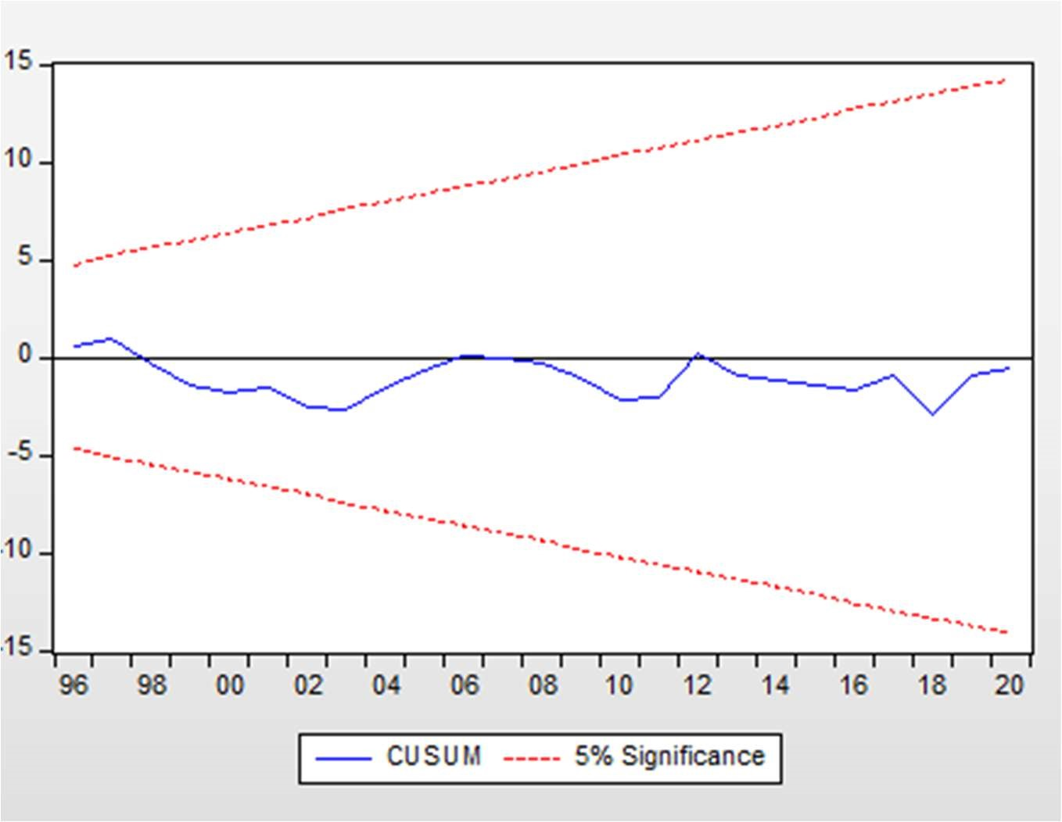

The diagram above represents the CUSUM of squares, the results without structural break under a 5% significance level. From the results the CUSUM line lies between the significance level therefore, we conclude that the model is structurally stable.

#### 4.3.3 Ramsey reset test

Table 9: Ramsey Reset Test

|  |  |  |  |
| --- | --- | --- | --- |
| t-statistic | 1.042715 | Probability | 0.3075 |
| F-statistic | 1.087254 | Probability | 0.3075 |
| Likelihood ratio | 1.329182 | Probability | 0.249 |

Source E-views 10 see appendix 4.4

The probability value of the Ramsey Reset test was found to be 0.249, which is far above 0.05 meaning that the model is specified correctly and is good for policy implications.

### 4.4 Model Results Interpretations and Discussion

The results of the model were used to drive the equation below for interpreting the results of the model by plugging in the obtained coefficients.

D(INDU) = - 0.1211 + 0.0176*EDU + 0.0046*D(GOVEN) - 0.0045*D(INV) + 5.4992*D(CAPU)

#### 4.4.1 EDUCATION

The estimated coefficient of EDU is positive and statistically significant at the 1% level of significance. This indicates that whilst holding other things constant, a 1% increase in education will result in a 1.76% (0.0176*100) increase in D(INDU). With 99% confidence, it can be concluded that a 1% increase in the change of education enrollment will result in a 1.76% increase in industrial output. This conforms to the Endogenous growth model, which posits that educational achievements of the labor force have a positive effect on productivity that will lead to better economics performance on aggregate. However, the results also align with those Hanushek and Kimko (2000) who identified that there is a remarkable increase in productivity and national growth rate due to an increase in education.

#### 4.4.2 GOVERNMENT SIZE

The estimated coefficient of D(GOVEN) is positive and significant at 1% level of significance. A1percentage increase in D(GOVEN) leads to a 0.46% (0.0046*100) increase in D(INDU). With a 99% confidence, it can be concluded that a 1% increase in the change of Government Size results in a positive increase in the change in industrial output. The findings, which conforms to Wagner’s law, which posits that as a country, experience economic development; there is an increase in demand of goods and service therefore to match the increase in demand of goods and services more output will be produced by the industries. According to Keynesian Economics government, intervention can stabilize the economy and promote industrial out, during the recession or periods of law demand government intervention is necessary to stimulate economic activity and increase industrial output. Further advocated for in the works of Odhiambo (2015) and Phiri (2017) which suggest that there is positive relationship between Government size and output.

#### 4.4.3 INVESTMENT

The estimated coefficient D(INV) is negatively and statistically significant at the 1% level of significant. Whilst holding another factors constant, a 1% increase in D(INV) will lead to a 0.45% (0.0045*100) decrease in D(INDU). With a 99% confidence, it can be concluded that a 1% increase in the change of Investment results in a 0.45% decrease in industrial output. The observed effects run contrary to the predictions of the theories in chapter 2, which suggest that FDI involves transfer on technology from foreign investors to domestic firms. This technology transfer can enhance the capabilities of domestic industries, leading to increased industrial output, which suggest. The results align with those of Sunday Anderu Keji (2003) who identified a negative relationship between foreign direct investment and industrial output growth. Based on the findings the researcher concluded that despite increase in investment in Zimbabwe, foreign direct investment affects industrial output.

There are possible reasons that might explain the negative impact of foreign direct investment on industrial output, as investigated by the researcher include:

1. Lack of infrastructure: Zimbabwe may the necessary infrastructure, such as reliable power supply, transport networks and communication systems, which are crucial or industrial production. Without adequate infrastructure, it becomes challenging foreign investors to establish and operate industrial facilities effectively.
2. Political instability: political instability can deter foreign investors from committing to longterm investments in Zimbabwe. Frequent changes in government policies, corruption, and uncertain legal frameworks can create an unfavorable business environment, leading to a decrease in FDI and subsequently affecting industrial output.

#### 4.4.4 CAPACITY UTILIZATION

The effect of D(CAPU) on D(INDU) is positive and significant at 1% level of significance. Holding others factors constant, a 1% increase in D(CAPU) will lead to a 5.4% increase in D(INDU). With a 99% confidence, it can be concluded that a 1% increase in the change of capacity utilization will result in a 5.4% increase on industrial output. This conforms to the Accelerator theory, which posits that changes in capacity utilization can have a significance impact on investment levels. When capacity utilization is high, firms may need to invest in expanding their production capacity to meet the demand. This increased investment can stimulate economic activity and lead to higher industrial output. The findings also support the results of Simon-Oke & Awoyemi (2010). Which revealed that there is a positive relationship between capacity utilization and industrial output.

### 4.5 Chapter Summary

This represents the findings of the study from 1990 to 2022. The diagnostic test was carried for the OLS estimator. This will provide sufficient evidence that the estimated model is BLUE that is it is reliable and unbiased. However, the model is stable in explaining the industrial sector in Zimbabwe.

### CHAPTER V

### SUMMARY, CONCLUSION AND POLICY RECOMMENDATIONS

### 5.0 Introduction

This chapter provides an extensive view of the research conducted in previous chapters, including summary of the empirical results, conclusions from research findings and policy recommendation that align with this conclusion. The third research question is answered in this chapter, which is to provide policy recommendations based on empirical results. The last chapter will provide potential avenues for future research.

### 5.1 Summary

The aim of the study was to investigate the relationship between education and industrial sector performance in Zimbabwe from 1990 to 2022, while considering variables such as education, investment, government size and capacity utilization. The time series data for the period was taken from World Bank database and was used to estimate an OLS econometric model. E-views 10 was used to regress the model and the diagnostics test were carried to make sure that the model was BLUE. The study was prompted by the increase in number of educational enrollments in Zimbabwe and the research problem was to determine whether this educational enrollment affects industrial sector performance given the limited empirical evidence on the subject. The researcher conducted this research with the aim of providing an insight of policy recommendation that will help the nation to achieve its 2030 vision to become a middle income.

The model developed by the researcher was based on theoretical and empirical evidence from other researchers. The researcher included variables such as education, government size, investment and capacity utilization to ensure that the model captures all aspects that might affect industrial sector performance in Zimbabwe. The major findings of the study indicated that education, government size and capacity utilization per capita were statistically significant to industrial output whilst investment was statistically insignificant to industrial output between 1990 and 2022. The CUSUM test results confirmed a 95% confidence that the model stability for forecasting.

### 5.2 Conclusion

The research question is based on the nature of relationship between education and industrial sector and how does education affect the industrial sector in Zimbabwe. The following conclusion were made:

1. There is a positive relationship between education and the industrial sector in Zimbabwe.
2. Education has a positive impact on the industrial sector in Zimbabwe, this is because technological advancement in STEM (science, technology, engineering, and mathematics) disciplines drives the development and adoption of new technologies. This technological advancement is crucial for the industrial sector to improve efficiency, productivity and competitiveness.

Based on the results from the model, it can be concluded that:

1. Government size has a positive relationship with the industrial sector performance
2. Investment negatively affects the industrial sector performance in Zimbabwe due to political and economic instability.

### 5.3 Policy Recommendations

This section answers the third research question “what are the policy recommendation based on the study”. The researcher proposes the following policy recommendations:

The study has found that education has a statistically significant relationship with the industrial sector out. As a result, policy makers should align Education Curriculum with Industrial Needs; this involves government collaborating with the industrial sector to identify the skills and knowledge required for the current and future needs of the industrial workforce. They should regularly review and update the education curriculum to ensure it provides the necessary technical, technological, and business skills. They should continue to promote STEM education and encourage more students to pursue these fields. Secondly, Strengthen Technical and vocational education and training (TVET); this also involves government in invest in the development of high- quality TVET institutions to provide industry- relevant skills and training. Collaborating with industries to design TVET programs that address specific skill and gaps and needs. They should Offer incentives and scholarships to attract more students to TVET programs.

Policy makers should develop industry-specific education Programs this will help meet the specific needs of growing industries; Zimbabwe can develop specialized education programs. For instance, if there is a surge in the manufacturing sector, the government can collaborate with industry experts to establish manufacturing-focused vocational training centers. These centers can offer courses that provide practical skills in areas such as production management, quality control, and industrial automation. They can also strengthen industry-academia collaboration for example, the National University of Science and Technology (NUST) in Zimbabwe has established partnerships with various industries, including mining and manufacturing companies. These partnerships facilitate research collaborations, internships, and industry placements for students, ensuring they gain practical experience and exposure to real-world challenges.

Policy makers can also implement incentives for industry engagement. This can be done through introducing incentives to encourage industries to actively engage with the education sector. For instance, tax incentives or grants can be provided to companies that offer internships, apprenticeships, or contribute to the development of industry-specific educational programs. These incentives incentivize industry participation and foster mutually beneficial collaborations.

Promote collaboration with international institutions policy makers Zimbabwe can foster partnerships with international educational institutions to leverage their expertise and resources. For instance, the University of Zimbabwe has collaborated with international universities to establish joint degree programs, exchange programs, and research collaborations. These partnerships provide students and faculty with exposure to global best practices, research opportunities, and international networks.

Zimbabwe can establish mechanisms to monitor and evaluate the outcomes of education-industry collaborations. The government can collect data on employment rates, industry feedback, and student outcomes to assess the effectiveness of educational programs in contributing to industrial growth. This data-driven approach enables policymakers to make informed decisions and allocate resources effectively.

### 5.4 Suggestion of Areas for Future Study

The additional research is necessary to investigate the impact of education on various sectors of the economy beyond the relationship with industrial sector. There is currently limited knowledge regarding how education affects social and economic inequality within the industrial sector. Therefore, there is a need to shed light on this topic has a better understanding on how education affects the social and economic inequality in Zimbabwe.

There is supposed to be further research on how education affects informal industries since this study was focusing on education and formal industries. This research is necessary since informal sector is also contributing to the overall GDP of the country.

### REFERENCES

Agha, E., Ukommi, A., Ekpenyong, O. and Effiong, U., 2020. Establishing the Nexus between Technical Education and Industrial Development in Nigeria. Journal of Research in Education and Society, 11(1), pp.38-56.

Alharbi, A.M., 2023. Implementation of Education 5.0 in developed and developing countries: A comparative study. Creative Education, 14(5), pp.914-942.

Babbie, E. 2016. Sampling in the Practice of Social Research (15th ed.): Cengage Learning.

Barro, R.J. (1991), Economic growth in a cross section of countries. The Quarterly Journal of Economics, 106(2), 407-443.

Bawakyillenuo, S., Akoto, I.O., Ahiadeke, C., Aryeetey, E.B.D. and Agbe, E.K., 2013. Tertiary education and industrial development in Ghana. Policy Brief, 33012, pp.1-13.

Benhabib, J., & Spiegel, M. (1994). The role of human capital in economic development is evidenced from aggregate cross-country data. Journal of Monetary Economics, 34(2), 143-173.

Bils, M., Klenow, P.J. (2000), does schooling cause growth. American Economic Review, 90(5), 1160-1183.

Booth, A., Sutton, A. and Papaioannou, D. 2016. Systematic Approaches to a Successful Literature Review (2nd ed.): Sage.

Bruno, M. and Easterly, W. (1998). Inflation crises and long-run growth. Journal of Monetary Economics 41: 3–26.

Central Statistical Office Publications: Various Publications between 1980 and 2008.

CHASOWA, M., 2010. An analysis of Zimbabwean economic crises on education.

Chaudhary, A. R., Iqbal, A., & Gillani, S. Y. M. (2009). The nexus between higher education and economic growth: An empirical investigation for Pakistan. Pakistan Journal of Commerce and Social Sciences (PJCSS), 3, 1-9.

Chikasha, P.N., Ramdass, K., Mokgohloa, K. and Maladzhi, R.W., 2020. Aligning industrial engineering education with industry through atomic curriculum manipulation. South African Journal of Industrial Engineering, 31(4), pp.92-103.

Cook, R. D. and Weisberg, S. 1982. Residuals and Influence in Regression, New York: Chapman and Hall.

Cooray, A. (2010). The role of education in economic growth. School of Economics, University of Wollongong, NSW, Australia.

Crawshaw, J., Lewis R. and Clegg, R. 2011. Business Statistics: McGraw-Hill Education.47 Cremin, Lawrence. 1976. Public Education. (Basic Books) ed): McGraw Hill.

De Meulemeester, J. L., Rochat, D. A., “Causality Analysis of the Link Between Higher Education and Development”, Economics of Education Review, vol.14, pp.351-61, 1995.

Glewwe, P., & Kassouf, A. L. (2012). The impact of the Bolsa Escola/Familia conditional cash transfer program on enrolment, dropout rates and grade promotion in Brazil. Journal of development Economics, 97(2), 505-517.

Grossman, G.M. and Helpman, E., 1991. Trade, knowledge spillovers, and growth. European economic review, 35(2-3), pp.517-526.

Gujarati, N. D. 2004. Basic Econometrics (4th ed), New Delhi: McGraw Hill.

Gyimah-Brempong, K., Paddison, O. and Mitiku, W., 2006. Higher education and economic growth in Africa. The Journal of Development Studies, 42(3), pp.509-529.

Hair, J. F., Black, W. C., Babin, B. J. and Anderson, R. E. 2014. Multivariate Data Analysis (7th ed): Pearson.

Hanif, N., & Arshed, N. (2016). Relationship between school education and economic growth: SAARC countries. International Journal of Economics and Financial Issues, 6(1), 294-300.

Lucas, R. (1988). On the mechanics of economic development. Journal of Monetary Economics, 22(1), 3-42

Hanushek, E.A. and Kimko, D.D., 2000. Schooling, labor-force quality, and the growth of nations. American economic review, 90(5), pp.1184-1208.

Idoko, C. U., & Taiga, U. U. (2018). Effect of Foreign Direct Investment (FDI) On Manufacturing Output in Nigeria (1981–2016). Advances in Social Sciences Research Journal, 5(5).

Jin, J.C. (2009), Economic research and economic growth: Evidence from East Asian Economies.

Journal of Asian Economics, 20(2), 150-155.

Kaur, H., Baharom, A.H. and Habibullah, M.S., 2014. Linkages between education expenditure and economic growth: Evidence from “CHINDIA”. Journal of Business Economics and Management, 5(5), pp.109-119.

Maireva, C. and Mabika, P., 2022. Role of the Higher and Tertiary Institutions in Human Capital Development in Zimbabwe. In Transformational Human Resources Management in Zimbabwe: Solutions for the Public Sector in the 21st Century (pp. 5-20). Singapore: Springer Nature Singapore.

Malangeni, L., & Phiri, A. (2018). Education and economic growth in post-apartheid South Africa: An autoregressive distributive lag approach. International Journal of Economics and Financial Issues, 8(2), 101-107.

Mankiw, G., Romer, D., & Weil, D. (1992). A contribution to the empirics of economic growth.

The Quarterly Journal of Economics, 107(2), 407-437.

Mavhunga, P.J., Madondo, M. and Phiri, M., 2009. Education for all in Zimbabwe: A Mirage.

McConnell, C. R., and Brue, S. L. 2003. Economics: Principles, Problems, and Policies (15th

OECD. (2020). https://www.data.oecd.org

The World Bank. 2022. World Development Indicators, Washington DC.

McNulty, P.J., 1973. Adam Smith's concept of labor. Journal of the History of Ideas, 34(3), pp.345366.

Ministry of Higher and Tertiary Education statistics provided upon request for the data from 2006 to2008.

Musibau, A.B. and Rasak, A.A., 2005. Long Run Relationship between Education and Economic Growth in Nigeria: Evidence from the Johnsen’s Co-Integration Approach: Constraints and Opportunities. In A paper Presented at the Regional Conference on Education in West Africa, Dakar Senegal on November (Vol. 1).

Nelson, R.R., Phelps, E.S. (1966), Investment in humans, technological diffusion, and economic growth. The American Economic Review, 56, 69-75.

Nowak, Z., Dahal, G. (2016). The contribution of education to economic growth: Evidence from Nepal. International Journal of Economic Sciences, 5(2), 22-41.

Odhiambo, N. (2015), Government spending and economic growth in South Africa: An empirical investigation. Atlantic Economic Journal,43(3), 393-406.

Oviawe, J.I., Uwameiye, R. and Uddin, P.S., 2017. Bridging skill gap to meet technical, vocational education and training school-workplace collaboration in the 21st century. International Journal of vocational education and training research, 3(1), pp.7-14.

Phiri, A. (2017), Nonlinearities in Wagner’s law: Further evidence from South Africa. International Journal of Sustainable Economy, 9(3), 231-249.

Pritchett, L., 1996. Measuring outward orientation in LDCs: Can it be done? Journal of Development Economics, 49(2), pp.307-335.

Rahimpoor, M., Heshmati, A. and Ahmadizad, A., 2016. The effect of education on industrial development: evidence from Iranian small industries. International Journal of Business and Development Studies, 8(1), pp.25-41.

Schultz, T.W. (1961), Investment in human capital. The American Economic Review, 51(1), 117.

Sola, O., Obamuyi, T.M., Adekunjo, F.O. and Ogunleye, E.O., 2013. Manufacturing performance in Nigeria: Implication for sustainable development. Asian economic and financial review, 3(9), pp.1195-1213.

Solow, R.M. (1956). A Contribution to the Theory of Economic Growth, Quarterly Journal of Economics, vol. 70, pp. 65-94.

Solow, R., 1990. Robert M. Solow. 1990, pp.268-84.

Solow, R. (1957). Technical change and the aggregate production function, Review of Economics and Statistics, vol. 39, pp. 312–320.

Zivengwa, T., 2006. Investigating the causal relationship between education and economic growth in Zimbabwe. Selim, 8

# APPENDICES

# APPENDICES INDEX

Appendix 1.1: Original Data set

YEAR INDU EDU GOVEN INV CAPU

1. 20.48478539 5.242390156 19.44613325 -0.138958362 7907233300
2. 24.09614198 5.276579857 16.11972169 0.032291753 7667736600
3. 26.89869922 5.934169769 24.15807029 0.221431698 6148410200
4. 21.02116159 6.013709227 14.94707353 0.425897783 5995982500
5. 19.05482699 6.093248685 16.69380286 0.502837235 6203067600
6. 19.26422236 2.172788143 18.01296075 1.655119106 6285457300
7. 16.68575983 6.252327601 16.93983475 0.945850735 7599075600
8. 15.87867672 6.331867059 16.31507613 1.583901352 7521221700
9. 14.41609473 6.411406517 15.7840506 6.940053217 5550407800
10. 13.20135565 6.490945975 17.79089194 0.860307485 5536450700
11. 13.38798171 6.570485433 24.26534512 0.346788445 5739475500
12. 13.14537155 6.650024891 17.69269199 0.056068824 6119517000
13. 11.87174048 0.729564349 17.9235184 0.408381024 5681802900
14. 12.16673996 6.809103807 17.91626282 0.066345508 5106264700
15. 13.94948538 6.888643265 21.0006276 0.149855352 5357389200
16. 15.12284892 6.968182723 15.21127134 1.786206014 5312500900
17. 16.01318835 7.047722181 5.882665109 0.734767827 5161605900
18. 16.09742314 7.127261639 3.20817462 1.301977507 5193887900
19. 16.33451644 7.206801097 2.047121468 1.168556906 4329702800
20. 11.03051314 7.286340555 9.442600019 1.086305042 8510874400
21. 9.208112851 7.365880013 15.31562372 1.018021731 10707619500
22. 9.172401152 7.47371006 18.77391904 2.441511459 12550668700
23. 14.04340216 7.671070099 20.00595693 2.044131278 15243858400 2013 12.91905671 7.630549908 18.43869736 1.954060076 17151180600
24. 12.5907647 9.11571002 19.56028348 2.425172602 17654780900
25. 11.88859922 10.60087013 18.87751257 1.999687364 17918808800
26. 11.59601989 7.926105976 18.12393762 1.669274353 18670635500
27. 11.01700859 8.542076111 21.65065629 1.746884527 15967459311
28. 13.678137 8.4251194 10.37430634 2.101721082 32223533291
29. 14.22235975 9.995643616 7.339160852 1.142805585 20636375851
30. 15.69656644 9.723605156 8.867854394 0.699033511 20312242538
31. 12.44293386 14.91590376 0.881174075 26752760388
32. 21.48686149 16.69580602 1.247870255 24185194426

Appendix 1.2: Transformed Data set

YEAR Dindu EDU DINV DCAPU GOVEN

1. N/A 5.242390156 N/A N/A 19.44613325
2. 0.146032 5.276579857 0.064208 -2.40E+08 16.11972169
3. -0.13679 5.934169769 1.678489 -1.50E+09 24.15807029
4. -0.27474 6.013709227 0.625896 -1.50E+08 14.94707353
5. -0.04961 6.093248685 0.214664 2.07E+08 16.69380286
6. 0.042441 2.172788143 1.222874 82389700 18.01296075
7. 0.040924 6.252327601 -0.37493 1.31E+09 16.93983475
8. -0.05234 6.331867059 0.512801 -7.80E+07 16.31507613
9. -0.38357 6.411406517 1.190485 -2.00E+09 15.7840506
10. -0.01921 6.490945975 -2.01896 -1.40E+07 17.79089194
11. -0.01077 6.570485433 -0.93339 2.03E+08 24.26534512
12. -0.0053 6.650024891 -1.80915 3.80E+08 17.69269199
13. -0.16829 0.729564349 1.919242 -4.40E+08 17.9235184
14. -0.07737 6.809103807 -1.91924 -5.80E+08 17.91626282
15. 0.150264 6.888643265 0.828322 2.51E+08 21.0006276
16. 0.072048 6.968182723 2.469462 -4.50E+07 15.21127134
17. 0.001595 7.047722181 -0.94391 -1.50E+08 5.882665109
18. -0.02306 7.127261639 0.543777 32282000 3.20817462
19. -0.1664 7.206801097 -0.28913 -8.60E+08 2.047121468
20. 0.390811 7.286340555 0.710439 4.18E+09 9.442600019
21. 0.039198 7.365880013 0.154858 2.20E+09 15.31562372
22. 0.154053 7.47371006 1.032695 1.84E+09 18.77391904
23. 0.619589 7.671070099 0.015991 2.69E+09 20.00595693
24. 0.025822 7.630549908 0.064208 1.91E+09 18.43869736
25. -0.00477 9.11571002 0.23696 5.04E+08 19.56028348
26. -0.03368 10.60087013 -0.16921 2.64E+08 18.87751257
27. 0.003992 7.926105976 -0.15169 7.52E+08 18.12393762
28. -0.20698 8.542076111 -0.11031 -2.70E+09 21.65065629
29. 0.880259 8.4251194 0.848823 1.63E+10 10.37430634
30. -0.40854 9.995643616 -1.05682 -1.20E+10 7.339160852
31. 0.083743 9.723605156 -0.50643 -3.20E+08 8.867854394
32. 0.044583 0.508428 6.44E+09 14.91590376
33. 0.510237 0.311887 -2.60E+09 16.69580602

Appendix 2.1 Descriptive statistics

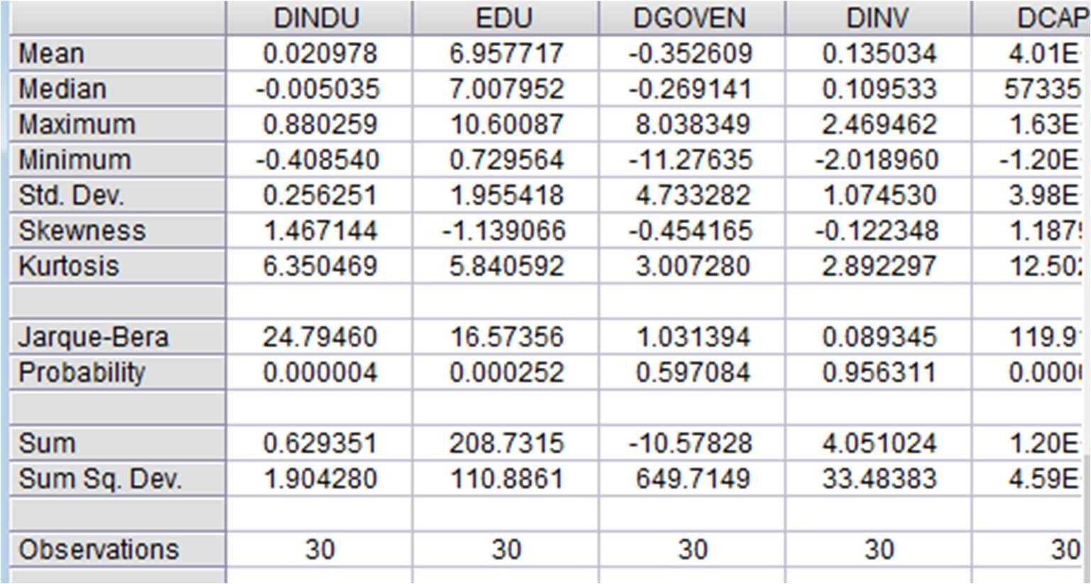

### Appendix 2.2: Diagnostic test

MULTICOLLINEARITY TEST Results

(Variance Inflation Factor)

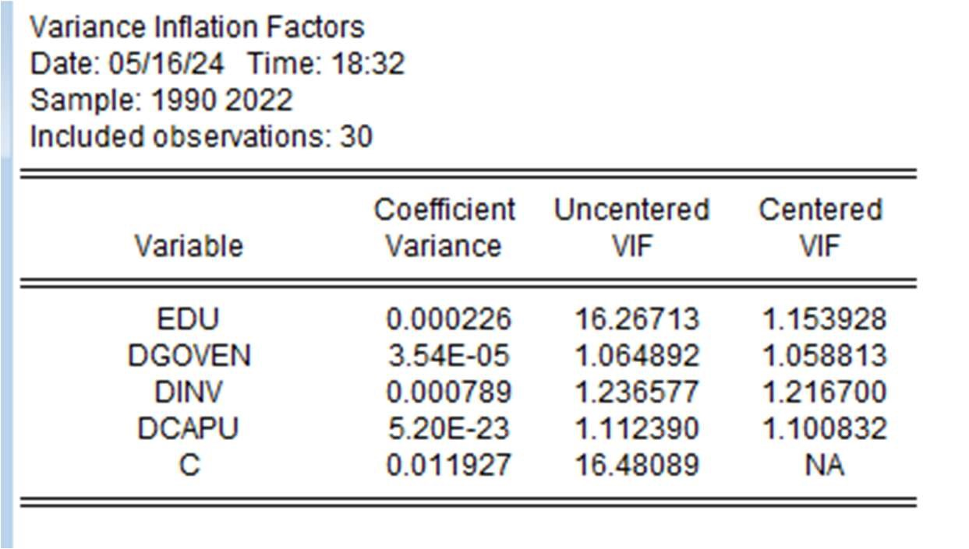

3.1 Unit root test

INDU Unit results

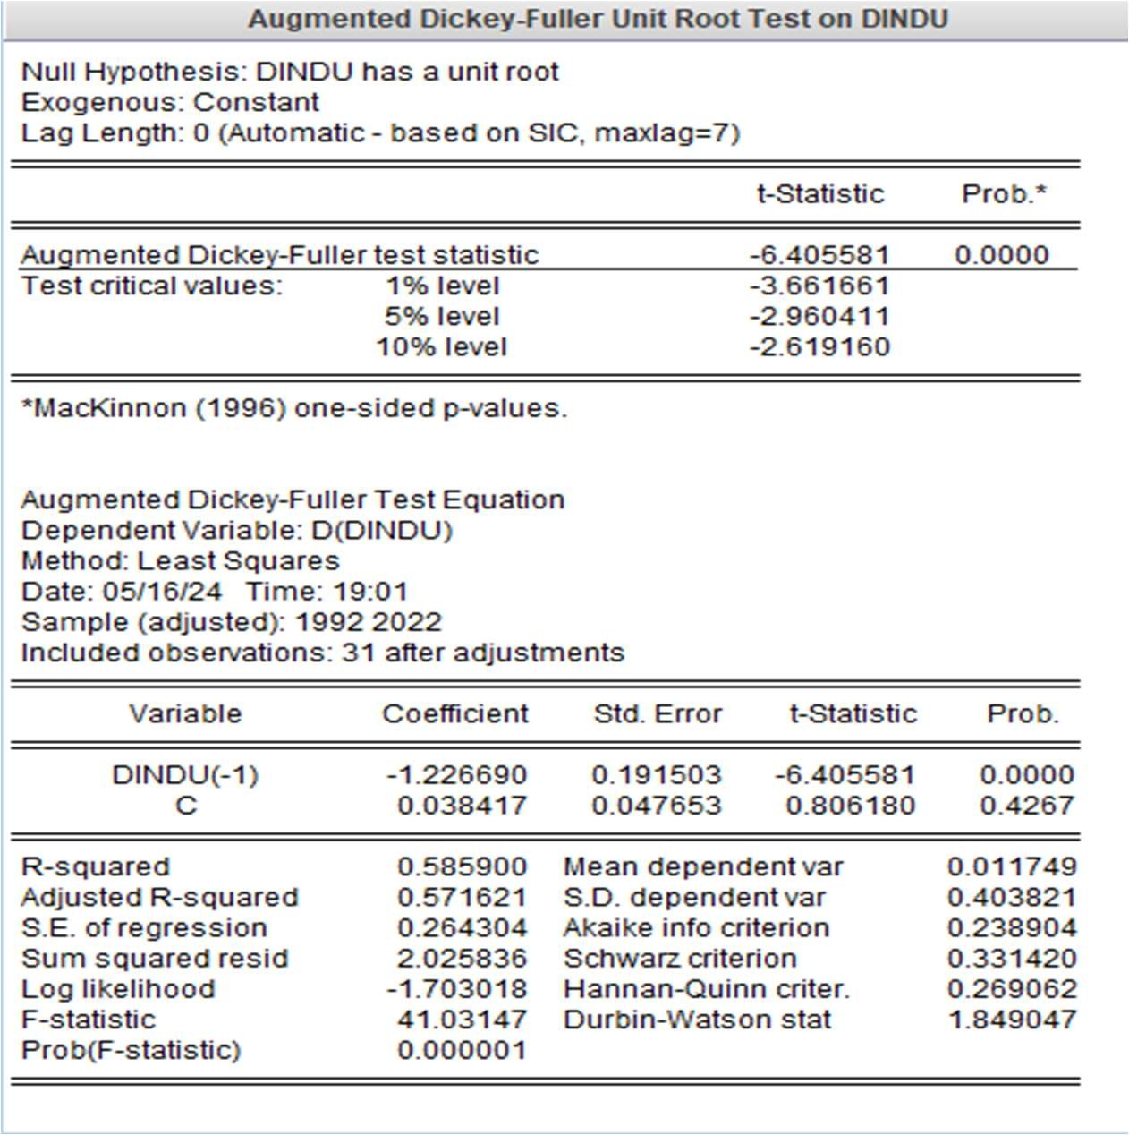

EDU Unit results

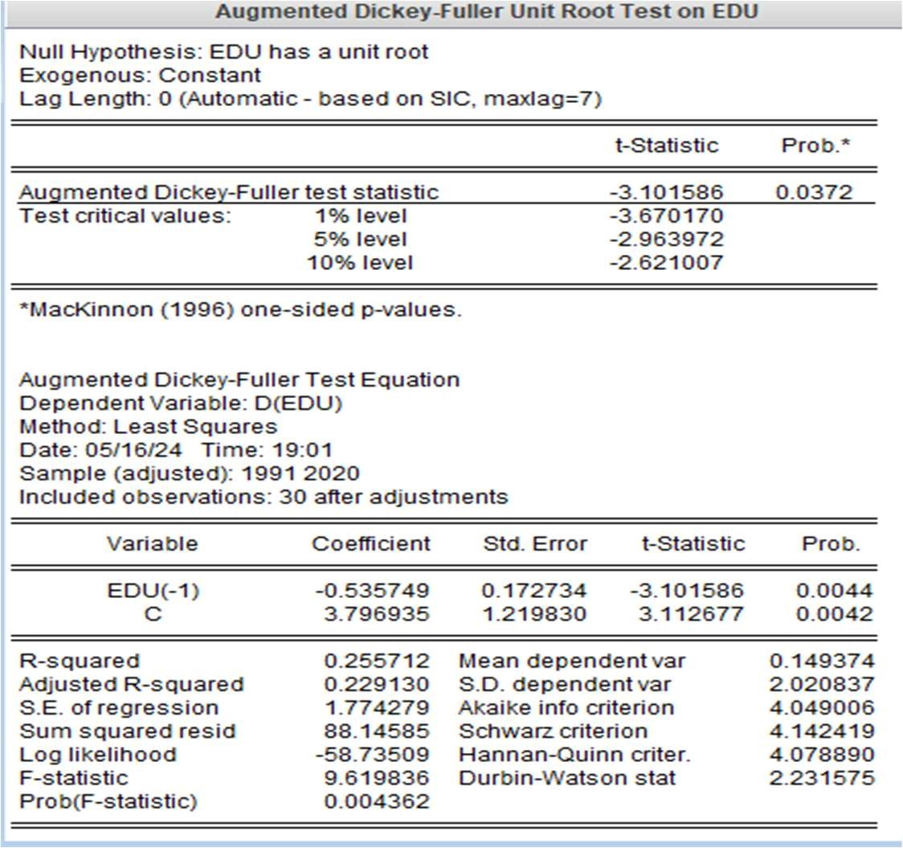

GOVEN Unit results

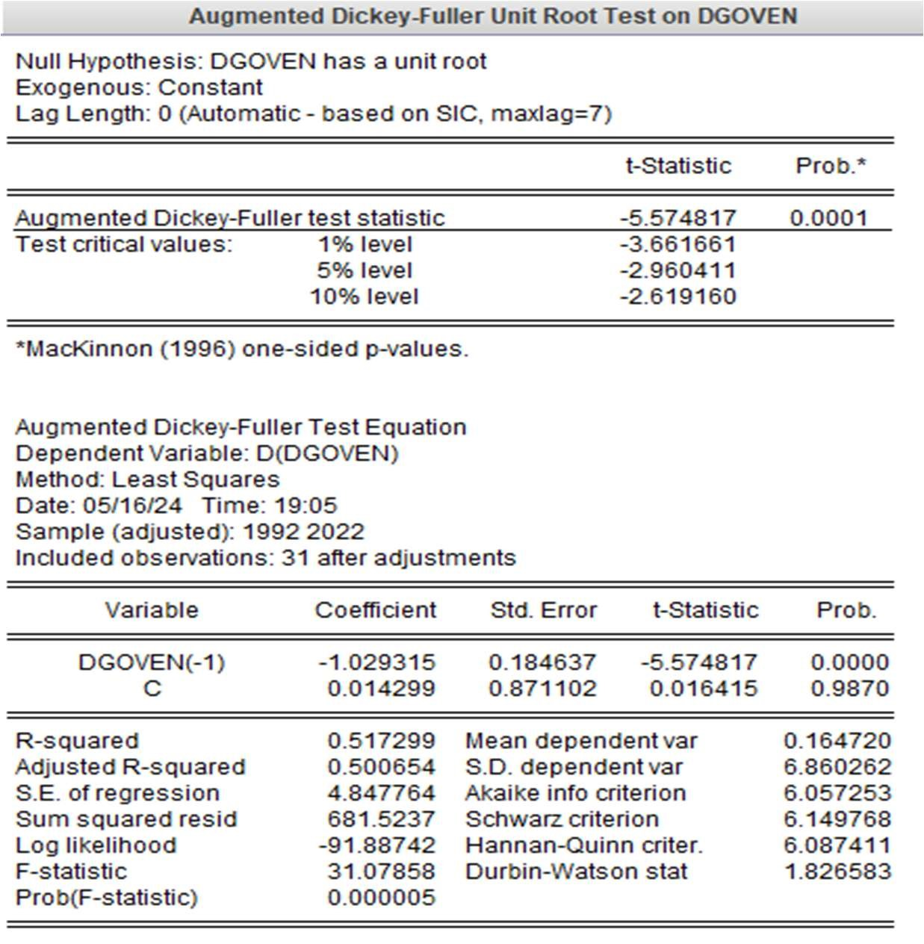

INV Unit results

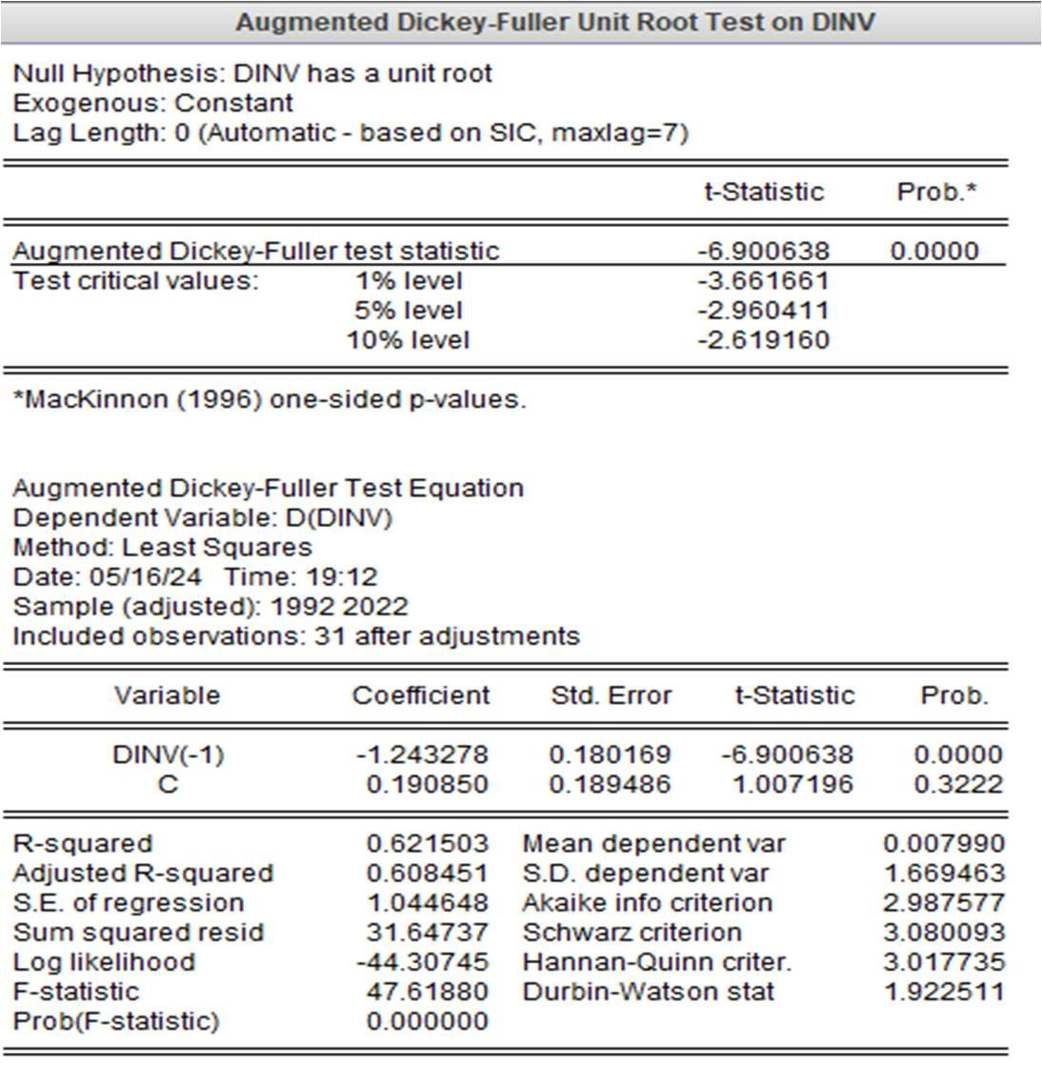

CAPU Unit results

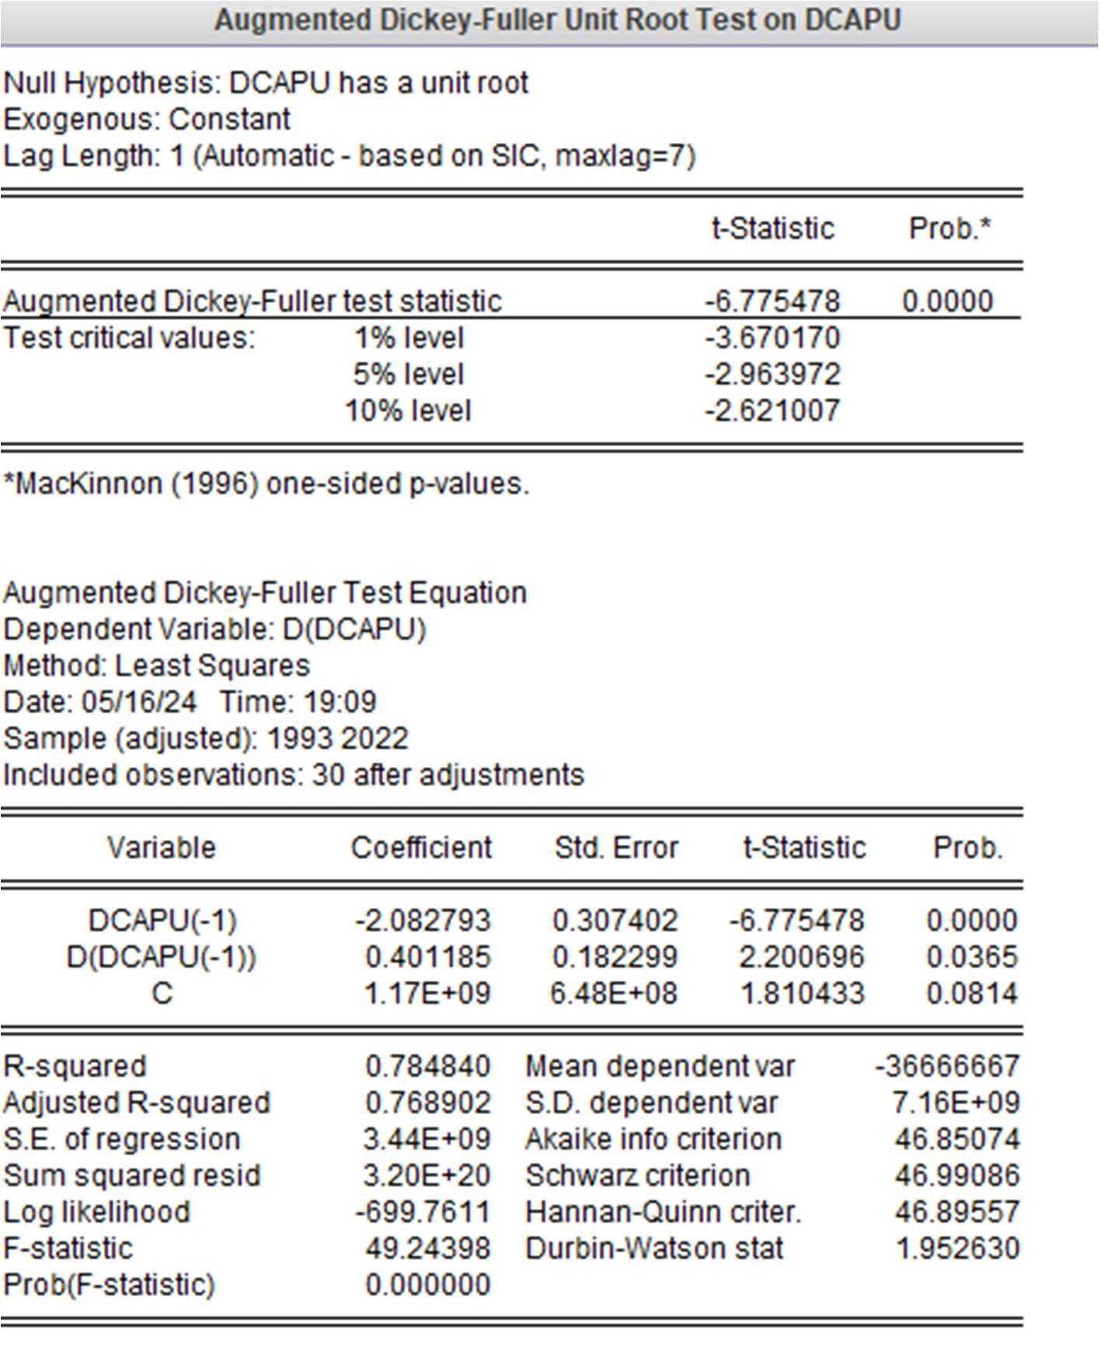

APPENDIX 4 Post Diagnostic

4.1 Auto correlation results

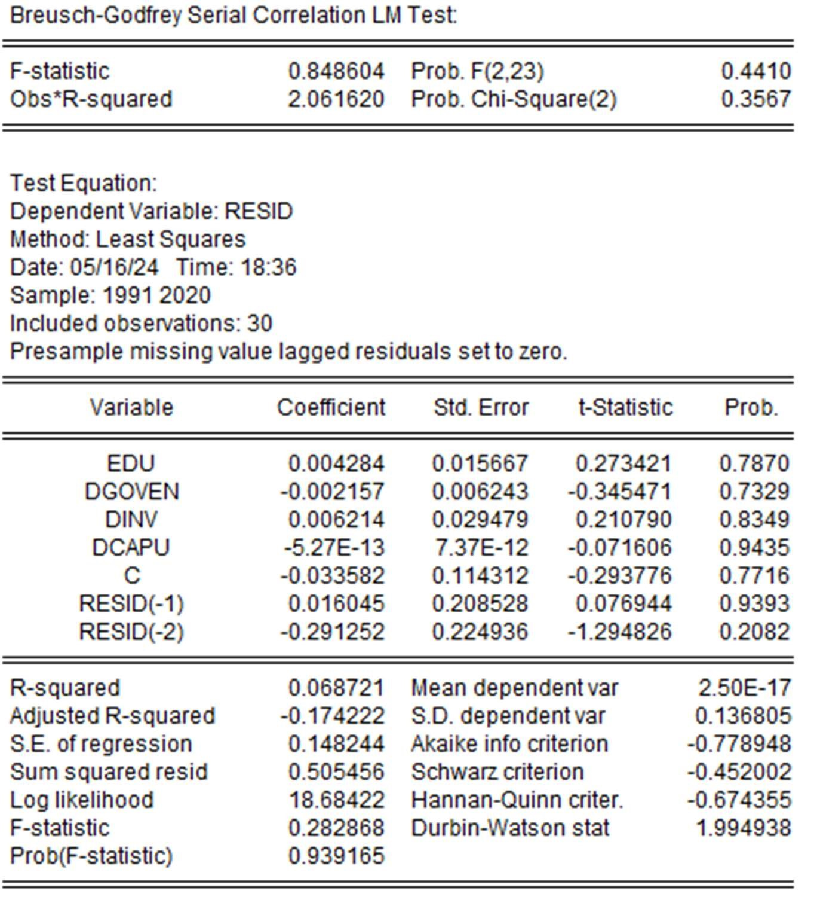

4.2 Hetroscedasticity Test results

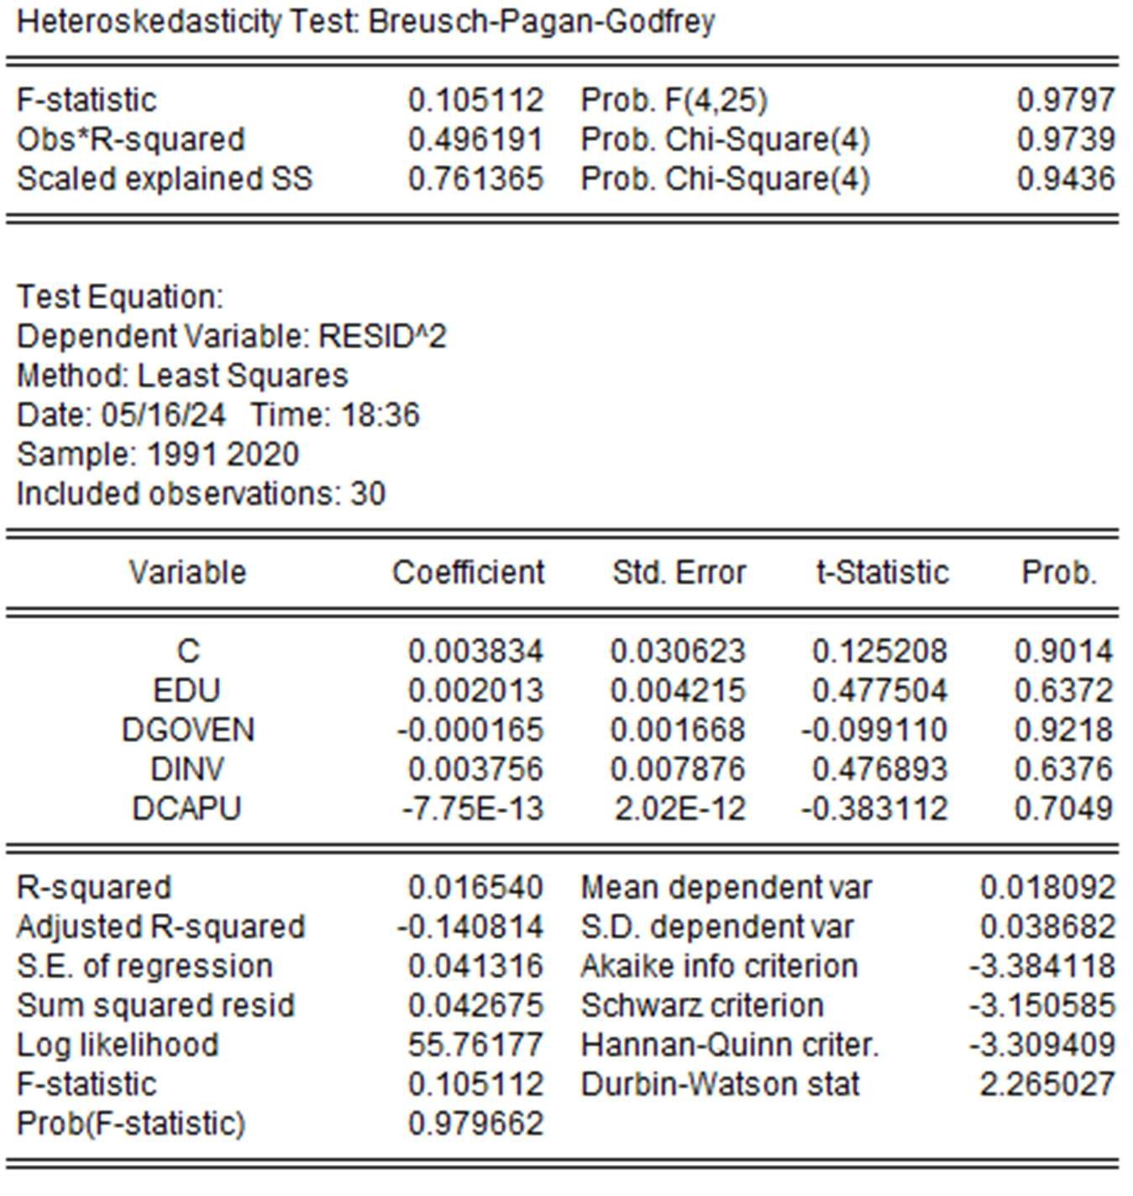

4.3 Normality Test results

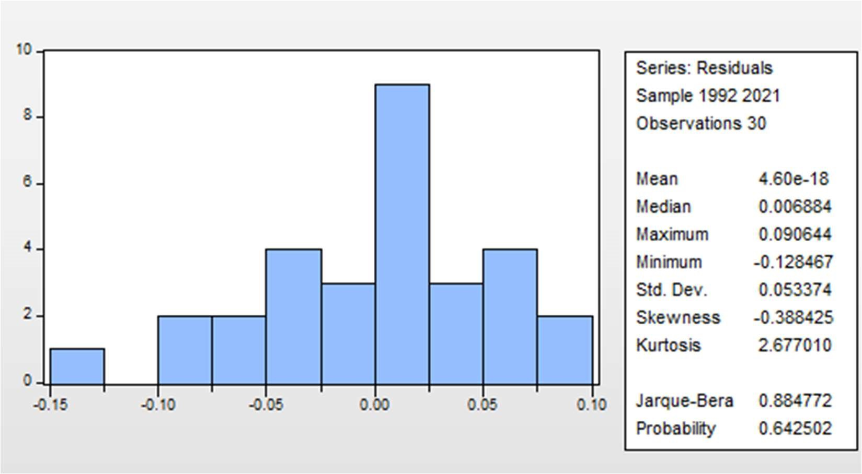

4.4 Ramsey reset test

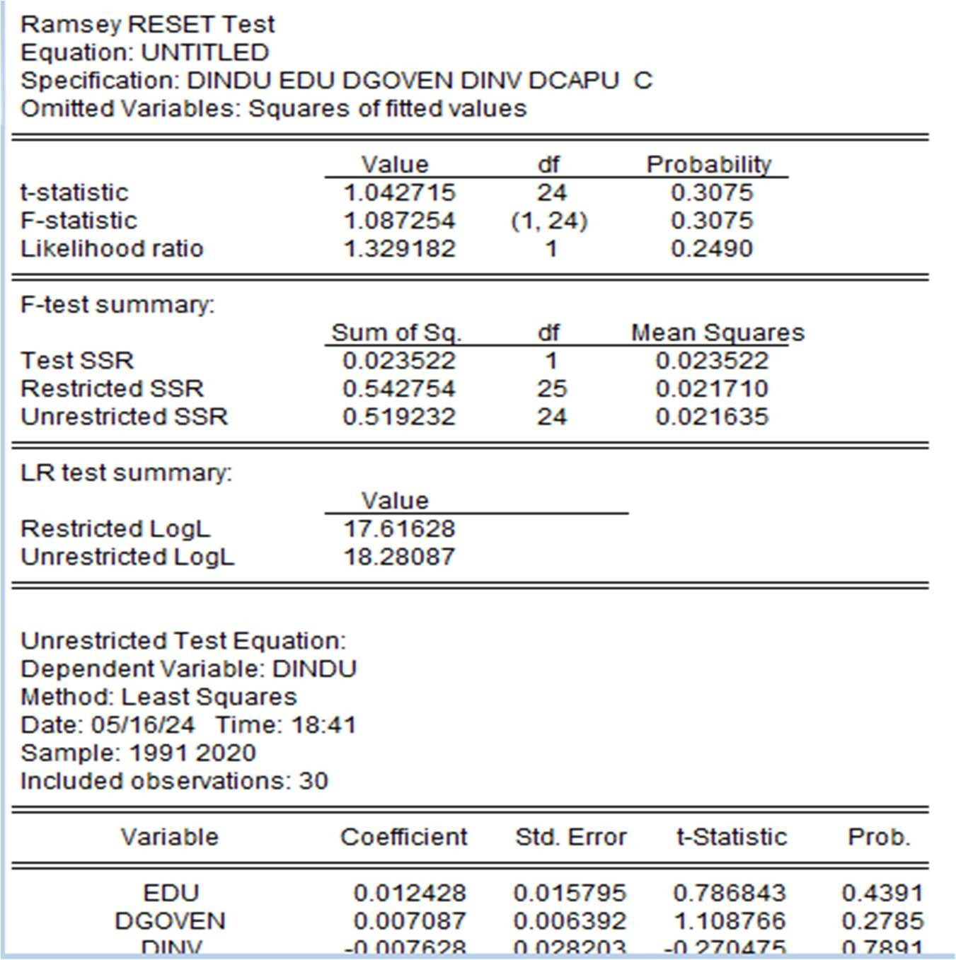

Appendix 5 Regression results

