BINDURA UNIVERSITY OF SCIENCE EDUCATION
FACULTY OF COMMERCE
DEPARTMENT OF ECONOMICS


E-procurement adoption and operational performance of public sector organizations in Harare, Zimbabwe.

BY B203158B

A DISSERTATION SUBMITTED IN PARTIAL FULFILMENT OF THE REQUIREMENTS FOR THE BACHELOR OF COMMERCE HONOURS DEGREE IN SUPPLY CHAIN MANAGEMENT DEGREE OF BINDURA UNIVERSITY OF SCIENCE EDUCATION. FACULTY OF COMMERCE.

SUBMITTED IN
JUNE 2024

Release form
Registration number: B203158B

Dissertation title: E-procurement adoption and operational performance of public sector organizations in Harare, Zimbabwe.

Degree title: Bachelor of Commerce Honours Degree in Supply Chain Management

Year granted: 2024
Permission is hereby granted to Bindura University of Science Education Library to produce single copies of this dissertation and to lend or sell such copies for private, scholarly, or scientific research purposes only. The author does not reserve other publication rights and the dissertation nor may extensive extracts from it be printed or otherwise reproduced without the author’s written permission

SIGNED: Cynthia Gadaga
DATE: May 2024

Approval form

I certify that this dissertation meets the preparation guidelines as presented in the faculty guide and instructions for typing dissertations
………………………………….. ………../……../…………….
(Signature of Student) (Date)

To be completed by the supervisor
This dissertation is suitable for submission to the faculty of commerce. This dissertation should be checked for conformity with the faculty guidelines.
………………………………… ………../……../…………….
(Signature of Supervisor) (Date)

To be completed by the Chairperson of the department
I certify, to the best of my knowledge, that the required procedures have been followed and the preparation criteria have been met on this dissertation.
……………………………….. ………../……../…………….
(Signature of Chairman) (Date)

Dedication
I dedicate this project to my family and to the almighty God for his love

Acknowledgement

First and foremost, I would like to thank the almighty God for wisdom, strength and hope throughout this research project. Many thanks go to my supervisor for tireless support, guidance and efforts throughout this project. Special gratitude goes to my family for being there for me and their support

The Abstract
The major aim of the study was to ascertain the ways in which the e-procurement can be adopted inclusive of its effects to the public sector organization. The research assessed how e-procurement adoption has affected the functioning of the public sector in Harare.

The research's is foundation is established in theories that will enable an indepth evaluation of e-procurement effects on organizational performance. The the Innovation Diffusion Theory (IDT), Technology-Organization-Environment (TEO) and the Technology Acceptance Model (TAM) are reviewed in this study.
A descriptive research design is used in this research. It is a methodological frameworks that use questionnaires or interviews to collect data on existing conditions, opinions, or behaviors. The population of this study are public sector entities in Zimbabwe and this includes parastatal such as National Railways of Zimbabwe, Grain Marketing Boards (GMB) and ZUPCO. A total of 80 questionnaires were distributed and 58 were successfully completed and collected by the researcher. The percentage of respondents who successfully participated in the survey is 73%. The research found that, most of the public sector entities’ practice is to locate suppliers for goods and services by searching through the internet. The study found that, adopting e-procurement will improve the performance of public sector organizations. It improves efficiency, reduces administration costs and enhances service delivery. The study recommended that, to improve staff expertise and guarantee efficient use of the e-procurement system, provide ongoing e-procurement training. Enhancement of the Legal Framework: To give e-procurement operations inside public sector organizations a strong legal base, push for the official recognition and regulation of electronic procurement transactions.

Table of contents

Release form I
Dissertation title: E-procurement adoption and operational performance of public sector organizations in Harare, Zimbabwe. I
Approval form II
Dedication III
Acknowledgement IV
The Abstract V
CHAPTER 1 1
INTRODUCTION 1
1.0 Introduction 1
1.1 Background of the study 1
1.2 Statement of the problem 3
1.3 The purpose of the research 4
1.4 Research objectives 4
1.5Research questions 5
1.6Significance of the study 5
1.6.1 Public sectors 5
1.6.2 Future researchers 5
1.6.3 To the researcher 5
1.7 Assumptions of the study 6
1.8 Delimitations of the study 6
1.9 Limitations 6
1.10 Definition of terms 6
1.11 SUMMARY 7
CHAPTER 2 8
LITERATURE REVIEW 8
2.1 INTRODUCTION 8
2.2 THEORETICAL FRAMEWORK 8
2.2.1 Technology Acceptance Model (TAM) 8
2.2.2 Technology-Organization-Environment (TOE) 10
2.2.3 Diffusion Theory of Innovation (IDT) 12
Innovation Diffusion theory in procurement 14
2.4 Objectives analysis 14
2.4.1 The effects of e-procurement adopting on operational performance of the public sector organizations. 14
2.4.2 Inherent challenges faces by public sector organization during the adoption of e- procurement 15
2.4.3 Ways of implementing e-procurement in the public sector organizations 16
2.4.4 Challenges in the adoption of e-procurement in public sector organizations in Zimbabwe. 17
2.5 Conceptual framework 18
Conceptual framework 19
2.5.1 Performance of public sector organizations 20
2.5.2 Adoption of e-procurement 20
2.6 Empirical literature 20
2.7 Research gap analysis 22
2.8 Summary 22
CHAPTER 3 23
RESEARCH METHODOLOGY 23
CHAPTER 4 29
DATA PRESENTATION, ANALYSIS AND DISCUSSION 29
4.0 Introduction 29
4.1 Response rate 29
4.2 Respondents by department 30
4.3 Employee level in the organization 31
4.4 Length of employment in the public sector 31
4.5 Direct and indirect procurement practices of public sector entities 32
4.6 The effects of adopting e-procurement on the operational performance of the public sector organizations 33
4.7 Factors influencing e-procurement adoption in public sector organizations in Harare. 34
4.8 The techniques for implementing e-procurement in the public sector organizations. 36
4.9 Summary 37
CHAPTER 5 38
SUMMARY, CONCLUSIONS AND RECOMMENDATIONS 38
5.1 INTRODUCTION 38
5.2SUMMARY OF FINDINGS 38
5.3 CONCLUSIONS 38
5.3.1 Current direct and indirect procurement practices of public sector entities 38
5.3.2 The effects of adopting e-procurement on the operational performance of the public sector organizations 39
5.3.3 Factors influencing e-procurement adoption in public sector organizations in Harare 39
5.3.4 The techniques for implementing e-procurement in the public sector organizations 40
5.4 RECCOMMENDATIONS 40
5.5 AREAS FOR FURTHER STUDIES 41
Reference List 42
APPENDIX 48
The End 56

LIST OF TABLES

Table 1 : Sample Framework 25
Table 2 : Current procurement practices in the public sector 32
Table 3 : E-procurement adoption and the performance of public sector organizations. 33

LIST OF FIGURES

Figure 1 : TAM 10
Figure 2 : Technology-Organization-Environment 11
Figure 3 : Diffusion Theory of Innovation 14
Figure 4 : Conceptual framework 19
Figure 5 : Survey response rate 29
Figure 6 : Departments of respondents 30
Figure 7 : Employee level in the organization 31
Figure 8 : Length of employment 32
Figure 9 : Factors influencing e-procurement adoption in public sector organizations 35
Figure 10 : Visionary leadership,and continuous improvement. 35
Figure 11 : Techniques to implement e-procurement in public sector organizations. 36

CHAPTER 1

INTRODUCTION

Introduction
This chapter is the introductory part of the study which aimed at evaluating e-procurement adoption by public sector entities in Zimbabwe with focus in Harare Metropolitan. This outlines the background of the study, problem statement the research objectives and questions that guide this study. The chapter proceeds to outline the significance of of the study, state the delimitation and finally give definition of key terms to be used in this research.

1.1 Background of the study
E-procurement, or electronic procurement, refers to the use of digital technology to manage the procurement process. It is considered an effective tool for combating corruption, increasing transparency, reducing procurement costs, and disseminating procurement information (Nurdin, & Pettalongi, 2022). E-procurement systems are designed to apply the principles of good governance, encourage efficiency and effectiveness of public spending, and adhere to the ethics and norms of procurement (Sitompul, 2022). Research has shown that the implementation of e-procurement can significantly affect firm performance, and it is an important part of public finances management, especially in the context of the fourth industrial revolution (Marei, 2022; Mavidis & Folinas, 2022).

Studies on the implementation of e-procurement in public sector organizations have been conducted in a number of nations, including Ghana, Nigeria, Kenya, and Sri Lanka. The adoption of e-procurement, its impact on organizational performance, and the responsibilities played by public sector organizations in e-procurement and public-private partnership (PPP) projects have all been the subject of research (Aliyu & Ibrahim, 2021).The results underscore the significance of elements like e-procurement and indicate that it can significantly and favorably affect public sector companies' performance, relative advantage, compatibility, complexity, top management attitude, employee competence, policies, technology, and data security in influencing the
adoption and performance of e-procurement. The studies also emphasize the need for government support, technological infrastructure, and leadership to improve the e-procurement process (Premathilaka, 2019; Aliyu & Ibrahim, 2021). Overall, the research provides valuable insights into the relationship between e-procurement adoption and the operational performance of public sector organizations in different contexts.

A study on the impact of e-procurement adoption on the performance of SMEs in emerging economies like Zimbabwe found that lack of awareness, resistance to change, and inadequate infrastructure are some of the challenges that hinder e-procurement adoption (Yusuf, Raji & Oshoma, 2023). Another study on the critical success factors affecting Tanzania National E-Procurement System adoption on the performance of public procurement in Tanzania identified factors such as lack of awareness, inadequate infrastructure, and resistance to change as some of the challenges that hinder e-procurement adoption (Fulgence, 2023).

Ogar & Idagu (2020) stated that, many African countries face challenges related to a dearth of integrity and ethical consciousness among procurement professionals and stakeholders. This hinders the effectiveness and efficiency of the procurement system. In South Africa public sector entities it was found that, despite ongoing training and workshops, the implementation of supply chain management and procurement practices is still hindered by a lack of proper knowledge and skills among practitioners (Ambe & Badenhorst-Weiss, 2012). Challenges stem from non-compliance with procurement policies and regulations, as well as issues related to fraud and corruption, which impede the efficient and effective implementation of procurement practices in the public sector (Mantzaris, 2014; Ambe & Badenhorst-Weiss, 2012). Excessive decentralization of the procurement system in South Africa has been identified as a challenge, potentially hindering the effective implementation of e-procurement practices.

In Zimbabwe the adoption of e-procurement in public sector organizations is faced with resistance to change from within the organizations, which can hinder the successful implementation of e-procurement systems (Ngatman, Alderei & Musa, 2020). Dzuke & Naude (2015) pointed out that, the challenges results from the legal framework for public procurement in Zimbabwe, which has a lack of strategic recognition of the procurement function and procurement policy, it is detracted from service delivery. Mazikana (2019) noted that, the public procurement process in Zimbabwe has been criticized for lagging behind, impacting public service delivery. E-procurement can be seen as a potential solution to enhance transparency, efficiency, and policy coherence. The public sector companies have been facing challenges related to procurement as they implement the manual system which involves heavy filing and loss of important data. It’s difficult to compile data related to a given period for reference as there are a lot of paperwork to go through (Chigubu, 2007).

These challenges highlight the complex environment in which e-procurement systems are being introduced in the public sector in Zimbabwe and the need for careful consideration of various factors to ensure successful adoption. Researches agree that effectively adopting e-procurement is very beneficial. E-procurement adoption in public sector organizations can lead to various benefits, reducing the cost and duration of the procurement cycle, improving information management, minimizing ordering and administrative errors, lowering the price of the product, facilitating the originator's focus on the strategic aspects of purchasing, and improving the payment process (Anthony, Okibo & Abuga, 2016). In this study, the influence of e-procurement adoptions on the operational performance of public sector companies in Harare was assessed.

1.2 Statement of the problem
Public sector organizations in Zimbabwe are still using the manual procurement systems which have resulted in massive delays in the procurement process, corruption and poor data management. The financial performance of firms in the public has been drastically decreasing and other detriments caused by the use of the manual procurement process despite the widespread transformation of public procurement systems worldwide, , the public sectors such as Zimbabwe United Passenger Company(ZUPCO), TelOne Zimbabwe, People's Own Savings Bank (POSB), Municipality of Chitungwiza and ZimPost are left behind in modernizing procurement and keep up with the unavoidable dynamics that are trending in the global technological environment (Dzuke & Naude, 2017b)
There is underutilisation of e-procurement systems such as e-sourcing, e-ordering and e-tendering, companies have half backed systems due to the costs of having the whole system and also factors which affect adoption of these systems include lack of funding, rigid organizational structures, poor ICT infrastructure, literacy rate, high labor turnover and limited Public-Private Partnership.
There is still more work to be done to achieve this goal, despite the Government of Zimbabwe's attempts to promote the use of e-procurement strategies in public procurement through a variety of projects such as internal training workshops and campaigns. In order to close the barriers, which is primarily present in the country, the president donated computers to public sector.
Majority of the companies in the private sector have already adopted the electronic procurement system which gives them a lot of advantages over the parastatals. When a business is using electronic procurement it enables it to conduct all its procurement business online making it easier to compare quotes and make the right decisions in relation to suppliers thus making it efficient in the smooth operations of the organization as a whole. Thus the need for the public sector to cope with technological advancement.

1.3 The purpose of the research
The major aim of the study is to ascertain the ways in which the e-procurement can be adopted inclusive of its effects to the public sector organization. The need to improve the procurement process from the manual system to the computerized system.

1.4 Research objectives
This study's main goal is to assess how e-procurement adoption has affected the functioning of the public sector in Harare. The following is a list of the study's precise objectives:
1. To ascertain the effects of e-procurement adoption on public sector enterprises' operational performance.
2. To determine the underlying challenges that public sector organizations encounter while implementing e-procurement.
3. To investigate the techniques for e-procurement implementation in public sector organizations.
4. To determine the elements that affect the adoption of e-procurement in Zimbabwe's public sector organizations in Harare.

1.5Research questions
- What are the effects of adopting e- procurement on the operational performance of the public sector organizations?
- What are the inherent challenges faced by the public sector organizations during the adoption of e- procurement?
- What are the techniques for implementing e-procurement in the public sector organizations?
- What factors are influencing e-procurement adoption in public sector organization in Harare, Zimbabwe?

1.6Significance of the study
The current research contributes to the growing body of literature on e-procurement in the public sector, a topic of research that is in its infancy in Zimbabwe and is not really been explored to the maximum. The successful conduct of this study is intended to benefit the following group of people.

1.6.1 Public sectors
Findings of the research could be much significant to the following public sectors entities in enlightening them on how they can adopt e-procurement and realize how they can strategically use it to achieve their goals.

1.6.2 Future researchers
The research will add to the body of knowledge and act as a guide for future researches. The insights from this research can be used a a stepping stone for further researches.

1.6.3 To the researcher
Research is a problem solving technique used in business and this research is equipping the researcher with investigative and critical thinking skills needed to solve problems in the corporate world.

1.7 Assumptions of the study
- Those being interviewed for data gathering will provide information that is not biased or tempered with.
- The researcher will be granted access to some of the processes that are conducted manually in most parastatals.
- The users of the current manual system cooperate fully.

1.8 Delimitations of the study
This study was mainly focused on the adoption of e-procurement and its effects in the performance of the following five public sectors which include, National Railways of ZImbabwe (NRZ), Zimbabwe Electricity Supplies Authority (ZESA), Environmental Management Authority (EMA), Grain Marketing Board (GMB) and Telone Zimbabwe. The study was mainly limited to five public sectors in Harare even though there are 107 state owned Enterprises in Zimbabwe, this due to geographical distance; therefore, the statistics are not accurately reflecting the adoption of e-procurement and its effect in the performance of Zimbabwe’s public sectors. The study was conducted by the researcher on the period of attachment between 2022 and 2023.

1.9 Limitations
The following limitations were encountered:
- Financial constraints - Lack of funds could make it difficult to complete the research and print the surveys; therefore the researcher therefore uses Google forms to distribute questionnaires to minimize printing costs.
- Time - The time to do the research was limited because the researcher was supposed to balance lectures. However, the researcher spends most of the weekend’s days doing the research to cover the gap.
- Lack of research skills - Since this will be the first-time conducting study, it will become difficult. However, in order to receive more assistance, the researcher will be working more closely with the supervisor

1.10 Definition of terms
Service delivery
Service delivery refers to the process of providing a service to a customer or client. It can encompass a wide range of industries and sectors, including healthcare, technology, and public services.
Electronic procurement
Electronic procurement, also known as e-procurement, is the process of purchasing goods and services using electronic methods, such as the internet or other computer networks. It encompasses the entire procurement process, from the initial order to the payment and can include e-sourcing, e-tendering, and e-reverse auction (Singh & Chan,2022).
Public sector companies
These are companies in which above 50% of its equity is owned and controlled by the government jointly or severally. These can also be known as parastatal entities.

1.11 SUMMARY
The chapter presented the background to the study, stated the research questions and objective on which this research is premised. It proceeded to outline the statement of the problem, reveal the significance of the study and finally touched on limitations and delimitations. In chapter 2 the researcher reviews scholarly articles related to the research topic and present the literature review for this study.

CHAPTER 2

LITERATURE REVIEW

2.1 INTRODUCTION
The previous chapter focused on presenting the introduction to the research. In this the researcher discusses a wide range of literature on e-procurement and the implications that it have on organizational performance. The researcher reviews the theoretical and empirical literature on the subjects and proceeds to pinpoint the research gap on e-procurement. A comprehensive literature review involved accessing publicly available sources, textbooks, journals and other publications.

2.2 THEORETICAL FRAMEWORK
The research's is foundation is established in theories that will enable an indepth evaluation of e-procurement effects on organizational performance. The the Innovation Diffusion Theory (IDT), Technology-Organization-Environment (TEO) and the Technology Acceptance Model (TAM) are reviewed in this study.

2.2.1 Technology Acceptance Model (TAM)
The TAM model has dominated empirical research on IT adoption. Davis developed it to predict IT adoption and usage Lee et al. (2017). Prior research on the TAM has concentrated on validating, replicating, growing, and refining the model, resulting in a strong understanding of drivers (Nilashi et al., 2015). Over the past 20 years, more than 500 studies have demonstrated the validity and economic viability of the TAM model for predicting user adoption of a wide range of new technologies. Usage intention (PEOU) is determined by three main factors: attitude, perceived utility (PU), and perceived ease of use. The extent to which an individual feels that utilizing the system would improve their performance at work is known as perceived usefulness. It is one popular information systems model that forecasts consumers' acceptance and usage of technology is the Technology Acceptance Model (TAM). It focuses on things like perceived utility and simplicity of usage. Researchers have used TAM in a variety of settings, including anticipating college students' intents to utilize metaverse-based learning platforms, instructors' use of digital technology in the classroom, users' intention to continue using MOOCs, and usage of social media sites like Facebook.
Perceived ease of use is the degree to which a user feels that a system is easy to use. Monzavi et al. (2013) state that external factors including system performance, system design, and training have an impact on PU and PEOU. We both agree that outside factors influencing IT adoption are channeled through the internal cognitive mechanisms of the TAM. Many models have been developed in the last thirty years to investigate the variables influencing people's adoption of technology (Burton-Jones & Hubona, 2006). Technology Acceptance Model (TAM) is the classic information systems model developed to explain computer-usage behavior and factors associated with technology adoption, according to Davis (1989).
According to this theory, behavior related to the use of information systems is primarily described by behavioral intention, which results from deliberate decision-making processes. In turn, behavioral intention is determined by the two belief components of perceived utility (PU) and perceived ease of use (EU) (PEOU). It's possible that system designers will have more control over how users perceive the system, which will impact how they plan to act and use it. Dillon & Morris (1996) defined technology acceptance as "a user group's evident willingness to use information technology (IT) for the tasks it was intended to enable."
The most often studied subjects are instrumental effects and acceptance decisions about the belief that using technology would result in quantifiable performance gains. Thompson & Associates (2006). This strategy may have had a constraining effect on technology development, according to Thompson et al. (2006), who extended their research to incorporate theories relating to non-instrumental influences on technology acceptability. According to the TAM, a system's perceived utility (PU) and perceived ease of use (PEOU) influence users' behavioral intention to use (BIU). Hu et al. (1999) postulated that while a multitude of factors influence technology's initial acceptability, fundamental factors (such perceived usability and ease of use) are more crucial for sustaining acceptability.
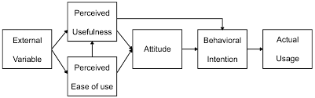
Figure 1: TAM
Source: Park and Park (2023)
Bagozzi (2007) states that he focused on the tenuous theoretical relationships among the various concepts created in TAM. He questioned the theoretical validity of the connection between intention and actual use and agreed that conduct could not be viewed as a means to an end. Rather, he said, behavior could not be viewed as an end in and of itself. According to him, intention may not be a good indicator of actual use because there may be a lot of uncertainty and other factors that could affect someone's decision to embrace a technology in the interim. External factors that impact the PU and PEOU include system performance, design, and, in some cases and financing availability.

2.2.2 Technology-Organization-Environment (TOE)
The adoption and effects of technology within businesses are studied using a theoretical model called the Technology-Organization-Environment (TOE) framework. It takes into account three important the adoption and effects of technology within businesses are studied using a theoretical model called the Technology-Organization-Environment (TOE) framework (Nguyen, Le, & Vu, 2022). It takes into account the three main contexts of technology, organizations, and the environment. The TOE framework has been used in numerous studies to examine the adoption of different technologies, including cloud computing, blockchain, online retailing, and remote work. One study on online retailing in Vietnam, for instance, discovered that adoption and commercial performance of online retailing are significantly influenced by technological, organizational, and environmental contexts (Nguyen, Le, & Vu, 2022)
The model suggests that organizations are more likely to adopt e-procurement if they perceive specific benefits, costs, absorptive capacity, top management backing, and competitive pressure. The degree of adoption of e-procurement is not directly impacted by the technical environment, despite the fact that it plays a big part in adoption decisions. The extent of e-procurement adoption is largely determined by organizational and environmental factors.

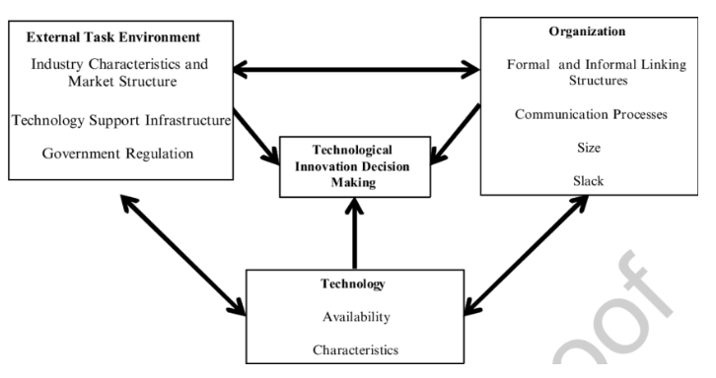
Figure 2: Technology-Organization-Environment
Source: Baker (2011)
According to this paradigm, the technology available to an organization is referred to as the technical context. Its primary concern is is how technology can affect adoption. The organizational environment of an organization defines its characteristics. The scale of the business, the degree of centralization and formalization, the complexity of the management structure, the caliber of the human resource pool, and the quantity of spare internal resources are common organizational characteristics.

The context in which an organization operates is known as the external environment. This talks about the laws, competition, market, and relationship with the government. According to Nguyen et al, 2022, these are external factors that offer opportunities and constraints for technological breakthroughs. The TOE framework is widely used in research to characterize various IT adoptions, such as electronic data interchange, open systems, knowledge management systems, e-business, and enterprise resource planning. Furthermore, because the model takes into account three crucial elements—the environment, the organization, and the technology—it is more appropriate for the research on the adoption of e-procurement.

2.2.3 Diffusion Theory of Innovation (IDT)
Innovation Diffusion Theory (IDT) is a theory that explains how new ideas, products, or technology spread among people in a society or among individuals. In 1962, Everett Rogers introduced it for the first time. A conceptual framework called Innovation Diffusion Theory (IDT) is used to analyze how inventions gradually spread throughout a community Omorodion & Osifo, 2020). IDT is used in the procurement environment to examine the uptake and spread of cutting-edge technology like electronic procurement systems (EPS). Everett Rogers proposed the theory, which highlights the impact of multiple factors influencing how quickly individuals or organizations adopt innovations.
The innovation process is divided into five steps, according to IDT: knowledge, persuasion, choice, implementation, and confirmation (Shantika, et al.2022). The idea also specifies five attributes of an innovation compatibility, trialability, complexity, observability, and relative advantage that influence acceptance. IDT has been used in a variety of industries, including fast food restaurants, mobile banking, and e-commerce, to identify the variables influencing the uptake of new products or technology (Ceyhan & Toraman, 2023).
"Innovation adoption" refers to the process by which some individuals are more likely than others to accept an idea, as opposed to it occurring simultaneously throughout a social system. Scholars have found that people who acquire innovations later in life are not the same as those who adopt them early.Kim & Namkung (2020) stated that, when presenting an invention to a target group, it is important to understand their characteristics as these characteristics may help or hinder the innovation's acceptance. Even though most people generally fall into one of the five established adopter categories, it's still crucial to understand what characteristics the target demographic possesses. Innovators, early adopters, early majority, late majority, and laggards are some of these groups (Kim & Namkung, 2020).
The procurement organization must be aware of the relative benefits and hazards of using e-Procurement, as it is a new invention that may cause ambiguity. It has been regularly observed that there is a positive correlation only between two variables: relative advantage (i.e., the degree to which an innovation is viewed as being better than the notion it supersedes) and compatibility (i.e., compatibility of an invention with existing practices and values). The only factor that has been repeatedly shown to be negatively correlated is complexity, or how much an innovation is thought to be linked to the concept it replaces. Downs and Mohr recommend using perception-based innovation characteristics instead of technology's fundamental qualities, which are constant across settings, because different public sector organizations have different adoption rates.
The idea was employed by the researcher because, according to Chan and Owusu (2022), it sheds light on how e-procurement is a technological innovation that evolves over time.Furthermore, Singh and Chan (2022) noted that the researcher employed the theory to consider how technology development is a continuous process and to show how e-procurement may be continuously upgraded to satisfy the ever-changing needs of the business context. The idea was also used to highlight a few crucial elements that are essential to the adoption of e-procurement technologies.

Innovation Diffusion theory in procurement
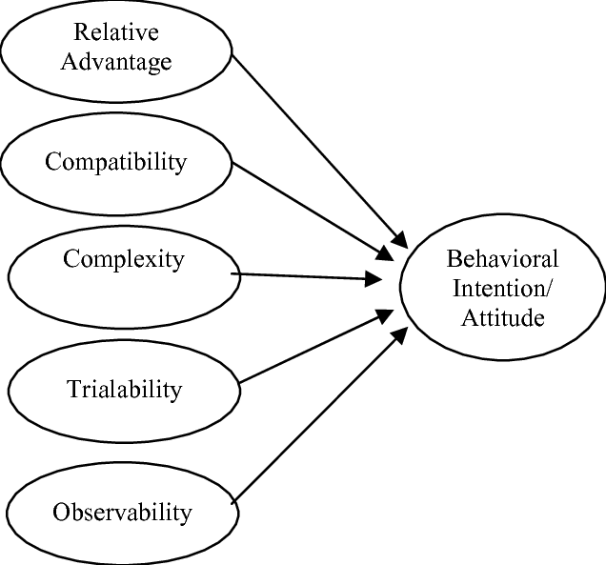
Figure 3: Diffusion Theory of Innovation
Source: Nor, 2010

2.4 Objectives analysis

2.4.1 The effects of e-procurement adopting on operational performance of the public sector organizations.
According to a Zimbabwean study, the public health sector's performance is influenced by procurement procedures, employee perceptions of service quality, and leadership style (Chikazhe, Bhebhe, Tukuta, Chifamba & Nyagadza, 2023). Vogler, Habimana & Haasis (2022) conducted another study in Portugal to assess the effectiveness of centralized medicine procurement and discovered that while it improved governance and process transparency, increased equity in access to medications, and reduced workload for certain users, it was also hindered by protracted, bureaucratic procedures and gaps in maintaining the list of active ingredients and conducting market consultations. Reservations, preferences, and indirect procedures had a detrimental impact on performance, according to a study conducted in Kenya to examine the impacts of discriminatory public procurement practices on organizational performance (Nteere, 2014).
Olojede, Opawole, Jagboro & Alao (2021) conducted a study in Nigeria and looked at the functions that public sector organizations carried out when procuring public-private partnership projects. It discovered that these functions, which are crucial to project success, were not frequently carried out in terms of managing variation, allocating penalties and abatements, choosing preferred bidders, and establishing management strategies for PPP risks.
Last but not least, a research conducted in Ondo State, Nigeria, discovered that the state government's ad hoc procurement methods led to construction project abandonment and cost and schedule overruns (Asekunowo & Ayodele, 2018). They suggested developing and implementing a procurement policies in public sector entities.

2.4.2 Inherent challenges faces by public sector organization during the adoption of e- procurement
Public sector organizations face several challenges when adopting e-procurement, as evidenced by research from various countries. Some of the inherent challenges includes, Information and Communication Technology (ICT) infrastructure that is insufficient or inadequate and it becomes a significant obstacle to the smooth adoption of e-procurement systems (Salifu, Nangpiire, Dawdi & Yussif, 2023). Salifu et al (2023) outlined that, effective adoption of e-procurement processes and procedures may be hampered by staff ignorance and incompetence. While converting to e-procurement platforms, public sector organizations face a number of obstacles. The efficacy and efficiency of procurement procedures may be hampered by these issues (Salifu et al, 2023). Employees used to manual processes may be resistant to the implementation of e-procurement because it necessitates a substantial change in traditional procurement techniques. It is essential to guarantee the security of sensitive procurement data. Organizations in the public sector that handle online transactions and data storage must manage cybersecurity concerns.

There can be problems with Integration. Dzuke & Naude (2015) stated that, it can be difficult and time-consuming to integrate e-procurement systems with current legacy systems, requiring a significant investment of time and IT knowledge.

Dzuke & Naude (2015) stated that, inadequate legal frameworks and procurement policies can lead to challenges in the public procurement process, which can detract from service delivery. They argued that, in Zimbabwe, inadequate accountability in the purchasing procedure may result in corruption and poor management.

2.4.3 Ways of implementing e-procurement in the public sector organizations
The employment of digital technologies to optimize and streamline the procurement process is a necessary step in the implementation of e-procurement in the public sector enterprises. There are many advantages to this shift, such as improved transparency, cost savings, and efficiency. These tactics and best practices can help public sector organizations successfully adopt e-procurement.

Rashid & Uddin (2023) carried out a study in Bangladesh to look into the key elements that make the Roads and Highways Division (RHD)'s computerized procurement system successful to implement. According to the report, the e-procurement system was effective and helped the government save money. An evaluation of the elements influencing the successful use of e-procurement within the framework of the Tanzania National Roads Agency (TANROADS) Iringa regional office was carried out in Tanzania. The study discovered that key factors influencing the success of e-procurement were e-infrastructure, staff competency, and management support (Anyisile, Kipilimba & Ng’elenge, 2023). It might be difficult to oversee a wide variety of vendors and make sure they follow e-procurement procedures, which can affect the system's overall efficacy (Anyisile, Kipilimba & Ng’elenge, 2023).
Training and Skill Gaps: Employees must receive sufficient training in order to use e-procurement systems efficiently. During implementation, skill gaps and the requirement for ongoing training may provide difficulties.
Legal and Regulatory Compliance when implementing e-procurement, public sector organizations have to follow stringent legal and regulatory frameworks, which complicates the process. There are costs and budgetary restraints (Anyisile, Kipilimba & Ng’elenge, 2023). The adoption of e-procurement systems may be hampered by the initial outlay and continuous maintenance requirements, which can put a pressure on the public sector's already tight budget. Encouraging stakeholder engagement, meticulous planning, and strong implementation techniques are essential for public sector organizations to successfully integrate e-procurement.

An analysis of the application of e-procurement using electronic identity cards was done in Indonesia. The study found that using the e-Purchasing technique and the e-Catalog mechanism was the most effective e-procurement implementation strategy for government purchases of goods and services (Hardinata, Kamaludin, Supratman, and Limun, 2022).

2.4.4 Challenges in the adoption of e-procurement in the public sector sector organizations in Zimbabwe.
The adoption of e-procurement in the public sector organizations in Zimbabwe, particularly in the National Pharmaceutical Company (NatPharm), faces several challenges. According to a study by Chilunjika, Chilunjika & Uwizeyimana, (2023), these challenges include power shortages and infrastructure limitations in the country, which can hinder the implementation of ICT systems. Lack of ICT skills and political will to adopt and implement sophisticated technologies. Several obstacles have made it difficult for public sector organizations in Zimbabwe to adopt e-procurement (Chilunjika, et al, 2023). In order to facilitate e-procurement, many public sector firms in Zimbabwe lack the computer systems, software, and dependable internet access.
Limited Knowledge and Training is major obstacles to adoption are a lack of knowledge about the advantages of e-procurement and the requirement for training on how to operate e-procurement systems. It's possible that representatives of the public sector are unfamiliar with or lack proficiency with the technology. Bringing about change can be challenging, particularly in established settings where manual procedures are strongly embedded.

Corruption, which is a serious threat to the attainment of Universal Health Coverage, and e-procurement is seen as a means to address this issue (Chilunjika, et al, 2023). The need to adapt to new suppliers and maintain collaboration without face-to-face communications, which can be challenging during the pandemic (Yuen, & Cheng, 2023).
These difficulties are widespread in underdeveloped nations where e-procurement is being implemented, not only in Zimbabwe (Chilunjika, et al, 2023). It is crucial to make ICT infrastructure investments, acquire the required skills, and foster political will to support the deployment of e-procurement systems in order to overcome these obstacles. In addition, combating corruption and advancing accountability and transparency are essential to the success of e-procurement programs. Security and Data Protection Concerns: Given that cybercrime is a major problem in Zimbabwe, public sector organizations there may have concerns about the security and data protection components of e-procurement (Yuen, & Cheng, 2023).
Cost and Budgetary Constraints: E-procurement system implementation can be expensive, which could be a major deterrent for Zimbabwe's public sector companies already running on a tight budget. Absence of Standardization: It may be challenging to deploy e-procurement technologies that are compatible with current systems due to the absence of standardization in Zimbabwe's procurement processes and procedures amongst various public sector companies.
Corruption and Fraud: The possibility of corruption and fraud in e-procurement systems can worry Zimbabwe's public sector enterprises since it can compromise the integrity of the procurement procedure (Kabanda, Pitso & Kapepo, 2019).

2.5 Conceptual framework
A dependent variable is one whose values are predicted or explained by one or more independent variables in the context of statistical analysis and research (Taylor, Macpherson, Spears & Weston, 2016). The result that is impacted by the independent variable(s) is known as the dependent variable. In this research for instance, public sector organization performance would be the dependent variable and adoption of e-procurement would be the independent variable in a study looking at the relationship between the two.

Conversely, an independent variable is one whose values are employed to forecast or elucidate the values of the dependent variable ((Taylor et al, 2016). The element that is changed or tested in order to ascertain how it affects the dependent variable is known as the independent variable. For example, adoption of e-procurement would be the independent variable in the same study, and its impact on performance of public sector organizations would be quantified.

Conceptual framework
Independent variable Dependent variable
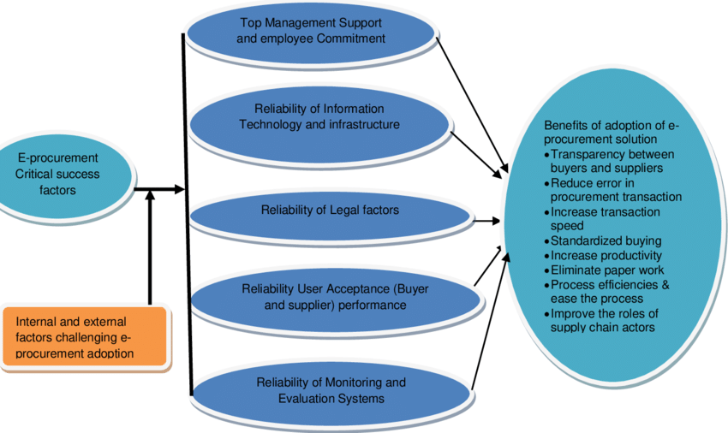
Figure 4: Conceptual framework
Source: Tebeka and Sediki (2019)
Whether in the public or private sector, a number of elements are essential to the success of any e-procurement program, according to Gunasekaran and Ngai (2008). The quality of the information that would be obtained, users' acceptance of new information systems, trust in the new systems, perceived risks, staff members' skill and training needs, top management support, the advantages of implementing the new system and continuous evaluations of the advantages, benchmarking and adherence to best practices, and the factual selection of an e-procurement solution are some of these factors.

2.5.1 Performance of public sector organizations
Performance of public sector organizations is noticed through reduced procurement errors, speed of transaction completion, transparency and increased efficiency.

2.5.2 Adoption of e-procurement
The adoption of e-procurement have some critical success factors that influence the performance of public sector organizations. The success factors includes, top management supports and commitment of employees, reliability of IT infrastructure, reliability of legal factors and reliability of monitoring and evaluation systems.

2.6 Empirical literature

The adoption, application, and effects of electronic procurement procedures in diverse contexts are the subject of several studies that are included in the empirical literature on e-procurement. These research yield several important conclusions, including the adoption elements. Kabanda, Pitso, & Kapepo. (2019) shows that e-security, staffing, user acceptability, and top management support are some of the elements that affect e-procurement adoption. Support from upper management is extremely important for the successful adoption of e-procurement, especially in the public sector.
Corruption Reduction. By addressing problems like monopoly of power, information asymmetry, and improving openness and accountability, e-procurement technology has the potential to minimize corruption in public procurement procedures (Imam Riauan,, Sitanggang & Ahmad, 2022).

The adoption and operational performance of e-procurement in the public sector organizations have been studied to understand the factors that influence its success and the impact on organizational performance hnology has the potential to minimize corruption in public procurement procedures (Imam Riauan,, Sitanggang & Ahmad, 2022). Premathilaka (2019) highlights that the adoption of e-procurement in Sri Lanka is influenced by several crucial success criteria, including Relative Advantage, Compatibility, Complexity, and Top Management Support. Studies show that the intention to use e-procurement and the decrease in public procurement corruption are positively correlated. Research also focuses on how e-procurement is implemented in certain areas, such as Indonesia's 3T regions, with the goal of creating strategies, policies, and implementation guidelines for efficient e-procurement methods in local government (Imam Riauan et al, 2022).

One important topic of research is how prepared lower- and lower-middle-income countries' public sectors are to use e-procurement systems (Adjei‐Bamfo, Domfeh, Bawole, Ahenkan, Maloreh‐Nyamekye, Adjei-Bamfo & Darkwah, 2020). Studies highlight how crucial it is to evaluate the conditions necessary for a complete e-procurement system in order to improve public procurement services as well as the socioeconomic advancement of these nations.
Together, these empirical studies help to clarify the nuances, difficulties, and advantages of adopting and implementing e-procurement as well as its potential to revolutionize procurement procedures across a range of industries ( (Adjei‐Bamfo et al, 2020).

In Nigeria, e-procurement was found to have a significant and positive impact on the performance of public sector organizations, with technological infrastructure, organization size, and top management attitude being important variables (Aliyu & Ibrahim, 2021). In Kenya, factors such as employee competence, policies, technology, and security of procurement data were found to influence adoption and performance of e-procurement in state corporations (Onsongo & Moronge, 2016). In Cape Coast, Ghana, e-procurement practices were found to help speed up the procurement process and increase performance, although challenges were also identified (Dwomoh & Affum, 2023).

These studies highlight the importance of various factors, such as technology, policies, and top management support, in the successful adoption and operational performance of e-procurement in the public sector organizations. The research also suggests that e-procurement can lead to more efficient and effective procurement processes, which in turn can improve overall organizational performance. However, challenges such as employee competence, data security, and the need for continuous improvement in technology infrastructure must be addressed to ensure the success of e-procurement initiatives.
Empirical reviews on the key success factors for the implementation of e-procurement. Technology deployment by itself does not guarantee technological intervention's success; users and buyers must utilize the new system and process for a public sector e-procurement project to be successful. The answer needs to persuade end users that e-procurement is the best way to make purchases of goods and services (KPMG, 2001). Effective communication with users is crucial for the e-procurement solution/project to succeed (Birks, Bond, & Radford, 2001). As stated by the CGEC (2002), users' readiness to modify long-standing internal corporate processes and their degree of technology understanding and acceptance are the two main barriers to growing user support.

2.7 Research gap analysis
While the results from the literature reviewed do not directly address Harare, they offer a framework for understanding e-procurement adoption and its factors in other African contexts, which can be relevant to Harare's context. The research aims to analyse the adoption specifically to Harare, and the study would need to address the unique challenges and opportunities faced by public sector organizations in that city. This study could build upon the existing literature and adapt the identified factors to Harare's context, while also identifying new factors that may be unique to Harare's public sector organizations.

2.8 Summary
This chapter was centered on theoretical and empirical review of literature pertaining to e-procurement and the performance of public sector entities. The views and findings of various authorities have been presented and what academics say about the subject under study. In the next chapter the researcher will present the methodology that has been adopted for this study.

CHAPTER 3

RESEARCH METHODOLOGY

3.0 INTRODUCTION
In the previous chapter the researcher focused on theoretical and empirical review of literature. In this chapter a clear and concise description of how the study was carried out is given. This involves description of all the activities and procedures undertaken during the course of the research. The chapter details the demographic, sample size, sampling techniques, and the research methodology that have been used in this research.
3.1 RESEARCH DESIGN
Research design refers to the planning framework employed by researchers prior to conducting their investigations (Creswell, 2010). It encompasses three primary approaches: quantitative, qualitative, and mixed methods. Each approach has its unique characteristics and strengths, allowing researchers to select the best fit for their specific questions and contexts.
A descriptive research design is used in this research. It is a methodological frameworks that use questionnaires or interviews to collect data on existing conditions, opinions, or behaviors (Creswell, 2010). A descriptive survey gather information about the characteristics, behaviors, or opinions of a particular group. It involves collecting data through questionnaires, interviews, or observations to describe a phenomenon without manipulating variables (Lal et al, 2020). In this study, these surveys support evidence-based decision-making by assisting researchers in understanding attitudes, behaviors, and trends among particular populations.

3.2 POPULATION
The research population refers to the entire group of individuals or entities about whom generalizations are sought within a specific context (Majid, 2018). The population of this study are public sector entities in Zimbabwe and this includes parastatal such as National Railways of Zimbabwe, Grain Marketing Boards (GMB) and ZUPCO among-st others and also municipalities. There are public sector entities in Zimbabwe (Chiuriri and Arshad, 2023). The population of this study focuses on public sector entities with head offices in Harare. Procurement is often handled by representatives from the finance, ICT, and procurement departments, which serve as hosts of services and technology enablers and these are the target respondents.

3.3 SAMPLING
A sample is a portion of the population that has been chosen especially for a given study (Majid, 2018). Samples can be chosen using a variety of strategies, including convenience sampling, stratified sampling, random sampling, and cluster sampling (Majid, 2018). Fifty five respondents will be selected to be participants from employees that work in finance, procurement and ICT departments of public sector entities in Harare.

Table 1: Sample Framework
Public sector entity | Population/ Average number of workers | Sample size
ZUPCO | 20 | 5
NRZ | 20 | 5
GMB | 20 | 5
Ministry of Roads | 20 | 5
EMA | 20 | 5
Parks and Wildlife Management | 20 | 5
POTRAZ | 20 | 5
ZESA | 20 | 5
Rural Electrification Agency | 20 | 5
CBZ | 20 | 5
POSB | 20 | 5
TOTALS | 220 | 55

3.4 RESEARCH INSTRUMENTS
The researcher used questionnaires and interviews to gather the research data.
3.4.1 Interviews
For precise and trustworthy data, the researcher will conduct in-person and video chat interviews. This kind of study instrument was chosen by the researcher since it allowed respondents to freely express their thoughts (Creswell, 2010). In addition, the researcher recorded the data they obtained from the different sample members regarding their perspectives of adopting e-procurement performance in the public sectors in Harare using audio and video recordings as well as a note book or notebook.
The researcher conducted both in-person and telephone interviews. Most of the respondents who were available were interviewed in-person; those who were unable to be present in person during the scheduled interviews were interviewed over the phone (Wegner, 2013).
Telephone interviews offer time efficiency and cost savings because they focus on specific questions rather than covering all aspects of a candidate's background (Wegner, 2013).
3.4.2 Questionnaires
Navarro-Rivera & Kosmin (2013) define a questionnaire as a carefully created document designed to obtain written responses from respondents without the researcher's assistance. A series of questions has been developed and gathered in an effort to comprehend the respondent's viewpoint regarding e-procurement adoption and operational efficiency of public sector entities. Likert-style questionnaire construction is the best method for questionnaire structuring (Hood, 2004).
Questionnaire were distributed to management and non-managerial staff members. The targeted respondents were given ten days to respond to the questionnaire by the researcher, which reduces the chance of low the respondents because respondents may be tied up by work. The questionnaire respected the respondents' requirement for anonymity, which allowed them to express their opinions without fear of retaliation or disclosure. Questionnaires can collect data from a large number of respondents quickly and cost-effectively (Demetriou, Ozer & Essau, 2015). Respondents can answer questions honestly without fear of judgment or bias, leading to more accurate data (Demetriou et al, 2015).

3.5 DATA COLLECTION PROCEDURES
The administration of interviews involved first requesting appointment with interviews and asking to be booked in space of three days depending with availability of respondents. Some of the interviews were walk in since some of the participants were willing to accommodate the researcher at the time that she arrives. The researcher also collected landline number to use for telephone interviews with respective respondents who were not available for face-to-face interviews.
Questionnaires were distributed and respondents given up to ten days to respond to them. By providing a clear deadline for completing the questionnaire, respondents may be more likely to prioritize it and complete it in a timely manner (Wachira, Tanui & Kalai, 2016). Overall, providing timelines for questionnaire respondents can help improve the quality and reliability of the data collected, while also making the data analysis process more efficient (Majid, 2018).

3.6 DATA PRESENTATION AND ANALYSIS
Descriptive statistics techniques like percentages, frequencies, and central tendency measures (mean, median, etc.) are commonly used to describe data distributions (Folasayo, 2021). Microsoft Excel have been used to record the quantitative data and content analysis was applied for qualitative data. Bar graphs, pie charts, line graphs, histograms, and other data presentation techniques will be used to illustrate the data that has been gathered. For visualization, bar charts, histograms, scatterplots, and box plots are examples of graphic representations that help with understanding trends within data sets and making results easier to communicate (Umar, 2021).
SPSS software have been used to statistically analyze the data and assistance of statistician have been sought. Working with statisticians or other specialists is advised when research becomes more complex in order to prevent misinterpretation of findings and guarantee robust analytical methods (Uter et al, 2004). SPSS analyzes data for descriptive research through various statistical procedures designed to summarize and describe datasets. SPSS analysed the data by calculating the frequency of each value or category inside a variable is known as a frequency distribution and measuring the central tendency. SPSS also worked in visualizing data patterns with charts and graphs.
3.7 RELIABILITY
Research reliability refers to the consistency and trustworthiness of scientific findings, ensuring that they can be reproduced and verified by other researchers (Sudo, 2019). To ensure reliability in e-procurement research the researcher followed several best practices strategies. The researcher used key theoretical framework commonly used in studies that examine the effects of electronic procurement on performance to direct the research for example Technology Acceptance Model. Using an appropriate research designs, such as descriptive research design, which allows the researcher to describe the characteristics of a particular group or phenomenon, as demonstrated in numerous studies enhance reliability (Ndei & Mutuku, 2021).
3.8 VALIDITY
Taherdoost (2016) states that validity evaluates if the study truly looks at the factors it set out to investigate or whether the findings are accurate.The degree to which a concept is accurately quantified in a quantitative investigation is another definition of validity (Taherdoost, 2016). The validity of the questionnaire will be tested in a pilot research with six government officials prior to its real administration. During this study, the most relevant items will be replaced with those that are unclear or unnecessary. Interview validity will be achieved by conducting them in private and with the clear guarantee that anything they discuss would only be disclosed in secret as part of the study, which will eliminate respondents' fear of sharing their honest opinions.
3.7 SUMMARY
This chapter discussed the research design, the target population, sampling techniques and data collection processes performed in this research as well as how it is analyzed. In the following chapter the researcher focuses on data analysis, presentation and discussions of research findings.

CHAPTER 4

DATA PRESENTATION, ANALYSIS AND DISCUSSION

4.0 Introduction
This chapter focuses on data analysis, presentation and discussion related to this study. The data that have been collected is presented in the form of graphs, charts, tables and descriptive statistical calculations such as measure of central tendency were used. A detailed analysis regarding the adoption of e-procurement and the effect on the performance of public sector entities was made using data collected from eleven organization in Harare where questionnaires were distributed and interviews conducted.

4.1 Response rate
A total of 80 questionnaires were distributed and 58 were successfully completed and collected by the researcher. The percentage of respondents who successfully participated in the survey is 73% and those who received the questionnaire and did not complete them is 27%. A response rate of 50% for questionnaires is generally considered acceptable in many research fields (Wegner, 2013).
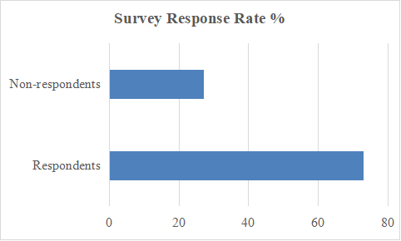
Figure 5: Survey response rate

4.2 Respondents by department
In order to understand different facets of e-procurement, the research entailed analysing responses by department. The departments which were involved in the survey are procurement, finance, stores and IT. Understanding e-procurement adoption in the public sector was be aided by this approach through collecting different perspectives from respondents on the subject matter. Organizations can obtain insights into various aspects of their e-procurement and make well-informed decisions by dividing responses based on department. There were 28 respondents from procurement function, 12 from finance department, 8 from IT department and 10 from the stores department. These departments have people well knowledgeable about e-procurement and its adoption and possessed the most relevant information in this study.

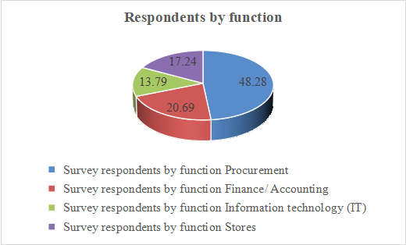
Figure 6: Departments of respondents

Figure 6 above gives a diagrammatic presentation of the respondents according to their departments in percentage terms. The procurement department represented 48% of the participants, followed by finance department that have 21%. The least respondents were from IT who formed 17% but this is inline with IT departments sizes in organization which are in most cases not very big.

4.3 Employee level in the organization
The participants indicated their level in the organization’s hierarchy. There were 7 participants who were executives in the public sector, 13 were heads of departments, 15 have designation of senior managers, 8 were supervisors and 15 were general employees. This allowed data collection to be holistic and incorporate the views of various people who are knowledgeable about e-procurement. The researcher presented the data in figure 7 below using a graph to present the levels of employee in the organization.
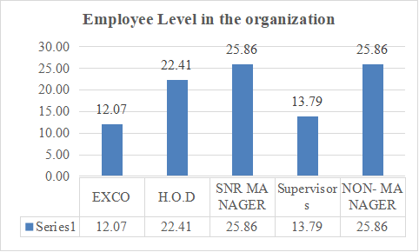
Figure 7: Employee level in the organization

4.4 Length of employment in the public sector
Feedback received from questionnaire contained 33.33% respondents being employees who have worked in procurement and other departments for more than 20 years. Followed by those who worked for 16-20 years who constituted 19% an the least the least number was from those who have 1-5 years who formed 10.10% of the respondents. The feedback shows that a significant number of workers in the public sector finance, IT, procurement an stores have many years of experience a knowledge but this can also be cause of concern since they may be resistant to change an have outdated procurement knowledge. Figure 8 below shows respondents by length of employment in the public sector. This reveals that many respondents are experts in the knowledge about e-procurement.

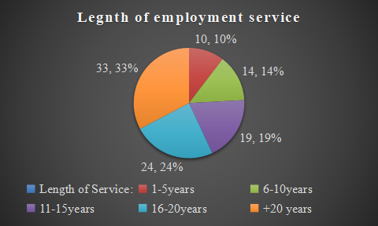
Figure 8: Length of employment

4.5 Direct and indirect procurement practices of public sector entities
The first step in the research involved and investigation of procurement practices being used in public sector entities in Harare. The results of the investigations are presented in table 2 below and discussed.

Table 2: Current procurement practices in the public sector
B. What are the current direct and indirect procurement practices of public sector entities? Please indicate with an ‘X’ (1– strongly disagree, 2– disagree, 3– neutral, 4–agree,5- strongly agree)
We use Internet-based technologies to:
 | 1 |  | 2 |  | 3 |  | 4 |  | 5
E-mail | 0 | 0% | 0 | 0% | 0 | 0 | 29 | 50% | 29 | 50%
Online ordering | 5 | 9% | 3 | 5% | 15 | 26% | 25 | 43% | 10 | 17%
Purchase approvals | 8 | 14% | 2 | 3% | 14 | 24% | 19 | 33% | 15 | 26%
Order tracking | 7 | 12% | 9 | 16% | 11 | 19% | 14 | 24% | 17 | 29%
Collaborate with suppliers on product design issues | 7 | 12% | 8 | 14% | 9 | 16% | 22 | 38% | 12 | 21%
Place orders on suppliers' web sites | 9 | 16% | 3 | 5% | 11 | 19% | 19 | 33% | 16 | 28%
Search for suppliers | 4 | 7% | 8 | 14% | 11 | 19% | 21 | 36% | 14 | 24%
Develop an integrated supply chain | 9 | 16% | 7 | 12% | 12 | 21% | 20 | 34% | 10 | 17%
Access electronic marketplaces | 6 | 10% | 12 | 21% | 13 | 22% | 16 | 28% | 11 | 19%

Table 2 above shows that in the public sector entities procurement practices currently in place involves the use of the internet to access electronic market place where 19 % and 28% agreed and strongly agreed. Most of the suppliers are searched through the internet where 24% strongly agreed and 36% agreed. Many of the respondents showed that order can now be placed online and tracked and email is the most used means of communication between the public sector and its suppliers where placing orders and receiving updates on deliveries.

4.6 The effects of adopting e-procurement on the operational performance of the public sector organizations
One of the objective of the study was to evaluate the effects that e-procurement have on performance of public sector organizations. The responses from public sector employees working in the IT, procurement and finance departments shows that e-procurement affect the way in which entities perform. A significant number of respondents agreed and strongly agreed that e-procurement will result in public sector entities improving their service delivery (12% and 62%) and it results in a reduction in administration costs.

Table 3: E-procurement adoption and the performance of public sector organizations.
What are the effects of adopting e-procurement on the operational performance of the public sector organizations?Please indicate with an ‘X’ Please indicate with an ‘X’ (1– strongly disagree, 2– disagree, 3– neutral, 4–agree,5- strongly agree)
We use Internet-based technologies to:
How performance of public sector organizations is affected | 1 |  | 2 |  | 3 |  | 4 |  | 5
Monthly utilities cost reduction | 0 | 0% | 0 | 0% | 5 | 0.1 | 30 | 52% | 23 | 40%
Improve efficiency | 0 | 0% | 0 | 0% | 7 | 12% | 39 | 67% | 12 | 21%
Improve effectiveness | 0 | 0% | 0 | 0% | 14 | 24% | 33 | 57% | 11 | 19%
Reduced Administration Costs | 0 | 0% | 0 | 0% | 13 | 22% | 35 | 60% | 10 | 17%
Enhancing service delivery | 0 | 0% | 0 | 0% | 15 | 26% | 36 | 62% | 7 | 12%

The effectiveness and efficiency of public sector organization is enhanced through adoption of e-procurement practices and a majority of respondents indicated that it can even result in reduction of utilities cost (40% strongly agreeing and 52% agreeing). This indicates that where procurement methods are highly efficient even service delivery and cost of delivering that service can be reduced hence improving performance of public sector entities.

4.7 Factors influencing e-procurement adoption in public sector organizations in Harare.
One of the objectives was to identify the factors influencing e-procurement adoption by public sector organizations in Harare. It was revealed by a total of 49 respondents who agreed and strongly agreed that the main factor that affect the adoption of e-procurement in the public sector entities is the lack of technological infrastructure. Inadequate financial resources was indicated by 44 respondents who agreed and strongly agreed that it is a major drawback to the adoption of e-procurement. Lack of skilled personnel and organizational culture are some of the significant factors that have been identified as limiting the adoption of e-procurement in the public sector entities.
Figure 9 below shows the factors that have been identified by the respondents as major factors affecting the adoption of e-procurement and expressed in percentage terms according to the feedback from respondents.

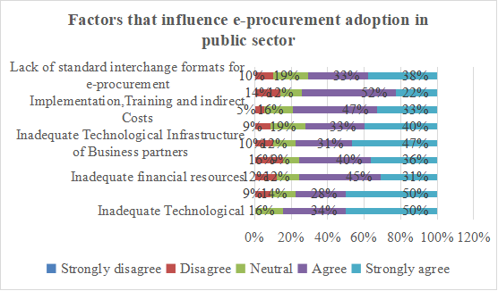
Figure 9: Factors influencing e-procurement adoption in public sector organizations

Figure 10 below reveals that the vision of public sector managers and continuous improvement strategies have an effect on the level of adoption of e-procurement in the public sector entities. Where the managers are visionary and focus on finding ways of streamlining procurement processes to be more efficient then adoption of e-procurement can be made. All 58 respondents agreed and strongly agreed that management’s vision regarding procurement strategy is important in influencing the adoption of e-procurement.

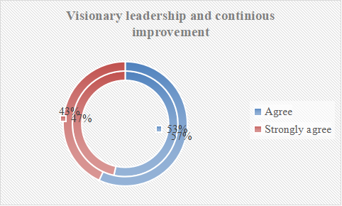
Figure 10: Visionary leadership,and continuous improvement.

4.8 The techniques for implementing e-procurement in the public sector organizations.
One of the research objective was to review the techniques for implementing e-procurement in the public sector organizations. In the study various techniques which can be followed in adopting e-procurement in the public sector organizations have been identified in the study. The key strategic factors included consolidation of suppliers, reducing the number of suppliers and selection of e-procurement software among other factors. The responses from the survey participants is presented in figure 11 below.
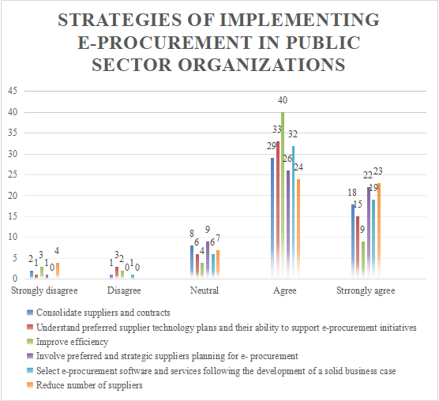
Figure 11: Techniques to implement e-procurement in public sector organizations.
A significant number of respondents (32 agreed and 19 strongly agreed) that selection of an e-procurement software is very important technique in the adoption of e-procurement in the public sector. It has been indicated that reducing the number of suppliers is very key when the public sector is adopting e-procurement with respondents agreeing and strongly agreeing making an aggregate of 47 out of the total participants. This may help the organizations to deal with suppliers who are capable of integrating their systems with the public sector entities.
It was identified that in making e-procurement initiative it is vital to understand the preferred supplier technology and their ability to support e-procurement initiatives. A total of 48 research participants indicated that this is very important element in the implementation of e-procurement in the public sector.

4.9 Summary
In this chapter the researcher concentrated on examining, summarizing and presenting the research data on e-procurement and its impact on the performance of public sector organizations. Pie charts, bar charts, and tables among other graphical presentations were used to present the research data. In the following chapter the researcher will be making summary, conclusion and recommendations.

CHAPTER 5

SUMMARY, CONCLUSIONS AND RECOMMENDATIONS

5.1 INTRODUCTION
The research on the impact of e-procurement on the performance of public sector enterprises is summarized in this chapter, which also presents the study's conclusion. The chapter will also include suggestions for future research topics and recommendations for the public sector's adoption of e-procurement.

5.2SUMMARY OF FINDINGS

The major aim of the study was to ascertain the ways in which the e-procurement can be adopted inclusive of its effects to the public sector organization. The need to improve the procurement process from the manual system to the computerized system. The research focused on evaluating the adoption of e-procurement and its effects in the performance of public sector in Harare.
A descriptive research design was used in this research and a sample of fifty five (55) participants was used in the study. The participants were selected from 11 big public sector organizations with offices in Harare Metropolitan province. The study was largely prompted by numerous reports that were received about poor performance of public sector organizations, procurement inefficiencies and procurement scandals. It was a challenging research because the participants were defensive in some cases about disclosing inefficiencies in the public sector procurement processes.

In spite of these constraints, findings and observations were made and the following conclusions were drawn:

5.3 CONCLUSIONS

5.3.1 Current direct and indirect procurement practices of public sector entities
The research found that, most of the public sector entities’ practice is to locate suppliers for goods and services by searching through the internet. The sector orders the goods online and track them by emails which is the most commonly used means of communication between the public sector and its suppliers when placing orders and receiving updates on deliveries.

5.3.2 The effects of adopting e-procurement on the operational performance of the public sector organizations

The study found that, adopting e-procurement will improve the performance of public sector oraganizations. It improves efficiency, reduces administration costs and enhances service delivery. The public sector's implementation of e-procurement has significantly impacted performance. Studies show that e-procurement improves cost savings, efficiency, and transparency (Machenyu, 2021). It enhances vendor management, minimizes paperwork, and streamlines the procurement process. E-procurement systems can also result in enhanced decision-making procedures, greater supplier competitiveness, and better regulatory compliance. All things considered, e-procurement can lead to improved performance in the public sector by increasing cost-effectiveness, efficiency, and transparency.

5.3.3 Factors influencing e-procurement adoption in public sector organizations in Harare
The study established that the main factors hampering the level of adoption of e-procurement in the public sector are: lack of financial resources, lack of standard interchange formats and technological barriers. Chimtengo, Hanif & Mvonye (2016) also noated that, the public sector organizations are facing challenges in adopting e-procurement due to various factors such as inadequate supplier readiness, insufficient end user training, bureaucracy, unsuitable adoption environment, users' ignorance of system benefits, resistance to change, incompatibility of systems, low staff motivation, inadequate data security, and absence of appropriate legal framework. In addition, Nigeria's sluggish adoption of e-procurement is attributed to a number of political, social, cultural, infrastructure, technological, and other variables (Chimtengo et al, 2016).

5.3.4 The techniques for implementing e-procurement in the public sector organizations
The study found that, some of the techniques used to implement e-procurement in public sector includes, consolidating suppliers, reduction on the number of suppliers and the selection of appropriate e-procurement software. Rosse (2019) established that, integration with Current Systems by integrating the e-procurement system with other current systems, such as ERP (Enterprise Resource Planning) software, redundant work is minimized and data flow is guaranteed. The procurement processes become more accurate and efficient as a result of this connection. Through the application of these strategies, public sector entities can efficiently integrate e-procurement platforms to optimize their procurement procedures, augment transparency, and realize financial benefits.

5.4 RECCOMMENDATIONS
Based on the results of numerous studies on the adoption of e-procurement and operational performance in Zimbabwe, especially in Harare, the public sector organizations in Harare, Zimbabwe might consider the following recommendations:
Openness and Responsibility: To lower corruption, boost accountability, and improve transparency in the procurement processes, use an open contracting and integrity pact transparent e-procurement system.
Education and Developing Competencies: To improve staff expertise and guarantee efficient use of the e-procurement system, provide ongoing e-procurement training. Enhancement of the Legal Framework: To give e-procurement operations inside public sector organizations a strong legal base, push for the official recognition and regulation of electronic procurement transactions.
Enhancing Technological Infrastructure: Invest in and upgrade the required technology to properly support e-procurement procedures in order to address issues relating to insufficient technological infrastructure.

Strengthen security protocols to protect procurement transaction information and guarantee the confidentiality and integrity of electronic transactions conducted through the e-procurement system. Process Alignment: To guarantee a smooth integration of the e-procurement system within the organizational framework, align current procurement processes with e-procurement protocols. The purpose of these recommendations is to improve e-procurement system adoption and operational effectiveness in Harare, Zimbabwean public sector companies by addressing important implementation obstacles and encouraging best practices.
Given the aforementioned findings, it is advised that the public sector create strong cybersecurity protections, maintain user-friendly interfaces, and offer comprehensive staff training programs in order to guarantee the successful deployment of e-procurement. Additionally, by lowering resistance to change, fostering an inventive and cooperative culture within the organization can aid in the adoption of e-procurement systems. In order for public sector organizations to build an e-procurement environment, they need financial support from the government to purchase the necessary software and equipment.

5.5 AREAS FOR FURTHER STUDIES
More research should be done in a number of areas on the operational effectiveness and acceptance of e-procurement by public sector entities in Harare, Zimbabwe:
Adoption barriers for e-procurement The research revealed several significant obstacles, including insufficient legal provisions, outdated technology, and data security related to procurement transactions. Additional investigation could go deeper into these issues and pinpoint viable remedies.
E-procurement's effect on procurement efficiency According to one study, there is a strong correlation between increased procurement efficiency and e-procurement. Further investigation may be necessary to measure the effect of e-procurement on important performance indicators in government agencies. Adoption of e-procurement is influenced by a number of factors, including perceived simplicity of use, utility, cost, and trust, according to the studies. Examining these variables within the framework of public sector institutions may yield knowledge to boost adoption rates.
Techniques for implementing e-procurement successfully: The research suggested techniques such as creating suitable business procedures, coordinating current procurement procedures, ongoing employee training, and formally recognizing electronic transactions as legal transactions.

Reference List
Aliyu, H., & Ibrahim, U.A. (2021). Assessing the Impact of E-Procurement on the Performance of Public Sector Organizations: Evidence from Nigeria. European Journal of Business and Management.
Aliyu, H., & Ibrahim, U.A. (2021). Assessing the Impact of E-Procurement on the Performance of Public Sector Organizations: Evidence from Nigeria. European Journal of Business and Management.
Ambe, I.M., & Badenhorst-Weiss, J.A. (2012). Supply chain management challenges in the South African public sector. African Journal of Business Management, 6, 11003-11014.
Anthony, A.O., Okibo, W.B., & Abuga, M.V. (2016). Survey to Examine the Drivers of E-Procurement in Public Hospitals in Kisii County, Kenya. European Journal of Business and Management, 8, 68-80.
Chimtengo, S.A., Hanif, R., & Mvonye, C. (2016). Factors Hindering the Adoption of Electronic Procurement System in Public Sector Organisations in Malawi. Strategic Journal of Business & Change Management.
Anyisile, S., Kipilimba, T., & Ng’elenge, H. (2023). Factors Influencing Effective Implementation of Public Sector E-procurement in Tanzania: A Case of TANROADS Iringa Regional Office. East African Journal of Business and Economics.
Asekunowo, V.O., & Ayodele, O.E. (2018). Effects of Public Sector Procurement Practices on Project Performance in Ondo State, Nigeria. African Journal of Sustainable Development, 8, 43-71.
Ceyhan, A., & Toraman, Y. (2023). User acceptance of e-commerce on metaverse from innovation diffusion theory and technology acceptance model. Akademik Hassasiyetler.
Chikazhe, L., Bhebhe, T., Tukuta, M., Chifamba, O., & Nyagadza, B. (2023). Procurement practices, leadership style and employee-perceived service quality towards the perceived public health sector performance in Zimbabwe. Cogent Social Sciences, 9.
Chilunjika, S.R., Chilunjika, A., & Uwizeyimana, D.E. (2023). Implementing e-procurement at the Zimbabwe’s National Pharmaceutical Company (NatPharm): Challenges and Prospects. JeDEM - eJournal of eDemocracy and Open Government.
Dwomoh, O.K., & Affum, M.Q. (2023). The effect of e-procurement practices on the performance of selected public sector organisation in cape coast: Cape Coast Technical University. International Journal of Computing, Programming and Database Management.
Dzuke, A., & Naude, M.J. (2015). Procurement challenges in the Zimbabwean public sector: A preliminary study. Journal of Transport and Supply Chain Management, 9,9.
Dzuke, A., & Naude, M.J. (2015). Procurement challenges in the Zimbabwean public sector: A preliminary study. Journal of Transport and Supply Chain Management, 9, 9.
Fulgence, D. (2023). The Critical Success Factors Affecting Tanzania National E-Procurement System Adoption on Performance of Public Procurement in Tanzania: A Case of Rural Water Supply and Sanitation Agency (RUWASA). International Journal of Science and Research (IJSR).
Hardinata, D., Kamaludin, Supratman, J.W., and Limun, K., (2022). How to minimise risk: The implementation of public sector service e-procurement in Indonesia. Jurnal Ilmiah Ekonomi Bisnis.
Kim, D., & Namkung, Y. (2020). A study on the use behavior of Kiosk consumers in fast food restaurant: Applying Innovation Diffusion Theory(IDT). Korean Journal of Hospitality & Tourism.
Mantzaris, E. (2014). Public procurement, tendering and corruption : realities, challenges and tangible solutions.
Marei, A. (2022). The effect of e-procurement on financial performance: Moderating the role of competitive pressure. Uncertain Supply Chain Management.
Mavidis, A., & Folinas, D. (2022). From Public E-Procurement 3.0 to E-Procurement 4.0; A Critical Literature Review. Sustainability.
Sudo H. (2019). Yakugaku zasshi : Journal of the Pharmaceutical Society of Japan, 139(6), 891–898. https://doi.org/10.1248/yakushi.18-00193-4
Ndei, F.M., & Mutuku, M.K. (2021). Electronic Procurement and Performance of Non-Governmental Organizations in Kenya. Empirical Evidence from Pathfinder International, Kenya. Journal of business management, 9, 71-80.
Mazikana, A. (2019). Reducing Contract Management Challenges in Public Sector Procurement in Zimbabwe. Manufacturing.
Ngatman, N., Alderei, H.S., & Musa, H. (2020). The Challenges faced by Public Sector Governance in implementing e-Procurement System: A Case Study of Education Department of Malacca.
Nguyen, T.H., Le, X., & Vu, T.H. (2022). An Extended Technology-Organization-Environment (TOE) Framework for Online Retailing Utilization in Digital Transformation: Empirical Evidence from Vietnam. Journal of Open Innovation: Technology, Market, and Complexity.
Nor, K. M., 2010. Consumer Attitudes Regarding Information Technology Usage - Scientific Figure on ResearchGate. Available from: https://www.researchgate.net/figure/Innovation-Diffusion-Theory_fig1_49610653 [accessed 14 Feb, 2024]
Nteere, K.K. (2014). Effect of Discriminatory Public Procurement Practices on Organizational Performance: A Survey of Public Sector Corporations in Kenya.
Nurdin, N., & Pettalongi, S.S. (2022). Menggunakan Paradigma Studi Kasus Kualitatif Interpretatif Online dan Offline Untuk Memahami Efektivitas Penerapan E-Procurement. Coopetition : Jurnal Ilmiah Manajemen.
Ogar, T.E., & Idagu, U.A. (2020). Public procurement in Africa and the intergrity question: towards an ethical narrative
Olojede, B.O., Opawole, A., Jagboro, G.O., & Alao, O.O. (2021). Examination of roles performed by public sector organizations in the procurement of public-private partnership projects.
Onsongo, N.M., & Moronge, M. (2016). E-PROCUREMENT ADOPTION AND SUPPLY CHAIN PERFORMANCE IN THE PUBLIC SECTOR IN KENYA. Strategic Journal of Business & Change Management.
Park, E. S and Park M., S.(2023). Factors of the Technology Acceptance Model for Construction IT. Retrieved from: https://www.mdpi.com/2076-3417/10/22/8299 on 17/2/24.
Premathilaka (2019). Critical Success Factors Affecting E-Procurement Adoption in Public Sector Organizations in Sri Lanka.
Premathilaka (2019). Critical Success Factors Affecting E-Procurement Adoption in Public Sector Organizations in Sri Lanka
Rashid, M.A., & Uddin, M.S. (2023). Efficiency Hypothesis Testing in an e-Procurement Implementation Assessment Model Framework: A Case Study of Bangladesh's Roads and Highways Division. World Journal of Advanced Research and Reviews.
Salifu, Z.N., Nangpiire, C., Dawdi, A., & Yussif, F. (2023). Assessing the Extent of Electronic Procurement Adoption Challenges in the Public Sector of Ghana. International Journal of Economics and Financial Issues.
Shantika, N.R., Lakunti Ardiatama, A., Purwaningrum, O., Yunanto Putra, Y., & Oktaviana Syafira, A. (2022). Analisis Adopsi Inovasi Teknologi Informasi Dompet Digital DANA Menggunakan Innovation-Diffusion Theory (IDT). Journal Of Information System And Artificial Intelligence.
Singh, P.K., & Chan, S.W. (2022). The Impact of Electronic Procurement Adoption on Green Procurement towards Sustainable Supply Chain Performance-Evidence from Malaysian ISO Organizations. Journal of Open Innovation: Technology, Market, and Complexity.
Sitompul, A. (2022). E-Procurement System In The Mechanism Of Procurement Of Goods And Services Electronically. International Asia Of Law and Money Laundering (IAML).
Taylor, J. M., Macpherson, T. W., Spears, I. R., & Weston, M. (2016). Repeated Sprints: An Independent Not Dependent Variable. International journal of sports physiology and performance, 11(7), 693–696. https://doi.org/10.1123/ijspp.2016-0081
Vogler, S., Habimana, K., & Haasis, M. A. (2022). Purchasing medicines for the public sector: Evaluation of the performance of centralised procurement in Portugal. The International journal of health planning and management, 37(4), 2007–2031. https://doi.org/10.1002/hpm.3444
Yuen, S.S., & Cheng, C. (2023). Sustainable E-Procurement Adoption and Practices in the Pandemic Era. International Journal of Economics and Business Administration.
Yusuf, A., Raji, I., & Oshoma, A. (2023). Impact of E-Procurement Adoption on the Performance of SMEs In Emerging Economy. International Journal of Procurement Management.
Uter, W., Schnuch, A., Gefeller, O., & ESCD working group: European Surveillance System on Contact Allergies (2004). Guidelines for the descriptive presentation and statistical analysis of contact allergy data. Contact dermatitis, 51(2), 47–56. https://doi.org/10.1111/j.0105-1873.2004.00406.x
Umar, U. (2021). An Analysis of Students’ Writing Essay Ability in English through Class Group Presentation on Fifth Semester of STKIP Paracendekia NW Sumbawa. e-Journal of Linguistics.
Folasayo, A.L. (2021). Competence of Secondary School Teachers‟ Usage of Bloom‟s Taxonomy of Education on Lesson Preparation, Presentation and Students‟ Assessments in Science. International Journal of Research and Innovation in Social Science.
Majid, U. (2018). Research Fundamentals: Study Design, Population, and Sample Size.
Wachira, P.M., Tanui, E.K., & Kalai, J.M. (2016). Relationship between Directive Leadership Style and d Teachers’ Job Satisfaction in Public Primary Schools Kenya: A Case of Nakuru County.
Demetriou, C., Ozer, B.U., & Essau, C.A. (2015). Self‐Report Questionnaires.
Creswell, J.W. (2010). Research Design: Qualitative, Quantitative, and Mixed Methods Approaches.
Lal, S., Abdel-Baki, A., Sujanani, S., Bourbeau, F., Sahed, I., & Whitehead, J. (2020). Perspectives of Young Adults on Receiving Telepsychiatry Services in an Urban Early Intervention Program for First-Episode Psychosis: A Cross-Sectional, Descriptive Survey Study. Frontiers in psychiatry, 11, 117. https://doi.org/10.3389/fpsyt.2020.00117
Omorodion, O., & Osifo, S.J. (2020). Employee Perceptions of the Electronic Procurement System (EPS) and Rate of Adoption of EPS by the Federal Public Hospitals in Edo State of Nigeria Based on the Diffusion of Innovations Theory. OUSL Journal.
Kabanda, S., Pitso, N., & Kapepo, M. (2019). The Role of Institutional Pressures in the Adoption of e-Procurement in Public Institutions in Developing Countries: The Case of Lesotho.
Limited Access to Technology: Some public sector organizations in Zimb

Imam Riauan, M.A., Sitanggang, Y., & Ahmad, Z.A. (2022). E-Procurement: Implementation Models in Indonesia Frontier, Outermost, and Least Developed Regions (3T). 2022 IEEE Creative Communication and Innovative Technology (ICCIT), 1-5.

Imam Riauan, M.A., Sitanggang, Y., & Ahmad, Z.A. (2022). E-Procurement: Implementation Models in Indonesia Frontier, Outermost, and Least Developed Regions (3T). 2022 IEEE Creative Communication and Innovative Technology (ICCIT), 1-5.

APPENDIX
Appendice 1
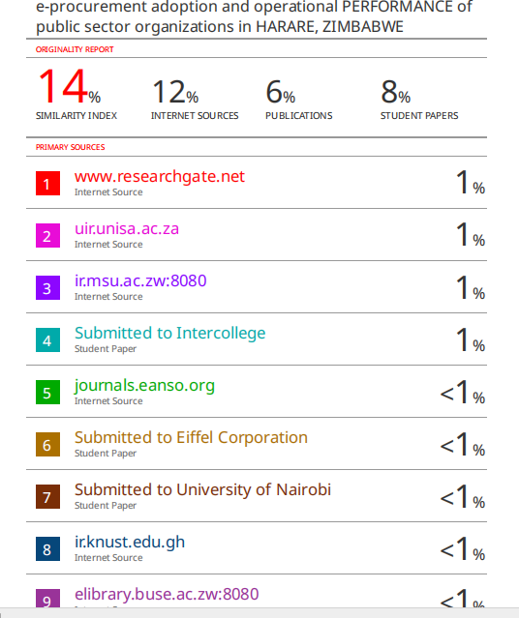
Appendice 2
Questionnaire



Thank you for participating in this survey on procurement practices in public sector. Your input is valuable in helping us understand and improve the procurement processes within local government.

The survey is for data collection on the topic titled, ‘e-procurement adoption and operational PERFORMANCE of public sector organizations in HARARE, ZIMBABWE’. A research project is a requirement for the partial fulfillment of the Bachelor of Commerce Honors Degree in Supply Chain Management and your assistance is highly appreciated.

Confidentiality
Your responses are anonymous, and no individual or organization will be identified in any reports resulting from this survey. Please answer the questions to the best of your knowledge and experience. Your responses will remain confidential and will be used solely for research purposes.

Yours Sincerely,

- Gadaga

SURVEY INSTRUMENT



A Questionnaire to Investigate the effects of e-procurement adoption and operational performance of public sector organizations in Harare.

Two major changes are currently taking place within Supply Chain Management, in particular the Procurement Management Function:
- E-procurement: use of information technologies such as Internet,e-mail,resulting in greater efficiency in ordering, transaction processing,information sharing with others in supply chain and global sourcing.
This research study investigates the effects of e-procurement adoption and operational performance of public sector organizations in Harare.

The survey will take approximately 30 minutes to complete. Your answers will be kept in strict confidence. Thank you for your participation.

A.DEMOGRAPHIC DETAILS – Please provide some background information
Department : | Procurement |  | Finance/ Accounting | Information technology (IT) | Stores
Level : | EXCO |  | H.O.D | SNR MANAGER | MANAGER | NON- MANAGER
Length of Service: | 1-5years |  | 6-10years | 11-15years | 16-20years | +20 years
B. What are the current direct and indirect procurement practices of public sector entities? Please indicate with an ‘X’ (1– strongly disagree, 2– disagree, 3– neutral, 4–agree,5- strongly agree)
We use Internet-based technologies to:
 |  | 1 | 2 | 3 | 4 | 5
E-mail
Online ordering
Purchase approvals

Order tracking
Collaborate with suppliers on product design issues
Place orders on suppliers' web sites
Search for suppliers
Develop an integrated supply chain
Access electronic marketplaces
C.1.What are the effects of adopting e-procurement on the operational performance of the public sector organizations?Please indicate with an ‘X’: Identify the most important effects of, ranking them from (1– least important, 2– less important, 3– neutral, 4–important,5
-most important)
How performance of public sector organizations is affected | 1 | 2 | 3 | 4 | 5
Monthly utilities cost reduction
Improve efficiency
Improve effectiveness
Reduced Administration Costs

Enhancing service delivery
- What factors are influencing e-procurement adoption in public sector organizations in Harare? | 1 | 2 | 3 | 4 | 5
Inadequate Technological
Infrastructure
Inadequate financial resources
Lack of Skilled Personnel
Inadequate Technological Infrastructure of Business partners
Lack of Integration with Business Partners
Implementation,Training and indirect Costs
Organizational Culture
Lack of standard interchange formats for e-procurement
D. What factors are influencing e-procurement adoption in public sector organization in Harare, Zimbabwe?
Factor  Please indicate with an ‘X’: ranking them from (1– least important, 2– less important, 3– neutral, 4–important,5 -most  important) | 1 | 2 | 3 | 4 | 5
D1-Visionary Leadership:
Leadership in strategic sourcing planning
D2-Continuous improvement:
People management
System improvement

Process improvement
D3- Status of procurement function:  Please indicate with an ‘X’ (1– strongly disagree, 2– disagree, 3– neutral, 4–agree,5-strongly agree) |  | 1 | 2 | 3 | 4 | 5
Top management of my organization
emphasises procurement functions’s strategic role
Procurement management has
high visibility with EXCO
D4- Integration coordination
of procurement with other functions:
There is frequent communication
between purchasing and other departments within our organization.
Procurement personnel are
included in income proposal activity
E. What are the techniques for implementing e-procurement in the public sector organizations?
Please indicate with an ‘X’: Identify the 5 most important key success factors of e- procurement uptake, ranking them from (1– least important, 2– less important, 3– neutral,
4–important,5 -most important)
Techniques | 1 |  | 2 | 3 | 4 | 5
Analyse purchasing behaviors of end users
Consolidate suppliers and contracts

Involve preferred and strategic suppliers planning for e- procurement
Select e-procurement software and services following the development of a solid business case
Reduce number of suppliers
Understand preferred supplier technology plans and their ability to support e-procurement initiatives

The End

