**BINDURA UNIVESITY OF SCIENCE EDUCATION**



**FACULTY OF COMMERCE**

**DEPARTMENT OF ECONOMICS**

**E-PROCUREMENT AND ITS IMPACT ON BUSINESS PROCESSES**

**BY TINOTENDA MITCHELL NYAHORE**

**B201001B**

**SUPERVISOR: MS. E.K. TAPFUMA**

**A RESEARCH PROJECT SUBMITTED TO BINDURA UNIVERSITY OF SCIENCE EDUCATION, DEPARTMENT OF ECONOMICS, IN PARTIAL FULFILLMENT OF THE REQUIREMENTS OF THE AWARD OF BACHELOR OF HONOURS DEGREE IN SUPPLY CHAIN MANAGEMENT.**

**BINDURA**

**YEAR :2024**

## APPROVAL FORM

I, Evelyn Tapfuma certify that the applicant worked under my direction as the university supervisor to complete the research study mentioned in this document. In my capacity as the university supervisor, I have approved the submission of this research project for evaluation.

Supervisor Name: Ms E.K. Tapfuma

Signature: ……………………………………………. Date: 24 May 2024

Student Signature: ……………………………………. Date: 24 May 2024

Chairperson of Department:

Name: …………………………………………………………………….

Signature: …………………………………………………………………. Date: ……. May 2024

## RELEASE FORM

**NAME OF STUDENT**: TINOTENDA MITCHELL NYAHORE

**STUDENT NUMBER**: **B201001B**

**TITLE OF THE RESEARCH PROJECT**: E-PROCUREMENT AND ITS IMPACT ON BUSINESS PROCESSES

**DEGREE PROGRAMME**: BACHELOR OF SCIENCE (HONOURS) SUPPLY CHAIN MANAGEMENT

**YEAR**: 2024

**STUDENT’S SIGNATURE: ………………………………………………………………..**

## DEDICATION

I dedicate this research to my parents, Mr and Mrs Nyahore, without whom I could not have accomplished my goals. You have been my foundation, my rock and my source of strength in everything I have done. I owe so much to your love and support. Words can never express how grateful I am.

## ABSTRACT

This study examines the effects of implementing an e-procurement system on integrated business processes within a state-owned enterprise (SOE) in a developing country. The research design used a case study of the Zimbabwe Electricity Transmission and Distribution Company (ZETDC) and collected data through questionnaires which consisted of closed-ended questions to measure employee perceptions of e-procurement usage and business process efficiency. Findings indicate the system provides clear benefits to procurement functions like purchase order management, invoice processing, workflow streamlining, improved transaction processing times and users reported increased productivity and usefulness across system functionalities. While the system enhanced core procurement accuracy and efficiency, user training emerged as an important issue requiring attention to fully realise benefits. Recommendations focus on strengthening user training programs through standardised, role-specific courses tailored to skill levels through ongoing evaluation and refresher training. Job responsibilities and measurable business objectives supported by the system must be clearly defined and communicated, and a more gradual implementation approach incorporating user acceptance testing is advised. Finally, the study recommends that establishing performance metrics benchmarked to pre-implementation baselines will facilitate ongoing impact monitoring. The study recommends conducting future research to explore the influence of organisational culture and potential cultural barriers within ZETDC on the adoption of the e-procurement system. Specifically, it suggests assessing cultural factors such as attitudes towards change management, technological acceptance, and perceptions of job role evolution.

## DECLARATION

I, Nyahore Mitchelle Tinotenda, hereby declare that this research report is the result of my own original work, and has not been previously submitted in whole or in part, for any other degree, except to the extent indicated in the acknowledgement, references and by comments included in the body of the report

Name of student: **Tinotenda Mitchelle Nyahore**

Date: **10 April 2024**

## ACKNOWLEDGEMENTS

First and foremost, I would like to express my deepest gratitude to God, who has been my source of strength and guidance throughout this research project. I would also like to extend my heartfelt thanks to Mrs E Tapfuma, who was a source of support and encouragement from beginning to end.

I would also like to acknowledge the staff of the Zimbabwe Electricity Transmission and Distribution Company (ZETDC) for their kindness, patience, and support during the course of the project.

Lastly, I want to express my profound appreciation to my friends, who have stood by me through thick and thin. Without their friendship and encouragement, this project would not have been possible.

I am truly grateful to all of the individuals who have helped me in completing this research project. Their help and support have been invaluable.

.

Contents

APPROVAL FORM i

RELEASE FORM ii

DEDICATION iii

ABSTRACT iv

DECLARATION v

ACKNOWLEDGEMENTS vi

LIST OF FIGURES xi

Chapter One 1

Introduction 1

1.0 Introduction 1

1.2 Statement of the problem 1

1.3 Research Objectives 2

1.4 Research Questions 2

1.5 Significance of the study 2

1.5.1 To the student 2

1.5.2 To academia 3

1.5.3 To ZETDC 3

1.6 Assumptions 3

1.7 Delimitations of the study 3

1.8 Limitations 4

1.9 Definition of terms 4

1.10 Summary 5

Chapter two 6

Literature review 6

2.0 Introduction 6

2.1 Theoretical framework 6

2.2 Impact on Procurement Processes 7

2.3 Impact on Other Business Functions 8

2.3.1 Integration with the supply chain 9

2.3.2 Performance Metrics and Benefits of E-procurement Adoption 9

2.4 Challenges of e-procurement implementation in state-owned enterprises 10

2.6 Research Gaps and Opportunities 12

2.7 Summary 12

CHAPTER THREE 13

RESEARCH METHODOLOGY 13

3.0 Introduction 13

3.1 Research Design 13

3.2 Population 13

3.4 Sample and Sampling Techniques 14

3.5 Research Instruments 14

3.6 Data Collection Procedures 14

3.7 Data Analysis and Presentation Procedures 15

3.8 Validity and reliability 15

3.9 Ethical Considerations 16

CHAPTER FOUR 18

DATA PRESENTATION, ANALYSIS AND DISCUSSION 18

4.1 Introduction 18

4.2 Questionnaire Responses 18

4.3 Findings 19

4.3.1 Respondents Background 19

4.3.2 General Impact on Integrated Business Processes. 21

4.3.3 Changes in Key Performance Metrics 23

4.3.4 Challenges in adopting e-procurement into the business process. 26

4.3.5 Perceived Utility of the E-Procurement System to Business processes 29

4.4 Discussion of the findings 34

4.4.1 General Impact on Integrated Business Processes 34

4.4.2 Challenges in the implementation of e-procurement 35

4.4.3 Perceived Utility of the E-Procurement System to Business processes 37

4.5 Chapter Summary 38

Chapter Five 40

Summary, Conclusions and recommendations 40

5.1 Summary of the study 40

5.2 Conclusions 40

5.3 Recommendations 41

5.4 Future Research 42

References 43

Appendix 1 – Approval Form 46

Appendix 2 – Questionnaire 47

Section 1 - Background Information 47

Section 2: Impact on Integrated Business Processes 47

**LIST OF TABLES**

**Table 4.1 Questionnaire Responses by department.** 18

Table 4.2. Time With ZEDTC * Time with Procurement Related Activities Crosstabulation 20

Table 4.3. Chi-Square Tests of CrossTabulation 20

Table 4.4. Incorrect invoice percentage before and after E-Procurement 23

Table 4.5 Did Participants understand Performance Metrics, Incentives 28

Table 4.6. Respondents understanding their role within the new system 29

**Table 4.7 Invoice management with e-procurement** 30

Table 4.8. State of the reporting and analysis 30

Table 4.9. Improvement in Procurement Systems 33

## LIST OF FIGURES

**Figure 4.1. Experience with ZEDTC** 19

**Figure 4.2 Procurement Cycles Pre-E-Procurement** 21

**Figure 4.3 Procurement Cycles Post-E-Procurement** 22

**Figure 4.4 Change in the number of suppliers** 24

**Figure 4.5. Invoice processing times before e-procurement.** 25

**Figure 4.6 Invoice processing times after e-procurement** 25

Figure 4.7. Training times for the implementation of e-procurement 26

**Figure 4.8. Perceptions on training duration** 27

**Figure 4.9. Tracking and managing procurement spending** 31

**Figure 4.10. Effectiveness at collaboration** 32

**Figure 4.11. Would Participants Recommend The E-procurement Adoption?** 34

# Chapter One

# Introduction

## 1.0 Introduction

Procurement is a key function for efficiently managing the acquisition of goods, works and services needed for organisational operations. As organisations globally strive to enhance operational efficiencies, electronic procurement (e-procurement) systems have become increasingly popular for facilitating procurement transactions between organisations and their supplier networks (Nani et al., 2020). E-procurement systems have seen widespread adoption globally over the last two decades as organisations look to leverage digital technologies to optimise procurement processes. Estimates indicate that over 70% of organisations now conduct at least some part of their procurement activities online using e-procurement platforms (Mélon and Spruk, 2020).

E-procurement is the use of electronic systems and platforms to manage the procurement process, from sourcing to payment (Afolabi et al., 2022). It can offer many benefits for developing countries, such as reducing costs, increasing transparency, and improving efficiency. However, it also faces some challenges and barriers that need to be addressed to ensure its successful implementation and adoption.

While e-procurement offers significant benefits like cost savings, process efficiencies and improved supplier management, implementing such systems also brings changes to how organisations conduct related business processes. Previous studies on e-procurement have mainly focused on quantifying savings and examining its impact on procurement functions. However, there is lack of in-depth research on how e-procurement implementation transforms interconnected business processes within procuring organisations with a focus on state-owned enterprises in developing economies (Afolabi et al., 2022). This is an important gap because procurement is tightly linked to finance, inventory management and logistics processes through material and information flows. The goal of this research study is to address the gap identified by conducting an in-depth case study of a parastatal’s e-procurement implementation. The research will provide valuable insights to both theory and practice regarding digital transformation of integrated business processes and suggest some possible solutions and recommendations.

## 1.2 Statement of the problem

While e-procurement systems have been widely adopted globally and can deliver significant benefits, implementing such digital technologies also fundamentally transforms integrated business processes within procuring organisations. However, much of the existing research has not examined this organisational change phenomenon within the specific context of government-owned companies in developing economies. State-owned enterprises in developing countries may face unique challenges in adapting to new digital workflows due to factors like existing resource constraints, underdeveloped technology infrastructure, and bureaucratic regulations. Without a clear understanding of how e-procurement impacts cross-functional collaboration across these companies, change efforts may not be properly managed to ensure process efficiencies are realised and supply chain resilience is maintained. Therefore, the goal of this study is to address this knowledge gap by conducting an in-depth case analysis of a government-owned company’s e-procurement implementation in a developing country context. The study aims to provide insights into how digital transformation impacts interconnected business processes within this specific population of procuring organisations.

## 1.3 Research Objectives

* To examine the impact of e-procurement implementation on integrated business processes within a state-owned enterprise in a developing country.
* To assess changes in key performance metrics across relevant functions before and after e-procurement implementation.
* To identify the key challenges faced in adapting to new digital processes and workflows within the organisational context.

## 1.4 Research Questions

* How has the implementation of an e-procurement system transformed existing workflows within procurement functions?
* What changes have occurred in these metrics as a result of e-procurement?
* What types of challenges have suppliers faced in transitioning to more digitised collaboration and transactions?

## 1.5 Significance of the study

While this research fulfils the partial requirements for a Bachelor of Purchasing and Supply degree, its impact extends far beyond personal development. This study delves into the realm of e-procurement, offering valuable insights for various stakeholders as discussed in the following sub-sections.

### 1.5.1 To the student

This research provides a valuable opportunity to put into practice the research skills and knowledge I’ve gained through my Bachelor of Purchasing and Supply program. By tackling a real-world problem, I can hone my ability to design and conduct effective research within an organisational setting. This experience will significantly enhance my problem-solving skills, equipping me to confidently contribute to future research initiatives.

### 1.5.2 To academia

The field of e-procurement is large and offers many opportunities for research; this study can be used as a foundation for future research initiatives. The knowledge gained from these insights will add to the body of existing research and pave way for other scholars who find value in this interesting topic. In addition to filling in knowledge gaps, this study raises fresh issues and avenues for inquiry that encourage theoretical expansion and additional research. When combined, these efforts can create an extensive e-procurement map that will direct next studies and technological advancements.

### 1.5.3 To ZETDC

In order to make the most of the application of e-procurement, ZETDC leadership can benefit significantly from the recommendations provided by this research. The research highlights opportunities for development and presents practical answers to current problems, allowing ZETDC to reduce expenditures, improve transparency, and expedite its procurement procedures. In the end, this means more productivity, lower risk, and better decision-making, which will help ZETDC become more successful.

## 1.6 Assumptions

This research operates under the following assumptions:

* Accessibility - The necessary data and resources will be obtainable to conduct the study.
* Confidentiality - All respondent data will be kept confidential and used solely for research purposes, ensuring participant anonymity.
* Response Accuracy - Respondents will provide honest and unbiased information to the best of their knowledge.
* Transparency - The research process and findings will be transparent and clearly communicated to relevant stakeholders.

While these assumptions are essential for the research to proceed, it is important to acknowledge that they may not always hold true entirely. Potential limitations and alternative perspectives will be addressed throughout the study.

## 1.7 Delimitations of the study

The study will be delimited to the geographical scope of Harare within the operational jurisdiction of the Zimbabwe Electricity Transmission and Distribution Company. This geographical limitation is essential to maintain a focused investigation specifically within the context of ZETDC in Harare. Consequently, the findings and conclusions of the study will primarily apply to this specific geographic area and may not be directly generalizable to other regions or districts outside the defined scope of Harare District.

## 1.8 Limitations

This study recognises several limitations that may affect the applicability and depth of its findings. Firstly, the organisation’s policies on secrecy and confidentiality posed challenges by limiting access to certain documents and internal data. This led to a heavier reliance on self-reported data through questionnaires, which can be influenced by social desirability bias and may not capture the full details found in documented records.

Secondly, the study mainly used questionnaires for data collection. While this approach was efficient and scalable, it lacked the richness and depth of information that qualitative methods like interviews or focus groups can provide. Some respondents couldn’t or wouldn’t complete the questionnaires due to time constraints or work commitments, despite efforts to follow up. This means that certain perspectives may have been missed.

However, the research team acknowledged these limitations and took steps to address them. They used multiple data sources where possible to verify their findings. The research design also explicitly stated these limitations, allowing readers to assess the generalizability of the results critically. Recognizing these limitations encourages further research that can explore specific areas in more depth and employ complementary data collection methods to obtain a more comprehensive understanding of the topic being studied**.**

## 1.9 Definition of terms

* **E-procurement:** Electronic procurement is the process of purchasing goods and services using internet-based technology and platforms.it encompasses the entire procurement lifecycle, from requisitioning and sourcing to ordering, invoicing, and payment, all conducted electronically.
* **Impact on Business Processes:** E-procurement can have several significant impacts on business processes which include efficiency, cost saving opportunities, compliance, visibility and control and supplier collaboration.
* Overall, e-procurement can transform traditional procurement processes, driving efficiency, cost saving, compliance and collaboration across the supply chain.

## 1.10 Summary

This chapter established out the structure for the study, carefully revealing the topic of choice and exploring its relevant background. It identified the main issue that needed to be investigated, outlined the precise goals of the study, and created thought-provoking research questions to direct the course of the inquiry. The chapter underlined the importance of the study and its possible contribution to the field, acknowledging the wider implications. It also carefully outlined the research’s limits, guaranteeing transparency and establishing precise parameters for the study. Lastly, by carefully explaining key terminology, the chapter gave readers and researchers a common understanding and served as a guide for research. The following chapter will give a review of the relevant literature.

# Chapter two

# Literature review

## 2.0 Introduction

With the steady rise of e-procurement adoption globally, there has been a growing body of research examining various aspects of electronic procurement systems and their impacts. This literature review aims to synthesize the key themes and findings from previous studies relevant to understanding how e-procurement implementation transforms interconnected business processes within procuring organisations, with a specific focus on government-owned enterprises in developing economies.

## 2.1 Theoretical framework

This study will be guided by the Conceptual Framework for E-Procurement Impacts proposed by De Boer et al. (2002). They proposed one of the earliest and most influential theoretical frameworks conceptualizing how e-procurement implementation may impact organisations. Their model outlines three key levels at which transformations are expected to occur due to digitalisation of procurement processes:

1. Front-end supplier interaction functions: This level involves the interaction divisions that source goods/services from suppliers. E-procurement is seen to streamline activities like generating requests for quotes, assessing bids, facilitating online catalogues/marketplaces, and providing supplier performance feedback mechanisms.
2. Core procurement execution processes: This refers to the main procurement workflows handling tasks from requisitioning through ordering, receiving, and payment. The model proposes e-procurement will automate and integrate core process execution to reduce manual work and cycle times.
3. Monitoring/control activities: This level involves the oversight functions ensuring compliance and managing spending. E-procurement is expected to generate transaction compliance data and spend visibility dashboards to aid control of procurement expenditures and supplier relationships.

This conceptual framework provides a useful structure for this study to investigate how e-procurement implementation has impacted processes at Zimbabwe Electricity Transmission and Distribution Company (ZETDC). Specifically, the model’s three impact levels will be used to guide data collection on: 1) Changes to supplier interaction workflows, 2) Transformations in core procurement execution processes like purchase order management, and 3) Impacts on monitoring/control capabilities through metrics generated. The case study research design allows observable, empirically validated insights to be gathered on digital shifts experienced within each defined framework dimension at ZETDC. Moreover, the context of a developing country government enterprise expands understandings of framework applicability beyond its original private sector focus. Overall, using De Boer et al.’s conceptualization as an analytical lens helps ensure this study provides a structured yet holistic account of organisational impacts. By looking at real-life examples and how well the model works in those situations, we can improve the theory behind changing how businesses state owned enterprises utilise e-procument. This will make the theory more relevant to real-world situations particularly to the Zimbabwean situation.

## 2.2 Objectives of e-procurement

E-procurement centralises and automates interactions between stakeholders (end users, procurement department, suppliers, etc.) in order to improve the performance of the procurement process, management and strategy. There are four major benefits.

### 2.2.1 Savings

The cost of a standard transaction is estimated at an average of $80 and that of a 100% digital transaction (from product selection to payment) at less than $16. One reason for this is the reduction in the cost of labour resources, since the process is fully automated. Relative to the number of orders, especially for indirect purchases, the savings are considerable.

### 2.2.2 Eliminate low value-added processes.

Getting rid of administrative and manual tasks is a strategic way to increase teams’ speed and efficiency, while reducing the rate of error by an average of 30-50%. With e-procurement, sending the purchase order, requesting approval, reconciling the order and the invoice. They’re all automated. This allows teams to focus their energy on tasks with higher added value.

### 2.2.3 Shortening the overall timeframe.

Whether placing orders or approving them, the process is streamlined and gives companies more transparency: there is no more down time, reminders, or handling and filing of administrative documents. This saves considerable time in the procurement process. Furthermore, since the order is converted directly into a preparation slip for the supplier, companies ultimately receive their goods more quickly.

### 2.2.4 Controlled spending

E-procurement provides better visibility, with a clear, real-time view of spending (principals, procurement process, etc.) through reporting features. This means they can:

* Better manage their spending.
* Manage costs and budgets more accurately.
* Adjust their strategy by identifying areas for improvement.

## 2.3 Impact on Procurement Processes

E-procurement has demonstrably impacted how organisations manage their procurement activities. Numerous studies highlight its ability to streamline and automate traditional workflows, transforming paper-based tasks into seamlessly integrated digital processes (Wang et al., 2022). Activities like requisitioning, supplier sourcing, order placement, receipt recording, and payments become digitized, leading to a reduction in procurement cycle times (Willy & Paul, 2021). This reduction, reaching up to 30% according to Kumar and Ganguly (2020), signifies faster sourcing, ordering, and delivery, directly impacting overall operational efficiency. Additionally, automation minimizes human error in data entry and document handling, enhancing data integrity and accuracy. Furthermore, real-time access to data and tracking capabilities offered by e-procurement systems improve visibility into procurement activities, enabling better control and informed decision-making (Willy & Paul, 2021).

While e-procurement systems promise costs savings and efficiencies for government agencies, their unique needs require customized solutions. According to Nzimakwe (2023), state-owned enterprises have strict regulations and laws governing procurement along with compliance processes that differ from private companies, thus, a one-size-fits-all e-procurement system will not seamlessly integrate with these existing frameworks (Nzimakwe, 2023). Wang et al. (2022) state that it is imperative that public agencies work closely with solution providers to develop customized digital platforms that meet regulatory compliance standards while streamlining procurement operations. Only with adaptation can e-procurement realize its full potential within the public sector’s unique legal and operational landscape (Kumar & Ganguly, 2020).

Beyond technological solutions, successful e-procurement implementation demands effective change management strategies (Belisari et al., 2020). As Belisari et al. (2020) explain resistance to new processes, user training requirements, and data migration complexities can pose significant challenges. Addressing these concerns through comprehensive training programs and clear communication plans is crucial for user adoption and system success. Additionally, ensuring data security and addressing potential integration issues with legacy systems are critical areas of focus (Gascó et al., 2018).

Mwabili and Kyalo (2022) note that even with a successful adoption of the efficient process provided by e-procurement it is very important to highlight that aside from process efficiency, good supplier integration is critical to maximizing the benefits of e-procurement. This involves engaging suppliers in the transition, providing training and support, and addressing their concerns regarding adapting to digital interactions. Establishing effective communication channels and collaborative partnerships with suppliers fosters their participation and optimizes the overall procurement ecosystem (Mwabili & Kyalo, 2022).

While long-term cost savings are often associated with e-procurement, a thorough cost-benefit analysis is crucial (Kumar & Ganguly, 2020). Initial implementation costs, ongoing system maintenance, and training requirements need to be factored into the analysis to ensure financial feasibility and a positive return on investment. Therefore, further research can shed light on the impact of e-procurement in specific areas within government procurement, such as tendering, contract management, and supplier relationship management. Investigating the long-term effects on organisational performance and efficiency in developing economies would also contribute valuable insights. Additionally, analysing the challenges of data security and privacy within government e-procurement systems and exploring best practices for mitigation are key areas for further exploration (Kumar & Ganguly, 2020).

It is important to note that e-procurement is considered separately from e-sourcing, which focuses on the Source to Contract (S2C) process. E-sourcing uses digital tools to digitise the Source to Contract process, which involves the identification and selection of suppliers.

## 2.4 Impact on Other Business Functions

Building upon research highlighting the streamlining of procurement processes through e-procurement, it’s crucial to delve deeper into its impact on integrated supply chain functions, particularly relevant to the context of state-owned enterprises (SOEs) in developing economies. This investigation aligns with Research Question 2 (Section 1.4), which aims to assess changes in key performance metrics across relevant functions before and after e-procurement implementation. Studies by Mafini et al. (2020) and Waithaka and Kimani (2021) demonstrate how e-procurement fosters tighter integration with inventory management and logistics, potentially leading to lower stock levels and improved demand forecasting accuracy. This aligns with the challenges faced by SOEs in developing economies, often struggling with resource constraints and inefficient inventory management. Furthermore, Martins et al. (2020) highlight the financial and accounting benefits of collaborative e-procurement systems, facilitating information sharing and expediting payment processing. Understanding how these integrated functions are impacted by e-procurement implementation within SOEs will be crucial for assessing its overall effectiveness and identifying potential areas for improvement, as explored in the following section.

While previous sections explored how e-procurement streamlines procurement processes, its impact extends beyond mere automation. E-procurement systems can tightly integrate procurement with related supply chain functions, offering significant benefits like reduced costs, improved visibility, and enhanced efficiency across the entire chain. This deeper integration is particularly relevant to this examination of state-owned enterprises (SOEs) in developing economies, often facing resource constraints and complex supply chains.

### 2.4.1 Integration with the supply chain

E-procurement systems do not just automate the purchasing process itself as they can help integrate it more tightly with related supply chain functions as well. Several studies have explored how e-procurement impacts areas like inventory management, logistics, demand planning, and financial activities. Research by Mafini et al. (20200 found that tighter integration of procurement with inventory management and logistics systems through an e-procurement platform resulted in significantly lower stock levels being kept by organisations. This is because real-time visibility into purchasing orders and deliveries allows inventory to be managed more dynamically to avoid surpluses. Similarly, Waithaka and Kimani (2021) noted e-procurement provided improved demand and sales data visibility that enhanced forecasting accuracy. By capturing past transaction details digitally, demand patterns could be analysed more effectively to predict future needs.

More recent studies also emphasise the financial and accounting benefits that are brought by the adoption of e-procurement. Martins et al. (2020) stress that collaborative e-procurement systems are needed to share information seamlessly across departments like finance, procurement, and accounting. Their research highlighted how platforms that integrated payment tracking functionality supported tasks like invoice receipt matching and expediting supplier payments processing. This level of end-to-end integration helped boost organisational cash flows (Martins et al., 2020). Thus, relative to manual paper-based systems, e-procurement provides the opportunity to break down barriers between supply chain functions through shared access to centralised procurement data. This in turn drives benefits like lower carrying costs, better demand visibility, and more efficient financial transaction management.

### 2.4.2 Performance Metrics and Benefits of E-procurement Adoption

When assessing the impact of e-procurement initiatives, researchers have relied on quantitative metrics to measure improvements in key areas. One such metric is analysing cost reductions through comparing manual versus electronic order processing. A study by Yu et al. (2020) found firms achieved significant cost savings of 15-30% by moving routine purchase orders onto online platforms versus processing them manually via phone, fax or paper forms. This allowed for streamlined automated workflows that removed inefficiencies. Another frequently cited metric is reductions in maverick or off-contract spending as e-procurement provides improved visibility into spending across an organisation. A study by Mélon & Spruk (2020) reported firms saw maverick rates drop by 15-30% after implementing systems that aggregated spend data and enforced compliant supplier selection. This quantified the financial impact of tightened non-compliance controls.

Additional research has focused on transaction compliance rates as a metric. Studies by Vaidya and Campbell (2016) analysed compliance with policies like obtaining required approvals, adhering to spending limits and using preferred suppliers. They found digital systems consistently drove higher compliance of 85-95% compared to 70-80% for manual processes due to enforced controls and approvals. Capturing supplier perceptions provides further quantitative insights. A survey conducted by Olatunji et al. (2021) polled suppliers that had interacted with customers’ e-procurement systems. They reported workflows for items like obtaining purchase order approvals had been optimized in 30-50% of cases, reducing delays. This quantified efficiency gains felt on the supply side.

By leveraging proven metrics and quantitative analyses from prior literature, this study aims to validate findings while offering new contextual insight into challenges and opportunities within state-owned enterprises.

## 2.5 Challenges of e-procurement implementation in state-owned enterprises

While the potential benefits of e-procurement are well established, adopting such systems in developing contexts faces substantial hurdles. The first and major challenge for implementing e-procurement in the developing economies are the technological infrastructure gaps which pose a major challenge, as noted by Afolabi et al. (2022). The lack of adequate nationwide broadband access and interconnectivity between government networks poses a major hurdle for the seamless integration and implementation of e-procurement systems in developing countries. Integrated cross-departmental e-procurement platforms are intended to provide a centralized system that allows all government agencies to share procurement data and information in real-time. However, fragmented technological infrastructure makes interoperability extremely challenging (Bobowski & Gola, 2018). If agencies are unable to access the system reliably due to connectivity issues or share electronic documents seamlessly, then the core value proposition of centralized e-procurement is compromised. Purchase orders, invoices, bids and other essential procurement records cannot be viewed and processed collaboratively in a digital ecosystem without dependable high-speed connectivity between all stakeholders. This significantly undermines the potential for improved transparency, process efficiency and cost savings that come with integrated e-procurement. Silos of disconnected data instead of integrated shared access will persist without addressing the infrastructure gaps.

Another challenge is the limited information technology (IT) skills among public sector staff which poses a major bottleneck for effective adoption of e-procurement systems in developing nations (Shatta et al., 2020; Siwandeti et al., 2021; Masoud, 2023). As many studies have shown, technological literacy is typically low, with most officials lacking experience with digital tools. This skills gap manifests in several problems that hinders implementation. Users struggle to learn new software interfaces, slowing initial training periods. They have difficulties navigating systems independently, again increasing reliance on expensive consultants. Basic troubleshooting abilities are also limited, so minor glitches become large issues without outside support. The skills shortage further prevents internal champions from emerging to drive adoption (Masoud, 2023). Without tech-savvy leaders, digital procurement lacks strong internal advocacy. Support and encouragement for reluctant users suffers. It also means ongoing system management, upgrades and integrations with new interfaces becomes a challenge without in-house expertise. Constant external assistance is needed, increasing long-term costs (Siwandeti et al., 2021). Data quality and security risks also increase when users do not understand best practices. Mistakes in entries or suspicious links are more likely to be clicked (Siwandeti et al., 2021). Reskilling an entire workforce requires intensive courses, which are costly and take staff away from duties for long stretches, hurting productivity and efficiency gains. Organisations struggle to find time and funding for such extensive training needs. Without concerted skills development, systemic barriers to successful e-procurement deployment will remain entrenched in developing markets.

Beyond technological barriers, deeply entrenched workflows and resistance to change management pose cultural adoption barriers (Yevu et al., 2022). Mlinga and Pellissier’s (2016) research in Tanzania found shifting to e-procurement disrupted long-used paper-based processes. This sparked unease from officials accustomed to existing control mechanisms and timelines. Change fatigue is understandably higher in under-resourced environments with numerous transition pressures (Yevu et al., 2022). Public sector regulations also introduce complexities, as noted in Adjei-Bamfo et al.’s (2019) review across the Middle East. Laws governing tendering, bids, local content policies and cybersecurity must be addressed in system design. However, developing nations often have less mature digital governance and inconsistent interoperability between legacy rules poses problems.

Overcoming these deeply intertwined technological, skills-based, cultural, and regulatory challenges that developing countries face in transitioning to e-procurement will require extensive strategic planning, piloting of solution approaches, and robust stakeholder engagement at all levels. Only through judiciously addressing these multifaceted barriers will governments be able to help ensure the successful long-term deployment and adoption of e-procurement within their unique and complex environments.

## 2.6 Research Gaps and Opportunities

While literature explores isolated themes around e-procurement’s technical and performance-based aspects, few studies have conducted in-depth case analyses to understand digital transformation of integrated business processes end-to-end within government companies in developing regions. As such organisations face unique contextual conditions, there is a lack of insight on change management best practices tailored to their needs and abilities. This research aims to address these gaps through an empirical case study examining organisational impacts of e-procurement at ZETDC, contributing theory and practical lessons on digital transformation in resource-constrained public sector contexts.

## 2.7 Summary

In summary, existing literature provides valuable conceptual frameworks and isolated findings on e-procurement’s technological, performance, and implementation-related impacts. However, research examining digital transformation of intertwined workflows on a holistic process level specifically within government enterprises in developing economies remains limited. This study aims to address this knowledge gap through an in-depth organisational case analysis, adding an empirical perspective relevant to public sector procuring organisations undergoing digital shifts. The next chapter will provide the research methodology that was used for this study.

# CHAPTER THREE

# RESEARCH METHODOLOGY

## 3.0 Introduction

This chapter fully describes the study variables, the research design used by the researcher and the study area where the research was conducted. In addition, this chapter explains the study population, sampling procedures and sample size used, construction of research tools, pilot study, validity and reliability of the tools, data collection methods and analysis of data gathered.

## 3.1 Research Design

The research study adopted a correlational research design. This quantitative approach aims to examine relationships between variables through collection and statistical analysis of numerical data (Creswell & Creswell, 2018). A correlational design is suitable as the study seeks to determine if a relationship exists between e-procurement usage and levels of business process efficiency (Muijs, 2011). Data were collected through an online survey, hosted on Google Forms, distributed to employees across various departments within the organisation. A correlational design is well-suited for this study as it allows investigation into the type and strength of association between the independent variable (use of e-procurement systems) and dependent variable (degree of business process efficiency achieved) without implying causation (Gravetter & Wallnau, 2017). The correlational approach will help identify how aspects of e-procurement system usage correlate with changes in the measurement of overall business process efficiency. Statistical analysis can then be conducted to analyse the survey data and determine if any significant relationships exist between e-procurement factors and perceived levels of procurement workflow optimisation. Adopting a correlational research design is thus appropriate given the goal of exploring potential connections between these important organizational variables.

## 3.2 Population

The target population comprised of all procurement personnel across the four regions who totalled 103. This population was selected because they have direct experience using e-procurement for supply chain activities within the energy sector. Given the specific population size and boundaries, a census allowed for comprehensive data collection on factors like e-procurement system usage and perceived impacts on business process indicators (Check & Schutt, 2012). Statistical analysis could then examine potential correlations between application of e-procurement technologies and metrics of procurement workflow optimization.

## 3.4 Sample and Sampling Techniques

The target population for this study consisted of all employees working in procurement functions across ZETDC’s four regions, totalling 103 individuals. To obtain a representative sample from this defined population, the researcher utilized a proportionate stratified random sampling technique. Stratified random sampling allows for subgroups within a population to be represented in the sample proportionate to their size (Fink, 2003). This sampling frame represented the target population subgroups. Referencing appropriate sample size calculation techniques, a desired sample of 46 responded was determined. From each regional stratum, a computerized random number generator was used to select participants ensuring representatives from each subgroup in proportion to their number. Due to the researcher’s industrial placement within ZETDC Eastern Region, obtaining approval to conduct research and access employee records was facilitated (Fliess, 2000). Confidentiality protocols were strictly followed to protect private information. This structured sampling approach aligned with research best practices (Punch, 2014; Trochim, 2020) and allowed for adequate representation across the target population increasing generalization of findings (Babbie, 2020). The sample size achieved the desired power for statistical analysis relative to the overall population parameters (Bartlett et al., 2001).

## 3.5 Research Instrumentso

Primary data collection was conducted using a self-administered questionnaire distributed to the randomly selected sample of 46 procurement employees. As noted by Dubey and Kothari (2022), questionnaires provide a method for systematically gathering subjective self-report data on respondents’ perceptions, opinions, and attitudes. The questionnaire was developed by the researcher and divided into scales corresponding to the key study variables: level of e-procurement system use, degree of perceived business process optimization, and potential impact areas. Closed questions utilising a 5-point Likert scale design collected quantitative data to assess relationships between variables (Phakiti, 2020). The scale items were informed by relevant literature on e-procurement adoption and performance metrics (Creswell & Creswell, 2018). Prior to distribution, the questionnaire was pilot tested with a small group of 5 participants to establish validity, reliability, and an approximate completion timeframe (Bougie & Sekaran, 2019). Revisions were made as needed before disseminating to the procurement staff sample via Google Forms, with responses anonymised to preserve confidentiality.

## 3.6 Data Collection Procedures

Data collection activities were undertaken following approval from ZETDC and in accordance with the ethical guidelines of the researcher’s academic institution. Upon obtaining permission to survey procurement staff, an introductory email was sent by the researcher to the sample explaining the study purpose and emphasizing the confidentiality of participant responses as per ethical research protocols. The questionnaire, along with an informed consent form, were delivered electronically to the individual work emails of the 46 randomly selected procurement employees. A cover letter accompanied the questionnaire to establish the voluntary and anonymous nature of participation while addressing any questions or concerns (Fink, 2003). Respondents were requested to complete the questionnaire at their convenience but within a week due to the timeframes that the researcher had to follow (Gillham, 2008). To improve the response rate, reminders were sent to non-respondents’ inboxes after 48 and 72 hours (Iarossi, 2006; Kelley et al., 2003). Completed questionnaires were automatically returned in real time. Upon closure of the collection phase, the data from questionnaires was compiled and preparation for analysis commenced using the collected data.

## 3.7 Data Analysis and Presentation Procedures

Data collection and initial handling followed the procedures outlined on Section 3.6. Upon completion of the data collection window, the researcher compiled the returned questionnaires. Preparation for analysis then commenced using the information gathered from participants. Consistent with guidelines from Creswell (2003), the first step involved summarizing key features of the data to gain an overall understanding. Descriptive statistics such as frequencies, percentages, measures of central tendency and dispersion were computed for quantitative variables using R, a statistical analysis software. Charts, graphs and tables were also constructed to present the quantitative data in a clear, visual manner aiding interpretation (Biggs et al. 2021). Bar graphs displayed response frequencies for Likert scale items examining opinions. Pie charts and line graphs compared proportions and relationships between variables respectively. Both descriptive and inferential statistics were generated to address the research question and objectives as postulated by Biggs et al. (2021). Correlation and regression tests examined the degree and direction of relationships between e-procurement usage factors and metrics of business process optimization. Presenting findings in tables, graphs and narrative form allowed for effective communication of patterns in a logical sequence linking back to the original problem context and hypotheses (Mohajan, 2020). The overall analytical procedures systematically organised, described and converted collected data into informative results for discussion.

## 3.8 Validity and reliability

Validity and reliability are two related but distinctly different concepts within research. Understanding what they are and how to achieve them is critically important to any research project. Both validity and reliability have to do with the measurement of variables and/or constructs – for example, job satisfaction, intelligence, productivity and so on. As you can be inferred, if measurements are not accurate or there are quality issues at play when one is collecting data, the entire study will be at risk. Therefore, validity and reliability are very important concepts to understand. Ensuring the validity and reliability of the research instrument was vital to obtaining accurate and meaningful results. A variety of techniques were employed to establish the validity of the questionnaire. The items were developed based on an in-depth review of current theories and literature related to the key variables under investigation. This helped ensure the questions addressed the intended constructs and measured what they purported to measure. Additionally, the questionnaire was subject to expert review to gain feedback on question wording, formatting, structure, and overall ability to capture the needed information. Three procurement academics and two professionals with over 10 years of industry experience evaluated the content validity of the instrument. Necessary modifications were implemented based on their suggestions. To further establish validity, a pilot test was administered to five procurement staff not involved in the main study. Their responses and recommendations helped identify ambiguities, problematic terms or formatting, and approximate completion time. Revisions improved question clarity and comprehension. Reliability was assessed through internal consistency evaluation using Cronbach’s alpha coefficient analysis on the results from the pilot test. Coefficient values above 0.7 indicated good levels of inter-item reliability across the scales. Test-retest reliability over a two-week interval likewise demonstrated consistency in responses. Strong consideration of validity and reliability through expert review, pilot testing, and statistical analysis ensured the questions accurately and dependably captured the intended measurements. This optimised the researcher’s ability to draw valid inferences and interpretations from participants’ responses. Establishing sound psychometric properties of the instrument supported the integrity and usefulness of the research findings.

## 3.9 Ethical Considerations

Research ethics govern the standards of conduct for scientific researchers. It is important to adhere to ethical principles in order to protect the dignity, rights and welfare of research participants. As such, all research involving human beings should be reviewed by the relevant ethics committee to ensure that the appropriate ethical standards are being upheld. Discussion of the ethical principles of beneficence, justice and autonomy are central to ethical review.

Upholding strict ethical protocols throughout the research process was imperative. Confidentiality and anonymity of participants was of utmost importance and ensured through various measures. Identifying information was not collected on the questionnaires to prevent linking of responses to individuals. Even on Google Forms the setting were such that they did not capture any personal information. Completed surveys were securely stored and any digital data files stored on password-protected computers only accessible by the researcher. Informed consent was obtained from all participants through a cover letter accompanying the questionnaire. This thoroughly explained the voluntary and confidential nature of participation as well as their right to withdraw at any point without repercussion. Respondents self-selected into the study and were under no obligation to partake. Additionally, institutional approval was granted by BUSE prior to data collection as per ethical research standards. Details provided included protocol for protecting subjects, data storage procedures, and plans for dissemination of anonymous, aggregate findings only. Permission from senior leadership at ZETDC was also obtained to survey employees. The survey questions aimed to gather only information pertinent to the research problem and avoided topics of a sensitive nature that could cause psychological distress. Participants were notified of the purpose to empirically study relationships between variables and potential implications for improving organizational processes. However, no inducements or rewards were offered to prevent potential for coercion. Adhering to strict ethical guidelines throughout the study helped ensure protection of participants and integrity of the research. This optimized trustworthiness and validity of the findings.

## 3.10 Summary

This chapter outlined the research methodology used in the study. A quantitative correlational research design was selected to examine relationships between variables. The target population was procurement staff at four ZETDC regions, totalling 100 individuals. Stratified random sampling was employed to select a sample of 46 participants proportionately representing subgroups. A self-administered questionnaire was developed as the primary data collection tool, containing closed and open-ended items. It incorporated Likert scales to measure key variables of e-procurement usage and perceived impact on business processes. The questionnaire was pilot tested and distributed via census to the entire sample. Participation was voluntary and responses anonymous to ensure confidentiality and ethics. Both qualitative and quantitative data analysis methods were applied. Qualitative responses underwent content analysis while quantitative data was analysed using descriptive and inferential statistics R. Strict adherence to protocols supported validity and reproducibility. Proper methodology allowed for rigorous examination of relationships between variables to address the research problem. The next chapter will provide the results and discussion of the findings.

# CHAPTER FOUR

# DATA PRESENTATION, ANALYSIS AND DISCUSSION

## 4.1 Introduction

This chapter outlines the analysis, presentation and interpretation of data collected as part of the e-procurement implementation evaluation at ZEDTC. As described in the methodology, the study aimed to assess the impact of the newly implemented e-procurement system on integrated business processes at the organisation. User surveys were utilised as the primary data collection instrument. Results address factors such as system usefulness, ease-of-use and task support. The chapter will be organised according to key themes emerging from the survey questions. Each theme will present data from related questions focusing on a common aspect of the e-procurement system implementation. Within each theme, the survey results will be presented in a clear and organised manner and then a discussion will follow. Relevant data from multiple questions will be consolidated to give the reader a holistic view.

## 4.2 Questionnaire Responses

The questionnaire was distributed relatively equally across the key sections of Procurement, Finance and Logistics that are involved in procurement activities as illustrated by Figure 4.1.

|  |  |  |  |  |  |
| --- | --- | --- | --- | --- | --- |
| **Table 4.1 Questionnaire Responses by department.** | | | | | |
|  | | Frequency | Percent | Valid Percent | Cumulative Percent |
| Valid | Logistics | 10 | 27.0 | 27.0 | 27.0 |
| Procurement | 17 | 45.9 | 45.9 | 73.0 |
| Finance | 10 | 27.0 | 27.0 | 100.0 |
| Total | 37 | 100.0 | 100.0 |  |

A total of 42 questionnaires were distributed to employees in the logistics, finance and procurement sections of ZEDTC. The researcher got 37 responses which is an 88.10% response rate. by. The highest number of responses came from Procurement with 17 responses (45.9%), followed by Finance and then Logistics both with 10 responses (27%).

## 4.3 Findings

### 4.3.1 Respondents Background

The background section of the questionnaire provides useful insights into the respondents’ experience and suitability to comment on the impact of e-procurement at ZEDTC. The responses are shown in Figure 4.1.

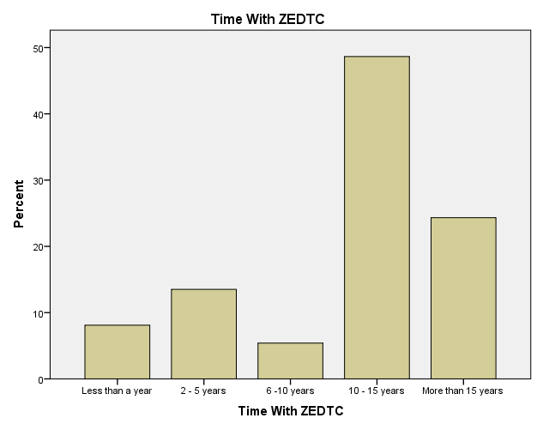

**Figure 4.1.** **Experience with ZEDTC**

In terms of experience at ZETDC, only three respondents (8.1%) less than a year’s experience with 8 respondents (21.62%) having more than 10 years. Most respondents (81.08%) had directly participated in procurement activities prior to e-procurement implementation. Only a small number (7 respondents or 18.92%) lacked this earlier experience.

This study then examined the relationship between time spent working with ZEDTC and time spent in procurement related activities. A crosstabulation was conducted to explore patterns in the data Table 4.2, while chi-square tests evaluated whether an association exists between the variables as shown in Table 4.3.

|  |  |  |  |  |  |  |  |
| --- | --- | --- | --- | --- | --- | --- | --- |
| Table 4.. Time With ZEDTC * Time with Procurement Related Activities Crosstabulation | | | | | | | |
|  | | | | | | | |
| Count | | Time With Procurement Related Activities | | | | | Total |
| Less than a year | 2 -5 years | 6 - 10 years | 10 -15 years | More than 15 years |
| Time With ZEDTC | Less than a year | 1 | 2 | 0 | 0 | 0 | 3 |
| 2 - 5 years | 1 | 0 | 2 | 2 | 0 | 5 |
| 6 -10 years | 1 | 0 | 1 | 0 | 0 | 2 |
| 10 - 15 years | 0 | 2 | 5 | 8 | 3 | 18 |
| More than 15 years | 1 | 2 | 1 | 1 | 4 | 9 |
| Total | | 4 | 6 | 9 | 11 | 7 | 37 |

The crosstabulation results provided some insights. Respondents who had spent more than 15 years in both roles formed the largest category, indicating coordination of long experience. Conversely, uncommon combinations like less than a year with ZEDTC and 6-10 years in procurement emerged, reflecting a trend towards proportional experience accumulation with other organisations prior to joining ZEDTC. This analysis hinted at a positive relationship between time variables.

The chi-square tests provided a more rigorous analysis of independence as shown in Table 4.3.

|  |  |  |  |
| --- | --- | --- | --- |
| Table 4.. Chi-Square Tests of CrossTabulation | | | |
|  | Value | df | Asymp. Sig. (2-sided) |
| Pearson Chi-Square | 24.494a | 16 | .079 |
| Likelihood Ratio | 26.918 | 16 | .042 |
| Linear-by-Linear Association | 5.870 | 1 | .015 |
| N of Valid Cases | 37 |  |  |
| a. 24 cells (96.0%) have expected count less than 5. The minimum expected count is .22. | | | |

Although the Pearson test was not significant, the likelihood ratio just met criteria for significance. More notably, a significant linear-by-linear association trend was observed. These results provided some evidence of a relationship between time spent in each organisation. Thus, the chi-square results point to an association between experience from the respondents.

Thus, the background data indicates the respondents come from all the key functional areas involved in procurement. Most possess extensive experience both generally within ZETDC and specifically related to procurement activities. The high proportion of respondents who were previously engaged in manual procurement and then in the e-procurement processes means they are well placed to offer insightful comparisons pre and post e-procurement system implementation. This suggests the responses provide a valid basis from which to evaluate the impacts of the new system.

### 4.3.2 General Impact on Integrated Business Processes.

The first theme in the survey had questions that were created to elicit useful before-and-after comparisons of how e-procurement has impacted key performance indicators at ZEDTC. It was composed of four questions that sought to identify the change in procurement cycles, transparency in procurement, time taken to replenish inventory, cost of inventory and other general business processes.

#### 4.3.2.1 Average procurement cycles.

The majority (62.2%) reported it took 3-5 days previously. Another 29.7% said it took 5-6 days. Only a small percentage reported even longer cycles of 7-14 days (5.4%) or over 14 days (2.7%). Therefore, the average time for the majority of respondents was between 3-6 days for procurement before the e-procurement system was implemented.

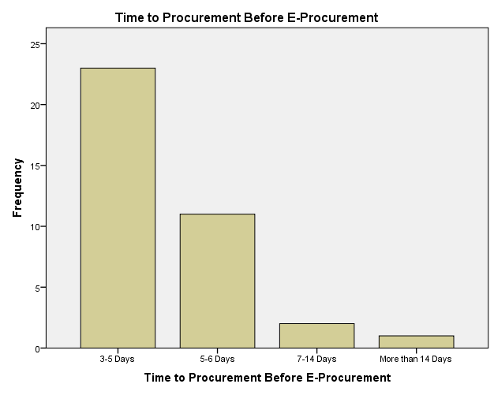

**Figure 4.2 Procurement Cycles Pre-E-Procurement**

This provided the baseline used to evaluate the changes in the procurement cycle times after implementation of the new digital procurement platform.

However, the majority of the respondents, 26 accounting for 70.3%, indicated that after the implementation of the e-procurement system it now takes 2-3 days now to complete procurement tasks with the new system. Around 21.6% of the respondents indicated that the procurement cycle can now take a time period of 2 days on average. However, three respondents or 8.1% stated that in their case, the procurement cycle can now be completed in less than a day in most cases. These respondents can be deemed an outlier. Even though, it can be argued strongly that on average, procurement cycle times were reduced significantly post e-procurement.

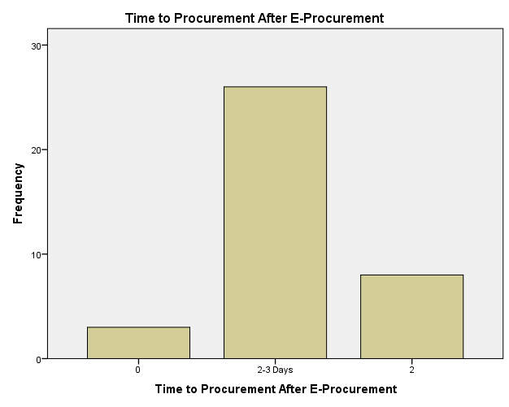

**Figure 4.3 Procurement Cycles Post-E-Procurement**

The results indicate that procurement cycles have notably accelerated following the implementation of the new e-procurement system. Most respondents reported that processes which previously took 3-5 days or 5-7 days were reduced to a timeframe of 2-3 days or less with the digital tools. This suggests e-procurement helped streamline activities and transactions.

#### 4.3.2.2. Invoice Error rates.

The majority of respondents (59.5%) reported incorrect invoice percentages between 10-15% before implementing the e-procurement system as shown in Table 4.4. The next highest error rate was the 15-19% range with around 19% (7) of the respondents indicating that. Together, this indicates over 75% perceived inaccuracies of 15% or less prior to e-procurement implementation. Only a small number reported lower error levels of 5% or below. This suggests invoice accuracy was an issue area previously, with a large proportion encountering double-digit incorrect rates under the manual processes.

|  |  |  |  |  |  |  |  |
| --- | --- | --- | --- | --- | --- | --- | --- |
| Table 4.. Incorrect invoice percentage before and after E-Procurement | | | | | | | |
| Count | | Incorrect Invoice percentage After E-Procurement | | | | | Total |
| 0-4% | 5-9% | 10-15% | 16-20% | Above 20% |
| Incorrect Invoice percentage before E-Procurement | 0-4% | 1 | 0 | 0 | 0 | 0 | 1 |
| 10-15% | 12 | 5 | 2 | 2 | 1 | 22 |
| 16-20% | 6 | 1 | 0 | 0 | 0 | 7 |
| 5-9% | 2 | 2 | 0 | 0 | 0 | 4 |
| 5 | 2 | 1 | 0 | 0 | 0 | 3 |
| Total | | 23 | 9 | 2 | 2 | 1 | 37 |

The survey requested the participants to indicate the level of post implementation invoice error rates. over 62.2% indicated inaccuracies between 0-5%, nearly 25% cited rates of 5-10% and only a small minority of 12.15% face errors above 10% (Table 4.4). This suggests the majority who had higher issues before now perceive notable improvements in accuracy. Agreeably, the post-implementation responses pointed to an improvement, with the respondents indicating they were now experiencing minimal errors which was a positive change. However, the responses show that there is room for improvement as was indicated by the fact that 12.15% of the respondents indicated that they still encounter errors rates above 10%, with one respondent (2.7%) indicating that they still encounter as much as 20% of errors in the procurement process.

### 4.3.3 Changes in Key Performance Metrics

The survey requested respondents to indicate the supplier base size before and after the e-procurement implementation. This data provides insights into percentage increases in the number of suppliers after implementing the e-procurement system as shown in figure xx.

#### 4.3.3.1 Change in supplier base

The majority (64.9%) reported increases between 40-50% in the number of suppliers after implementation of the e-procurement system. This suggests most saw the supplier base grow substantially, around half again as large. A smaller number of the respondents (8.1%) indicated even larger growth of 50-99% and 30-40% (8.1%). Nevertheless, some respondents indicated a modest gain of 20-30% of suppliers (10.8%) and yet another small number 8.1%) indicated that they noted no change in the number of suppliers.

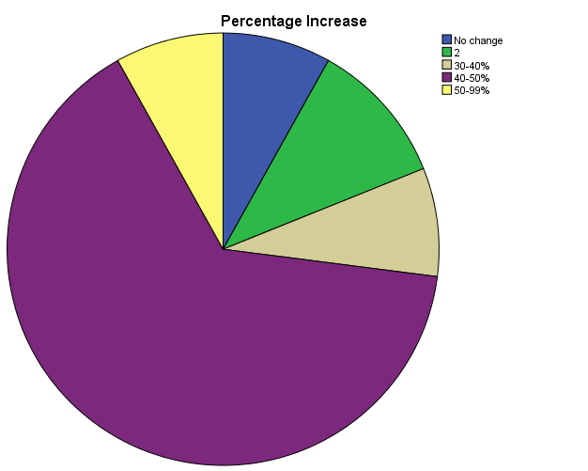

**Figure 4.4 Change in the number of suppliers**

#### 4.3.3.2 Invoice processing times

This study investigated the impact of a new e-procurement system on invoice processing times. Figure 4.5 provides insight into how long respondents perceived it took on average to process invoices prior to the new system implementation. The invoice processing time refers to the time that an invoice a quotation is raised to the time the invoice is ready for payment. The majority at 67.6% reported typical processing times of 3-5 days. An additional 16.2% indicated it took 5 or more days to process invoices. Taken together, this implies over 80% perceived processing to take an average of 5 days for most invoices to be processed. Only a small number faced better durations, with 10.8% citing 2-3 days and just 5.4% managing processing within 1-2 days. The prolonged times, with the clear majority taking 3 days or longer, point to inefficiencies in manual review workflows under the prior methods.

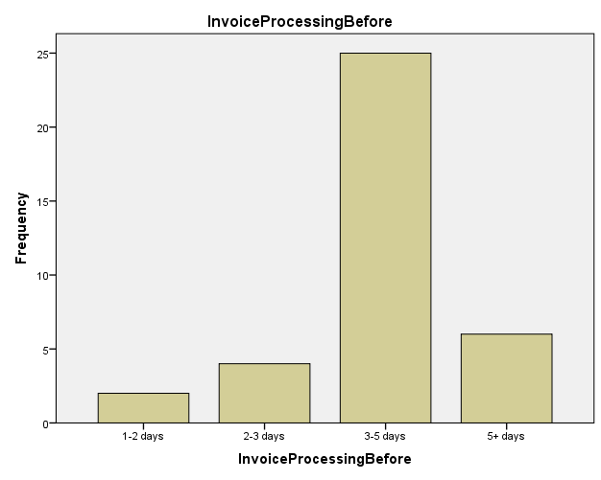

**Figure 4.5. Invoice processing times before e-procurement.**

In contrast to the workflow before e-procurement the data revealed a significant improvement in efficiency as shown in Figure 4.6.

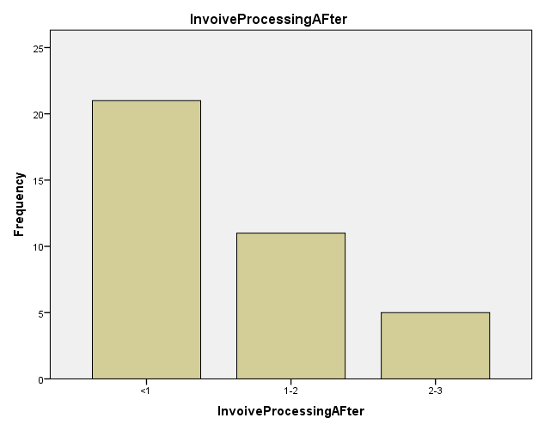

**Figure 4.6 Invoice processing times after e-procurement**

Over half (56.8%) of respondents reported invoice processing times of less than one day, with an additional 29.7% experiencing processing within 1-2 days. Previously, manual processing resulted in over 80% of invoices taking three or more days. The implementation of the e-procurement system, with its automated digital workflows and approval routing, seems to have reduced the proportion of invoices requiring more than two days for processing to a mere 13.5%. This shift signifies a transformation towards near real-time or 1–2-day processing for the vast majority of invoices. The elimination of instances exceeding five days, previously commonplace, demonstrates a complete resolution of prior workflow delays. These findings paint a clear picture of the remarkable enhancements in invoice processing performance achieved through the adoption of e-procurement. Respondents overwhelmingly reported significant reductions in processing times.

### 4.3.4 Challenges in adopting e-procurement into the business process.

The survey sought to identify challenges in adapting to the new e-procurement system. Responses to questions under Section 4 indicated training received was largely viewed as helpful, with the subsequent user experience rated highly positive.

#### 4.3.4.1 Training for the e-procurement system

Respondents pointed out to gaps in the training offered by the company particularly regarding knowledge and skills gaps. Analysis of the findings are illustrated by Figure 4.7 in provide better insights that could help address this objective.

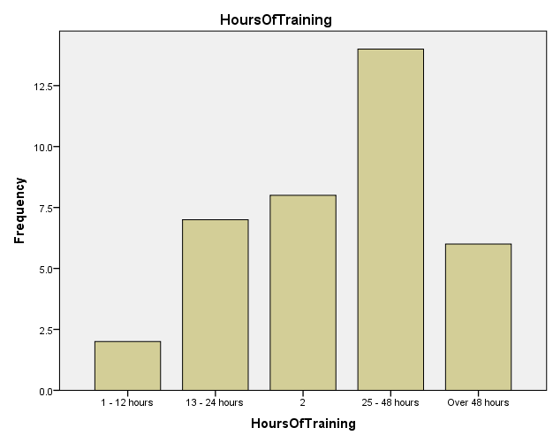

Figure 4.7. Training times for the implementation of e-procurement

An analysis of training duration revealed a spread across various timeframes. The data suggests that a significant portion (37.8%) of respondents received training between 25-48 hours, representing the most frequent duration. This could indicate a standardised training program within this range. However, a notable presence (24.3%) fell within the 13–24-hour category, suggesting potential variations in training intensity or specialization for different roles. Furthermore, a combined 16.2% and 5.4% received training durations exceeding 48 hours and under 12 hours respectively. This highlights the existence of tailored training programs catering to either highly specialized needs or foundational knowledge gaps. The distribution of training durations reflects a potential multi-tiered approach to employee training. The significant presence within the 25–48-hour range might represent a core training program, while the variations above and below suggest supplemental or specialized training depending on individual roles or prior knowledge.

The survey asked respondents about the effectiveness of training programmes before, during and after implementation of the e-procurement system. Perceptions regarding training duration adequacy revealed a mixed response as shown illustrated by Figure 4.8.

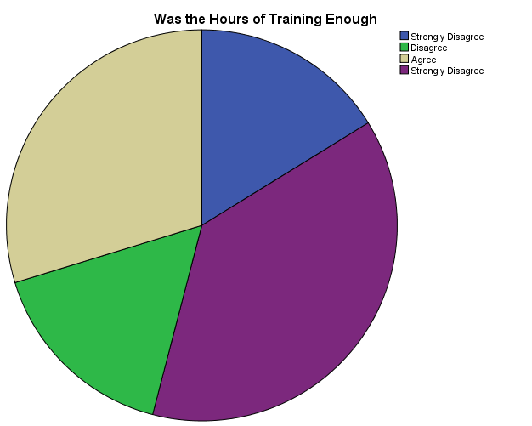

**Figure 4.8. Perceptions on training duration**

Interestingly, the largest portion (37.8%) of respondents strongly agreed the training hours were sufficient. However, a combined 32.4% expressed dissatisfaction, with 16.2% disagreeing and an equal number strongly disagreeing. This suggests a potential gap between the training provided and the perceived needs of a significant minority. Furthermore, a sizeable group (29.7%) simply agreed the training duration was adequate.

#### 4.3.4.1 Organisational alignment with the e-procurement system

The survey results revealed significant challenges regarding organisational alignment with the new e-procurement system. The organisational alignment component was a composite of four sub-questions that assessed participants’ understanding of:

* Performance metrics and incentives
* Role clarity during the transition
* Awareness of organisational goals/objectives
* Overall alignment with the new system.

From this component the major findings revealed that over half (54.1%) of respondents expressed uncertainty about whether performance metrics, incentive structures, and decision-making authorities were adapted to harmonise with the new workflows (Table 4.5).

|  |  |  |  |  |  |
| --- | --- | --- | --- | --- | --- |
| Table 4. Did Participants understand Performance Metrics, Incentives | | | | | |
|  | | Frequency | Percent | Valid Percent | Cumulative Percent |
| Valid | These were very hard to understand | 2 | 5.4 | 5.4 | 5.4 |
| These were not so clear but understandable | 5 | 13.5 | 13.5 | 18.9 |
| These were very clear | 10 | 27.0 | 27.0 | 45.9 |
| Unclear | 20 | 54.1 | 54.1 | 100.0 |
| Total | 37 | 100.0 | 100.0 |  |

This lack of clarity could potentially hinder user adoption and limit the effectiveness of the system. Furthermore, a concerning number of respondents, 12 (32.4%) reported experiencing role confusion during the transition as illustrated and an even concerning aspect is that 18.9% of the respondents indicated that they did not know their role during the implementation phase of the system as illustrated in Table 4.6.

|  |  |  |  |  |  |
| --- | --- | --- | --- | --- | --- |
| Table 4.. Respondents understanding their role within the new system | | | | | |
|  | | Frequency | Percent | Valid Percent | Cumulative Percent |
| Valid | Yes, clearly | 18 | 48.6 | 48.6 | 48.6 |
| Yes, but only sometimes | 12 | 32.4 | 32.4 | 81.1 |
| No. I did not know my role at all | 7 | 18.9 | 18.9 | 100.0 |
| Total | 37 | 100.0 | 100.0 |  |

This indicates a potential communication gap regarding how individual roles would be impacted by the e-procurement system. Additionally, 5% of respondents were completely unaware of the organisational goals and objectives associated with the implementation suggesting a failure to effectively communicate the strategic intent behind the system’s adoption. In contrast, only 5% of respondents indicated a clear understanding of the organisational alignment with the e-procurement system. This stark disparity underscores the need for a more comprehensive approach to ensure alignment between the new technology and the organisation's broader strategic objectives.

The survey also uncovered challenges relating to the scope and complexity of the implementation of the e-procurement system. Over 75% of respondents indicated that the scale of change involved in adopting the new e-procurement system was large and 50% noted they felt the project was not managed in an adequately phased manner.

### 4.3.5 Perceived Utility of the E-Procurement System to Business processes

The final theme that the study sought to unravel was the perceived utility of the e-procurement systems by the users. A key factor in the successful implementation of any new technology solution is how useful, efficient and easy-to-use it is perceived by end users. Assessing perceptions of the system’s usefulness from a user perspective directly supports this study’s objectives. This section analyses insights gathered from stakeholders on how useful they found various features and functionality within the new procurement platform. The section was made up of three sub-sections where responses were sought from the different departments that are related to the procurement system, that is, the actual procurement section, the finance and accounting department and the logistics department.

#### 4.3.5.1 Invoice Management Effectiveness

An analysis of invoice management effectiveness revealed a positive perception among respondents. The majority (64.9%) found the system to be very useful or extremely useful. This suggests that the new system has significantly improved the invoice management process for a substantial portion of the users. While a smaller percentage (27%) found the system to be a little bit useful or useful, it's noteworthy that there were no respondents who rated it as ineffective. This indicates a generally positive sentiment towards the new system, even if some users might find room for improvement. These findings suggest that the new invoice management system has been successful in enhancing the efficiency and user experience for most respondents.

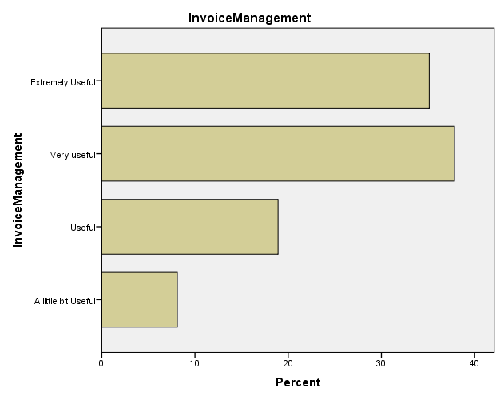

**Table 4.7 Invoice management with e-procurement**

#### 4.3.5.2 Reporting and Analysis functionality

In terms of the with built-in reporting and analytics functions none of the respondents indicated that they were poor or not satisfactory as illustrated in Table 4.8.

|  |  |  |  |  |  |
| --- | --- | --- | --- | --- | --- |
| Table 4.. State of the reporting and analysis | | | | | |
|  | | Frequency | Percent | Valid Percent | Cumulative Percent |
| Valid | Good | 5 | 13.5 | 13.5 | 13.5 |
| Very Good | 23 | 62.2 | 62.2 | 75.7 |
| Excellent | 9 | 24.3 | 24.3 | 100.0 |
| Total | 37 | 100.0 | 100.0 |  |

The state of reporting and analysis within the system received positive evaluations from a significant portion of respondents. Over two-thirds (62.2%) rated the capabilities as very good, indicating a high level of satisfaction with the current functionalities for generating reports and conducting data analysis. Furthermore, an additional 24.3% found them to be excellent, suggesting a strong endorsement of the system’s ability to support informed decision-making. While all responses were positive, a minority (13.5%) rated the capabilities as simply good. This suggests there might be room for improvement in specific areas or for addressing the needs of certain user groups. The findings paint a positive picture of user perception regarding the system's reporting and analysis functionalities. The high proportion of very good and excellent ratings (86.5%) indicates the system effectively meets the needs of most users. However, considering the “good” responses, further exploration into potential enhancements or targeted user training could be beneficial to maximize user satisfaction and analytical capabilities. The findings indicate high levels of satisfaction among respondents regarding the built-in reporting and analytics functions within the e-procurement system.

#### 4.3.5.3 Tracking and Management of Procurement Processes

The survey question aimed to understand how the e-procurement system impacted the ease of tracking and managing procurement spending. The findings were quite positive in this regard.

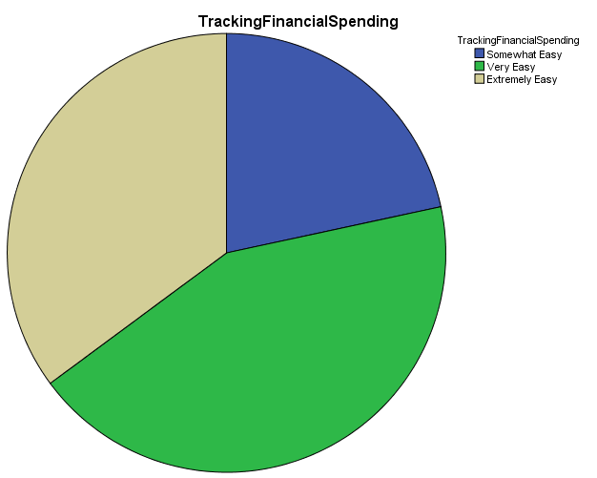

**Figure 4.9. Tracking and managing procurement spending**

The data regarding ease of tracking financial spending with the new system reveals a positive user experience. There were no respondents who found it difficult or challenging. This suggests that the e-procurement system has successfully simplified the process of monitoring and managing procurement spending. However, a closer look reveals some potential areas for improvement. While the majority (80.8%) found it very easy (35.1%) or easy (43.2%) to track spending, a minority (21.6%) reported it to be somewhat easy. This indicates that for some users, the system might still require further refinement or user training to achieve optimal user-friendliness. The findings are encouraging. The absence of negative responses and the high proportion of positive experiences suggest that the system has streamlined this crucial task for most users. However, considering the “somewhat easy” responses, efforts to enhance system usability or provide targeted training could further improve user satisfaction and ensure seamless financial management within the e-procurement system.

#### 4.3.5.4 Inter-departmental and Inter-organisational collaboration with e-procurement

This analysis examines how the new e-procurement system has impacted collaboration departments in the procurement pipeline. The findings reveal a generally positive sentiment, with a significant portion of respondents experiencing improved collaboration capabilities as shown in Table 4.1.

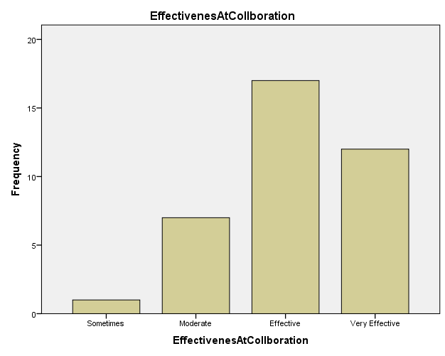

**Figure 4.10. Effectiveness at collaboration**

While a small minority (2.7%) found collaboration to be only sometimes effective, the majority reported experiencing moderate or better effectiveness. Nearly half (45.9%) viewed it as effective, suggesting the system has facilitated a notable improvement in collaboration compared to previous methods. Encouragingly, a sizeable portion (32.4%) rated collaboration as very effective. This indicates that for many users, the e-procurement system has become a strong driver of successful collaboration within the procurement process. These results suggest that the e-procurement system has had a positive impact on collaboration among users. The high proportion of responses indicating effectiveness (78.4%) highlights the system’s potential to foster improved communication and teamwork within the procurement function. However, considering the presence of a few responses indicating “sometimes” effectiveness, further investigation into potential challenges or targeted training for specific user groups might be beneficial to maximise collaboration benefits.

#### 4.3.5.5 General Improvement in Procurement Systems

Respondents were then asked to assess the level of improvement in performance metrics since implementing the new e-procurement system. Encouragingly, all respondents reported at least a moderate level of improvement, with the largest share seeing big or very big gains as shown in Table 4.9.

|  |  |  |  |  |  |
| --- | --- | --- | --- | --- | --- |
| Table 4.. Improvement in Procurement Systems | | | | | |
|  | | Frequency | Percent | Valid Percent | Cumulative Percent |
| Valid | Moderate Improvement | 6 | 16.2 | 16.2 | 16.2 |
| Big Improvement | 23 | 62.2 | 62.2 | 78.4 |
| Very Big Improvement | 8 | 21.6 | 21.6 | 100.0 |
| Total | 37 | 100.0 | 100.0 |  |

Specifically, 23 respondents (62.2%) indicated that “A big improvement” had been noted while 21.6% (8 respondents) indicated that they had noted “A very big improvement” in procurement performance metrics.

#### 4.3.5. Recommendation of e-procurement adoption

Finally, the study sought to see if the respondents would recommend other organisations or person to adopt an e-procurement system. Encouragingly, a significant majority (64.9%) of respondents indicated they would recommend the new e-procurement system to other departments within the organisation. This positive endorsement suggests that the system has delivered value and users have had a successful experience. However, it’s important to acknowledge the presence of a minority (29.7%) who were unsure about recommending the system.

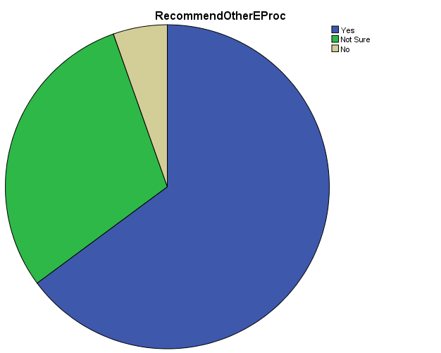

**Figure 4.11. Would Participants Recommend The E-procurement Adoption?**

## 4.4 Discussion of the findings

The successful implementation of an e-procurement system can significantly enhance an organization's efficiency, transparency, and cost control within the procurement process. This study aimed to comprehensively evaluate the impact of a newly implemented e-procurement system on various aspects of user experience and organizational effectiveness. A survey was administered to a sample of 37 users, gathering data on their perceptions of the system's functionality, training effectiveness, and overall impact on core procurement activities. The following discussion will explore the key findings from this survey, examining areas where the system has demonstrably improved processes and highlighting potential areas for further optimisation. The discussion shall take the findings for each theme and analyse them.

### 4.4.1 General Impact on Integrated Business Processes

The findings show a positive picture of the e-procurement system’s impact on ZEDTC’s procurement processes. The data offers valuable preliminary insights into how e-procurement affected several important areas of procurement performance within the organisation. Streamlined purchase-to-pay workflows facilitated through the digital system appear to have accelerated processes like invoice handling. This finding aligns with existing research highlighting e-procurement’s ability to streamline workflows through features like automated approvals and electronic communication (Afolabi et al., 2022).

While the survey doesn’t definitively measure the impact on the supplier network, it suggests a potential expansion due to the system’s digital access features. This aligns with research indicating e-procurement solutions can broaden the pool of potential vendors, fostering greater competition among suppliers. This increased competition can then drive down procurement costs over time. While the survey does not provide definitive data on cost reduction, the potential for a more competitive supplier landscape lays the groundwork for future cost savings (Yevu et al., 2022).

Additionally, improved visibility and synchronisation afforded by e-procurement could explain perceived increases in inventory holding levels company-wide. Therefore, it can be concluded that the e-procurement system has offered means to optimise procurement outcomes centred around efficiency, collaboration and cost management. While not definitive on its own, the survey feedback provides early positive indicators that e-procurement has aided the organisation’s progress towards goals like spend control and supply chain responsiveness when properly implemented as opined by (Wang et al, 2022).

The findings also showed that accuracy of the procurement process also showed marked improvement. Prior to implementation, a significant portion of respondents experienced high invoice error rates (Table 4.4). However, post-implementation, the majority indicated lower invoice errors. This positive change reflects the established benefits of e-procurement systems in minimising errors through functionalities like automated data validation and integration with supplier catalogues (Wang et al, 2022).

Therefore, the survey results provide strong quantitative and qualitative evidence that e-procurement has delivered clear benefits to ZETDC’s integrated business operations. Most notably, procurement time savings and reduced invoice errors according to the experienced staff perspectives. The findings suggest overall positive impact on both efficiency and accuracy from the new system.

### 4.4.2 Challenges in the implementation of e-procurement

The survey results paint a mixed picture of the e-procurement system’s implementation at ZEDTC. While efficiency and accuracy demonstrably improved, as evidenced by reduced cycle times and lower error rates (similar to findings by Afolabi et al., 2022; Bobowski & Gola, 2018), challenges emerged that require attention.

The results indicate that ZEDTC may not have adequately prepared staff through training programmes for migration to the e-procurement platform and that training effectiveness could likely be enhanced to better align skills with the e-procurement system demands. The variation in training duration suggests a potential lack of standardisation. Furthermore, user perceptions regarding adequacy of the training programmes were divided. A significant minority felt the training was not enough, indicating a gap between what was provided and what users needed. This aligns with research by Shatta et al. (2020) who emphasise that tailoring training programs to user needs and experience levels will result in increased effectiveness of systems. Additionally, Bobowski and Gola (2018) found a link between training satisfaction and user adoption of new technologies, suggesting a need to bridge the gap between perceived training adequacy and user requirements to maximise system adoption.

Another challenge that came from the findings was the misalignment of organisational goals with the new procurement system. Limited awareness of the system’s strategic goals was a concern, with only a small percentage fully understanding how the e-procurement system aligned with broader organisational objectives. This could be clearly seen as many respondents expressed uncertainty about performance metrics, incentives, and decision-making authorities after the system’s introduction. This can present challenges in the long run and previous studies have shown that effective communication regarding a system’s strategic goal is crucial for user buy-in and long-term success (Shatta et al., 2020). This lack of clarity could hinder user adoption and limit the system’s effectiveness, as highlighted by Olatunji et al. (2021) who found that aligning performance metrics and incentives with new technologies encourages user adoption and achieves desired outcomes. Furthermore, a concerning number of employees experienced role confusion during the transition, highlighting a potential communication gap regarding how individual roles would be impacted. This finding aligns with Masoud (2023) who emphasise the importance of change management communication in ensuring user understanding of roles and goals during technology implementation.

Finally, the survey revealed challenges related to the complexity of the e-procurement system implementation. The perceived large scale of change associated with the new system suggests potential disruption, and half the respondents felt the project was not managed in a well-phased way, indicating room for improvement in rollout strategies. This aligns with research by Martins et al. (2020) who explored the challenges of large-scale organisational change initiatives, including technology implementations. Additionally, project management research by Gascó et al. (2018) emphasise the importance of well-phased project management approaches in minimising disruption and ensuring successful implementation.

Therefore, in terms of potential hurdles it can be summed up that while the e-procurement system has yielded positive results, addressing the identified challenges is crucial for the long-term adoption of the system. Standardised, targeted training, improved communication regarding roles and goals, and a more phased implementation approach can all contribute to smoother user adoption and maximise the system’s long-term benefits for ZEDTC. By aligning with established best practices in training, communication, and project management, ZEDTC can ensure its e-procurement system reaches its full potential and delivers sustained improvements in efficiency, accuracy, and potentially, cost savings over time.

### 4.4.3 Perceived Utility of the E-Procurement System to Business processes

The results of the e-procurement system survey at ZEDTC provide insight into potential process improvements across key business functions. Users in procurement, finance, and logistics reported the system’s capabilities help streamline activities like purchase requisitioning, invoice processing, and inventory management. This section delves into user perceptions of the e-procurement system’s utility within ZEDTC’s business processes. Perceived usefulness is a critical factor in technology adoption success, as highlighted by research like Brandon-Jones and Kauppi (2018). A positive user perception translates to smoother system adoption and ultimately, greater impact on the organisation.

A significant proportion of respondents found the system “very” or “extremely” useful for invoice management. This aligns with the work of Kumar and Ganguly (2020), who found out that e-procurement systems have the potential to streamline invoice processing and improve financial efficiency. The findings demonstrate the implementation favourably influenced perceived ease of using procure-to-pay systems. By automating manual tasks and integrating spend visibility in one platform, it seems that the ZETDC e-procurement system improved the business processes by running procurement in a more simplified manner. This has important implications for operational efficiency goals as the streamlining of the procurement processes and making key tasks simpler or easier and frees up time and resources that can be reallocated therefore enhancing efficiency for the organisation.

When it comes to reporting functionality, notably, none of the respondents rated the reporting and analysis functionalities poorly, with over two-thirds considering them as very good. Reporting and analytics are important features that allow users to glean meaningful insights from procurement data (Kumar & Ganguly, 2020). Satisfaction with these capabilities implies the system supports performance monitoring goals (Mafini et al., 2020). Previous studies also find sufficient reporting impacts perceived usefulness of procurement platforms (Mafini et al., 2020; Martins et al., 2020). The responses suggest stakeholders find value in data-driven visibility provided through the built-in reporting and analytics functions. This supports the conclusions of Mélon & Spruk (2020) regarding the importance of robust reporting and analytics for informed decision-making. Nevertheless, a small minority found these capabilities merely good enough indicating room for optimising usage through targeted training. The positive feedback on ease of tracking procurement spending, with no reports of difficulty, suggests the system has simplified financial monitoring as intended. However, since some respondents felt it was “Somewhat easy” to use, this signifies that the interface usability could be enhanced through further refinements as advocated by Mwabili and Kyalo (2022).

The survey also revealed generally positive perceptions of collaboration effectiveness, with a sizeable portion rating the e-procurement system as very effective at managing collaboration between departments and other organisations. This finding aligns with Mwabili and Kyalo (2022) who highlight e-procurement systems have the ability to enhance internal and external collaboration, this improving the general business process for the organisation. From the findings a few responses pointed out that the e-procurement system is effective only some of the times which necessitates investigation into potential challenges or training for specific users. Such responses generally indicate underlying problems in the e-procurement pipeline. Encouragingly, all noted at least moderate performance improvements since implementation, with the majority seeing “big” or “very big” gains consistent with the metrics of efficiency, accuracy and cost identified as important by Nzimakwe (2023). Therefore, while the system has demonstrably improved key processes, the presence of user suggestions for improvement underscores the value of ongoing feedback and targeted training to ensure full realisation of benefits, as the researcher understands based on relevant literature. This will be critical to the system’s sustained success. These findings are in line with what Nzimakwe (2023) came up with in their study which showed that procurement systems strengthen engagement through digital interfaces that support collaborative workflows (Siwandeti et al., 2021). By enabling online collaboration tools, documentation and process integrations, the system appears to well-serve the goal of cohesive procurement lifecycles involving both internal and external parties. This favours outcomes like quality, compliance and delivery performance (Siwandeti et al., 2021).

## 4.5 Chapter Summary

This chapter presented the findings of a study examining the impact of e-procurement systems on the business process of a state-owned enterprise in a developing country. The findings show progress through improved functionalities like efficiency and reduced errors. However, the system’s full potential remains dependent on addressing challenges. Positively, key procurement processes showed measurable benefits, aligning with research on e-procurement impacts. Additionally, expanded digital access could foster supplier competition and cost savings. However, user adoption faces hurdles. Variations in training duration and perceptions highlight the need for standardised, targeted programs. A disconnect also exists between the system and organisational alignment regarding individual roles and objectives. The large perceived scale of change and rollout concerns indicate areas to improve change management. While benefits have been realised, addressing challenges is critical to maximise adoption and unlock the system’s full potential. Implementing standardised training, improving communication on roles and goals, and adopting a more phased approach could create a smoother experience. Aligning with best practices in training, communication and management can ensure the system achieves its full capabilities and delivers sustained procurement improvements. The next chapter will present the conclusion and recommendations of the study.

.

# Chapter Five

# Summary, Conclusions and recommendations

## 5.1 Summary of the study

This study investigated the impact of e-procurement system implementation on integrated business processes within a state-owned enterprise (SOE) in a developing country. While prior research documented the benefits of e-procurement in private sector organisations, the specific challenges faced by SOEs remained unexplored. A correlational research design was employed to examine the potential relationship between e-procurement usage and business process efficiency (methodology). Data was collected through a self-administered survey distributed to a representative sample of procurement personnel across the SOE’s four regions. The survey measured employee perceptions of e-procurement usage and business process efficiency. From the 42 questionnaires distributed, 37 were returned for a response rate of 88.10%. The survey measured employee perceptions of e-procurement usage and business process efficiency.

The study acknowledges limitations inherent to the correlational design, where findings suggest associations but not causation. Additionally, the reliance on self-reported data through surveys could introduce social desirability bias. Despite these limitations, the study offers valuable insights for SOEs considering e-procurement implementation. The findings suggest a positive correlation between e-procurement usage and perceived business process efficiency. However, the study also identifies challenges related to user training, communication, and implementation complexity. By addressing these challenges, SOEs can maximise the positive impact of e-procurement on process efficiency. This research paves the way for future studies that can explore the topic in more depth. Employing multi-case study approaches and incorporating objective performance metrics can offer a more comprehensive understanding of e-procurement's role in optimising business processes within SOEs of developing countries.

## 5.2 Major findings

### 5.2.1 General Impact on Integrated Business Processes.

The findings showed that the introduction of the e-procurement system brought about notable enhancements in integrating various business processes. According to the findings, users reported significant improvements in invoice management, reporting and analysis functionalities, and tracking procurement spending. In addition, collaboration among departments also benefited, indicating improved communication and teamwork. All in all, the e-procurement platform facilitated greater process integration and optimisation, positively impacting organizational efficiency and decision-making processes.

### 5.2.2 Perceived Utility of the E-Procurement System to Business processes

From the study, feedback on the utility of the e-procurement system was predominantly positive, with users acknowledging its effectiveness in invoice handling, reporting/analytics, tracking spending, and collaboration. The findings showed that most respondents observed notable improvements in key performance metrics since the system’s deployment, although some encountered usability issues with certain functions, indicating room for refinement.

### 5.2.3 Challenges in adopting e-procurement into the business process.

According to the findings, several challenges were encountered during the adoption of the e-procurement platform. Communication gaps led to unclear role understanding among users, while strategic alignment with organisational goals was lacking for many. The findings indicated that the magnitude of change and the pacing of implementation were perceived as significant hurdles, suggesting a need for better planning and phased deployment strategies to facilitate smoother integration into existing workflows.

### 5.2.4 Recommendation of e-procurement adoption

A majority of users expressed willingness to recommend the e-procurement platform to other company units, indicating its perceived value in streamlining procurement operations. However, a notable portion remained undecided, suggesting a need for continued enhancements to ensure widespread satisfaction and support across the user base.

## 5.3 Conclusions

The study concludes that while the e-procurement system demonstrated clear benefits to procurement efficiency and accuracy at ZETDC, user training emerged as an area still requiring attention to unlock the system’s full benefits. The integration of core procurement processes such as purchase order management and invoice processing, the streamlining of transactional workflows and optimisation of these processes came out as the major advantages of the use of the e-procurement system. The study also found out that services like invoice processing times significantly and user perceptions pointed to increased productivity, usefulness and efficiency across functionalities, signifying benefits to performance metrics. However, variations in user training effectiveness highlighted challenges in supporting organisational adaptation to the new digital processes and workflows. While the system demonstrably improved efficiency and accuracy in core procurement, user training emerged as an important challenge requiring attention.

## 5.4 Recommendations

Based on the key findings from this study, several recommendations can be suggested to help ZEDTC further optimise use of their e-procurement system and address remaining challenges. These are discussed in the following passages:

* ZEDTC should strengthen user training programs by developing standardized, role-specific training tailored to varying skill levels, with continuous learning opportunities through refresher courses incorporated over time. Ensuring adequate dedicated training support resources and budget allocations will be important to effectively address evolving user needs. Regular post-training evaluations and user surveys can help keep leadership apprised of changing needs to ensure training programs remain optimized. Establishing clear performance metrics benchmarked to pre-implementation baselines will also facilitate ongoing monitoring of impacts to further guide training enhancements.
* The organisation must clearly define how job responsibilities may evolve and communicating measurable business objectives supported by the system can strengthen organisational alignment.
* ZEDTC must adopt a more gradual and phased implementation approach for any new features with user acceptance and testing incorporated at each stage. This may foster smoother adaptation of features whilst limiting user resistance.
* Finally, the study recommends establishing clear performance metrics benchmarked to pre-implementation baselines will facilitate ongoing monitoring of impacts.

Adopting these recommended strategies would allow ZEDTC to capitalise on opportunities identified through this study. Strengthening user training programs, communication practices, change management processes and ongoing evaluation techniques can maximize value extraction from their e-procurement investment. Sustained benefits can be achieved by continually enhancing the system based on business and user requirements as those needs evolve over time. Implementing these recommendations would position ZEDTC well to address both current and future challenges in optimising utilisation of their e-procurement solution.

## 5.5 Future Research

In light of the findings, this study recommends that further research be conducted on the influence of organisational culture and potential cultural barriers within ZEDTC to establish their impact on user adoption of the e-procurement system. Assessing cultural factors such as attitudes towards change management, technological acceptance, and perceptions of job role evolution could provide valuable insights into any unidentified non-technical barriers to adoption.

## References

Adjei-Bamfo, P., Maloreh-Nyamekye, T., & Ahenkan, A. (2019). The role of e-government in sustainable public procurement in developing countries: A systematic literature review. *Resources, Conservation and Recycling*, *142*, 189-203.

Afolabi, A., Ibem, E., Aduwo, E., & Tunji-Olayeni, P. (2022). Digitizing the grey areas in the Nigerian public procurement system using e-Procurement technologies. *International Journal of Construction Management*, *22*(12), 2215-2224.

Belisari, S., Binci, D., & Appolloni, A. (2020). E-procurement adoption: A case study about the role of two Italian advisory services. *Sustainability*, *12*(18), 7476.

De Boer, L., Harink, J., & Heijboer, G. (2002). A conceptual model for assessing the impact of electronic procurement. *European Journal of purchasing & supply management*, *8*(1), 25-33.

Gascó, M., Cucciniello, M., Nasi, G., & Yuan, Q. (2018). Determinants and barriers of e-procurement: A European comparison of public sector experiences.

Kumar, N., & Ganguly, K. K. (2020). Non-financial e-procurement performance measures: their interdependence and impact on production cost. *International Journal of Productivity and Performance Management*, *70*(1), 41-64.

Mafini, C., Dhurup, M., & Madzimure, J. (2020). E-procurement, supplier integration and supply chain performance in small and medium enterprises in South Africa. *South African Journal of Business Management*, *51*(1), 1-12.

Martins, J., Parente, M., Amorim-Lopes, M., Amaral, L., Figueira, G., Rocha, P., & Amorim, P. (2020). Fostering customer bargaining and E-procurement through a decentralised marketplace on the blockchain. *IEEE transactions on engineering management*, *69*(3), 810-824.

Masoud, Y. (2023). The effects of political interference on procurement performance in the parastatal organizations in Dar es Salaam Region. *International Journal of Research in Business and Social Science (2147-4478)*, *12*(2), 158-169.

Mélon, L., & Spruk, R. (2020). The impact of e-procurement on institutional quality. *Journal of Public Procurement*, *20*(4), 333-375.

Mwabili, P. M., & Kyalo, J. (2022). Intergrated Financial Management Information Systems and Procurement Performance of Taita Taveta County Government, Kenya.

Nzimakwe, T. I. (2023). Procurement in State-Owned Enterprises and its Implications on Service Delivery in South Africa. *African Journal of Public Affairs*, *14*(1), 1-18.

Olatunji, S. O., Adeniyi, O., & Jegede, B. E. (2021). Perspectives on the benefits of e-procurement to the nigerian construction industry. *Journal of Contemporary Research in the Built Environment (JOCREBE)*, 34.

Shatta, D. N., Shayo, F. A., & Layaa, J. N. (2020). Determinants of e-procurement adoption model for green procurement in developing countries: Experience from Tanzania. *International Academic Journal of Procurement and Supply Chain Management*, *3*(2), 1-18.

Siwandeti, M. L., Sanga, C., & Panga, F. (2021). Technological factors influencing vendors’ participation in public electronic procurement system in Ilala, Tanzania.

Vaidya, K., & Campbell, J. (2016). Multidisciplinary approach to defining public e-procurement and evaluating its impact on procurement efficiency. *Information Systems Frontiers*, *18*, 333-348.

Waithaka, R. K., & Kimani, J. G. (2021). Effect of e-procurement practices on supply chain performance. *Global Journal of Purchasing and Procurement Management*, *1*(1), 32-42.

Wang, Y., Wang, L., Gao, Z., Cui, Z., Yang, M., Li, B., & Chen, S. (2022, September). Procurement management mode of electrostatic protection materials in supply chain environment-Taking state-owned enterprises as an example. In *2022 Asia-Pacific International Symposium on Electromagnetic Compatibility (APEMC)* (pp. 154-157). IEEE.

Willy, T. K., & Paul, M. (2021). Integrated financial management information system implementation on procurement performance of state-owned enterprises in Kenya. *International Research Journal of Business and Strategic Management*, *2*(2).

Yevu, S. K., Yu, A. T. W., Nani, G., Darko, A., & Tetteh, M. O. (2022). Electronic procurement systems adoption in construction procurement: A global survey on the barriers and strategies from the developed and developing economies. *Journal of Construction Engineering and Management*, *148*(1), 04021186.

Yu, A. T. W., Yevu, S. K., & Nani, G. (2020). Towards an integration framework for promoting electronic procurement and sustainable procurement in the construction industry: A systematic literature review. *Journal of Cleaner Production*, *250*, 119493.

Dubey, U. K. B., & Kothari, D. P. (2022). *Research methodology: Techniques and trends*. CRC Press.

Phakiti, A. (2020). Likert-type scale construction. In *The Routledge handbook of second language acquisition and language testing* (pp. 102-114). Routledge.

Biggs, R., De Vos, A., Preiser, R., Clements, H., Maciejewski, K., & Schlüter, M. (2021). *The Routledge handbook of research methods for social-ecological systems* (p. 526). Taylor & Francis.

Mohajan, H. K. (2020). Quantitative research: A successful investigation in natural and social sciences. *Journal of Economic Development, Environment and People*, *9*(4), 50-79.

## Appendix 1 – Approval Form



## Appendix 2 – Questionnaire

My name is Tinotenda Nyahoreka. I am a BCom Purchasing and Supply Degree student with Bindura University of Science Education (BUSE). I would like to thank you for agreeing to participate in this survey. Your answers will help me understand the impact of e-procurement implementation on your organisation. Please note, do not including any personal information and all responses will be kept confidential. Participation is entirely voluntary without any monetary or personal benefits, and you may withdraw your participation at any time without any adverse action being taken against you.

# Section 1 - Background Information

1. What is your section within ZEDTC?

Procurement

Finance

Logistics

1. How long have you been working at ZEDTC?

Less than 1 year

1 – 2 years

2 - 4 years

4 - 6 years

6 - 8 years

8 – 10 years

More than 10 years

1. Of the time you have been how long have been with a section related to procument? (In years)

years.

1. Have you been involved in any procurement activities before the e-procurement implementation?

Yes No

# Section 2: Impact on Integrated Business Processes

1. On a scale of 1 (very slow) to 5 (very fast), how has e-procurement affected the speed of the procurement process?

|  |  |  |  |  |
| --- | --- | --- | --- | --- |
| **1** | **2** | **3** | **4** | **5** |

1. To what extent has e-procurement improved data accuracy and transparency in procurement activities? (1 being not at all accurate/transparent, 5 being very accurate/transparent)

|  |  |  |  |  |
| --- | --- | --- | --- | --- |
| **1** | **2** | **3** | **4** | **5** |

1. What is the average number of days the procurement process took before e-procurement? (Select the most appropriate)

|  |  |
| --- | --- |
| Less than 1 day |  |
| 1-2 working days at most |  |
| 2-3 working days at most |  |
| 3-5 working days at most |  |
| 5-7 working days at most |  |
| More than 7 working days |  |
| More than 14 working days |  |

1. What is the average number of days the procurement process takes now?

|  |  |
| --- | --- |
| Less than 1 day |  |
| 1-2 working days at most |  |
| 2-3 working days at most |  |
| 3-5 working days at most |  |
| 5-7 working days at most |  |
| More than 7 working days |  |
| More than 14 working days |  |

1. What percentage of invoices were processed incorrectly before e-procurement?

0-5%

5-10%

10-15%

15-20%

Above 20%

1. What percentage of invoices are processed incorrectly now?

0-5%

5-10%

10-15%

15-20%

Above 20%

Section 3: Changes in Key Performance Metrics

1. What was the average procurement cost per unit before e-procurement?

Less than $100

$100 - $200

$200 - $300

$300 - $400

$400 - $500

Above $500

1. What is the average procurement cost per unit now?

Less than $100

$100 - $200

$200 - $300

$300 - $400

$400 - $500

Above $500

1. What was the average inventory level (percentages for all types of inventories) before e-procurement?

Less than 10%

10% - 20%

20% - 30%

30%- 40%

40% - 50%

Above 50%

1. What is the average inventory level (percentages for all types of inventories) after implementation of e-procurement?

Less than 10%

10% - 20%

20% - 30%

30%- 40%

40% - 50%

Above 50%

1. What was the number of different suppliers used before implementation of e-procurement?

Less than 100

Between 100 and 150 suppliers

Between 150 and 200 suppliers

Between 200 and 300 suppliers

Between 300 and 400 suppliers

Above 400 suppliers

1. Has there been an increase in the number of suppliers after the e-procurement system?

Yes

No

1. If you answered yes to the question above, what has been the increase in percentages?

Below 10% more suppliers

Aboout 10% - 20% more suppliers

About 20% - 30% more suppliers

About 30%- 40% more suppliers

About 40% - 50% more suppliers

Above 50% but below 100% more suppliers

Above 100% more suppliers

1. What was the average invoice processing time (in days) before e-procurement?

Less than 1 days

1-2 days

2-3 days

3-5 days

More than 5 days

1. What is the average invoice processing time (in days) now?

Less than 1 day

1-2 days

2-3 days

3-5 days

More than 5 days

**Section 4: Challenges in Adapting to New Processes**

1. How many hours of training did you receive on the new e-procurement system?

Less than 1 day

1-2 days

2-3 days

3-5 days

More than 5 days

1. On a scale of 1 (strongly disagree) to 5 (strongly agree), how helpful was the training you received?

|  |  |  |  |  |
| --- | --- | --- | --- | --- |
| **1** | **2** | **3** | **4** | **5** |

**Section 5. Usefulness of the E-Procurement System**

1. On a scale of 1 (not useful at all) to 5 (very useful), how useful do you find the e-procurement system for your daily work tasks?

|  |  |  |  |  |
| --- | --- | --- | --- | --- |
| **1** | **2** | **3** | **4** | **5** |

1. To what extent does the e-procurement system help you complete your procurement tasks more efficiently? (1 being not at all efficient, 5 being very efficient)

|  |  |  |  |  |
| --- | --- | --- | --- | --- |
| **1** | **2** | **3** | **4** | **5** |

1. How many additional procurement tasks can you complete per day using the e-procurement system compared to the previous manual processes?

0-10% more

10-20% more

20-40% more

50% more

Above 50% more

1. On a scale of 1 (strongly disagree) to 5 (strongly agree), I find the e-procurement system to be an easier way to manage my procurement activities.

|  |  |  |  |  |
| --- | --- | --- | --- | --- |
| **1** | **2** | **3** | **4** | **5** |

1. On a scale of 1 (strongly disagree) to 5 (strongly agree), the e-procurement system helps me make better decisions when choosing suppliers.

|  |  |  |  |  |
| --- | --- | --- | --- | --- |
| **1** | **2** | **3** | **4** | **5** |

1. On a scale of 1 (strongly disagree) to 5 (strongly agree), I would recommend the e-procurement system to others in my department.

|  |  |  |  |  |
| --- | --- | --- | --- | --- |
| **1** | **2** | **3** | **4** | **5** |

**Section 6. Department Specific Perceptions**

*(Answer this only if you are part of the Procurement Department/Section)*

1. How useful is the e-procurement system for managing purchase orders and invoices? 1 (not useful at all) to 5 (very useful)

|  |  |  |  |  |
| --- | --- | --- | --- | --- |
| **1** | **2** | **3** | **4** | **5** |

1. How satisfied are you with the reporting and analytics capabilities of the e-procurement system? (not satisfied at all) to 5 (very satisfied)

|  |  |  |  |  |
| --- | --- | --- | --- | --- |
| **1** | **2** | **3** | **4** | **5** |

*(Answer this only if you are from the Finance Department/Section)*

1. To what extent has the e-procurement system improved the accuracy and timeliness of financial reporting? 1 (No difference) 5 (Improved very much)

|  |  |  |  |  |
| --- | --- | --- | --- | --- |
| **1** | **2** | **3** | **4** | **5** |

1. How much easier is it to track and manage procurement spending with the e-procurement system? 1 (Not easy) to 5 (very easy)

|  |  |  |  |  |
| --- | --- | --- | --- | --- |
| **1** | **2** | **3** | **4** | **5** |

*(Answer this only if you are from the Logistics Department/Section)*

1. How effectively does the e-procurement system facilitate collaboration with suppliers on order fulfillment? 1 (Not effective at all) to 5 (very effective)

|  |  |  |  |  |
| --- | --- | --- | --- | --- |
| **1** | **2** | **3** | **4** | **5** |

1. To what extent has the e-procurement system improved the accuracy and efficiency of inventory management? 1 (No improvement) to 5 (Very big improvement)

|  |  |  |  |  |
| --- | --- | --- | --- | --- |
| **1** | **2** | **3** | **4** | **5** |

Thank you for your time and participation.