**BINDURA UNIVESITY OF SCIENCE EDUCATION**

**FACULTY OF COMMERCE**

**DEPARTMENT OF ECONOMICS**



**EVALUATION ON THE EFFECT OF SUPPLIER RELATIONSHIP MANAGEMENT IN ENHANCING PROCUREMENT PERFORMANCE IN ZIMBABWE. CASE STUDY OF CAILOGISTICS TRANSPORTATION COMPANY**

**BY**

**SUE MUCHUWENI**

**[B200576B]**

**A DISSERTATION SUBMITTED IN PARTIAL FULFILMENT OF THE REQUIREMENTS FOR THE BACHELOR OF COMMERCE IN PURCHASING AND SUPPLY CHAIN MANAGEMENT OF BINDURA UNIVERSITY OF SCIENCE EDUCATION**

**2024**

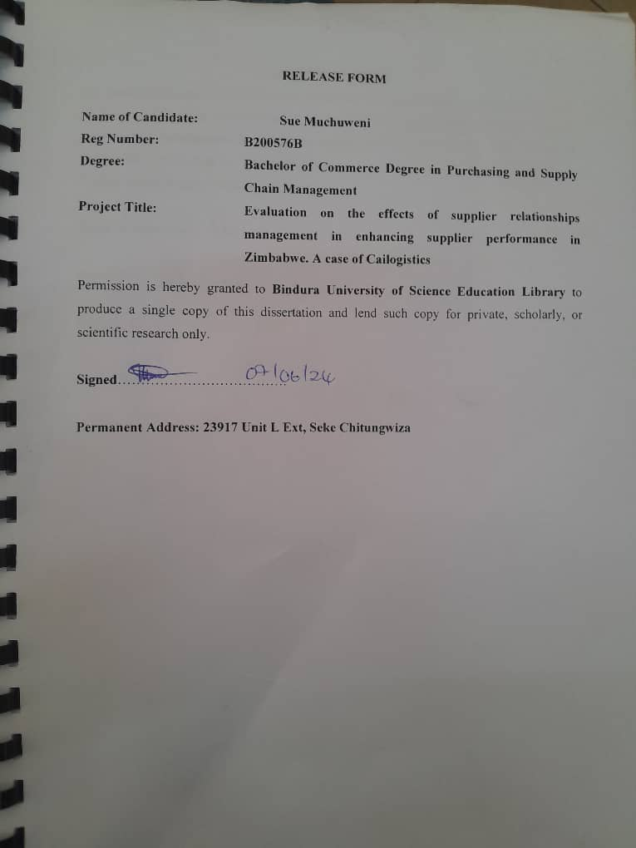

# RELEASE FORM

**Name of Candidate: Sue Muchuweni**

**Reg Number: B200576B**

**Degree: Bachelor of Commerce Degree in Purchasing and Supply Chain Management**

**Project Title: Evaluation on the effects of supplier relationships management in enhancing supplier performance in Zimbabwe. A case of Cailogistics**

Permission is hereby granted to **Bindura University of Science Education Library** to produce a single copy of this dissertation and lend such copy for private, scholarly, or scientific research only.

**Signed**……………………………….

**Permanent Address: 23917 Unit L Ext, Seke Chitungwiza**

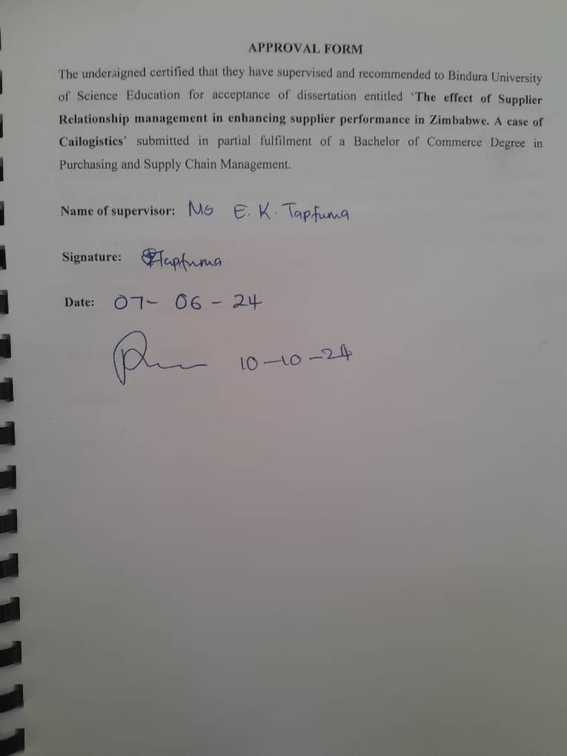

# APPROVAL FORM

The undersigned certified that they have supervised and recommended to Bindura University of Science Education for acceptance of dissertation entitled ‘**The effect of Supplier Relationship management in enhancing supplier performance in Zimbabwe. A case of Cailogistics**’ submitted in partial fulfilment of a Bachelor of Commerce Degree in Purchasing and Supply Chain Management.

**Name of supervisor:**

**Signature:**

**Date:**

# DECLARATION

I hereby declare that the research project entitled ‘**The effect of Supplier Relationship management in enhancing supplier performance in Zimbabwe. A case of Cailogistics**’ submitted to Bindura University of Science Education, Faculty of Commerce, Department of Economics, is a record of an original work done by me under the guidance and supervision of Ms Tapfuma and this work is submitted in partial fulfilment of the requirements for the award of a Bachelor of Commerce Degree in Purchasing and Supply Chain Management. The results embodied in this thesis have not been submitted to any University or Institute for the award of any degree of diploma.

**Author: Sue Muchuweni**

**Reg. Number: B200576B**

**Signature:**

**Date:**

# DEDICATION

I dedicate this work to my family

# 

# ACKNOWLEDGEMENTS

Firstly, I would like to send my special thanks to my family for supporting me in my studies. I would also like to express my gratitude to my supervisor for his guidance in the writing of this research. To my colleagues and lectures your assistance in getting me this far will never go unnoticed. Thank you for pushing me to the limits, and for all the encouragement and cooperation. This research would not have been possible without the cooperation of the participants of the research from whom l gathered the required data for the research. For thank I am grateful to them. All said and done I would like to give all the thanks to God for all His blessings and for making this research a success.

# 

# ABSTRACT

The effectiveness of Supplier Relationship Management (SRM) in enhancing procurement performance is a critical concern for organizations operating in dynamic business environments. This study evaluates the impact of SRM practices on procurement performance within the context of Cailogistics Transportation Company in Zimbabwe. With increasing complexities and competition in the business landscape, organizations are compelled to adapt their operational strategies to remain competitive. The objectives of this study are to ascertain the effect of SRM on cost efficiency, supplier performance, lead time, timeliness, quality, and compliance at Cailogistics Transportation Company. Employing a quantitative research methodology, this study adopts a case study approach, with data collected from 49 purposively selected respondents within the company. The results reveal significant relationships between SRM practices and various procurement performance metrics. Notably, effective SRM is found to positively influence cost efficiency, supplier performance, and timeliness of delivery. However, while SRM demonstrates a significant impact on quality and compliance, its effect on lead time and communication efficiency is less pronounced. These findings underscore the importance of prioritizing SRM initiatives to optimize procurement outcomes and drive organizational success. In conclusion, the study recommends that Cailogistics Transportation Company invests in enhancing its SRM practices, particularly focusing on communication efficiency and lead time optimization. Additionally, future research should delve deeper into specific SRM strategies to further enhance procurement performance and organizational competitiveness.

Table of Contents

RELEASE FORM ii

APPROVAL FORM iii

DECLARATION iv

DEDICATION v

ACKNOWLEDGEMENTS vi

ABSTRACT vii

LIST OF TABLES x

LIST OF FIGURES xi

LIST OF APPENDICIES xii

CHAPTER ONE 1

INTRODUCTION 1

1.0 Introduction 1

1.1 Background 1

1.2 Problem Statement 2

1.3 Purpose of the Study 3

1.3.1 Specific Objectives 3

1.4 Research Questions 3

1.5 Significance of the Study 3

CHAPTER TWO 7

LITERATURE REVIEW 7

2.0 Introduction 7

2.0 Conceptualisation of key terms 7

2.1.1 Conceptualisation of Supplier Relationship Management 7

2.1.2 Conceptualisation of Procurement Performance 7

2.2 Impact of SRM on Cost Efficiency 8

2.3 Influence of SRM on Supplier Performance 9

2.4 Effect of Competitive SRM on Lead Time and Timeliness 10

2.5 Relationship between SRM and Quality/Compliance 10

2.6 Theoretical Framework 11

2.6.1 Transaction Cost Economics (TCE) 11

2.6.2 Resource Dependency Theory (RDT) 12

2.6.3 Social Exchange Theory 13

2.7 Conceptual Framework 14

2.8 Chapter Summary 15

CHAPTER THREE 16

RESEARCH METHODOLOGY 16

3.0 Introduction 16

3.1 Research Design 16

3.2 Research Approach 16

3.3 Target Population 17

3.4 Sampling Procedure 17

3.5 Data collection procedure 18

3.6 Research Instruments 18

3.6.1 Questionnaire 18

3.7 Data analysis Framework 19

3.8 Data Validity and reliability 19

3.8.1 Validity 19

3.8.2 Reliability 19

CHAPTER FOUR 21

RESULTS 21

4.1 Questionnaire response rate 21

4.2 Demographic data 21

4.2.1 Gender 21

4.2.2 Age 22

4.2.3 Educational Level 23

4.2.5 Experience in the sector. 24

4.2.6 Perception of SRM within the organisation 25

4.3 Effect of supplier relationship management on cost efficiency 25

4.4 Influence of supplier relationship management on supplier performance 26

4.5 Effect of competitive supplier relationship management on lead time and timeliness 27

4.6 Relationship between supplier relationship management and compliance 28

4.7 Summary of Chapter 29

CHAPTER FIVE 31

SUMMARY CONCLUSION AND RECOMMENDATIONS 31

5.0 Introduction 31

5.1 Summary 31

5.2 Conclusion 32

5.3 Recommendations 32

REFERENCES 34

# LIST OF TABLES

Table 3. 1 Sample Population 17

Table 4. 1: Questionnaire Response rate 21

Table 4. 2 Designation of respondents 24

Table 4. 3 Years of experience of respondents in the sector 24

Table 4. 4 Ratings of SRM in the organisation 25

Table 4. 5 Correlation analysis between SRM and cost efficiency 26

Table 4. 6 ANOVA analysis of SRM and supplier performance 27

Table 4. 7 Correlation analysis of SRM and lead time and timeliness 28

Table 4. 8 Correlation analysis of SRM and supplier compliance 29

# LIST OF FIGURES

Figure 4. 1: Gender distribution of respondents 22

Figure 4. 2 Age distribution of Respondents 23

Figure 4. 3 Level of Education of respondents 23

# LIST OF APPENDICIES

Appendices 1: Questionnaire 37

# CHAPTER ONE

# INTRODUCTION

## 1.0 Introduction

This chapter is the introductory chapter of this research which focuses on the articulation of the background and the problem statement that compounded this research to be undertaken. It also contains the main aim of the study together with the specific objectives. Further to this this section also contains the research questions, the significance of the study, the limitations, and delimitations as well as the definition of key terms. The chapter concludes with a chapter summary which summates all the contents of this chapter.

## 1.1 Background

In today's dynamic business landscape characterized by heightened complexities and intense competition, enterprises face the imperative to continuously evolve and adapt their operational approaches (Anh and Ha, 2020). Remaining stagnant in terms of system development and management practices can result in a decline in overall business performance, particularly concerning compliance with environmental standards and meeting evolving market demands. As a response to these challenges, many businesses have increasingly emphasized relationship management as a central pillar of their operational strategies. Recognizing the pivotal role of robust partnerships and collaborations in navigating the often-hostile business environment, organizations are investing significant resources into cultivating and nurturing meaningful alliances within their industries (Kosgei and Gitau, 2016). These collaborative efforts serve not only as a means of enhancing performance but also as a mechanism for fostering resilience and competitiveness amidst ever-changing market dynamics.

Supplier relationship management (SRM) constitutes a systematic approach through which organizations cultivate and sustain robust, mutually advantageous partnerships with their suppliers (Al-Abdallah, Abdallah and Bany, 2018). At its core, SRM involves the establishment of transparent channels of communication, fostering trust, and nurturing collaborative engagements aimed at achieving shared objectives. The impacts of effective SRM on procurement performance are manifold, encompassing various facets of operational efficiency and effectiveness (Saichitema, 2022). One significant outcome is the enhancement of communication channels between the organization and its suppliers, facilitating seamless information exchange, clarifying expectations, and mitigating potential misunderstandings or discrepancies.

Additionally, by cultivating strong supplier relationships, organizations can streamline procurement processes, leading to reduced lead times and enhanced agility in responding to market demands (Nyakundi, Anaya and Senelwa, 2018). Moreover, heightened supplier responsiveness, fostered through proactive relationship management practices, enables prompt adaptation to change circumstances, thereby bolstering supply chain resilience and overall operational robustness. Furthermore, effective SRM strategies contribute to risk mitigation efforts, as closer collaboration with suppliers allows for early identification and mitigation of potential disruptions, ensuring continuity of supply and minimizing procurement-related uncertainties (Mwangi and Muli, 2022).

Within the broader context of the study on Supplier Relationship Management (SRM), Cailogistics' expertise in coordination and transportation services serves as a crucial focal point. As a company deeply entrenched in facilitating the movement of goods and optimizing supply chain operations, Cailogistics exemplifies the significance of effective supplier relationships in driving procurement performance. By leveraging its experience and specialized solutions, Cailogistics epitomizes the transformative potential of SRM in enhancing operational efficiency, reducing costs, and mitigating supply chain risks. The seamless coordination of warehousing, distribution, and transportation services offered by Cailogistics underscores the interconnectedness of supplier relationships with procurement processes, emphasizing the pivotal role of collaboration and partnership in achieving strategic procurement objectives. Thus, Cailogistics serves as a compelling case study through which to explore the effectiveness of SRM in the context of enhancing procurement performance within Zimbabwe's dynamic business landscape.

## 1.2 Problem Statement

Within the landscape of Zimbabwe's procurement environment, marked by persistent challenges including supply chain disruptions, economic instability, and regulatory intricacies, a significant gap emerges in comprehensively understanding the effectiveness of Supplier Relationship Management (SRM) practices. This research aims to bridge this gap by delving into the dynamics of SRM initiatives and their direct implications on procurement performance within the context of Cailogistics Transportation Company. Cailogistics Transportation Company is experiencing inefficiencies in their procurement processes, such as delays in acquiring necessary supplies and difficulties in managing supplier relationships effectively. Cailogistics, faces a critical issue: inefficient communication and collaboration with fuel suppliers. This results in frustrating delays in fuel delivery, disrupting their operations. Despite understanding the urgency of timely fuel supply, persistent challenges in coordinating with suppliers have led to potential financial losses. Addressing these issues is imperative to enhance procurement performance and ensure the smooth functioning of Cailogistics’ logistics operations.

## 1.3 Purpose of the Study

The main purpose of the study is to evaluate the effect of supplier relationship management on procurement performance a case of Cailogistics Transportation Company.

### 1.3.1 Specific Objectives

1. To identify the effect of supplier relationship management on cost efficiency at Cailogistics Transportation Company
2. To evaluate the influence of supplier relationship management on supplier performance at Cailogistics Transportation Company
3. To assess the effect of competitive supplier relationship management on lead time and timeliness at Cailogistics Transportation Company
4. To analyse the relationship between supplier relationship management and quality and compliance at Cailogistics Transportation Company

## 1.4 Research Questions

1. What is the effect of supplier relationship management on cost efficiency at Cailogistics Transportation Company
2. What is the influence of supplier relationship management on supplier performance at Cailogistics Transportation Company
3. What is the effect of competitive supplier relationship management on lead time and timeliness at Cailogistics Transportation Company
4. What is the relationship between supplier relationship management and quality and compliance at Cailogistics Transportation Company

## 1.5 Significance of the Study

The significance of this study extends to multiple stakeholders. For Cailogistics, the findings will offer invaluable insights into optimizing their Supplier Relationship Management (SRM) strategies, thereby enhancing procurement performance, mitigating risks, and fostering sustainable supplier partnerships. Government policy makers can utilize the research outcomes to inform regulatory frameworks and policies aimed at promoting effective SRM practices within the broader business community, fostering economic growth and resilience. Academic researchers will benefit from the study's contribution to the existing body of knowledge on SRM effectiveness in the Zimbabwean context, paving the way for further exploration and scholarly discourse. Suppliers, on the other hand, stand to gain a deeper understanding of their role in the procurement process and the benefits of collaborative engagement with their clients, facilitating mutually beneficial partnerships and fostering a conducive business environment.

**1.6 Delimitations**

It is important to acknowledge certain delimitations that constrain the scope and generalizability of this study. Firstly, the research focuses exclusively on Supplier Relationship Management (SRM) practices and their impact on procurement performance within Cailogistics Transportation Company in Zimbabwe, limiting the applicability of findings to this specific organizational context. Secondly, the study adopts a quantitative research approach, thereby prioritizing numerical data analysis and potentially overlooking qualitative nuances and contextual intricacies that may influence SRM effectiveness. Additionally, the research relies on self-reported data obtained through survey questionnaires, which may be subject to respondent bias and interpretation errors. Furthermore, the study's sample size and selection criteria may not fully capture the diverse perspectives and experiences of all stakeholders involved in procurement and SRM activities within Cailogistics. Despite these delimitations, the study aims to provide valuable insights into the dynamics of SRM and procurement performance, offering a foundation for future research and practical implications within the field of procurement management.

**1.7 Limitations**

The study encountered several limitations including competing academic priorities, cost constraints, and geographical limitations. Balancing academic commitments alongside the research project posed challenges in time management, while financial constraints restricted access to specialized resources and data collection expenses. Geographical limitations further restricted the scope of the study, limiting the diversity of the sample and potential stakeholder engagement. To mitigate these limitations, the student implemented strategies such as careful planning and time management, seeking cost-effective alternatives for data collection and analysis, and utilizing online platforms for remote engagement. Despite these challenges, the student aimed to maintain the integrity of the research process and optimize the validity and reliability of the study findings.

**1.8 Definition of Key terms**

**Supplier Relationship Management (SRM)** refers to the strategic approach adopted by organizations to effectively manage and nurture relationships with their suppliers. It involves activities aimed at building trust, collaboration, and mutual benefit to optimize procurement processes and drive performance.

**Procurement Performance** encompasses the effectiveness and efficiency of the procurement function within an organization. It includes metrics such as cost savings, supplier performance, lead times, quality, compliance, and overall supply chain effectiveness.

**Cost Efficiency** is defined as the ability of an organization to achieve its procurement objectives while minimizing costs. It involves optimizing procurement processes, negotiating favourable terms with suppliers, and maximizing the value obtained from procurement activities.

**Lead time** represents the duration between the initiation of a procurement request and the receipt of the requested goods or services. It encompasses the time taken for order processing, supplier response, production, and delivery, and is crucial for ensuring timely fulfilment of organizational requirements.

**Quality and Compliance:** Quality refers to the degree to which goods or services meet specified standards and customer expectations. Compliance, on the other hand, pertains to adherence to regulatory requirements, contractual agreements, and internal policies. Together, quality and compliance ensure that procured goods and services meet desired specifications and legal obligations, contributing to overall procurement effectiveness.

**1.9 Summary**

The first chapter of the study provides an introductory overview of the research topic, outlining the rationale, objectives, and significance of investigating the effectiveness of Supplier Relationship Management (SRM) in enhancing procurement performance within the context of Cailogistics Transportation Company in Zimbabwe. The chapter highlights the challenges faced by the Zimbabwean procurement landscape, such as supply chain disruptions and economic volatility, emphasizing the critical need for effective SRM practices. Additionally, key terms relevant to the study, including SRM, procurement performance, cost efficiency, lead time, and quality/compliance, are defined to establish a mutual understanding. Overall, the first chapter sets the stage for the subsequent chapters by framing the research problem, objectives, and theoretical underpinnings within the specific organizational and contextual context.

# CHAPTER TWO

# LITERATURE REVIEW

## 2.0 Introduction

This chapter contains the review of literature for the study. It contains the conceptualisation of the key terms which are supplier relations management and procurement efficiency. It then further contains review of literature on the key objectives, which is on the influence of SRM on cost efficiency as part of procurement efficiency, on the relationship between SRM and supplier performance, on the relationship between SRM and lead time and on the influence of SRM on supplier compliance.

## 2.0 Conceptualisation of key terms

### 2.1.1 Conceptualisation of Supplier Relationship Management

Supplier Relationship Management (SRM) is conceptualised as the main variable in this study, drawing upon existing literature that defines SRM as a strategic approach adopted by organizations to cultivate and maintain mutually beneficial relationships with suppliers. According to Taengwa & Choga, (2022), SRM encompasses activities such as supplier segmentation, performance measurement, and collaboration aimed at optimizing supplier interactions and achieving strategic objectives. Similarly, Thongrawd et al., (2019) highlight the importance of trust, transparency, and collaboration in SRM practices, emphasizing their role in enhancing supply chain performance and resilience. In this study, SRM is conceptualised as the primary focus, with an emphasis on its impact on procurement performance within Cailogistics Transportation Company.

### 2.1.2 Conceptualisation of Procurement Performance

Procurement performance is conceptualised as depicted by supplier performance, lead time, cost efficiency, and compliance to regulations, drawing upon literature that explores the multidimensional nature of procurement effectiveness. Mohamed, (2017) emphasize the importance of supplier performance in achieving procurement objectives, highlighting metrics such as on-time delivery, product quality, and responsiveness. Lead time, as defined by Chepng’etich et al., (2020), represents the duration between procurement initiation and receipt of goods or services, reflecting the efficiency of procurement processes. Cost efficiency, according to Mwangi & Muli, (2022), refers to the ability to achieve procurement objectives while minimizing costs, encompassing negotiation outcomes, cost savings, and procurement cycle times. Compliance to regulations pertains to adherence to legal and regulatory requirements, contractual agreements, and internal policies, ensuring procurement activities align with organizational standards and legal obligations. In this study, procurement performance is conceptualised as a composite measure incorporating these dimensions, reflecting the effectiveness and efficiency of procurement operations within Cailogistics Transportation Company.

## 2.2 Impact of SRM on Cost Efficiency

The impact of Supplier Relationship Management (SRM) practices on cost efficiency has been a subject of extensive research, with Thongrawd et al., (2019) delving into the intricacies of this relationship. Their findings underscore the critical role of effective SRM in generating cost savings within procurement processes. Thongrawd et al., (2019) together with Shi & Zhang, (2023) highlight various mechanisms through which SRM contributes to cost efficiency, including the negotiation of volume discounts, improved outcomes in procurement negotiations, and reductions in procurement cycle times. Moreover, Serem et al., (2015) emphasize the importance of fostering collaborative supplier relationships as a means to drive cost efficiencies, noting that mutually beneficial partnerships enable organizations to achieve economies of scale and streamline procurement operations.

In line with these findings, Kosgei & Gitau, (2016) further emphasize the significance of collaborative supplier relationships in enhancing cost efficiency within procurement operations by underscores the pivotal role played by trust, communication, and collaboration in SRM practices. By cultivating strong relationships with suppliers, organizations can negotiate more favourable terms, leading to better procurement outcomes and cost-saving opportunities. These insights highlight the multifaceted nature of SRM and its potential to drive tangible cost efficiencies within organizations.

Drawing upon the insights provided this study aims to delve deeper into the mechanisms through which effective SRM practices contribute to cost efficiency within Cailogistics Transportation Company. Supplier Relationship Management (SRM) significantly impacts cost savings in terms of performance management by fostering collaborative partnerships with suppliers, thereby optimizing procurement processes and reducing expenses (Saichitema, 2022). Effective SRM practices enable organizations to negotiate favourable terms, leverage volume discounts, and improve procurement cycle times, leading to cost efficiencies throughout the supply chain. By establishing transparent communication channels and building trust with suppliers, organizations can mitigate risks associated with price fluctuations, quality issues, and delivery delays, ultimately enhancing their ability to achieve cost-saving objectives (Poku, 2022). Furthermore, SRM facilitates proactive supplier development initiatives, ensuring that suppliers meet performance expectations and deliver value-added services, which further contribute to cost savings and overall performance improvement.

## 2.3 Influence of SRM on Supplier Performance

The influence of Supplier Relationship Management (SRM) on supplier performance metrics has been a focal point of research, with Saichitema, (2022) exploring this relationship in depth. Handfield et al. elucidate the positive impact of collaborative SRM practices on various aspects of supplier performance, including responsiveness, reliability, and adherence to contractual agreements. Through fostering open communication channels and nurturing mutual trust, effective SRM facilitates a deeper understanding of organizational requirements among suppliers, thereby enhancing alignment with performance expectations (Anh and Ha, 2020). By emphasizing the importance of establishing robust relationships with suppliers SRM plays a pivotal role in driving improvements in supplier performance.

Similarly, Loice, (2015) delve into the role of SRM in fostering supplier development initiatives aimed at enhancing overall supplier performance underscoring the significance of SRM practices in driving improvements in product quality, on-time delivery, and overall supplier reliability. By investing in supplier development activities and cultivating collaborative partnerships, organizations can not only enhance the performance of individual suppliers but also strengthen their overall supply chain capabilities. In addition, SRM possess transformative potential in driving tangible improvements in supplier performance metrics.

Overall, (SRM) significantly influences supplier quality by fostering collaborative and transparent relationships between organizations and their suppliers. Effective SRM practices enable organizations to establish clear quality standards and expectations, ensuring that suppliers understand and adhere to these requirements (Fröhlich and Steinbiß, 2020). By maintaining open communication channels and providing feedback, organizations can collaborate closely with suppliers to address any quality issues promptly and proactively. Moreover, SRM facilitates supplier development initiatives, such as training programs and quality improvement projects, which help suppliers enhance their capabilities and meet higher quality standards. Additionally, by prioritizing long-term partnerships and incentivizing suppliers to invest in quality assurance measures, SRM creates a conducive environment for continuous improvement and innovation, leading to improved supplier quality and overall procurement performance.

## 2.4 Effect of Competitive SRM on Lead Time and Timeliness

Competitive Supplier Relationship Management (SRM) practices are instrumental in optimizing lead times and improving supply chain agility, according to research findings. Qian et al. (2023) highlight that organizations implementing competitive SRM strategies often benefit from shorter lead times due to their collaborative relationships with suppliers. By collaborating closely with suppliers, these organizations can streamline order fulfilment processes and reduce production cycle times, resulting in more efficient operations and quicker delivery times. Additionally, Khan et al. (2022) emphasizes the role of competitive SRM in enhancing timeliness by proactively addressing supply chain disruptions. Through the implementation of contingency plans and risk mitigation strategies, organizations can effectively manage unexpected challenges, ensuring that production schedules and delivery timelines remain on track.

Furthermore, competitive SRM practices contribute to the overall responsiveness of supply chains, enabling organizations to adapt quickly to changing market conditions and customer demands. Research by Qian et al. (2023) suggests that organizations with competitive SRM strategies are better equipped to respond promptly to fluctuations in demand or disruptions in the supply chain. By fostering agile and flexible supplier relationships, these organizations can adjust production schedules, expedite deliveries, and meet customer expectations more effectively. Similarly, Khan et al. (2022) highlights the proactive nature of competitive SRM, which enables organizations to anticipate potential bottlenecks or challenges and implement pre-emptive measures to minimize their impact on lead times and timeliness. Overall, competitive SRM practices are essential for organizations seeking to enhance their supply chain efficiency and maintain a competitive edge in today's dynamic business environment.

## 2.5 Relationship between SRM and Quality/Compliance

The relationship between Supplier Relationship Management (SRM) and quality/compliance has garnered significant attention from researchers such as Cousins et al. (2008), who have explored how robust SRM practices contribute to higher levels of product quality and regulatory compliance within organizations. Cousins et al. highlight that organizations with effective SRM practices are better equipped to ensure adherence to quality standards and regulatory requirements by engaging in proactive supplier development activities and fostering a culture of continuous improvement. By investing in supplier development initiatives and nurturing collaborative partnerships, organizations can enhance their ability to monitor and maintain quality levels, thereby mitigating risks related to product defects and non-compliance with regulatory standards.

In a similar vein, Monczka et al. (2015) underscore the importance of integrating quality considerations into SRM processes to optimize procurement performance. They emphasize the role of performance metrics and supplier audits in monitoring and evaluating supplier performance, enabling organizations to identify areas for improvement and implement corrective actions to ensure compliance with quality standards. By incorporating quality considerations into SRM practices, organizations can effectively manage risks associated with product quality and regulatory compliance, thereby safeguarding their reputation, and enhancing overall procurement effectiveness.

Drawing upon the insights provided by Cousins et al. and Monczka et al., this study aims to examine how SRM practices influence quality and compliance outcomes within the procurement operations of Cailogistics Transportation Company. By empirically investigating the relationship between SRM strategies and procurement performance metrics related to quality and compliance, the study seeks to provide empirical evidence of the impact of SRM on ensuring adherence to quality standards and regulatory requirements within the organizational context. Through this examination, the study aims to contribute to a deeper understanding of the mechanisms through which SRM practices influence quality and compliance outcomes, thereby informing strategies for optimizing supplier relationships and enhancing overall procurement effectiveness.

## 2.6 Theoretical Framework

The theoretical framework of the study draws upon three key theories that are relevant to understanding the dynamics of Supplier Relationship Management (SRM) and its impact on procurement performance within the context of Cailogistics Transportation Company in Zimbabwe.

### 2.6.1 Transaction Cost Economics (TCE)

Transaction Cost Economics (TCE), pioneered by Williamson (1975), offers valuable insights into the governance structures that organizations employ to manage transactions with external parties, including suppliers. TCE posits that the selection of governance mechanisms, whether hierarchical control or market transactions, is contingent upon transaction-specific attributes such as asset specificity, uncertainty, and frequency. Within the realm of Supplier Relationship Management (SRM), TCE provides a theoretical framework for understanding why firms opt to cultivate collaborative relationships with suppliers. By investing in such relationships, organizations aim to mitigate transaction costs stemming from opportunistic behaviour, information asymmetry, and contractual hazards.

In the context of SRM, TCE sheds light on the rationale behind firms' decisions to prioritize relationship-building with suppliers. By reducing transaction costs associated with uncertainties and risks inherent in market transactions, organizations can enhance efficiency and minimize resource wastage. Moreover, TCE underscores the importance of aligning governance mechanisms with transaction-specific attributes to optimize transaction outcomes. For instance, in situations characterized by high asset specificity or uncertainty, hierarchical control mechanisms may be preferred to mitigate risks and ensure transactional efficiency.

By incorporating TCE principles into SRM practices, organizations can make informed decisions regarding the governance structures that best suit their transactional needs. Through a deeper understanding of transaction-specific attributes and their implications for governance choices, organizations can devise strategies to foster collaborative relationships with suppliers, thereby enhancing procurement efficiency and reducing transaction costs (Poku, 2022). Thus, TCE serves as a valuable theoretical lens for elucidating the dynamics of SRM and informing strategic decision-making in procurement management.

### 2.6.2 Resource Dependency Theory (RDT)

Resource Dependency Theory (RDT), pioneered by Pfeffer and Salancik (1978), offers insights into how organizations strategically manage dependencies on external resources to achieve their objectives. Within the realm of Supplier Relationship Management (SRM), RDT asserts that organizations heavily rely on suppliers for critical resources and capabilities, leading to interdependence between the focal firm and its suppliers. By cultivating strong relationships with suppliers, organizations aim to mitigate the risks associated with dependency and exert greater influence over the supply chain dynamics (Saichitema, 2022). RDT underscores the significance of collaborative and reciprocal exchanges between organizations and their suppliers to enhance procurement performance and ensure the continuity of the supply of essential resources.

In the context of SRM, RDT provides a theoretical framework for understanding the dynamics of supplier relationships and their implications for organizational performance. By recognizing the importance of suppliers as key sources of resources and capabilities, organizations can proactively manage their dependencies and strengthen their competitive position in the market (Taengwa and Choga, 2022). RDT highlights the strategic importance of aligning supplier relationships with organizational goals and objectives, thereby fostering mutually beneficial exchanges that enhance procurement efficiency and supply chain resilience.

By integrating RDT principles into SRM practices, organizations can develop strategies to effectively manage their dependencies on external resources while optimizing procurement performance. Through collaborative partnerships and reciprocal exchanges with suppliers, organizations can minimize the risks associated with resource dependency and ensure the availability of critical resources to support their operations (Qian *et al.*, 2023). Thus, RDT serves as a valuable theoretical lens for elucidating the dynamics of SRM and informing strategic decision-making in procurement management.

### 2.6.3 Social Exchange Theory

Social Exchange Theory, rooted in sociology and psychology, explores the dynamics of interpersonal relationships and the exchange of resources based on mutual benefits and reciprocity. According to SET, individuals engage in social exchanges to maximize rewards and minimize costs, with trust and commitment playing crucial roles in fostering sustained relationships. Applied to SRM, SET suggests that organizations and their suppliers engage in relational exchanges characterized by trust, cooperation, and mutual value creation. By adhering to the principles of reciprocity and fairness, organizations can cultivate enduring supplier relationships that yield positive outcomes in terms of cost efficiency, supplier performance, and overall procurement effectiveness (Khan, Ahmed and Irshad, 2022). Trust and commitment are central to SET, fostering sustained relationships and facilitating positive exchanges.

Applied to SRM, SET provides a framework for understanding how organizations can cultivate enduring relationships with their suppliers. By adhering to the principles of reciprocity and fairness, organizations can foster trust and cooperation, thereby enhancing the quality of their interactions with suppliers. Through collaborative exchanges based on mutual benefit, organizations can optimize procurement outcomes, including cost efficiency, supplier performance, and overall procurement effectiveness (Mohamed, 2017).

SET offers valuable insights into the relational aspects of SRM, emphasizing the importance of trust, cooperation, and mutual value creation in supplier relationships. By embracing the principles of SET, organizations can develop strategies to cultivate and maintain enduring relationships with their suppliers, thereby enhancing procurement performance and achieving strategic objectives. Through reciprocal exchanges grounded in trust and fairness, organizations can foster a conducive environment for collaboration and innovation, driving competitive advantage and long-term success in the marketplace.

## 2.7 Conceptual Framework

The conceptual framework of the study depicts Supplier Relationship Management (SRM) as the independent variable influencing procurement performance, with supplier quality, lead time, cost efficiency, and compliance as variables under SRM. This framework reflects the objectives of the study, which aim to evaluate the impact of SRM on various dimensions of procurement performance at Cailogistics Transportation Company. By examining these relationships, the study seeks to provide insights into how effective SRM practices contribute to enhancing overall procurement performance, shedding light on the mechanisms through which SRM strategies influence key aspects such as cost efficiency, supplier performance, lead time, and compliance with regulations.

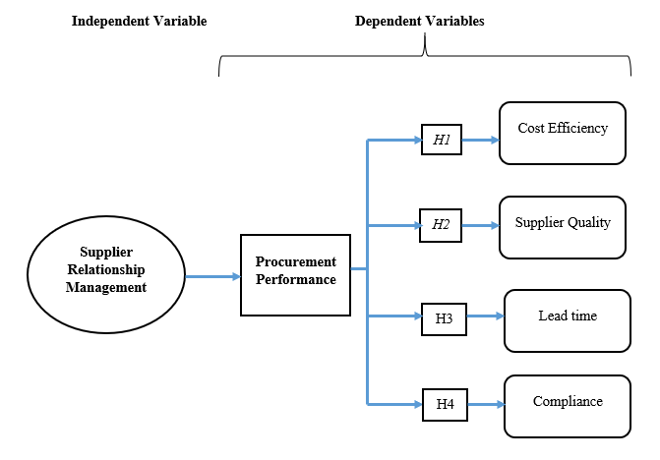

## 2.8 Chapter Summary

The literature review synthesized various scholarly works on Supplier Relationship Management (SRM) and its impact on procurement performance. Literature review also touched on the influence of effective SRM practices on supplier performance metrics, including responsiveness, reliability, and adherence to contractual agreements. Additionally, this section also highlighted the role of SRM in driving cost efficiencies through mechanisms such as volume discounts and improved negotiation outcomes. Furthermore, the section also contains literature on importance of integrating quality considerations into SRM processes, emphasizing the role of trust, communication, and collaboration in fostering enduring supplier relationships. The chapter contains the theoretical framework which comprised the transactional economy theory, the resource dependency theory, and the social exchange theory. It concludes with a conceptual framework which is author formulated and shows the relationship between SRM as the independent variable and procurement quality as the dependent variable.

# CHAPTER THREE

# RESEARCH METHODOLOGY

## 3.0 Introduction

This section focuses on the research methodology of the study. It opens with a research design which is followed by the research approach. This section also contains the target population as well as the sampling framework of the study which leads to the determination of the research participants which participated in the data collection of the study. In addition. The section also contains the data collection procedure as well as the research instruments section. This is followed by the data analysis framework and the validity and reliability section. The ethical consideration and the chapter summary conclude this chapter.

## 3.1 Research Design

The study adopted a case study research design. A case study research design is a research approach that focuses on the in-depth exploration and analysis of a specific case or cases within their real-life context (Hirose & Creswell, 2023). In this case study, the research examined supplier relationship management, specifically focusing at Cailogistics, seeking to understand its complexities, dynamics, and underlying processes. This research design involved the collection and analysis of multiple sources of data, including interviews, observations, and documents, to generate rich, detailed insights into the case under investigation. This study employed a holistic and interpretive approach, allowing researchers to uncover nuances, patterns, and relationships within the context of the case.

## 3.2 Research Approach

The research employed a quantitative research approach. Quantitative research is a method that systematically gathers and scrutinizes numerical data to reveal patterns, correlations, and trends in a specific subject matter (Pawar, 2020). This technique depends on well-structured research models, such as surveys, experiments, or statistical scrutiny of pre-existing datasets, to collect quantifiable data that can be statistically evaluated. A primary benefit of quantitative research is its capacity to yield accurate and measurable data, enabling researchers to formulate unbiased conclusions and make statistical deductions about the studied population. Furthermore, quantitative research allows researchers to verify hypotheses, discern cause-and-effect relationships among variables, and extrapolate results to broader populations with considerable certainty.

## 3.3 Target Population

The target population, also referred to as a target audience, is a group of people with characteristics that may be effectively defined to distinguish them from the general population. It is a subset of the entire population chosen to serve as the objective audience (Hirose & Creswell, 2023). The target population consisted of individuals and groups directly involved in the procurement process within the organization. This includes procurement officers, supply chain managers, and other key decision-makers who interact with suppliers on a regular basis. Additionally, the study would also target suppliers who work with Cailogistics, as their perspective on SRM practices could provide valuable insights. Furthermore, stakeholders in departments that depend on procurement, such as operations and finance, could also be included to understand the downstream effects of procurement efficiency. This comprehensive approach ensures a holistic understanding of the impact of SRM on procurement efficiency at Cailogistics.

## 3.4 Sampling Procedure

Sampling is the process of selecting a representative part of a population for the purpose of determining parameters or characteristics of the whole population (Hirose & Creswell, 2023). The sampling procedure for this study was a combination of purposive sampling and random sampling. The purposive sampling was used to select key informants from the target population who have specific knowledge about the procurement process and supplier relationship management at Cailogistics. The rationale for selecting purposive sampling is, it allows for the selection of participants who have specific knowledge and experience in procurement and supplier relationship management, thereby ensuring that the data collected is relevant and insightful (Ames, Glenton, & Lewin, 2019). This method also allows for the inclusion of a diverse range of perspectives, as participants can be selected from distinct roles and levels within the organization. Furthermore, purposive sampling can be more time and cost-efficient as it targets specific individuals rather than a broad population The random sampling was used to select the remaining participants to ensure a representative sample of the target population. The sample size has been determined to be 49, as calculated using RAO soft. The distribution of the sample across the various target populations is as follows:

Table 3. 1 Sample Population

|  |  |
| --- | --- |
| **Target Population** | **Sampled** |
| Procurement Officers | 20 |
| Supply Chain Managers | 10 |
| Management | 7 |
| Suppliers | 10 |
| Stakeholders in Operations and Finance | 2 |
| **Total Sample size** | **49** |

## 3.5 Data collection procedure

Prior to the main data collection process, a pilot study was conducted to evaluate the reliability and validity of the research instruments. The questionnaire was administered to a small sample of participants who match the characteristics of the main study’s target population. The feedback from the pilot study was used to refine the questionnaire. Similarly, a mock interview was conducted to evaluate the interview guide. After refining the research instruments based on the pilot study’s feedback, the main data collection phase begun.

The researcher administered the questionnaire face-to-face to the selected participants. The questionnaire contained structured questions related to procurement and supplier relationship management practices at Cailogistics. The researcher also conducted in-depth interviews. The interview guide contained open-ended questions to gain deeper insights into the participants’ experiences and perceptions. All responses from the questionnaires and interviews were recorded meticulously. For interviews, with the consent of the participants, audio recording may be used to ensure accuracy.

## 3.6 Research Instruments

### 3.6.1 Questionnaire

A questionnaire is a research instrument consisting of a series of questions designed to gather information from respondents (Ames, Glenton, & Lewin, 2019). It is a cost-effective and efficient tool for collecting data from many participants. In the context of this study, the questionnaire was used to collect quantitative data on Supplier Relationship Management at Cailogistics. The questionnaire contained structured questions related to procurement and supplier relationship management practices. The responses provided statistical data that can be analysed to identify patterns, trends, and correlations.

## 3.7 Data analysis Framework

Data analysis is the practice of working with data to glean useful information, which can then be used to make informed decisions (Mishra & Alok, 2022). To ascertain the effect of supplier relationship management on cost efficiency, a correlation analysis was conducted. The other variable be cost efficiency measures (such as cost per unit or cost savings percentage), and the other variable was supplier relationship management. The co-efficient coefficients indicated the strength and direction of the relationship.

To determine the influence of supplier relationship management on supplier performance, a correlation analysis was be used. Supplier performance metrics (like on-time delivery rate, defect rate, etc.) can be correlated with supplier relationship management practices to identify any significant relationships. To identify the effect of competitive supplier relationship management on lead time and timeliness, and correlation analysis was used. Various levels of supplier relationship management competitiveness can be compared to see if they result in significant differences in lead time and timeliness.

To analyse the relationship between supplier relationship management, quality, and compliance, a correlation analysis was be used. This helped to determine if there is a significant association between the level of supplier relationship management and the level of quality and compliance. SPSS 24 was used to conduct the above functions and in addition descriptive statistics was used to analyse quantitative data.

## 3.8 Data Validity and reliability

### 3.8.1 Validity

Data validity refers to the extent to which the data collection methods accurately measure what they are intended to measure (Marczyk, DeMatteo, & Festinger, 2015). In the context of this study, validity was ensured by carefully designing the questionnaire and interview questions to directly address the research objectives. The questions were based on established theories and concepts related to supplier relationship management. Additionally, a pilot study was conducted to evaluate the questionnaire and interview protocol. Feedback from the pilot study was used to refine the data collection tools, thereby enhancing their validity.

### 3.8.2 Reliability

Reliability, on the other hand, pertains to the consistency and repeatability of the data collection methods (Marczyk, DeMatteo, & Festinger, 2015). If the same study were to be conducted under the same conditions, the results should be similar. To ensure reliability in this study, the data collection process was standardized. This means that the questionnaire was administered in the same way to all participants, and the interviews followed a set protocol. Furthermore, the data analysis was conducted using reliable statistical software, and all steps were documented to allow for replication of the study. This rigorous approach enhanced the reliability of the findings.

**3.9 Ethical Considerations**

Ethical considerations in research refer to the principles and guidelines that researchers must follow to ensure that their studies are conducted in an ethical and responsible manner (Mishra & Alok, 2022). Ethical considerations are paramount in any research study. In this study, all participants were informed about the purpose of the research and their rights as participants, including the right to withdraw at any time without penalty. Confidentiality and anonymity was be maintained throughout the study to protect the privacy of the participants. All data collected was used solely for the purpose of this research and was not shared with third parties. Prior to the commencement of the study, ethical approval was sought from the relevant authorities at Bindura University. Additionally, permission was obtained from Cailogistics to conduct the study within their organization. This rigorous approach to ethics ensures that the study adheres to the principles of respect, integrity, and transparency**.**

# CHAPTER FOUR

# RESULTS

**4.0 Introduction**

This chapter contains the presentation and discussion of the results in the study. It begins with the questionnaire response rate as well as the presentation of the demographic results in the study. It then goes on to present and discuss each of the results analysed for the research questions within the study.

## 4.1 Questionnaire response rate

The results of the study presented in table 4.1 below show that a total of 49 questionnaires were disbursed, and all 49 were returned, resulting in a questionnaire response rate of 100%. This indicates that the study achieved full participation from the intended sample population. A 100% response rate is ideal as it ensures that data collection is comprehensive and representative of the entire population under study. The high response rate enhances the reliability and validity of the study findings, as it minimizes the risk of non-response bias.

Table 4. 1: Questionnaire Response rate

|  |  |  |
| --- | --- | --- |
| **Number of questionnaires disbursed** | **Number of questionnaires returned** | **Questionnaire Response rate** |
| 49 | 49 | 100% |

## 4.2 Demographic data

### 4.2.1 Gender

The results in Figure 4.1 below indicate that out of a total of 49 participants, 32 were male, accounting for 65.3% of the sample, while 17 were female, representing 34.7% of the sample. This distribution suggests a higher proportion of male participants compared to female participants in the study which shows that the procurement arena is male dominated.

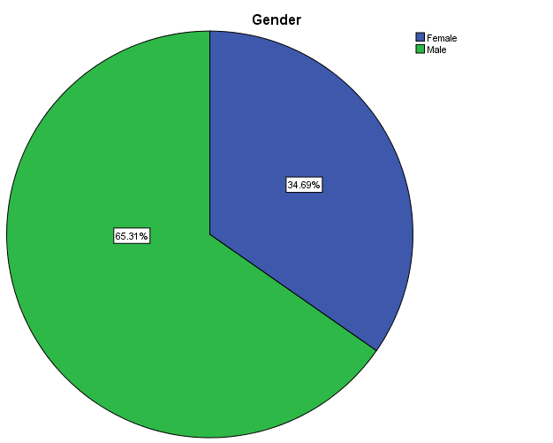

Figure 4. 1: Gender distribution of respondents

SPSS Data output 2024

### 4.2.2 Age

The study findings in figure 4.2 reveal that among the participants, 4 individuals (8.2%) fell within the age range of 18 to 25 years, while 23 participants (46.9%) were aged between 26 and 40 years. Additionally, 13 participants (26.5%) were within the age bracket of 41 to 65 years, and 9 participants (18.4%) were aged 65 years or older. This distribution illustrates a that most of the participants where in the economic active zone.

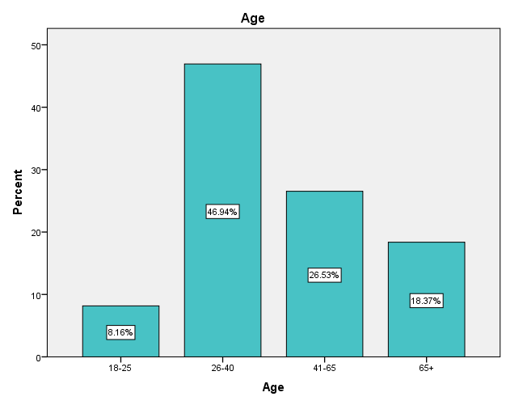

Figure 4. 2 Age distribution of Respondents

SPSS Data output 2024

### 4.2.3 Educational Level

The study findings in Figure 4.3 reveal a varied distribution of education levels among the participants. Specifically, 4.1% reported having a non-formal education, while 6.1% indicated completing primary or secondary education. Furthermore, 24.5% reported holding a certificate, and a majority of 51.0% possessed a degree. Interestingly, 14.3% reported having a postgraduate education. The notably high percentage of participants with a degree or higher education level underscores the high literacy and educational attainment within the study sample. This suggests a well-educated participant pool.

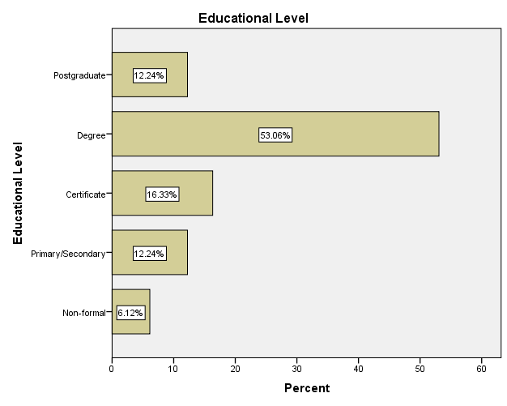

Figure 4. 3 Level of Education of respondents

SPSS Data output 2024

4.2.4 Designation

According to Table 4.2, the study's target population consists of various groups, with procurement personnel comprising 24.5% of the sample, supply chain managers representing 10.2%, and management accounting for 14.3%. Additionally, suppliers constitute a sizeable portion of the sample at 30.6%, while stakeholders in operations and finance make up 18.4%. This distribution reflects the diverse range of stakeholders involved in procurement processes and supply chain management within the context of the study. By including perspectives from multiple stakeholders, the study can offer a comprehensive understanding of the dynamics and challenges within the procurement landscape, thus enhancing the relevance and applicability of the research findings.

Table 4. 2 Designation of respondents

|  |  |  |  |  |  |  |
| --- | --- | --- | --- | --- | --- | --- |
| **Designation** | | | | | | |
|  | | Frequency | Percent | Valid Percent | Cumulative Percent |
| Valid | Procurement Personnel | 12 | 24.5 | 24.5 | 24.5 |
| Supply Chain Managers | 5 | 10.2 | 10.2 | 34.7 |
| Management | 7 | 14.3 | 14.3 | 49.0 |
| Suppliers | 15 | 30.6 | 30.6 | 79.6 |
| Finance and Administration | 10 | 20.4 | 20.4 | 100.0 |
| Total | 49 | 100.0 | 100.0 |  |

SPSS Data output 2024

### 4.2.5 Experience in the sector.

According to figure 4.4 the distribution of participants' experience in the sector reveals that 32.7% of respondents have 0 to 2 years of experience, while 26.5% have 3 to 5 years of experience. Additionally, 20.4% of participants reported having 6 to 8 years of experience, and 10.2% have 9 years or more of experience in the sector. This breakdown illustrates a range of experience levels among the participants**,** from new entrants to those with significant tenure in the sector.

Table 4. 3 Years of experience of respondents in the sector

|  |  |  |  |  |  |
| --- | --- | --- | --- | --- | --- |
| **Experience in the Sector** | | | | | |
|  | | Frequency | Percent | Valid Percent | Cumulative Percent |
| Valid | 0-2 years | 26 | 53.1 | 53.1 | 53.1 |
| 3-5 years | 13 | 26.5 | 26.5 | 79.6 |
| 6-8 years | 10 | 20.4 | 20.4 | 100.0 |
| Total | 49 | 100.0 | 100.0 |  |

SPSS Data output 2024

### 4.2.6 Perception of SRM within the organisation

The ratings of Supplier Relationship Management (SRM) in figure 4.5 among respondents indicate varying levels of perception regarding its effectiveness. Specifically, 6.1% of respondents rated SRM as exceptionally low, while 10.2% considered it to be low. A considerable proportion of 16.3% rated SRM as neutral. Moreover, 28.6% of respondents perceived SRM to be high, and the highest percentage, 38.8%, rated SRM as extremely high. This distribution suggests that a substantial majority of respondents view SRM favourably, with a notable percentage attributing extremely high effectiveness to SRM practices.

Table 4. 4 Ratings of SRM in the organisation

|  |  |  |  |  |  |
| --- | --- | --- | --- | --- | --- |
| **Level of SRM implementation** | | | | | |
|  | | Frequency | Percent | Valid Percent | Cumulative Percent |
| Valid | Very Low | 3 | 6.1 | 6.1 | 6.1 |
| Low | 5 | 10.2 | 10.2 | 16.3 |
| Medium | 8 | 16.3 | 16.3 | 32.7 |
| High | 14 | 28.6 | 28.6 | 61.2 |
| Very High | 19 | 38.8 | 38.8 | 100.0 |
| Total | 49 | 100.0 | 100.0 |  |

SPSS Data output 2024

## 4.3 Effect of supplier relationship management on cost efficiency

The analysis in Table 4.4 reveals a strong positive correlation between SRM and Cost Efficiency, with a correlation coefficient of 0.509** (p < 0.01). This indicates that as the effectiveness of SRM increases, so does the level of cost efficiency within the organization's procurement operations. These findings suggest that organizations with robust SRM practices are more likely to achieve higher levels of cost efficiency in their procurement processes. This correlation aligns with previous research by Taengwa and Choga, (2022) who found a significant positive relationship between SRM effectiveness and cost-saving initiatives within procurement operations. Additionally, Al-Abdallah, Abdallah and Bany, (2018) reported comparable results, highlighting the importance of effective SRM strategies in driving cost efficiency and overall procurement performance.

Table 4. 5 Correlation analysis between SRM and cost efficiency

|  |  |  |  |
| --- | --- | --- | --- |
| **Correlations** | | | |
|  | | Supplier Relationship Management | Cost Efficiency |
| Supplier Relationship Management | Pearson Correlation | 1 | .509 |
| Sig. (2-tailed) |  | .001** |
| N | 49 | 49 |
| Cost Efficiency | Pearson Correlation | .509 | 1 |
| Sig. (2-tailed) | .001** |  |
| N | 49 | 49 |

**. Correlation is significant at the 0.01 level (2-tailed).

SPSS Data output 2024

## 4.4 Influence of supplier relationship management on supplier performance

The ANOVA analysis in Table 4.4 examines the significance of Supplier Relationship Management (SRM) in relation to various procurement performance metrics, including quality of goods, supplier reliability, supplier delivery efficiency, and supplier communication efficiency. For quality of goods, the between-groups variance accounted for a substantial proportion of the total variance (16.961 out of 115.909), resulting in a significant F-ratio (F = 1.057) with a p-value of .003. Similarly, for supplier reliability and supplier delivery efficiency, the between-groups variance was significant, with F-ratios of 1.065 and .475 respectively, and p-values less than .001, indicating strong evidence against the null hypothesis. However, the analysis also revealed non-significant results for supplier communication efficiency, with an F-ratio of .309 and a p-value of .084.

The significant findings in the ANOVA analysis suggest that Supplier Relationship Management (SRM) has a notable impact on procurement performance across various dimensions within Cailogistics Transportation Company. Particularly, the results indicate that effective SRM practices are associated with higher quality of goods received, increased reliability of suppliers, and enhanced delivery efficiency. These findings align with previous research highlighting the importance of building strong supplier relationships for improving operational performance and ensuring consistency in product/service delivery. These findings suggest that organizations with effective SRM practices are more likely to receive higher quality goods and experience increased reliability from their suppliers. This findings aligns with previous research by Al-Abdallah, Abdallah and Bany, (2018), who found significant positive associations between SRM effectiveness and supplier performance metrics such as quality and reliability. Additionally, Mwangi and Muli, (2022) reported related results, emphasizing the importance of strong supplier relationships in ensuring consistent quality and reliability within the supply chain.

Table 4. 6 ANOVA analysis of SRM and supplier performance

|  |  |  |  |  |  |  |
| --- | --- | --- | --- | --- | --- | --- |
| **ANOVA** | | | | | | |
|  | | Sum of Squares | df | Mean Square | F | Sig. |
| Quality of Goods | Between Groups | 16.961 | 6 | 2.827 | 1.057 | .003 |
| Within Groups | 98.948 | 37 | 2.674 |  |  |
| Total | 115.909 | 43 |  |  |  |
| Supplier Reliability | Between Groups | 22.711 | 6 | 3.785 | 1.065 | .001 |
| Within Groups | 131.471 | 37 | 3.553 |  |  |
| Total | 154.182 | 43 |  |  |  |
| Supplier Delivery efficiency | Between Groups | 11.426 | 6 | 1.904 | .475 | .001 |
| Within Groups | 148.461 | 37 | 4.012 |  |  |
| Total | 159.886 | 43 |  |  |  |
| Supplier communication efficiency | Between Groups | 7.233 | 6 | 1.206 | .309 | .084 |
| Within Groups | 144.403 | 37 | 3.903 |  |  |
| Total | 151.636 | 43 |  |  |  |

SPSS Data output 2024

## 4.5 Effect of competitive supplier relationship management on lead time and timeliness

The correlation analysis in Table 4.8 explores the relationship between Supplier Relationship Management (SRM) and lead time as well as timely delivery. Spearman's rho correlation coefficient revealed significant positive correlations between SRM and both lead time and timely delivery. For SRM and lead time, the correlation coefficient was 0.605** (p < 0.01), indicating a strong positive relationship. Similarly, SRM showed a correlation coefficient of 0.586** (p < 0.01) with timely delivery, signifying a strong positive correlation as well. Moreover, lead time exhibited a strong positive correlation with timely delivery, with a correlation coefficient of 0.599** (p < 0.01). These findings suggest that organizations with effective SRM practices are more likely to experience shorter lead times and achieve timely delivery of goods or services. This correlation is consistent with previous research by Saichitema, (2022), who found significant positive associations between SRM effectiveness and lead time reduction as well as timely delivery. Additionally, Mwangi and Muli, (2022) reported similar results, emphasizing the critical role of SRM in optimizing lead time management and enhancing overall operational timeliness.

Table 4. 7 Correlation analysis of SRM and lead time and timeliness

|  |  |  |  |  |
| --- | --- | --- | --- | --- |
| **Correlations** | | | | |
|  | | Supplier Relationship Management | Lead Time | Timely Delivery |
| Supplier Relationship Management | Pearson Correlation | 1 | .605** | .586** |
| Sig. (2-tailed) |  | .001 | .001 |
| N | 49 | 49 | 49 |
| Lead Time | Pearson Correlation | .605** | 1 | .451** |
| Sig. (2-tailed) | . .001 |  | .002 |
| N | 49 | 49 | 49 |
| Timely Delivery | Pearson Correlation | . .586** | .451** | 1 |
| Sig. (2-tailed) | .001 | .002 |  |
| N | 49 | 49 | 49 |
| **. Correlation is significant at the 0.01 level (2-tailed). | | | | |

SPSS Data output 2024

## 4.6 Relationship between supplier relationship management and compliance

The correlation analysis in Table 4.10 reveals the relationship between Supplier Relationship Management (SRM) and Compliance. Spearman's rho correlation coefficient shows a significant positive correlation between SRM and Compliance, with a correlation coefficient of 0.211** (p < 0.01). This indicates a moderate positive relationship between the two variables, suggesting that organizations with effective SRM practices are more likely to achieve higher levels of compliance with regulations and company policies. Similarly, Compliance showed a correlation coefficient of 0.211** with SRM, reinforcing the positive relationship between the two variables. These findings suggest that SRM plays a crucial role in promoting compliance within procurement operations. This correlation aligns with prior research by Al-Abdallah, Abdallah and Bany, (2018), who found significant positive associations between SRM effectiveness and compliance with regulatory requirements. Additionally, Qian, et al. (2023) reported similar results, highlighting the importance of robust SRM practices in ensuring adherence to compliance standards.

Table 4. 8 Correlation analysis of SRM and supplier compliance

|  |  |  |  |  |
| --- | --- | --- | --- | --- |
| **Correlations** | | | | |
|  | | Supplier Relationship Management | Compliance | |
| Supplier Relationship Management | Pearson Correlation | 1 | .211 | |
| Sig. (2-tailed) |  | .001** | |
| N | 49 | 49 | |
| Compliance | Pearson Correlation | .211 | 1 | |
| Sig. (2-tailed) | .001** |  | |
| N | 49 | 49 | |
| **. Correlation is significant at the 0.01 level (2-tailed). | | | |

SPSS Data output 2024

## 4.7 Summary of Chapter

This section contained the presentation and discussion of results collected and analysed in the study. Through quantitative analysis, significant positive correlations were found between SRM and various aspects of procurement performance, including cost efficiency, supplier performance metrics such as quality, reliability, lead time, and timely delivery, as well as compliance. These findings underscore the crucial role of effective SRM practices in optimizing procurement processes, reducing costs, improving supplier relationships, and ensuring compliance with regulations and company policies. The study contributes to the body of knowledge by providing empirical evidence of the positive impact of SRM on procurement performance, emphasizing the importance of fostering collaborative relationships with suppliers to achieve organizational objectives efficiently.

# CHAPTER FIVE

# SUMMARY CONCLUSION AND RECOMMENDATIONS

## 5.0 Introduction

The previous chapter contained the presentation and discussion of the research findings which this chapter anchors on. This chapter contains the summary of the research, the conclusions derived from the findings and the recommendations of the study.

## 5.1 Summary

The study aimed to evaluate the effectiveness of Supplier Relationship Management (SRM) in enhancing procurement performance within Cailogistics Transportation Company, focusing on cost efficiency, supplier performance, lead time, timeliness, and compliance. Employing a quantitative approach, the research involved purposively sampling 49 respondents from various departments within the company. A case study research design was employed to delve into the intricacies of SRM practices and their impact on procurement performance within the specific organizational context. However, the study faced several limitations, including constraints related to the sample size and the generalizability of findings beyond the specific case study context. Additionally, the reliance on self-reported data and the potential for response bias may have influenced the study's results.

The results of the study revealed significant positive correlations between SRM and various aspects of procurement performance. Specifically, effective SRM practices were found to correlate positively with cost efficiency, supplier performance metrics such as quality, reliability, lead time, and timely delivery, as well as compliance with regulations and company policies. These findings underscore the importance of fostering collaborative relationships with suppliers to optimize procurement processes and achieve organizational objectives efficiently. The implications of these results suggest that investing in robust SRM practices can yield tangible benefits for organizations, including cost savings, improved supplier relationships, and enhanced compliance with regulatory requirements. Moreover, the study highlights the need for organizations to prioritize SRM strategies as a means of driving procurement performance and maintaining competitive advantage in today's dynamic business environment.

## 5.2 Conclusion

* The study revealed that effective Supplier Relationship Management (SRM) practices positively influence cost efficiency within Cailogistics Transportation Company. This was evidenced by the significant correlation between SRM and cost-saving initiatives, including negotiation outcomes and procurement cycle times. Organizations that invest in collaborative supplier relationships are better positioned to negotiate favourable terms and reduce procurement costs.
* The findings indicate a strong association between Supplier Relationship Management (SRM) and supplier performance metrics at Cailogistics Transportation Company. Improved quality of goods/services received, enhanced reliability of suppliers, and increased responsiveness were observed among organizations with effective SRM practices. This underscores the importance of fostering long-term, mutually beneficial relationships with suppliers to ensure consistent performance and reliability.
* Competitive Supplier Relationship Management (SRM) practices were found to have a significant impact on lead time and timeliness within Cailogistics Transportation Company. Organizations that adopt competitive SRM strategies experience shorter lead times and improved efficiency in meeting customer deadlines. These findings highlight the role of SRM in optimizing supply chain processes and enhancing operational agility.
* The study revealed a positive relationship between Supplier Relationship Management (SRM) and compliance with regulations and company policies at Cailogistics Transportation Company. Effective SRM practices contribute to ensuring adherence to quality standards and regulatory requirements, thereby reducing the risk of non-compliance. This underscores the importance of integrating compliance considerations into SRM processes to mitigate risks and maintain operational integrity.

## 5.3 Recommendations

Considering the conclusions drawn from the study, several recommendations emerge for enhancing procurement performance within Cailogistics Transportation Company. Firstly, it is recommended that the company invests in ongoing training and development programs for employees involved in Supplier Relationship Management (SRM). These programs should focus on enhancing negotiation skills, communication strategies, and collaborative problem-solving techniques to foster stronger relationships with suppliers and optimize procurement outcomes.

Secondly, considering the significant impact of SRM on supplier performance metrics such as quality, reliability, and responsiveness, it is recommended that Cailogistics Transportation Company implements a supplier performance management system. This system should include regular performance evaluations, feedback mechanisms, and incentives for suppliers who consistently meet or exceed performance expectations. By actively managing supplier performance, the company can ensure a higher level of consistency and reliability in its supply chain operations.

Lastly, this study recommends further research to explore the long-term effects of SRM practices on procurement performance in diverse organizational contexts. Specifically, future studies could evaluate the sustainability of cost-saving initiatives, the scalability of SRM strategies across different industries, and the role of technology in enhancing SRM effectiveness. By expanding the scope of research in this area, organizations can gain deeper insights into the mechanisms through which SRM contributes to overall business success and identify best practices for implementation.

# REFERENCES

Al-Abdallah, G.M., Abdallah, A.B. and Bany, H.K. (2018) ‘The Impact of Supplier Relationship Management on Competitive Performance of Manufacturing Firms’, *International Journal of Business and Management*, 9(2), pp. 192–202. Available at: https://doi.org/10.5539/ijbm.v9n2p192.

Anh, L.T.T. and Ha, N.T. (2020) ‘Contribution of Supplier Relationship Management to Firm Performance’, *VNU Journal of Science: Economics and Business*, 36(5E), pp. 11–20. Available at: https://doi.org/10.25073/2588-1108/vnueab.4457.

Chepng’etich, C., Waiganjo, E. and Ismael, N. (2020) ‘Strategic supplier relationship on performance of devolved systems of government in Kenya’, *International Journal of Research in Business and Social Science (2147- 4478)*, 9(4), pp. 437–443. Available at: https://doi.org/10.20525/ijrbs.v9i4.769.

Fröhlich, E. and Steinbiß, K. (2020) ‘Supplier Relationship Management Goes Digital: First Empirical Insights’, *Universal Journal of Management*, 8(3), pp. 63–73. Available at: https://doi.org/10.13189/ujm.2020.080303.

Khan, M.A., Ahmed, N. and Irshad, M. (2022) ‘Effect of Uncertainty, Supplier Involvement, Supplier Performance and Partnership Quality on Buyer-Supplier Relationship’, *Market Forces*, 17(1), pp. 41–58. Available at: https://doi.org/10.51153/mf.v17i1.537.

Kosgei, R.C. and Gitau, R. (2016) ‘Effect of Supplier Relationship Management on Organizational Performance: A Case Study of Kenya Airways Limited’, *International Academic Journal of Procurement and Supply Chain Management*, 2(2), pp. 134–148. Available at: http://www.iajournals.org/articles/iajpscm_v2_i2_134_148.pdf.

Loice, K. (2015) ‘Effect of Buyer-Supplier Relationships on Procurement Performance: Evidence From Kenyan Supermarket’, *European Scientific Journal*, 1(December), pp. 1857–7881.

Mohamed, A.A. (2017) ‘Influence of Supplier Relationship Management on Procurement Performance. a Case Study of Zaruq Stores’, p. 56.

Mwangi, F.W. and Muli, S. (2022) ‘Influence of Supplier Relationship Management on the Performance of Food and Beverage Manufacturing Firms in Kenya: A Survey of Kiambu County International Journal of Business and Social Research’, *International Journal of Business and Social Research*, 12(03), pp. 13–30. Available at: https://doi.org/10.18533/ijbsr.v12i02.1439.

Nyakundi, G., Anaya, D.R. and Senelwa, W. (2018) ‘Influence of Supplier Relationship Management on Procurement Performance in State Corporations in Kenya: (a Case of Geothermal Development Company)’, *International Journal of Recent Research in Social Sciences and Humanities (IJRRSSH)*, 5(4), pp. 91–99. Available at: www.paperpublications.org.

Poku, O.A. (2022) *Supplier Relationship Management and Firm Performance : The role of operational capabilities*, *Kwame Nkrumah University of Science and Technology, Kumasi*. Kwame Nkrumah University of Science and Technology.

Qian, C. *et al.* (2023) ‘Efficacy of supply chain relationships – differences in performance appraisals between buyers and suppliers’, *Operations Management Research*, 16(3), pp. 1302–1320. Available at: https://doi.org/10.1007/s12063-023-00354-3.

Saichitema, R. (2022) *Effect of Supplier Relationship Management Practices on Performance of Supermarkets in Nairobi County, Keny*. United States International University-Africa. Available at: www.aging-us.com.

Serem, W. *et al.* (2015) ‘Buyer-Supplier Relationship and Firm’S Procurement Performance: Evidence From Kenya Medium and Large Scale Enterprises’, *International Journal of Economics, Commerce and Management United Kingdom*, III(6), pp. 416–430. Available at: http://ijecm.co.uk/.

Shi, X. and Zhang, W. (2023) ‘Research on Supplier Selection, Evaluation, and Relationship Management’, *Open Journal of Business and Management*, 11(03), pp. 1208–1215. Available at: https://doi.org/10.4236/ojbm.2023.113067.

Taengwa, D.E. and Choga, F. (2022) ‘Effect of Supplier Relationship Management on Organizational Performance: A Case Study of the Plastic Manufacturing Industry in Harare Between 2015-2019’, *Open Journal for Information Technology*, 5(1), pp. 17–32. Available at: https://doi.org/10.32591/coas.ojit.0501.02017d.

Thongrawd, C. *et al.* (2019) ‘The mediating effect of the key supplier relationship management practices in the relationship between the supply chain orientation and the organizational buying effectiveness’, *International Journal of Supply Chain Management*, 8(4), pp. 205–215.

**Appendices 1: Questionnaire**

My name is Sue Muchuweni (B200576B) and I am currently pursuing a Bachelor of Commerce in Purchasing and Supply at Bindura University of Science Education in Zimbabwe. As part of my academic research, I am conducting a study on the topic **“EFFECTS OF SUPPLIER RELATIONSHIP MANAGEMENT IN EHANCING PROCUREMENT PERFORMANCE IN ZIMBABWE, A CASE OF CAILOGISTICS”**. Your valuable insights as a participant in this questionnaire will contribute significantly to the depth and comprehensiveness of the study. Your responses will be treated with confidentiality, and the gathered information will be used solely for academic purposes**.**

**Section A: Demographics**

Please tick the appropriate answer

1. **Gender**

Male

Female

1. **Age**

Below 24

25-34

35-44

45-54

55-64

65 or older

1. **Educational Level**

Less than High School

High School

Certificate/Diploma

Bachelor's Degree

Master's Degree

Doctoral Degree

Other

1. **Occupation**

Procurement Officer

Finance Officer

Logistics

Management

1. How long have in terms of experience do you have in the sector?

………………………………………………………….. [years]

1. How do you rate Supplier Relationship Management in your organisation (5 highest and 1 the lowest)

……………………………………………………………………………………………

1. What are the challenges with Supplier Relationship management in your organisation?

………………………………………………………………………………………………………………………………………………………………………………………………………………………………………………………………………………………………………………………………………………………………………………………………………………………………………………………………………………………………………………………………………………………………………………………………………………

**Section B: Effect of supplier relationship management on cost efficiency**

Please rate the following statements on a scale of 1 (Strongly Disagree) to 5 (Strongly Agree):

|  |  |  |  |  |  |
| --- | --- | --- | --- | --- | --- |
| **Statement** | 1 | 2 | 3 | 4 | 5 |
| Effective supplier relationship management reduces procurement costs. |  |  |  |  |  |
| Supplier relationship management helps in negotiating better contracts. |  |  |  |  |  |
| Supplier relationship management reduces the risk of supply chain disruptions. |  |  |  |  |  |
| Supplier relationship management helps in achieving cost efficiency. |  |  |  |  |  |
| Supplier relationship management contributes to the overall profitability of the company. |  |  |  |  |  |

1=strongly Disagree, 2=Disagree, 3=Neutral, 4=Agree, 5=Strongly Agree

How do you think Supplier Relationship Management can be improved to increase cost efficiency.

………………………………………………………………………………………………………………………………………………………………………………………………………………………………………………………………………………………………………………………………………………………………………………………………………………………………………………………………………………………………………………………………………………………………………………………………………………

**Section C: Influence of supplier relationship management on supplier performance**

1. Please rate the following statements on a scale of 1 (Strongly Disagree) to 5 (Strongly Agree):

|  |  |  |  |  |  |
| --- | --- | --- | --- | --- | --- |
| **Statement** | **1** | **2** | **3** | **4** | **5** |
| Supplier relationship management improves the quality of goods/services received. |  |  |  |  |  |
| Supplier relationship management enhances the reliability of suppliers. |  |  |  |  |  |
| Supplier relationship management improves the responsiveness of suppliers. |  |  |  |  |  |
| Supplier relationship management helps in building long-term relationships with suppliers. |  |  |  |  |  |
| Supplier relationship management leads to improved supplier performance. |  |  |  |  |  |

1=strongly Disagree, 2=Disagree, 3=Neutral, 4=Agree, 5=Strongly Agree

1. How do you think Supplier Relationship Management can be improved to increase supplier performance

………………………………………………………………………………………………………………………………………………………………………………………………………………………………………………………………………………………………………………………………………………………………………………………………………………………………………………………………………………………………………………………………………………………………………………………………………………

**Section D: Effect of competitive supplier relationship management on lead time and timeliness**

1. Please rate the following statements on a scale of 1 (Strongly Disagree) to 5 (Strongly Agree):

|  |  |  |  |  |  |
| --- | --- | --- | --- | --- | --- |
| **Statement** | **1** | **2** | **3** | **4** | **5** |
| Competitive supplier relationship management reduces lead time. |  |  |  |  |  |
| Competitive supplier relationship management ensures timely delivery of goods/services. |  |  |  |  |  |
| Competitive supplier relationship management helps in meeting customer deadlines. |  |  |  |  |  |
| Competitive supplier relationship management improves the efficiency of the supply chain. |  |  |  |  |  |
| Competitive supplier relationship management contributes to the overall timeliness of operations. |  |  |  |  |  |

1=strongly Disagree, 2=Disagree, 3=Neutral, 4=Agree, 5=Strongly Agree

1. How do you think Supplier Relationship Management can be improved to add to lead time and timeliness ………………………………………………………………………………………………………………………………………………………………………………………………………………………………………………………………………………………………………………………………………………………………………………………………………………………………………………………………………………………………………………………………………………………………………………………………………………

**Section E: Relationship between supplier relationship management and quality and compliance**

1. Please rate the following statements on a scale of 1 (Strongly Disagree) to 5 (Strongly Agree):

|  |  |  |  |  |  |
| --- | --- | --- | --- | --- | --- |
| **Statement** | **1** | **2** | **3** | **4** | **5** |
| Supplier relationship management ensures the quality of goods/services received. |  |  |  |  |  |
| Supplier relationship management helps in ensuring suppliers’ compliance with company policies. |  |  |  |  |  |
| Supplier relationship management contributes to the overall quality of operations. |  |  |  |  |  |
| Supplier relationship management helps in meeting regulatory compliance. |  |  |  |  |  |
| Supplier relationship management is crucial for maintaining quality and compliance. |  |  |  |  |  |

1=strongly Disagree, 2=Disagree, 3=Neutral, 4=Agree, 5=Strongly Agree

1. How do you think Supplier Relationship Management can be improved to increase quality and compliance.

………………………………………………………………………………………………………………………………………………………………………………………………………………………………………………………………………………………………………………………………………………………………………………………………………………………………………………………………………………………………………………………………………………………………………………………………………………

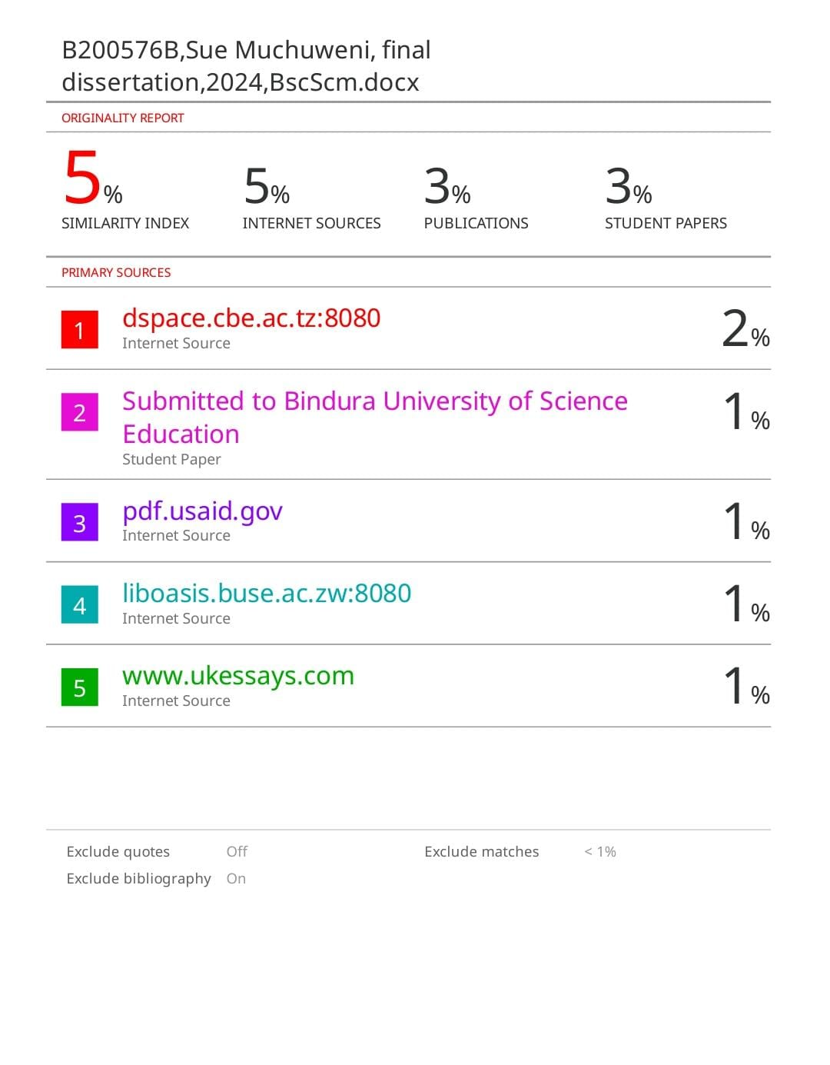-The end-

