BINDURA UNIVERSITY OF SCIENCE EDUCATION
FACULTY OF AGRICULTURE AND ENVIRONMENTAL SCIENCE

INVESTIGATING THE EFFECTS OF VARIABLE MOISTURE LEVELS AND MAIZE GENOTYPE ON SEED GERMINATION AND SEEDLING TRAITS.


MAHACHI TARIROYASHE
B203177B
A DISSERTATION SUBMITTED IN PARTIAL FULFILMENT OF THE REQUIREMENTS OF THE BACHELOR OF AGRICULTURAL SCIENCE HONORS DEGREE IN CROP SCIENCE
JUNE 2024

DECLARATION
Student
I, Tariroyashe, do hereby declare to Bindura University of Science Education that this research project is a result of my original research work. It is being submitted in partial fulfilment of the Bachelor of Agricultural Science Honors Degree in Crop Science. The findings of this research have never been submitted in any other institution.

26/09/2024
Signature……………………………….. Date……………………………………..

Supervisor
I have supervised the research project for the above mentioned student and I am convinced that the research project can be submitted.
26/09/2024

Signature……………………………….. Date……………………………………..
Chairman (Crop Science Department)
I hereby certify that this is a true copy of the research project and it can proceed for submission.

26/09/2024
Signature……………………………….. Date……………………………………..

DEDICATION
Special dedication goes to my loving parents, Mr. and Mrs. Mahachi, and my sister Kudzaishe, for their undying love and unwavering support and encouragement during stressful moments.

ACKNOWLEDGEMENTS
My heartfelt appreciation goes to my supervisor, Prof. R. Mandumbu, for supervising this research project. I benefited immensely from his vast experience, advice given, and encouragement towards the successful accomplishment of this research project. He selflessly rose to the occasion anytime I sought after his feedback which helped me to navigate through the unavoidable hurdles I faced. I would also like to extend my gratitude to my parents for their financial support and encouragement towards the success of this research. Much gratitude goes to the entire BUSE staff especially those in the Nursery department and Crop Science department for their immeasurable support towards the success of this research. Above all, I would like to thank the LORD Almighty for granting me the strength and courage to endure through hard times and for giving me the ability to understand whatever I was tasked to do.

ABSTRACT
This research project investigated the effects of variable moisture levels and maize genotype on the germination of maize seeds and various seedling traits. Maize, a staple crop in Zimbabwe, with significant economic and agricultural importance, is known to be sensitive to moisture levels during its early growth stages. The study aimed to contribute to the understanding of how moisture levels affect maize seed germination and subsequent seedling development. It also aimed at evaluating the effects of maize genotype on germination of maize seed and various seedling traits. The research methodology involved subjecting maize seeds from two different varieties to controlled soil moisture levels and monitoring their germination rates, as well as assessing the resulting seedling traits such as chlorophyll content, leaf area, stem girth, number of leaves, and the dry matter accumulation. This was achieved through a carefully designed experiment and statistical analysis (Analysis of Variance) to determine the impact of varying moisture levels and maize genotype on maize seed germination and seedling characteristics. From the results obtained, it was found that that there was a significant (P<0.05) difference observed in dry matter accumulation in the roots recorded across all moisture levels (30%, 50%, and 70% moisture). However, there was no significant (P>0.05) difference in germination and seedling traits across varying moisture levels (30%, 50%, and 70%) and maize genotypes (SC419 and SC547). This demonstrates the flexibility of the two maize varieties and their capability to be grown in areas with various average annual rainfall. A positive relationship was also observed between moisture levels and maize seed germination percentage and rate. This means that as the amount of moisture increases, the percentage of maize seeds that germinated, as well as the speed at which they germinated, also increased.

Contents
DECLARATION i
DEDICATION ii
ACKNOWLEDGEMENTS iii
ABSTRACT iv
ABBREVIATIONS vii
TABLE OF FIGURES viii
Chapter 1: Introduction 1
1.1 Introduction 1
1.1 Background to the study 1
1.2 Problem statement 3
1.3 Objectives 4
1.3.1 Main objective 4
1.3.2 Specific objectives 4
1.4 Justification 4
1.5 Hypotheses 5
Chapter 2: Literature Review 6
2.1 Economic significance of maize in Zimbabwe 6
2.2 Maize seed varieties and moisture stress 7
2.2 Germination, and critical moisture stages 7
2.3 Effects of moisture on germination 9
2.4 Varied moisture levels and maize seed germination rates 10
2.5 Practical recommendations 11
2.6 Dry matter partitioning 12
2.6.1 Hormonal regulation 12
2.6.2 Photosynthate allocation 12
2.6.3 Seed reserve mobilisation 13
2.6.4 Environmental factors 13
2.7 Moisture stress and seedling growth 13
2.7.1 Morphological changes 13
2.7.2 Physiological responses 13
2.7.3 Metabolic changes 14
2.7.4 Gene expression and signalling pathways 14
2.7.5 Impact on growth and development 14
2.8 Root physiology under varied moisture levels 14
Chapter 3: Methodology 16
3.1 Experimental site 16
3.2 Experimental design and treatments 16
3.3 Soil moisture 16
3.4 Planting 17
3.5 Management of the crop 17
3.6 Data collection 17
3.7 Data analysis 18
Chapter 4: Data Analysis 19
4.1 Effects of maize genotype and moisture levels on germination percentage and rate 19
4.2 Effects of moisture level on dry matter accumulates in the roots 22
4.3 Effects of maize genotype and moisture levels on total dry matter accumulated 22
4.4 Effects of maize genotype and moisture levels on chlorophyll content 23
4.5 Effects of maize genotype and moisture level on leaf area 24
4.6 Effects of maize genotype and moisture level on stem girth 25
4.7 Effects of maize genotype and moisture on the number of leaves per plant 26
Chapter 5: Discussion of Results 28
Chapter 6: Conclusion and Recommendations 32
6.1 Conclusion 32
6.2 Recommendations 33
6.3 Further Research Needs 33
References 34
APPENDIX 40
ANOVA TABLES 40

ABBREVIATIONS
SeedCo: Seed Company (Zimbabwe)
FAO: Food and Agriculture Organisation
WAP: Weeks After Planting
ANOVA: Analysis of Variance
CV: Coefficient of Variance
SED: Standard Error of Differences (between two means)

TABLE OF FIGURES
Figure 1: Maize Germination 9
Figure 2: Framework integrating the root responses to water stress at genetic and morphological levels 15
Figure 4.1: Effects of maize genotype on germination percentage of maize seeds 19
Figure 4.2: Effects of moisture on germination percentage of maize seeds 20
Figure 4.3: Effects of maize genotype on germination rate of maize seeds 20
Figure 4.4: Effects of moisture on germination rate of maize seeds 21
Figure 4.5: Effects of moisture on dry matter accumulation of maize seedling roots…..…………….30
Figure 4.6: Effects of maize genotype on total dry matter accumulation of maize seedlings 22
Figure 4.7: Effects of moisture on total dry matter accumulation of maize seedlings 23
Figure 4.8: Effects of maize genotype on chlorophyll content of maize seedlings 23
Figure 4.9: Effects of moisture level on chlorophyll content of maize seedlings 24
Figure 4.10: Effects of maize genotype on leaf area of maize seedlings 24
Figure 4.11: Effects of moisture level on leaf area of maize seedlings 25
Figure 4.12: Effects of maize genotype on stem girth of maize seedlings 25
Figure 4.13: Effects of moisture level on stem girth of maize seedlings 26
Figure 4.14: Effects of maize genotype on the number of leaves of maize seedlings 26
Figure 4.15: Effects of moisture level on the number of leaves of maize seedlings 27

Chapter 1: Introduction

1.1 Introduction

Background to the study
Maize is among the very widely cultivated crops, playing a key role in global food security. According to Woomer, Roobroeck, & Mulei (2024), globally, maize cultivation for dry grain is done annually on an estimated 197M hectares of land, therefore it makes it the second widely grown cereal crop in the world, after wheat. Globally, maize is a nutritionally vital cereal crop and it ranks first in production (tonnage) ahead of rice and wheat. About 1, 137 million tons (M t) of dry grain maize is produced globally per year (Erenstein, Jaleta, Sonder, Mottaleb, & Prasanna, 2022). In Zimbabwe, the production of maize varies from 950 000 tonnes (1 500 000 ha) to 2 500 000 tonnes (2 000 000 ha) per annum (Mugiyo H. , Mhizha, Chimonyo, & Mabhaudhi, 2021). Maize production is affected from germination up to physiological maturity by droughts and mid-season droughts.
Zimbabwe, like many other countries in the Sub Saharan region, is highly at risk to the effects of droughts and mid-season droughts, because of its intense reliance on rain-fed agriculture (Brazier, 2015). Droughts, defined by extended periods of below-average precipitation, have become more common and severe in Zimbabwe. These extreme weather events disturb the agricultural cycle, resulting in lower crop yields and fewer water resources. According to Yadav, Srivastava, Pant, Kumar, & Arora (2023), drought has an especially severe impact during the mid-season, when crops are in vital growth phases and require appropriate rainfall to develop properly. This can lead to significant yield losses. Aroca (2012) suggested that reduced rainfall in the middle of the season can lead to stunted crop development, poor grain formation, and, eventually, poorer yields, endangering the population's food security.
The effects of droughts and mid-season droughts extend beyond the agricultural sector, impacting the overall economy of Zimbabwe. Reduced food production leads to increased food prices, affecting the purchasing power of consumers and aggravating food insecurity. Furthermore, Dell'Aquila, Ford, & Conforti (2007) state that relying on food imports to cover domestic shortfalls puts extra strain on the country's foreign exchange reserves. Therefore, to address the challenges posed by droughts and mid-season droughts, adoptive and holistic measures can be adopted by farmers. For example, investing in climate-resilient agricultural practices, such as conservation agriculture, drought-resistant maize varieties, and efficient water management systems.
Bewley & Black (2013) found that germination is defined as a physiological process which begins and develops a seedling by activating a lot of biological and chemical reactions. It is also defined by Bradbeer (2013) as the budding of a spore, seed, or other reproductive body, normally after a period of dormancy. During the initial stages of germination (imbibition), seeds take in water rapidly, and this causes the seed coat to expand and then soften. Maize seeds are known to have low moisture and metabolically dormant in their inactive state, so the germination process is a crucial stage in a plant’s lifecycle as it marks the transition from a dormant seed to an actively growing seedling. It is during this stage that the seed absorbs water, triggering biochemical and physiological changes which then lead to radicle emergence, which is the primary root. The rate and success of germination are largely influenced by the moisture availability, thereby making it a critical factor to consider in agricultural practices. Late germination can lead to a lower yield. Leonard (2011)suggested that under temperate and humid conditions maize seedlings emerge after approximately six to ten days. Under a cool or dry environment they may take fourteen days or more.
Moisture is required to provide dissolved oxygen to the seed embryo, hydrate metabolic activities in the protoplasm, soften the seed’s outer coat, and improve the penetrability of the seed. Bewley, Bradford, Hilhorst, & Nonogaki (2012) affirmed that moisture also aids in seed rupturing and converts the insoluble materials stored in the endosperm into a soluble state through activation, breakdown, and translocation of enzymes, and also reserving the storage materials in the endosperm and translocating them to the growing embryo. Water contributes to the successive germination metabolic stages, and its level has more complex effects on seed germination. Water stress, however, lowers enzymatic activity, which has adverse impacts on carbohydrate metabolism. It also reduces the water potential and soluble potassium and calcium, and alters the seed’s physiological regulators.
There are several significant differences in the characteristics of maize seed, such as germination. These significant differences in characteristics are very reliant on the genotypes and unresponsive to other variables such as the environment. In addition, the size of the maize seed affects the rate of germination. Omar, et al., (2023) emphasized that smaller seed varieties generally germinate faster than larger seed varieties because they are more permeable, thereby making their germination more uniform than larger maize seed varieties. However, larger seed varieties are linked to better performance in the field and more resilient seedlings. This is because bigger seeds retain their cotyledons for a longer duration, and it is shown in their strength and vigour, with a greater food store.

1.2 Problem statement
Maize is very crucial in ensuring food security in many developing countries, including Zimbabwe. However, due to the shift in climatic patterns experienced in Zimbabwe in the recent years, the germinative response of maize to moisture levels has been put to a compromise. With climate change leading to increased variability in precipitation patterns, it is important to assess the effect of changing moisture levels on maize seed germination. By studying the germinative response of maize seeds to varied moisture levels, this research can participate to the understanding of how the changing climate may affect maize cultivation and identify potential strategies of adaptation, such as selecting the most drought-tolerant maize seed variety.
Over the years, maize has been planted from mid-October to mid-December in Zimbabwe, depending on the agro-ecological region, variety, and time of crop maturity. However, in the recent past, planting dates were negatively affected by the dry spell experienced in the period between the planting dates. According to Mugiyo, et al. (2023), the effects of ENSO (El Nino Southern Oscillation) on local agro-climate elements altered vegetation patterns and the interannual agricultural production variability, which varied among crop regions and crop types. Brazier (2015) affirmed that El Nino occurrences frequently cause lower rainfall and prolonged dry spells in Southern Africa, causing intense problems for the agricultural industry, and rural communities. Countries whose entire crop cycle is influenced by drier-than-average meteorological conditions are mainly concerned, because water deficits could reduce plantings and yields with accumulating negative effects on the final production (Speed, et al., 2016). Zimbabwe is one of the countries in the region’s at-risk agricultural belt and has frequently experienced the destructive effects of El Nino.
Understanding how different maize seed varieties respond to varied moisture levels is essential for many reasons. Firstly, it can provide valuable insights to the adaptability and resilience of maize varieties to environmental stressors, particularly drought conditions (Mora-Poblete, Heidari, & Fuentes, 2023). This information can guide the selection and breeding of more resilient maize cultivars, ensuring better crop performance under water-limited conditions. Secondly, investigating the germinative response of maize seeds to varied moisture levels can inform irrigation practices and water management strategies. By understanding how different maize varieties respond to different moisture conditions, farmers and agricultural practitioners can optimize water usage, minimize water wastage, and improve overall crop water productivity.
While it is widely recognized that optimal moisture conditions promote higher germination rates and vigorous seedling growth, the specific response of different maize seed varieties to varying moisture levels has yet to be thoroughly investigated. Therefore, there is a pressing need to investigate the germinative response of different maize seed varieties to varied moisture levels. Addressing this research gap will not only enhance the understanding of how maize seeds respond to moisture stress but also provide valuable information for developing more resilient maize varieties and optimizing agricultural practices in water-limited environments. Overall, this study’s results will be beneficial to all the farmers in Zimbabwe and contribute to global food security by promoting the widespread adoption of the use of drought-resistant maize seed varieties.

1.3 Objectives

1.3.1 Main objective
The main objective of this research is to determine the effects of differing moisture regimes on seed germination, and early growth of two different maize varieties.

1.3.2 Specific objectives
- To determine the impact of varied moisture levels on the germination percentage and growth rates and times of two different maize seed varieties.
- To determine the impact of different moisture regimes and maize genotypes on the dry matter partitioning of maize seedlings.

1.4 Justification
Maize is amongst the most widely grown and consumed cereal crops globally, therefore understanding factors that affect its germination process is pivotal for optimizing its output and ensuring food security. Due to the increasing impact of climate change, water availability and variability are significant challenges for agriculture. Therefore, investigating the germinative response of maize seed varieties to varied moisture levels can provide insights into their adaptability to changing environmental conditions.
Maize seed varieties exhibit genetic diversity, leading to variations in their response to different environmental conditions. By studying the germinative response of different maize seed varieties to varied moisture levels, seed companies and farmers can make informed decisions with regards to seed selection for specific moisture conditions. Lastly, the research findings can have direct practical implications for farmers by providing them with evidence-based recommendations on moisture management during seed germination. This knowledge can help farmers to improve their farming practices, optimize resource allocation, and enhance overall crop productivity. Furthermore, investigating the germinative response of different maize seed varieties to varied moisture levels can contribute to the existing scientific knowledge on seed germination and plant physiology.
The findings of this research will enhance the understanding of the germinative response of different maize seed varieties to varied moisture levels, leading to improved crop management practices, increasing agricultural productivity, and better adaptation to changing environmental and climatic conditions.

1.5 Hypotheses
H_{a} 1 (Alternative Hypothesis) – There is a significant effect of different moisture regimes on maize seed germination and the early growth of different maize genotypes.
H_{a} 2 (Alternative Hypothesis) – There is a significant impact of varied moisture levels on the germination percentage and growth rates and times of different maize seed varieties.
H_{a} 3 (Alternative Hypothesis) – There is a significant influence of different moisture regimes and maize genotypes on the dry matter partitioning of maize seedlings.

Chapter 2: Literature Review

2.1 Economic significance of maize in Zimbabwe
Maize holds extensive economic importance in Zimbabwe, and it plays an important role in the country's agricultural sector, and overall economy. It is one of the primary staple crops, serving as an essential source of food for the population, providing nourishment and sustenance to millions of people. According to Kahan (2013), the cultivation and production of maize create employment opportunities for farmers, labourers, and those involved in the agricultural value chain. This contributes to increasing rural livelihoods and income generation.
In Zimbabwe, besides ensuring food security, maize is also important in the economy of the country through commercialization and trade of its products. The surplus maize product is often sold locally, and this contributes to the growth of the agricultural industry and the overall Gross Domestic Product (GDP) of Zimbabwe (Mutambara, 2015). Selling maize generates revenue, and these sales help in supporting farmers’ livelihoods and their families. This, in turn, improves their standard of living and enables them to invest in education, healthcare, and other necessities.
Furthermore, maize serves as a critical raw material for several industries in Zimbabwe. Gwirtz & Garcia-Casal (2013) stated that the maize processing industry, including milling, produces maize meal, flour, and other maize-based products that are in high demand both domestically and regionally. They go on to suggest that processed maize products cater to the local market, and are also exported to neighbouring countries, thus contributing to the country’s export revenue, and generating foreign exchange earnings. The economic importance of maize extends beyond its direct contribution to the agricultural and industrial sectors. According to USAID-KAVES (2015), it stimulates rural development, as it encourages infrastructure development, access to markets, and the growth of support services such as transportation, marketing, and storage. Tawodzera (2022) affirmed that the maize value chain also creates employment opportunities in secondary sectors like packaging, distribution, and retail, thereby promoting economic growth, and reducing unemployment rates.
Lastly, as stated by Okou, Spray, & Unsal (2022), maize exhibits an important part in mitigating inflation of food prices, and also stabilizing the economy. The country can reduce its reliance on costly maize imports by ensuring sufficient production of maize, thereby maintaining price stability and safeguarding the consumers’ purchasing power (Mutambara, 2015). This contributes to overall macroeconomic stability and reinforces the resilience of the national economy at large.

2.2 Maize seed varieties and moisture stress
In Zimbabwe, where dry spells can cause a significant challenge to agricultural productivity, it is important to select maize seed varieties with high rates of germination. This process becomes crucial for ensuring successful crop establishment and overall growth and productivity of maize. According to Seleiman, et al., (2021), dry spells can remarkably impact the germination of maize seeds, leading to poor emergence and reduced crop establishment. Therefore, to maximize the yield potential of maize, which in turn ensures food security in Zimbabwe, identifying maize seed varieties with high germination rates under water-stressed conditions is important. A research by Oliveira, et al., (2019) investigated the germination performance of drought-tolerant maize seed varieties, evaluating the effect of water unavailability on the germination of maize seeds and identifying varieties that exhibit increased germination rates even under seasons of dry spells. Focusing on these varieties can help farmers improve their chances of successful crop establishment, even when water is scarce.
Besides drought tolerance, agronomic factors also exhibit a significant part in determination of the germination rates of maize seeds during dry spells. A study by Lunduka, Mateva, Magorokosho, & Manjeru (2017) examined several agronomic traits, for example, seed size, seed treatment, planting depth, and soil moisture management, to identify the best practices for achieving maximum germination rates in water-stressed conditions. Maree (2008) suggested that an appreciation of the interaction between these factors and their impact on germination will guide farmers in selecting the most suitable maize seed varieties under water stress, measuring germination rates, emergence rates, and seedling vigour. These studies provide valuable insights into the performance of various varieties during long periods of water stress. After examining the results from this study, farmers can be able to make informed choices about the selection of maize seed varieties that are much likely to exhibit high germination rates under water-stressed conditions. Selecting maize seed varieties with high germination rates is important for successful crop establishment during dry spells in Zimbabwe.

2.2 Germination, and critical moisture stages
Maize seed germination is an intricate process which is affected by various factors, including temperature and moisture conditions. According to Encyclopaedia Britannica (2006), germination is defined as the sprouting of a seed, or other reproductive body, usually after a period of dormancy. Germination involves imbibition, respiration, and activation of metabolic processes, radicle emergence, shoot emergence, leaf expansion, root development, photosynthesis, and lastly, seedling growth (Heslop-Harrison, 2024).
The germination process starts with imbibition, where the seed rapidly absorbs water. It results in the expansion and softening of the seed coat. This stage is crucial for activating enzymes and initiating the growth process. After imbibition, the seed enables its internal physiology and begins respiration, produces proteins, and metabolizes stored food (Bewley, Bradford, Hilhorst, & Nonogaki, 2012). This is the lag phase of germination. The radicle then unfolds from the seed and grows downward into the soil. Pessarakii (2001) stated that moisture is critical at this stage as it helps in softening the soil and provides the necessary hydration for root growth. After the radicle emerges, the shoot or plumule starts to grow upward towards the soil surface. Moisture is essential for shoot emergence because it supports the expansion of the embryonic leaves and stems.
As the shoot emerges from the soil, the embryonic leaves expand and develop. Moisture is required for leaf expansion as it facilitates cell elongation and turgor pressure. The root system progresses in development and grows deeper into the soil, absorbing water and nutrients. Adequate moisture is very crucial for root growth and nutrient uptake. As soon as the shoot emerges from the soil and the leaves expand, the plant will then start to photosynthesize. Moisture is necessary for photosynthesis because it facilitates the transportation of water and dissolved nutrients within the plant. The last stage in germination is seedling growth. Due to the establishment of photosynthesis, the seedling grows rapidly, developing more leaves, stems, and roots (Yang & Wen, 2017). The plant continues to grow and mature into a fully developed maize plant.
Throughout the germination process, moisture is required for seed imbibition, softening of the testa, root growth, shoot emergence, leaf expansion, root development, and photosynthesis. Adequate moisture availability ensures the successful germination and growth of maize seeds. Maize seeds require sufficient moisture for successful germination, but excessive moisture can lead to waterlogging and hinder the process.
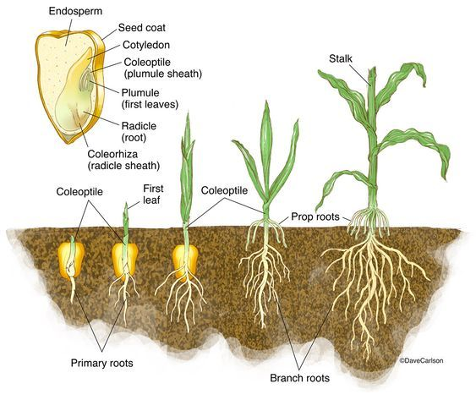
Figure 2.1: Maize Germination

2.3 Effects of moisture on germination
Maize seed germination is an intricate process that is influenced by various factors, with moisture playing a pivotal role. Adequate moisture availability is crucial for the successful germination of maize seeds. Water acts as an activator, initiating the rehydration of the seed and activating several biochemical processes required for germination. According to Ali & Elozeiri (2017), moisture softens the seed coat, allowing for the absorption of water and the successive expansion of the embryo. Moisture also facilitates the breakdown of stored reserves, such as starch, into simpler forms that can be utilized by the developing seedling. This energy release fuels the metabolic activities necessary for growth and emergence.
Insufficient moisture can significantly hinder germination, leading to decreased germination rates, delayed seedling emergence, and even mortality (Jabbari, et al., 2013). Excessive moisture can create anaerobic conditions, depriving the seeds of oxygen and hindering the respiration process (Suo, et al., 2023). This can lead to poor germination and increased susceptibility to diseases and seed rot. It is important to maintain an optimal moisture level during the germination process, ensuring a balance between water availability and oxygen diffusion. To maximize germination success, farmers need to monitor and control moisture levels. This can be done either through appropriate seedbed preparation or through proper irrigation. In addition, various environmental variables such as rainfall, soil texture, and temperature, also determine moisture availability.

2.4 Varied moisture levels and maize seed germination rates
The impact of varied moisture levels on the germination rates and times of different maize seed varieties is an important aspect of crop production, and it sheds light on the complex relationship between water availability and seed development. When it comes to maize seed germination, moisture directly influences the seed's ability to sprout and grow into a healthy plant. Mugiyo, Mhizha, Chimonyo, & Mabhaudhi (2021) appreciated the fact that that different maize seed varieties may exhibit varying sensitivities to moisture levels, making it crucial to investigate the specific responses of each variety.
Maize seeds generally require a specific range of moisture levels for germination to initiate. If the moisture content is too low, the seeds may remain dormant and fail to germinate altogether. Conversely, excessive moisture can lead to rotting or fungal infections, hindering germination and compromising the overall seed quality (AgriBusiness Review, 2013). Therefore, finding the optimal balance of moisture levels is crucial for successful germination.
A study which was done by Magorokosho (2006) showed that different maize seed varieties display unique preferences for moisture levels. Some varieties thrive in relatively moist conditions, while others are more tolerant of drier environments. This inconsistency can be attributed to genetic variations and adaptations acquired over time. By subjecting different maize varieties to controlled moisture conditions, researchers have been able to observe the distinct responses of each variety.
Moreover, the influence of moisture levels on germination times is a crucial aspect of this study. Maize seed varieties that require higher moisture levels may exhibit quicker germination times, while varieties adapted to drier conditions may have longer germination periods (Khaeim, et al., Impact of Temperature and Water on Seed Germination and Seedling Growth of Maize, 2021). This is because of the variations in the biochemical and physiological processes involved in seed imbibition and embryo growth.
Understanding the impact of varied moisture levels on maize seed germination rates and times is crucial for agricultural practices. Farmers can resort to this knowledge to optimize irrigation strategies and ensure that water is efficiently utilized, minimizing wastage and reducing environmental impact. Additionally, breeders can use this information to come up with maize varieties that are more tolerant to specific moisture levels, ultimately improving crop productivity and the country’s food security (Prassana, et al., 2021).

2.5 Practical recommendations
Providing practical recommendations for optimizing germination and early seedling growth amidst varied moisture levels is an important aspect of this research project, which focuses on investigating the germinative response of different maize seed varieties to varied moisture levels. By analyzing existing research and studies in this field, practical strategies can be developed to enhance the success of germination and promote vigorous early seedling development in maize, even in environments characterized by fluctuating moisture availability or long periods of moisture stress.
Firstly, it is crucial to select maize seed varieties that are well-suited to the prevailing moisture conditions in an area (Mugiyo H. , Mhizha, Chimonyo, & Mabhaudhi, 2021). Selecting varieties with inherent drought tolerance or the ability to germinate and establish under water-stressed conditions will help farmers increase the likelihood of successful crop establishment. Conducting thorough research and consulting with local agricultural experts can provide valuable insights into the most suitable seed varieties for specific moisture conditions.
Secondly, proper seedbed preparation is essential for optimizing germination and early seedling growth. According to Kaur, et al. (2019), the use of a well-drained seedbed can help to prevent excessive waterlogging, which can hinder germination and lead to poor seedling emergence. By promoting sufficient soil moisture levels without creating waterlogged conditions, seedbed preparation can help to come up with an ideal environment for development of roots, and nutrient uptake (WasteX, 2023).
Thirdly, seed treatment can also be used to enhance the germination potential and early growth of maize seeds under varied moisture levels. Cardarelli, Woo, Rouphael, & Colla (2022) alluded that priming or coating with beneficial microorganisms, as methods of pre-sowing seed treatment can help improve seed vigour, enhance water absorption, and increase water stress tolerance. These treatments can provide an added advantage, especially in environments where moisture availability is limited or unpredictable.
Furthermore, proper irrigation management is crucial for optimizing maize seed germination and early seedling growth. Implementing irrigation practices that match the specific moisture requirements of the maize seed varieties being cultivated can significantly improve crop establishment (El-Sanatawy, El-Kholy, Ali, Awad, & Mansour, 2021). Timing and amount of irrigation should be carefully monitored to avoid overwatering or under-watering, as both can negatively impact germination and seedling growth.
Carrying out soil moisture monitoring techniques, such as using moisture sensors or conducting regular soil moisture tests, can help farmers make informed irrigation decisions. According to Camporese, Gumiere, Putti, & Botter (2021), closely monitoring soil moisture levels can help farmers adjust their irrigation schedules and amounts accordingly, thus ensuring that the maize seeds receive optimal moisture for their germination and early growth. This in turn minimizes the risk of water stress.

2.6 Dry matter partitioning
Dry matter partitioning is the distribution of assimilated nutrients and carbon within different plant organs (Vos, Marcelis, de Visser, Struik, & Evers, 2007). Lambers, Chapin, Chapin III, & Pons (2013) suggested that dry matter accumulation influences the shoot-root ratio, thereby determining the plant’s ability to capture resources from the soil and above-ground environment. For efficient nutrient uptake, water absorption, and overall plant performance, an optimal shoot-root ratio is essential. Efficient dry matter partitioning contributes to biomass accumulation, which is a key factor in determining crop yield (Coulter, 2020). Lastly, dry matter partitioning plays a crucial role in stress adaptation. This is because plants delegate more resources to the roots for enhancing moisture and nutrient uptake in response to natural challenges. Several factors influence dry matter partitioning. These are seed reserve mobilisation, photosynthate allocation, hormonal regulation, and environmental factors.

2.6.1 Hormonal regulation
Plant hormones also greatly influence dry matter partitioning in maize. Srivastava (2002) affirmed that auxins, abscisic acid, and gibberellins influence sink strength, cell division, elongation, and differentiation. The allocation of resources to various plant organs is determined by hormonal interactions and signalling pathways. This has an impact on the overall growth and development of the plant. It also affects dry matter partitioning in maize seedlings.

2.6.2 Photosynthate allocation
Photosynthesis becomes the primary source of assimilates as soon as the maize seed reserves are depleted. Therefore, the allocation of photosynthates to different plant parts is influenced by factors such as moisture availability, nutrient availability, light availability, and temperature. Furthermore, the allocation patterns are influenced by competition between sinks, such as roots, stems, leaves, and reproductive structures.

2.6.3 Seed reserve mobilisation
Maize seedlings rely on stored reserves, mainly starch, to supply energy for early growth. There must be effective mobilisation for these reserves for a strong seedling to effectively establish. Some of the factors that affect seed reserve mobilisation include seed quality, environmental factors (moisture, and temperature), and genetic traits.

2.6.4 Environmental factors
Environmental conditions significantly impact dry matter partitioning in maize seedlings. According to Ghazi & Fantechi (2013), temperature, light intensity, water availability, and nutrient status affect photosynthesis, respiration, and translocation of assimilates. Stress conditions such as drought, heat, or nutrient deficiency, alter the dry matter allocation patterns, leading to compromised growth and yield.

2.7 Moisture stress and seedling growth
Moisture stress is the key abiotic factor that significantly impacts maize seedling growth. Therefore, farmers have to consider the effects of moisture stress, to reduce the negative effects of moisture unavailability. Studies have been done on how moisture stress influences seedling growth and development in maize.

2.7.1 Morphological changes
Several morphological alterations can be caused by moisture stress during the early stages of seedling development. These alterations include reduced root length, decreased shoot height, decreased leaf area, and altered leaf morphology. The extent of these morphological changes is directly affected by the intensity and duration of moisture strain (Brunner, Hergoz, Dawes, Arend, & Sperisen, 2015). Reduced root growth can limit water and nutrient uptake, while decreased shoot height and leaf area reduce photosynthetic capacity.

2.7.2 Physiological responses
A range of physiological responses in maize seedlings are triggered by moisture stress. These responses happen to cope with limited water availability. Responses include stomatal closure to reduce water loss through transpiration, increased root-to-shoot ratio, and altered osmotic potential (Coulter, 2020). Stomatal closure helps conserve water but also affects photosynthesis by limiting carbon dioxide uptake. Plants maintain cellular turgor and prevent dehydration due to changes in osmotic potential.

2.7.3 Metabolic changes
Various metabolic changes are affected by moisture stress. According to Aroca (2012), one notable change is the build-up of coherent solutes, for example as sugars and proline, which act as osmoprotectants and help maintain cellular integrity. Moisture stress also leads to changes in hormone levels, including abscisic acid, which plays an crucial role in regulating stomatal conductance and drought responses.

2.7.4 Gene expression and signalling pathways
Complex gene expression and signalling pathways in maize seedlings are triggered by moisture stress (Camporese, Gumiere, Putti, & Botter, 2021). These responses involve the ignition of regulatory proteins, transcription factors, and stress-responsive genes. Several key genes involved in drought tolerance, such as those related to ABA biosynthesis and signalling, have been identified in maize seedlings.

2.7.5 Impact on growth and development
Moisture stress during the seedling stage can have long-lasting effects on growth and development of seedlings. Reduced growth of roots and compromised nutrient uptake can lead to stunted growth and poor establishment of the crop. Caemmerer (2000) stated that the decreased leaf area and photosynthetic capacity can limit biomass accumulation and negatively impact yield potential. Additionally, moisture stress during the early stages has the capability to impair reproductive development and reduce overall crop productivity.

2.8 Root physiology under varied moisture levels
Because the root system serves as a plant's primary means of obtaining nutrients and water from the soil and anchors it in the ground, it promotes growth of terrestrial vegetation. (Sebastian, et al., 2016) (Fromm, 2019). The spatial arrangement of the roots in the soil profile is known as the root system architecture, (Lynch, 1995) (Koevoets, Venema, Elzenga, & Testerink, 2016). It is primarily determined by the length, thickness, angle, and branching. In response to water stress, roots have evolved the capacity to modify the characteristics of their architecture (plasticity) (Fromm, 2019) (Gupta, Rico-Medina, & Cano-Delgado, 2020). According to a review, dryness affected root branching in tree species but not tip frequency or total root length. It also increased the depth of rooting (Brunner, Hergoz, Dawes, Arend, & Sperisen, 2015). According to a systematic analysis of root attributes, low moisture levels increased root diameter and the biomass ratio from roots to the shoots while considerably reducing the root length and length density (Zhou, et al., 2018). Several researches have indicated that plants adapted the distribution of their roots under water-stress environments so as to obtain the moisture available in the various soil levels (Morris, et al., 2017).
According to Huang, DaCosta, & Jiang (2014), many environmental stresses regularly endanger plant life, development, and reproduction in natural ecosystems and have an impact on crop yield and crop quality (Maqbool, et al., 2022) in the agricultural ecosystems (FAO, 2020). Gupta, Rico-Medina, & Cano-Delgado (2020) postulated that among these challenges is drought, to which the root has evolved as the first organ to detect changes in soil moisture levels and to further adjust at the anatomical, morphological, and molecular levels (Amtmann, Bennett, & Henry, 2022). The development of high-yielding crops under water-stressed conditions is necessary to ensure food security globally, especially in dryland agriculture systems. Even with the tremendous progress in comprehending above-ground components' climate-adaptive mechanisms, Li, et al. (2021) noted that such plant root system research has not gotten enough attention. An essential component of crop production, particularly in arid regions, is understanding the root growth patterns and responses in situations where moisture is scarce (White, 2019).
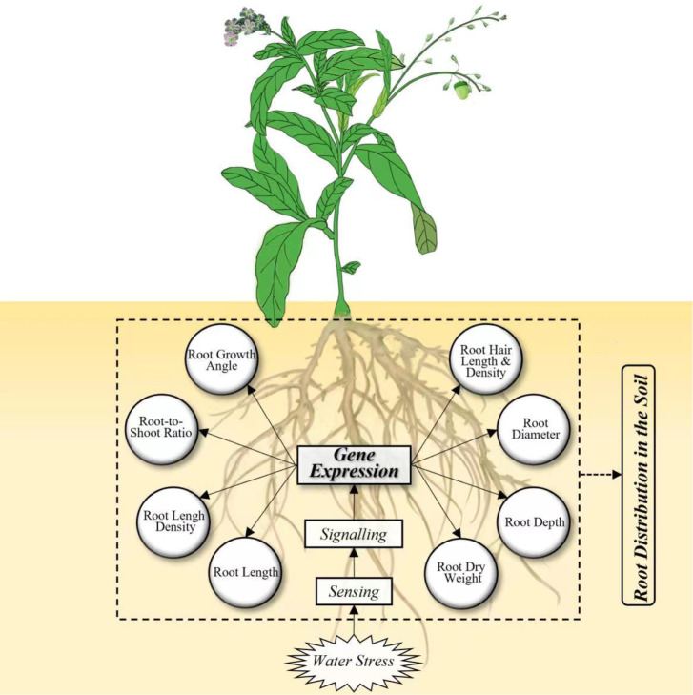

Figure 1.2: Framework integrating the responses of roots to water stress at morphological and genetic levels

Chapter 3: Methodology

3.1 Experimental site
The research was conducted at Bindura University of Science Education Astra Campus, located in Natural Region 2b of Zimbabwe -17.30192 latitude, and 31.33056 longitude. The annual rainfall ranges from 650mm to 1000mm and it is characterised by mid-season dry spells with summer temperatures ranging between 27ºC and 38ºC and winter temperatures between 6ºC and 25ºC. Astra campus is located 0.9km from Bindura CBD along Trojan road.

3.2 Experimental design and treatments
The experiment was laid out as a Randomized Complete Block Design (RCBD) with 2 factors. The first factor being maize seed variety, with two varieties which are SC419 (short season) and SC547 (Medium season) obtained from SeedCo. These two varieties were chosen based on their season lengths, SC419 is a short-season variety, and SC547 is a mid-season variety. The second factor was percentage moisture; 30%, 50%, and 70%. The experiment had three replicates and was randomized to ensure statistical validity. Control variables that were maintained throughout the experiment are temperature, and light.

3.3 Soil moisture
In terms of soil moisture, loam soil was obtained from the school nursery and sun-dried for four days to bring the moisture levels down to 0-5%. The soil was then placed in black 24*21cm black plastics and weighed. To obtain the amount of water required for the moisture level to reach the required percentage, the formula below was manipulated, assuming that the mass of 1ml of water is 1g.

To calculate the amount of water to add to the dry soil to achieve, for example, 30% moisture content, the first step is to convert the moisture content to decimal by dividing it by 100. In this case, 30% is 0.3. Secondly, to calculate the required mass of water, the dry soil’s mass in the black plastics is multiplied by the moisture content as a decimal. Lastly, the mass of water is converted to volume using the density of water, which is 1g/ml.

3.4 Planting
The black plastics with different moisture contents were placed in a fenced open-field so as to represent natural open-field conditions. To obtain the germination percentage, five maize seeds were planted in each black plastic, at 7cm depth each to ensure even germination rates. After germination had occurred, four of the seedlings were then transplanted, to remain with just one plant per pot, for data collection of other parameters.

3.5 Management of the crop
The maize seedlings were grown for a period of four weeks. Watering was done once a week to ensure that the moisture levels remain constant at 30%, 50%, and 70% in the black plastics. Weeding was also done whenever a weed was observed.

3.6 Data collection
Data were collected on a weekly basis. Data collected included germination rate and percentage, chlorophyll content, number of leaves per plant, stem girth, leaf length and width, and leaf area. To measure the leaf dimensions and girth, a tape measure was used. Chlorophyll content was measured with a chlorometer. The leaf area was calculated using the formula below:

To assess germination, germination percentage was calculated by using the formula below:

Germination rate was calculated as follows:
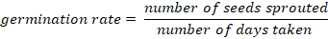
Dry matter partitioning
Each plant was divided into three parts and cut using a laboratory razor blade. These parts are the leaves, stem, roots. To ensure that no soil was part of the dry weight, the plant roots were washed using running water until they were clean. These plant parts were then placed in envelopes and labels were added to identify each plant part and location. For drying, the envelopes containing the plant parts were placed in a laboratory drying oven for 24 hours at 60°C. After drying, the weight of each plant part was added and recorded.

3.7 Data analysis
The data were analysed for variance using GenStat Statistical package version 17. Where there were significant differences, the means were divided using the Least Significant Differences at a probability level of 0.05.

Chapter 4: Data Analysis

4.1 Effects of maize genotype and moisture levels on germination percentage and rate
There was no significant (P>0.05) difference in observed in germination percentage for both maize genotypes (SC419 and SC547)(Figure 4.1).
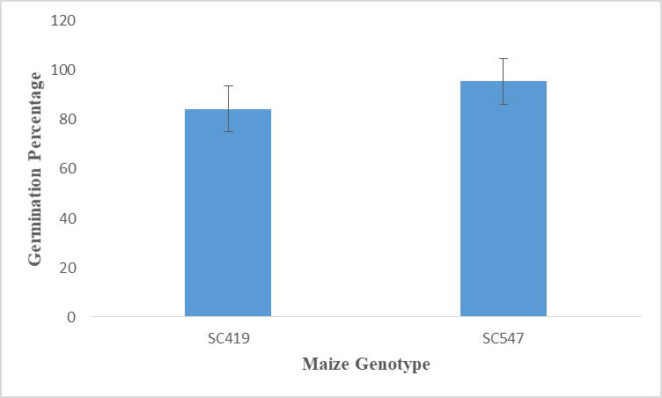
Figure 4.1: Effects of maize genotype on germination percentage of maize seeds

There was no significant (P>0.05) difference on germination percentage for all moisture levels (30%, 50%, and 70%) (Figure 4.2). The highest germination percentage was for 70% moisture, followed by 50%, and lastly, 30% moisture. The results obtained from the correlation analysis indicated that there was a positive relation between the moisture level and germination percentage. The positive R² value (0.9423) indicates that the additional input variables adding value to the model. An increase in moisture level increases the germination percentage.

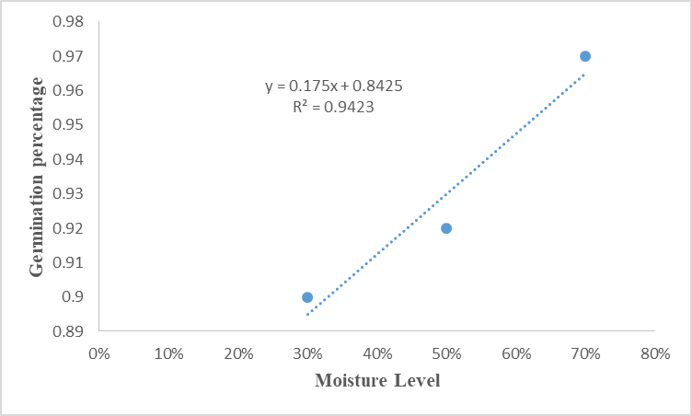
Figure 2.2: Effects of moisture on the germination percentage of maize seeds

There was no significant (P>0.05) difference observed in germination rate between the maize genotypes (Figure 4.3). SC419 was recorded to have a higher germination rate than that of SC547.
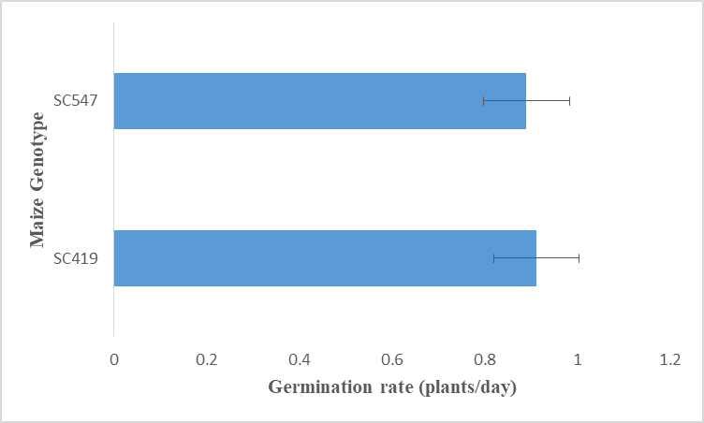
Figure 4.3: Effects of maize genotype on germination rate of maize seeds

There was no significant (P>0.05) difference in the germination rate in the three moisture levels (Figure 4.4). The highest germination rate was recorded under the 70% moisture level, followed by 50%, and lastly, 30% moisture level. The results obtained from the correlation analysis indicated that there was a positive relation between the moisture level and germination rate. The positive R² value (0.9423) indicates that the additional input variables adding value to the model. An increase in moisture level increases the germination rate.
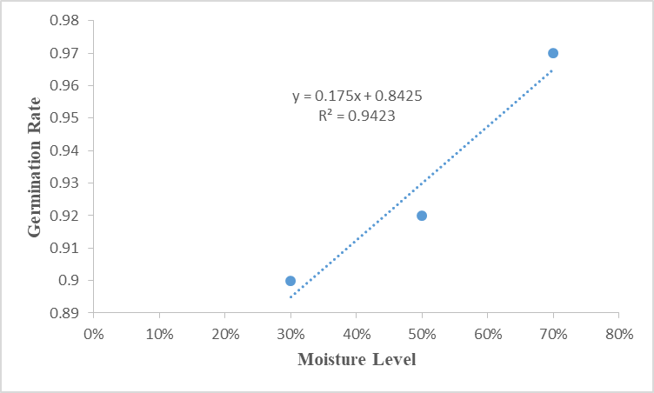
Figure 4.4: Effects of moisture on the germination rate of maize seeds

4.2 Effects of moisture level on dry matter accumulates in the roots
There was a significant (P<0.05) difference in dry matter accumulation in the roots recorded across all moisture levels (30%, 50%, and 70% moisture) (Figure 4.5).
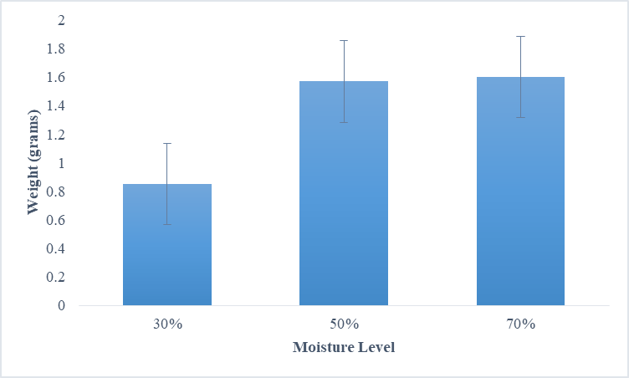

Figure 4.5: Effects of moisture on dry matter accumulation of maize seedlings roots

4.3 Effects of maize genotype and moisture levels on total dry matter accumulated
There was no significant (P>0.05) difference in the dry matter accumulation for both SC419 and SC547 maize genotypes (Figure 4.6). SC547 had a higher dry matter recorded as compared to SC419.
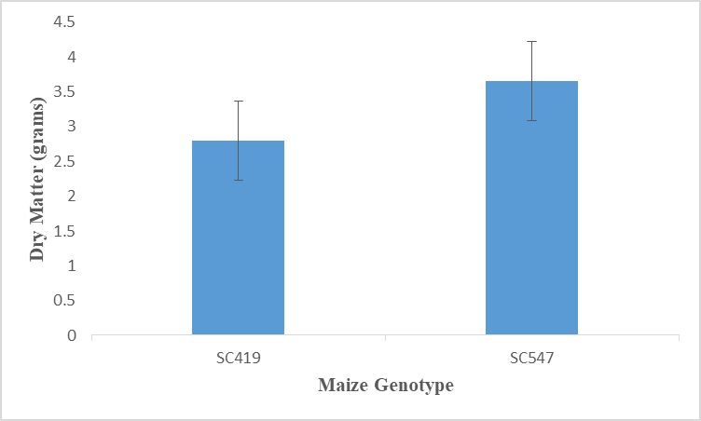
Figure 4.6: Effects of maize genotype on total dry matter accumulation of maize seedlings
There was no significant (P>0.05) difference in dry matter accumulation among the moisture levels observed (Figure 4.5). The results obtained from the correlation analysis indicated that there was a positive relation between the moisture level and germination percentage. The positive R² value (0.6476) indicates that the additional input variables adding value to the model. An increase in moisture level increases the germination percentage.
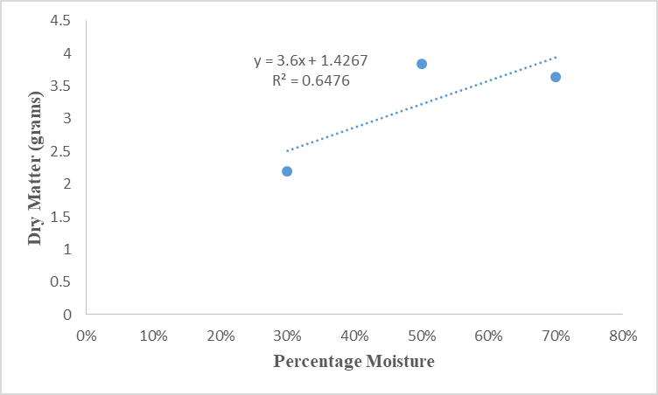
Figure 4.7: Effects of moisture on total dry matter accumulation of maize seedlings

4.4 Effects of maize genotype and moisture levels on chlorophyll content
There was no significant (P>0.05) difference in chlorophyll content between the two maize genotypes (SC419 and SC547) (Figure 4.7). The means recorded indicate an increase in chlorophyll content for both varieties from week 1 to week 4.
Variety | Chlorophyll (mmcm⁻²) 1WAP | Chlorophyll (mmcm⁻²) 2WAP | Chlorophyll (mmcm⁻²) 3WAP | Chlorophyll (mmcm⁻²) 4WAP
SC419 | 8.13ª | 14.4ª | 20.7ª | 24.7ª
SC547 | 9.24ª | 16.2ª | 20.5ª | 24.9ª
sed | NS | NS | NS | NS
cv% | 31.5 | 32.4 | 51.8 | 49.3

Figure 4.8: Effects of maize genotype on chlorophyll content of maize seedlings
There was no significant (P>0.05) difference in the chlorophyll content across all three moisture levels (Figure 4.8). In week 1 the highest recorded chlorophyll content was in plants that had exposure to 50% moisture levels, and in week 2, 3, and 4, the chlorophyll content was highest in plants that had 50% moisture.
Moisture | Chlorophyll (mmcm⁻²) 1WAP | Chlorophyll (mmcm⁻²) 2WAP | Chlorophyll (mmcm⁻²) 3WAP | Chlorophyll (mmcm⁻²) 4WAP
30% | 7.05ª | 15.1ª | 17.6ª | 20.7ª
50% | 10.53ª | 16.1ª | 23.6ª | 28.9ª
70% | 8.48ª | 14.6ª | 20.6ª | 24.8ª
Sed | NS | NS | NS | NS
cv% | 35.1 | 32.4 | 51.8 | 49.3

Figure 4.9: Effects of moisture level on chlorophyll content of maize seedlings

4.5 Effects of maize genotype and moisture level on leaf area
There was no significant (P>0.05) difference in the leaf area observed for the two maize genotypes from week 1 to week 4 (Figure 4.9). The highest recorded leaf area for SC419 variety was obtained in week 4, while the highest recorded leaf area was for SC547 variety. the trends in the graph below show that leaf area increases as the weeks increase (Figure 4.8).
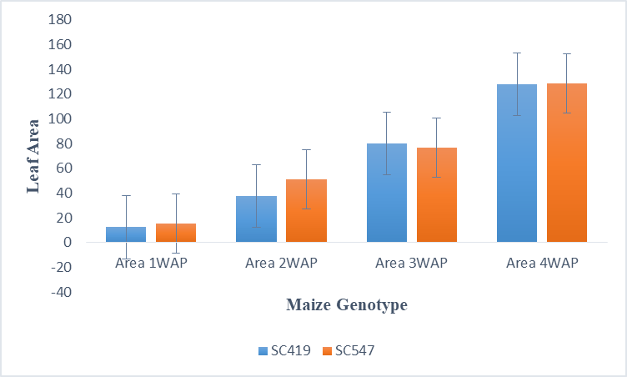
Figure 4.10: Effects of maize genotype on leaf area of maize seedlings
There was no significant (P>0.05) difference in the leaf area in the three moisture levels (Figure 4.10). Across all weeks, the highest recorded leaf areas were recorded in plant pots that were exposed to 50% moisture levels.
Moisture | Leaf area (cm²) 1WAP | Leaf area (cm²) 2WAP | Leaf area (cm²) 3WAP | Leaf area (cm²) 4WAP
30% | 13.1ª | 40.5ª | 36.0ª | 113.0ª
50% | 16.9ª | 52.8ª | 93.0ª | 151.0ª
70% | 11.3ª | 40.2ª | 80.0ª | 122.0ª
sed | NS | NS | NS | NS
cv% | 57.6 | 48.9 | 56.3 | 53.9

Figure 4.11: Effects of moisture level on leaf area of maize seedlings

4.6 Effects of maize genotype and moisture level on stem girth
There was no significant (P>0.05) difference in the stem girth observed between the two maize varieties (SC419 and SC547) (Figure 4.11). Trends in the recorded information show that stem girth of maize increases gradually with increasing number of weeks.
Variety | Stem girth (cm) 1WAP | Stem girth (cm) 2WAP | Stem girth (cm) 3WAP | Stem girth (cm) 4WAP
SC419 | 1.33ª | 1.99ª | 2.61ª | 3.62ª
SC547 | 1.47ª | 1.97ª | 2.27ª | 3.19ª
Sed | NS | NS | NS | NS
cv% | 39.5 | 30.8 | 31.6 | 33.9

Figure 4.12: Effects of maize genotype on stem girth of maize seedlings

There was no significant (P>0.05) difference in the stem girth across the three moisture levels (Figure 4.12). The trend shows that the stem girth increases with increasing days, regardless of the moisture levels.
Moisture | Stem girth (cm) 1WAP | Stem girth (cm) 2WAP | Stem girth (cm) 3WAP | Stem girth (cm) 4WAP
30% | 1.20ª | 1.68ª | 2.15ª | 3.08ª
50% | 1.50ª | 2.18ª | 2.78ª | 3.88ª
70% | 1.50ª | 2.07ª | 2.38ª | 3.25ª
sed | NS | NS | NS | NS
cv% | 39.5 | 30.8 | 31.6 | 33.9

Figure 4.13: Effects of moisture level on stem girth of maize seedlings

4.7 Effects of maize genotype and moisture on the number of leaves per plant
There was no significant (P>0.05) difference in the number of leaves obtained between the two varieties (Figure 4.13). The highest recorded number of leaves were from the SC419 variety. There was an increase in number of leaves across both maize genotypes as the weeks progressed.
Variety | Number of Leaves 1WAP | Number of Leaves 2WAP | Number of Leaves 3WAP | Number of Leaves 4WAP
SC419 | 3.22ª | 4.67ª | 6.89ª | 8.89ª
SC547 | 3.44ª | 4.78ª | 6.11ª | 7.89ª
sed | NS | NS | NS | NS
cv% | 21.2 | 27.0 | 31.4 | 28.2

Figure 4.14: Effects of maize genotype on the number of leaves of maize seedlings

There was no significant (P>0.05) difference in the number of leaves in all moisture levels applied to the maize plants (Figure 4.14).
Moisture | Number of Leaves 1WAP | Number of Leaves 2WAP | Number of Leaves 3WAP | Number of Leaves 4WAP
30% | 3.17ª | 4.00ª | 6.00ª | 7.33ª
50% | 3.33ª | 5.17ª | 6.83ª | 8.83ª
70% | 3.50ª | 5.00ª | 6.67ª | 9.00ª
sed | NS | NS | NS | NS
cv% | 21.2 | 27.0 | 31.4 | 28.2

Figure 4.15: Effects of moisture level on the number of leaves of maize seedlings

Chapter 5: Discussion of Results
There was no notable difference in germination percentage of the two maize genotypes (SC419 and SC547) across the three moisture contents (30%, 50%, and 70%). This is because several factors contribute to the argument that there is no notable difference in the germination percentage for short-season and mid-season varieties. It is vital to consider that both types of varieties are exposed to the same environmental conditions during the germination phase. According to Khaeim, et al. (2022), factors such as temperature, humidity, moisture levels, light exposure, soil nutrients, and soil quality play important roles in determining the success of germination, and these factors are not intrinsically biased toward a specific type of maize variety. As a result, the basic requirements for germination are largely similar for both short-season and mid-season varieties. The multifaceted nature of these interactions can result in a complicated web of impacts that may overshadow the direct impact of moisture variations on germination percentage (Roberto & Sanchez, 2004).
There is a genetic diversity within each type of maize variety. While short-season and mid-season varieties are broadly classified based on their maturation characteristics, within each group, there exists a range of genetic variation (Magorokosho, Genetic Diversity and Performance of Maize Varieties from Zimbabwe, Zambia, and Malawi, 2006). This genetic variation can result in a range of germination behaviors within short-season and mid-season varieties, making it difficult to generalize about significant differences in germination percentages based on maturity group. Physical properties of soil, such as compaction and pore volume, have a direct impact on water retention (Singh, Salaria, & Kaul, 2015), and the availability to maize seeds. Heavily compacted soils with reduced pore volume may impact the germination process by limiting the water uptake by the seeds.
Ali & Elozeiri (2017) stated that during germination, seeds efficiently mobilize their reserves to fuel enzymatic activity, radicle emergence, and seedling establishment. This decreases the demand for immediate soil moisture during the earliest stages of germination. There might also be a threshold moisture level below which germination becomes significantly inhibited. However, within a range above this threshold, even modest moisture fluctuations might not significantly impact the overall germination rate.
Furthermore, soil is a complex and dynamic medium with a certain degree of moisture buffering capacity. This buffering capacity enables the soil to retain moisture within a range of levels, creating a somewhat stable environment for seed germination. Even when exposed to varying moisture levels, the soil can maintain a degree of consistency in the immediate proximity of seeds (Datta & Meena, 2021), thus minimizing the effect of fluctuations on the germination process. According to Magorokosho (2006), the genetic predisposition of these maize varieties to maintain a similar leaf area across varying soil moisture levels can be attributed to the evolutionary adaptation to various environmental conditions.
However, there was a significant difference in the dry matter accumulation in the roots of the seedlings across varying moisture levels (30%, 50%, and 70%). It is important to note that soil moisture has a direct impact on the availability of water and nutrients for the plant roots. In the pots which had low moisture levels, the limited water availability hindered the uptake of essential nutrients in the roots (Aroca, 2012), thereby affecting the roots’ dry matter accumulation. Conversely, in the pots that were exposed more moisture, the roots had better access to water and nutrients, encouraging accumulation of dry matter in the roots. Furthermore, the impact of soil moisture on root morphology and architecture and cannot be ignored. Maize seedlings in drier soils develop deeper and longer roots in quest of water, which may result in greater dry matter accumulation in the deeper root zones. According to Datta & Meena (2021), on the other hand, in moist soil, the roots spread more laterally, leading to a different pattern of dry matter distribution in the root system. In addition to the physiological aspects, the microbial activity in the soil is also influenced by soil moisture levels. Water availability in the soil affects the microbial population and their activities (Condron, Stark, O'Callaghan, & Clinton, 2010), which in turn can impact organic matter decomposition and nutrient release for root uptake. This intricate relationship between soil moisture, microbial activity, and nutrient availability directly influences the accumulation of dry matter in the roots of maize seedlings.
The physiological response of maize to varying moisture levels is significant in determining the leaf area. Maize plants have developed mechanisms to regulate their transpiration and water-use efficiency in reaction to water availability. Xu, Liu, & Xia, (2023) commented that when exposed to different soil moisture levels, these plants adjust their stomatal conductance and leaf expansion rates to maintain the best leaf area for photosynthesis and resource utilization. As a result, the ability of maize seedlings to modify their physiological processes as a response to changing soil moisture levels may contribute to the lack of significant differences in the mean leaf area. Due to the synergistic impacts of environmental variables, under water stress, both short-season and mid-season maize varieties may undergo slight adjustments in leaf area to optimize their energy capture and reduce water loss, regardless of their genetic differences (Cai, Zhang, Mi, & Ming, 2020).
Moreover, it is essential to evaluate the dynamic nature of soil moisture and its spatial and temporal variability. The relationship between soil moisture and root distribution in maize plants might affect the overall leaf area development. However, the adaptive root structure of short-season and mid-season varieties may allow the plants to effectively obtain water from varying soil depths, thereby reducing the effects of soil moisture variations on leaf area. As a result, the ability of these maize varieties to adapt to changes in soil moisture conditions may account for the lack of significant differences in mean leaf area.
Short-season and mid-season varieties have undergone extensive genetic improvement to adapt to a range of moisture levels, allowing them to maintain consistent growth and dry matter accumulation across varying soil moisture levels. Maize plants possess remarkable water uptake, retention, and utilization mechanisms, enabling them to maintain metabolic processes and growth even under fluctuating soil moisture conditions. According to Sun, Gao, Chen, Fu, & Zhang (2016), the ability of maize plants to regulate transpiration, maximize water use efficiency, and modify root development in response to soil moisture availability contributes to the consistent dry matter accumulation observed across various soil moisture levels.
In addition, the intricate relationship between soil moisture levels and nutrient uptake by maize plants has a profound effect on dry matter accumulation. Fageria & Moreira (2011) suggest that while it is well-established that water availability is essential for nutrient uptake by plant roots, the adaptability of short-season and mid-season varieties to varying soil moisture levels allows them to efficiently access essential nutrients, thereby maintaining consistent dry matter accumulation regardless of soil moisture conditions (Singh, et al., 2024). Seedlings prioritize survival during the initial growth stages. They possess inherent mechanisms to preserve resources and survive a specific range of environmental stresses, including fluctuations in soil moisture (Wiley, Landhausser, Solarik, Kulbaba, & Goeppel, 2023). This resilience can potentially mask differences in dry matter accumulation across varying moisture levels. According to Seleiman, et al. (2021), seedlings often demonstrate lower metabolic activity compared to mature plants. This corresponds to lower water consumption, allowing them to tolerate drier conditions without significantly impacting dry matter accumulation in the short term.
The chlorophyll content of leaves is a vital sign of photosynthetic activity and the overall health of the plant, directly affecting crop productivity. It is widely acknowledged that water availability has a direct influence on plant physiological processes, including photosynthesis. However, research has shown that the impact of soil moisture levels and chlorophyll content can be determined by plant species and their adaptive mechanisms (Cai, Zhang, Mi, & Ming, 2020). Short-season and mid-season cultivars generally differ in their growth and development patterns. However, when comparing the mean leaf chlorophyll content of seedlings from these varieties, it becomes apparent that the differences are not statistically significant. This observation suggests that the genetic and physiological characteristics of these maize varieties may result in a consistent chlorophyll content despite their varying growth durations.
There was no significant difference in the average number of leaves for short-season and mid-season maize varieties. While there may be intrinsic genetic variations across these varieties, it is possible that their response to soil moisture levels in terms of leaf growth could be more consistent than anticipated. Mazibuko, Mutengwa, Magorokosho, Kutywayo, & Kamutando (2024) postulate that the genetic tendency of these maize varieties to flourish in specific environmental conditions may minimize the expected differences in the mean number of leaves of seedlings, resulting in a convergence of growth patterns across different soil moisture levels. Seedlings at an early stage of growth may not yet exhibit significant differences in leaf development. The impact of moisture level and maize genotype may become more discernible at later stages of growth, reflecting the complex interplay between genetic, environmental, and developmental factors.

Chapter 6: Conclusion and Recommendations

6.1 Conclusion
This research’s findings shed light on the impact of varying soil moisture levels on maize seed germination as well as the relationship between maize seedling characteristics and moisture levels. Despite the initial hypotheses, the research reflected that there were no significant differences in germination percentage and rate, as well as seedling traits under different moisture conditions. This unexpected outcome demonstrates the complexities of plant responses to varying moisture levels. It also emphasizes the need for further research into the underlying processes that influence maize seed germination and early growth in response to moisture levels. The results of this research call into question the existing assumptions regarding the direct relationship between moisture levels and maize seed germination and seedling traits. The interplay of environmental factors, genetic variability, and physiological adaptations may contribute to the maize seed and seedling resilience in the face of varying moisture conditions. This calls into question the conventional understanding of the deterministic relationship between moisture levels and germination outcomes, calling for a more nuanced approach to studying the multifaceted dynamics at play.
However, the significant difference in dry matter accumulation in maize seedling roots across varying moisture levels demonstrates the complex interplay of physiological, morphological, environmental, and microbiological elements that shape plant response to water availability. This research has significant implications for agricultural practices and irrigation management aimed at improving maize crop resilience and productivity in a variety of soil moisture conditions. The unavailability of a notable difference in other parameters, with the exception of roots, is owing to the fact that the study focused on seedling characteristics rather than maturity. So, as the crop progresses beyond the seedling stage, these factors have the potential to show significant differences across moisture levels because the dry matter accumulation in the roots is significantly different.
Moving forward, it is critical to explore deeper into the complicated mechanisms that control maize seed germination and seedling characteristics in response to moisture variability. Further research should focus on identifying the underlying genetic, physiological, and environmental factors that contribute to the observed the endurance of maize seeds and seedlings under varied moisture levels. Furthermore, comparative research across different maize cultivars and field-based experiments under diverse environmental conditions can provide a thorough understanding of the complex connections between moisture levels and maize germination, and early growth. While the findings of this research may contradict established assumptions, they also act as a catalyst for further research and discovery in the field of maize seed germination and seedling attributes. Future research efforts that acknowledge the complexity of plant responses to moisture variability can pave the way for a more holistic appreciation of the relationship between moisture levels and maize growth, ultimately contributing to advancements in agricultural practices and crop resilience in the face of environmental variability.

6.2 Recommendations
Based on the results of this research, recommendations can be given:
- Farmers can have flexibility in managing soil moisture levels in areas which receive 30%, 50%, and 70% total moisture content.
- When selecting maize varieties to grow, farmers can select between SC419 and SC547 because their performance during the initial stages (germination and seedling stage) has no significant difference.
- Since maize roots respond differently to water availability, and 30% moisture gives a lower dry matter accumulation than 50% and 70%, farmers concerned with root dry matter accumulation for both SC419 and SC547 can consider a higher moisture level (between 50% and 70%).

6.3 Further Research Needs
Further research with regards to this research project should focus more on investigating the relationship between moisture levels and root dry matter. This could emphasize more on the effects of moisture levels on root architecture, branching, and nutrient/water uptake efficiency.

References
AgriBusiness Review. (2013). Factors Influencing Seed Germination in Plants. Retrieved from AgriBusiness Review: https://www.agribusinessreview.com/news/factors-influencing-seed-germination-in-plants-nwid-1043.html
Ali, A. S., & Elozeiri, A. A. (2017). Metabolic Processes During Germination. Advances in Seed Biology, 132-134.
Ali, A. S., & Elozeiri, A. A. (2017). Metabolic Processes During Seed Germination. Advances in Seed Biology.
Amtmann, A., Bennett, M. J., & Henry, A. (2022). Root Phenotypes for the Future. Plant Cell Environment 45 (3), 595-601.
Aroca, R. (2012). Plant Responses to Drought Stress: From Morphological to Molecular Features. Heidelberg: Springer.
Bewley, J. D., Bradford, K., Hilhorst, H., & Nonogaki, H. (2012). Seeds. Physiology of Development, Germination and Dormancy, 3rd Edition. New York: Springer.
Bradbeer, J. W. (2013). Seed Dormancy and Germination. New York CIty: Springer US.
Brazier, A. (2015). Climate Change in Zimbabwe: Facts for Planners and Decision Makers. Harare: Konrad-Adenauer-Stiftung.
Brunner, I., Hergoz, C., Dawes, M. A., Arend, M., & Sperisen, C. (2015). How Tree Roots Respond to Drought. Front, Plant Sci, 6.
Caemmerer, S. V. (2000). Biochemical Models of Leaf Photosynthesis. Clayton: CSIRO Publishers.
Cai, F., Zhang, Y., Mi, N., & Ming, H. (2020). Maize (Zea mays L.) Physiological Responses to Drought and Rewatering, and the Associations with Water Stress Degree. Agricultural Water Management, 241. Retrieved from ResearchGate.
Camporese, M., Gumiere, S. J., Putti, M., & Botter, G. (2021). Efficient Irrigation of Maize Through Soil Moisture Monitoring and Modeling. Frontiers in Water.
Cardarelli, M., Woo, S., Rouphael, Y., & Colla, G. (2022). Seed Treatments with Microorganisms Can Have a Biostimulant Effect by Influencing Germination and Seedling Growth of Crops. National Center for Biotechnology Information.
Condron, L. M., Stark, C., O'Callaghan, M., & Clinton, P. W. (2010). The Role of Microbial Communities in the Formation and Decomposition of Soil Organic Matter. Soil Microbiology and Sustainable Crop Production, 81-118.
Coulter, J. C. (2020). Sustainable Cropping Systems. Basel: Mdpi AG.
Datta, R., & Meena, R. S. (2021). Soil Moisture Importance. London: IntechOpen.
Dell'Aquila, C., Ford, D., & Conforti, P. (2007). Agricultural Trade Policy and Food Security: Structural Issues, Multilateral Negotiations and Competitiveness. Carribean: FAO UN.
Dixon, G. R., & Tilston, E. L. (2010). Soil Microbiology and Sustainable Crop Production. Heidelberg: Springer Netherlands.
El-Sanatawy, A., El-Kholy, S., Ali, M., Awad, M., & Mansour, E. (2021). Maize Seedling Establishment, Grain Yield and Crop Water Productivity Response to Seed Priming and Irrigation Management in a Mediterranean Arid Environment. Agronomy (2021), 756.
Encyclopaedia Britannica, I. (2006). Britannica Concise Encyclopedia. Chicago: Encyclopaedia Britannica, Inc.
Erenstein, O., Jaleta, M., Sonder, K., Mottaleb, K., & Prasanna, B. M. (2022, May 17). Global Maize Production, Consumption and Trade: Trends and R&D Implications. Retrieved from Springer: https://doi.org/10.1007/s12571-022-01288-7
Fageria, N. K., & Moreira, A. (2011). The Role of Mineral Nutrition on Root Growth of Crop Plants. Advances in Agronomy, 251-331.
FAO. (2020). The State of Food and Agriculture. Rome: Overcoming Water Challenges in Agriculture, 406.
Fromm, H. (2019). Root Plasticity in the Pursuit of Water. Plants-Basel, 236.
Ghazi, A., & Fantechi, R. (2013). Current Issues in Climate Research: Proceedings of the EC Climatology Programme Symposium, Sophia Antipolis, France, 2–5 October 1984. Chicago: Springer.
Gupta, A., Rico-Medina, A., & Cano-Delgado, A. I. (2020). The Physiology of Plant Responses to DRough. Scie 368 (6488), 266-269.
Gwirtz, J. A., & Garcia-Casal, M. N. (2013). Processing Maize Flour and Corn Meal Food Products. National Center for Biotechnology Information, 66.
Heslop-Harrison, J. (2024). Germination: Botany. Life Cycle, Processes & Properties.
Huang, B., DaCosta, M., & Jiang, Y. (2014). Research Advances in Mechanisms of Turfgrass Tolerance to Abiotic Stresses: From Physiology to Molecular Biology. Cri. Rev. Plant Sci 33 (2-3), 141-189.
Jabbari, H., Akbari, G. A., Sima, N. K., Rad, A. S., Alahdadi, I., Hamed, A., & Shariatpanahi, M. E. (2013). Relationships Between Seedling Establishment and Soil Moisture Content for Winter and Spring Rapeseed Genotypes. Industrial Crops and Products. Volume 49, 177-187.
Kahan, D. (2013). Managing Risk in Farming. Bloomington: Food and Agriculture Organisation of the United Nations.
Kaur, G., Singh, G., Motavalli, P., Nelson, K., Orlowski, J., & Golden, B. (2019). Impacts and Management Strategies for Crop Production in Waterlogged or Flooded Soils: A Review. Agronomy Journal, 1475-1501.
Khaeim, H., Kende, Z., Jolankai, M., Kovacs, G. P., Gyuricza, C., & Tarnawa, A. (2022). Impact of Temperature and Water on Seed Germination and Seedling Growth of Maize (Zea mays L.). Agronomy, 12(2), 397.
Khaeim, H., Kende, Z., Jolankai, M., Kovaks, G. P., Gyuricza, C., & Tarnawa, A. (2021). Impact of Temperature and Water on Seed Germination and Seedling Growth of Maize. Agronomy.
Koevoets, I. T., Venema, J. H., Elzenga, J. M., & Testerink, C. (2016). Roots with Standing their Environment: Exploiting Root System Architecture Responses to Abiotic Stress to Improve Crop Tolerance. Front. Plant Science 7.
Lambers, H., Chapin, F. S., Chapin III, F. S., & Pons, T. L. (2013). Plant Physiological Ecology. New York City: Springer.
Leonard, D. K. (2011). Traditional Field Crops. Washington, D.C.: Peace Corps, Information Collection & Exchange.
Li, C., Li, L., Reynolds, M. P., Wang, J., Chang, X., & Mao, X. (2021). Recognising the Hidden Half in Wheat: Root System Attributes Associated with Drought Tolerance. J. Exp. Bot 72 (14), 5117-5113.
Lunduka, R. W., Mateva, K. I., Magorokosho, C., & Manjeru, P. (2017). Impact of Adoption of Drought-tolerant Maize Varieties on Total Maize Production in South Eastern Zimbabwe. Climate and Development, 35-46.
Lynch, J. (1995). Root Architecture and Plant Productivity. Plant Physiology 109 (1), 7-13.
Magorokosho, C. (2006). Genetic Diversity and Performance of Maize Varieties from Zimbabwe, Zambia, and Malawi. Texas: Texas A&M University.
Magorokosho, C. (2006). Genetic Diversity and Performance of Maize Varieties from Zimbabwe, Zambia, and Malawi. Texas.
Maqbool, S., Hassan, M. A., Xia, X., York, L. M., Rasheed, A., & He, Z. (2022). Root System Architecture in Cereals: Progress, Challenges and Perspective. Plant Journal 110 (1), 23-42.
Maree, P. H. (2008). Prediction of Field Emergence of Maize (Zea mays L.) Hybrids Exposed to Cold and Wet Conditions. Pretoria: University of Pretoria.
Mazibuko, P., Mutengwa, C., Magorokosho, C., Kutywayo, D., & Kamutando, C. N. (2024). Genetic Grain Yield among the Maize Cultivars Released over a Century from the National Breeding Program of Zimbabwe. Agronomy, 246.
Mora-Poblete, F., Heidari, P., & Fuentes, S. (2023). Integrating Advanced High-throughput Technologies to Improve Plant Resilience to Environmental Challenges. Lausanne: Frontiers Media SA.
Morris, E. C., Griffiths, M., Golebiowska, A., Mairhofer, S., Burr-Hersey, J., & Goh, T. (2017). Shaping 3D Root System Architecture. Current Biology 27 (17), R919-R930.
Mugiyo, H., Mhizha, T., Chimonyo, V. G., & Mabhaudhi, T. (2021, February). Investigation of the optimum planting dates for maize varieties using a hybrid approach: A case of Hwedza, Zimbabwe. Retrieved from ScienceDirect: Heliyon: https://www.sciencedirect.com/science/article/pii/S2405844021002140#:~:text=The%20production%20of%20maize%20in,areas%2C%20will%20reduce%20food%20insecurity.
Mugiyo, H., Mhizha, T., Chimonyo, V. G., & Mabhaudhi, T. (2021). Investigation of the Optimum Planting Dates for Maize Varieties Using a Hybrid Approach: A Case of Hwedza, Zimbabwe. Heliyon (2021), 1-12.
Mutambara, J. (2015, June). USAID Strategic Economic Research and Analysis- Zimbabwe (SERA) Program. Retrieved from United States Agency for International Development (USAID): https://pdf.usaid.gov/pdf_docs/PA00M75W.pdf
Okou, C., Spray, J., & Unsal, D. F. (2022). Staple Food Prices in Sub-Saharan Africa. An Empirical Assessment. London: Palgrave Macmillan.
Oliveira, C. E., Steiner, F., Zoz, T., Vendruscolo, E. P., Silva, M. V., Mello, B. F., . . . Zuffo, A. M. (2019). Drought Stresses on Seed Germination and Early Growth of Maize and Sorghum. Journal of Agricultural Science, 310-311.
Omar, S., Ghani, R. I., Khalid, N., Jolankai, M., Tarnawa, A., Percze, A., . . . Kende, Z. (2023). Effects of Seed Quality and Hybrid Type on Maize Germination and Yield in Hungary. Agriculture, 1836.
Pessarakii, M. (2001). Handbook of Plant and Crop Physiology. Florida: CRC Press.
Prassana, B. M., Cairns, J., Zaidi, P., Beyene, Y., Makumbi, D., Godwa, M., . . . Zhang, X. (2021). Beat the Stress: Breeding for Climate Resilience in Maize for the Tropical Rainfed Environment. Theoretical and Applied Genetics, 1729-1752.
Roberto, L. B., & Sanchez, R. A. (2004). Handbook of Seed Physiology: Applications to Agriculture. Wisconsin: Taylor & Francis.
Sebastian, J., Yee, M. C., Viana, W. G., Rellan-Alvarez, R., Feldman, M., & Priest, H. D. (2016). Grasses Suppress Shoot-borne Roots to Conserve Water During Drought. Proc. National Academic Sciences USA, 8861-8866.
Seleiman, M. F., Al-Suhaibani, N., Ali, N., Akmal, M., Alotaibi, M., Refay, Y., . . . Battaglia, M. L. (2021). Drought Stress Impacts on Plants and Different Approaches to Aleviate its Adverse Effects. Plants (Basel), 259.
Seleiman, M. F., Al-Suhaibani, N., Ali, N., Akmal, M., Alotaibi, M., Refay, Y., . . . Battaglia, M. L. (2021). Drought Stress Impacts on Plants and Different Approaches to Alleviate its Adverse Effects. National Center for Biotechnology Information, 1-2.
Singh, J., Salaria, A., & Kaul, A. (2015). Impact of Soil Compaction on Soil Physical Properties and Root Growth. International Journal of Food, Agriculture, and Veterinary Sciences, 23-32.
Singh, V. K., Gandhamanagenahalli, R. A., Dass, A., Venkatesh, P., Choudhary, A. K., Upadhyay, P. K., . . . Shyam, C. S. (2024). Soil Moisture Dynamics, Rooting Traits, Crop and Water Productivity of Wheat Under Different Tillage, Irrigaion, and Nutrition Conditions. Farming Systems.
Speed, Robert, Tickner, David, Lei Gang, Sayers, . . . Qui Bing. (2016). Drought Risk Management: A Strategic Approach. Paris: UNESCO Publishing.
Srivastava, L. M. (2002). Plant Growth and Development: Hormones and Environment. Elsevier Science: Rome.
Sun, C., Gao, X., Chen, X., Fu, J., & Zhang, Y. (2016). Metabolic and Growth Responses of Maize to Successive Drought and Re-watering Cycles. Agricultural Water Management, 62-73.
Suo, R., Sandhu, K., Wang, M., You, F., Conner, R., Cober, R., & Hou, A. (2023). Seed Germination in Response to Waterlogging and Cold Climate: A Review on the Genetics and Molecular Mechanisms of Resistance to the Abiotic Stress. Canadian Journal of Plant Science, 13-28.
Tawodzera, G. (2022). The Role of the Information Sector in Epworth's Food System, Zimbabwe. Transforming Urban Food Systems in Secondary Cities in Africa, 85-98.
USAID-KAVES. (2015, August). Maize Value Chain Analysis. Retrieved from United States Agency for International Development: https://pdf.usaid.gov/pdf_docs/PA00M2T3.pdf
Vos, J., Marcelis, L. M., de Visser, P. B., Struik, P. C., & Evers, J. B. (2007). Functional Structural Plant Modelling in Crop Production. New York City: Springer.
WasteX. (2023, August 4). 5 Land Preparation Practices for Planting Corn. England.
White, P. J. (2019). Root Traita Benefitting Crop Production in Environments with Limited Water and Nutrient Availability. Ann. Bot 124 (6), 883-890.
Wiley, E. T., Landhausser, S. M., Solarik, K. A., Kulbaba, S. P., & Goeppel, A. E. (2023). The Importance of Initial Seedling Characteristics in Controlling Allocation to Growth and Reserves under Different Soil Moisture Conditions. Forests, 796.
Woomer, P., Roobroeck, D., & Mulei, W. (2024). Agricultural Transformation in Maize Producing Areas of Africa. New Prospects of Maize.
Xu, Z., Liu, Z., & Xia, X. (2023). Comprehensive Effects of Atmosphere and Soil Drying on Stomatal Behaviour of Different Plant Types. Water 15(9), 1657.
Yadav, A. S., Srivastava, D. S., Pant, H., Kumar, N., & Arora, S. (2023). Advances in Crop Production and Climate Change. Oxfordshire: Taylor & Francis.
Yang, L., & Wen, B. (2017). Seed Quality. Encyclopedia of Applied Plant Sciences (Second Edition), 553-563.
Zhou, G., Zhou, X., Nie, Y., Bai, S. H., Zhou, L., & Shao, J. (2018). Drought-induced Changes in Root Biomass Largely Result from Altered Root Morphological Traits: Evidence from a Synthesis of Global Field Trials. Plant Cell Environ 41 (11), 2589-2599.

APPENDIX

ANOVA TABLES
Analysis of Variance for chlorophyll content at week 1

Source of variation d.f. s.s. m.s. v.r. F pr.

Block stratum 2 5.028 2.514 0.27

Block.*Units* stratum
Variety 1 5.556 5.556 0.60 0.457
Moisture 2 36.781 18.391 1.98 0.188
Variety.Moisture 2 40.001 20.001 2.15 0.167
Residual 10 92.832 9.283

Total 17 180.198

Analysis of Variance for chlorophyll content at week 2

Source of variation d.f. s.s. m.s. v.r. F pr.

Block stratum 2 50.01 25.00 1.02

Block.*Units* stratum
Variety 1 13.52 13.52 0.55 0.475
Moisture 2 6.97 3.48 0.14 0.869
Variety.Moisture 2 92.53 46.26 1.88 0.202
Residual 10 245.61 24.56

Total 17 408.64

Analysis of Variance for chlorophyll content at week 3

Source of variation d.f. s.s. m.s. v.r. F pr.

Block stratum 2 214.7 107.3 0.94

Block.*Units* stratum
Variety 1 0.3 0.3 0.00 0.959
Moisture 2 109.8 54.9 0.48 0.631
Variety.Moisture 2 25.8 12.9 0.11 0.894
Residual 10 1137.8 113.8

Total 17 1488.4

Analysis of Variance for chlorophyll content at Week 4

Source of variation d.f. s.s. m.s. v.r. F pr.

Block stratum 2 220.2 110.1 0.74

Block.*Units* stratum
Variety 1 0.2 0.2 0.00 0.970
Moisture 2 200.1 100.0 0.67 0.534
Variety.Moisture 2 44.4 22.2 0.15 0.864
Residual 10 1494.7 149.5

Total 17 1959.6

Analysis of Variance for leaf area at week 1

Source of variation d.f. s.s. m.s. v.r. F pr.

Block stratum 2 24.49 12.24 0.19

Block.*Units* stratum
Variety 1 35.05 35.05 0.56 0.472
Moisture 2 95.36 47.68 0.76 0.493
Variety.Moisture 2 8.94 4.47 0.07 0.932
Residual 10 628.54 62.85

Total 17 792.38

Analysis of Variance for leaf area at week 2

Source of variation d.f. s.s. m.s. v.r. F pr.

Block stratum 2 79.4 39.7 0.08

Block.*Units* stratum
Variety 1 780.9 780.9 1.65 0.228
Moisture 2 627.9 313.9 0.66 0.537
Variety.Moisture 2 282.4 141.2 0.30 0.749
Residual 10 4743.6 474.4

Total 17 6514.2

Analysis of Variance for leaf area at week 3

Source of variation d.f. s.s. m.s. v.r. F pr.

Block stratum 2 6654. 3327. 1.70

Block.*Units* stratum
Variety 1 62. 62. 0.03 0.862
Moisture 2 2749. 1375. 0.70 0.518
Variety.Moisture 2 931. 466. 0.24 0.792
Residual 10 19555. 1955.

Total 17 29951.

Analysis of Variance for leaf area at week 4

Source of variation d.f. s.s. m.s. v.r. F pr.

Block stratum 2 6122. 3061. 0.64

Block.*Units* stratum
Variety 1 3. 3. 0.00 0.979
Moisture 2 4663. 2331. 0.49 0.629
Variety.Moisture 2 2524. 1262. 0.26 0.774
Residual 10 47982. 4798.

Total 17 61293.

Analysis of Variance for number of leaves at week 1

Source of variation d.f. s.s. m.s. v.r. F pr.

Block stratum 2 0.3333 0.1667 0.33

Block.*Units* stratum
Variety 1 0.2222 0.2222 0.44 0.520
Moisture 2 0.3333 0.1667 0.33 0.724
Variety.Moisture 2 0.1111 0.0556 0.11 0.896
Residual 10 5.0000 0.5000

Total 17 6.0000

Analysis of Variance for number of leaves at week 2

Source of variation d.f. s.s. m.s. v.r. F pr.

Block stratum 2 5.778 2.889 1.78

Block.*Units* stratum
Variety 1 0.056 0.056 0.03 0.857
Moisture 2 4.778 2.389 1.47 0.275
Variety.Moisture 2 0.778 0.389 0.24 0.791
Residual 10 16.222 1.622

Total 17 27.611

Analysis of Variance for number of leaves at week 3

Source of variation d.f. s.s. m.s. v.r. F pr.

Block stratum 2 4.333 2.167 0.52

Block.*Units* stratum
Variety 1 2.722 2.722 0.65 0.438
Moisture 2 2.333 1.167 0.28 0.762
Variety.Moisture 2 3.444 1.722 0.41 0.672
Residual 10 41.667 4.167

Total 17 54.500

Analysis of Variance for number of leaves at week 4

Source of variation d.f. s.s. m.s. v.r. F pr.

Block stratum 2 7.444 3.722 0.67

Block.*Units* stratum
Variety 1 4.500 4.500 0.81 0.391
Moisture 2 10.111 5.056 0.90 0.435
Variety.Moisture 2 6.333 3.167 0.57 0.585
Residual 10 55.889 5.589

Total 17 84.278

Analysis of Variance for stem girth at week 1

Source of variation d.f. s.s. m.s. v.r. F pr.

Block stratum 2 0.0700 0.0350 0.11

Block.*Units* stratum
Variety 1 0.0800 0.0800 0.26 0.620
Moisture 2 0.3600 0.1800 0.59 0.573
Variety.Moisture 2 0.2533 0.1267 0.41 0.672
Residual 10 3.0567 0.3057

Total 17 3.8200

Analysis of Variance for stem girth at week 2

Source of variation d.f. s.s. m.s. v.r. F pr.

Block stratum 2 0.4578 0.2289 0.62

Block.*Units* stratum
Variety 1 0.0022 0.0022 0.01 0.940
Moisture 2 0.8211 0.4106 1.10 0.368
Variety.Moisture 2 0.8744 0.4372 1.18 0.348
Residual 10 3.7156 0.3716

Total 17 5.8711

Analysis of Variance for stem girth at week 3

Source of variation d.f. s.s. m.s. v.r. F pr.

Block stratum 2 1.2144 0.6072 1.02

Block.*Units* stratum
Variety 1 0.5339 0.5339 0.90 0.366
Moisture 2 1.2311 0.6156 1.04 0.390
Variety.Moisture 2 1.6178 0.8089 1.36 0.300
Residual 10 5.9456 0.5946

Total 17 10.5428

Analysis of Variance for stem girth at week 4

Source of variation d.f. s.s. m.s. v.r. F pr.

Block stratum 2 4.581 2.291 1.72

Block.*Units* stratum
Variety 1 0.845 0.845 0.63 0.445
Moisture 2 2.138 1.069 0.80 0.476
Variety.Moisture 2 0.840 0.420 0.31 0.737
Residual 10 13.346 1.335

Total 17 21.749

Analysis of Variance for roots dry matter accumulation

Source of variation d.f. s.s. m.s. v.r. F pr.

Block stratum 2 0.4198 0.2099 0.86

Block.*Units* stratum
Variety 1 0.2152 0.2152 0.88 0.371
Moisture 2 2.1647 1.0823 4.41 0.042
Variety.Moisture 2 0.1414 0.0707 0.29 0.756
Residual 10 2.4536 0.2454

Total 17 5.3947

Analysis of Variance for total dry matter accumulation

Source of variation d.f. s.s. m.s. v.r. F pr.

Block stratum 2 1.298 0.649 0.44

Block.*Units* stratum
Moisture 2 9.671 4.835 3.31 0.079
Variety 1 3.181 3.181 2.18 0.171
Moisture.Variety 2 2.122 1.061 0.73 0.507
Residual 10 14.595 1.459

Total 17 30.866

